**Report**

**1. Overview of the Analysis :-**

In our notebook, I made a Neural Network Model using the Charity Data. Firstly, we did the pre-processing steps that were mentioned in the Module 21-word file. After that, we have neural network architecture for the classification task to get the desired results.

**2. Results :-**

• Target and independent features of the mode. So, the IS_SUCCESSFUL is the target feature of the model and the left rest of the features are the independent features of the model.

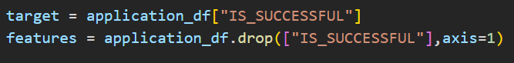

• These are the features of our model that we have used. We have used 9 columns as the features for our model classification part.

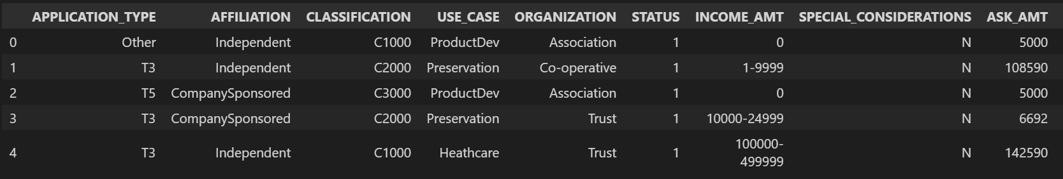

• For this model we are removing the EIN and NAME columns as they will not add value to our final result.



**• Compiling , Training and Evaluation  
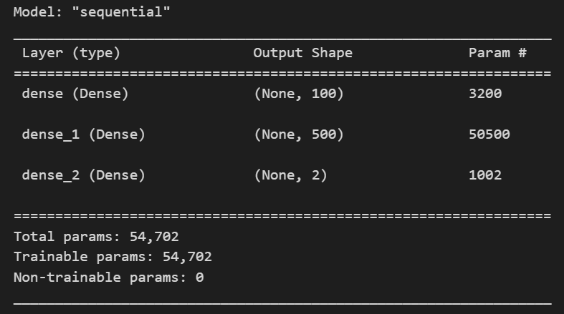**

This is the summary of the model that we have used. Looking at the data as we have around 9 columns and it is a binary classification problem so neural networks are the best choice. Neural Networks are robust to outliers and can handle them very well. We have used 100 neurons in the input layer and after that, we have used one dense layer in which we have used 500 neurons as we have 2 categories to classify so we will be having 2 neurons in the output layer. And we have used Adam as an optimizer and loss as sparse categorical cross entropy and we have used accuracy as the metrics.

• We were not able to get the desired output results as the model was not able to understand the patterns of the data well. So training for more epochs will help the model learn the data patterns.



We are able to achieve an accuracy of 54% on the testing data and 53% on the training data.

• We have used some techniques instead of using pd. Get dummies () we have used Label Encoder to encode the categorical data and we have only standardized the numerical variable in the dataset rather than all the variables. And we have used more neurons in the layers of the neural network.

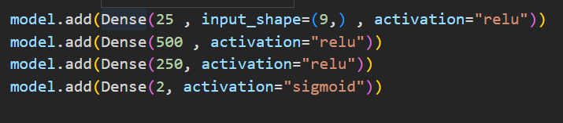

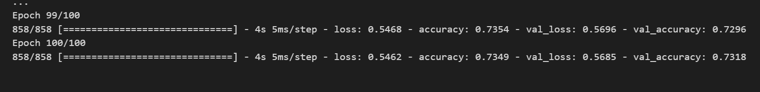

We are able to achieve an accuracy of 74% on the training and the testing data.

• In the approach 2 we have increased the number of neurons.

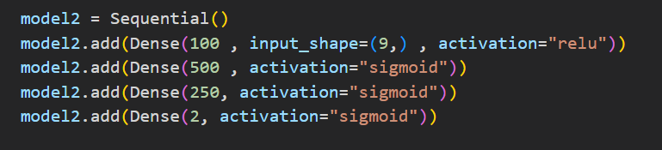



We can achieve an accuracy of around 73% on the training and testing data.

• Summary

In the end, we can conclude that after the optimization we are able to achieve increased accuracy of the neural network. The other model that we could use on this problem is Logistic Regression or Random Forest Classifier for the Classification of this task.