AssetManager
System Guide

IT Department . Your Organization

May 2026

1. What Is AssetManager?
AssetManager is a system that tracks IT equipment. It records when equipment (laptops, phones, screens, etc.) is given to an engineer or returned to the storeroom.

It has three parts:

Part | What It Does
Server | Stores all data. Runs on the asset-server computer. Must stay on at all times.
Storekeeper App | Used by the storekeeper to record assets going in or out.
Notifier App | Used by each engineer. Shows a popup when an asset is assigned to them.
Installer | Used to set up the apps on team computers.

There are also two support files:

File | What It Does
asset_lookup.xlsx | A list of all assets (number, serial, type, model). The system reads this automatically.
assets.db | The database. Created automatically. Do not delete.

2. How to Set Up
On the server computer (asset-server only):
- Right-click ServerApp.exe and choose Run as Administrator.
(Administrator access is required because the server uses port 80.)
- The server window opens and shows live statistics.
- Leave it running. Do not close it.
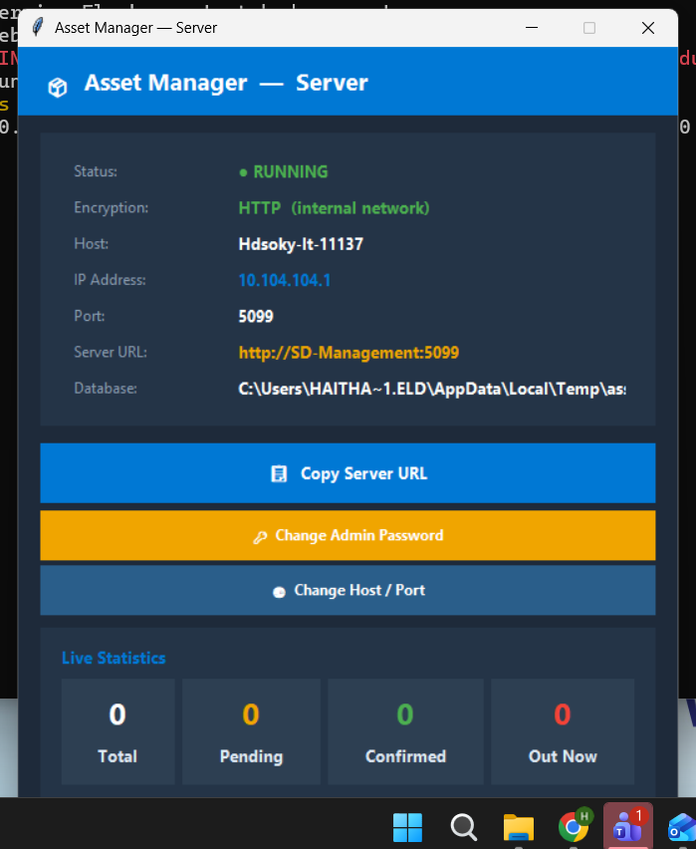
Server App running — shows status, IP address, and live transaction statistics

[ Screenshot -- Add here ]
Server app running

On each engineer's computer:
- Run installer.exe.
- Choose Notifier App from the list.
- Follow the steps on screen.
- The app will appear in the system tray (the bottom-right corner of the screen) once launched.
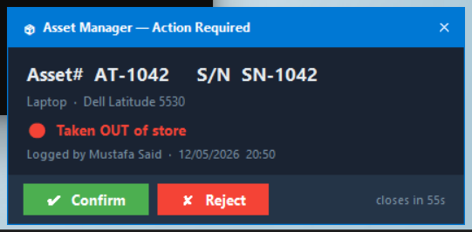
Notifier App popup — engineer can Confirm or Reject the transaction

On the storekeeper's computer:
- Run installer.exe.
- Choose Storekeeper App.
- Follow the steps on screen.

3. The Asset List (asset_lookup.xlsx)
This file tells the system what each asset is. When the storekeeper types an asset number or serial number, the system looks it up here. It fills in the type and model automatically.

The file has 4 columns:

Column | Example
Asset Number | 1042
Serial Number | ABC123456
Asset Type | Laptop
Asset Model | Dell Latitude 5530

To add or edit assets:
- Open asset_lookup.xlsx in the server folder.
- Add or edit rows.
- Save the file.
- The change takes effect immediately. No restart needed.

[ Screenshot -- Add here ]
asset_lookup.xlsx open in Excel

4. Features
4.1 Automatic Type and Model Fill
When the storekeeper enters an asset number or serial number, the system finds the matching row in asset_lookup.xlsx. It fills in the Type and Model automatically. The storekeeper cannot change these fields -- they are locked after auto-fill.

If the asset is not in the lookup file, the Type field stays editable and Model stays empty.
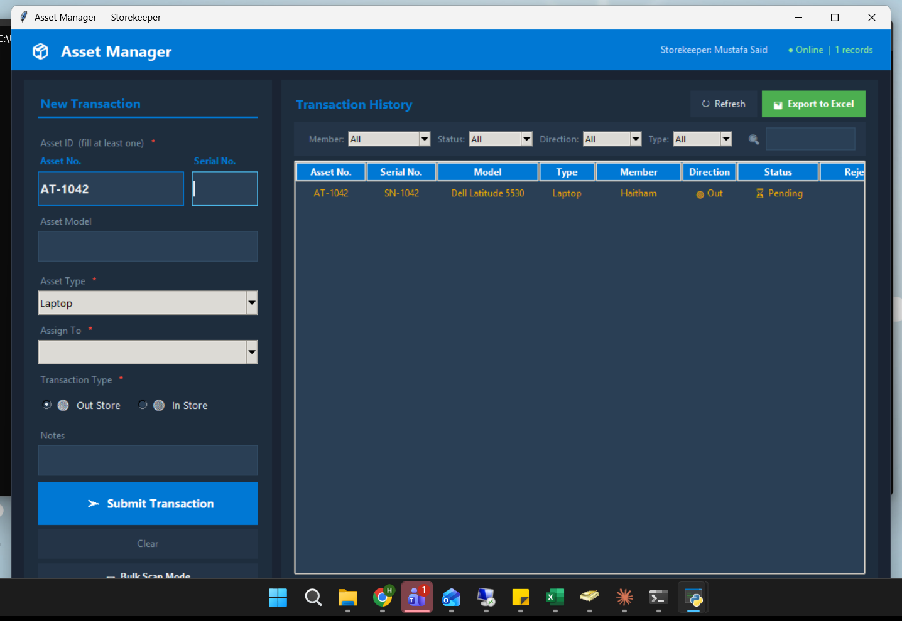
Asset Type auto-filled to 'Laptop' after entering asset number AT-1042

4.2 Duplicate Protection
If an asset is already waiting to be confirmed (pending means it has been submitted but not yet confirmed or rejected), the system will not allow it to be submitted again. It shows an error message:

"This asset already has a pending transaction. Confirm or reject it first."

This prevents the same asset from being logged twice by mistake.
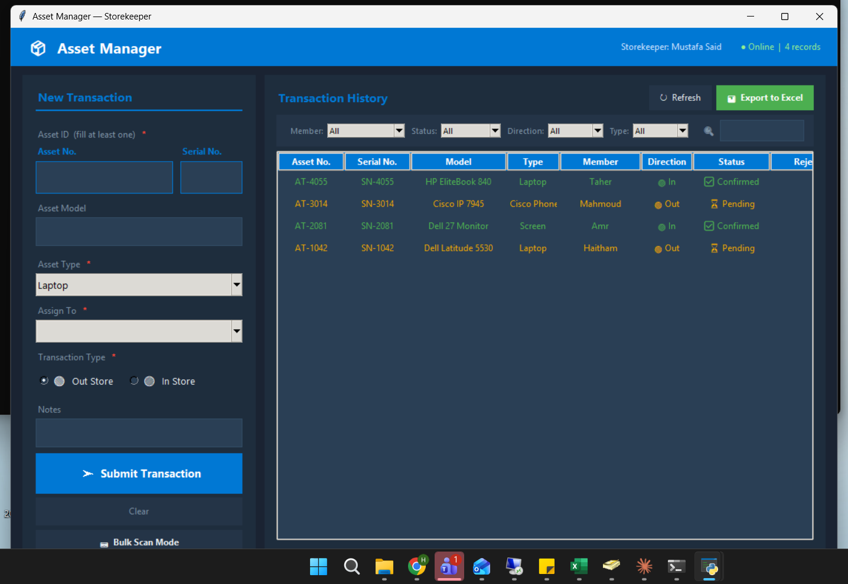
History showing a Pending record — duplicate protection blocks a second submission

4.3 Excel Export
The storekeeper can export all transactions to an Excel file. The file has two sheets:
- Asset Transactions -- full list of all transactions, color-coded by status.
- Summary -- totals, percentages, and 3 charts (status chart, per-engineer chart, in/out chart).
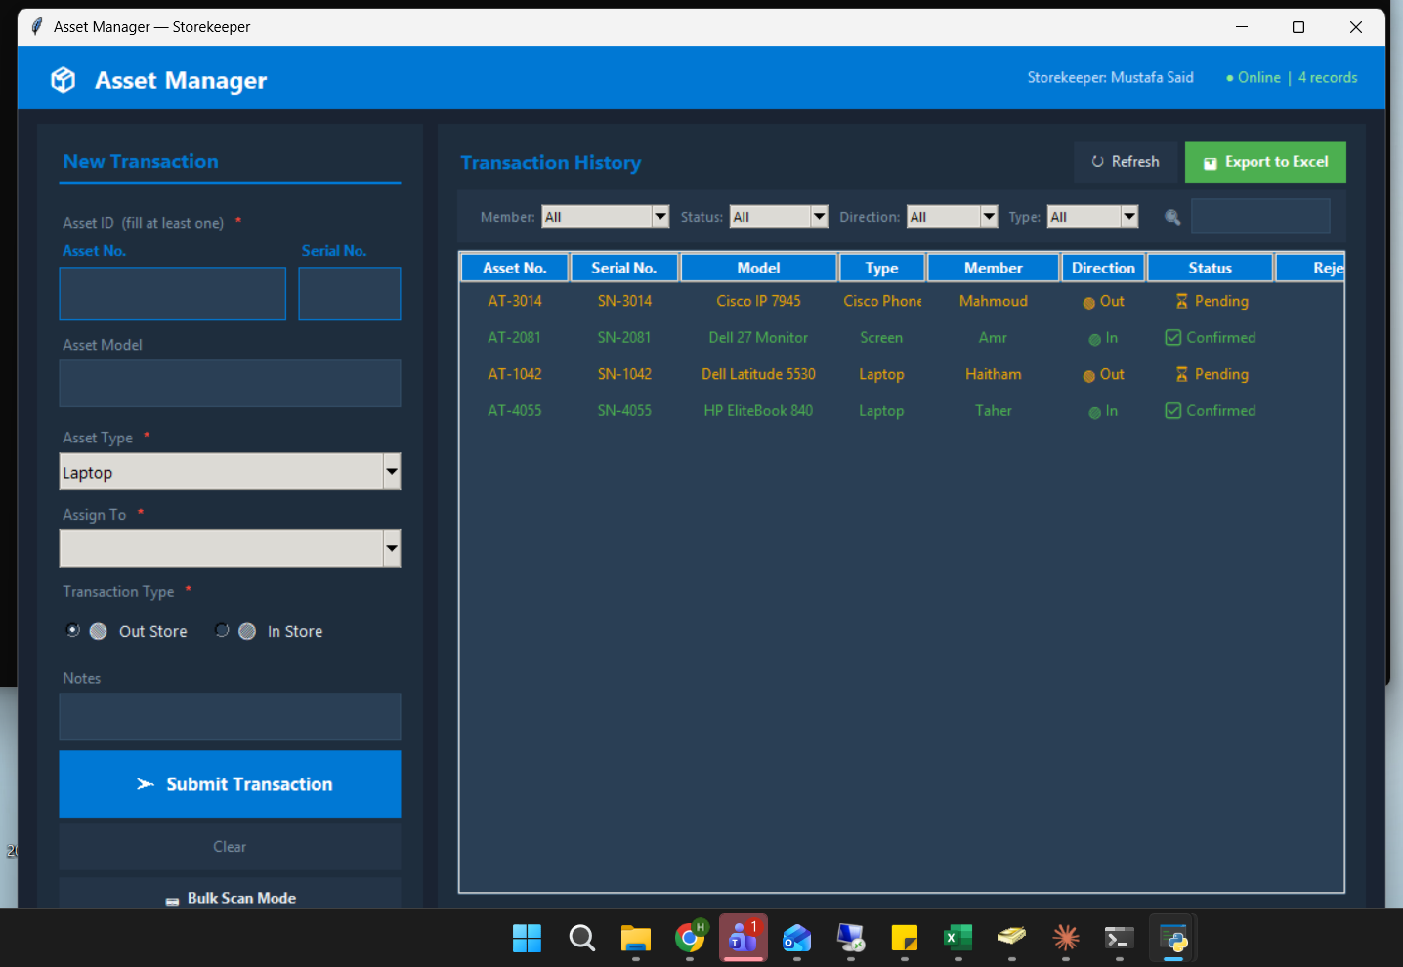
Transaction history — showing all statuses and the Export to Excel button

4.4 Change Port or Host
The server can be moved to a different network port if needed. Use the Change Host / Port button in the server window (admin password required). The change saves to a file and takes effect after restarting the server.

Default port: 8081
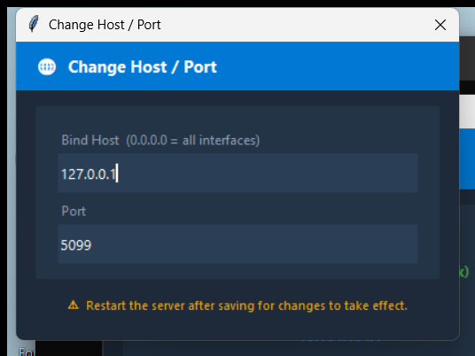
Change Host / Port dialog

4.5 Asset Types Supported
Laptop, Desktop, Mobile, Tablet, Screen, UPS, Server, Cisco Phone, Printer, Scanner, Switch

5. Admin Settings
All admin settings are in the server window. You need the admin password to change them.

Setting | How to Change
Admin password | Click Change Admin Password in the server window
Server port | Click Change Host / Port in the server window
Asset list | Edit asset_lookup.xlsx directly in the server folder

Default admin password: Set during first run. If you forget it, contact the system owner (Engineer 1).

5.1 Clear All Records
The Clear All Records button permanently deletes all transaction records from the database. It is available only in the Server App window, protected by admin password.
This action is permanent and cannot be undone. It requires the admin password and a second confirmation prompt.
How to use it:
- Click the red Clear All Records button in the Server App window.
- The server window will ask for the admin password. Enter it and confirm to proceed. All records are permanently deleted.

[ Screenshot -- Add here ]
Server window with buttons

5.2 SSL Certificate
The SSL Certificate button lets you encrypt all traffic between the server and clients using HTTPS. Once a certificate is installed, the server restarts on HTTPS and the Encryption label in the server window updates automatically.
Supported certificate formats: .pfx / .p12 (PKCS#12), .crt / .cer (DER or PEM), .pem (PEM bundle).
How to install a certificate:
- Click the green 🔒 SSL Certificate button in the Server App window.
- Click Browse and select your certificate file.
- If the file is a .pfx with a password, enter it in the PFX Password field.
- Click Upload Certificate. The server saves the certificate and restarts with HTTPS.
After installation, the Encryption label changes to "HTTPS (SSL encrypted)" and all clients must use https://asset-server:8081.
Note: The certificate file (ssl_cert.pem) is automatically copied to each app’s folder by the installer so clients can verify the server identity.
5.3 Minimise to System Tray
The Server App minimises to the Windows system tray when you click the X (close) button. The server continues running in the background.
To show or exit the server, right-click the tray icon in the bottom-right corner of the taskbar:
- Click Show / Hide to toggle the server window.
- Click Exit Server to stop the server (you will be asked to confirm).
The tray icon tooltip shows the current status: “Asset Manager — Server ● RUNNING (HTTPS)” or “(HTTP)”.

6. What the System Saves
What | Where | Notes
All transactions | assets.db | Auto-created. Do not delete or move.
Admin password | admin_config.json | Stored as a secure hash.
Server port settings | server_config.json | Edited via the GUI or manually.
Client settings (URL, user) | config.json | One file per client app.

7. API Endpoints (for reference)
If another system needs to connect to AssetManager, it can use these addresses. All requests go to the server's IP address on port 80.

What It Does | Address | Notes
Check server is running | GET /health | No password needed
Get all transactions | GET /transactions | No password needed
Add a transaction | POST /transactions | No password needed
Confirm a transaction | POST /confirm/{id} | No password needed
Reject a transaction | POST /reject/{id} | No password needed
Get statistics | GET /stats | No password needed
Export all transactions | GET /export | No password needed
Look up an asset | GET /lookup?q= | No password needed
Upload new lookup file | POST /lookup/upload | Admin password required
Get/change port settings | GET or POST /admin/server_config | Admin password required
Change admin password | POST /admin/change_password | Admin password required

8. Troubleshooting
Problem | What to Do
Server won't start | Make sure you right-clicked and chose Run as Administrator.
App says "Cannot reach server" | Check the server is running on asset-server. Check the server URL in the app's Settings.
Port 80 is already in use | Another program is using port 80. Use the Change Host/Port button to switch to another port (e.g., 8080).
Asset type/model not filling in | The asset is not in asset_lookup.xlsx. Add it to the file.
"Duplicate pending" error | Confirm or reject the existing transaction first.
Lost admin password | Contact Engineer 1 to reset it manually in admin_config.json.

[ Screenshot -- Add here ]
Storekeeper App main screen

[ Screenshot -- Add here ]
Notifier popup

[ Screenshot -- Add here ]
Excel export Summary sheet

