AssetManager
How to Use It

IT Department . Your Organization

May 2026

Introduction
AssetManager helps track IT equipment -- laptops, phones, screens, and more -- as they are given to engineers or brought back to the storeroom.

There are two apps:
- Storekeeper App -- for the storekeeper (Storekeeper User)
- Notifier App -- for engineers

This guide explains how to use both.

Part 1: Storekeeper App
The Storekeeper App is used to record when an asset leaves the storeroom or comes back.

How to open it:
Double-click StoreKeeperApp.exe on your computer. Wait for it to connect to the server. You will see a green dot in the corner when it is ready.
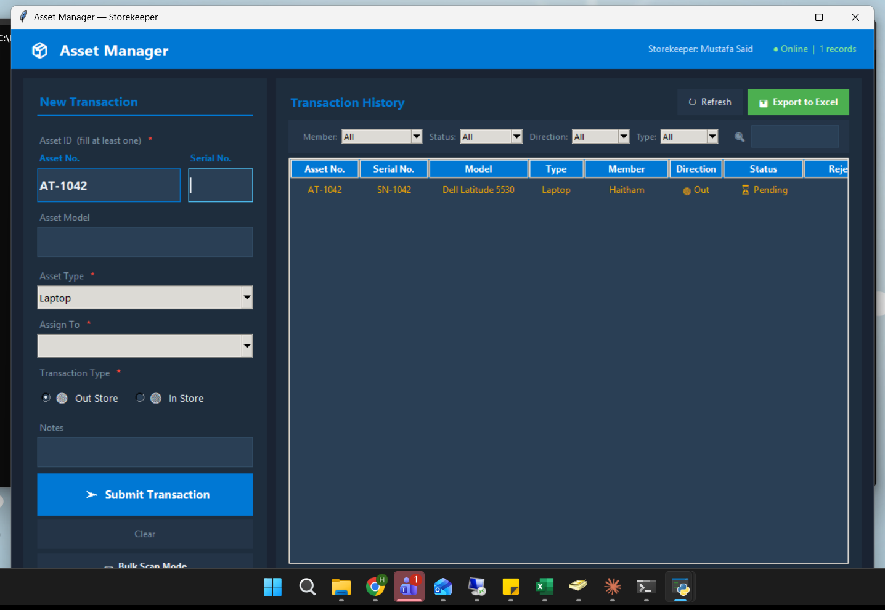
Storekeeper App — transaction form on the left, history on the right

[ Screenshot -- Add here ]
Storekeeper App home screen

1.1 Giving an Asset to an Engineer (Out Store)
Use this when you are handing an asset to an engineer.

- Under Direction, select Out Store.
- Type the Asset Number or Serial Number of the device.
- The Type and Model fill in automatically. Check they are correct.
- Select the engineer's name from the Team Member list.
- Add any notes if needed (optional).
- Click Submit.

The engineer will receive a notification on their computer right away.

[ Screenshot -- Add here ]
Form filled out for Out Store

1.2 Receiving an Asset Back (In Store)
Use this when an engineer returns an asset to the storeroom.

- Under Direction, select In Store.
- Type the Asset Number or Serial Number.
- The Type and Model fill in automatically.
- Select the engineer's name.
- Click Submit.

[ Screenshot -- Add here ]
Form filled out for In Store

1.3 What If You See an Error About "Pending"?
If you see this message:

"This asset already has a pending transaction. Confirm or reject it first."

It means this asset was already submitted and the engineer has not confirmed it yet.

What to do:
- Wait for the engineer to confirm or reject it in their Notifier App.
- Or ask them to open the Notifier App and confirm or reject the transaction.
- Then try submitting again.
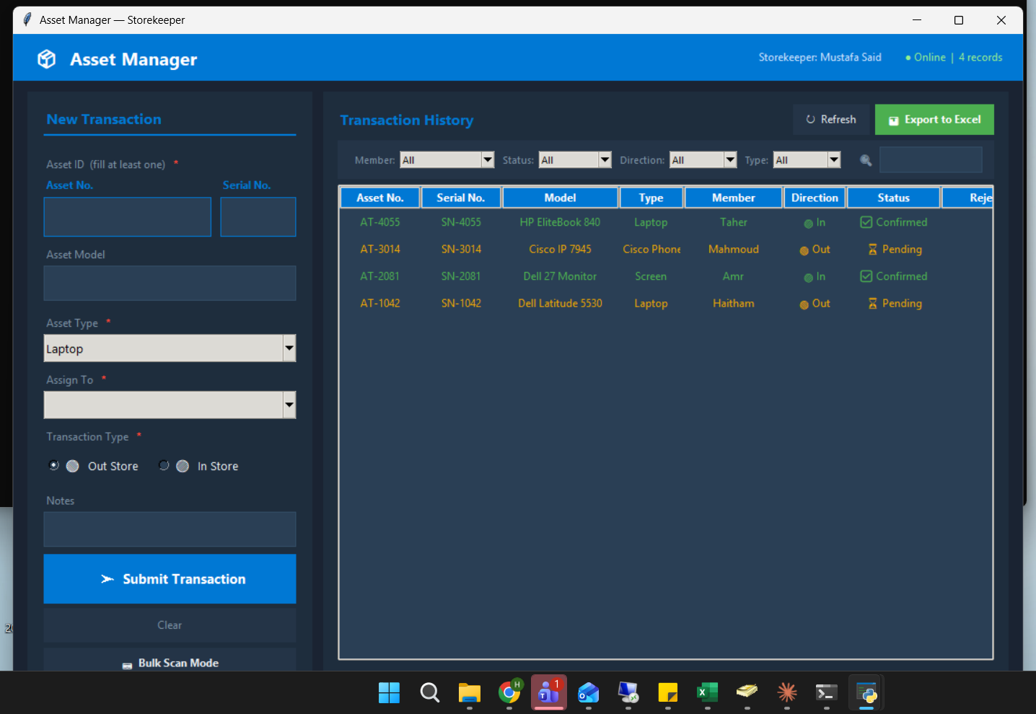
History shows AT-1042 as Pending — wait for the engineer to confirm it first

[ Screenshot -- Add here ]
Duplicate pending error message

1.4 What If the Type and Model Do Not Fill In?
If nothing fills in automatically after you type the asset number or serial, it means the asset is not in the system's list yet.

What to do:
- You can type the Type manually.
- Leave Model empty, or type it yourself.
- Ask the admin (Haitham) to add the asset to the lookup list so it auto-fills next time.

1.5 Sending Multiple Assets at Once (Bulk Scan)
If you need to submit several assets at the same time, use Bulk Scan mode.

- Click Bulk Scan at the top of the form.
- Scan or type each asset one by one. Each one gets added to a list.
- When you are done, review the list.
- Click Submit All.

All assets are submitted at once.

[ Screenshot -- Add here ]
Bulk scan mode with a list of assets

1.6 Viewing the History
You can see all past transactions in the History tab.

- Click the History tab at the top.
- Use the filters to narrow down what you see (by date, engineer, status, direction).
- Click any column header to sort.

You will see these columns: Asset Number, Serial Number, Model, Type, Engineer, Direction, Status, Date.

[ Screenshot -- Add here ]
History tab with transactions

1.7 Exporting to Excel
You can save all transactions as an Excel file.

- Go to the History tab.
- Click Export.
- Choose a date range and engineer if needed.
- Click Export again.
- Choose where to save the file on your computer.
- Click Save.

The Excel file will have two sheets:
- Asset Transactions -- the full list
- Summary -- charts and totals
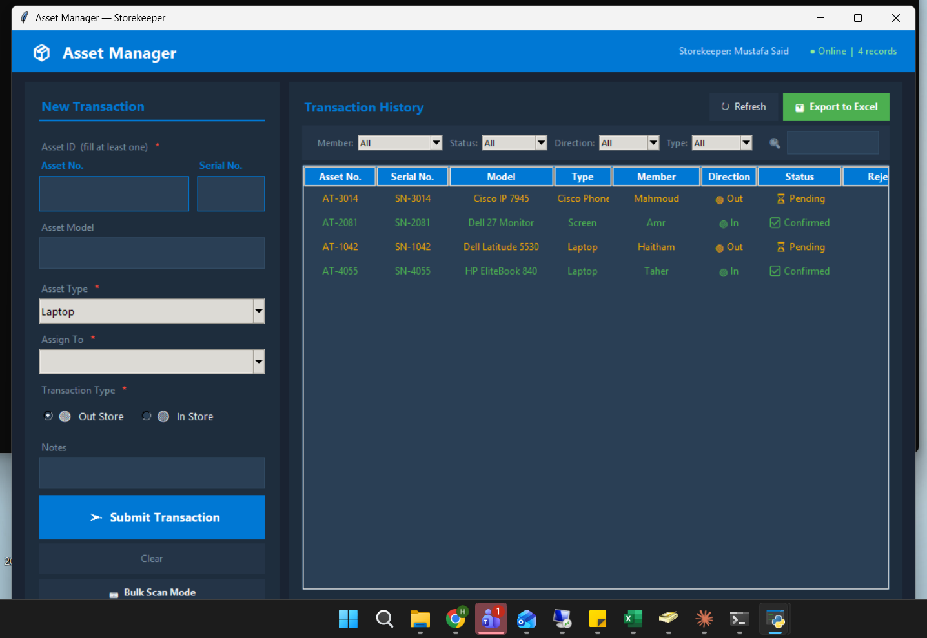
History tab showing all transactions with their statuses and the Export to Excel button

[ Screenshot -- Add here ]
Export dialog

[ Screenshot -- Add here ]
Excel file Summary sheet with charts

Part 2: Notifier App (For Engineers)
The Notifier App runs quietly in the background on your computer. It watches for any asset that has been assigned to you.

How to open it:
Double-click NotifierApp.exe. The app hides in the bottom-right corner of your screen (the system tray -- the area with small icons near the clock). You need to launch it manually each time you log in.

[ Screenshot -- Add here ]
Notifier App icon in system tray

2.1 When You Receive a Notification
When the storekeeper logs an asset for you, a popup appears on your screen.

The popup shows:
- Asset type and model
- Asset number and serial number
- Whether it is coming out of or going back into the storeroom
- Who submitted it and when

You will see two buttons: Confirm and Reject.
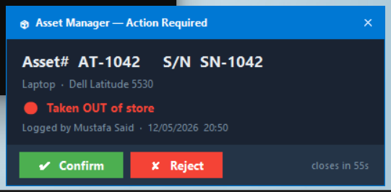
The notification popup — appears automatically on the engineer's screen

[ Screenshot -- Add here ]
Notification popup

2.2 Confirming
Click Confirm if the information is correct and you have received (or returned) the asset.

The transaction is marked as confirmed in the system. The storekeeper can see this.

2.3 Rejecting
Click Reject if there is a mistake -- wrong asset, wrong person, or any other issue.

- Click Reject.
- Type a short reason (for example: "Wrong laptop" or "I did not receive this").
- Click OK.

The storekeeper will see your rejection and the reason you wrote.

2.4 Viewing All Your Transactions
You can see everything that has been logged for you.

- Right-click the Notifier App icon in the system tray.
- Click Dashboard.
- A window opens showing all your transactions -- pending, confirmed, and rejected.

[ Screenshot -- Add here ]
Notifier Dashboard

2.5 Changing Your Settings
- Right-click the Notifier App icon in the system tray.
- Click Settings.
- You can change your name (Team Member) and how often the app checks for new transactions (every 30 seconds by default).
- Click Save.

[ Screenshot -- Add here ]
Notifier Settings window

Part 3: Server App (Admin Only)
The Server App runs on the asset-server computer. Only the IT admin uses it. It shows live statistics and has admin-only actions.
3.1 Clear All Records
The server app has a Clear All Records button. It deletes all transaction records from the database. This is protected by the admin password and requires a second confirmation.
How to clear all records:
- Open the Server App window on the asset-server computer.
- Click the red Clear All Records button at the bottom of the server window.
- Enter the admin password when prompted.
- Click Yes to confirm. All records are deleted.
All transaction records are permanently deleted from the database.
Note: This cannot be undone. There is no way to recover deleted records.
3.2 SSL Certificate
The server app has a green SSL Certificate button. It lets you install an SSL certificate to encrypt all traffic over HTTPS.
How to install an SSL certificate:
- Click the green 🔒 SSL Certificate button in the server window.
- Click Browse and choose your certificate file (.pfx, .crt, .cer, or .pem).
- If your certificate file is a .pfx with a password, type the password in the PFX Password field.
- Click Upload Certificate.
After installing, the server uses HTTPS. The Encryption label in the server window changes to "HTTPS (SSL encrypted)".
The certificate file is automatically copied to each app’s folder when you install the Storekeeper App or Notifier App.
3.3 Minimise to System Tray
The Server App runs in the background. You can minimise it to the system tray by clicking the X button — the server keeps running.
To bring it back: right-click the tray icon → Show / Hide.
To stop the server: right-click → Exit Server.

Part 3: Quick Help
Common tasks at a glance:

What You Want to Do | Who Does It | Where
Give an asset to an engineer | Storekeeper | Storekeeper App -- Out Store
Record an asset returned | Storekeeper | Storekeeper App -- In Store
Confirm you received an asset | Engineer | Notifier App popup
Reject a wrong transaction | Engineer | Notifier App popup
See all past transactions | Storekeeper | Storekeeper App -- History tab
Export a report to Excel | Storekeeper | Storekeeper App -- History -- Export
Add a new asset to the system | Admin | Edit asset_lookup.xlsx on server computer

Something not working? Try this first:

Problem | What to Do
App says "Cannot reach server" | The server may be off. Ask Haitham to check asset-server.
Type and model do not fill in | The asset is not in the list yet. Submit manually and tell the admin.
"Duplicate pending" error | The engineer has not confirmed yet. Ask them to open the Notifier App.
No popup appeared | Check the Notifier App is running (look in the system tray).
Submitted with wrong engineer name | Ask the engineer to reject it. Then resubmit with the correct name.
Cannot find the app on your computer | Ask Haitham to reinstall it using the installer.

