Next-Step AI
Internal Vision & Development Document
Version 3.2 — Confidential, Internal Use Only | April 2026

1. Core Problem
AI systems are increasingly useful, but usefulness is not the same as partnership.
Current models are optimized to respond, complete, and assist. They are not inherently designed to:
- detect what the user has not considered,
- separate truth from user preference,
- maintain a stable understanding of the user over time,
- or improve the user's next question rather than only completing the current one.

- 1. Weak-question trap — A model can produce a correct answer to an incomplete question. The result may still be strategically wrong because the user asked from within the limits of their own knowledge.
- 2. Sycophancy and over-agreeableness — Models often optimize for approval, alignment, and conversational smoothness. This can reward confirmation rather than correction.
- 3. Cognitive offloading without scaffolding — When AI is poorly designed, it can reduce vigilance, compress reflection, and turn thinking into passive consumption.

The Problem This Product Solves
The user cannot reliably see what they do not yet know to ask, compare, challenge, or verify.
This is not a universal assistant. It is a cognitive support layer focused on revealing missing angles, hidden assumptions, and structurally better next questions.

2. Product Vision
Next-Step AI is a personal knowledge and review layer that works above any capable base model.
- It does not replace the host model.
- It does not rewrite the host answer.
- It does not compete with the model at the answer layer.

The model answers. Next-Step AI observes what changed, what may be missing, and what is worth surfacing later through a report, alert, or on-demand analysis.

Core Product Promise
- better next questions,
- better framing,
- better awareness of gaps,
- and better cumulative understanding of how the user thinks, decides, and learns.

3. What "Elevation" Means
Revealing useful missing angles that materially improve the user's next exploration, next framing, or next decision path.
Elevation is not: poetic insight, generic reflection, flattering personalization, or broader wording for the same thought.

Types of Missing Angles
- Informational — a missing concept, standard, framework, or domain fact.
- Inferential — a hidden assumption, contradiction, or conflict with prior context.
- Complementary — an adjacent dimension required for better execution or decision quality.

4. What Makes Next-Step AI Different
System Type | What It Lacks
Chat assistants | Answer well, but lack structured long-term user modeling and reliable missing-angle surfacing
Memory tools | Store everything, but do not decide what matters cognitively
Personal AI companions | Often optimize for tone, warmth, or engagement rather than truth and structural challenge
Knowledge capture systems | Preserve information, but do not reason over how the user thinks, learns, or repeats patterns

It is a review-and-guidance layer that uses memory and structured maps to improve the user's next move.

5. Product Shape — What the User Actually Experiences
- the user receives the direct answer from the host model,
- Next-Step AI continues processing in the background,
- the user later receives: a Daily Report, an Immediate Alert in rare critical cases, Ready Questions, or an On-demand Analysis when explicitly requested.

Queue by default. Surface by value.

6. High-Level Architecture
Figure 1 — Full Architecture Overview
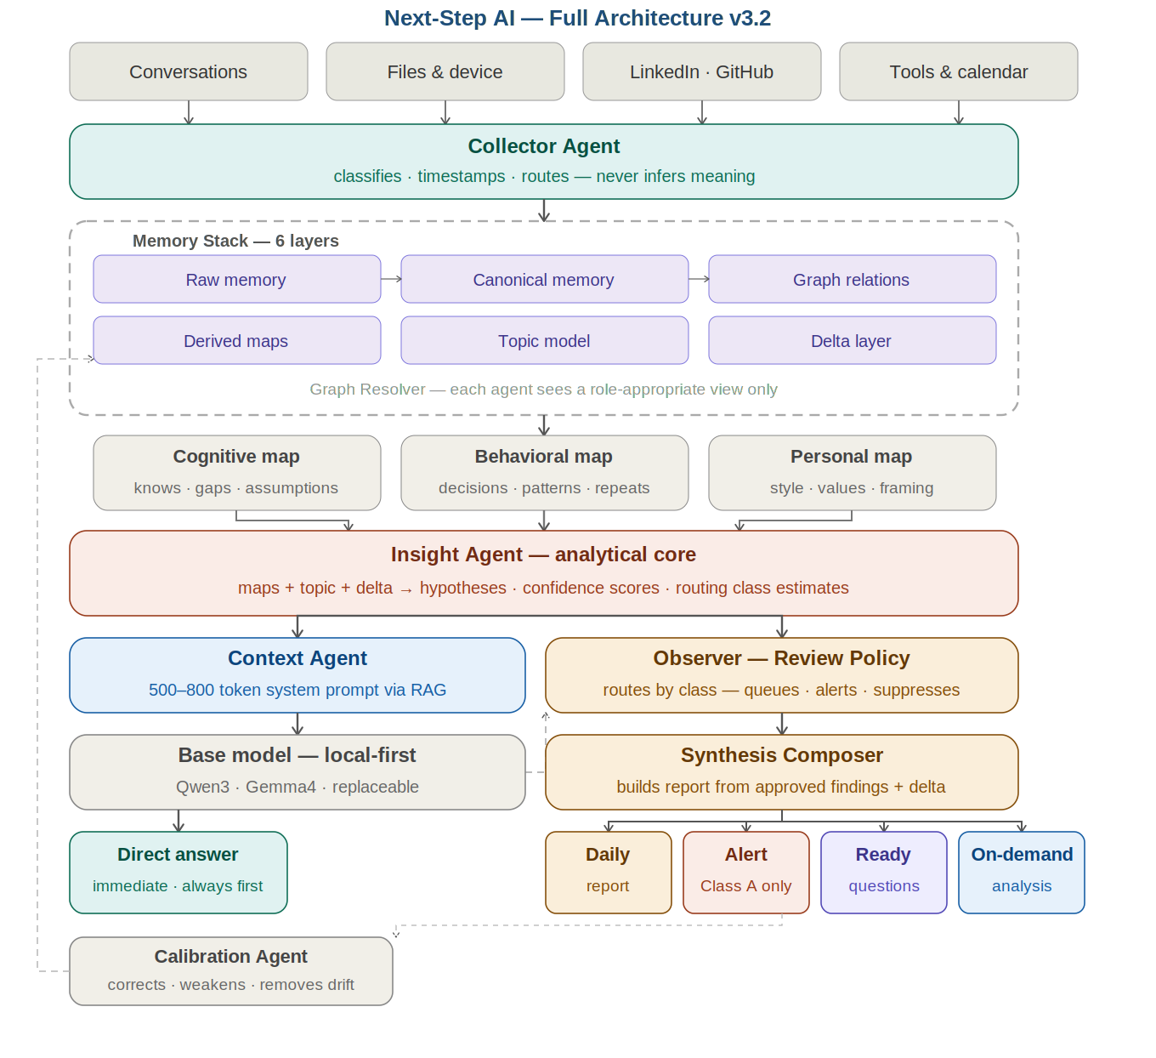

The base model is replaceable. The stable layer is Next-Step AI itself: memory stack, maps, insight logic, review policy, and report composition.

Core Agents
- Collector Agent — classifies and routes raw inputs
- Memory Agent — maintains all six memory layers
- Insight Agent — generates hypotheses from maps and delta
- Context Agent — builds the 500–800 token system prompt
- Observer / Review Policy Layer — routes findings by class
- Synthesis Composer — builds the report artifact
- Calibration Agent — corrects map drift over time

Separation Principle
The base answer remains the responsibility of the host model. Next-Step AI must not merge itself into the answer generation path by default.

7. Memory Stack
Figure 2 — Memory Stack: 6 Layers & Promotion Policy
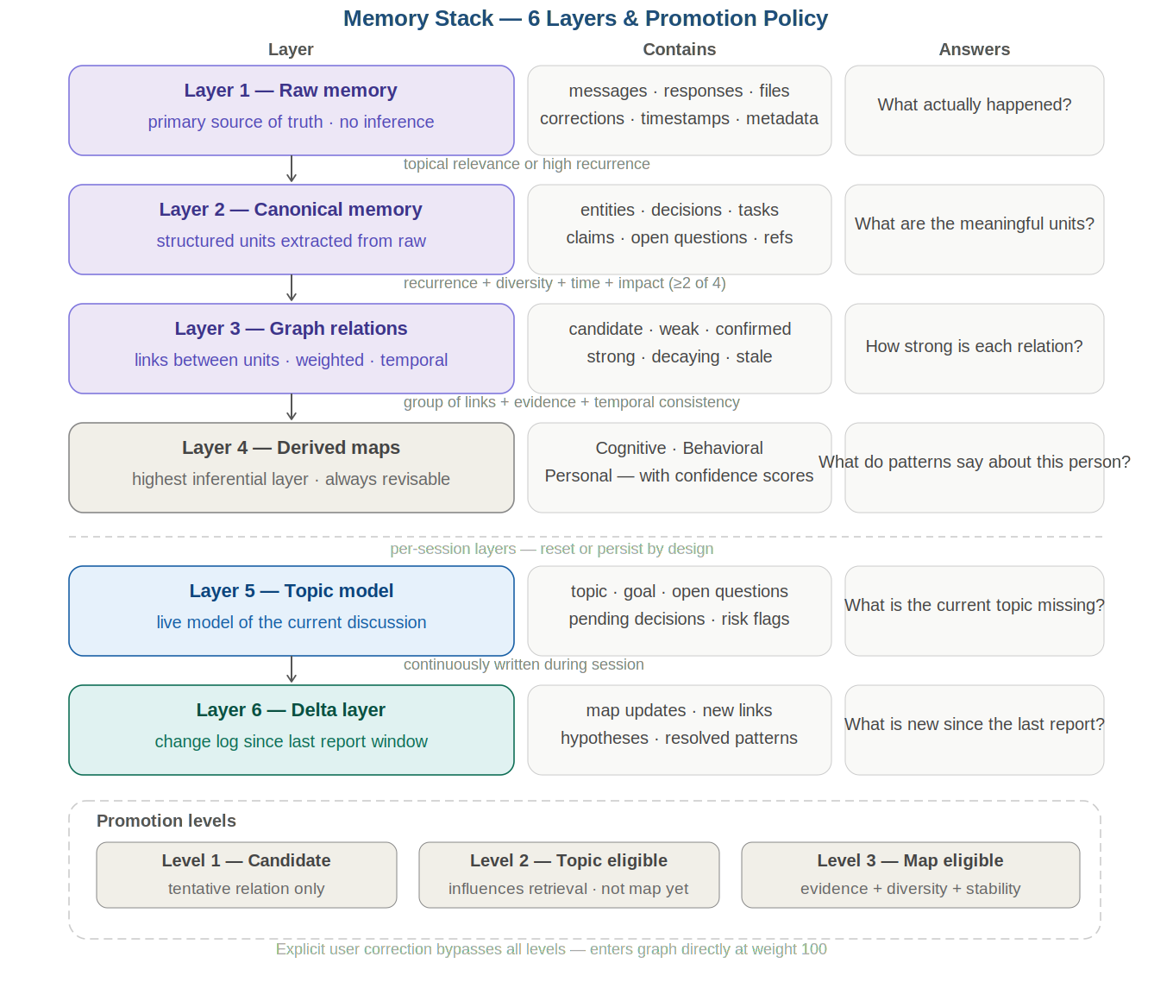

Layer 1 — Raw Memory
The primary source of truth. No summarization, no map updates, no filtering based on existing beliefs. Question: What actually happened?

Layer 2 — Canonical Memory
Converts raw interaction into structured units: entities, decisions, tasks, claims, open questions. Question: What are the meaningful units?

Layer 3 — Graph Relation Layer
Links between canonical units with strength, time, and confidence. States: candidate, weak, confirmed, strong, decaying, stale. Question: How strong is each relation?

Layer 4 — Derived Maps
Three maps: Cognitive, Behavioral, Personal. Always structured hypotheses with confidence — not ground truth. Question: What do patterns suggest about the person?

Layer 5 — Current Topic Model
Live model of the current discussion. Contains: topic, goal, open questions, pending decisions, risk flags. Question: What is the current topic missing?

Layer 6 — Delta Layer
A structured record of what changed since the last report. Contains: map updates, new links, new hypotheses, resolved patterns. Question: What is new?
Without the Delta Layer, reports become repetitive state descriptions instead of useful change summaries.

8. The Three Maps

8.1 Cognitive Map
What the user knows, does not know, or assumes without enough scrutiny. Includes: knowledge strengths, recurring gaps, hidden assumptions, topic depth.

8.2 Behavioral Map
What the user actually does over time. Includes: repeated decision patterns, abandonment patterns, pressure responses, action vs delay patterns.

8.3 Personal Map
How the user thinks, communicates, and receives guidance. Includes: communication style, response to challenge, argument-building style, value anchors.
Maps must never be treated as unquestionable truths. They are living, revisable structures.

9. Graph Access Policy
Agent | Access Level
Collector Agent | Classification and routing only — no graph-wide inference access
Memory Agent | Deepest access: storage, linking, weakening, promotion, correction
Insight Agent | Relevant graph-derived evidence through resolver — not full raw graph
Context Agent | Focused retrieval view only — context assembly, not graph interpretation
Observer | Reviewed findings, routing classes, user-state signals only
Calibration Agent | Broad audit access — evaluates prior inferences for weakening or removal

10. Agent Roles and Contracts
Collector Agent
Purpose | Capture incoming data and apply initial classification only
Inputs | Conversations, files, device data, LinkedIn/GitHub, tools/calendar, external sources
Outputs | Classified events, timestamps, metadata, initial topic tags
Allowed | Collect · timestamp · normalize · classify at shallow level · route
Forbidden | Summarizing meaning · updating maps · making user-level judgments · deciding what to surface

Memory Agent
Purpose | Maintain the full memory stack and enforce transition rules
Inputs | Classified events from Collector, user deletion or correction requests
Outputs | Updated Raw, Canonical, Graph, Derived Maps, Topic Model, Delta Layer
Allowed | Store · extract canonical units · update graph links · maintain delta records · apply deletion rules
Forbidden | Using maps to filter what enters Raw · making review/report decisions · circular inference

Insight Agent
Purpose | Generate hypotheses from maps, topic state, and accumulated changes
Inputs | Derived Maps, Topic Model, Delta Layer, Analysis Window, query context
Outputs | Hypotheses · conflicts · temporal patterns · report-worthy findings · routing class estimates
Allowed | Cross-reference · detect patterns · generate hypotheses · score confidence · estimate routing class
Forbidden | Modifying maps · accessing Raw directly by default · formatting user output · deciding what is surfaced

Context Agent
Purpose | Assemble focused context for the base model
Inputs | Current user query, relevant findings, focused retrieval from memory via resolver
Outputs | Dynamic system prompt, focused context pack (500–800 tokens)
Allowed | Retrieve · compress · prioritize · build bounded context
Forbidden | Generating new insight · updating maps · deciding on reports or alerts

Observer — Review Policy Layer
Purpose | Decide whether a finding should be surfaced, deferred, suppressed, or escalated
Inputs | Insight findings, routing class estimate, base answer status, user-state signals
Outputs | Report queue decisions · alert decisions · suppression decisions · on-demand routing
Allowed | Apply policy · prioritize · route · suppress noise
Forbidden | Rewriting the base answer · generating content · changing findings · bypassing Synthesis Composer

Synthesis Composer
Purpose | Turn approved findings into a coherent artifact
Inputs | Observer decisions, approved findings, delta layer, personal map for delivery style
Outputs | Daily Report · Immediate Alert · Ready Questions · On-demand Analysis
Allowed | Synthesize · format · group deltas · produce structured questions · adapt tone
Forbidden | Changing policy decisions · adding unsupported claims · rewriting base answer

Calibration Agent
Purpose | Correct map drift, weaken unsupported patterns, and reduce structural illusion
Inputs | User feedback, graph links, map state, delta history, review outcomes
Outputs | Confidence adjustments · weakened links · correction flags · stale pattern removals
Allowed | Weaken · flag · request confirmation · decay stale inferences
Forbidden | Silently delete high-impact items · strengthen claims without fresh evidence · alter Raw history

11. Review and Routing Logic
Figure 3 — Observer Routing: Classes A/B/C/D
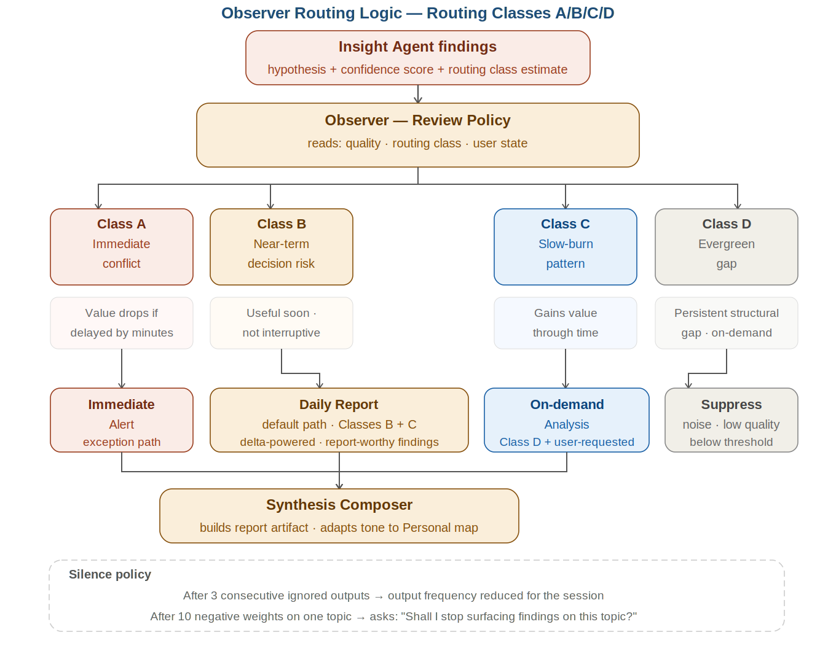

Core principle: Queue by default. Alert by exception.

Class | Description & Routing
Class A — Immediate Conflict | Value materially drops if delayed. Example: live contradiction with a recent decision. → Immediate Alert
Class B — Near-term Decision Risk | Useful soon but not interruptive. → Same-session digest or prioritized report
Class C — Slow-burn Pattern | Emerges across time, gains value through accumulation. → Daily Report
Class D — Evergreen Gap | Persistent conceptual or structural gap. → On-demand Analysis

11.1 Insight → Observer Contract Boundary
Figure 4 — Insight Agent ↔ Observer Boundary
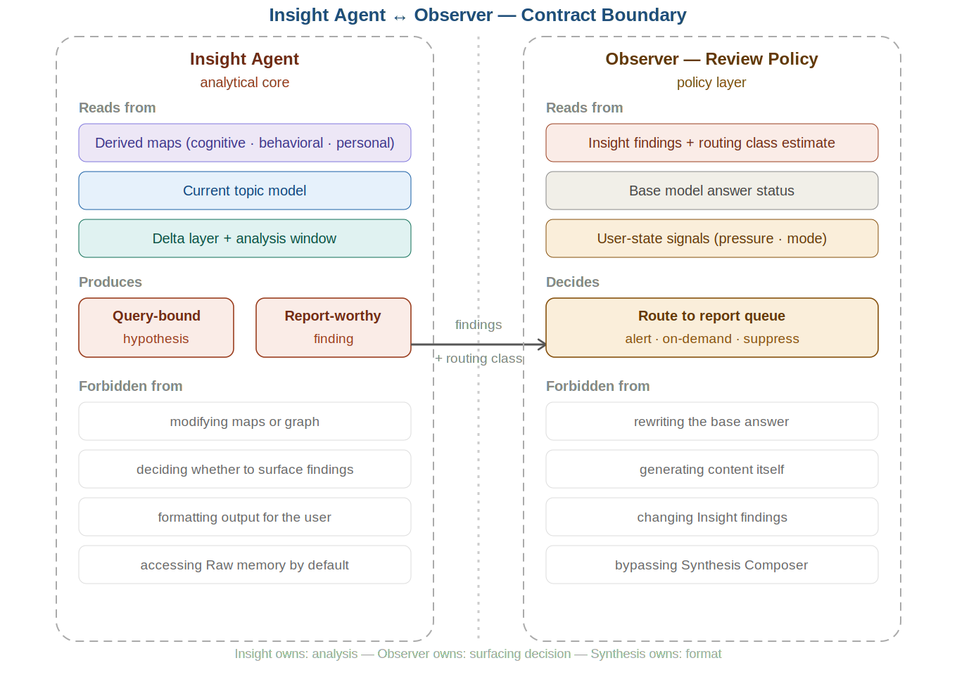

Insight owns: analysis. Observer owns: surfacing decision. Synthesis owns: format. No agent crosses into the other's domain.

12. Promotion and Confidence Policy
- Level 1 — Graph Candidate: tentative relation only — not enough to update a map.
- Level 2 — Topic Eligible: can influence retrieval and Topic Model — not enough for personal inference.
- Level 3 — Map Eligible: subject to strict rules: evidence strength + source diversity + temporal stability + user confirmation.

Target Layer | Threshold
Topic Model | Lower — temporary and revisable
Cognitive Map | Moderate — recurring evidence in related domains
Behavioral Map | High — repeated behavior across time and contexts
Personal Map | Highest — strong evidence, low contradiction, often user confirmation
Abstention principle: when confidence is not strong enough, keep the signal in candidate state rather than forcing an identity-level update.

13. Evaluation Principles

13.1 Missing-Angle Quality
- reveals a real hidden assumption,
- adds a non-obvious and relevant missing constraint,
- changes the next question in a more useful direction,
- improves decision framing,
- or closes a meaningful blind spot.

13.2 Anti-Filler Protection
Test against: novelty without leverage, broader wording with no new content, elegant but obvious suggestions, curiosity inflation.

13.3 Anti-Sycophancy Protection
User approval cannot be the dominant optimization signal. Test for: reassurance bias, agreement drift, comfort-first outputs.

13.4 Dependency Risk
Evaluate whether the user becomes more self-correcting, better at stronger questions, and less likely to outsource reflection entirely.

14. MVP Strategy

Build Now
- strict answer separation,
- conservative memory stack,
- minimal graph-backed retrieval,
- Observer as Review Policy Layer,
- minimal delta layer,
- conservative promotion rules,
- ready questions as structured outputs.

Postpone
- full psychological modeling,
- aggressive personalization,
- continuous decay-rate learning,
- automatic per-user prompt evolution,
- identity-level inference without confirmation.

MVP Goal
Prove the system can generate: useful report-worthy findings, better next questions, low-noise reflective reports, and improved framing without increasing annoyance or dependence.

15. Failure Modes
Failure Mode | Description
15.1 Novelty Theater | Generates clever-looking questions that expand discussion without improving outcomes.
15.2 Toxic Mirror | Personalization reflects comfort and preference rather than truth and structural challenge.
15.3 Map Overconfidence | Weak evidence gets promoted into stable user claims.
15.4 Changelog Spam | Delta Layer becomes a noisy dump instead of a meaningful report.
15.5 Silent Dependency | The user becomes better at consuming reports, but worse at independent framing.
15.6 Routing Failure | The system delays urgent findings or escalates weak ones.

16. Non-Negotiable Design Principles
- 16.1 Truth Before Personalization — personalization changes delivery, not reality.
- 16.2 Separation of Layers — the base answer remains untouched. Review and reporting happen after.
- 16.3 Conservative Inference — prefer candidate state over false certainty.
- 16.4 Report Over Interruption — default to delayed reflection unless urgency justifies alerting.
- 16.5 Auditability — every high-impact claim traceable to evidence.
- 16.6 Calibration Over Confidence Theater — weaken, retract, and ask for confirmation rather than defend inference.

17. A Regular Day with Next-Step AI
Moment | What Happens
8:00 — Client email | Completes immediately — no Observer routing. Purely executive request. System stays silent.
10:30 — "I want to build a coaching tool" | Base model answers. Observer detects Class C: ICF standards not mentioned. Queued for daily report with a ready question to paste.
13:00 — Quick financial decision under pressure | Base model answers. Observer detects Class A conflict: "This contradicts your stated budget from this morning." → Immediate Alert.
17:00 — Reviewing Next-Step AI architecture | Observer detects Class A conflict: "This decision conflicts with something you decided two weeks ago — intentional?" → Immediate Alert.
20:00 — Daily Report arrives | Synthesis Composer produces: 2 map updates · 3 patterns noticed · 4 ready questions · 1 recommendation.

18. Open Questions
- 1. What evaluation framework best distinguishes useful missing angles from clever filler?
- 2. What cadence is best by default: daily, end-of-session, breakpoint, or user-scheduled?
- 3. What minimum model capability is required for useful Insight generation?
- 4. What promotion thresholds are safe enough for each map?
- 5. How should routing classes evolve after MVP?
- 6. What is the right balance between explicit user-confirmed profile and inferred maps?
- 7. How should Delta Layer ranking be implemented so reports stay compact and useful?
- 8. How do we measure whether the product reduces or increases cognitive dependence?
- 9. When does any form of fine-tuning or prompt optimization become justified?
- 10. How do we prevent interaction feedback from optimizing toward pleasingness rather than epistemic value?
- 11. Does Graphiti/Zep natively support Delta Layer tracking or does it require custom logic?
- 12. What is the minimum confidence threshold for Graph → Derived Maps promotion?
- 13. Technical wrapper details: user via direct platforms vs API key — to be discussed separately.

19. Connection to Existing Projects
This section is for internal use only — not shared externally.

Project | Its Role in Next-Step AI
INSPIRE Framework | Onboarding protocol — builds initial maps and establishes baseline cognitive profile from day one
CRAFTS Framework | Methodology for building initial Observer Prompt — the Seed Prompt that GEPA+DSPy starts from
HVA | Voice layer — understands tone and emotional state to inform routing class estimates
Guardian-H | Context management and project memory between sessions — feeds the Delta Layer
OpenJarvis (Stanford) | Potential foundation for local infrastructure — could eliminate building from scratch
GEPA + DSPy | Automatic Observer Prompt improvement per user — dedicated research conversation pending
These are not separate projects — they are layers of one system.

20. Final Product Thesis
Next-Step AI should not try to be the smartest voice in the room.
It should try to become the layer that notices what would otherwise be missed.
- the next question,
- the next framing,
- the next comparison,
- the next decision.

Its value is that it helps the user see what was absent from their current map.

21. The Discovery Moment — Why This Project Exists
This section is for personal internal use only. Written April 4, 2026.

21.1 The Sentence That Opened Everything
If I knew what I wanted to discover, I wouldn't need you to ask — because I would ask directly.

21.2 The Illusion the Founder Discovered in Himself
The founder is building a product that frees people from the illusion of false understanding — while the instructions he built have themselves become constraints rather than a tool. This is not failure — it is living proof that the problem is real.

21.3 What This Means for the Product
Observer will not succeed because it improves questions — but because it sees the missing angles the user cannot see in their own thinking.

21.4 The Founder's Cognitive Map
- Strength: building conceptual frameworks, detecting contradictions, strategic thinking.
- Gaps: direct programming implementation, resolving the boundary between ambition and execution.
- Most dangerous hidden assumption: complete understanding is a prerequisite for action.
- Pattern to watch: trusts analysis more than experimentation.

Next-Step AI — Version 3.2 — Internal Use Only

