`

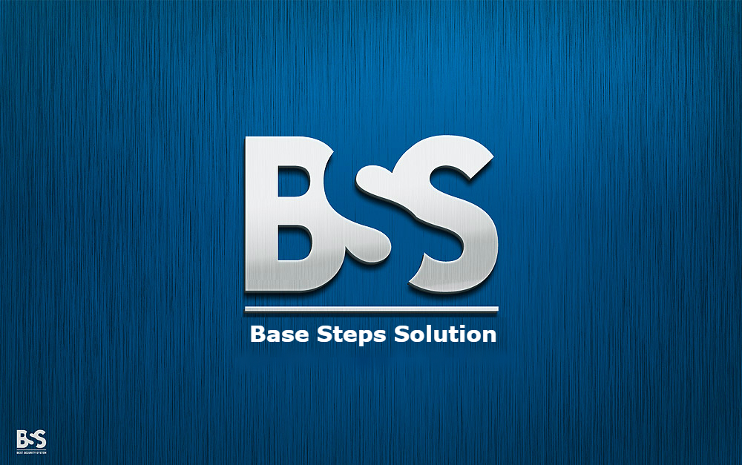

REQUIREMENT DEVELOPMENT PROCESS

Van Lang Admissions

# Revision Table

|  |  |  |  |
| --- | --- | --- | --- |
| Author | Date | Reason for changes | Version |
| Hai Tran | 1/11/2016 | Initial the document | 1.1 |
| Khoi Nguyen | 2/11/2016 | Re-format document | 1.2 |
| Hai Tran | 8/11/2016 | Re-Draw Process, Fix metric | 1.3 |

Contents

Revision Table 1

1. INTRODUCTION 3

1.1. Purpose 3

1.2. Audience 3

2. Process 4

2.1. Process Activities/step 4

2.2. Activities description 5

3. role and responsibility 7

4. Tools and method 8

5. GOAL, QUESTION, METRICS 9

5.1 Goal 9

5.2 Question 9

5.3 Metrics 10

# INTRODUCTION

## Purpose

Software Requirements is a field within software engineering that deals with establishing the needs of stakeholders that are to be solved by software. The IEEE Standard Glossary of Software Engineering Terminology defines a requirement as:

* A condition or capability needed by a user to solve a problem or achieve an objective.
* A condition or capability that must be met or possessed by a system or system component to satisfy a contract, standard, specification, or other formally imposed document.
* A documented representation of a condition or capability as in 1 or 2.
* The activities related to working with software requirements can broadly be broken up into Elicitation, Analysis, Specification, and Validation.

## Audience

* The main audiences of this document are: Mentor, Base Steps Solution Team and may be customer of they need.

# Process

## Process Activities/step



## Activities description

|  |  |  |  |  |
| --- | --- | --- | --- | --- |
| Phase | Objective | Input | Output | Activities |
| Elicitation | Understand business workflow, customer needs  , constraints of proposed system | Customer needs | Business workflow doc  Proposed system function doc with constraint and quality attribute | 1. Identify stakeholder 2. Meeting with customer 3. Gather customer requirement using: Req. E technique |
| Analysis | Analyze customer requirements to offer solutions for proposed system | Business workflow doc  Proposed system function doc with constraint and quality attribute | System prototype  Proposal doc | 1. Define scope of project 2. Identify customer problem 3. Use 4W+ 1H method 4. Review and give priority to requirements 5. Draw prototype 6. Make proposal doc |
| Specification | Specify the requirement into user and developer requirement to implement easier | System prototype  Proposal doc | ConOps doc  URD  SRS  Usecase doc  System prototype | 1. Write Requirement in structure for Customer, Developer and User to understand 2. Make document |
| Validation | Validate with stakeholder(customer) to make sure the requirement is correct | ConOps doc  URD  SRS  Usecase doc  System prototype | ConOps doc  URD  SRS  Usecase doc  System prototype | 1. Present document with customer 2. Re-evaluate 3. Re-write if needed |

# role and responsibility

|  |  |
| --- | --- |
| **Role** | **Responsibility** |
| Requirement Leader | * Make and managephase plan * Set up meeting schedule with stakeholder * Prepare template to use in phase * Summarize and release phase document |
| Requirement Engineer | * Agree and apply method, technique to use in phase * Communicate, explore, gather Customer’s requirement * Define perspective of requirement, make prototype * Write document * Prioritize and validate requirement (complete, consistent) * Convert the user Req. to software Req. |
| Stakeholder (customer) | * Meet with team to provide and communicate requirement * Validate the document |
| Developer | * Involve in Specification to provide idea of Software function, help team understand better |
| Architect | * Involve in Specification to provide idea, help team understand better * Ensure the requirement match with scope * Identify the conflict of hardware, software, system |

# Tools and method

|  |  |  |
| --- | --- | --- |
| **Phase** | **Method used** | **Supported tool** |
| Elicitation | * Interview * Questionaire * Brainstorm * Storyboarding * Analyze existing documents | End-user tool: AnnotatePro! iRequire, ImmerdiateVisualization |
| Analysis | * Priortize * Use workflow, scenarios * Use dataflow diagram, state diagram * Prototyping (proposed system) * Conduct trade-off | Draw.io, ConTexter |
| Specification | * Prototyping * Use UML lang, flowcharts, swimlane * Use Use-cases | UML Language program |
| Validation | * Inspection * Review: walkthrough * Prototype | Checklist  Perspective-based reading  Creation of Artifacts |

# GOAL, QUESTION, metric

## 5.1 Goal

Goals are defined in term of purpose, perspective.

* Purpose: To analyze requirements to understand it and develop it.

- Perspective: Examines the requirement change from the point of view of thecustomer.

## 5.2 Question

The question for requirement development process:

* What data should be collected?
* What kind of the program that stakeholder want to develop?
* Is the data that give by customer clearly?
* How to collect data from customer?
* The data from the customer enough to build the software?

## 5.3 Metrics

|  |  |  |  |
| --- | --- | --- | --- |
| **Attribute** | **Formula** | **Purpose** | **Reference value** |
| Unambiguous | Q =Nui / Nr | Percentage of requirement that have been interpreted by all reviewer | <= 0.5: Ambiguous requirement  > 0.5: Unambiguous requirement |
| Correct | Q = Nc / Nr | Percentage of all requirement that are valid | < = 0.5: Incorrect  > 0.5: Correct |
| Complete | Q = Nu / Ni * Ns | The number of functions currently specified | Closer to 1, the more complete |
| Understandable | Q = Nur / Nr | The number of requirements that are understood by all users and reviewers | <= 0.7: No requirement understood  > 0.7: All requirements understood |

* Nui: the number of requirement for which all reviewers presented identical interpretations
* Nr: total number of requirement
* Ni: the stimulates input of the function
* Ns: the stage input of the function
* Nur: the current unique functions requirement
* Nc: the clear requirement