SonarQube代码检测操作手册

1. SonarQube服务端地址：<http://10.202.11.93:9000/>

点开链接，可以查看当前服务器已经扫描过的项目代码检测的结果。

SonarQube服务部署在10.202.11.93服务器上，在/app目录下，可以直接在SonarQube目录下面的bin/linux下启停服务。

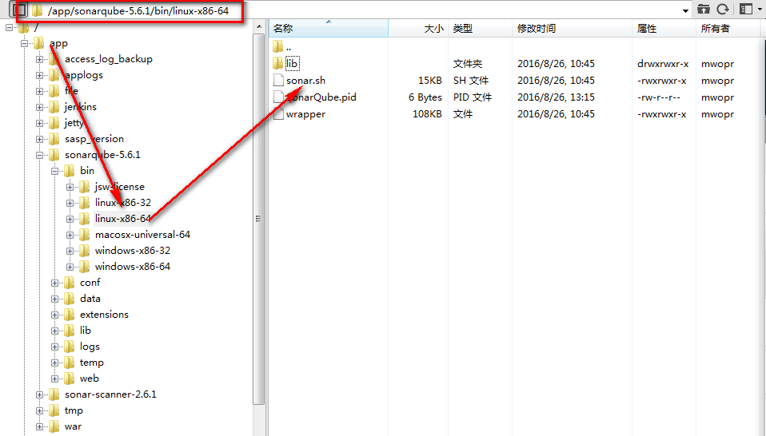

1. 在本地配置SonarQube环境

首先需要到SonarQube官网：http://www.sonarqube.org/

或是本人共享：\\Sf0001083449b\共享

将SonarQube解压，将SonarQube的bin目录放置到Path系统环境变量中

如：D:\TOOOOOOL\sonar-scanner-2.7\bin

1. 在项目文件夹下创建 sonar-project.properties 文件

文件中具体内容为：

|  |
| --- |
| # must be unique in a given SonarQube instance  sonar.projectKey=**novatar**  # this is the name displayed in the SonarQube UI  sonar.projectName=**novatar**  sonar.projectVersion=1.0    # Path is relative to the sonar-project.properties file. Replace "\" by "/" on Windows.  # Since SonarQube 4.2, this property is optional if sonar.modules is set.  # If not set, SonarQube starts looking for source code from the directory containing  # the sonar-project.properties file.  sonar.sources=.    # Encoding of the source code. Default is default system encoding  sonar.sourceEncoding=UTF-8 |

注意的是此文件需要加入到每一个项目的文件夹下面并需要要修改properties文件下的

sonar.projectKey=**novatar和** sonar.projectName=**novatar**

**Novatar修改成自己的项目名字**

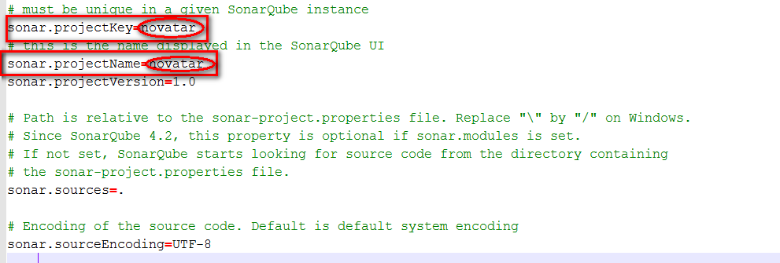

1. 修改D:\....\sonar-scanner-2.7\conf下的sonar-scanner.properties文件中的代码

|  |
| --- |
| #Configure here general information about the environment, such as SonarQube DB details for example  #No information about specific project should appear here  #----- Default SonarQube server  sonar.host.url=http://10.202.11.93:9000/  #----- Default source code encoding  sonar.sourceEncoding=UTF-8  #----- Global database settings (not used for SonarQube 5.2+)  sonar.jdbc.username=sonar  sonar.jdbc.password=sonar  #----- PostgreSQL  #sonar.jdbc.url=jdbc:postgresql://localhost/sonar  #----- MySQL  sonar.jdbc.url=jdbc:mysql://10.202.7.24:3306/sonar?useUnicode=true&amp;characterEncoding=utf8  #----- Oracle  #sonar.jdbc.url=jdbc:oracle:thin:@localhost/XE  #----- Microsoft SQLServer  #sonar.jdbc.url=jdbc:jtds:sqlserver://localhost/sonar;SelectMethod=Cursor |

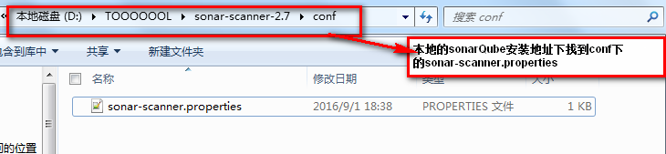

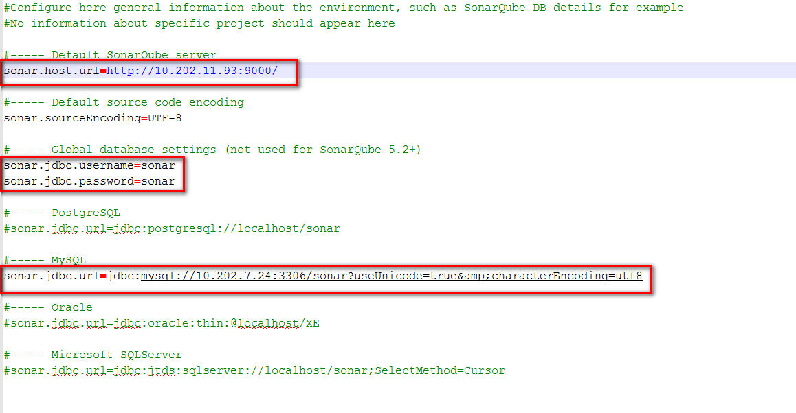

1. 将sonar-scanner.vbs文件放置在项目外一层文件夹下，其文件的具体代码为：

|  |
| --- |
| Set ws = CreateObject("Wscript.Shell")  ws.run "cmd /c del log.txt&cd achievement&sonar-scanner>>../log.txt&cd ../activity&sonar-scanner>>../log.txt&cd ../clue&sonar-scanner>>../log.txt&cd ../commission&sonar-scanner>>../log.txt&cd ../customer-agreement&sonar-scanner>>../log.txt&cd ../customer-base&sonar-scanner>>../log.txt&cd ../customer-finance&sonar-scanner>>../log.txt&cd ../customer-income&sonar-scanner>>../log.txt&cd ../customer-service&sonar-scanner>>../log.txt&cd ../customer-waybill&sonar-scanner>>../log.txt&cd ../news&sonar-scanner>>../log.txt&cd ../sasp-app-update&sonar-scanner>>../log.txt&cd ../sasp-authority&sonar-scanner>>../log.txt&cd ../sasp-login&sonar-scanner>>../log.txt&cd ../sasp-manager/project/sasp-manager&sonar-scanner>>../../../log.txt&cd ../../&echo 'Excute End。。。。。。'>>../log.txt",vbhide |

注意：修改代码中的红色部分，红色部分主要是SonarQube所要扫描的项目文件例如achievement、commission、customer-agreement

样例：

Set ws = CreateObject("Wscript.Shell")

ws.run "cmd /c del log.txt&cd projectname&sonar-scanner >>[../log.txt&cd ../projectname2&sonar-scanner>>]../../../log.txt&cd ../../&echo 'Excute End…………'>>../log.txt",vbhide

下面是例子：

标准的扫描单个项目文件的sonar-scanner.vbs的代码如下：

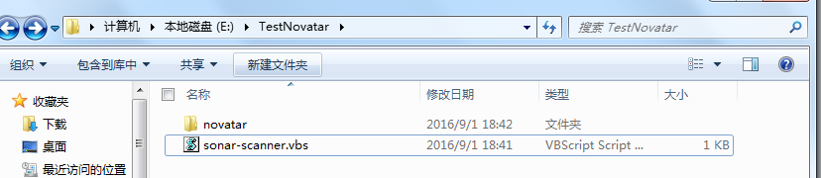



|  |
| --- |
| Set ws = CreateObject("Wscript.Shell")  ws.run "cmd /c del  log.txt&cd novatar&sonar-scanner>>../../../log.txt&cd ../../&echo 'Excute End…………'>>../log.txt",vbhide |

两个或两个以上需要扫描的项目

|  |
| --- |
| Set ws = CreateObject("Wscript.Shell")  ws.run "cmd /c dellog.txt&cd achievement&sonar-scanner>>../log.txt&cd ../activity&sonar-scanner>>../../../log.txt&cd ../../&echo 'Excute End…………'>>../log.txt",vbhide |

修改完成Sonar-scanner.vbs文件后，保存执行，即可完成对项目的扫描。

到SonarQube服务端地址：<http://10.202.11.93:9000/>

即可查看自己项目的代码的检测情况！