**Proposal – Project 2**

Team Members - Tanja Nyberg, Haiyan Richter, Meliza Abanilla

Topic: We will be focusing on major airports and airlines performance in the United States.

Potential Data Sources: <https://ntl.bts.gov/>

<https://www.transportation.gov/policy/aviation-policy/>

Inspiration/Idea: <https://cse442-17s.github.io/Airline-Performance-In-US/final/#Cover>

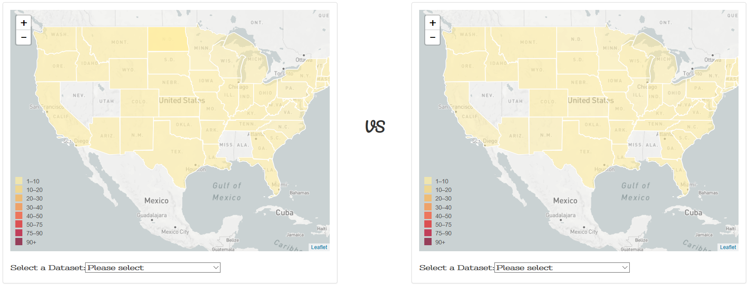

Initial Overview:

The intention is to create a webpage using Python, HTML/CSS, JavaScript, Database, Geomapping and Tweepy that will visualize the causes of flight delays in major airports, the airline fatalities per state, and twitter analysis of what is considered as the best and worst airlines and airports in the country.