**Evaluating the HCR-20V3 Violence Risk Assessment Measure with Mentally Disordered Offenders and Civil Psychiatric Patients in China**

**Supporting Information**

**TABLE S1**

*Diagnostic Composition of Participants Using DSM-5 Diagnoses*

Diagnosis Participants, n (%)

Neurodevelopment disorders 8 (5.3)

Schizophrenia spectrum and 109 (71.7)

other psychotic disorders

Bipolar and related disorders 15 (9.9)

Depressive disorders 26 (17.1)

Anxiety disorders 5 (3.3)

Obsessive-compulsive and 1 (0.7)

related disorders

Trauma- and stressor-related disorders 2 (1.3)

Dissociative disorders 4 (2.6)

Substance-related and addictive disorders 7 (4.6)

Neurocognitive disorders 1 (0.7)

Personality disorders 16 (10.5)

**Total 152 (100)**

**TABLE S2** *Item Descriptives [Participants, n (%)]*

Presence Relevance

Item Omit No Possibly Yes Omit Low Moderate High

Historical Scale (History of problems with…)

H1 Violence 0(0) 19(12.5) 5(3.3) 128(84.2) 0(0) 63(41.4) 43(28.3) 46(30.3)

H2 Other Antisocial Behavior 0(0) 103(67.8) 2(1.3) 47(30.9) 0(0) 120(78.9) 25(16.4) 7(4.6)

H3 Relationships 0(0) 19(12.5) 20(13.2) 113(74.3) 0(0) 95(62.5) 41(27.0) 16(10.5)

H4 Employment 4(2.6) 74(48.7) 29(19.1) 45(29.6) 4(2.6) 135(88.8) 11(7.2) 2(1.3)

H5 Substance Use 0(0) 133(87.5) 5(3.3) 14(9.2) 0(0) 140(92.1) 6(3.9) 6(3.9)

H6 Major Mental Disorder 0(0) 1(0.7) 2(1.3) 149(98.0) 0(0) 33(21.7) 24(15.8) 95(62.5)

H7 Personality Disorder 0(0) 135(88.8) 9(5.9) 8(5.3) 0(0) 136(89.5) 9(5.9) 7(4.6)

H8 Traumatic Experiences 0(0) 55(36.2) 12(7.9) 85(55.9) 0(0) 120(78.9) 32(21.1) 0(0)

H9 Violent Attitudes 0(0) 117(77.0) 24(15.8) 11(7.2) 0(0) 126(82.9) 19(12.5) 7(4.6)

H10 Treatment or Supervision Response 0(0) 49(32.2) 19(12.5) 84(55.3) 0(0) 83(54.6) 68(44.7) 1(0.7)

Clinical Scale (Recent problems with…)

C1 Insight 0(0) 31(20.4) 34(22.4) 87(57.2) 0(0) 104(68.4) 44(28.9) 4(2.6)

C2 Violent Ideation or Intent 0(0) 134(88.2) 8(5.3) 10(6.6) 0(0) 139(91.4) 7(4.6) 6(3.9)

C3 Symptoms of Major Mental Disorder 0(0) 12(7.9) 63(41.4) 77(50.7) 0(0) 63(41.4) 49(32.2) 40(26.3)

C4 Instability 0(0) 60(39.5) 25(16.4) 67(44.1) 0(0) 95(62.5) 47(30.9) 10(6.6)

C5 Treatment or Supervision Response 0(0) 100(65.8) 27(17.8) 25(16.4) 0(0) 122(80.3) 29(19.1) 1(0.7)

Risk Management Scale (Future problems with…)

R1 Professional Services and Plans 0(0) 9(5.9) 143(94.1) 0(0) 0(0) 150(98.7) 2(1.3) 0(0)

R2 Living Situation 0(0) 112(73.7) 32(21.1) 8(5.3) 0(0) 131(86.2) 16(10.5) 5(3.3)

R3 Personal Support 0(0) 97(63.8) 37(24.3) 18(11.8) 0(0) 144(94.7) 7(4.6) 1(0.7)

R4 Treatment or Supervision Response 0(0) 75(49.3) 60(39.5) 17(11.2) 0(0) 102(67.1) 48(31.6) 2(1.3)

R5 Stress or Coping 0(0) 76(50.0) 34(22.4) 42(27.6) 0(0) 109(71.7) 33(21.7) 10(6.6)

Table S3 compares the means and standard deviations of patients with mental disorders from hospitals or prisons on the HCR-20V3 and VRS indices. The results of independent-sample t-test indicate: (1) the values of offenders were significantly higher than those of hospital patients with respect to the H Scale presence rating sum, the H Scale relevance rating sum, and the VRS Total (*p* < .000); (2) the values of offenders were significantly lower than those of hospital patients with respect to the C Scale presence rating sum and the C Scale relevance rating sum (*p* < .01); (3) there were not significantly different with respect to other five indices.

Table S3 also compares the means and standard deviations of male or female psychiatric patients on the HCR-20V3 and VRS indices. Some independent-sample t-tests between males and females were performed on the means of each index, and the results indicate: (1) the values of male patients were significantly higher than those of female patients with respect to the H Scale presence rating sum, the H Scale relevance rating sum, the HCR-20 Total Scale relevance rating sum, and the VRS Total (*p* < .05); (2) the value of male patients was significantly lower than that of female patients with respect to the C Scale presence rating sum (*p* < .001); (3) there were not significantly different with respect to other five indices.

**TABLE S3**

*Descriptive Information on HCR-20V3 and VRS*

Civil Psychiatric Offender Male Female Combined

Index *M (SD)* *M (SD)* *t-setting* 95% CI *M (SD)* *M (SD)* *t-gender* 95% CI *M (SD)*

∑ Presence

H 9.18（2.85） 10.85（2.69） -3.59*** [-2.58,-0.75]10.67（2.60） 8.47（2.85） 4.90*** [1.32,3.09] 9.82（2.89）

C 5.16（1.78） 3.54（2.07） 5.12*** [0.99,2.24] 4.04（2.10） 5.32（1.69） -3.91*** [-1.92,-0.63]4.53（2.05）

R 3.32（1.69） 2.88（1.42） 1.67 [-0.08,0.96] 3.05（1.64） 3.31（1.54） -0.96 [-0.78,0.27] 3.15（1.60）

Total 17.64（4.49） 17.29（4.49） 0.47 [-1.13,1.82] 17.78（4.42） 17.07（4.57） 0.96 [-0.76,2.19] 17.51（4.48）

∑ Relevance

H 3.53（2.63） 5.24（2.39） -4.03*** [-2.54,-0.87]4.97（2.41） 2.94（2.60） 4.88*** [1.21,2.85] 4.20（2.67）

C 2.31（1.77） 1.39（1.63） 3.22** [0.36,1.49] 1.83（1.77） 2.15（1.77） -1.10 [-0.91,0.26] 1.95（1.77）

R 1.04（1.12） 0.93（1.11） 0.60 [-0.26,0.48] 0.95（1.11） 1.09（1.13） -0.75 [-0.51,0.23] 1.00（1.12）

Total 6.88（4.66） 7.57（4.23） -0.92 [-2.17,0.79] 7.75（4.15） 6.17（4.89） 2.05* [0.05,3.11] 7.15（4.50）

SRRs 1.47（0.70） 1.54（0.70） -0.59 [-0.30,0.16] 1.52（0.70） 1.47（0.71） 0.48 [-0.18,0.29] 1.50（0.70）

VRS 16.37（7.21） 25.84（7.91） -7.59*** [-11.93,-7.00]23.44（8.33） 14.55（6.44） 6.95*** [6.37,11.42] 20.05（8.78）

***Note.*** \**p*< .05, \*\**p*< .01, \*\*\**p*< .001.

**Description of Violent Incidents**

Every violent act committed by all participants in the near-phase, far-phase and over the long-term follow-up periods was recorded by RAs. Table S4 compares the types, number of violent incidents, and time to first violent act across different sub-groups and time lengths.

Among all participants, with regard to the types of violence, pushing-grabbing-shoving and throwing object were the two types of the highest proportion, whether in the near-phase, far-phase or over the long-term. For male participants, pushing-grabbing-shoving was also the most frequent violence type (44.2%), followed by throwing object and hitting-beating up (both were 20.8%). For female participants, throwing object was the most frequent one (44.7%), followed by pushing-grabbing-shoving (27.7%). Among the civil psychiatric participants, like the female participants, two types of violence with the highest proportion were throwing object (38.0%) and pushing-grabbing-shoving (32.4%). Within the offender sub-sample, the most frequent type of violence was the same as that of male participants, it was pushing-grabbing-shoving (45.3%), followed by hitting-beating up (22.6%).

Turning to the number of violent incidents, the average number of violent incidents of all participants in the near-phase was 2.20 (55 violent incidents occurred in 25 participants), which was slightly higher than that of those in the far-phase (mean = 2.09, 69 violent incidents occurred in 33 participants); and over the long-term, 43 participants committed 124 violent acts, averaging 2.88 acts per person. Comparing male and female participants, 28 male participants had 77 violent incidents over the long-term, averaging 2.75 incidents per person, which was slightly lower than that of female participants (mean = 3.13, 47 violent incidents occurred in 15 female participants). In the meantime, 24 civil psychiatric participants committed 71 violent incidents (mean = 2.96), which was slightly higher than offenders sub-sample (mean = 2.79, 53 violent incidents occurred in 19 offenders).

Among all the violent acts, the earliest one occurred in the 7th day after baseline interview, the latest one occurred in the 175th day after baseline interview. The average time to first violent act of all participants was 71.72 days; the average time of male participants was 77.71 days, while that of female participants was 60.53 days; and the average time of civil psychiatric and offender sub-samples were 74.13 and 68.68 days, respectively.

Overall, the above results revealed that pushing-grabbing-shoving, throwing object and hitting-beating up were the three most common types of violence, whether in the near-phase, far-phase or over the long-term; Besides, the average number of violent incidents of all participants within these three follow-up period lengths had no significant difference compared with each other (all *p*s > .05). By comparing male and female participants, the results showed that female participants conducted a little more violent acts than male participants in the same time, and the average time to their first violent act of female participants was shorter than that of male participants. However, in terms of the seriousness of these types of violence, the violent acts conducted by male participants were obviously more serious than those committed by female participants (as shown, the highest proportion of all violent incidents of female participants mainly involved throwing objects, while the male participants conducted much more acts of physical aggression, such as pushing-grabbing-shoving and hitting-beating up, especially involving two weapon-using acts). In the comparison between civil psychiatric and offender sub-samples, although civil psychiatric patients had a little more violent acts than offenders over the long-term follow-up period, the violent acts conducted by offenders were obviously more serious than those of civil psychiatric patients. Besides, these acts of offenders occurred earlier than those of civil psychiatric patients.

**TABLE S4**

*Types, Number, and Time of First Occurrence of Violent Incidents across Different Sub-groups and Time Lengths*

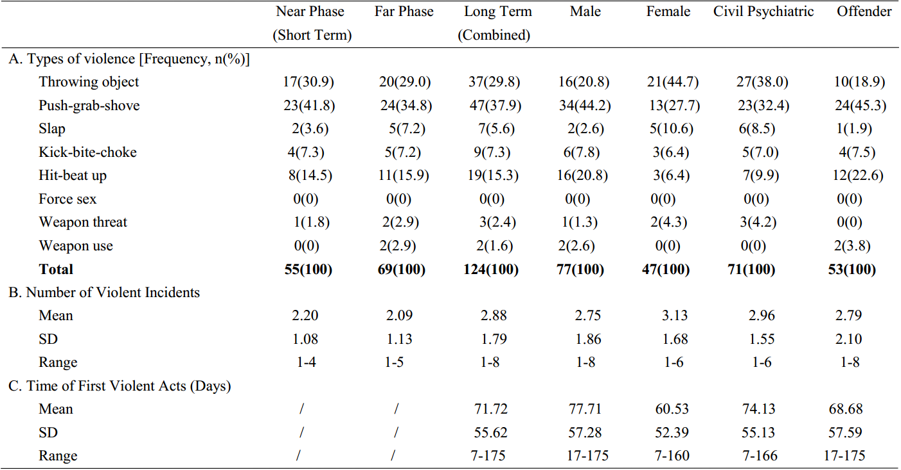

**TABLE S5**

*The Predictive Validity Results of the HCR-20V3 Indices on Violence across Different Sub-groups within 7-24 weeks*

Violence within 7-24 weeks

Civil Offender Male Female Combined

Index *rpb* 95%CI AUC 95%CI *rpb* 95%CI AUC 95%CI  *rpb* 95%CI AUC 95%CI *rpb* 95%CI AUC 95%CI *rpb* 95%CI AUC 95%CI

∑ Presence

H .36*** [.21, .52] .77***[.67, .87] .20 [-.04, .43] .65 [.50, .80] .29** [.10, .47] .71** [.59, .82] .30*  [.11, .49] .77** [.65, .89].31***[.18, .43].73***[.64, .81]

C .21* [.03, .38] .65a [.51, .79] .25[.01, .49] .67a [.52, .82] .19 [-.01, .36] .62[.50, .75] .28* [.08, .46] .75* [.57, .92] .18*  [.02, .32] .61* [.51, .72]

R .32** [.07, .53] .68* [.53, .82] .30* [.05, .53] .70* [.55, .85] .30** [.10, .48] .69** [.57, .81] .31*  [-.03, .58] .66[.44, .88] .29***[.10, .45].67**[.57, .78]

HCR-20V3 .43*** [.27, .57] .81*** [.72, .91] .32* [.11, .54] .72* [.58, .86] .37*** [.18, .54] .73*** [.62, .85] .40** [.21, .59] .83***[.72, .94].38***[.24, .50] .77***[.69, .85]

∑ Relevance

H .38*** [.21, .54] .78***[.66, .89] .21[-.03, .45] .64[.48, .80] .31** [.14, .48] .72**[.61, .83] .31* [.06, .54] .74* [.57, .90] .32*** [.19, .45] .73***[.64, .82]

C .39*** [.21, .56] .79*** [.68, .89] .36** [.03, .61] .68* [.51, .85] .30** [.07, .50] .67* [.53, .80] .45*** [.25, .66] .85***[.75, .96] .34***[.16, .49] .72***[.61, .82]

R .34*** [.14, .55] .75*** [.62, .88] .44*** [.16, .64] .75** [.60, .90] .49*** [.29, .65] .78*** [.66, .90].20[-.04, .47].69 [.51, .86] .38***[.20, .53] .75***[.65, .84]

HCR-20V3 .45*** [.28, .59] .82*** [.74, .91] .37** [.12, .57] .73** [.60, .87].44*** [.24, .57] .78*** [.68, .88] .38** [.18, .56] .78** [.66, .91] .42*** [.29, .54].79***[.71, .87]

SRR .53*** [.32, .70] .82*** [.70, .94] .45*** [.21, .68] .77** [.62, .91].54*** [.34, .70] .81*** [.70, .92] .41** [.15, .66].78** [.61, .94] .49*** [.34, .64].80***[.71, .89]

***Note.***\**p*<0.05, \*\**p*<0.01, \*\*\**p*<0.001, a*p*<0.06.

Comparing the correlations and AUC values of civil psychiatric patients and offenders within the three follow-ups, correlations of civil psychiatric patients were significantly larger than those of offenders on the H scale (Presence and Relevance), Total scale (Presence), and significantly smaller than those of offenders on the Risk Management scale (Relevance). With regard to AUC, the values of civil psychiatric patients were significantly larger than those of offenders on the Historical (Presence and Relevance) and Total scales (Presence and Relevance).

Comparing the correlations and AUC values of male and female participants within the three follow-ups, with regard to both correlations and AUC values, those of male participants were significantly larger than those of female participants on the Risk Management scale (Relevance), and significantly smaller than those of female participants on the Clinical scale (Presence) and Total scale (Presence). In addition, AUC values of male participants on the Clinical scale (Relevance) were also significantly smaller than those of female participants.

**TABLE S6**

*The Descriptive Information of Correlations and AUC Values within Three Follow-ups on HCR-20V3 Indices*

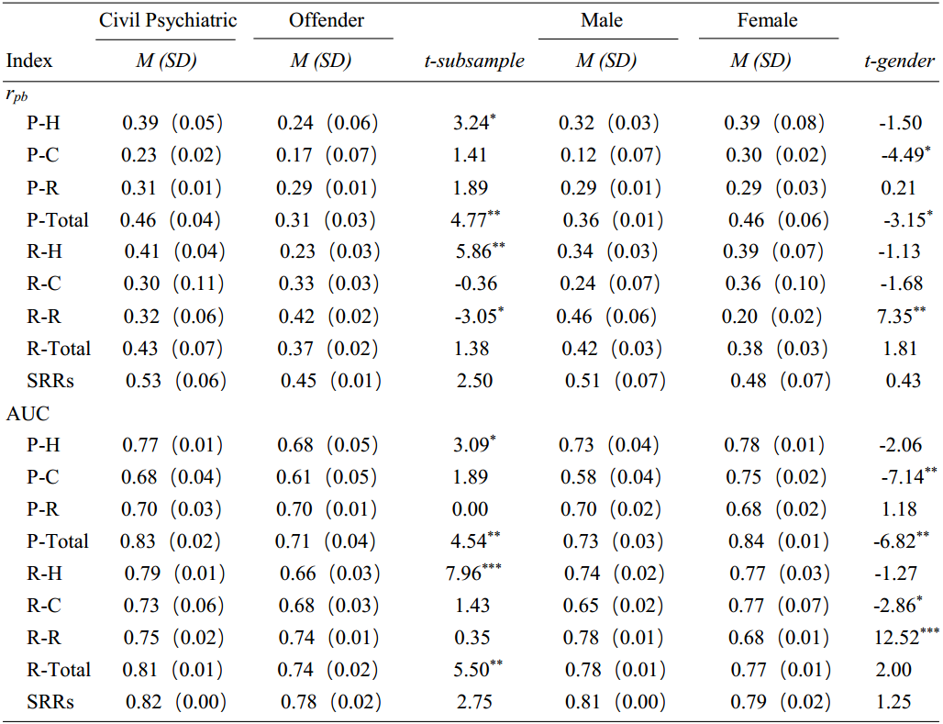

***Note.***\**p*<0.05, \*\**p*<0.01, \*\*\**p*<0.001. “P” indicates Presence Rating, and “R” indicates Relevance Rating. For example, “P-H” is the sum of Presence Ratings for the Historical Scale. “R-C” is the sum of Relevance Ratings for the Clinical Scale. For convenience, these indices are replaced by their abbreviations (e.g., “P-H”, “R-C” etc.) in the following text.

**Evaluating Sub-Sample and Gender’s Potential Effects on the Associations between the HCR-20V3 Indices and Violence**

To test formally whether sub-sample and gender had moderating effects on the associations between the main indices of HCR-20V3 and violence over three follow-up lengths (within 6 weeks, 7-24 weeks, and 6 months), we conducted 18 separate logistic regression analyses, respectively. All of these regressions entered Age (i.e. as a control variable) on step 1, entered independent variable 1 and independent variable 2 on step 2, and entered interaction of independent variable 1 (zero-centered) and independent variable 2 (zero-centered) on step 3. From 1st -9th logistic regression analysis, independent variable 1 was the Presence or Relevance scores from the H, C, R, Total scales, and SRRs, successively. In 1st -9th logistic regression analysis, independent variable 2 was sub-sample. Independent variable 2 of 10th -18th logistic regression analysis was gender. The outcome of these analyses was whether the patient acted violent (“0” or “1”) within the corresponding follow-up period.

For the 6-week follow-up, in only 1 of these 18 regressions did the interaction between sub-sample (or gender) and HCR-20V3 main indices add significantly to the model (Block *X*2 was significant), when the independent variable 1 was the C Scale (Presence) and the independent variable 2 was gender. Moreover, in none of these 18 regressions was sub-sample or gender statistically significant in the final model.

For further evaluating whether sub-sample and gender had confounding effects on the associations between the HCR-20 V3 main indices and violence at 6 weeks, we ran another 18 separate logistic regression analyses. All of these regressions entered sub-sample or gender (i.e. as a covariate) on step 1, and entered HCR-20V3 main indices on step 2. In 17 of 18 of these regressions, the HCR-20V3 main index was statistically significant in the final model (*p* < .05). The only index that became a non-significant predictor was the C Scale (Presence), when gender was controlled as a covariate.

Within 7-24 weeks follow-up period, in none of these 18 regressions did the interaction between sub-sample (or gender) and the HCR-20V3 main indices add significantly to the model, and in only 2 of these 18 regressions was sub-sample or gender statistically significant in the final model. The first index was the C Scale (Relevance), when the independent variable 2 was sub-sample. The second was the C Scale (Presence), when the independent variable 2 was gender.

For further testing whether sub-sample and gender had confounding effects on the associations between HCR-20V3 main indices and violence within 7-24 weeks, we conducted another 18 separate logistic regression analyses. In all of these 18 regression analyses, the HCR-20V3 main index remained significant in the final model (*p* < .05), when sub-sample (or gender) was controlled as a covariate.

For 6 months follow-up, in none of these 18 regressions did the interaction between sub-sample (or gender) and the HCR-20 main indices add significantly to the model, and in only 1 of these 18 regressions was sub-sample (or gender) be statistically significant in the final model, when the independent variable 1 was the C Scale (Presence) and the independent variable 2 was sub-sample. For further testing whether a confounding effect for sub-sample and gender existed, another 18 separate logistic regression analyses were conducted. In all of these 18 regression analyses, the HCR-20V3 main index was still significant in the final model (*p* < .05), when sub-sample (or gender) was entered.

Although there was a small number of differences between two sub-samples and genders as reported earlier, we found that sub-sample and gender themselves did not have moderating or confounding effects on the associations between the main indices of HCR-20V3 and violence over three follow-up lengths, basing on the above results of regressions. The one possible exception was for the C Scale presence and relevance ratings, but even here the moderating effects were not consistent across all analyses.

**Examining Incremental Predictive Validity of Relevance Ratings vis-à-vis Presence Ratings**

During the 7-24 weeks follow-up period, the overall model for H Scale (Model *X*2 = 17.75，*p* < .001, -2LL = 139.82, Negelkerke *R*2 = .17), C Scale (Model *X*2 = 16.68，*p* < .001, -2LL = 140.90, Negelkerke *R*2 = .16), R Scale (Model *X* 2 =20.81，*p* < .001, -2LL = 136.77, Negelkerke *R*2 = .20), and HCR-20 Total Scale (Model *X*2 = 28.73，*p* < .001, -2LL = 128.84, Negelkerke *R*2 = .27) was significant. Relevance ratings (B = .53, *SE* = .17, Wald = 10.13, *p* = .001, Exp(B) = 1.70, 95% CI = [1.23, 2.35]) of C Scale added incrementally to Presence ratings (Block *X*2 = 11.92，*p* = .001); Relevance ratings (B = .63, *SE* = .23, Wald = 7.46, *p* = .006, Exp(B) = 1.88, 95% CI = [1.20, 2.97]) of R Scale added incrementally to Presence ratings (Block *X* 2 = 8.27，*p* = .004); and Relevance ratings (B = .17, *SE* = .07, Wald = 5.07, *p* = .024, Exp(B) = 1.18, 95% CI = [1.02, 1.37]) of HCR-20 Total Scale added incrementally to Presence ratings (Block *X*2 = 5.64，*p* = .018).

**Figures**

**FIGURE S1**

*Rates of Violence for Combined Sample*

**FIGURE S2**

*Comparing Rates of Violence between Male and Female*

**FIGURE S3**

*Comparing Rates of Violence between Civil Psychiatric Patients and Offenders*