INF3490 Mandatory Assignment 2

Multi-layer perceptron

Name: Haiyue Chen

Username: haiyuec

**Instructions on how to run my programs:**

Python movement.py [number_of_hidden_nodes]

**Result with 10 hidden nodes:**

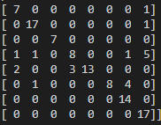 Confusion table:

Accuracy: 81.99%

**Result with 20 hidden nodes:**

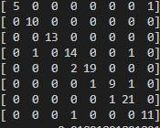 Confusion table:

Accuracy: 91.89%

**Result with 40 hidden nodes:**

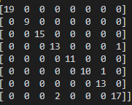 Confusion table:

Accuracy: 96.40%

**Result with 40 hidden nodes:**

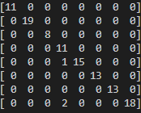 Confusion table:

Accuracy: 97.30%

I found that with numbers higher than 40 the results are usually quite good, normally between 90% and 95%. The cases reported here are some of the best runs.