

**BEAR RIDES**

**USER’S MANUAL**

*Baylor Ride Sharing Software*

**Team TBD 2**

November 2018

**USER’S MANUAL**

**TABLE OF CONTENTS**

Page #

A. GENERAL INFORMATION A-1

1.1 System Overview A-1

1.2 Project References A-2

1.3 Authorized Use Permission A-2

1.4 Points of Contact A-2

1.4.1 Information A-2

1.4.2 Coordination A-2

1.4.3 Help Desk A-2

1.5 Organization of the Manual A-2

1.6 Acronyms and Abbreviations A-2

B. SOFTWARE SUMMARY B-1

2.1 Software Configuration B-1

2.2 Data Flows B-1

2.3 User Access Levels B-1

C. GETTING STARTED C-1

3.1 Register C-1

3.2 Logging On C-1

3.3 Software Menu C-1

3.3.1 Your Trip C-1

3.3.2 Message Board C-1

3.3.3 Account Setting C-1

3.4 Exit System C-1

Appendix D-1

**1.0 GENERAL INFORMATION**

# GENERAL INFORMATION

## 1.1 Software Overview

A travel aid for Baylor students:

1. A software based on the Java Platform.
2. Ride post system
3. User ride sharing system
4. Software name: Bear Rides
5. System requirement: Platform can run Java application (recommend Windows 10)

## 1.2 Project References

References that were used in preparation of this document in order of importance to the end user.

<https://en.wikipedia.org/wiki/Peer-to-peer_ridesharing>

<https://en.wikipedia.org/wiki/Swing_(Java)>

## 1.3 Authorized Use Permission

We provide you with access to our website (“http://cs.baylor.edu/~snavely”), including documentation and other product, download areas, and software.  The Documentation, Software are subject to our Terms of Use ("TOU"), unless we have provided those items to you under more specific terms, in which case, those more specific terms will apply to the relevant item.

## 1.4 Points of Contact

### 1.4.1 Information

Team TBD 2 is a small software development team of Baylor Computer Science department.

### 1.4.2 Coordination

The list of organizations that require coordination between the project and its specific support function (e.g., installation coordination, security, etc.) are currently not available.

### 1.4.3 Help Desk

If you meet any problem during use of our software, please email xingan_wan@baylor.edu

## 1.5 Organization of the Manual

User’s Manual v1 (11/28/2018 Updated).

## 1.6 Acronyms and Abbreviations

Provide a list of the acronyms and abbreviations used in this document and the meaning of each.

App: Application

Wiki: Wikipedia

**2.0 SOFTWARE SUMMARY**

# SOFTWARE SUMMARY

## 2.1 Software Configuration

This software based on Swing Graphical User Interface (GUI)*, is part of Oracle's Java Foundation Classes (JFC).

## 2.2 Data Flows

Users join or start a trip by viewing/adding a message, which will be listed on message board page. Users may change the message detail before the trip start. Also, one user can send a message to another user.

## 2.3 User Access Levels

Only authorized user may be able to add and modify data and information.

**3.0 GETTING STARTED**

# GETTING STARTED

## 3.1 Register

Register will require your personal information of your name, your age, your contact information, your email address, and you must set up a password to process register.

## 3.2 Logging On

Your email and password are required to log onto the software.

## 3.3 Software Menu

### 3.3.1 Your Trip

Open the list of your trip.

### 3.3.2 Message Board

Open the message board that you will see yours and other’s message with message title, time posted, and its creator. You can click on the message to see its detail description.

### 3.3.3 Account Setting

You can change your account information here, including set up for become a driver, changing your name, age, gender, contact information, email address, and change your password. To become a driver, click on Driver Info button and enter your driver license and vehicle information, and then save.

## 3.4 Exit Software

Click on Close tab. When you close the software, it will sign out.

# Appendix

*Screen Shots:*

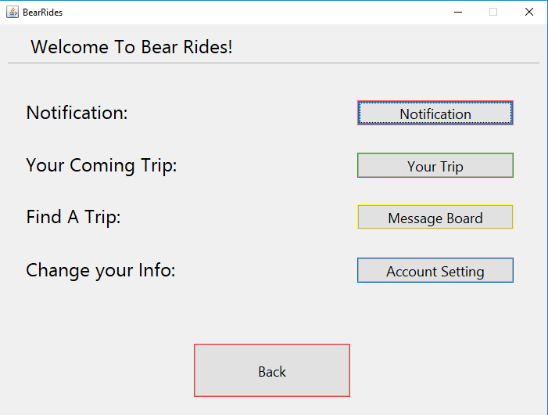

*Home Page*

*Screen Shots:*

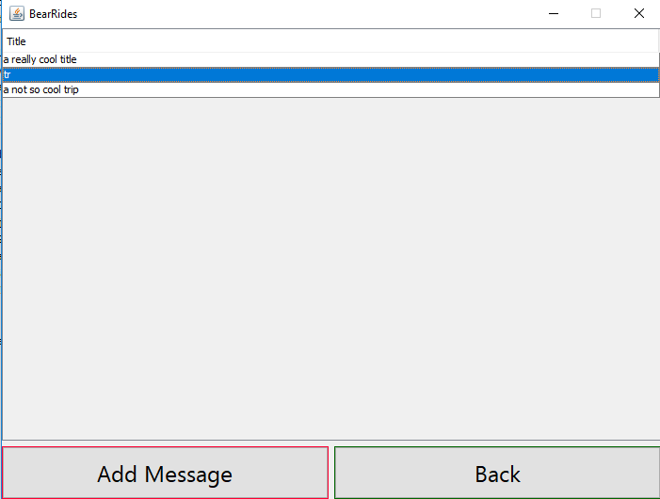

*Message Board Page*

*Screen Shots:*

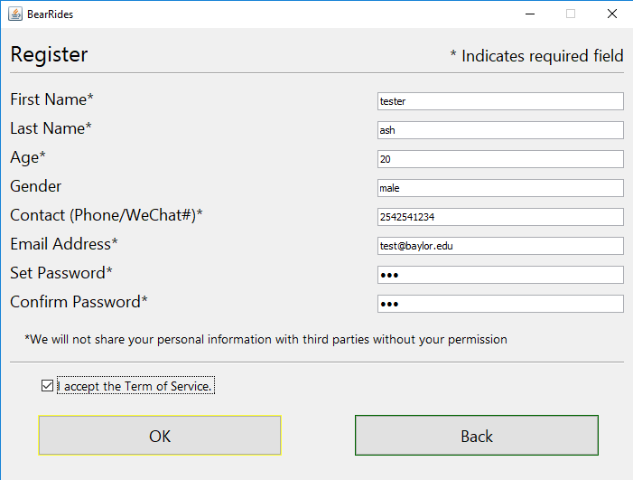

*Register Page*