
Numerical Integration and Differentiation

CPCS 212
omar madani
Turki saman
khaled al-shehri
Applied math project

INTRODUCTION

Numerical integration and differentiation are important tools in mathematics, they give practical solutions for problems where analytical methods are difficult or impossible to apply.
These methods are used to approximate areas under curves, rates of change, and other mathematical problems that arise in different fields.
This report will discuss three numerical integration methods: the Trapezoidal Rule, Simpson’s Rule, and the Monte Carlo Method. As well as three numerical differentiation methods: Forward Difference, Backward Difference, and Central Difference.
We will use different functions as test cases to evaluate the performance of these methods in both integration and differentiation tasks. By comparing their results to the analytical answers, and we shall understand at what conditions they will performs best, while also knowing the limitations and strengths of each method.

Numerical Integration Methods
The Trapezoidal Rule:
The Trapezoidal Rule is a numerical method for approximating the definite integral of a function by dividing the area under the curve into a series of trapezoids. These trapezoids are formed by connecting consecutive points on the curve with straight lines. The area of each trapezoid is calculated, and their sum gives the approximate value of the integral.
Strengths:
- Simplicity: The Trapezoidal Rule is straightforward to understand and implement, making it an accessible option for estimating integrals.
- Versatility: It can handle functions that are continuous and differentiable over the interval.
- Improvement with Smaller Intervals: The accuracy of the Trapezoidal Rule improves as the number of intervals (n) increases.
Limitations:
- Accuracy Issues for Curved Functions: Since this method approximates the curve with straight lines.
- Less Efficient for Complex Functions: For functions that are irregular, the Trapezoidal Rule might require a very large (n) to achieve acceptable accuracy.
- Dependent on Evenly Spaced Intervals: The method assumes that the intervals are evenly spaced, which can be limiting for some problems.

While the Trapezoidal Rule may not be as accurate as some other methods, its simplicity and reliability make it an excellent choice for simple problems.
Numerical Integration Methods
The Trapezoidal Rule:
Procedure:
- Divide the Interval: Split the interval [a,b] into n equal subintervals. The width of each subinterval is:
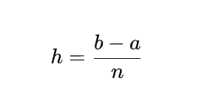
- Calculate Function Values: Evaluate the function at each endpoint and intermediate point

- Apply the Formula:

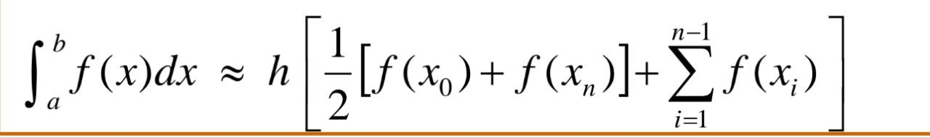
- Add the first and last values together and multiply them by half
- Add the middle function values.
- Add the result of step 1 with the result of step 2
- Multiply them by h

Numerical Integration Methods
The Trapezoidal Rule:
Experiment with e^{-x}:
Since e^{-x} is a continuously decreasing exponential function, it exhibits nonlinear behavior. To get better results with the Trapezoidal Rule, we will use a larger number of subintervals (n) to minimize the error caused by approximating the curve with straight lines.
Parameters:
- Function: f(x)= e^{-x}
- Interval: [1,3]
- Number of subintervals (n): n=10
- Analytical solution: 0.31809
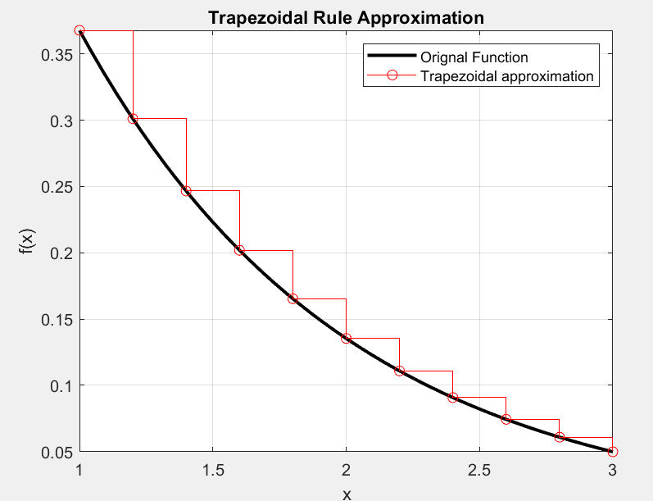
Apply the Trapezoidal Rule:

Approximate integral using Trapezoidal Rule: 0.31915
Numerical Integration Methods
The Trapezoidal Rule:
Experiment with e^{-x}:
Since e^{-x} is a continuously decreasing exponential function, it exhibits nonlinear behavior. To get better results with the Trapezoidal Rule, we will use a larger number of subintervals (n) to minimize the error caused by approximating the curve with straight lines.
Parameters:
- Function: f(x)= e^{-x}
- Interval: [1,3]
- Number of subintervals (n): n=50
- Analytical solution: 0.31809
- Apply the Trapezoidal Rule:
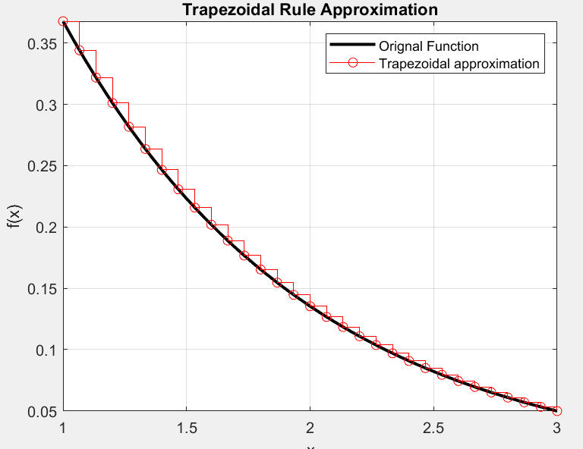

Approximate integral using Trapezoidal Rule: 0.31813
Numerical Integration Methods
The Trapezoidal Rule:
Experiment with x³ + 2x² – x + 5:
Parameters:
- Function: f(x)= x³ + 2x² – x + 5
- Interval: [1,5]
- Number of subintervals (n): n=25
- Analytical solution: 246.6667
- Apply the Trapezoidal Rule:
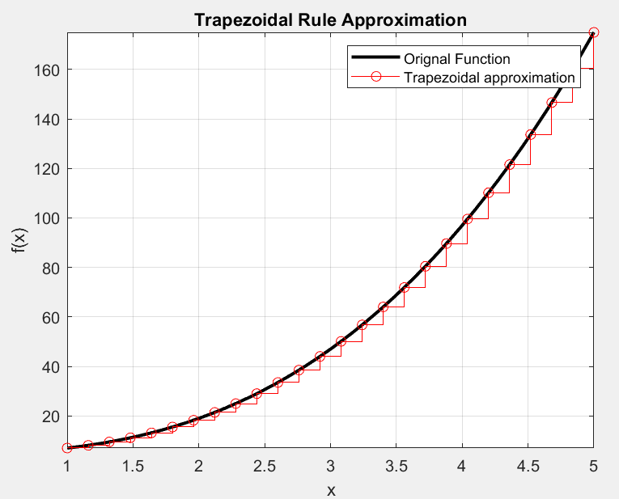

Approximate integral using Trapezoidal Rule: 246.8544

Numerical Integration Methods
The Trapezoidal Rule:
Experiment with Sin(x) * Log(x):
Parameters:
- Function: f(x)= Sin(x) * Log(x)
- Interval: [2,4]
- Number of subintervals (n): n=10
- Analytical solution: 0.053729
- Apply the Trapezoidal Rule:
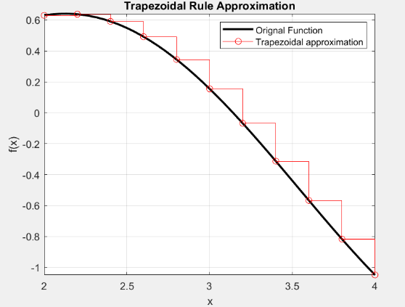

Approximate integral using Trapezoidal Rule: 0.049519

Numerical Integration Methods
The Simpson Rule:
Simpson's Rule is a method of numerical integration that estimates the area under a curve using parabolic arcs rather than straight lines. In this way, it is better, for smooth functions, than the Trapezoidal Rule because each parabolic arc follows the curvature of the function within the subinterval.
Strengths:
- Higher Accuracy: Simpson’s Rule is significantly more accurate than the Trapezoidal Rule for smooth functions
- Efficient: It achieves high accuracy without requiring a very large number of subintervals, saving computation time.
- Error Decreases Rapidly: The error in Simpson’s Rule decreases proportionally to ( 1 / n⁴ )
Limitations:
- Even Subinterval Requirement: Simpson’s Rule only works if the interval is divided into an even number of subintervals.
- More Computational Steps: The formula requires careful application of weights (1, 4, and 2), making it slightly more complex than the Trapezoidal Rule.
- Dependency on Function Continuity: which can limit its use for discontinuous functions.
While Simpson’s Rule is slightly more complex than the Trapezoidal Rule, its high accuracy and ability to handle curvature make it an excellent choice when greater precision is required.

Numerical Integration Methods
The Simpson Rule:
Procedure:
- Divide the Interval: Split the interval [a,b] into n equal subintervals. The width of each subinterval is:

- Calculate Function Values: Evaluate the function at each endpoint and intermediate point

- Apply the Formula:

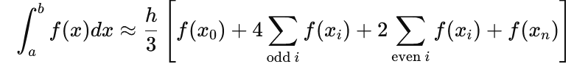
- Multiply the first and last function values by 1.
- Multiply the function values at all odd-indexed points by 4.
- Multiply the function values at all even-indexed points by 2.
- Add these values together and multiply by h/3

Numerical Integration Methods
The Simpson Rule:
Experiment with e^{-x}:
Since e^{-x} is a continually decreasing exponential function, Simpson's Rule is particularly suited to this type of behavior. Even with a fairly moderate number of subintervals, as with n=6, the approach yields an acceptable approximation. Increasing n, such as using n=16, does an even better job.
Parameters:
- Function: f(x)= e^{-x}
- Interval: [1,3]
- Number of subintervals (n): n=2
- Analytical solution: 0.31809
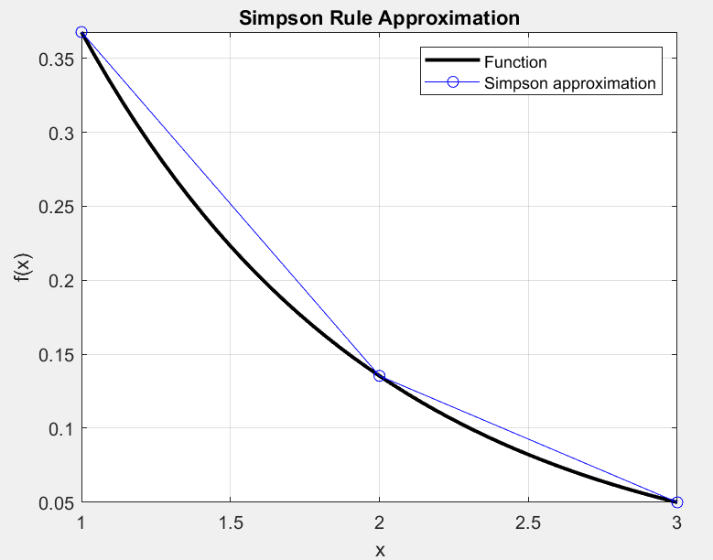
Apply the Simpson Rule:
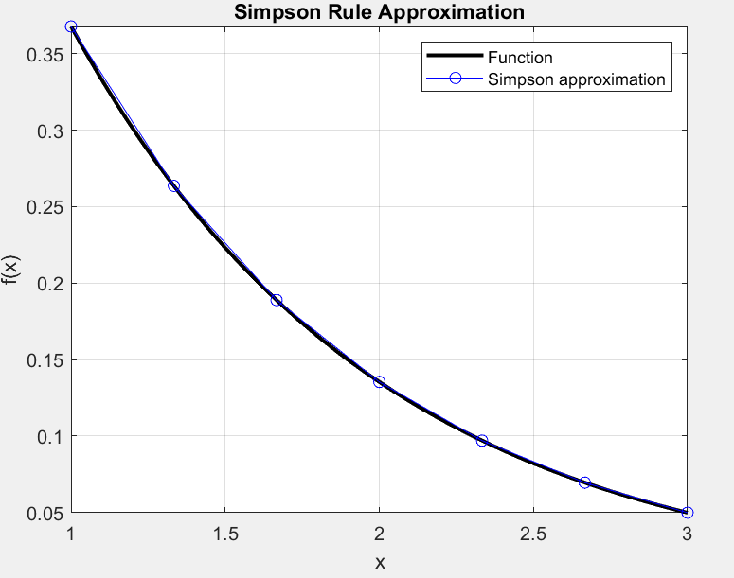

Approximate integral using Simpson Rule: 0.31967
Numerical Integration Methods
The Simpson Rule:
Experiment with e^{-x}:
Since e^{-x} is a continually decreasing exponential function, Simpson's Rule is particularly suited to this type of behavior. Even with a fairly moderate number of subintervals, as with n=2 the approach yields an acceptable approximation. Increasing n, such as using n=6, does an even better job.
Parameters:
- Function: f(x)= e^{-x}
- Interval: [1,3]
- Number of subintervals (n): n=6
- Analytical solution: 0.31809
Apply the Simpson Rule:


Approximate integral using Simpson Rule: 0.31811
Numerical Integration Methods
The Simpson Rule:
Experiment with x³ + 2x² – x + 5:
Parameters:
- Function: f(x)= x³ + 2x² – x + 5
- Interval: [1,5]
- Number of subintervals (n): n=10
- Analytical solution: 246.6667
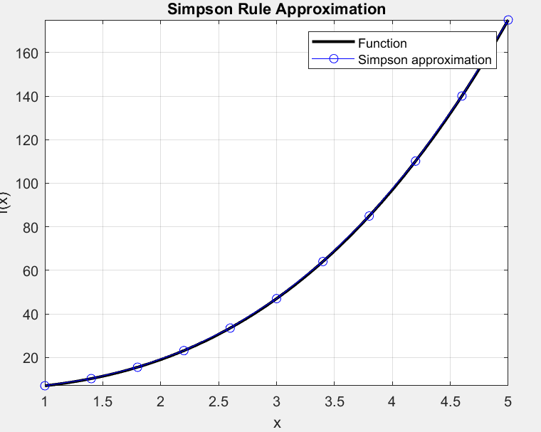
- Apply the Simpson Rule:

Approximate integral using Simpson Rule: 246.666

Numerical Integration Methods
The Simpson Rule:
Experiment with Sin(x) * Log(x):
Parameters:
- Function: f(x)= Sin(x) * Log(x)
- Interval: [2,4]
- Number of subintervals (n): n=10
- Analytical solution: 0.053729
- Apply the Simpson Rule:
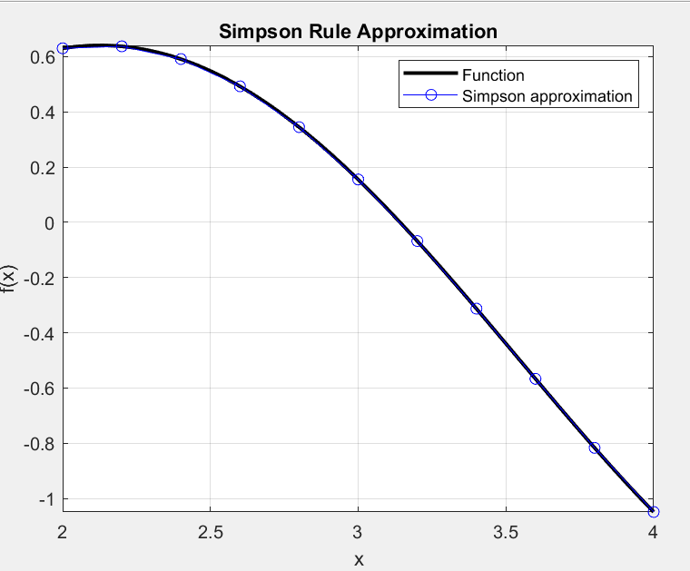

Approximate integral using Simpson Rule: 0.053748

Numerical Integration Methods
The Monte Carlo Rule:
The Monte Carlo Method is a probabilistic technique for numerical integration that estimates the area under a curve by using random sampling. Unlike the Trapezoidal Rule or Simpson’s Rule, which rely on geometric approximations, the Monte Carlo Method uses randomness to predict the result. It is especially useful for functions that are complex, irregular, or exist in high-dimensional spaces
Strengths:
- Flexibility: The Monte Carlo Method is not restricted by the shape of the function.
- Ease of use: It’s straightforward to implement, requiring only the ability to generate random numbers.
- Handles High Dimensions: Particularly useful for multidimensional integrals where traditional methods struggle.
Limitations:
- Slow Convergence: Achieving high accuracy often requires an extremely large sample size.
- Random Variability: Since the method relies on randomness, results can vary between runs.
- Computational Cost: Requires more computational effort compared to the other 2 methods to achieve similar accuracy, especially in lower-dimensional problems.
While the Monte Carlo Method might take a little longer to converge than some other methods, in flexibility and robustness it is second to none for complex or high-dimensional problems where traditional methods struggle.
Numerical Integration Methods
The Monte Carlo Rule:
Procedure:
- Choose the Interval: Choose the interval [a,b] over which you want to integrate the function.

- Generate random points: Generate N random points within the interval [a,b]. These points are distributed uniformly across the range.

- Evaluate the Function: For each random point x​, compute the corresponding function value f(x)

- Compute the Average:
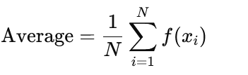

- Get the Integral: Multiply the average function value by the width of the interval
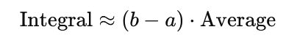

Numerical Integration Methods
The Monte Carlo Rule:
Experiment with e^{-x}:
Since e^{-x} is a continuously decreasing exponential function, the Monte Carlo Method can handle it effectively. However, because this method relies on randomness, the results may vary slightly between runs. To improve accuracy and reduce variability, we increase the number of random samples (N).
Parameters:
- Function: f(x)= e^{-x}
- Interval: [1,3]
- Number of subintervals (n): n=100
- Analytical solution: 0.31809
- Apply the Monte Carlo Rule:
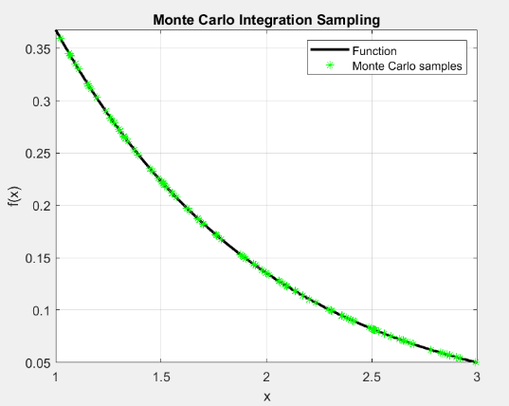

Approximate integral using Monte Carlo Rule: 0.31872
Numerical Integration Methods
The Monte Carlo Rule:
Experiment with e^{-x}:
Since e^{-x} is a continuously decreasing exponential function, the Monte Carlo Method can handle it effectively. However, because this method relies on randomness, the results may vary slightly between runs. To improve accuracy and reduce variability, we increase the number of random samples (N).
Parameters:
- Function: f(x)= e^{-x}
- Interval: [1,3]
- Number of subintervals (n): n=100
- Analytical solution: 0.31809
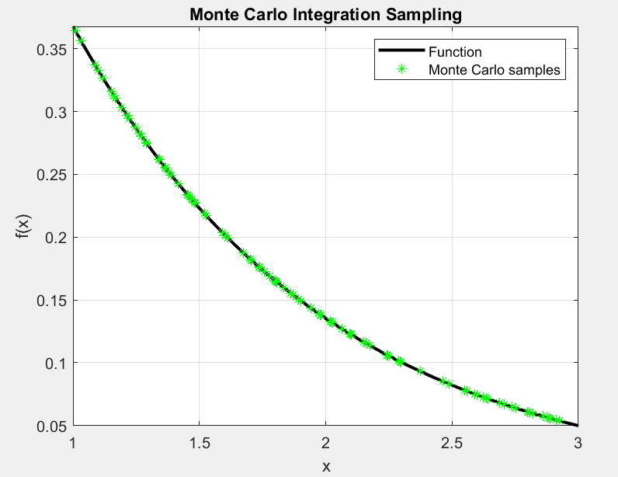
- Apply the Monte Carlo Rule: RERUN

Approximate integral using Monte Carlo Rule: 0.31569
Numerical Integration Methods
The Monte Carlo Rule:
Experiment with x³ + 2x² – x + 5:
Parameters:
- Function: f(x)= x³ + 2x² – x + 5
- Interval: [1,5]
- Number of subintervals (n): n=100
- Analytical solution: 246.6667
- Apply the Monte Carlo Rule:
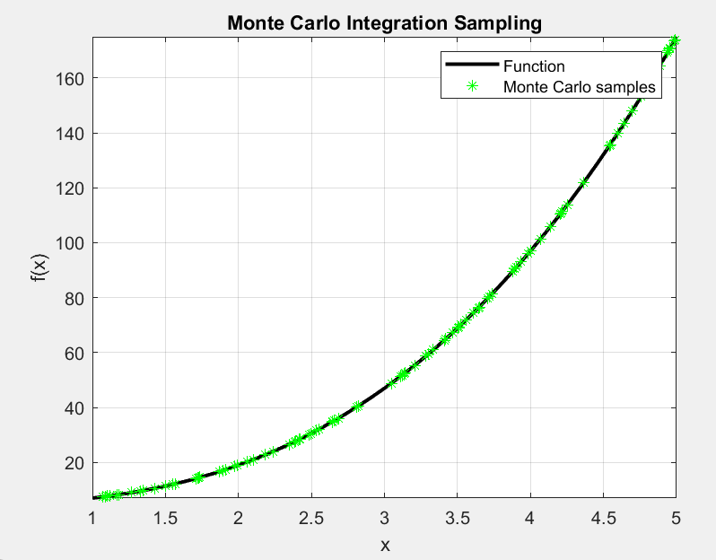

Approximate integral using Monte Carlo Rule: 257.9416

Numerical Integration Methods
The Monte Carlo Rule:
Experiment with x³ + 2x² – x + 5:
Parameters:
- Function: f(x)= x³ + 2x² – x + 5
- Interval: [1,5]
- Number of subintervals (n): n=100
- Analytical solution: 246.6667
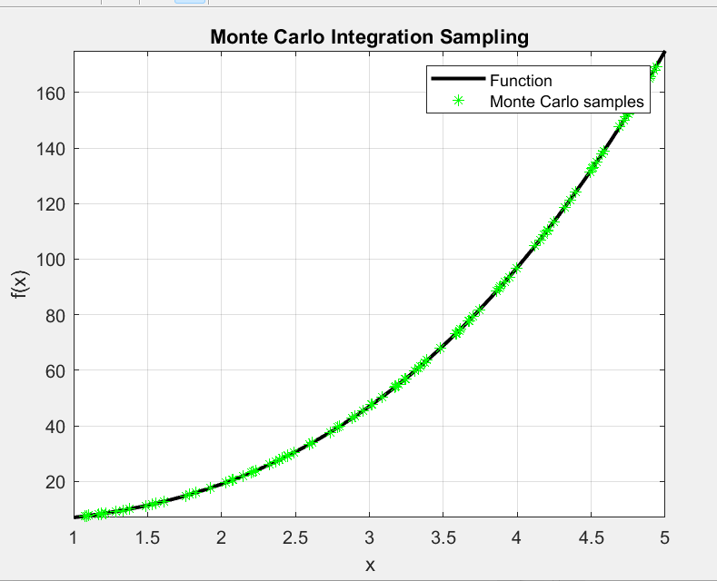
- Apply the Monte Carlo Rule: RERUN

Approximate integral using Monte Carlo Rule: 267.0066

Numerical Integration Methods
The Monte Carlo Rule:
Experiment with Sin(x) * Log(x):
Parameters:
- Function: f(x)= Sin(x) * Log(x)
- Interval: [2,4]
- Number of subintervals (n): n=1000
- Analytical solution: 0.053729
- Apply the Monte Carlo Rule:
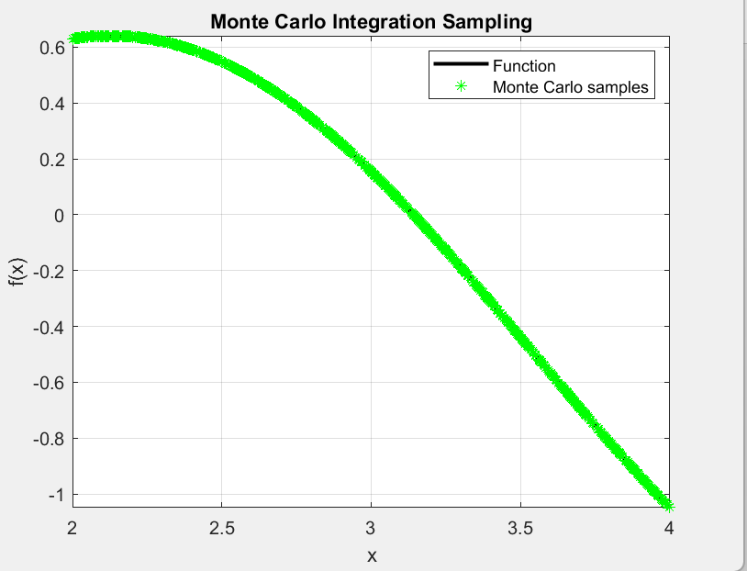

Approximate integral using Monte Carlo Rule: 0. 044612

Numerical Differentiation Methods
Forward Difference Method
The forward difference method estimates the derivative of a function f(x) at a x point using the values of the function at x and x + h:
Strength:
- Simplicity: Easy to implement.
- Efficiency: Only requires one function evaluation at x + h.
Limitations:
- Accuracy: Can be less accurate with small step size due to truncation errors.
- Sensitivity: The choice of h can greatly affect results.
How to Implement
- Choose a small value for h (step size).
- Calculate f(x + h).
- Use the formula to find the derivative.
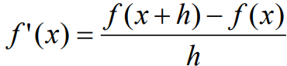
Numerical Differentiation Methods
Backward Difference Method
The backward difference method uses the function values at x and x – h, like forward difference but may perform slightly better in some cases.
Strength:
- Simplicity: Also easy to implement.
- Efficiency: Requires just one function evaluation at x - h.
Limitations:
- One-sided: Only provides an estimate from one direction.
- Sensitivity: Like the forward method, it’s sensitive to h (step size).
How to Implement
- Choose a small value for h.
- Calculate f (x - h).
- Use the formula to find the derivative.
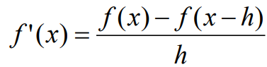

Numerical Differentiation Methods
Central Difference Method
The central difference method combines the forward and backward differences:
Strength
- Accuracy: More accurate than the forward and backward methods.
- Balanced: Uses information from both sides of x.
- Reduces the truncation error.
Limitations:
- More Evaluations: Requires two function evaluations.
- Still Sensitive: The choice of step size is still important.
How to Implement
- Choose a small value for h (step size).
- Calculate both f (x + h) and f (x - h).
- Use the formula to find the derivative.
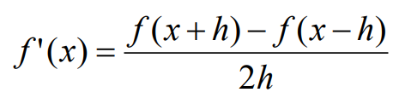

Numerical Differentiation Methods
Comparison of the methods:
x³ + 2x² – x + 5, on x = 4
Step Size (h) | Forward | Backward | Central | Analytical
0.5 | 70.25 | 56.25 | 63.25 | 63
0.1 | 64.41 | 61.61 | 63.01 | 63
0.05 | 63.7025 | 62.3025 | 63.0025 | 63

Step Size (h) | Error of forward | Error of backward | Error of central
0.5 | 7.25 | 6.75 | 0.25
0.1 | 1.41 | 1.39 | 0.01
0.05 | 0.7025 | 0.6975 | 0.0025

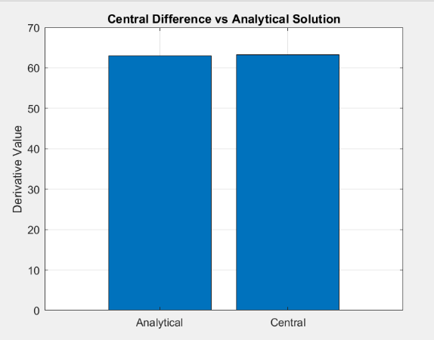
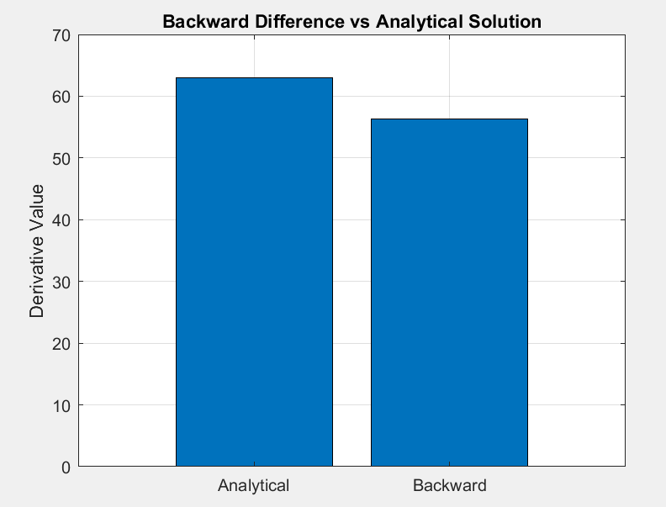
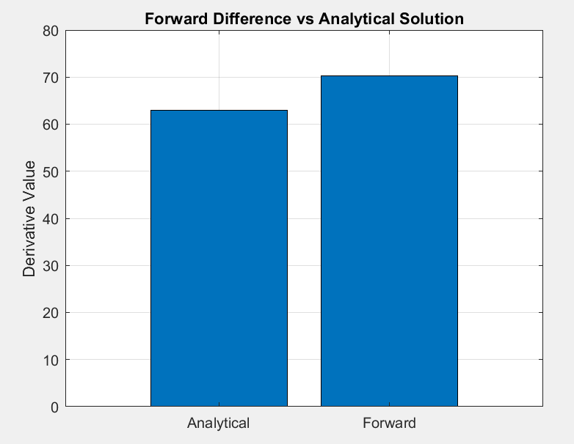
The error convergence at step size 0.5:

Observations:
- The Central Difference method consistently provides the most accurate approximation.
- Forward and Backward Difference methods show larger errors, with Forward slightly outperforming Backward.
- Reducing the step size (h) improves the accuracy of all methods.
Numerical Differentiation Methods
Comparison of the methods:
e^{-x}, on x = 5
Step Size (h) | Forward | Backward | Central | Analytical
0.5 | -0.0053024 | - 0.0087421 | -0.0070222 | -0.0067379
0.1 | -0.006412 | -0.0070864 | -0.0067492 | -0.0067379
0.05 | -0.0065723 | -0.0069092 | -0.0067408 | -0.0067379

Step Size (h) | Error of forward | Error of backward | Error of central
0.5 | 0.0014356 | 0.0020042 | 0.00028428
0.1 | 0.00032594 | 0.00034841 | 1.1236e-05
0.05 | 0.00016568 | 0.00017129 | 2.8078e-06

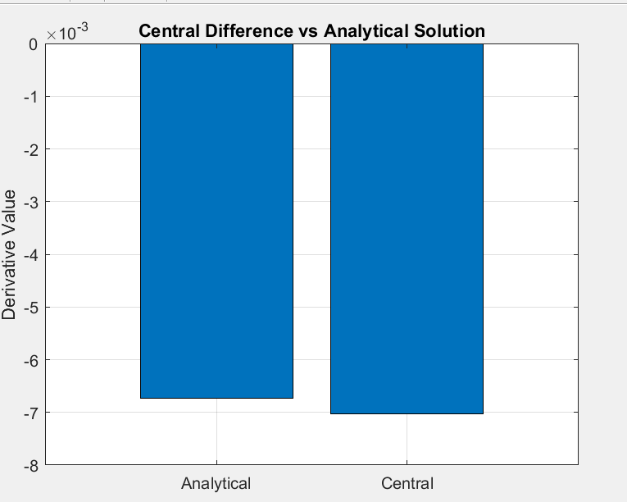
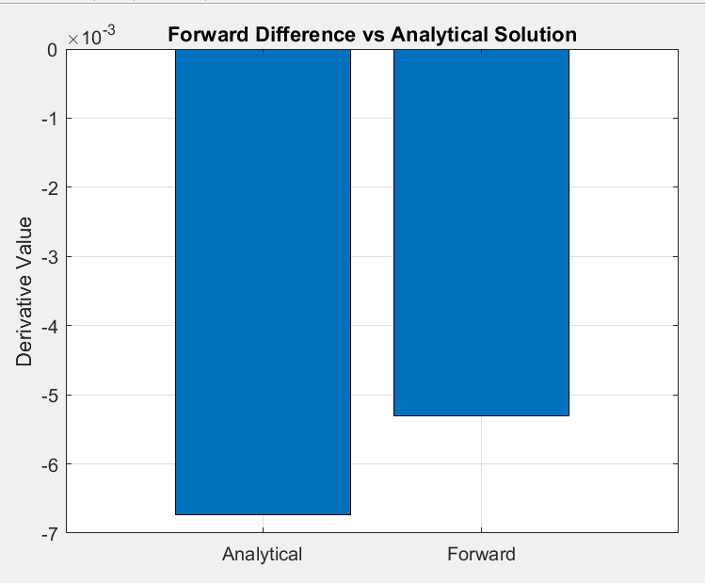
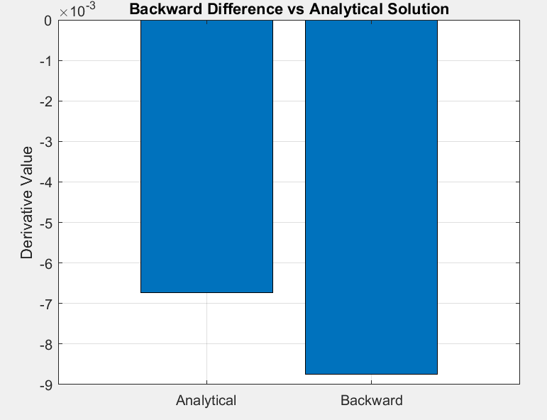
The error convergence at step size 0.5:

Observations:
- The Central Difference method outperforms Forward and Backward Difference methods.
- Forward and Backward methods becomes more accurate the lower the step size is
- Errors decrease substantially as h is reduced.

Numerical Differentiation Methods
Comparison of the methods:
Sin(x) * Log(x), on x = 3
Step Size (h) | Forward | Backward | Central | Analytical
0.5 | -1.189 | -0.78668 | -0.98782 | -1.0406
0.1 | -1.0799 | -0.99695 | -1.0384 | -1.0406
0.05 | -1.0608 | -1.0193 | -1.04 | -1.0406

Step Size (h) | Error of forward | Error of backward | Error of central
0.5 | 0.14839 | 0.2539 | 0.052755
0.1 | 0.039339 | 0.043626 | 0.0021435
0.05 | 0.020225 | 0.021297 | 0.00053614

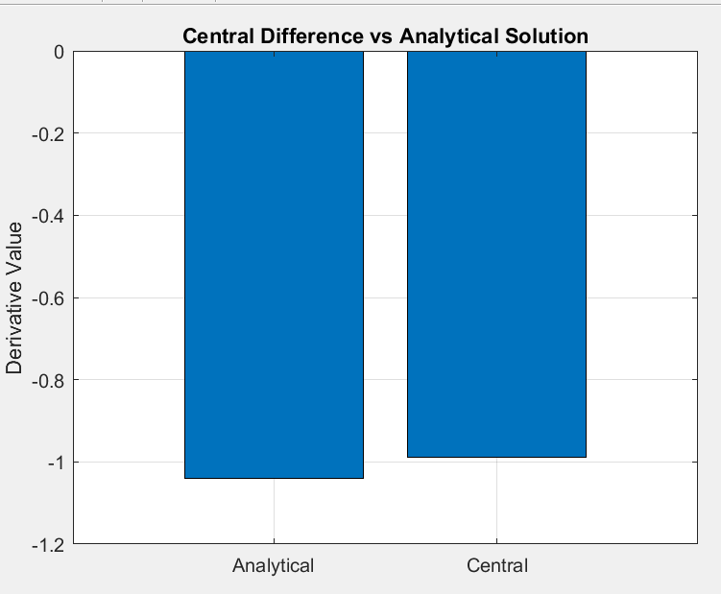
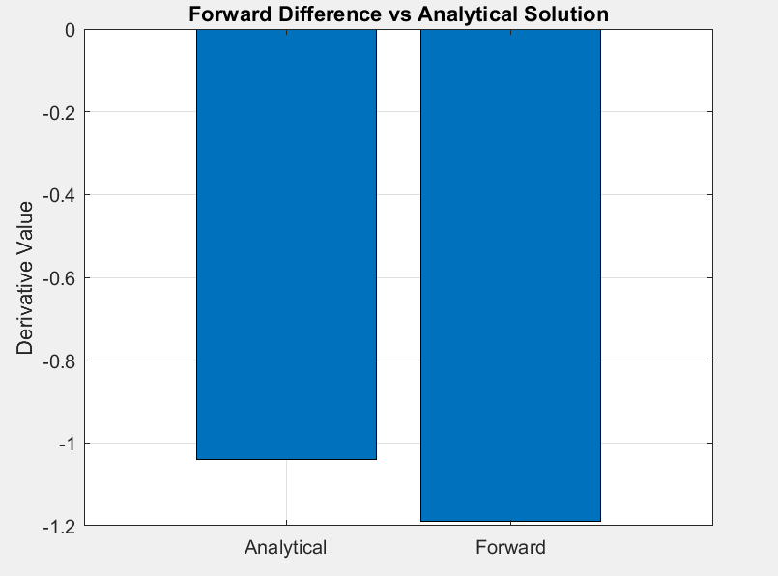
The error convergence at step size 0.5:
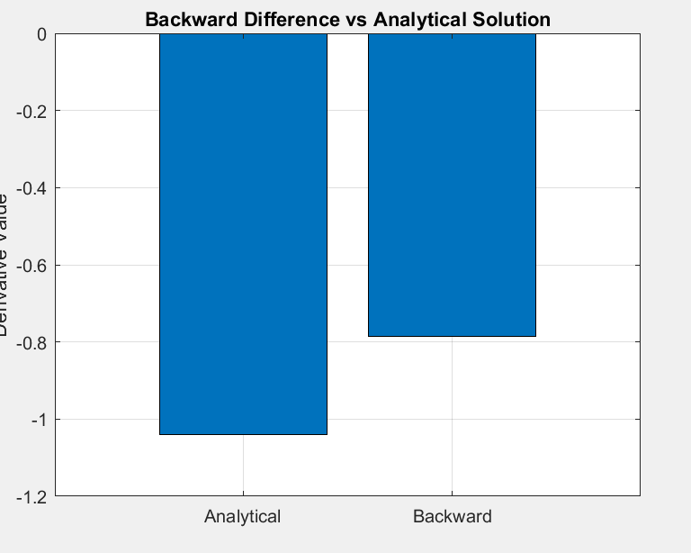
Observations:
- The Central Difference method consistently provides the most accurate results, with the smallest error for all step sizes.
- Forward Difference performs better than Backward Difference.
- Reducing the step size significantly improves the accuracy of all methods,

