Programming II
Project Report
Wind speed predictions using mathematical models

STUDENTS:
Layan Alhattami , Hajer Bakoor

INSTUCTOR:
Dr. Narjisse Kabbaj

Table of Contents
Abstract: 3
Introduction : 3
Methodology: 4
Results: 5
Conclusion: 5

Abstract
This project investigates the analysis of wind speed data using mathematical modeling to identify the best-fit model for prediction. Data normalization and cleaning were performed to ensure the quality of input data. Four models—linear, polynomial, logarithmic, and exponential—were developed and evaluated using error metrics such as Mean Squared Error (MSE), Root Mean Squared Error (RMSE), and R². Among these, the polynomial model provided the most accurate predictions, closely matching the data patterns. This work demonstrates the importance of mathematical modeling in understanding wind energy dynamics and highlights the role of collaborative problem-solving and computational tools in renewable energy research.

Introduction
Wind energy is a vital component in the transition to sustainable energy sources. Understanding the factors that influence wind speed is crucial for developing effective wind energy systems. This project aims to analyze wind speed data using various mathematical models—namely linear, polynomial, logarithmic, and exponential—to determine the best-fit model for the dataset and gain insights into wind speed behavior under different conditions. The combined effort enhanced our technical programming skills and broadened our understanding of wind energy dynamics and the application of computational tools in renewable energy research.

Methodology
- Data Preprocessing
Data normalization and cleaning were essential steps to ensure the quality of the input data. Invalid or missing entries were filtered out to maintain model accuracy. The dataset was prepared for analysis by handling NaN and infinite values.

- Mathematical Modeling
Four mathematical models were implemented:
- Linear Model: A straightforward linear relationship between variables.
- Polynomial Model: A higher-degree polynomial fit to capture more complex relationships.
- Logarithmic Model: Utilized for data exhibiting exponential growth characteristics.
- Exponential Model: Applied where growth is constant in percentage terms.
Each model's performance was evaluated using the following error metrics:
- Mean Squared Error (MSE): Measures the average of the squares of the errors.
- Root Mean Squared Error (RMSE): The square root of MSE, providing error in the original units.
- R²: Indicates the proportion of variance explained by the model.

- Model Evaluation
Models were assessed based on their performance metrics. The polynomial model emerged as the best performer in terms of accuracy and fit to the dataset.

Results
The polynomial model provided the best fit for the dataset, achieving the lowest composite scores based on MSE, RMSE, and R². Other models, such as linear, logarithmic, and exponential fits, performed satisfactorily but did not generalize well to the data patterns. The results indicated that the polynomial model was the most accurate choice for wind speed prediction.
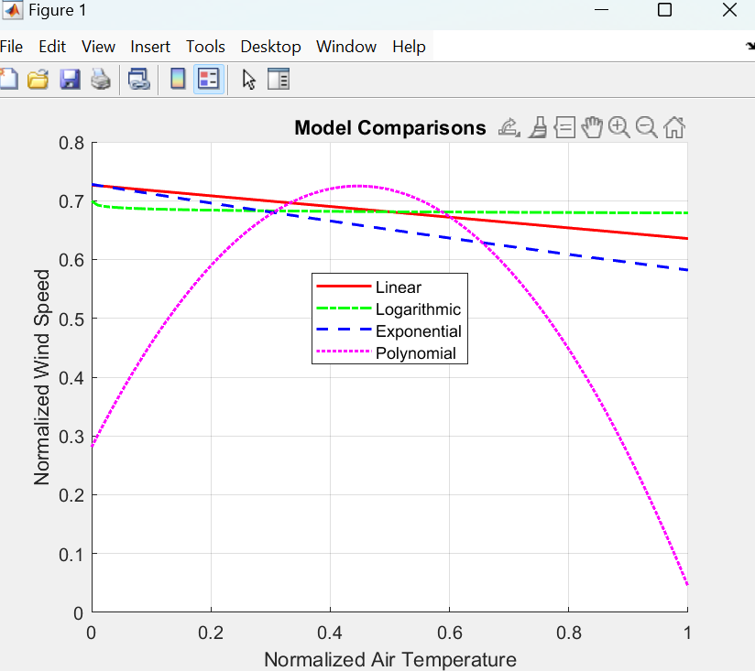

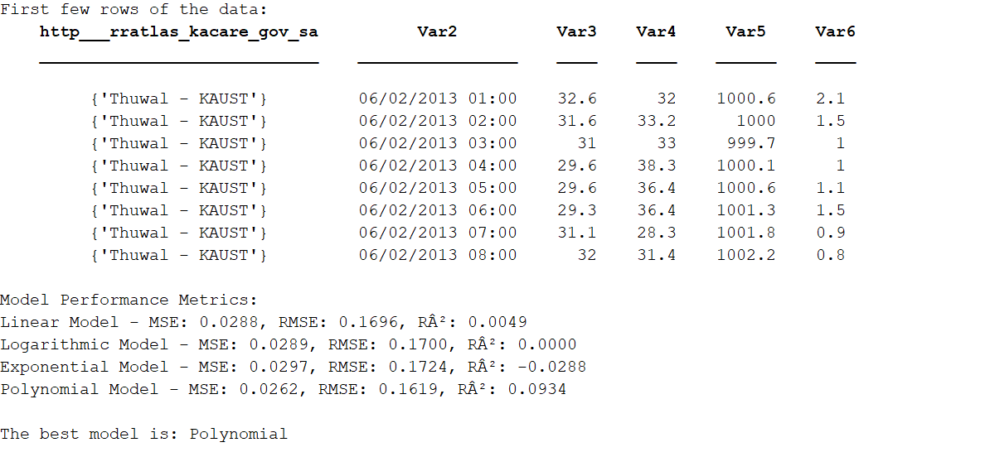

Conclusion
This study demonstrated the application of mathematical modeling to analyze wind speed data effectively. Among the models tested, the polynomial model performed the best, yielding the most accurate predictions and closely matching the dataset. The experience emphasized the significance of data preparation, consistent assessment measures, and collaborative problem-solving in producing reliable findings. By leveraging computational tools and teamwork, we enhanced our understanding of wind energy potential while developing crucial technical and analytical skills.

