INDUSTRY PROJECT
ON
CUSTOMER SEGMENTATION AND RECOMMENDATION
TCS iON AIP 135
Name: Hajira Ayath
Campus ID: 30984
Register Number: 23BBCBDB12
College Name: Yenepoya (Deemed to Be University)-Bengaluru
GitHub :
Hajira-27/Customer-Segmentation-and-Recommendation-System
Google Drive : Video Execution Link
https://drive.google.com/file/d/1BqNngyJUpPnl_5V7R-2zgXqmwM9aZoQj/view?usp=sharing

Industry Project Title | TCS iON AIP 135
Project Title | Customer Segmentation and Recommendation System
Name of the Company | Tata Consultancy Services
Name of the Institute | Yenepoya (Deemed to Be University)

Start Date | End Date | Total Effort (hrs.) | Project Environment | Tools Used
13-11-2025 | 11-02-2026 | 80 – 90 hr | Python, Jupyter Notebook, Power BI | Python, Pandas, NumPy, Scikit-learn, Matplotlib, Seaborn, Power BI

TABLE OF CONTENT
- Acknowledgements
- Objective and Scope
- Problem Statement
- Existing Approaches
- Approach / Methodology - Tools and Technologies used
- Workflow
- Assumptions
- Implementation - Data collection, Processing Steps, Diagrams - Charts, Table
- Solution Design
- Challenges & Opportunities
- Reflections on the project
- Recommendations
- Outcome / Conclusion
- Enhancement Scope
- Link to code and executable file
- Research questions and responses
- References

1. Acknowledgements
I would like to express my sincere gratitude to Tata Consultancy Services (TCS) and TCS iON for providing the opportunity to work on this industry-oriented project. This project helped me gain hands-on exposure to real-world data analytics and machine learning applications in the retail domain.
I would also like to thank my institution, Yenepoya (Deemed to Be University), and my mentors for their continuous guidance, encouragement, and support throughout the project duration. Their insights and feedback played a vital role in the successful completion of this project.

2. Objective and Scope
2.1 Objective
The primary objective of this project is to design and implement a Customer Segmentation and Recommendation System using unsupervised machine learning. The system analyzes transactional purchasing behavior of customers from an online retail dataset and groups them into meaningful segments. Based on these segments, the system generates personalized product recommendations to support targeted marketing and customer engagement strategies.
2.2 Scope
The scope of this project covers the complete analytical pipeline required by the TCS iON Industry Project guidelines. It includes analyzing a UK-based retail transactional dataset to understand customer purchasing behavior, performing feature engineering to create customer-centric metrics such as Purchase Frequency, Customer Lifetime Value, Average Transaction Value, Recency, Total Quantity, Unique Products, and Rolling Purchase Average, and applying K-Means clustering to segment customers into distinct behavioral groups.
The project also includes the development of a cluster-based product recommendation system that suggests top-selling products to customers within each segment, and the creation of an interactive Power BI dashboard to visualize customer segments, key performance indicators, and business insights.
The scope is limited to transactional behavioral data available in the dataset and does not include external demographic or real-time data integration.

3. Problem Statement
Retail businesses often use uniform marketing strategies that do not consider differences in customer purchasing behavior. This results in inefficient promotional spending, low customer engagement, and increased customer churn. Without a structured analytical approach, businesses struggle to distinguish high-value loyal customers from occasional or low-spending customers, leading to missed opportunities in cross-selling, up-selling, and retention planning.
The key challenges addressed in this project are the lack of a data-driven method to identify meaningful customer segments from raw transaction data, the absence of a personalized product recommendation mechanism, and the difficulty of presenting machine learning outcomes in a clear and business-oriented visual format.
This project resolves these issues by implementing an end-to-end pipeline that performs data preprocessing, feature engineering, customer segmentation using unsupervised learning, and cluster-based product recommendations, with results delivered through an interactive Power BI dashboard for practical business decision-making in alignment with TCS iON industry project requirements.
4. Existing Approaches
In the retail industry, customer analytics was traditionally based on demographic segmentation, where customers were grouped by factors such as age, gender, or location. While easy to implement, this approach often ignored actual purchasing behavior and resulted in broad segments with limited marketing value. Another common method was rule-based recommendation systems, which suggested products using fixed associations like “frequently bought together.” These systems lacked flexibility and required frequent manual updates. Retail businesses also relied on static dashboards for reporting, which provided limited interactivity and did not allow deep analysis of customer segments. In recent years, organizations have shifted toward behavioral analytics especially, RFM analysis combined with machine learning techniques such as K-Means clustering. This modern approach focuses on real transaction data rather than assumptions. The present project builds on this behavioral strategy and extends it with additional engineered features, enabling more accurate and actionable customer segmentation aligned with TCS iON project expectations.

5. Approach / Methodology
5.1 Tools and Technologies Used
Component | Technology
Programming Language | Python 3.x
Data Manipulation | Pandas, NumPy
Machine Learning | Scikit-learn (K-Means, PCA, StandardScaler)
Visualization (Python) | Matplotlib, Seaborn
Dashboard | Microsoft Power BI
Development Environment | Jupyter Notebook
Evaluation Metrics | Silhouette Score, Davies-Bouldin Index, Calinski-Harabasz Index

5.2 Methodology Overview
The project methodology follows the Knowledge Discovery in Databases (KDD) framework to ensure a structured and systematic analytical process. The workflow progresses from data collection to final business insights through clearly defined stages including data cleaning, feature engineering, clustering, evaluation, recommendation generation, and dashboard visualization.
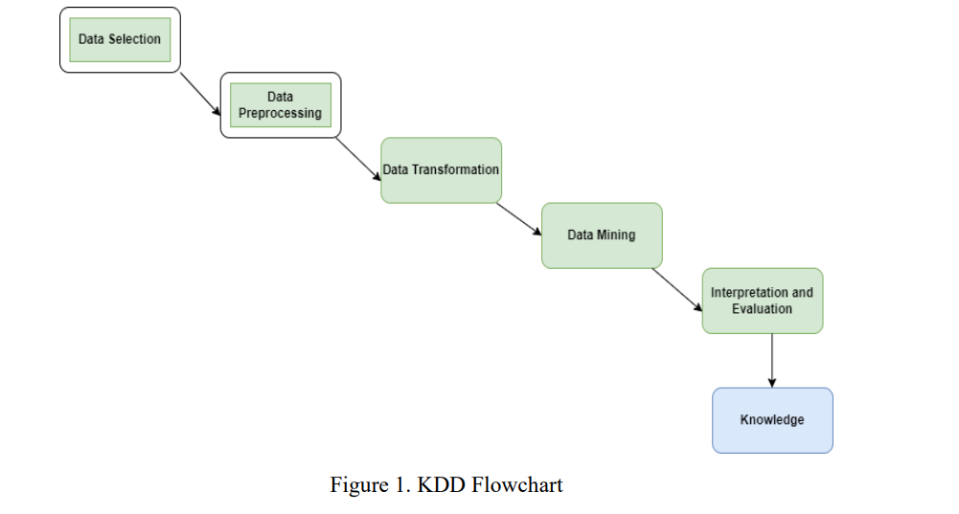
Data Acquisition and Selection
The initial phase involves loading a retail transactional dataset containing attributes such as Invoice Number, Stock Code, Quantity, Unit Price, Invoice Date, Customer ID, and Country. This stage forms the foundation for all subsequent analysis, as accurate and relevant data selection directly influences segmentation quality and recommendation accuracy.
6. Workflow
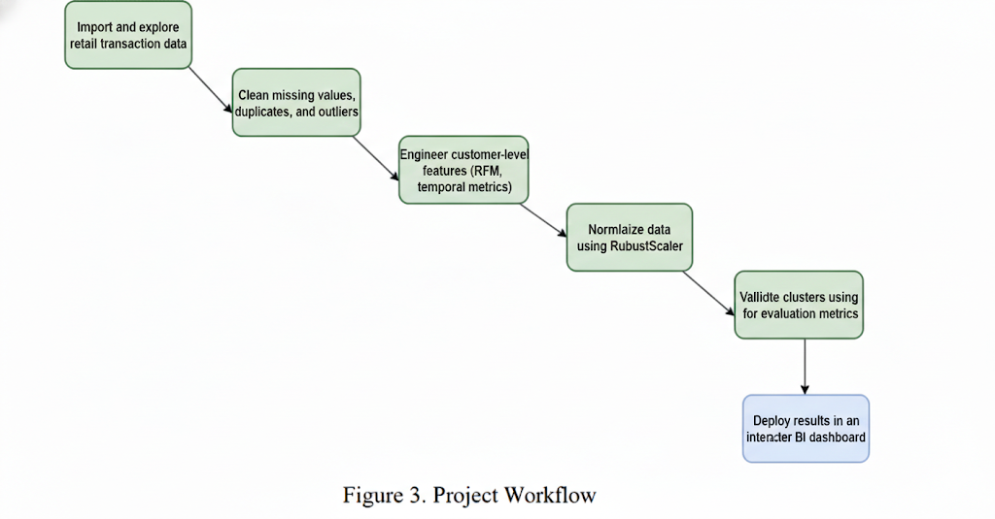

7. Assumptions
- Customers with similar purchasing behavior are likely to share similar product preferences.
- Transactional records accurately represent customer buying patterns.
- Cancelled or negative transactions are removed to maintain data integrity.
- Behavioral features such as Recency, Frequency, and Monetary value are sufficient for meaningful segmentation without external demographic data.

8. Implementation
8.1 Data Collection
The dataset used in this project is the Online Retail Dataset, a publicly available transactional dataset that records all purchases made by customers of a UK-based online retail store between December 2010 and December 2011. The raw dataset contains 541,909 transaction records with eight attributes.

Attribute | Description | Data Type
InvoiceNo | Unique 6-digit invoice number (C prefix = cancellation) | Object
StockCode | Unique 5-digit product code | Object
Description | Product name | Object
Quantity | Quantity of product per transaction | Integer
InvoiceDate | Date and time of the invoice | Datetime
UnitPrice | Product price per unit in GBP | Float
CustomerID | Unique 5-digit customer identifier | Float
Country | Country of the customer | Object
Table 1: Dataset Attribute Description

8.2 Data Cleaning and Preprocessing
The raw dataset contained significant noise and inconsistencies that required a systematic cleaning pipeline before any analytical operations could be performed.
Missing Value Treatment: An initial diagnostic revealed that 135,080 rows (approximately 25% of the dataset) had missing CustomerID values. Since CustomerID is the fundamental key for customer-level segmentation, these rows were dropped entirely. An additional 1,454 missing Description values were filled with the placeholder string "Unknown" to preserve the transactional record.
Cancelled Transaction Removal: Invoices prefixed with the letter "C" represent cancelled orders. These were filtered out to ensure only completed purchases contribute to the behavioral analysis.
Positive Value Filtering: Records with non-positive Quantity or UnitPrice were removed, as these indicate data anomalies or return adjustments that could distort the aggregated customer features.
Duplicate Removal: A total of duplicate rows were identified and removed to prevent the model from over-weighting specific transactions.
Resulting Clean Dataset: After all preprocessing steps, the clean dataset contains 392,692 transaction records across 4,338 unique customers.

8.3 Outlier Analysis
Box plots were generated for the Quantity and UnitPrice attributes to identify the presence and extent of outliers in the dataset.
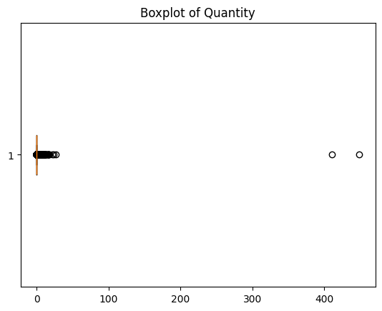
Figure 1: Box Plot of Quantity Distribution
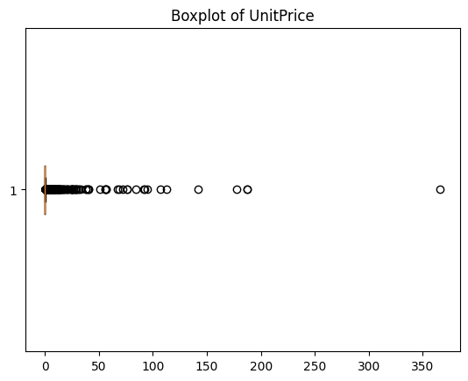
Figure 2: Box Plot of UnitPrice Distribution
The box plots reveal extreme outliers in both attributes, with Quantity values reaching up to 80,995 units and UnitPrice values extending to 8,142.75 GBP. These outliers were intentionally retained because they represent genuine bulk purchases and premium product transactions. Removing them would have eliminated high-value customer behavior from the segmentation, reducing the practical utility of the resulting clusters.

8.4 Feature Engineering
Raw transaction-level data was aggregated into customer-centric features to create a meaningful representation of each customer's purchasing behavior. The following seven features were engineered for each of the 4,338 unique customers:

Feature | Description | Calculation Method
PurchaseFrequency | Number of unique invoices | Count of distinct InvoiceNo per customer
CustomerLifetimeValue | Total spending in GBP | Sum of (Quantity x UnitPrice) per customer
AverageTransactionValue | Mean spending per invoice | Mean of TotalAmount per customer
UniqueProducts | Product diversity | Count of distinct StockCode per customer
TotalQuantity | Total items purchased | Sum of Quantity per customer
Recency | Days since last purchase | (Snapshot Date - Last Invoice Date) in days
AvgRollingAmount | Rolling purchase average | Mean of 3-transaction rolling average of TotalAmount
Table 2: Engineered Customer Features

The rolling average feature (AvgRollingAmount) was specifically designed to capture patterns of spending consistency or irregularity. By computing a three-transaction rolling window of purchase amounts and then averaging across all windows for each customer, this feature provides an additional behavioral signal that pure aggregate metrics cannot capture.

8.5 Feature Scaling and Dimensionality Reduction
All seven numerical features were standardized using StandardScaler to ensure that each attribute contributes equally to the distance calculations performed by the K-Means algorithm. Without standardization, features with larger absolute ranges (such as CustomerLifetimeValue) would dominate the clustering process.
Principal Component Analysis (PCA) was applied to the scaled feature matrix with a threshold of 95% cumulative explained variance. This reduced the original seven-dimensional feature space to five principal components while retaining 97.9% of the total variance. The first component alone captured 42.8% of the variance, followed by the second component at 27.9%.
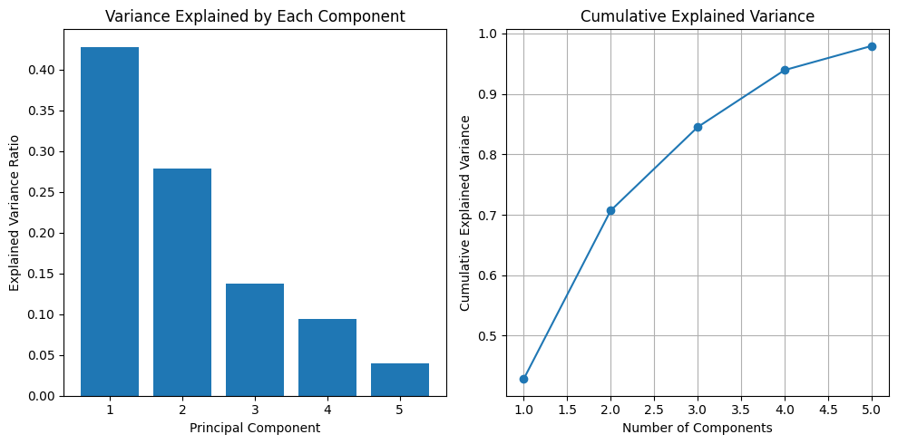
Figure 3: PCA Variance Explained by Each Component and Cumulative Variance
8.6 K-Means Clustering
Why K-Means?
"While algorithms like Hierarchical Clustering and DBSCAN were considered, K-Means was selected as the primary architecture for this project due to:
- Scalability: K-Means has a linear time complexity $O(n)$, making it significantly more efficient for the large 'Online Retail' dataset compared to Hierarchical clustering, which struggles with $O(n^2)$ or $O(n^3)$ complexity.
- Centroid-Based Logic: Since the business goal is to define 'Average Customer Profiles' for marketing personas, K-Means’ focus on centroids provides a clear mathematical 'middle ground' for each segment.
- DBSCAN Limitations: DBSCAN was bypassed because the dataset contains varying densities; K-Means, combined with Silhouette Analysis, allowed for more deliberate control over the number of segments ($k=4$) required for actionable business strategy."

The Elbow Method and Silhouette Analysis were employed to determine the optimal number of clusters for the K-Means algorithm.
Elbow Method: The Within-Cluster Sum of Squares (inertia) was calculated for K values ranging from 2 to 10. The resulting elbow curve shows a noticeable inflection around K=4, where the rate of inertia reduction begins to diminish.
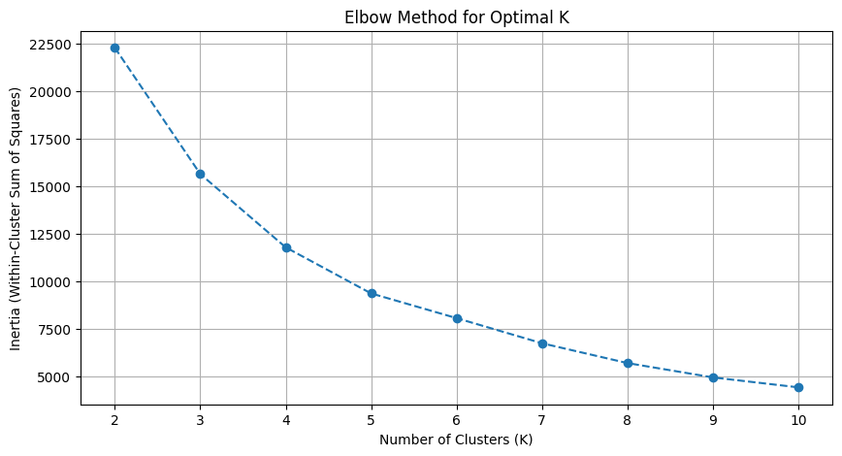
Figure 4: Elbow Method for Optimal K Selection
Silhouette Analysis: Silhouette scores were computed for each value of K. While K=2 produced the highest silhouette score (0.9332), this was considered too coarse for meaningful business segmentation. K=4 was selected as it provides a better balance between cluster granularity and cohesion, with a silhouette score of 0.4572 that still indicates reasonable cluster separation.
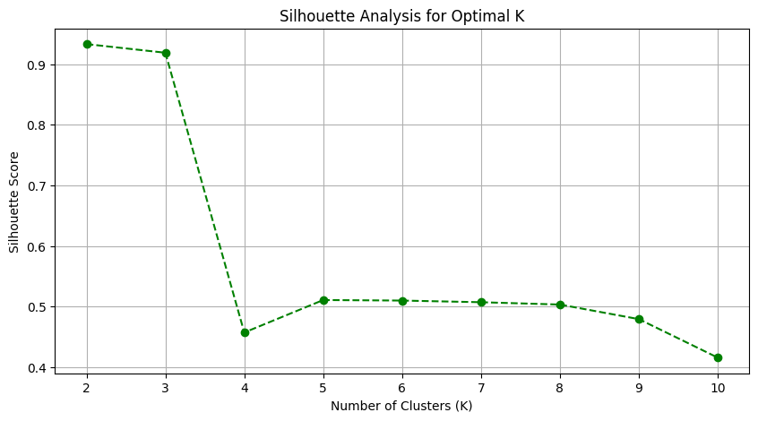
Figure 5: Silhouette Score Analysis for Optimal K
K-Means was applied with K=4 clusters, random_state=42 for reproducibility, and n_init=10 to ensure robust centroid initialization. The resulting cluster distribution across 4,338 customers is shown below.
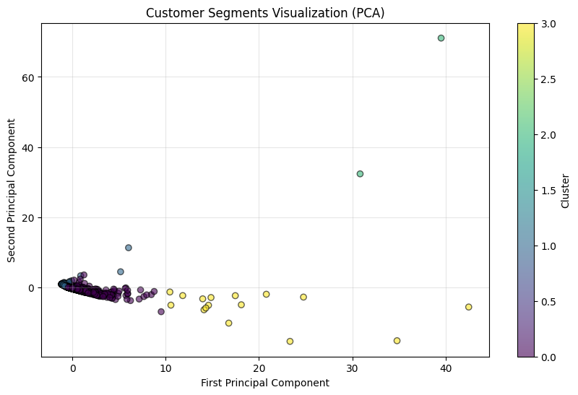
Figure 6: Customer Segments Visualized in PCA Space

8.7 Cluster Analysis and Profiling
Each of the four clusters was analyzed based on the mean values of all engineered features and assigned a descriptive business label based on Customer Lifetime Value ranking.

Cluster Label | Customers | Avg CLV (£) | Avg Frequency | Avg Recency (Days)
Regular Customers | 3,177 | 1,978.64 | 4.89 | 39.66
Budget Customers | 1,143 | 544.23 | 1.56 | 240.57
Premium VIP Customers | 2 | 122,828.05 | 1.50 | 163.50
High-Value Customers | 16 | 108,334.77 | 75.63 | 7.19
Table 3: Cluster Profile Summary
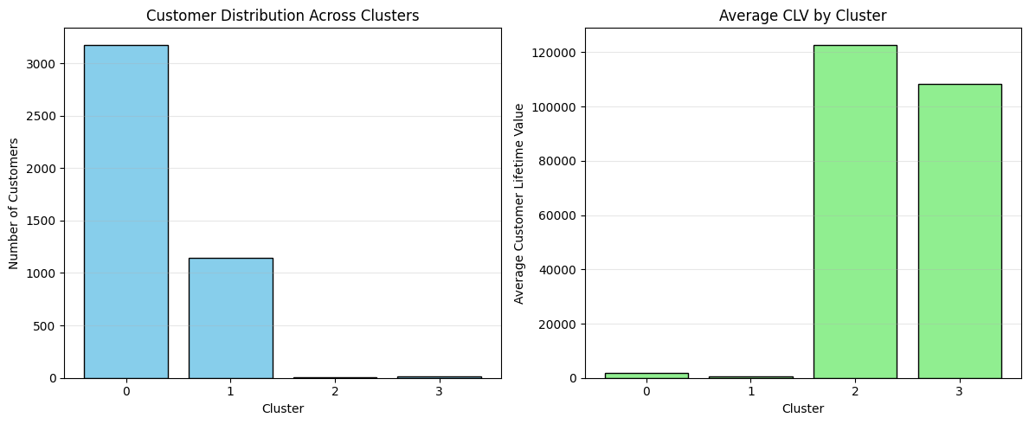
Figure 7: Customer Distribution and Average CLV by Cluster
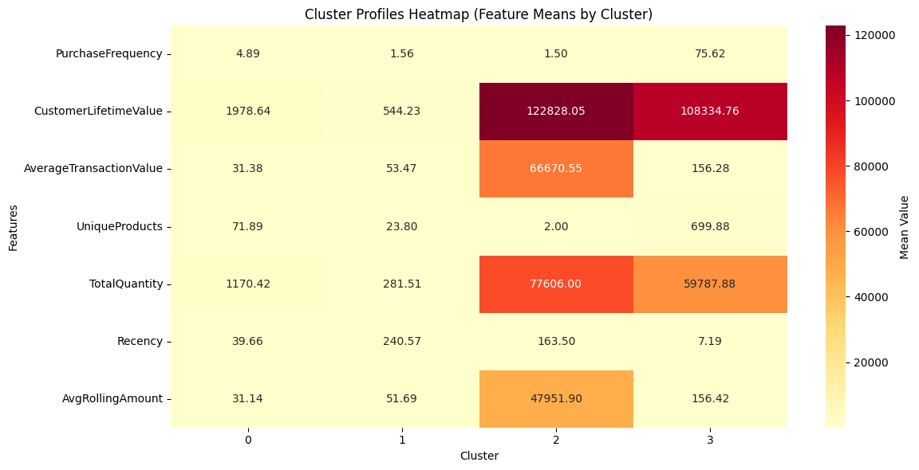
Figure 8: Cluster Profiles Heatmap (Feature Means by Cluster)
The Regular Customers segment (Cluster 0) represents the largest group at 73.2% of the customer base. These customers show moderate purchasing frequency and CLV with low recency, indicating active engagement. Budget Customers (Cluster 1) account for 26.4% and exhibit low frequency, low CLV, and very high recency (240 days on average), suggesting disengagement. The High-Value Customers (Cluster 3) are a small but extremely valuable group of 16 customers with the highest purchase frequency (75.63 on average) and very low recency (7.19 days), representing the most actively engaged buyers. The Premium VIP Customers (Cluster 2) consist of just 2 customers with extraordinarily high CLV values exceeding 122,000 GBP, likely representing bulk wholesale buyers.

8.8 Recommendation System
A cluster-based product recommendation engine was built to suggest relevant products to each customer. The recommendation logic operates through three sequential steps.
First, top-selling products within each cluster are identified by aggregating total revenue, total quantity sold, and the number of unique customers who purchased each product. The top 10 products per cluster serve as the recommendation pool. Second, for any given customer, the system retrieves the top products from their assigned cluster and filters out items the customer has already purchased. Third, the remaining products are ranked by total revenue and the top 5 are presented as personalized recommendations.
This approach generated a total of 21,612 product recommendations across all 4,338 customers, ensuring that every customer received at least one recommendation. The system is designed to be easily extensible; as new transaction data becomes available, the cluster assignments and product rankings can be refreshed to keep recommendations current.

Recommendation Engine Design
To bridge the gap between identifying customer segments and driving business value, this project implements a Cluster-Based Collaborative Filtering recommendation engine. Unlike generic “Best-Seller” lists, this system leverages the collective intelligence of each segment to provide personalized suggestions tailored to customer behavior.

The Logic and Implementation
The recommendation engine follows a three-step analytical process:
- Segment Identification:
The system identifies the specific cluster (0, 1, 2, or 3) assigned to a Customer ID based on their behavioral metrics such as Recency, Frequency, and Monetary value.
- Intra-Cluster Filtering:
For a target customer, the system analyzes the purchasing history of other customers within the same cluster to identify commonly purchased products.
- Top-N Selection:
The engine selects the top 5 most frequently purchased items within that cluster that the target customer has not already purchased. This ensures recommendations remain relevant, personalized, and fresh.

Strategic Mapping per Segment
The recommendation strategy adapts according to the behavioral characteristics of each customer segment:
Segment | Strategy | Recommendation Type
Regular Customers | Reward and Retain | Loyalty rewards, bundle offers, and early access to trending products.
Budget Customers | Upsell and Cross-sell | Affordable complementary items and value-based product suggestions.
Premium VIP Customers | Exclusive Engagement | Luxury product bundles, premium collections, and personalized priority offers.
High-Value Customers | Retention and Appreciation | Early-release products, personalized deals, and high-margin cross-category recommendations.

Business Impact
By shifting from a “One-Size-Fits-All” recommendation model to a Cluster-Based Collaborative Filtering approach, the system delivers multiple business benefits:
- Increases Relevance: Customers receive suggestions validated by peers with similar purchasing behavior.
- Optimizes Marketing Spend: Promotions are focused on products already proven successful within each segment.
- Enhances User Experience: Personalized recommendations improve engagement and increase Click-Through Rate (CTR).
- Improves Customer Retention: Tailored offers encourage repeat purchases and long-term loyalty.
8.9 Dashboard Development
The final stage of the project involved building an interactive Power BI dashboard to translate the analytical outputs into a business-friendly visualization layer. All cluster profiles, customer segments, and product recommendations were exported as CSV files from the Jupyter Notebook and imported into Power BI for dashboard construction.
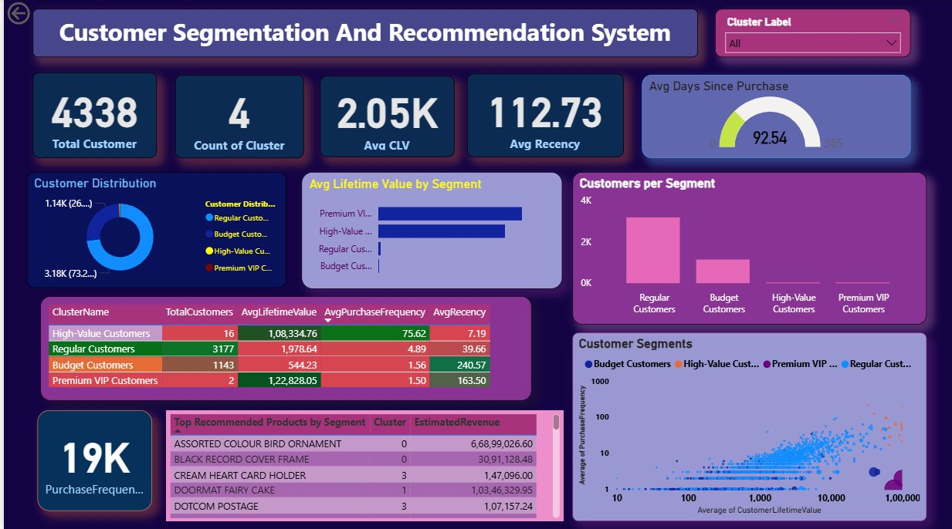
Figure 9: Interactive Customer Segmentation Dashboard (Power BI)
The dashboard incorporates the following visual components: KPI summary cards displaying Total Customers (4,338), Count of Clusters (4), Average CLV (2.05K GBP), and Average Recency (112.73 days); a donut chart showing customer distribution across segments; a horizontal bar chart comparing average lifetime value by segment; a vertical bar chart displaying customer counts per segment; a detailed cluster profile table with all key metrics; a scatter plot visualizing customer segments on a CLV vs. Purchase Frequency plane using logarithmic scaling; a gauge chart showing average days since purchase; a table of top recommended products by segment with estimated revenue; and a cluster label slicer enabling dynamic filtering of all dashboard elements.

9. Solution Design
The solution architecture is built as a Modular Data Pipeline, ensuring a seamless flow from raw transactional data to actionable business insights. The system is designed to handle high-dimensional retail data through a structured sequence of processing layers.
9.1 Technical Architecture
- Data Ingestion & Cleaning Layer: The system ingests raw CSV data and implements a rigorous cleaning engine. This layer specifically filters for valid CustomerID entries and removes cancellations (invoices starting with 'C') to ensure the model trains only on successful revenue-generating transactions.
- Feature Transformation Engine: Unlike standard RFM models, this engine calculates advanced behavioral metrics including Purchase Frequency, Customer Lifetime Value (CLV), and a 3-transaction Rolling Purchase Average. This captures not just "how much" a customer spends, but the "consistency" of their spending patterns.
- Dimensionality Reduction Core: To optimize clustering performance, the system utilizes a PCA (Principal Component Analysis) layer. This reduces the 7-dimensional feature space into principal components that capture 97.9% of the variance, effectively removing noise and multi-collinearity before the data reaches the clustering algorithm.
- Unsupervised Learning Module: The system employs the K-Means++ initialization algorithm. By leveraging the Elbow Method and Silhouette Analysis, it assigns each customer to one of four distinct behavioral clusters (Regular, Budget, High-Value, and Premium VIP).
- Collaborative Recommendation Generator: This module serves as the final output layer. It maps individual Customer IDs to their cluster-level preferences, filters out items already owned by the user, and suggests the Top-5 "Next-Best-Offers" based on intra-cluster popularity.
9.2 Design Principles
- Scalability: By using vectorized operations in Pandas and Scikit-learn, the pipeline can process hundreds of thousands of rows (e.g., the 541,909 raw records) with linear time complexity.
- Interpretability: The design prioritizes "Human-in-the-loop" analytics. Every technical output (Cluster Label) is translated into a business persona (e.g., "At-Risk") to ensure the results are usable by marketing teams.
- Interoperability: The pipeline is designed to be tool-agnostic at the visualization stage, exporting structured CSV payloads that allow for seamless integration with Power BI or other BI tools.

10. Challenges and Opportunities
10.1 Challenges
- Handling Missing Data: Approximately 25% of records lacked CustomerID values. Dropping these rows was necessary but resulted in a significant reduction of the dataset, potentially excluding some behavioral patterns.
- Outlier Management: The dataset contained extreme values in Quantity and UnitPrice. Deciding to retain outliers required careful consideration, as they significantly influence cluster formation in K-Means, which is sensitive to extreme values.
- Optimal Cluster Selection: The silhouette analysis suggested K=2 as the optimal value, but this was too coarse for actionable business segmentation. Choosing K=4 required domain judgment to balance statistical metrics with practical utility.
- Imbalanced Cluster Sizes: The resulting clusters are highly imbalanced, with Cluster 0 containing 3,177 customers while Cluster 2 contains only 2. This imbalance reflects the natural distribution of customer behavior but poses challenges for recommendation diversity.
- Bridging Technical Outputs and Business Context: Translating clustering metrics and feature importance into language that non-technical stakeholders can understand and act upon was a recurring challenge throughout the dashboarding phase.
10.2 Opportunities
- Targeted Retention Campaigns: The identification of Budget Customers with high recency values provides a direct opportunity to design win-back campaigns before these customers churn permanently.
- Personalized Cross-Selling: The recommendation system enables targeted product suggestions that can increase average order value, particularly for Regular Customers who represent the largest segment.
- VIP Customer Programs: The identification of High-Value and Premium VIP segments enables the creation of exclusive loyalty programs and personalized service offerings for the most valuable customers.
- Data-Driven Inventory Planning: Product popularity data by segment can inform inventory stocking decisions, ensuring that high-demand items within each customer segment remain available.

11. Reflections on the Project
This project provided hands-on experience across the full data science lifecycle, from raw transactional data to a functional customer segmentation and recommendation system. It strengthened practical understanding of applying K-Means clustering, PCA, and feature engineering to real retail scenarios.
A key learning was that model evaluation metrics must be balanced with business understanding to create segments that are both statistically valid and actionable. The feature engineering stage highlighted the importance of meaningful behavioral metrics such as Recency, Frequency, and Rolling Purchase Value while maintaining data integrity.
Building the Power BI dashboard improved skills in presenting technical outputs through clear visual insights, emphasizing the importance of visualization for business decision-making as expected in TCS iON project deliverables.

13. Outcome / Conclusion
This project successfully delivered an end-to-end Customer Segmentation and Recommendation System in line with the stated objectives. A total of 4,338 customers were segmented into four behavioral groups, each showing clear differences in purchase frequency, lifetime value, recency, and product diversity.
The K-Means model achieved a Silhouette Score of 0.4572, Davies-Bouldin Index of 0.7259, and Calinski-Harabasz Index of 2278.85, indicating acceptable cluster separation with strong practical business usefulness. The recommendation engine generated over 21,000 personalized product suggestions, recommending top-selling products within each customer’s segment.
An interactive Power BI dashboard was developed to present cluster profiles, KPIs, and recommendations in a user-friendly format for business stakeholders. Overall, the project demonstrates how unsupervised machine learning can transform retail transaction data into actionable marketing and retention insights
14. Enhancement Scope
While the current system meets project requirements, future improvements could further increase its value:
- Real-Time Data Integration: Connect to live databases for continuous segmentation instead of batch processing.
- Advanced Clustering Methods: Explore DBSCAN or Gaussian Mixture Models for better handling of imbalanced clusters.
- Collaborative Filtering: Add customer-to-customer similarity for more personalized recommendations.
- Predictive Modeling: Use deep learning techniques to forecast churn or future purchases.
- Automated Retraining: Implement scheduled model updates to adapt to changing customer behavior.
- Web Deployment: Deploy the system using Flask or Streamlit for real-time access beyond dashboards.

15. Link to Code and Executable File
The complete project source code, datasets, and exported outputs are available through the following links:
GitHub :
Hajira-27/Customer-Segmentation-and-Recommendation-System
Google Drive : Video Execution Link
https://drive.google.com/file/d/1BqNngyJUpPnl_5V7R-2zgXqmwM9aZoQj/view?usp=sharing

The repository contains the Jupyter Notebook with the complete implementation, all exported CSV files used for dashboard construction, and the Power BI dashboard file.

16. Research Questions and Responses
Q1: How did you determine the optimal number of clusters (K)?
The optimal number of clusters was determined using a combination of the Elbow Method and Silhouette Analysis. The Elbow Method plots inertia (Within-Cluster Sum of Squares) against K values from 2 to 10, and the elbow point where the rate of decrease slows was observed around K=4. Silhouette Analysis was used to validate this choice by measuring how similar each customer is to its own cluster compared to neighboring clusters. While K=2 had the highest silhouette score (0.9332), K=4 was selected because it produces segments with greater business interpretability, yielding four distinct customer profiles that support targeted marketing strategies.

Q2: What is the Cold Start problem in recommendation systems, and how does your project handle it?
The Cold Start problem arises when the system encounters a new customer who has no prior purchase history, making it impossible to generate personalized recommendations. In this project, the recommendation engine addresses this by falling back to cluster-level product popularity. Since every customer is assigned to a cluster based on their initial behavioral features, even customers with minimal transaction history receive recommendations drawn from the top-performing products within their assigned segment.

Q3: Why was StandardScaler chosen over other scaling methods?
StandardScaler was selected because it centers each feature around a mean of zero with unit variance, which is important for distance-based algorithms like K-Means that are sensitive to the scale of input features. While RobustScaler is an alternative that is less influenced by outliers, StandardScaler was deemed appropriate here because outliers in this dataset represent legitimate business transactions that should influence cluster formation rather than being suppressed.

Q4: How does PCA help in the clustering process?
Principal Component Analysis reduces the dimensionality of the feature space while retaining the most informative variance. In this project, PCA compressed seven features into five principal components that retained 97.9% of the total variance. This reduction helps the K-Means algorithm by removing noise and redundant information, leading to more stable cluster assignments. It also enables 2D visualization of the clusters by projecting onto the first two components.

Q5: How do you handle returns and cancellations in the dataset?
Cancelled transactions were identified by invoice numbers prefixed with the letter C. These records were removed during the preprocessing stage to ensure that only completed purchases contribute to the behavioral feature calculations. Additionally, records with non-positive Quantity or UnitPrice values were filtered out, as these typically represent return adjustments or data entry errors that would distort aggregate metrics like Customer Lifetime Value and Purchase Frequency.

Q6: How can this system be applied to inventory management?
By identifying which customer segments prefer specific products, businesses can optimize inventory stocking decisions. For instance, products that are consistently top-sellers among High-Value Customers should be prioritized in stock planning to avoid lost sales. Similarly, the recommendation data can reveal emerging product trends within specific segments, enabling proactive inventory adjustment before demand peaks.

Q7: How often should the K-Means model be retrained?
Customer purchasing behavior evolves due to seasonality, market trends, and promotional activities. In a production setting, the clustering model should be retrained on a monthly or quarterly basis to capture these shifts. Regular retraining ensures that segment definitions remain current and that customers who have changed their behavior are reclassified appropriately, enabling timely retention or upselling interventions.

Q8: What are the specific evaluation metrics used, and what do they indicate?
Three clustering evaluation metrics were used. The Silhouette Score (0.4572) measures how similar each data point is to its own cluster versus the nearest neighboring cluster, on a scale of -1 to 1, where values above 0.4 indicate reasonable structure. The Davies-Bouldin Index (0.7259) measures average cluster similarity, where lower values indicate better separation. The Calinski-Harabasz Index (2,278.85) measures the ratio of between-cluster to within-cluster variance, where higher values indicate more distinct clusters. Together, these metrics confirm that the four-cluster model produces meaningful and well-separated customer segments.

17. References
- Scikit-learn Documentation – K-Means Clustering, StandardScaler, PCA, Silhouette Score. https://scikit-learn.org/stable/
- Pandas Documentation – Data Manipulation and Analysis. https://pandas.pydata.org/docs/
- Matplotlib Documentation – Data Visualization. https://matplotlib.org/stable/contents.html
- Seaborn Documentation – Statistical Data Visualization. https://seaborn.pydata.org/
- Microsoft Power BI Documentation. https://learn.microsoft.com/en-us/power-bi/
- Chen, D., Manning, C.D. – Online Retail Dataset, UCI Machine Learning Repository.
- TCS iON Industry Project Guidelines – Tata Consultancy Services.
- NumPy Documentation – Numerical Computing. https://numpy.org/doc/

