SOFTWARE ENGINEERING

Project Iteration 1

CRIM – Explainable AI-Based Customer Churn Risk Analysis System

Group Members
Adeela Nasir (23L-0823)
Hajirah (23L-0929)
Sundas Habib (23L-2580)

Submitted to
Ms. Ansa Liaqat

Date of Submission
March 24, 2026



National University of Computing and Emerging Sciences, Lahore
- Introduction
Customer churn (i.e., the rate at which customers stop doing business with a company) is a major challenge for subscription-based businesses. CRIM addresses this by analyzing historical customer data, predicting the probability of churn for each customer, and categorizing them into risk levels. The system also explains why a customer is at risk, making the predictions transparent and trustworthy.
- User Stories

Story ID: US-01

Story Title: Customer Data Upload
Priority: High
Estimated Hours: 8

User Story:
As an admin, I want to upload customer data in CSV format so that the system can analyze churn risk.

Description:
This story involves developing a data upload mechanism that allows users to upload structured customer datasets. The system will validate, process, and prepare the data for churn prediction.

Sub User Stories:
- As an admin, I want to upload a CSV file containing customer data.
- As an admin, I want the system to validate the dataset format.
- As an admin, I want the system to preprocess the data before prediction.

Acceptance Criteria:
- The system should accept only CSV files.
- The system should validate dataset structure first.
- The system should display an error for invalid files.
- Uploaded data should be ready for prediction after preprocessing.

Story ID: US-02

Story Title: Churn Prediction Engine
Priority: High
Estimated Hours: 8

User Story:
As a manager, I want the system to predict customer churn probability so that I can identify customers likely to leave.

Description:
This story focuses on implementing a machine learning model that processes customer data and generates churn probability scores.

Sub User Stories:
- As a system, I want to load a trained ML model.
- As a system, I want to generate churn predictions.
- As a manager, I want to view churn probability results.

Acceptance Criteria:
- The system should generate a probability score per customer.
- Predictions should be generated without errors.
- Results should be stored and displayed.

Story ID: US-03

Story Title: Risk Categorization
Priority: High
Estimated Hours: 4

User Story:
As a user, I want customers categorized into risk levels so that I can prioritize retention strategies.

Description:
This story involves converting churn probability into meaningful risk categories such as Low, Medium, and High.

Sub User Stories:
- As a system, I want to define probability thresholds.
- As a system, I want to assign risk labels.
- As a user, I want categorized results displayed clearly.

Acceptance Criteria:
- Customers should be categorized into Low, Medium, and High risk.
- Categorization should be based on defined thresholds.
- Results should be clearly visible.

Story ID: US-04

Story Title: Basic Dashboard
Priority: High
Estimated Hours: 5

User Story:
As a manager, I want to view a churn summary dashboard so that I can quickly understand overall churn trends.

Description:
This story focuses on presenting summarized churn insights through a simple dashboard interface.

Sub User Stories:
- As a user, I want to see total customers.
- As a user, I want to see churn percentage.
- As a user, I want to see distribution of risk categories.

Acceptance Criteria:
- Dashboard should display total customers.
- Dashboard should show churn rate.
- Risk distribution should be visible.

Structured Specifications
User Story 1

US-01.1: Upload CSV file

Type | Specification
Functional | The system must allow users to upload CSV files through the interface.
Functional | Only files with .csv extension should be accepted.
UX | A confirmation message should be displayed after successful upload.

US-01.2: Validate dataset

Type | Specification
Functional | The system must check required columns before processing.
Functional | Invalid datasets must be rejected with an error message.
UX | Error messages should indicate missing or incorrect fields.

US-01.3: Data preprocessing

Type | Specification
Functional | Missing values must be handled appropriately.
Functional | Categorical data must be encoded into numerical format.
Performance | Preprocessing should complete within a few seconds for standard datasets.

User Story 2

US-02.1: Load ML model
Type | Specification
Functional | The system must load a pre-trained ML model before prediction.
Performance | Model loading should be efficient and not delay processing.

US-02.2: Generate predictions
Type | Specification
Functional | The system must calculate churn probability for each customer.
Functional | Predictions must be based on input dataset features.
Performance | Predictions should be generated within acceptable time limits.

US-02.3: Store prediction results
Type | Specification
Functional | The system must store predicted probabilities for each record.
Functional | Results should be accessible for further analysis.

User Story 3

US-03.1: Define thresholds
Type | Specification
Functional | The system must define probability thresholds for risk categories.
Functional | Threshold values should be configurable if needed.

US-03.2: Assign risk labels
Type | Specification
Functional | Each customer must be assigned a risk category.
Functional | Risk labels must be consistent with probability values.

US-03.3: Display categorized results
Type | Specification
Functional | Risk categories must be displayed alongside each customer.
UX | Different colors should distinguish risk levels (e.g., red, yellow, green).

User Story 4

US-04.1: Display total customers
Type | Specification
Functional | The system must display the total number of customers.

US-04.2: Display churn rate
Type | Specification
Functional | The system must calculate and display churn percentage.
Performance | Calculation should be accurate and efficient.

US-04.3: Show risk distribution
Type | Specification
Functional | The system must show counts of Low, Medium, and High risk customers.
UX | Data should be presented using charts or simple visuals.

- Scrum Board
The snapshots throughout the iteration are attached below.
After uploading the backlog,
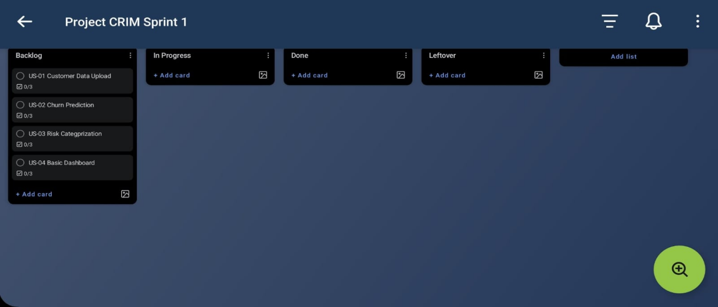

In the middle of the iteration (halfway done),
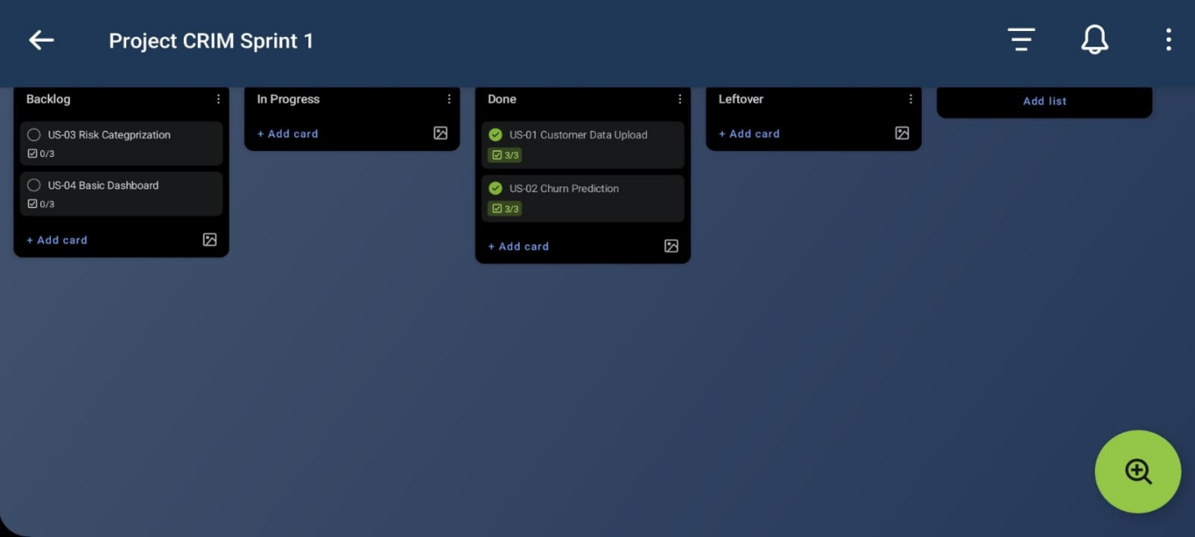
End of iteration update,
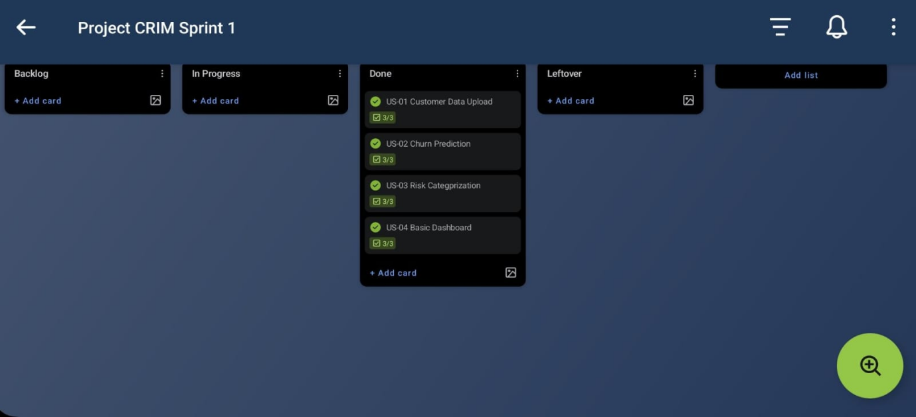

Sprint 1 - Product Burn-Down Chart
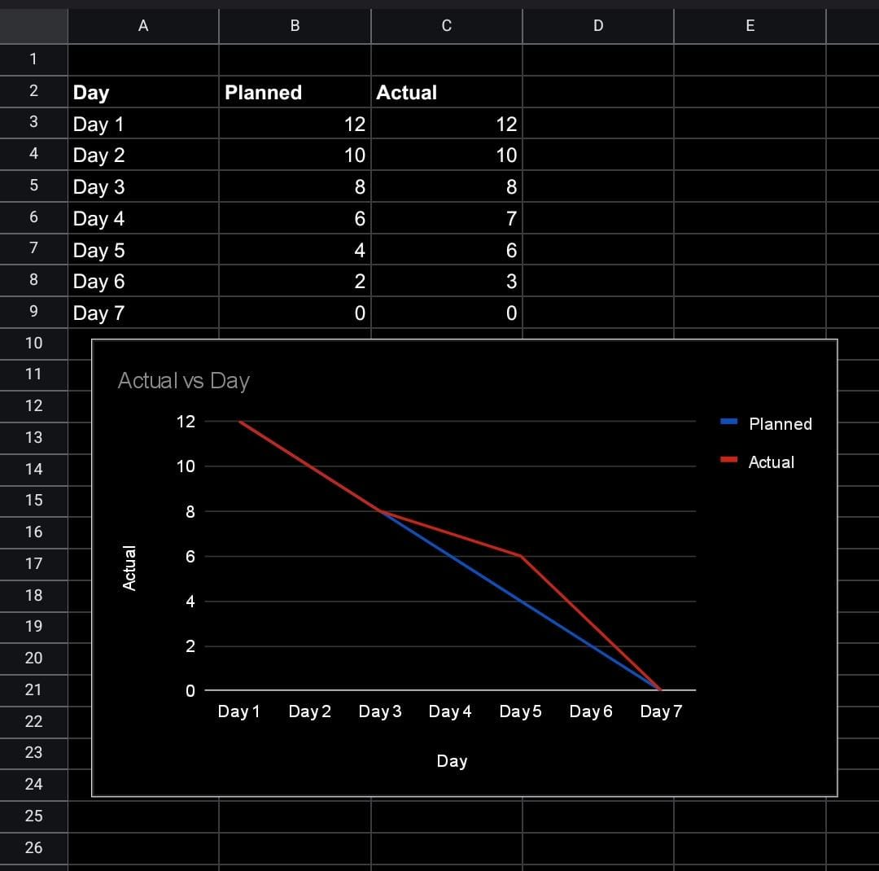

- Non Functional Requirements (NFR)
1. Performance
The system should process and return churn predictions within an acceptable time frame to ensure a smooth user experience. Upon CSV upload, the prediction pipeline must complete and return results for up to 7,000 customer records within 10 seconds on standard hardware. The dashboard must render summary cards and the customer table within 2-5 seconds of receiving the API response. Performance should remain stable across repeated uploads without requiring a server restart.
2. Usability
The system should be usable by business managers and analysts with no technical or programming background. A new user must be able to upload a dataset, view the churn dashboard, and interpret customer risk levels within 5 minutes of opening the application for the first time. The interface should clearly label all risk categories with color-coded badges, display meaningful error messages for invalid file formats, and require no manual configuration before use.
3. Reliability
The system should operate consistently without unexpected failures or data loss during normal use. The backend server must handle malformed or incomplete CSV files gracefully by returning a descriptive error message rather than crashing. The prediction pipeline must produce consistent and reproducible results, uploading the same CSV file twice must return identical predictions both times.
4. Scalability
The system should handle varying dataset sizes without significant degradation in performance. The prediction pipeline must support CSV files containing between 100 and 10,000 customer records. Processing time should scale linearly and must not exceed 30 seconds for files at the upper limit on standard hardware. The backend architecture should be modular enough to allow replacement of the machine learning model in future iterations without changes to the API layer.
5. Security
The system should handle uploaded data responsibly and prevent unauthorized access. Uploaded CSV files must be processed in memory and not permanently stored on the server after the prediction response is returned. The API must validate all incoming requests and reject files that do not conform to the expected format with an appropriate HTTP error code. Environment variables such as configuration settings must be stored in a .env file and never hardcoded in source files.
6. Maintainability
The system should be structured in a way that allows future developers to understand, modify, and extend it with minimal effort. The codebase must follow a layered architecture separating data processing, machine learning logic, and API routing into distinct modules. Each module must have a single clearly defined responsibility. The machine learning model must be replaceable by updating a single file without modifying any route or preprocessing logic. Code must follow consistent naming conventions throughout the backend and frontend.
7. Compatibility
The system should function correctly across commonly used development and deployment environments. The backend must run on any machine with Python 3.9 or above installed. The frontend must render correctly on the latest versions of Google Chrome, Microsoft Edge, and Mozilla Firefox without layout or functionality differences. The application must be fully functional on Windows 10 and above, which is the primary development environment for this project.
- Implementation Screenshots
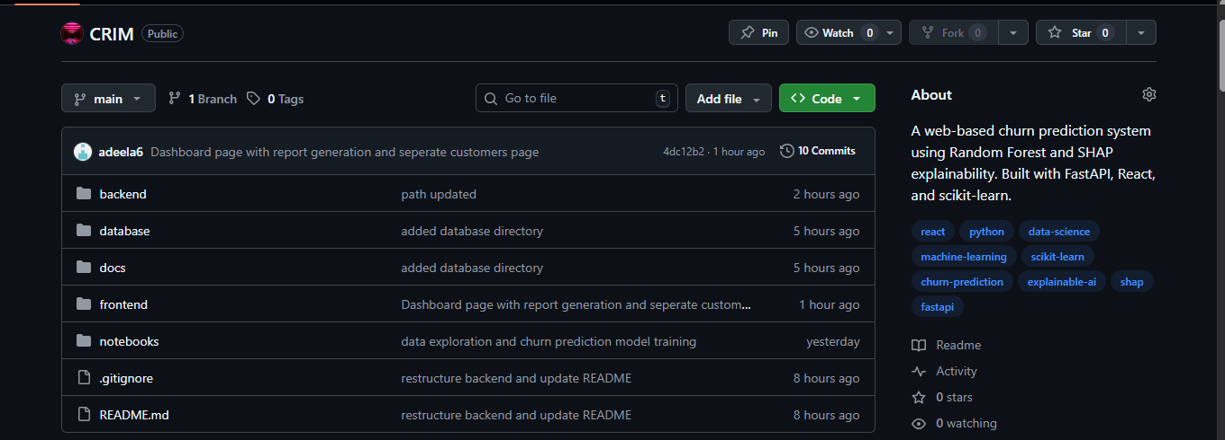
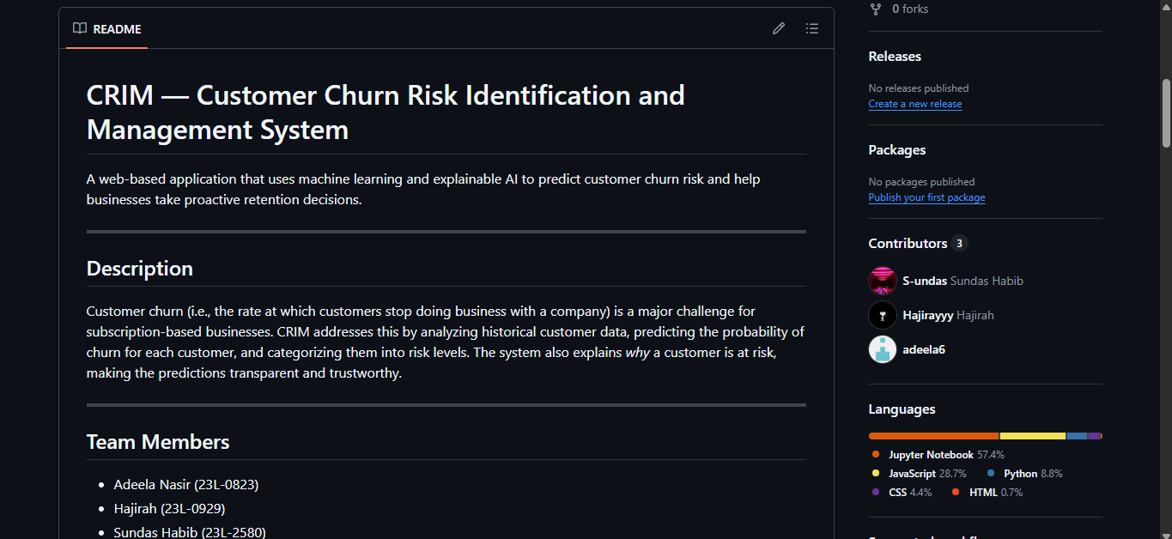
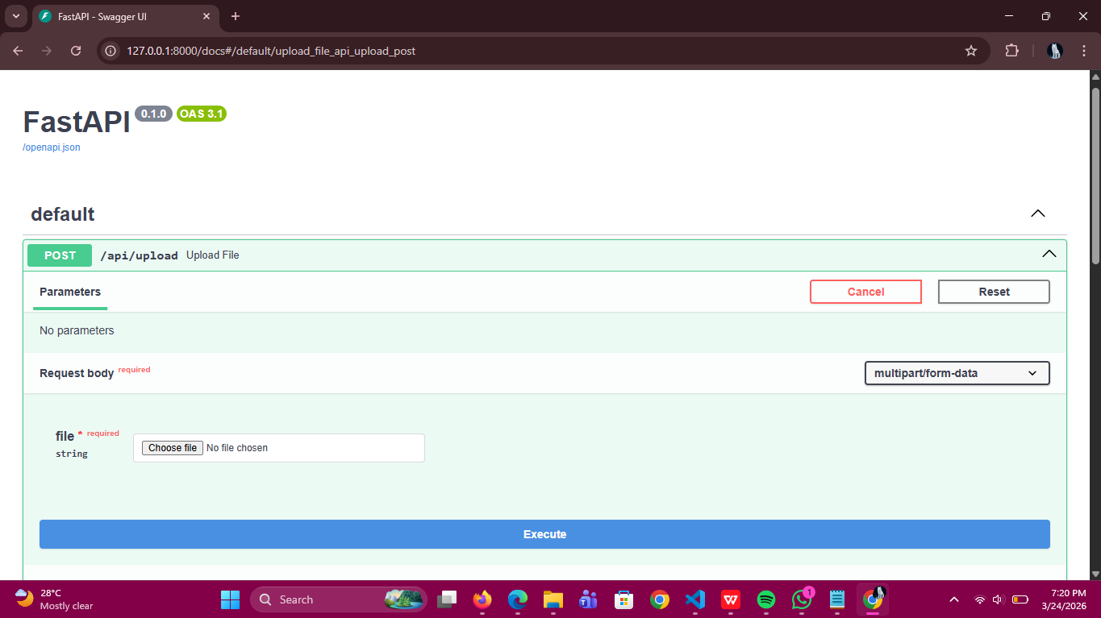
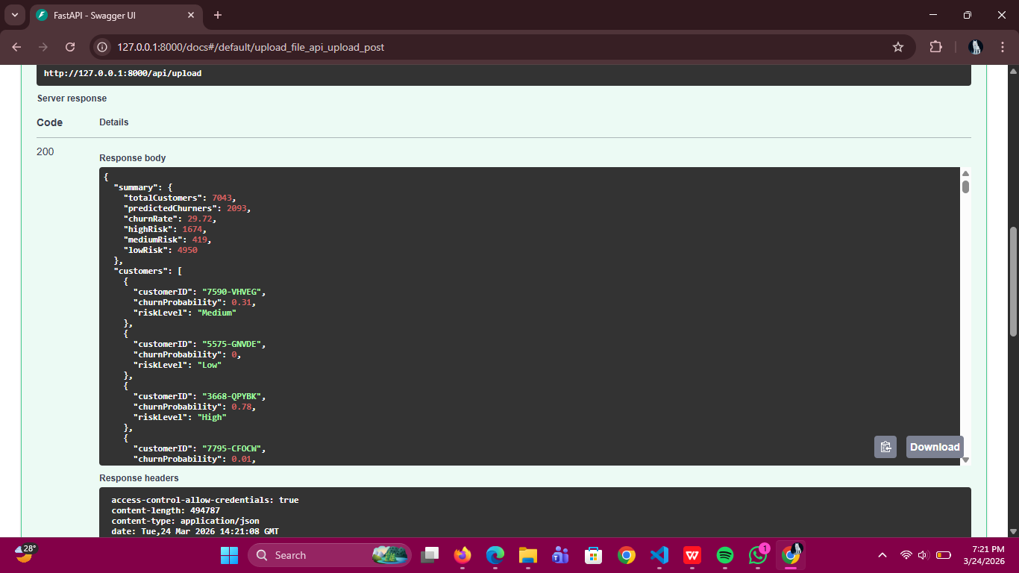
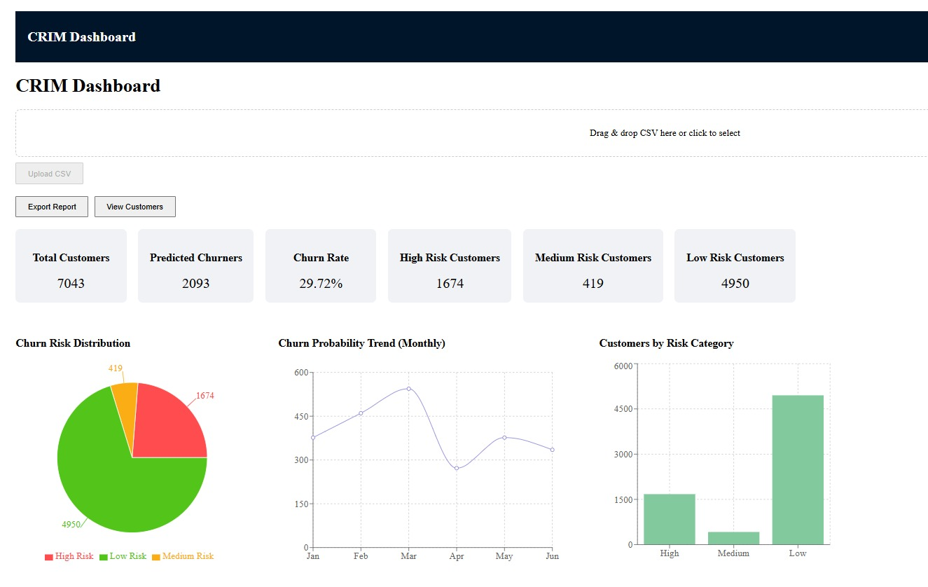
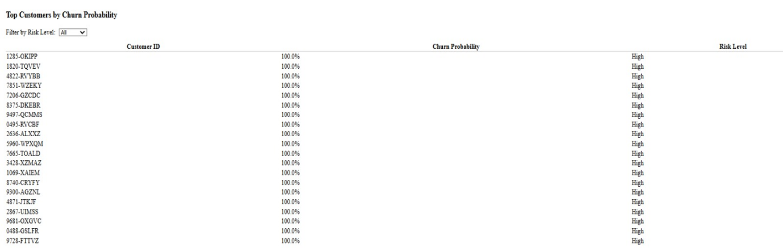

- Work Division
Name | Role | Assigned Tasks
Adeela Nasir | Project Manager & System Architect | - Sprint backlog, create user stories and sub-user stories.  - Structured specifications of user stories.  - Implement dashboard and customers pages using React on frontend.
Hajirah | Backend Developer & Integration Engineer | - Maintain the scrum board over Trello and update it throughout iteration.  - Make product burn-down chart.  - Build API layer and project structure setup.  - Document the NFR of project.
Sundas Habib | ML Engineer & Data Analyst | - Data preprocessing pipeline  - Model training and evaluation.  - Prediction logic and risk categorization.

Github Repository Link,
https://github.com/S-undas/CRIM

