Original Project Brief
The following pages reproduce the complete assessment brief supplied for the Campus One Digital Academy final project.


Original project brief page 1

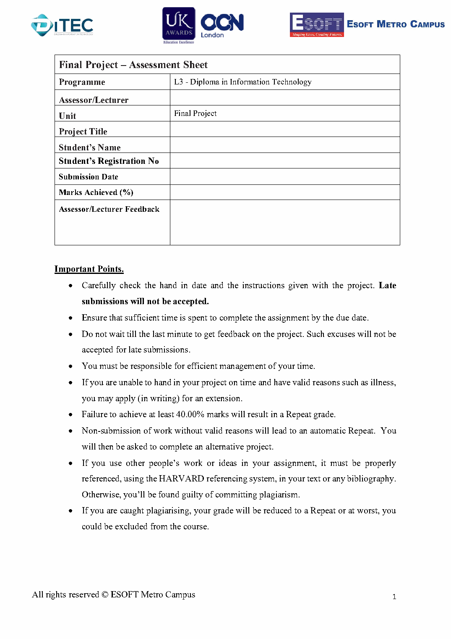
Original project brief page 2

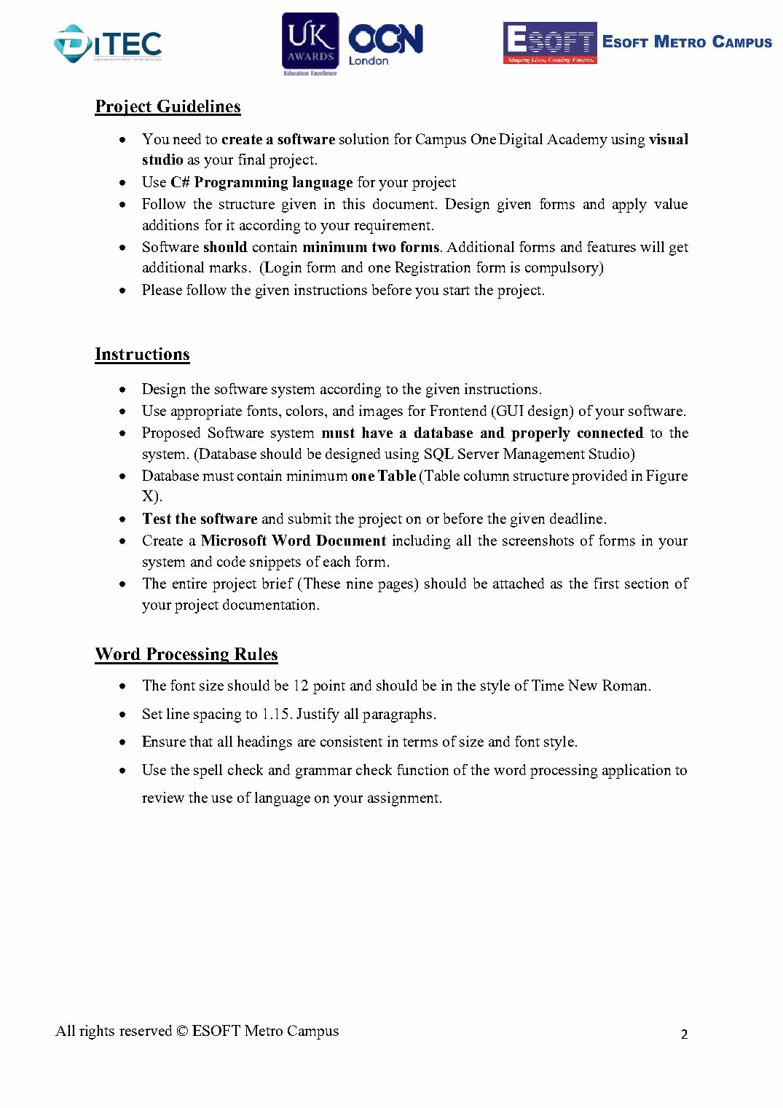
Original project brief page 3

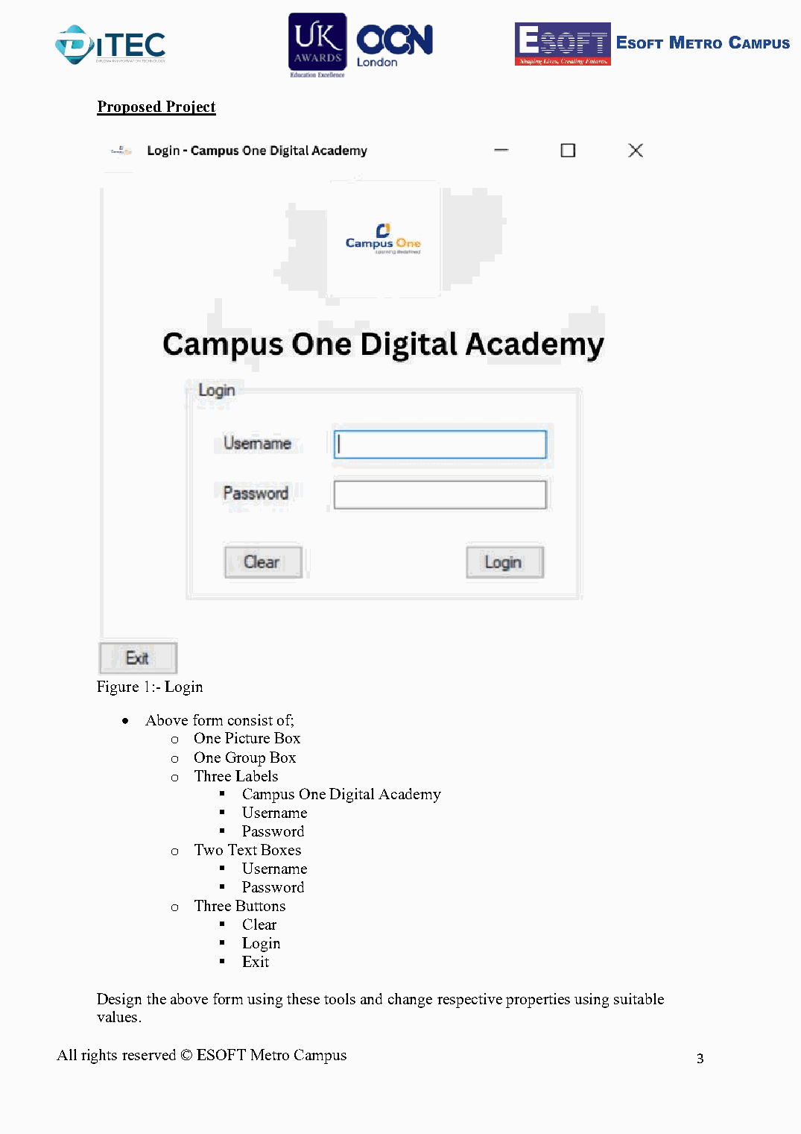
Original project brief page 4

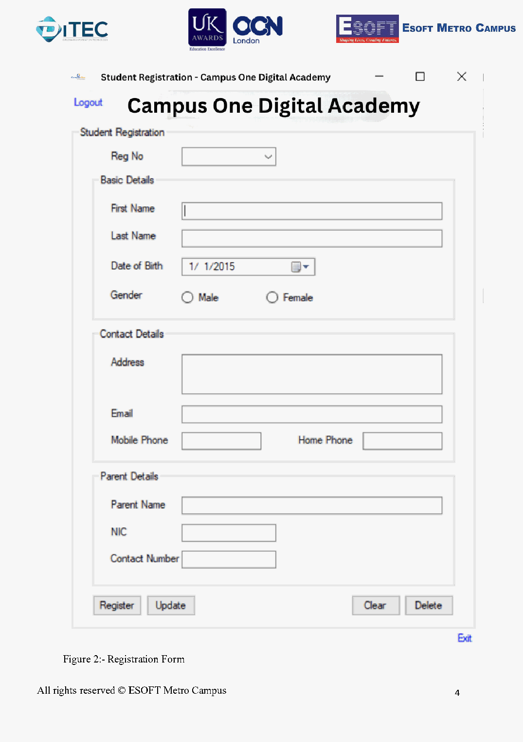
Original project brief page 5

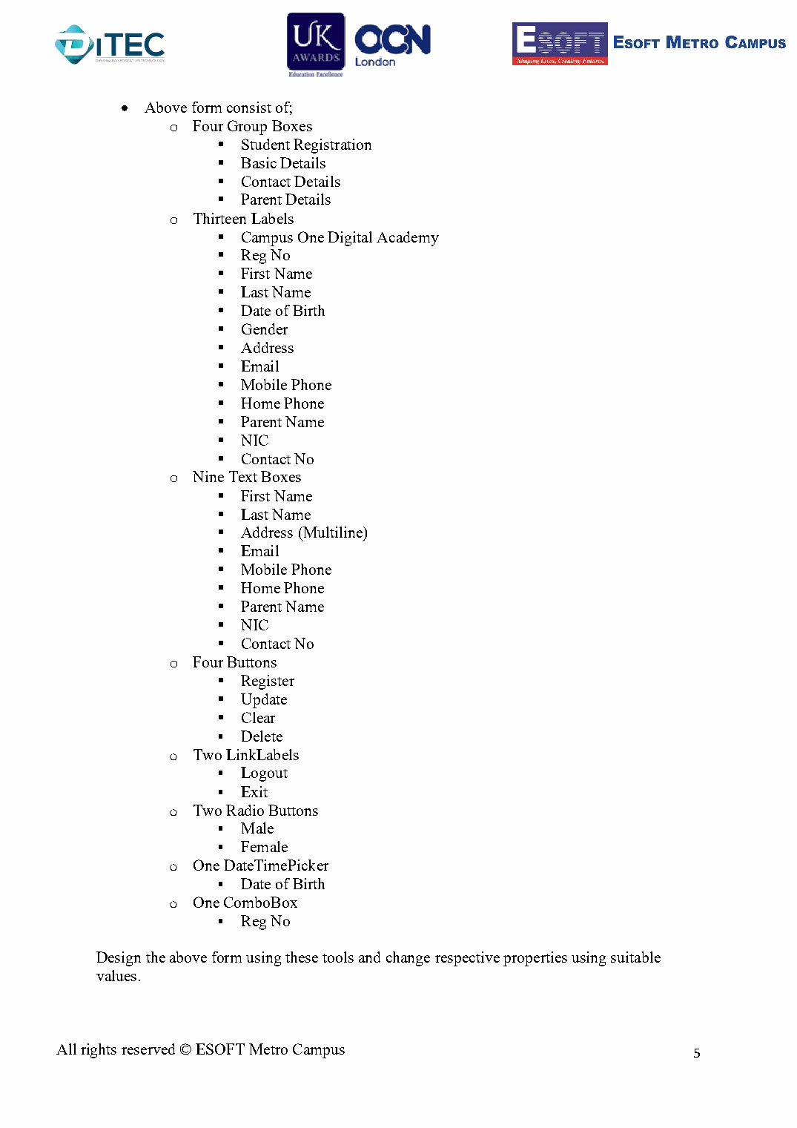
Original project brief page 6

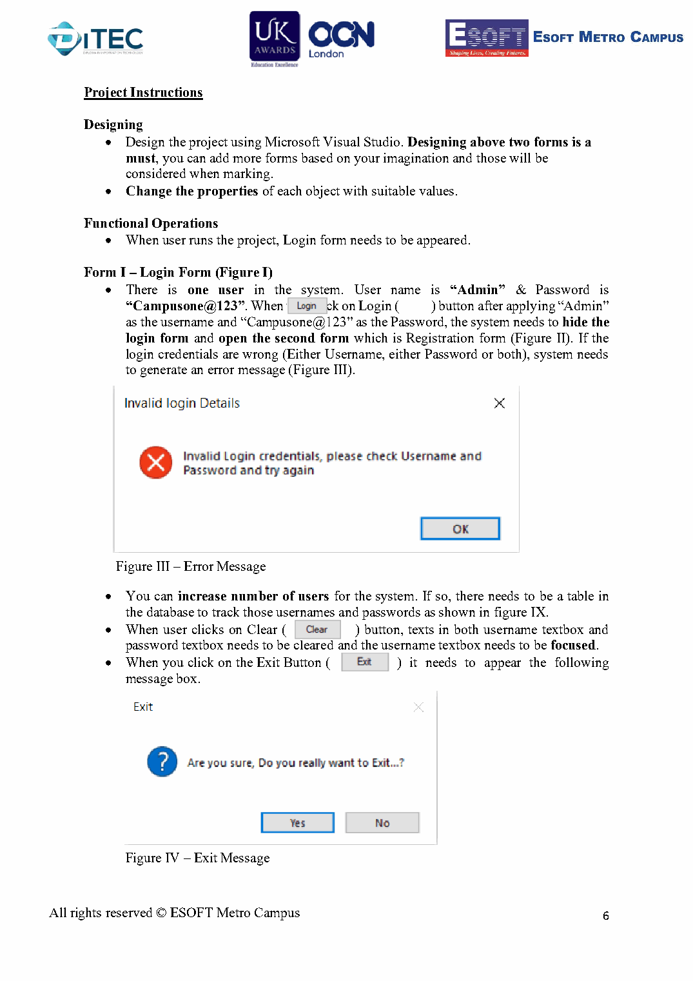
Original project brief page 7

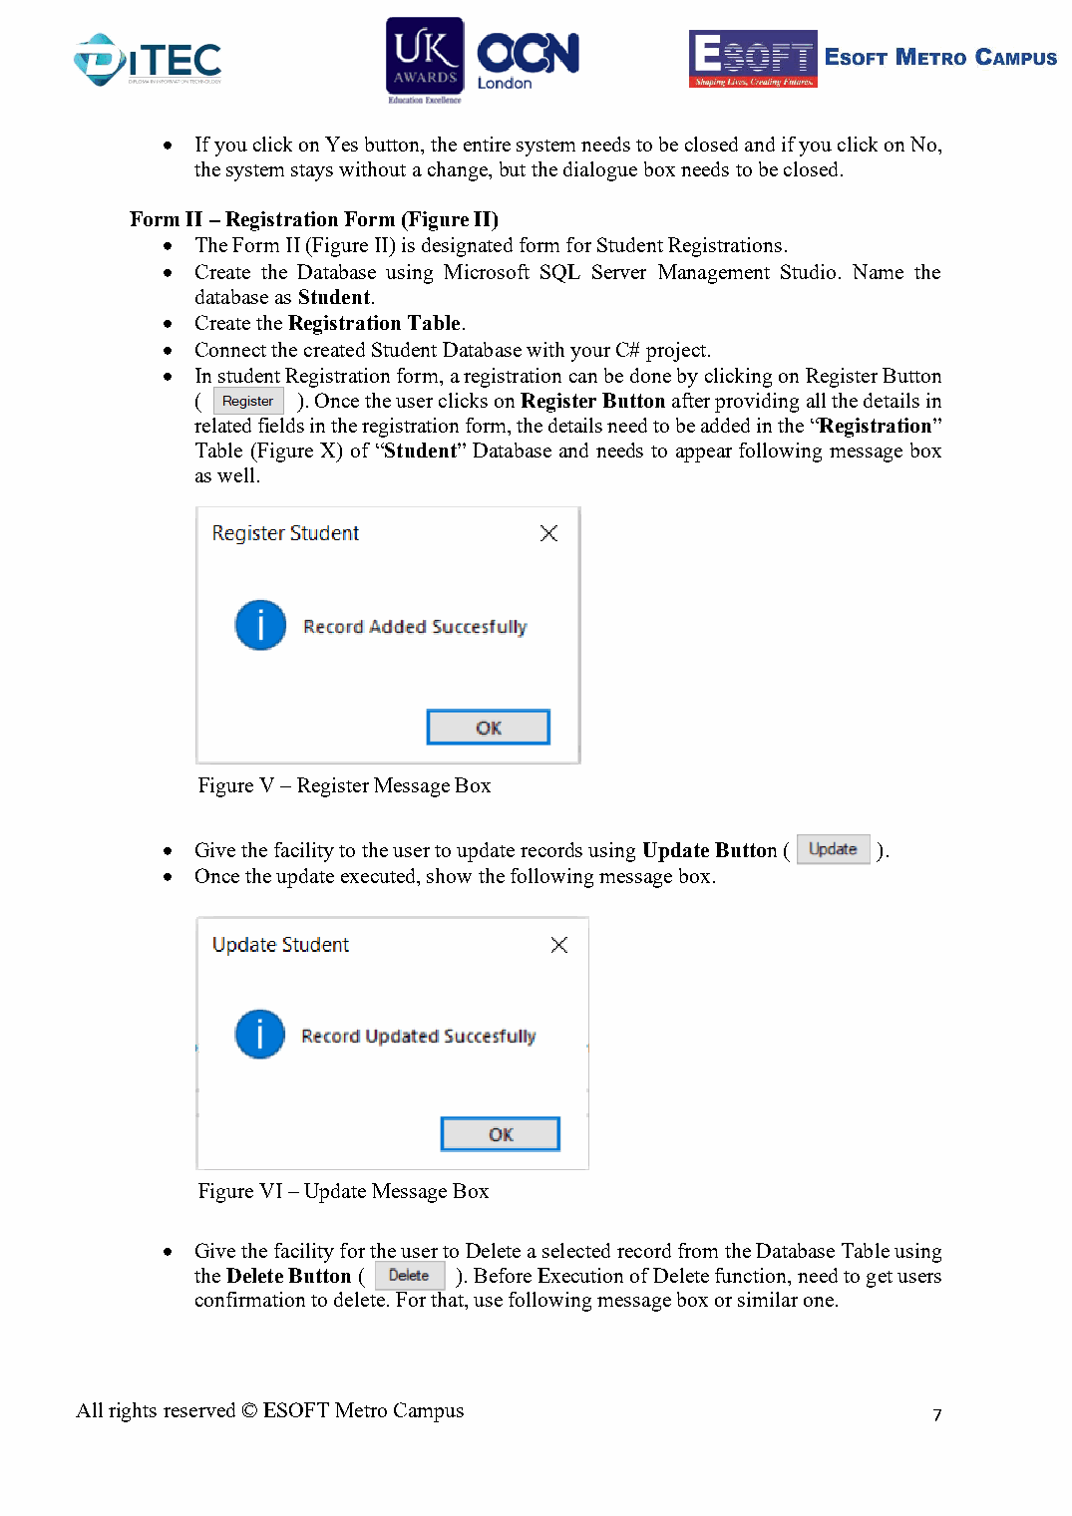
Original project brief page 8

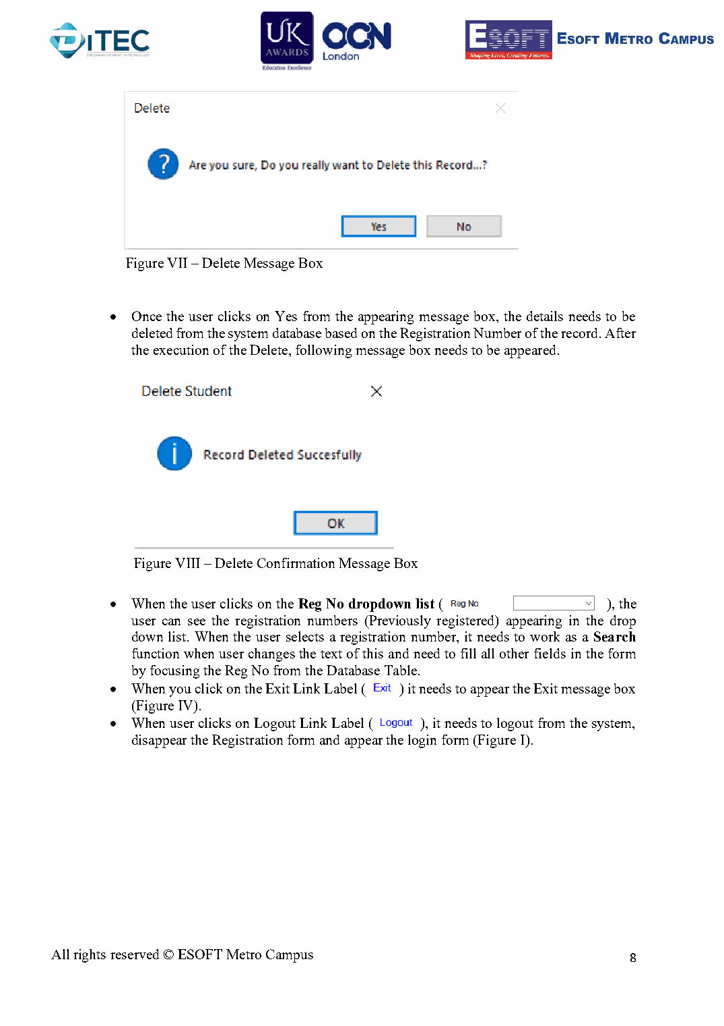
Original project brief page 9

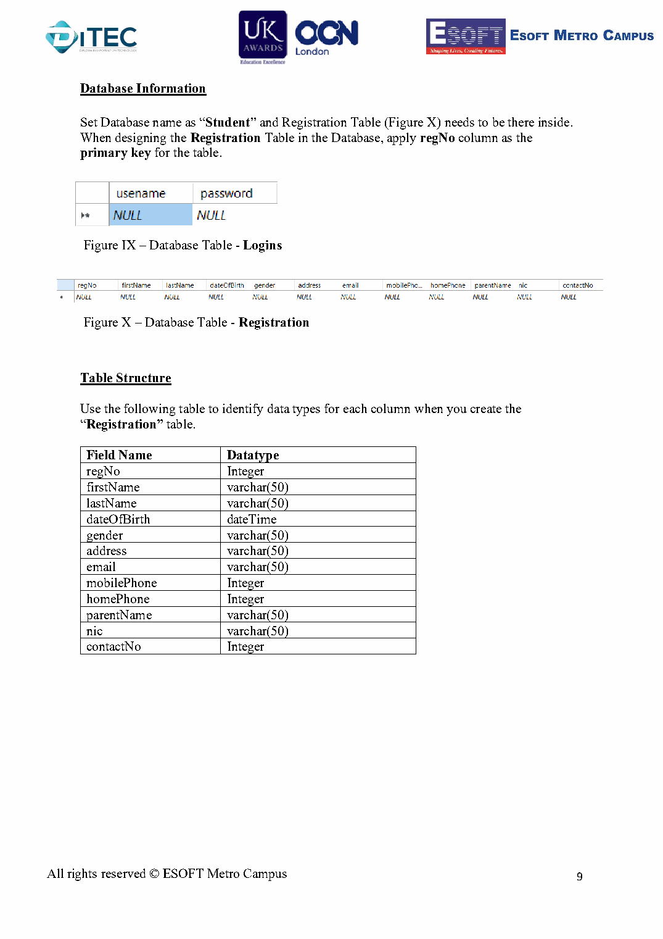
Original project brief page 10

Campus One Digital Academy Student Registration Management System
Final Project Report

Student Name: ______________________________
Student Registration Number: ______________________________
Programme: ______________________________
Submission Date: ______________________________

Contents
1 Project Overview
2 Requirements and Technology
3 System Design
4 User Interface Implementation
5 Database Design
6 Core Functionality
7 Additional Features
8 Validation and Error Handling
9 Testing
10 User Guide
11 Problems and Solutions
12 Conclusion
13 Code Evidence

1 Project Overview
This project implements a Windows desktop system for Campus One Digital Academy. It authenticates an administrator and provides facilities to register, retrieve, update and delete student records stored in Microsoft SQL Server. The completed application also includes a searchable student-records screen, summary totals, selection-based editing and CSV export.

1.1 Project Objectives
- Provide controlled access through the required Login form.
- Store student and parent information in the required Student database.
- Implement reliable Create, Read, Update and Delete operations using parameterized SQL.
- Present a clear interface that follows the supplied form structure.
- Add useful record browsing, searching, reporting and validation features.

2 Requirements and Technology
Area | Implementation
Development environment | Microsoft Visual Studio compatible solution
Language | C#
Framework | .NET 8 Windows Forms
Database | Microsoft SQL Server / SQL Server Express
Database access | ADO.NET with Microsoft.Data.SqlClient 7.0.2
Database name | Student
Main table | Registration

3 System Design
The solution uses three forms. The Login form is the entry point. Successful authentication opens the Registration form, which performs all compulsory student operations. The Student Records form is an additional screen opened from Registration and displays database records in a DataGridView.
Form | Purpose
frmLogin | Authenticates the administrator and controls application entry.
frmRegistration | Registers, retrieves, updates and deletes student records.
frmStudentRecords | Lists, searches, summarizes, exports and selects records for editing.

4 User Interface Implementation

4.1 Login Form
The Login form contains the required PictureBox, Login GroupBox, three labels, two textboxes and three buttons. The password is masked. Clear resets both fields, Login validates the supplied administrator credentials, and Exit requests confirmation.
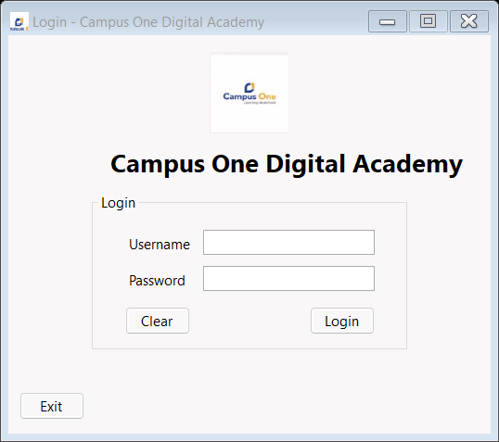
Figure 1 Login form

4.2 Student Registration Form
The Registration form contains the four required GroupBoxes and every field specified in the assessment. The enlarged layout separates labels from input controls and keeps Logout, action buttons and Exit visible.
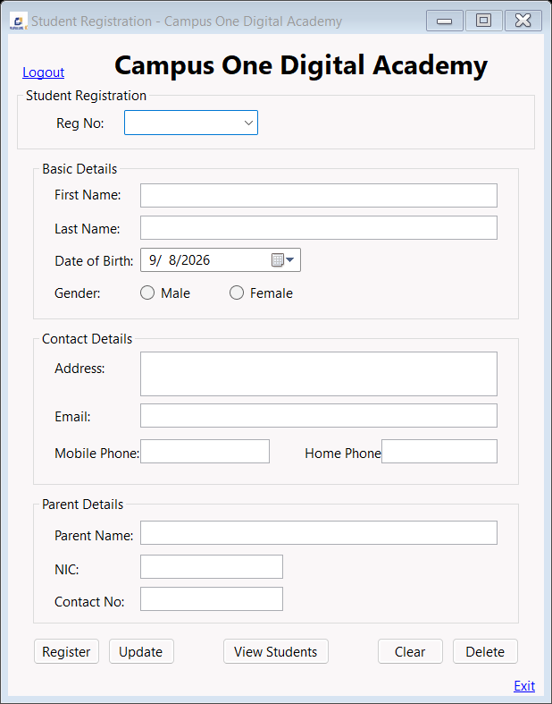
Figure 2 Student Registration form

4.3 Student Records Form
The additional Student Records form displays registered students in a read-only DataGridView. It supports live filtering, refresh, CSV export and returning the selected registration number to the Registration form for editing.
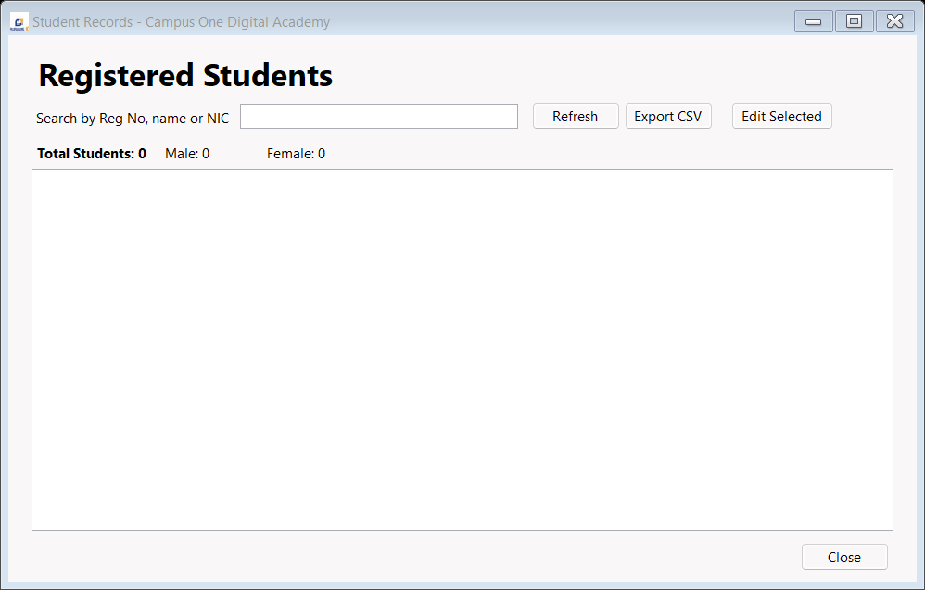
Figure 3 Student Records form

5 Database Design
The database is named Student and contains the Registration table. The registration number is the primary key. The application uses the exact field names and SQL Server types supplied in the assessment brief.
Field | SQL type | Purpose
regNo | INT PRIMARY KEY | Unique student registration number
firstName | VARCHAR(50) | Student first name
lastName | VARCHAR(50) | Student last name
dateOfBirth | DATETIME | Student date of birth
gender | VARCHAR(50) | Selected gender
address | VARCHAR(50) | Student address
email | VARCHAR(50) | Student email address
mobilePhone | INT | Student mobile number
homePhone | INT | Student home number
parentName | VARCHAR(50) | Parent or guardian name
nic | VARCHAR(50) | National identity number
contactNo | INT | Parent contact number

6 Core Functionality

6.1 Login
The application compares the entered username and password with Admin and Campusone@123. Correct credentials hide Login and open Registration. Incorrect credentials display an error.

6.2 Register
The Register operation validates every required field, checks for a duplicate registration number and inserts the record with parameters.

6.3 Search and Load
Registration numbers are loaded into the ComboBox. Selecting or entering an existing number retrieves the complete student record.

6.4 Update
Update modifies the matching database row and reports whether a record was found.

6.5 Delete
Delete requires a registration number and confirmation before removing the matching row.

6.6 Clear Logout and Exit
Clear resets fields and focus. Logout returns to Login. Exit closes the application only after confirmation.

7 Additional Features
Feature | Benefit
Student Records DataGridView | Provides a complete, sortable overview of stored students.
Live search | Filters by registration number, first name, last name or NIC while typing.
Dashboard totals | Shows total, male and female counts for the displayed records.
Edit selected record | Returns the selected registration number to the main form.
CSV export | Creates a portable spreadsheet-compatible copy of displayed records.
Window branding | Uses the supplied Campus One logo and title-bar icon.

8 Validation and Error Handling
The Registration form uses ErrorProvider messages beside invalid controls. It validates positive registration numbers, required names and addresses, email format, numeric phone fields, gender selection, NIC entry and future dates. SQL operations use exception handling and display clear database messages.

9 Testing
Test | Expected result | Status
Start application | Login form opens first | Pass
Correct login | Registration form opens | Pass
Incorrect login | Login error appears | Pass
Clear login | Credentials clear and Username receives focus | Pass
Register valid student | Record is inserted and success appears | Pass
Duplicate Reg No | Duplicate warning appears | Pass
Select Reg No | Student details populate | Pass
Update record | Matching row changes | Pass
Delete No | Record remains | Pass
Delete Yes | Record is removed | Pass
Live search | Grid filters while typing | Pass
CSV export | Displayed rows are written to CSV | Pass
Release build | Build completes with zero code warnings or errors | Pass

10 User Guide
- Start SQL Server Express and run DatabaseScript.sql in SQL Server Management Studio if the Student database has not been created.
- Run the application and log in with Username Admin and Password Campusone@123.
- Enter all student, contact and parent information, then select Register.
- Choose a registration number to retrieve a student. Change the details and select Update when required.
- Select Delete and confirm Yes to remove the selected student.
- Select View Students to search, export or choose a record for editing.
- Use Logout to return to Login and Exit to close the program safely.

11 Problems and Solutions
Problem | Solution
Registration table not found | Added an idempotent database script and startup schema check.
Labels overlapped input fields | Enlarged the form and separated label and textbox coordinates.
Logout overlapped the logo | Kept branding in the title bar and repositioned Logout.
Limited record navigation | Added a searchable DataGridView screen with selection-based editing.
Generic validation feedback | Added field-specific ErrorProvider messages and format checks.

12 Conclusion
The completed system satisfies the compulsory Login and Student Registration requirements and connects the required workflow to Microsoft SQL Server through parameterized ADO.NET commands. The additional records screen, search, summary, CSV export and detailed validation improve usability while preserving the required database structure.

13 Code Evidence

13.1 Login Form Authentication
if (username == AdminUsername && password == AdminPassword)
{
Hide();
frmRegistration registrationForm = new frmRegistration();
registrationForm.FormClosed += (s, args) => Close();
registrationForm.Show();
}
else
{
MessageBox.Show("Invalid Username or Password. Please try again.");
}

13.2 Registration Insert
string sql = @"INSERT INTO Registration
(regNo, firstName, lastName, dateOfBirth, gender, address, email,
mobilePhone, homePhone, parentName, nic, contactNo)
VALUES
(@regNo, @firstName, @lastName, @dateOfBirth, @gender, @address,
@email, @mobilePhone, @homePhone, @parentName, @nic, @contactNo)";
using SqlCommand command = new SqlCommand(sql, connection);
AddStudentParameters(command);
command.ExecuteNonQuery();

13.3 Student Records Search
SELECT regNo, firstName, lastName, dateOfBirth, gender, address,
email, mobilePhone, homePhone, parentName, nic, contactNo
FROM Registration
WHERE @search = '' OR CONVERT(VARCHAR(20), regNo) LIKE @pattern
OR firstName LIKE @pattern OR lastName LIKE @pattern OR nic LIKE @pattern
ORDER BY regNo

13.4 Database Creation
-- SQL Script to create the Student database and required Registration table.
-- Create the Student database
IF DB_ID(N'Student') IS NULL CREATE DATABASE Student;
GO
USE Student;
GO
-- Registration table: stores student registration details
IF OBJECT_ID(N'dbo.Registration', N'U') IS NULL
CREATE TABLE Registration (
regNo INT PRIMARY KEY,
firstName VARCHAR(50) NOT NULL,
lastName VARCHAR(50) NOT NULL,
dateOfBirth DATETIME NOT NULL,
gender VARCHAR(50) NOT NULL,
address VARCHAR(50) NOT NULL,
email VARCHAR(50) NOT NULL,
mobilePhone INT NOT NULL,
homePhone INT NOT NULL,
parentName VARCHAR(50) NOT NULL,
nic VARCHAR(50) NOT NULL,
contactNo INT NOT NULL
);
GO

