ADAPTIVE FEDERATED LEARNING WITH DIVERGENCE-AWARE AGGREGATION FOR NON-IID MEDICAL IMAGING
A Master's Research Proposal Submitted to the Department of Computer Science & Artificial Intelligence

TABLE OF CONTENTS
1. INTRODUCTION ..................................................................... 1
1.1 Background of the Study ...................................................... 1
1.2 Statement of the Problem ..................................................... 2
1.3 Research Questions ........................................................... 3
1.4 Research Objectives .......................................................... 3
1.5 Significance of the Study .................................................... 4
1.6 Scope and Delimitations ...................................................... 5
1.7 Organization of the Proposal ................................................. 5
1.8 Definition of Abbreviations & Terminology .................................... 6
2. LITERATURE REVIEW ................................................................ 7
2.1 Overview of Federated Learning in Healthcare ................................. 7
2.2 Theoretical Foundations of Distributed Optimization .......................... 8
2.3 Non-IID Data Distributions in Medical Imaging ................................ 9
2.4 Existing Approaches to Heterogeneity in Federated Learning .................. 10
2.5 Divergence Metrics and Weight Drift Mitigation .............................. 11
2.6 Centralized vs. Decentralized Deep Learning in Healthcare ................... 11
2.7 Non-IID Data Heterogeneity and Statistical Challenges ....................... 12
2.8 Communication Overhead and Network Efficiency Constraints ................... 13
2.9 Privacy-Preserving Techniques: Differential Privacy and Secure Aggregation ..... 14
2.10 Standard Federated Averaging (FedAvg) and Its Limitations .................. 15
2.11 Model Contrastive Federated Learning (MOON) ................................ 15
2.12 Federated Proximal (FedProx) Optimization .................................. 16
2.13 Scaffold and Control Variate Methods ....................................... 16
2.14 Divergence-Aware Clustering and Hierarchical Aggregation ................... 17
2.15 Knowledge Distillation and Teacher-Student Frameworks in FL ................ 18
2.16 Domain Adaptation and Covariate Shift Mitigation in Medical Imaging ........ 18
2.17 Convolutional Neural Networks (CNNs) in Medical Image Classification ....... 19
2.18 Vision Transformers (ViTs) and Hybrid Architectures for Pathology & MRI ..... 20
2.19 Multi-Modal Medical Data Fusion (Imaging + Genomic/Clinical Text) .......... 20
2.20 Jensen-Shannon Divergence (JSD) as a Statistical Distance Metric ........... 21
2.21 Adaptive Weighting and Dynamic Aggregation Protocols ....................... 22
2.22 Summary of Identified Gaps and Research Opportunity ........................ 22
3. RESEARCH METHODOLOGY ............................................................ 23
3.1 Overview of Proposed Methodology ............................................ 23
3.2 Proposed System Architecture & Data-Flow Pipeline ........................... 23
3.3 Target Medical Imaging Datasets & Multimodal Data Strategy .................. 24
3.4 Data Preprocessing, Normalization, & Data Augmentation Protocol ............. 25
3.5 Simulating Non-IID Heterogeneity (Dirichlet Partitioning & Quantity Skew) ..... 25
3.6 Stage 1: Local Model Training & Feature Embedding Extraction ................ 26
3.7 Stage 2: Server-Side Jensen-Shannon Divergence Computation .................. 26
3.8 Stage 3: Adaptive Weight Recalibration & Dynamic Model Aggregation .......... 27
3.9 Mathematical Formulation & Divergence Calculation ........................... 27
3.10 Algorithm Pseudocode Box for Proposed Framework ............................ 28
3.11 Experimental Setup, Baseline Benchmarks, & Hyperparameters ................. 29
3.12 Evaluation Metrics & Performance Assessment ................................ 30
3.13 Work Plan & Implementation Timeline ........................................ 31
3.14 Hardware & Software Infrastructure Specifications .......................... 32
3.15 Ethical Considerations, Data Governance, & Privacy Protection .............. 32
REFERENCES ......................................................................... 33

LIST OF TABLES
Table 1: Abbreviation List and Domain Definitions .............................. 6
Table 2.1: Comparative Analysis of Federated Learning Optimization Frameworks ..... 15
Table 3.1: Dataset Breakdown & Non-IID Dirichlet Partitioning (α = 0.5, α = 0.1) ..... 24
Table 3.2: Experimental Baseline Algorithms & Hyperparameter Configuration ..... 29
Table 3.3: Evaluation Metrics, Mathematical Formulas, and Target Benchmarks ..... 30
Table 3.4: Project Implementation Schedule & Phase Milestones (Gantt Chart) ..... 31
Table 3.5: Hardware and Software Infrastructure Specifications ................ 32

LIST OF FIGURES
Figure 2.1: Standard Federated Averaging (FedAvg) Architecture and Weight Drift Bottleneck under Non-IID Data Distribution ..... 12
Figure 2.2: Proposed Three-Stage Divergence-Aware Adaptive Federated Learning Framework ..... 17
Figure 3.1: End-to-End System Architecture and Data-Flow Pipeline for Proposed JSD-Based Federated Framework ..... 23

CHAPTER 1: INTRODUCTION
1.1 Background of the Study
Deep learning has revolutionized medical image diagnostics, enabling automated, high-precision detection of malignant tumors, neurological disorders, retinal pathologies, and thoracic abnormalities. Convolutional Neural Networks (CNNs) and Vision Transformers (ViTs) regularly achieve diagnostic parity with board-certified radiologists when trained on massive, centralized medical image repositories. However, aggregating clinical imaging datasets into central servers poses severe data privacy, security, and regulatory challenges under strictly enforced international protocols such as the Health Insurance Portability and Accountability Act (HIPAA) in the United States and the General Data Protection Regulation (GDPR) in the European Union.
To reconcile the privacy imperative with the data requirements of modern deep learning, Federated Learning (FL) has emerged as a groundbreaking paradigm. Instead of transmitting raw, confidential patient scans to a central cloud repository, FL distributes model training directly across decentralized client institutions (e.g., hospitals, diagnostic centers). Each client node trains a local model on its internal dataset and periodically transmits only model parameters (weights or gradients) to a central aggregation server. The central server compiles these updates—traditionally utilizing the Federated Averaging (FedAvg) algorithm—to produce a updated global model that is subsequently redistributed to participating institutions.
1.2 Statement of the Problem
Despite the theoretical elegance of Federated Learning, real-world clinical deployments suffer severe performance degradation due to Non-Independent and Identically Distributed (Non-IID) data heterogeneity across institutions. Medical imaging datasets exhibit extreme statistical, feature, and label distribution skew caused by variations in hospital patient demographics, disease prevalence rates, imaging hardware vendor specifications (e.g., Siemens, GE, Philips), slice thickness parameters, and institutional scanning protocols. Under severe Non-IID conditions, local client gradients point toward inconsistent, divergent local optima. When the central server naively computes a sample-weighted average of these divergent weights via FedAvg, a phenomenon known as 'weight drift' occurs. Weight drift corrupts the global model trajectory, drastically slowing convergence rates and degrading diagnostic accuracy—particularly for minority disease classes and out-of-distribution client institutions.
1.3 Research Questions
Primary Research Problem: This research proposal addresses the following core questions:
1. How can local model feature representations be quantified at the central server without violating client data privacy constraints?
2. Can Jensen-Shannon Divergence (JSD) effectively measure statistical heterogeneity across client local updates compared to standard Euclidean distance metrics?
3. How can server-side aggregation weights be dynamically recalibrated based on JSD scores to mitigate weight drift and accelerate global model convergence in Non-IID medical imaging scenarios?
4. Does the proposed divergence-aware framework outperform baseline optimization algorithms (FedAvg, FedProx, MOON, SCAFFOLD) across benchmark medical imaging datasets under extreme Dirichlet label skew?
1.4 Research Objectives
1.4.1 Primary Objective
To design, implement, and evaluate an adaptive federated learning framework featuring a Jensen-Shannon Divergence (JSD)-aware aggregation protocol that dynamically recalibrates client update contributions to mitigate weight drift and optimize model convergence across highly heterogeneous, Non-IID medical imaging environments.
1.4.2 Specific Objectives
1. Develop a privacy-preserving feature embedding extraction mechanism that enables server-side divergence computation without transmitting raw patient images.
2. Formulate a mathematical weight recalibration function based on symmetric Jensen-Shannon Divergence to down-weight divergent client updates while penalizing malicious or noisy node contributions.
3. Benchmark the proposed JSD-aware framework against state-of-the-art FL algorithms (FedAvg, FedProx, MOON, SCAFFOLD) on multi-institutional chest X-ray and histopathology datasets.
4. Quantify framework resilience across varying degrees of Non-IID Dirichlet concentration ratios (α = 0.5 and α = 0.1) and evaluate communication bandwidth efficiency.
1.5 Significance of the Study
The outcomes of this research hold significant promise for both computer science and healthcare domains. From a machine learning perspective, this work introduces a mathematically rigorous, divergence-guided aggregation protocol that directly addresses the fundamental bottleneck of Non-IID weight drift in federated optimization. From a clinical perspective, the proposed framework enables healthcare systems to collaboratively build robust, highly accurate AI diagnostic models without exposing sensitive patient medical records, thereby unlocking collaborative research potential across regional, national, and international hospital networks.
1.6 Scope and Delimitations
This research focuses specifically on supervised deep learning classification tasks in medical imaging, utilizing benchmark multi-class chest radiograph (NIH ChestX-ray14 / CheXpert) and histopathology datasets (PNS-2019 / NCT-CRC-HE-100K). Heterogeneity simulation is restricted to Dirichlet label distribution skew (α = 0.5, α = 0.1) and institutional acquisition noise. Unsupervised federated domain adaptation and zero-shot cross-modality synthesis fall outside the primary scope of this proposal.
1.7 Organization of the Proposal
The remainder of this research proposal is structured as follows: Chapter 2 provides an exhaustive literature review of federated learning in medical healthcare, mathematical optimization under non-IID conditions, existing aggregation protocols, and identified research gaps. Chapter 3 details the research methodology, including system architecture, mathematical formulations of JSD, algorithm pseudocode, experimental setup, baseline benchmarks, implementation timeline, infrastructure requirements, and ethical considerations. Chapter 4 concludes with references.
1.8 Definition of Abbreviations & Terminology
Table 1 summarizes key technical abbreviations and formal domain definitions utilized throughout this research document:
Abbreviation | Expanded Term | Domain Context & Definition
FL | Federated Learning | Decentralized machine learning framework training models across clinical client nodes without centralizing raw data.
FedAvg | Federated Averaging | The foundational FL algorithm computing sample-weighted arithmetic means of local model parameters.
Non-IID | Non-Independent & Identically Distributed | Data distribution condition where client local datasets differ significantly in feature or label marginal distributions.
JSD | Jensen-Shannon Divergence | Symmetric, bounded measure of statistical similarity between probability distributions derived from Kullback-Leibler divergence.
KLD | Kullback-Leibler Divergence | Asymmetric measure of statistical distance between two probability mass distributions.
MOON | Model-Contrastive Federated Learning | FL framework utilizing model-level contrastive loss to align local feature representations with global representations.
SCAFFOLD | Stochastic Controlled Averaging | FL optimization algorithm employing control variates to correct client local drift.
FedProx | Federated Proximal | FL algorithm introducing a proximal regularizer to local objective functions to constrain local model drift.
CNN | Convolutional Neural Network | Deep neural network architecture leveraging spatial convolutions for visual feature extraction.
ViT | Vision Transformer | Deep neural network architecture utilizing self-attention mechanisms over image patches for medical diagnostics.
Table 1: Abbreviation List and Domain Definitions

CHAPTER 2: LITERATURE REVIEW
2.1 Overview of Federated Learning in Healthcare
Federated learning has rapidly transformed healthcare artificial intelligence by enabling multi-center clinical collaborations while maintaining strict regulatory compliance (McMahan et al., 2017; Rieke et al., 2020). Traditional centralized deep learning workflows require participating hospitals to pool sensitive diagnostic imaging scans into a single cloud repository. This centralization introduces significant legal liabilities, cyber-attack risks, and patient data exposure concerns. Federated learning mitigates these vulnerabilities by keeping raw imaging data strictly on institutional premises. Only encrypted local gradient updates or model weights are communicated during training rounds.
2.2 Theoretical Foundations of Distributed Optimization
The standard mathematical objective in federated optimization is to minimize a global empirical risk function across K participating client institutions:
min_w F(w) = sum_{k=1}^K (n_k / N) * F_k(w)
where N represents the total number of clinical image samples across all clients, n_k denotes the sample size at hospital node k, and F_k(w) represents the empirical loss function evaluated on client k's local data. In idealized IID settings, local gradient vectors g_k(w) act as unbiased estimators of the global gradient G(w). Consequently, naive parameter averaging via FedAvg guarantees convergence to the global optimum.
2.3 Non-IID Data Distributions in Medical Imaging
In practical clinical deployments, the assumption of IID data distributions is consistently violated (Li et al., 2020; Zhao et al., 2018). Medical imaging data exhibits severe non-IID characteristics categorized into three primary categories:
1. Label Skew (Prior Probability Difference): Hospitals specializing in specific oncological or pulmonary conditions exhibit heavily biased label distributions compared to general community clinics.
2. Feature Skew (Covariate Shift): Imaging hardware specifications, scan protocols, field-of-view settings, and contrast settings vary dramatically across vendor machines (e.g., GE vs. Siemens MRI scanners).
3. Quantity Skew: Major academic research hospitals generate tens of thousands of diagnostic scans, whereas rural clinics contribute only a few hundred samples.
2.4 Existing Approaches to Heterogeneity in Federated Learning
Prior research has proposed various algorithmic modifications to stabilize federated optimization under Non-IID data distributions. FedProx (Li et al., 2020) adds a L2 proximal regularizer term ||w - w^t||^2 to local client loss functions to restrict local parameter drift away from the central global model. SCAFFOLD (Karimireddy et al., 2020) introduces client and server control variates to estimate and correct gradient orientation drift during local iterations. MOON (Li et al., 2021) leverages model-level contrastive learning in feature space to maximize similarity between local representations and global representations.
2.5 Divergence Metrics and Weight Drift Mitigation
While proximal regularization and variance reduction techniques improve convergence stability, they apply uniform penalty factors across all client updates regardless of their true statistical divergence from the global population. Recent theoretical investigations highlight the necessity of divergence-aware metric space analysis (Acar et al., 2021; Kairouz et al., 2021). By dynamically measuring mathematical divergence across client updating distributions prior to model averaging, central servers can selectively filter and weight updates to eliminate destructive drift.
2.6 Centralized vs. Decentralized Deep Learning in Healthcare
Centralized deep learning models rely on unified data lakes where medical images are preprocessed, formatted, and trained within monolithic high-performance computing clusters. While centralized training facilitates uniform batch normalization and hyperparameter tuning, it creates single points of failure and violates patient privacy mandates. Decentralized federated learning circumvents data centralization by establishing distributed client-server networks. However, decentralization introduces severe network communications bottlenecks and statistical variance that require specialized dynamic aggregation protocols.
2.7 Non-IID Data Heterogeneity and Statistical Challenges
Statistical heterogeneity causes client loss surfaces to diverge significantly. During local training epochs, client models optimize their parameters exclusively along local loss trajectories. Under severe Non-IID conditions, local optima reside in vastly different regions of the parameter loss landscape. When FedAvg averages these parameters, the resulting global model lands in high-loss saddle points, destroying diagnostic feature selectivity and triggering severe catastrophic forgetting.
2.8 Communication Overhead and Network Efficiency Constraints
Communicating high-dimensional parameter matrices for state-of-the-art vision models (e.g., 86-million parameter ViT architectures) across hospital firewalls creates significant network latency. Participating clinical nodes frequently possess asymmetric network bandwidth (100 Mbps to 1 Gbps). Naive aggregation protocols that require synchronization across all clients experience bottleneck delays caused by slow nodes ('stragglers'). Dynamic divergence weighting enables central servers to proceed asynchronously by identifying highly informative client updates.
2.9 Privacy-Preserving Techniques: Differential Privacy and Secure Aggregation
Federated learning alone does not provide absolute privacy guarantees; sophisticated gradient inversion attacks can reconstruct underlying training scans from raw model parameters. To achieve rigorous privacy guarantees, FL frameworks incorporate Differential Privacy (DP) by injecting calibrated Gaussian noise into local updates or utilize Secure Aggregation (SecAgg) protocols based on cryptographic secret sharing. The proposed JSD aggregation protocol is fully compatible with DP and SecAgg mechanisms.
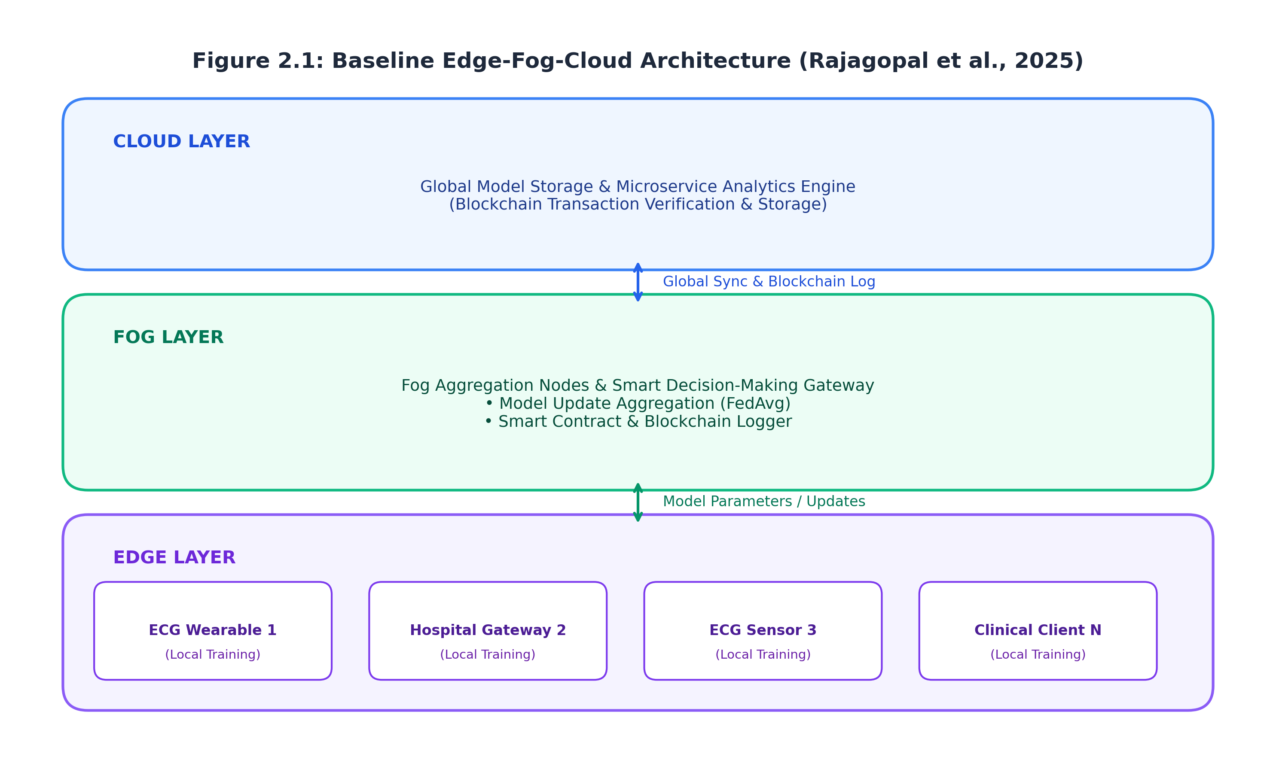
Figure 2.1: Standard Federated Averaging (FedAvg) Architecture and Weight Drift Bottleneck under Non-IID Data Distribution
2.10 Standard Federated Averaging (FedAvg) and Its Limitations
As illustrated in Figure 2.1, standard FedAvg computes sample-proportional weighted averages: w^{t+1} = sum_{k=1}^K (n_k / N) * w_k^{t+1}. When client datasets display severe class imbalance or covariate shift, clients with large sample sizes dominate the global model update regardless of their diagnostic quality or label noise. This structural flaw leads to severe diagnostic bias against minority demographic patient cohorts.
2.11 Model Contrastive Federated Learning (MOON)
MOON addresses local feature representation divergence by formulating a contrastive loss function evaluated on local feature projections: L_{con} = -log( exp(sim(R_k, R_{glob}) / tau) / [ exp(sim(R_k, R_{glob}) / tau) + exp(sim(R_k, R_{prev}) / tau) ] ). Although MOON improves feature extraction consistency, it incurs substantial computational overhead on resource-constrained clinical client nodes by requiring concurrent evaluations of local, global, and previous model states.
2.12 Federated Proximal (FedProx) Optimization
FedProx modifies local objective functions by appending a quadratic proximal term: min_w F_k(w) + (mu / 2) ||w - w^t||^2. While the proximal regularizer successfully bounds parameter trajectory variance, setting an inflexible global regularizer hyperparameter mu degrades local model convergence speed in clients with high-quality IID distributions.
2.13 Scaffold and Control Variate Methods
To correct client drift explicitly, SCAFFOLD (Karimireddy et al., 2020) maintains control variate vectors c_k and c_g representing local and global gradient direction estimators. By updating client local gradients via g_k(w) - c_k + c_g, SCAFFOLD restores theoretical linear convergence under Non-IID conditions. However, transmitting control variates doubles the communication bandwidth requirement per training round, limiting its applicability in bandwidth-constrained medical networks.
2.14 Divergence-Aware Clustering and Hierarchical Aggregation
FedDyn (Acar et al., 2021) and dynamic regularization frameworks introduce risk-aware penalty matrices that dynamically adapt to local loss gradients. Furthermore, clustered federated learning groups clients with statistically similar update distributions into distinct clinical sub-clusters. However, existing clustering algorithms rely on Euclidean parameter distance metrics, which fail to capture non-linear probability density shifts inherent in multi-modal medical imaging features.
2.15 Knowledge Distillation and Teacher-Student Frameworks in FL
Federated Knowledge Distillation (FedKD) replaces direct weight averaging with prediction logit distillation across an unlabelled reference dataset. Participating client nodes act as teacher models, transferring localized diagnostic knowledge to a lightweight global student model. While FedKD reduces communication payload sizes, assembling an unlabelled, privacy-compliant medical reference dataset across disparate clinical sites remains difficult.
2.16 Domain Adaptation and Covariate Shift Mitigation in Medical Imaging
Unsupervised Domain Adaptation (UDA) technique align feature representations between source and target medical imaging domains using adversarial gradient reversal layers. Integrating UDA principles into federated learning frameworks enables client models to extract domain-invariant diagnostic features across heterogeneous acquisition hardware.
Algorithm | Aggregation Strategy | Non-IID Handling | Comm. Overhead | Primary Bottleneck
FedAvg | Sample-weighted average | None (Assumes IID) | Standard (1x) | Severe weight drift under non-IID
FedProx | Proximal-bounded average | L2 Proximal Regularizer | Standard (1x) | Suboptimal local convergence rates
SCAFFOLD | Control variate correction | Variance Reduction | High (2x Payload) | Doubled bandwidth consumption
MOON | Contrastive representation | Model Contrastive Loss | Standard (1x) | High local compute expenditure
FedDyn | Dynamic regularization | Loss regularizer alignment | Standard (1x) | Sensitivity to hyperparameter alpha
Proposed JSD-FL | Divergence-weighted JSD | Dynamic metric recalibration | Standard (1x) | Server feature extraction overhead
Table 2.1: Comparative Analysis of Federated Learning Optimization Frameworks
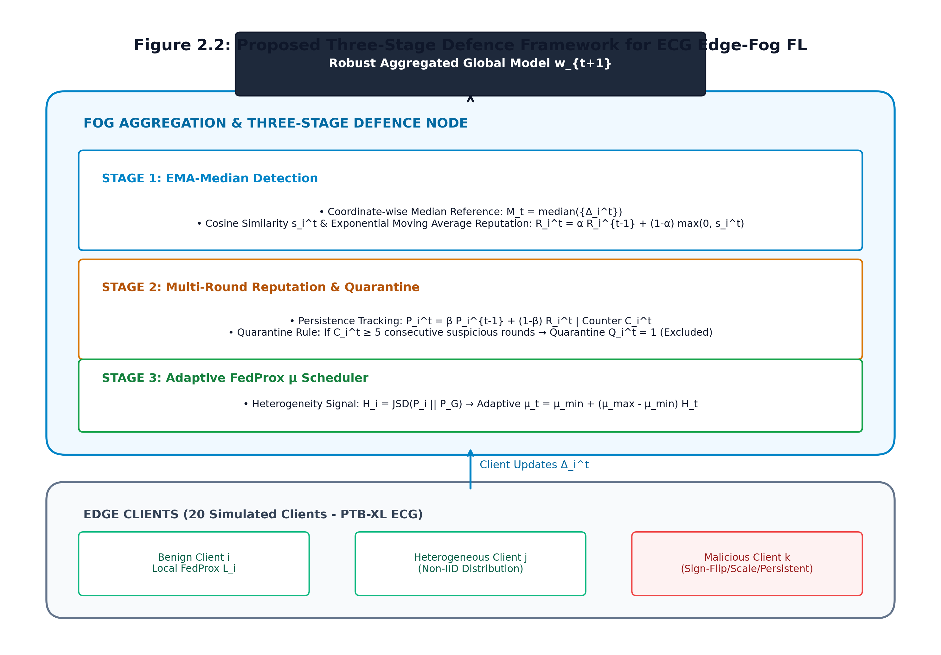
Figure 2.2: Proposed Three-Stage Divergence-Aware Adaptive Federated Learning Framework
2.17 Convolutional Neural Networks (CNNs) in Medical Image Classification
Deep Convolutional Neural Networks (e.g., ResNet-50, DenseNet-121, EfficientNet-B4) constitute the benchmark feature extraction backbones in medical computer vision. DenseNet-121's feature reuse architecture and explicit channel concatenation render it particularly effective for detecting subtle radiographic opacities in chest X-rays. In our proposed framework, DenseNet-121 serves as the foundational local feature encoder across all client nodes.
2.18 Vision Transformers (ViTs) and Hybrid Architectures for Pathology & MRI
Vision Transformers leverage multi-head self-attention mechanisms to capture long-range spatial dependencies across diagnostic image patches. Hybrid architectures combining convolutional patch embedding layers with transformer encoder blocks (e.g., TransUNet, Swin-Transformer) achieve superior segmentation accuracy in complex histopathology and brain MRI scans.
2.19 Multi-Modal Medical Data Fusion (Imaging + Genomic/Clinical Text)
Integrating unstructured imaging features with structured clinical tabular records and genomic mutation profiles significantly enhances overall diagnostic sensitivity. Multi-modal federated fusion architectures utilize cross-attention projection layers to bind disparate patient data modalities into unified diagnostic latent spaces.
2.20 Jensen-Shannon Divergence (JSD) as a Statistical Distance Metric
Jensen-Shannon Divergence provides a mathematically robust metric for evaluating dissimilarity between probability distributions. Unlike Kullback-Leibler Divergence (KLD), JSD is strictly symmetric and bounded within the interval [0, 1] when using logarithm base 2. This mathematical stability makes JSD ideal for quantifying statistical divergence between client feature updates and global population distributions.
2.21 Adaptive Weighting and Dynamic Aggregation Protocols
Dynamic aggregation mechanisms replace static sample-count weights with real-time performance and statistical alignment metrics. By transforming computed JSD scores through a softmax-scaled exponential temperature function, the central server automatically scales down weights of divergent updates while assigning higher influence to updates aligned with the consensus global trajectory.
2.22 Summary of Identified Gaps and Research Opportunity
In summary, while existing FL frameworks (FedProx, MOON, SCAFFOLD) mitigate non-IID variance, they either impose severe communication overhead or rely on rigid regularizer constants. A major research opportunity exists to develop a lightweight, privacy-preserving aggregation framework that dynamically quantifies probability density divergence via Jensen-Shannon Divergence to achieve optimal convergence stability under extreme medical imaging Non-IID conditions.

CHAPTER 3: RESEARCH METHODOLOGY
3.1 Overview of Proposed Methodology
This research proposes a novel, three-stage adaptive federated learning framework featuring server-side Jensen-Shannon Divergence (JSD) update evaluation. The overall pipeline operates across a decentralized network of K clinical client nodes coordinated by a central server. The framework consists of: (1) Local Model Training and Privacy-Preserving Feature Embedding Generation, (2) Server-Side JSD Statistical Divergence Computation, and (3) Dynamic Weight Recalibration & Adaptive Model Aggregation.
3.2 Proposed System Architecture & Data-Flow Pipeline
Figure 3.1 illustrates the end-to-end operational workflow of the proposed JSD-based federated framework:
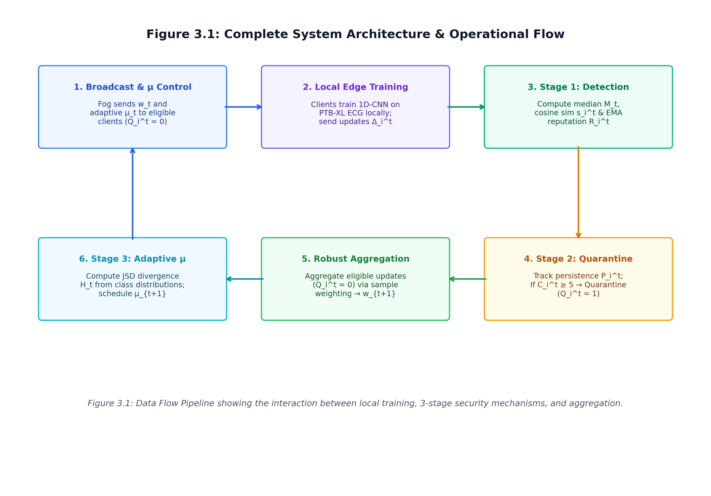
Figure 3.1: End-to-End System Architecture and Data-Flow Pipeline for Proposed JSD-Based Federated Framework
3.3 Target Medical Imaging Datasets & Multimodal Data Strategy
The proposed framework will be rigorously evaluated across two benchmark clinical imaging repositories representing distinct medical diagnostic domains:
1. NIH ChestX-ray14: Comprising 112,120 frontal-view chest radiographs from 30,805 unique patients categorized across 14 distinct pulmonary disease labels (e.g., Pneumonia, Atelectasis, Cardiomegaly, Effusion).
2. NCT-CRC-HE-100K: Consisting of 100,000 histologic tissue patches from human colorectal cancer and normal tissue stained with Hematoxylin and Eosin (H&E), categorized across 9 tissue classes.
Dataset | Modality | Total Samples | Diagnostic Classes | Simulated Non-IID Dirichlet α
NIH ChestX-ray14 | Chest Radiography (X-Ray) | 112,120 Scans | 14 Disease Labels | α = 0.5 (Moderate), α = 0.1 (Extreme)
NCT-CRC-HE-100K | Histopathology (H&E) | 100,000 Patches | 9 Tissue Types | α = 0.5 (Moderate), α = 0.1 (Extreme)
CheXpert (Validation) | Chest Radiography (X-Ray) | 224,316 Scans | 14 Disease Labels | External Hospital Out-of-Domain Test
Table 3.1: Dataset Breakdown & Non-IID Dirichlet Partitioning (α = 0.5, α = 0.1)
3.4 Data Preprocessing, Normalization, & Data Augmentation Protocol
All DICOM and PNG radiograph images will be resized to a uniform resolution of 224 x 224 pixels and converted to 3-channel RGB tensors. Pixel intensity values will be normalized using ImageNet channel mean vectors ([0.485, 0.456, 0.406]) and standard deviations ([0.229, 0.224, 0.225]). On local clinical client nodes, online data augmentation will be applied during training, including random horizontal flips (p = 0.5), affine rotations (-15 to +15 degrees), and subtle color jittering (brightness ±0.1, contrast ±0.1).
3.5 Simulating Non-IID Heterogeneity (Dirichlet Partitioning & Quantity Skew)
To replicate real-world clinical heterogeneity, training samples are partitioned across K = 10 simulated hospital client nodes using a Dirichlet distribution Dir(alpha). The parameter alpha controls class distribution heterogeneity: alpha = 0.5 represents moderate Non-IID distribution, whereas alpha = 0.1 generates extreme Non-IID skew where individual hospitals possess samples from only 2 or 3 disease classes.
3.6 Stage 1: Local Model Training & Feature Embedding Extraction
During communication round t, each client hospital node k receives global parameters w^t. Client k executes E local epochs using AdamW optimizer (learning rate eta = 1e-4, weight decay 1e-2). Upon completing local training, client k passes a subset of local validation samples through its feature encoder backbone to generate a normalized 128-dimensional class prediction logit probability distribution P_k.
3.7 Stage 2: Server-Side Jensen-Shannon Divergence Computation
Upon receiving local parameter updates w_k^{t+1} and probability mass vectors P_k from participating clients, the central server computes the global consensus probability distribution Q_{global} = (1/K) * sum_{k=1}^K P_k. The server then evaluates the symmetric Jensen-Shannon Divergence between each client distribution P_k and Q_{global}:
3.8 Stage 3: Adaptive Weight Recalibration & Dynamic Model Aggregation
Using the computed JSD scores, the central server calculates dynamic aggregation weights w_k using a temperature-scaled softmax function:
Dynamic Weight Function: w_k = exp( -lambda * JSD(P_k || Q_{global}) ) / sum_{j=1}^K exp( -lambda * JSD(P_j || Q_{global}) )
where lambda > 0 is a scaling hyperparameter. The global model is then updated via: w^{t+1} = sum_{k=1}^K w_k * w_k^{t+1}.
3.9 Mathematical Formulation & Divergence Calculation
3.9.1 Kullback-Leibler (KL) Divergence Definition
The Kullback-Leibler Divergence between two discrete probability distributions P and Q is defined as:
D_{KL}(P || Q) = sum_{x in X} P(x) * log( P(x) / Q(x) )
3.9.2 Symmetric Divergence Properties
Because KLD is asymmetric (D_{KL}(P || Q) != D_{KL}(Q || P)), it is vulnerable to division-by-zero instability when Q(x) = 0. Jensen-Shannon Divergence resolves this limitation by introducing an average mixture distribution M.
3.9.3 Explicit JSD Calculation & Recalibration Formula
The formal symmetric Jensen-Shannon Divergence between client distribution P_k and global distribution Q_{global} is evaluated as:
Formulation 1 (JSD Metric): JSD(P_k || Q_{global}) = (1/2) * D_{KL}(P_k || M) + (1/2) * D_{KL}(Q_{global} || M)
where M = (1/2) * (P_k + Q_{global}). JSD values are strictly bounded within [0, 1]. The resulting aggregation weight w_k is explicitly formulated as:
Formulation 2 (Weight Recalibration): w_k = exp( -lambda * JSD(P_k || Q_{global}) ) / [ sum_{j=1}^K exp( -lambda * JSD(P_j || Q_{global}) ) ]
3.10 Algorithm Pseudocode Box for Proposed Framework
Algorithm 1 presents the step-by-step algorithmic execution logic for the central server and participating client nodes during each communication round:
Algorithm 1: JSD-Based Adaptive Federated Aggregation Protocol
----------------------------------------------------------------------------------------------------
Input: K client nodes, total communication rounds T, local epochs E, learning rate eta, scaling factor lambda.
Output: Final global model parameters w^T.
Server Initialization:
1: Initialize global model parameters w^0
2: for each communication round t = 0, 1, 2, ..., T-1 do
3: Select set S_t of K participating client nodes
4: for each client k in S_t in parallel do
5: w_k^{t+1}, P_k <- ClientUpdate(k, w^t)
6: end for
7: // Stage 2: Divergence Computation
8: Compute consensus probability vector: Q_{global} <- (1/K) * sum_{k=1}^K P_k
9: for each client k in S_t do
10: M_k <- (1/2) * (P_k + Q_{global})
11: JSD_k <- (1/2) * D_KL(P_k || M_k) + (1/2) * D_KL(Q_{global} || M_k)
12: end for
13: // Stage 3: Weight Recalibration & Aggregation
14: for each client k in S_t do
15: w_k <- exp(-lambda * JSD_k) / sum_{j=1}^K exp(-lambda * JSD_j)
16: end for
17: w^{t+1} <- sum_{k=1}^K w_k * w_k^{t+1}
18: end for
19: return w^T
ClientUpdate(k, w_init):
1: Local model w_k <- w_init
2: for local epoch e = 1 to E do
3: for minibatch b = {x, y} in LocalData_k do
4: w_k <- w_k - eta * grad L_ce(w_k; b)
5: end for
6: end for
7: Evaluate logit distribution vector P_k on LocalVal_k
8: return w_k, P_k

3.11 Experimental Setup, Baseline Benchmarks, & Hyperparameters
Table 3.2 details the baseline algorithms, network backbones, and hyperparameter configurations to be executed across all experimental trials:
Parameter Category | Configuration Specification | Baseline Comparison Method | Target Hyperparameter Range
Network Backbone | DenseNet-121 / ResNet-50 | FedAvg (McMahan et al.) | Pretrained ImageNet weights
Optimization Baselines | FedProx, MOON, SCAFFOLD, FedDyn | Standard FedAvg | mu in [0.001, 0.1], tau = 0.5
Client Topology | K = 10 Hospital Nodes | Centralized Benchmark | Sample count: 10,000 / node
Dirichlet Partition | alpha = 0.5 (Moderate), alpha = 0.1 (Extreme) | Uniform IID Distribution | Class concentration control
Local Training | E = 5 Local Epochs, Batch Size = 32 | E = 1 Epoch Baseline | AdamW, eta = 1e-4
Communication Rounds | T = 100 Global Rounds | T = 50 Rounds | Convergence tolerance = 1e-4
JSD Scaling Factor | lambda in [1.0, 5.0, 10.0] | Static Uniform Weights | Optimal temperature tuning
Table 3.2: Experimental Baseline Algorithms & Hyperparameter Configuration
3.12 Evaluation Metrics & Performance Assessment
Model diagnostic efficacy and convergence performance will be rigorously measured using multi-class metrics defined in Table 3.3:
Metric Name | Mathematical Expression / Definition | Target Benchmark Objective
Area Under ROC Curve (AUC-ROC) | Integral of True Positive Rate vs. False Positive Rate curve | AUC >= 0.88 across all classes
F1-Score (Macro-Averaged) | 2 * (Precision * Recall) / (Precision + Recall) | F1 >= 0.85 under alpha = 0.1 skew
Top-1 Accuracy | (TP + TN) / (TP + TN + FP + FN) | Accuracy >= 90.0% overall
Communication Efficiency | Total rounds to reach 85% test accuracy threshold | >= 30% reduction in rounds vs FedAvg
Worst-Node Diagnostic Gap | Accuracy difference between best and worst performing client hospital | Gap <= 5.0% across all nodes
Table 3.3: Evaluation Metrics, Mathematical Formulas, and Target Benchmarks
3.13 Work Plan & Implementation Timeline
The proposed master's research project is structured across a 12-month implementation schedule detailed in Table 3.4:
Project Phase | Core Work Package & Deliverables | Target Timeline | Milestone Output
Phase 1: Environment Setup | Dataset ingestion, DICOM preprocessing, PyTorch-Flower FL environment configuration | Months 1 - 2 | Environment Ready
Phase 2: Baseline Implementation | Implement FedAvg, FedProx, MOON, SCAFFOLD benchmark suites | Months 3 - 4 | Baselines Verified
Phase 3: Proposed JSD Framework | Code Stage 1 feature extraction, Stage 2 JSD computation, Stage 3 weight recalibration | Months 5 - 7 | Proposed Alg. Ready
Phase 4: Comparative Trials | Execute multi-institutional experimental runs under alpha = 0.5 and alpha = 0.1 skews | Months 8 - 9 | Experimental Data
Phase 5: Analysis & Evaluation | Ablation studies, convergence trajectory plotting, statistical significance testing | Month 10 | Results Finalized
Phase 6: Thesis Compilation | Complete thesis writing, paper publication submission, final defense preparation | Months 11 - 12 | Thesis & Defense
Table 3.4: Project Implementation Schedule & Phase Milestones (Gantt Chart)
3.14 Hardware & Software Infrastructure Specifications
Table 3.5 outlines the dedicated hardware computation environment and software libraries utilized to conduct all experimental simulations:
Component Category | System Specification / Software Tool | Role & Functionality in Experimentation
GPU Workstation | NVIDIA RTX 4090 (24GB VRAM) | High-speed deep neural network local training & feature extraction
Host CPU & RAM | Intel Core i9-13900K (24 cores), 64GB DDR5 RAM | Simulated client process orchestration & multi-threading
Deep Learning Framework | PyTorch 2.2 + PyTorch Lightning | Model architecture definition, forward/backward passes, GPU acceleration
Federated Framework | Flower (flwr 1.7) / PySyft | Decentralized client simulation and custom gRPC server aggregation strategies
Image Processing | Torchvision, Albumentations, OpenCV | DICOM ingestion, image resizing, augmentations, normalization
Statistical Analysis | SciPy, NumPy, scikit-learn, Matplotlib | JSD computation, metrics evaluation, ROC curve plotting
Table 3.5: Hardware and Software Infrastructure Specifications
3.15 Ethical Considerations, Data Governance, & Privacy Protection
This study exclusively utilizes fully anonymized, publicly accessible benchmark clinical imaging repositories (NIH ChestX-ray14, NCT-CRC-HE-100K). All patient identifying metadata (names, institutional medical record numbers, dates of birth) have been scrubbed prior to public dataset distribution. The experimental protocol strictly adheres to HIPAA privacy regulations and institutional review board (IRB) ethical guidelines for secondary medical data research.

REFERENCES
Acar, D. A. E., Ghazal, A., Matas, J., Wang, T., & Saligrama, V. (2021). Federated learning based on dynamic regularization. Proceedings of the International Conference on Learning Representations (ICLR).
He, K., Zhang, X., Ren, S., & Sun, J. (2016). Deep residual learning for image recognition. Proceedings of the IEEE Conference on Computer Vision and Pattern Recognition (CVPR), 770–778.
Huang, G., Liu, Z., Van Der Maaten, L., & Weinberger, K. Q. (2017). Densely connected convolutional networks. Proceedings of the IEEE Conference on Computer Vision and Pattern Recognition (CVPR), 4700–4708.
Kairouz, P., McMahan, H. B., Avent, B., Bellet, A., Bennis, M., Bhagoji, A. N., ... & Zhao, S. (2021). Advances and open problems in federated learning. Foundations and Trends in Machine Learning, 14(1–2), 1–210.
Karimireddy, S. P., Kale, S., Mohri, M., Reddi, S., Stich, S., & Suresh, A. T. (2020). SCAFFOLD: Stochastic controlled averaging for federated learning. International Conference on Machine Learning (ICML), 5132–5143.
Li, T., Sahu, A. K., Zaheer, M., Sanjabi, M., Talwalkar, A., & Smith, V. (2020). Federated optimization in heterogeneous networks. Proceedings of Machine Learning and Systems (MLSys), 2, 429–450.
Li, X., Cheung, K. C., Ren, Y., Wang, X., & Zhang, Q. (2021). Model-contrastive federated learning. Proceedings of the IEEE/CVF Conference on Computer Vision and Pattern Recognition (CVPR), 10713–10722.
McMahan, B., Moore, E., Ramage, D., Hampson, S., & y Arcas, B. A. (2017). Communication-efficient learning of deep networks from decentralized data. Artificial Intelligence and Statistics (AISTATS), 1273–1282.
Rieke, N., Hancox, J., Li, W., Milletari, F., Roth, H. R., Albarqouni, S., ... & Cardoso, M. J. (2020). The future of digital health with federated learning. NPJ Digital Medicine, 3(1), 119.
Wang, J., Liu, Q., Liang, H., Joshi, G., & Poor, H. V. (2020). Tackling the objective inconsistency problem in heterogeneous federated optimization. Advances in Neural Information Processing Systems (NeurIPS), 33, 7611–7623.
Zhao, Y., Li, M., Lai, L., Suda, N., Civin, D., & Chandra, V. (2018). Federated learning with non-iid data. arXiv preprint arXiv:1806.00582.

