**Mobile Application Development Course Project**

PURRRFECT PAIR

**Final Report**

Hajra Mujahid-251707426

Momina Binte Asad-251694202



**Department of Computer Science  
Forman Christian College University  
Lahore, Pakistan**

Table Of Contents

**ABSTRACT** 2

**INTRODUCTION** 3

**PROBLEM STATEMENT** 3

**Unmet Needs and Issues faced in Society:** 4

**Significance and Impact:** 4

**Target Audience:** 4

**LITERATURE REVIEW** 4

**PROJECT OBJECTIVE** 5

**Primary Goals:** 6

**Proposed Solution:** 6

**Final Project Output:** 6

**DESIGN** 7

**UI /Figma Prototype** 7

**SYSTEM ARCHITECTURE** 16

**Client-Server Architecture** 16

**Components** 16

**Development Tools:** 16

**Data Flow** 16

**DATABASE DESIGN** 18

**Testing** 19

**Conclusion** 21

# **ABSTRACT**

In today's era of technological advancement, the "Purrrfect Pair" mobile application emerges as a visionary solution to enhance the relationship between pet owners and their beloved companions. This proposal outlines the application's mission to revolutionize pet socialization, simplify mating processes, and promote responsible ownership. Through innovative features and cutting-edge algorithms, it aims to create a vibrant community where pet enthusiasts can connect seamlessly. By addressing the challenges of limited socialization opportunities, complex mating processes, and inadequate emphasis on responsible ownership, the application strives to improve the well-being of both pets and their owners. Leveraging advanced matching algorithms and agile development methodologies, "Purrrfect Pair" seeks to redefine the pet ownership experience, fostering enduring relationships and a sense of belonging within the pet community.

# **INTRODUCTION**

In an age where technology has revolutionized the way we connect with one another, it's time to extend these advancements to our beloved animal companions. "Purrrfect Pair" – a visionary mobile application that will change the way people socialize with their pets. With a mission to cultivate meaningful interactions and lasting relationships among pets and their owners, Purrrfect Pair represents the next evolution in pet-related platforms.

At its core, Purrrfect Pair serves as a medium for pets and their owners, to go beyond traditional boundaries to create a vibrant community of like-minded pet enthusiasts. Through innovative features and cutting-edge algorithms, the platform empowers pet owners to connect with others who share their passion for animal companionship. Whether seeking playdates, potential mates, or enduring friendships, Purrrfect Pair offers a seamless and personalized experience tailored to the unique needs and preferences of each pet.

By harnessing the power of advanced profiling and matchmaking technologies, Purrrfect Pair ensures that introductions between pets are not only effortless but also harmonious. Owners can take comfort in knowing that their pets are interacting with individuals who share compatible temperaments, fostering enduring relationships built on mutual understanding and companionship.

Furthermore, Purrrfect Pair goes beyond mere matchmaking, fostering a sense of community and inclusivity among pet owners. Through shared experiences, support networks, and opportunities for engagement, the platform cultivates a thriving ecosystem where pets and their owners can thrive together.

# **PROBLEM STATEMENT**

The "Purrrfect Pair" application aims to address several unmet needs and issues within the pet owner community, focusing on enhancing pet socialization, simplifying pet mating processes, and promoting responsible pet ownership. The significance of these problems is substantial, impacting both pet owners and their animals, as well as the broader pet community. The estimated impact of addressing these issues is significant, leading to improved well-being for pets and their owners, increased community engagement, and a more streamlined approach to pet care and socialization.

## **Unmet Needs and Issues faced in Society:**

1. **Limited Socialization Opportunities:** Many pet owners face challenges in finding suitable opportunities for their pets to socialize and interact with other animals. Traditional methods of arranging playdates or social gatherings can be time-consuming and may not always result in successful matches.
2. **Complex Pet Mating Processes:** The process of finding suitable mates for pets can be cumbersome and complicated, requiring pet owners to navigate through various third-party services and platforms. This process often involves significant time, effort, and financial investment.
3. **Lack of Emphasis on Responsible Pet Ownership:** While pet ownership brings joy and companionship, it also entails significant responsibilities, including proper care, vaccination, and adherence to local regulations. Many pet owners may lack access to comprehensive resources and guidance on responsible pet ownership.

## **Significance and Impact:**

1. **Enhanced Pet Well-being:** By providing a platform for pet socialization and facilitating meaningful interactions between animals, the application can contribute to improved mental and emotional well-being for pets, reducing feelings of isolation and loneliness.
2. **Simplified Pet Mating:** Streamlining the process of finding compatible mates for pets can alleviate stress and frustration for pet owners, leading to more successful breeding outcomes and healthier offspring.
3. **Promotion of Responsible Pet Ownership:** Byoffering educational resources, guidance on proper pet care, and tools for monitoring pet health, the application can empower pet owners to make informed decisions and ensure the well-being of their animals.

## **Target Audience:**

* Pet Owners
* Breeders
* Pet Service Providers
* Animal Welfare Organizations

# **LITERATURE REVIEW**

Existing attempts to address the challenges of pet socialization, mating processes, and responsible pet ownership have led to the development of various market solutions. These solutions encompass a range of platforms and services designed to facilitate interactions between pet owners, simplify mating processes, and provide resources for responsible pet care. However, these solutions also have their limitations, which highlight the need for innovative approaches.

Research by Wells (2019) highlights the influence of changes in pet population and husbandry on human attitudes towards pet cats. While existing socialization platforms like "Meet My Dog" and "Tindog" have emerged to facilitate pet interactions, they primarily focus on dogs and lack comprehensive features for other pet species (Wells, 2019). Additionally, these platforms may not adequately address the specific needs and preferences of pet owners, limiting their effectiveness in promoting meaningful connections among diverse pet communities.

Clark et al. (2016) conducted a study on the socialization practices of owners of adult shelter dogs, shedding light on the challenges faced by pet owners in finding suitable mates for their animals. While services like "Breedr" and "Pawfect Match" offer platforms for pet mating, they often lack robust matching algorithms and may not adequately verify the authenticity of pet profiles (Clark et al., 2016). This can result in mismatches, unreliable breeding outcomes, and potential risks to pet health and welfare.

The study by Murray et al. (2010) on the attitudes and behaviors of pet owners towards responsible pet ownership highlights the importance of educational resources and support systems. While platforms like "PetMD" and "Petfinder" offer valuable information on pet care and adoption, they may lack personalized guidance and interactive features tailored to individual pet owners' needs (Murray et al., 2010). Moreover, accessibility barriers such as language limitations or digital literacy may hinder certain pet owners' ability to benefit from these resources fully.

While existing market solutions provide valuable resources and platforms for pet owners, they often face limitations such as:

1. Lack of inclusivity and diversity in pet species and communities.
2. Insufficient verification and screening processes for pet profiles, leading to unreliable matches.
3. Limited personalization and interactivity, hindering user engagement and satisfaction.
4. Accessibility barriers that exclude certain segments of pet owners from accessing and benefiting from available resources.

While existing market solutions have made strides in addressing the challenges of pet socialization, mating, and responsible ownership, they still face significant limitations. The "Purrrfect Pair" aims to overcome these limitations by offering a comprehensive, inclusive, and innovative platform that caters to the diverse needs and preferences of pet owners, breeders, and service providers. By leveraging advanced algorithms, user-centric design, and educational resources, the project seeks to redefine pet socialization and ownership experiences, fostering meaningful connections and promoting the well-being of pets and their owners.

# **PROJECT OBJECTIVE**

The "Purrrfect Pair" project aims to revolutionize the way pet owners connect and interact with each other and their pets. With a focus on enhancing pet socialization, simplifying mating processes, and promoting responsible pet ownership, the project seeks to create a digital sanctuary for pets and their owners.

The scope of the project encompasses the development of a mobile application that serves as a dedicated platform for the pet community. The primary goals of the project are as follows:

## **Primary Goals:**

* **Creating a Digital Community:** The app seeks to establish a vibrant and inclusive digital environment where pet owners can connect, interact, and build meaningful relationships with fellow pet enthusiasts. By providing a dedicated platform for pet-related discussions, events, and interactions, "Purrrfect Pair" aims to unite pet owners from diverse backgrounds and interests.
* **Facilitate Pet Socialization**: The app endeavors to facilitate pet-to-pet interactions and playdates, enriching the social lives of animals while providing entertainment and companionship. By offering features for scheduling playdates, organizing pet events, and creating virtual play spaces, "Purrrfect Pair" promotes active engagement and socialization among pets within the community.
* **Simplify Pet Mating Processes**: The app aims to simplify the process of pet mating by eliminating the need for pet owners to navigate through third-party services, often accompanied by cumbersome procedures and costs. Through advanced matching algorithms and streamlined communication tools, the project facilitates seamless connections between compatible pets for mating purposes.
* **Promote Responsible Pet Ownership:** The application is committed to encouraging responsible pet ownership by emphasizing the importance of proper pet care, vaccinations, and adherence to local regulations. Through educational resources, health monitoring tools, and community outreach initiatives, the project aims to empower pet owners with the knowledge and support necessary to provide optimal care for their animals.

## **Proposed Solution:**

The proposed solution, the "Purrrfect Pair" mobile application, stands out from existing alternatives through several key features:

* **Comprehensive Platform**: Unlike existing solutions that may focus solely on pet socialization or mating, the "Purrrfect Pair" app offers a holistic platform that caters to multiple aspects of pet ownership. By providing a one-stop destination for pet-related needs, the app enhances user convenience and satisfaction.
* **Inclusivity and Diversity:** Unlike some existing platforms that may be limited to specific pet species or communities, the "Purrrfect Pair" app welcomes pets of all species, breeds, and backgrounds. By promoting inclusivity and diversity within the pet community, the app fosters a sense of belonging and camaraderie among users.

## **Final Project Output:**

* **Mobile Application:** The core deliverable is a fully functional mobile application available for both iOS and Android devices. The app provides users with access to a range of features and functionalities, including pet profile creation, matchmaking algorithms, messaging and communication tools, event organization capabilities, and a directory of pet services.
* **Packaging and Components:** The mobile application will be packaged and distributed through respective app stores, accompanied by comprehensive documentation, user guides, and tutorials. Additionally, the app will include a user-friendly interface with intuitive navigation and personalized recommendations to enhance user experience.
* **Key Components:** Key components of the app include pet profile creation, advanced matching algorithms, messaging and communication features, event organization tools, a pet service directory, and privacy settings. By integrating these components seamlessly, the app offers users a comprehensive and engaging pet ownership experience.

# **DESIGN**

## **UI /Figma Prototype**

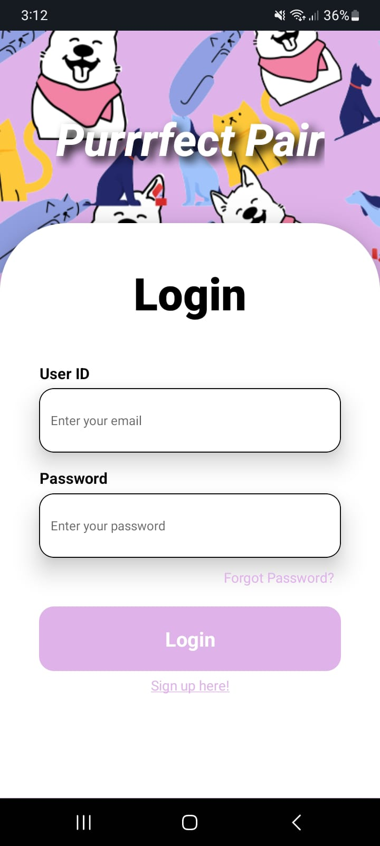 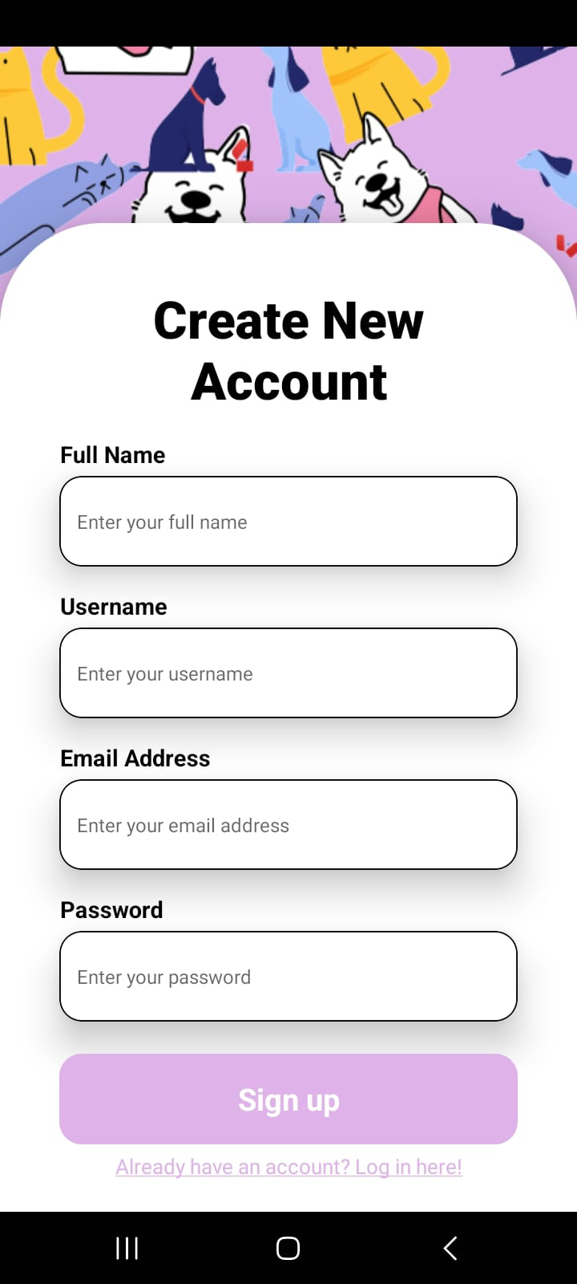

**LOGIN SCREEN SIGNUP SCREEN**

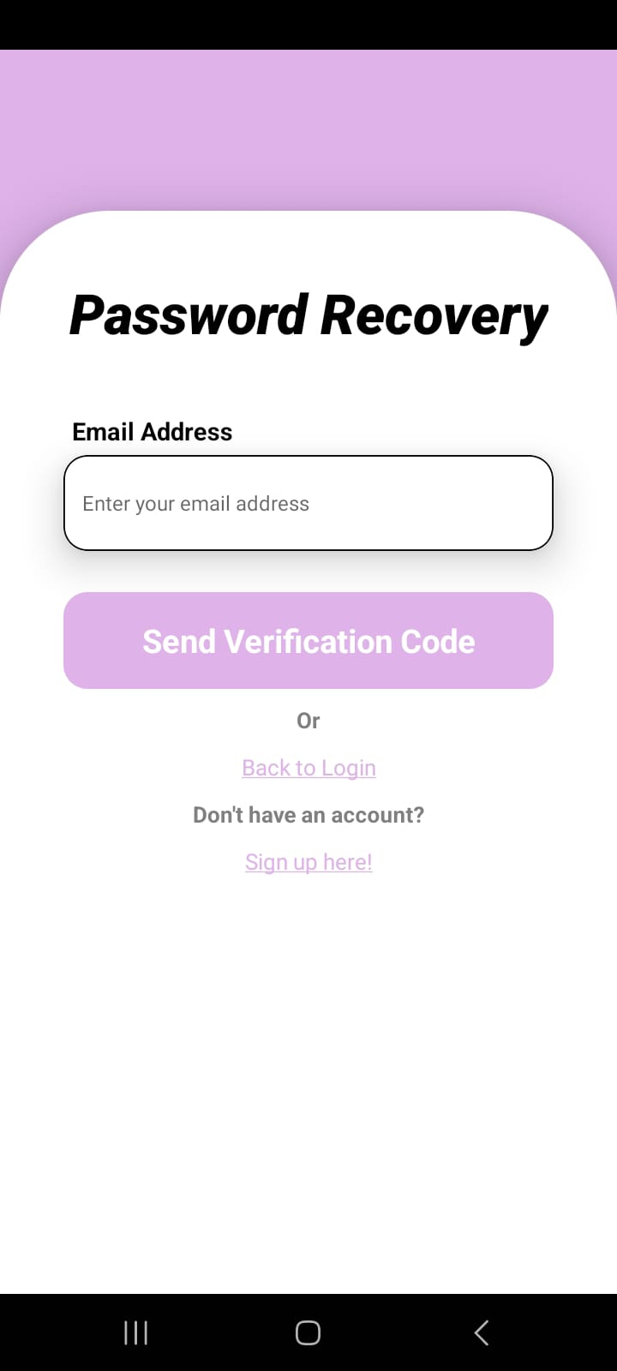 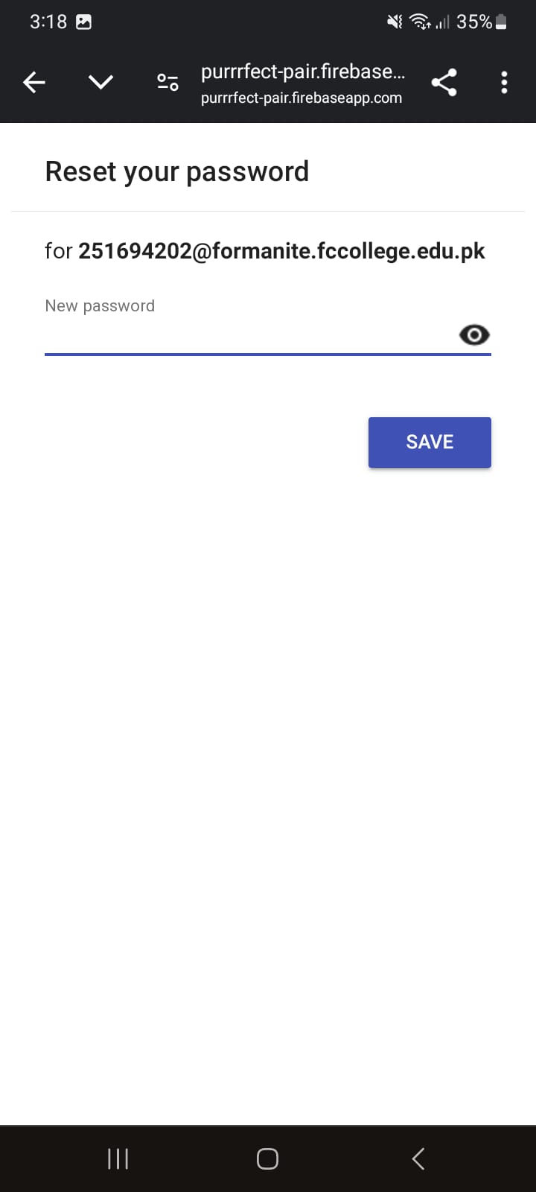

**PASSWORD RECOVERY**

**RESET PASSWORD**

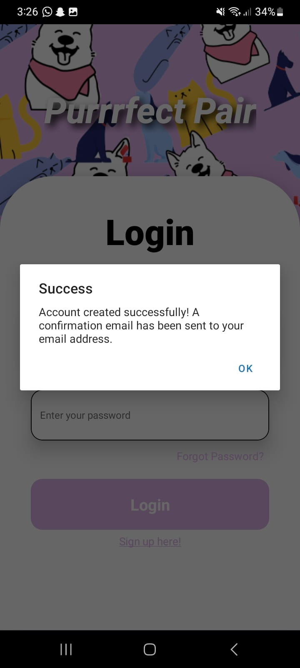 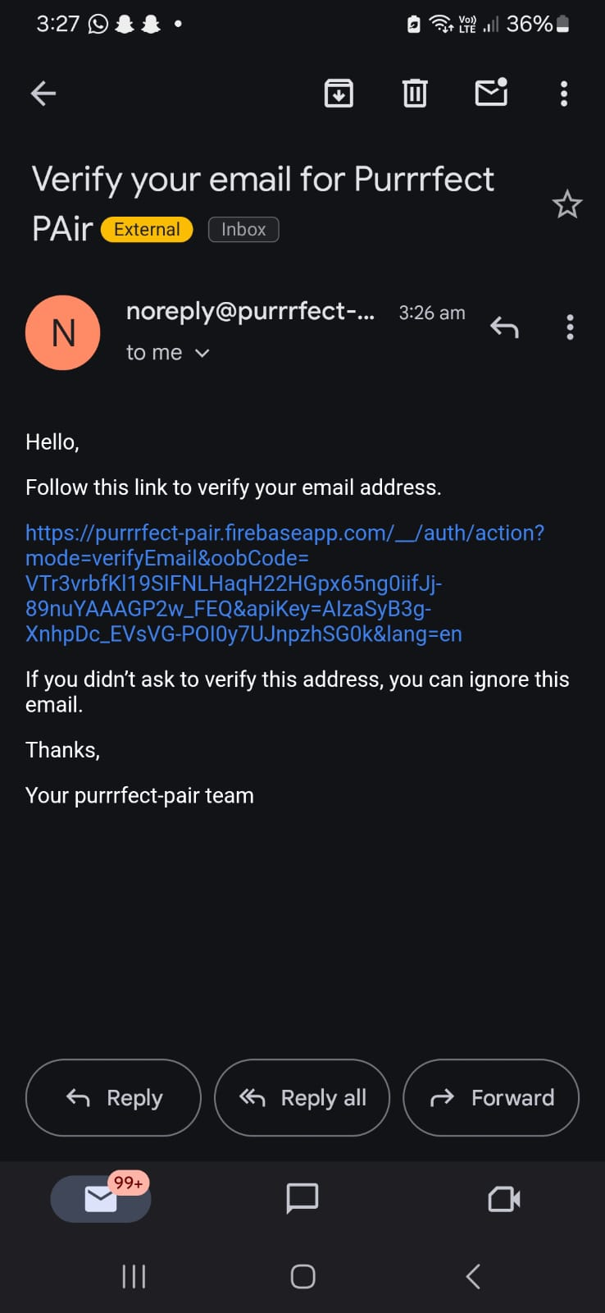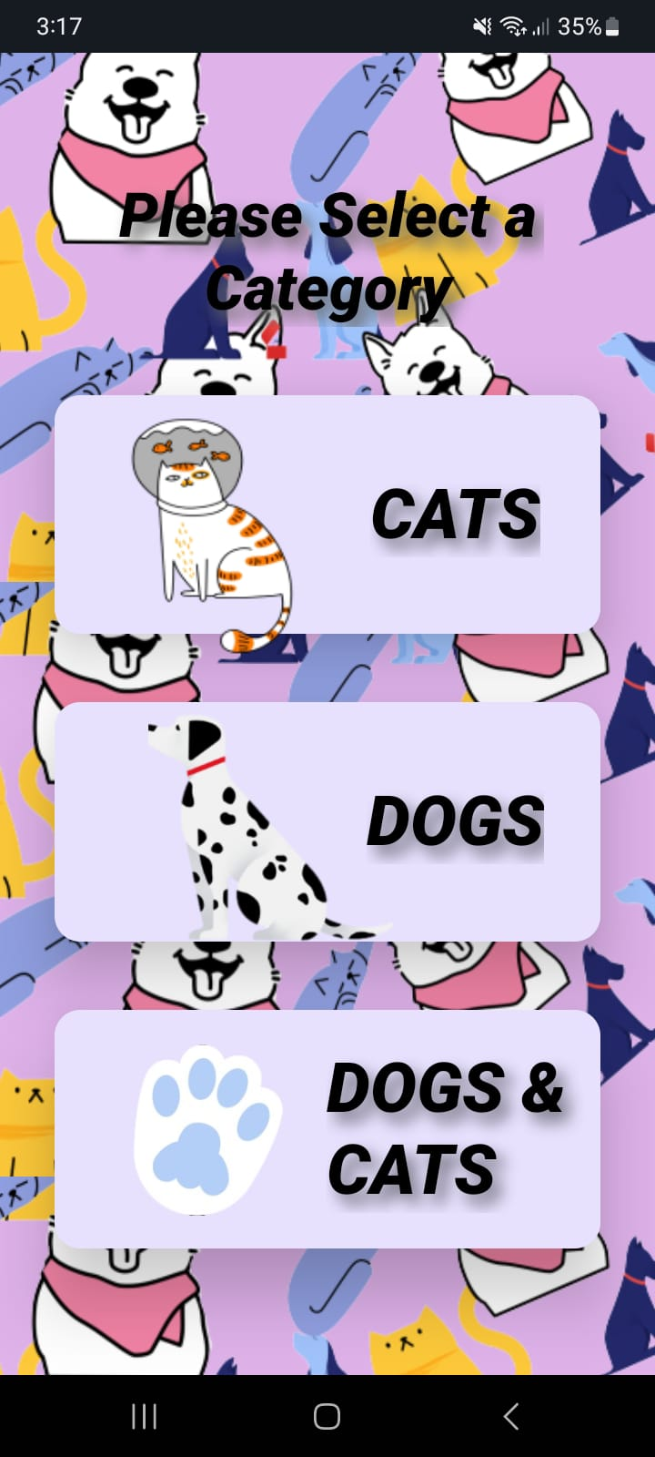 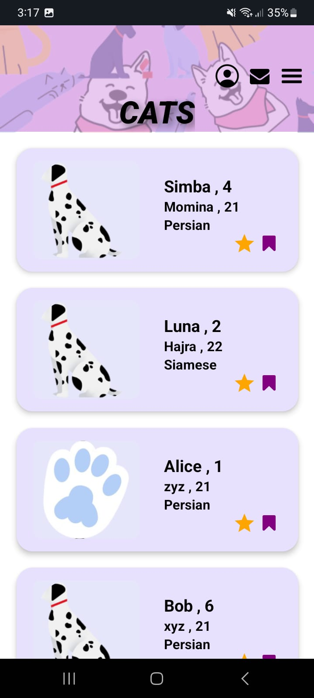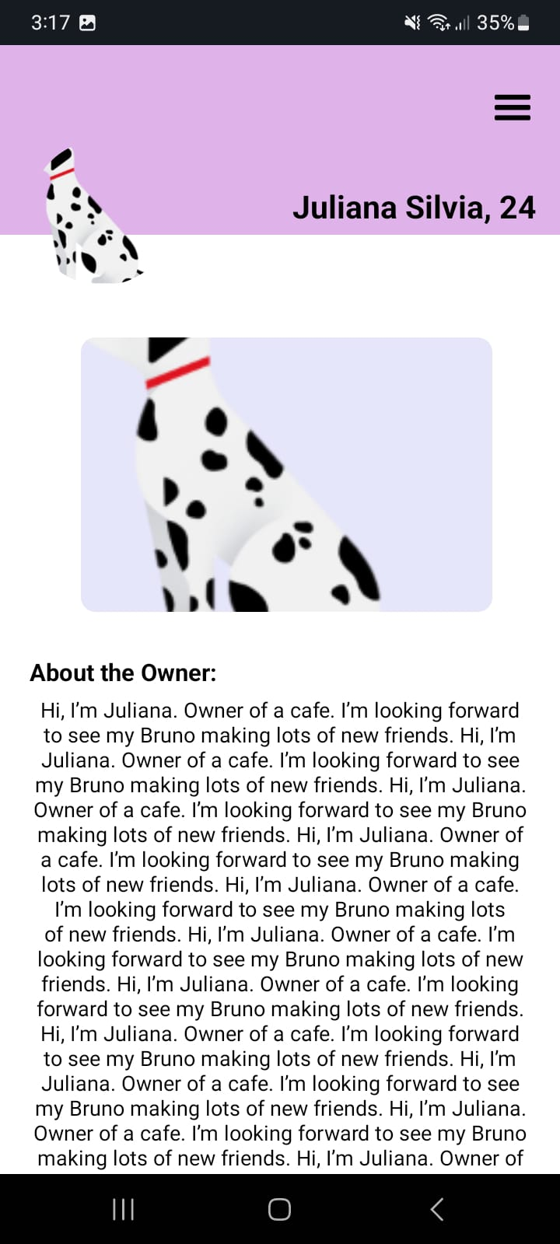 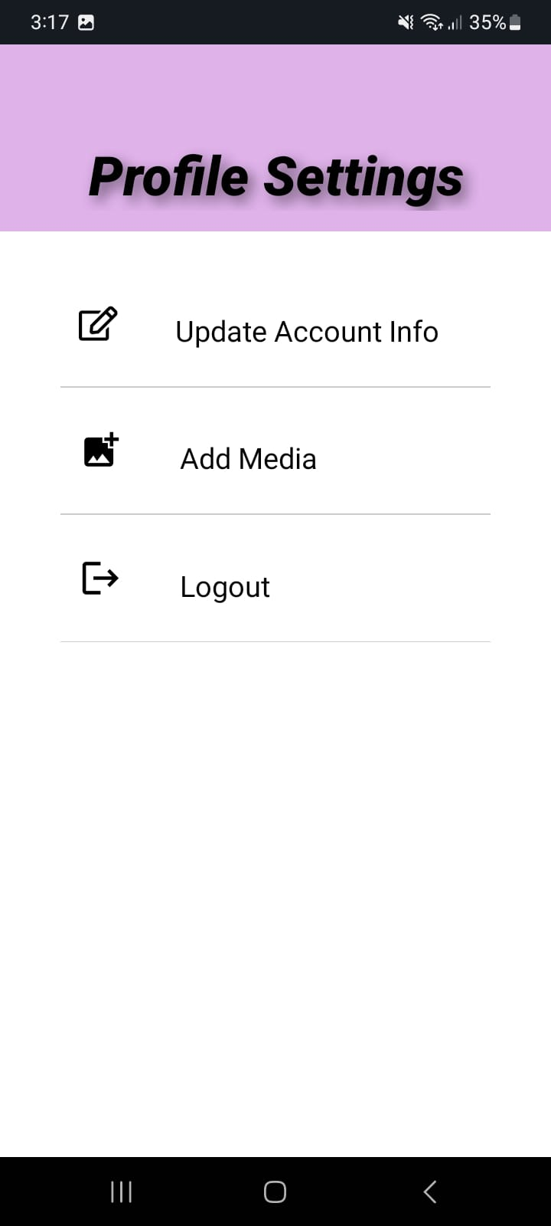 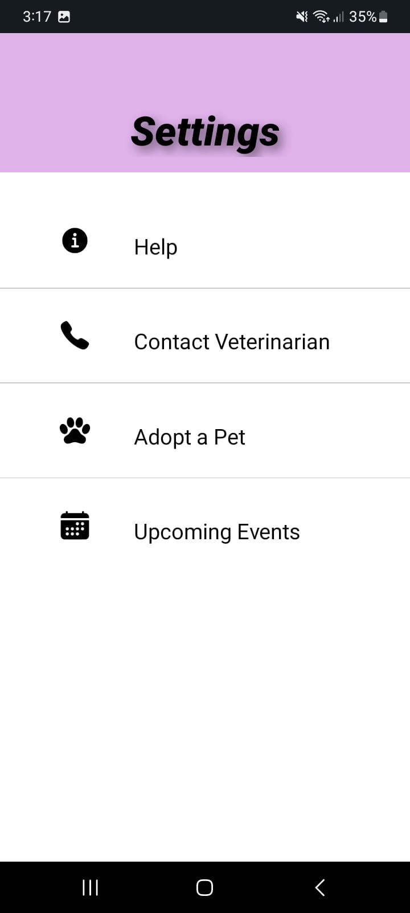 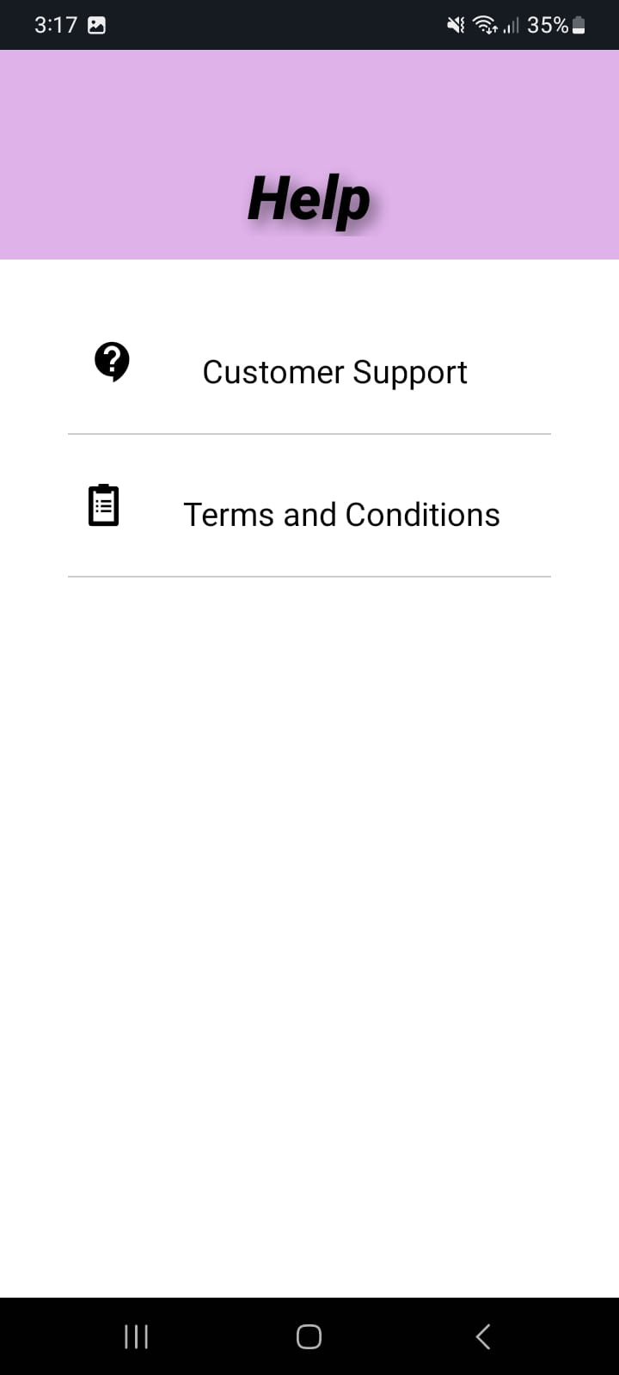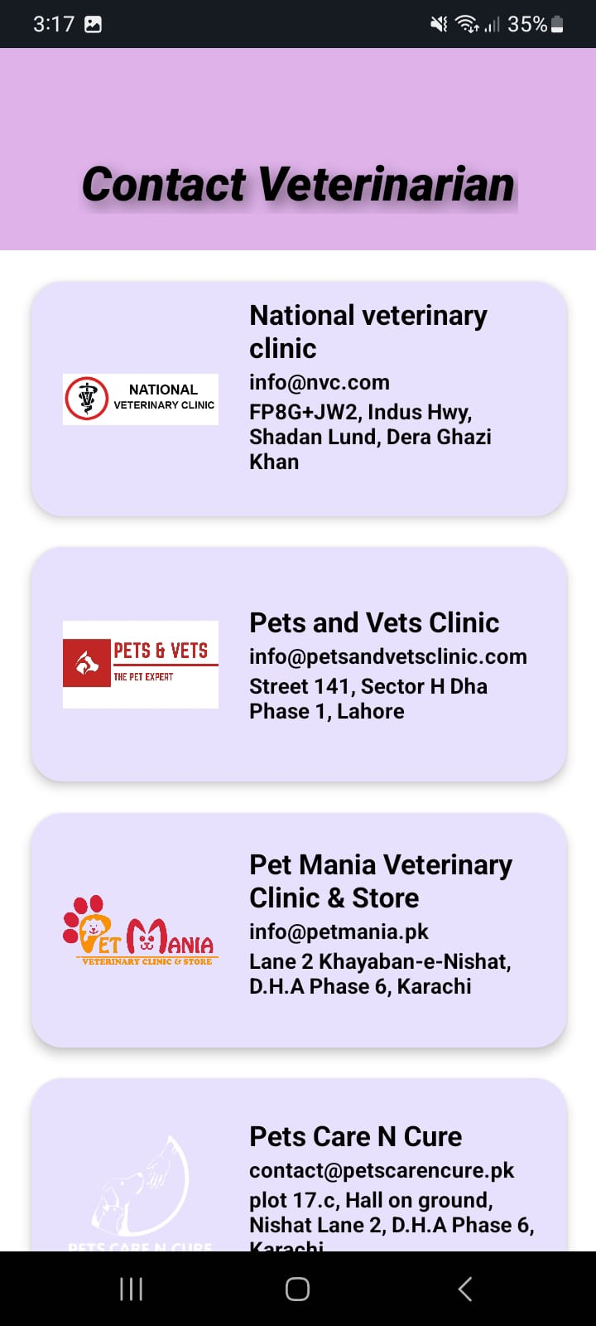 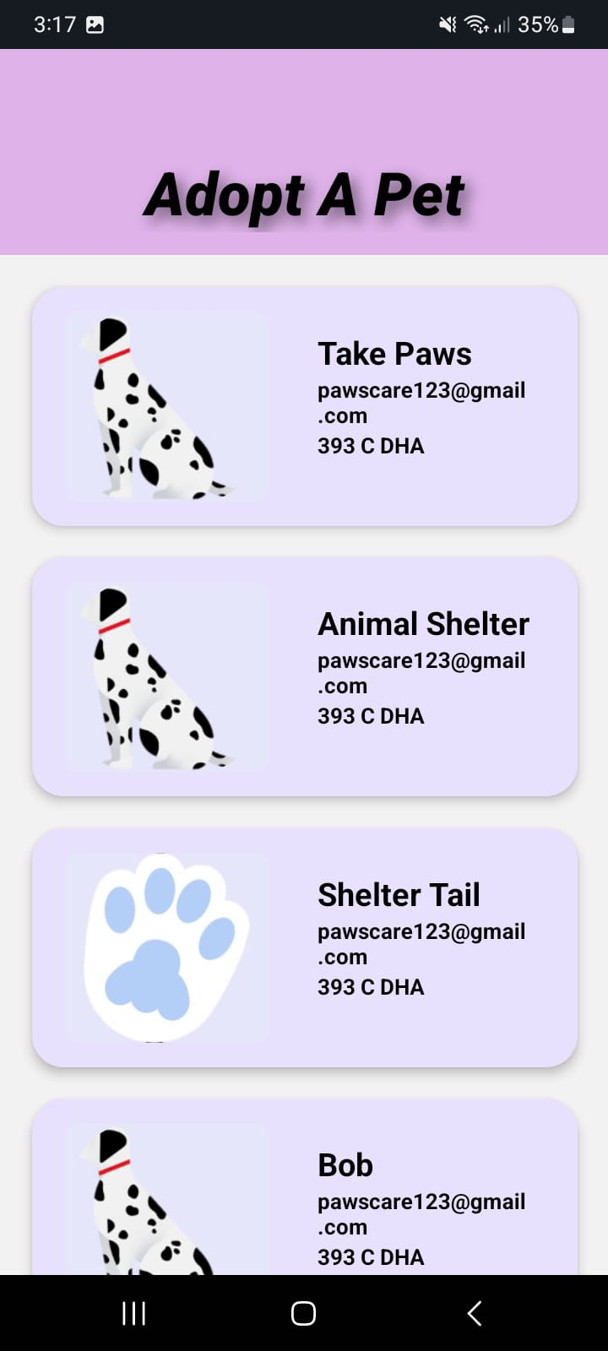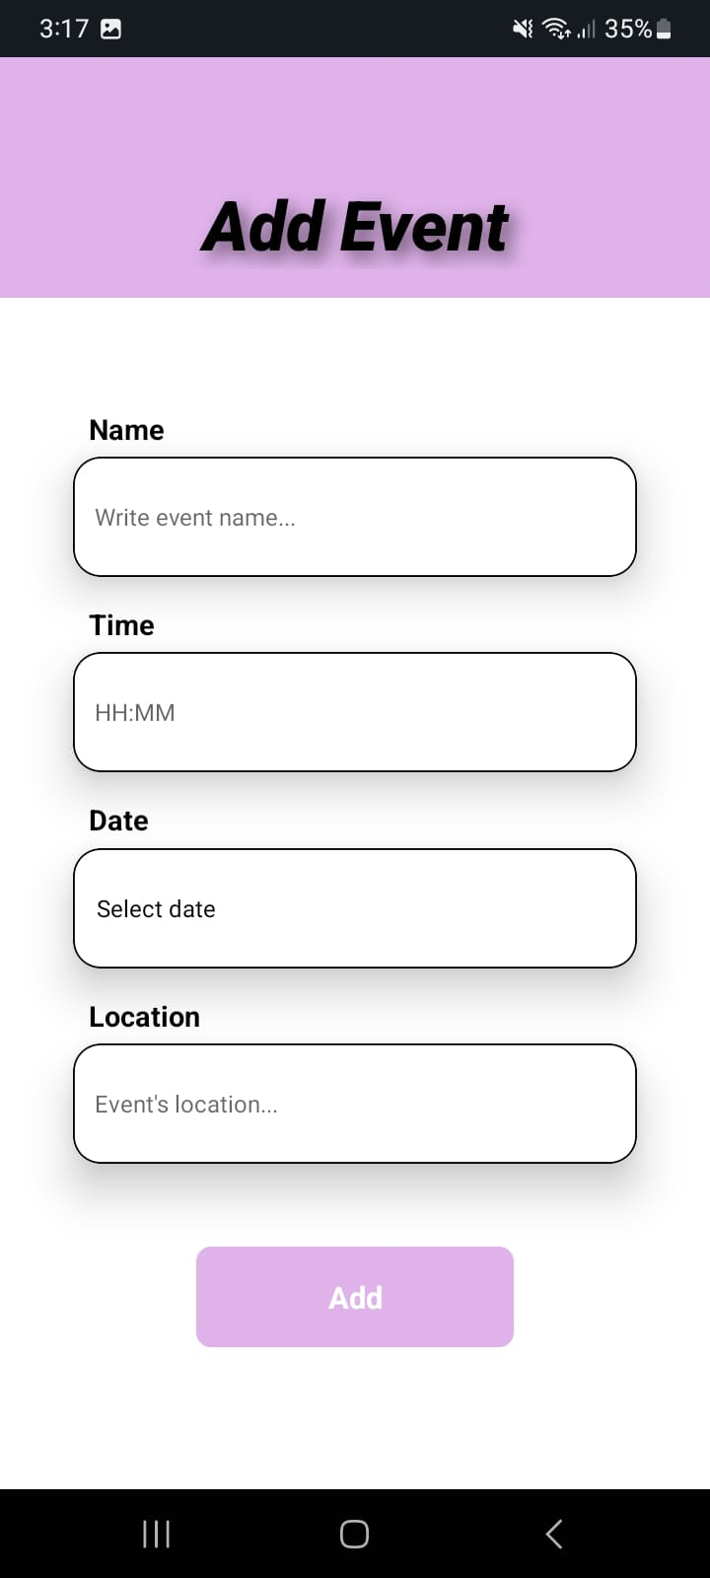  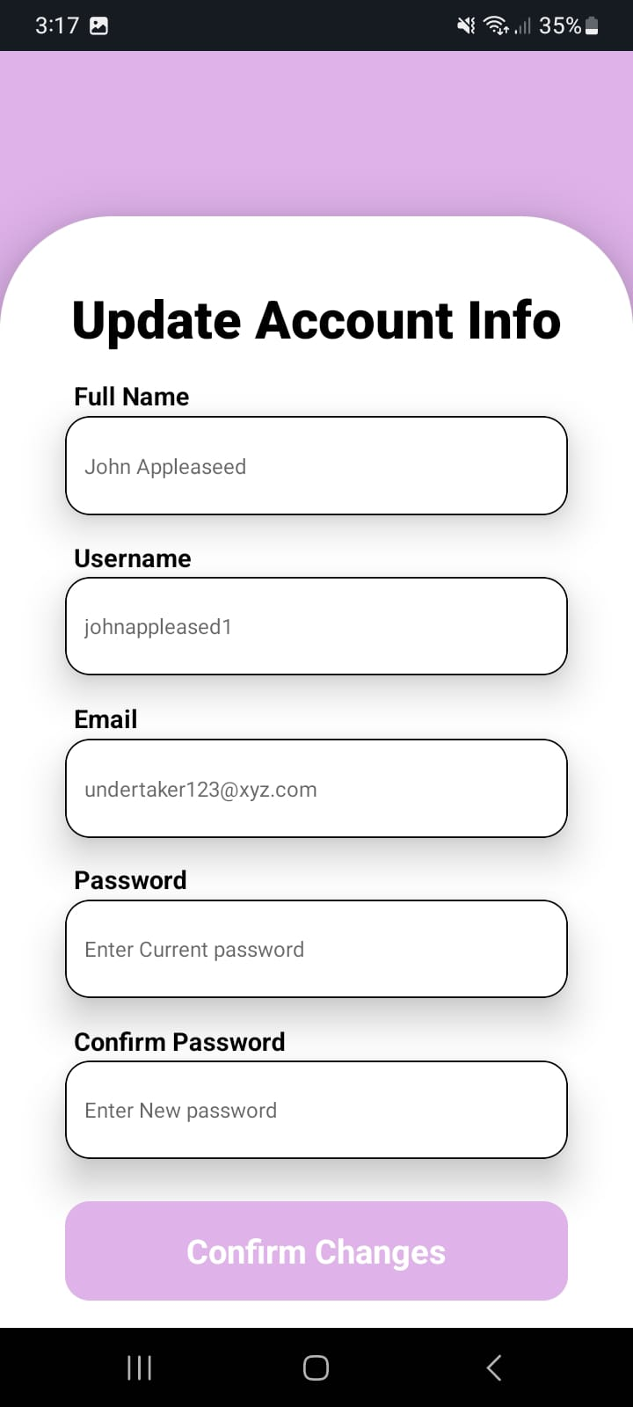 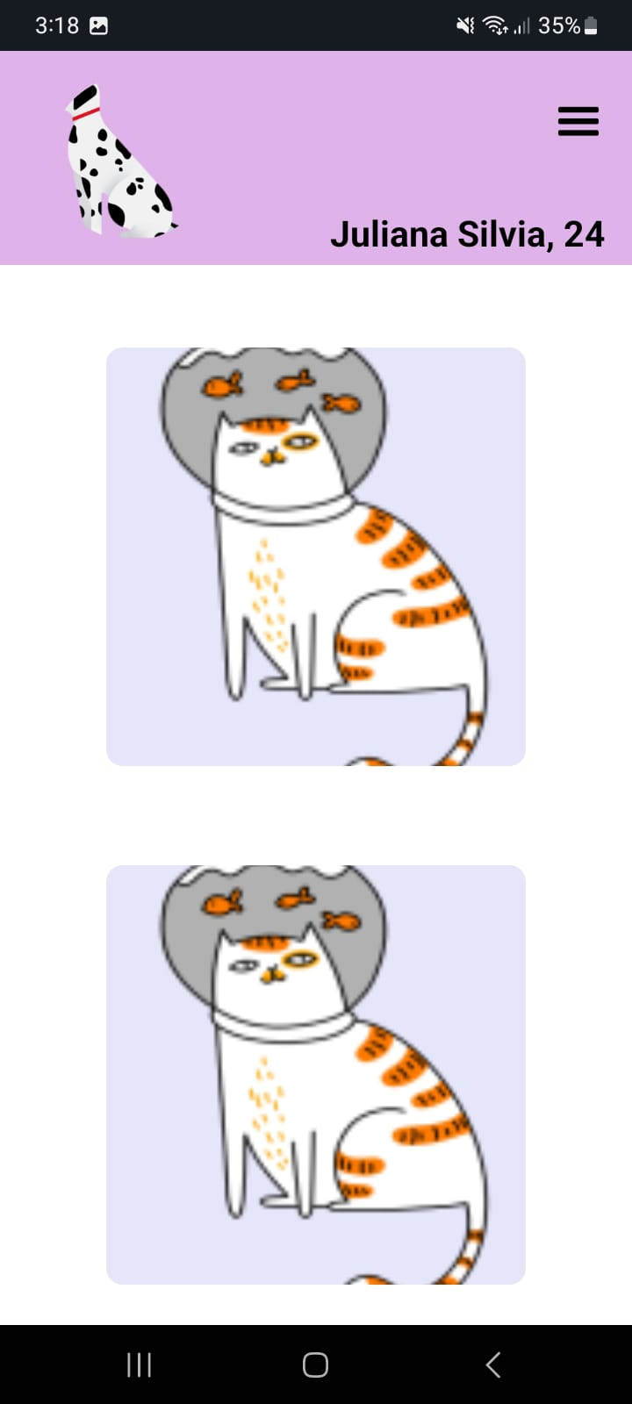

**SIGNUP CONFIRMATION EMAIL**

**RIGNUP SUCCESSFUL**

**CATEGORY SELECTION**

**CATS CATEGORY**

**PROFILE SETTINGS**

**PROFILE SCREEN**

**HELP SCREEN**

**MAIN SETTINGS**

**ADOPT A PET**

**CONTACT VETERINARIAN**

**UPCOMING EVENTS**

**ADD EVENT**

**UPLOADED PICTURES**

**UPDATE ACCOUNT INFO**

# **SYSTEM ARCHITECTURE**

## **Client-Server Architecture**

The "Purrrfect Pair" application utilizes a client-server architecture where the mobile application (client) interacts with the backend services (server) provided by Firebase. The architecture is designed to ensure scalability, security, and efficient real-time communication.

## **Components**

**Frontend (Client):**

* React Native: Handles the user interface and user interactions.
* React Navigation: Manages the navigation between different screens.
* Camera and File Upload: For capturing and uploading images and documents.

**Backend (Server):**

* Firebase Authentication: Manages user authentication and authorization.
* Firebase Realtime Database & Firestore: Stores user, pet profiles, messages, events, and other data.
* Firebase Cloud Messaging: Handles push notifications.
* Firebase Storage: Stores user-uploaded images and documents.

## **Development Tools:**

Visual Studio Code: IDE for coding.

Git: Version control system.

## **Data Flow**

User Authentication:

* Users register and log in using Firebase Authentication.
* User credentials are securely stored and managed by Firebase.

Data Storage and Retrieval:

* User and pet profile data, messages, and event details are stored in Firebase Firestore.
* Real-time updates are handled by Firebase Realtime Database for instant messaging and notifications.

Messaging and Notifications:

* Real-time messaging is facilitated by Firebase Realtime Database.
* Push notifications are managed by Firebase Cloud Messaging to alert users of new messages, events, and updates.

File Handling:

* Images and documents uploaded by users are stored in Firebase Storage.

# **DATABASE DESIGN**

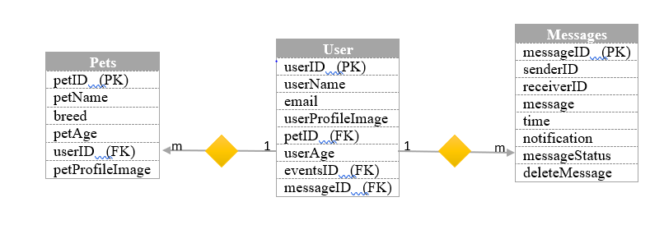

# **Testing**

**Testing Strategy**

The testing strategy for "Purrrfect Pair" includes unit testing, integration testing, and user acceptance testing.

**Test Cases:**

|  |  |  |  |  |  |  |  |
| --- | --- | --- | --- | --- | --- | --- | --- |
| Test Case ID | Description | Pre-Condition | Input | Steps | Expected Results | Actual Result | Status |
| TC001 | Verify that a new user can register successfully | None | Valid user details | 1. Open the registration screen. 2.Enter valid user details. 3.Submit the registration form. | Create user account, and the redirect to the home screen. | User account is created, and user is redirected to the home screen. | Pass |
| TC002 | Verify that a user can create a pet profile | User must be logged in | Valid pet details | 1. Navigate to the pet profile creation screen.  2. Enter valid pet details.  3. Submit the form. | Create pet profile and store in Firestore. | Pet profile is created and stored in Firestore. | Pass |
| TC003 | Verify that users can send and receive messages in real time | Two users are logged in | Message text | 1. User A sends a message to User B.  2. User B receives the message in real time. | User B receives the message without delay. | User B received the message without delay. | Pass |
| TC004 | Verify that a user can add an event | Location should be accessible | Event details | 1. User fills the requirements in event details page. 2. User clicks on the Add button. | User can check all the upcoming events. | User can check all the upcoming events. | Pass |
| TC005 | Verify that users find the app intuitive and easy to navigate | None | User interactions | 1. Users explore various features of the app.  2. Collect user feedback on ease of use and functionality | Majority of users report a positive experience with minimal confusion. | Majority of users reported a very positive experience with minimal confusion. | Pass |

# **Conclusion**

The "Purrrfect Pair" mobile application aims to transform the pet ownership experience by fostering a vibrant, inclusive community for pet enthusiasts. By addressing critical issues such as limited socialization opportunities, complex mating processes, and the lack of emphasis on responsible pet ownership, this project aspires to enhance the well-being of pets and their owners. Through innovative features like real-time messaging, event organization, and educational resources, the app will offer a comprehensive, user-centric platform that caters to diverse pet-related needs. Utilizing an agile development methodology and leveraging a robust technology stack, including React Native and Firebase, ensures that "Purrrfect Pair" will be scalable, reliable, and maintainable. By delivering a high-quality, feature-rich mobile application, this project seeks to redefine pet socialization and ownership experiences, fostering meaningful connections and promoting the health and happiness of pets and their owners.