ARTIFICIAL INTELLIGENCE AI2002

ASSIGNMENT REPORT
“AI Pathfinder - Uninformed Search Algorithms”

GROUP:
Sara Shakeel 23F-0617
Hajra Haseeb 23F-0789

SUBMISSION DATE:
FEBRUARY 17, 2026

PROFESSOR:
Dr. Hashim Yasin

EXPLANATION:
This project implements six uninformed search algorithms (BFS, DFS, UCS, DLS, IDDFS, Bidirectional) to navigate a dynamic grid from a Start point (S) to a Target point (T). The system visualizes the search process step-by-step and adapts to dynamic obstacles.

CONTROLS INSIDE GUI:
KEYS | ALGORITHM
1 | BFS
2 | DFS
3 | UCS
4 | DLS
5 | IDDFS
6 | Bidirectional
R | RESET

COLORS REPRESENTATION:
Green - Start Node
- The starting position of the agent where the search begins.
Blue - Goal Node
- The destination the algorithm is trying to reach.
Red - Obstacle
- Blocked cell that cannot be traversed.
Yellow - Frontier Nodes
- Nodes discovered but not yet explored.
- Currently in queue, stack, or priority queue.
Grey - Explored Nodes
- Nodes already visited and processed by the algorithm.
Purple - Final Path
- The successful path from start to goal.
White - Empty Cell
- Free space not yet explored.
IMPLEMENTATION DETAILS:
- Breadth-First Search (BFS)
- Explores nodes level by level using a queue.
- Algorithm expands nodes in this order: Up → Right → Down → Down-Right → Left → Top-Left → Top-Right → Bottom-Left
- Handles dynamic obstacles by recalculating the path if blocked.
- Python Implementation: Used queue.Queue for the frontier and a set to track visited nodes.
Pros:
- Guarantees the shortest path if all moves have the same cost.
- Explores all nearby nodes first — good for small grids.
Cons:
- Memory-intensive for large grids (stores all frontier nodes).
- Slower if the target is deep in the grid.

Test cases (Screenshots):
Best case:
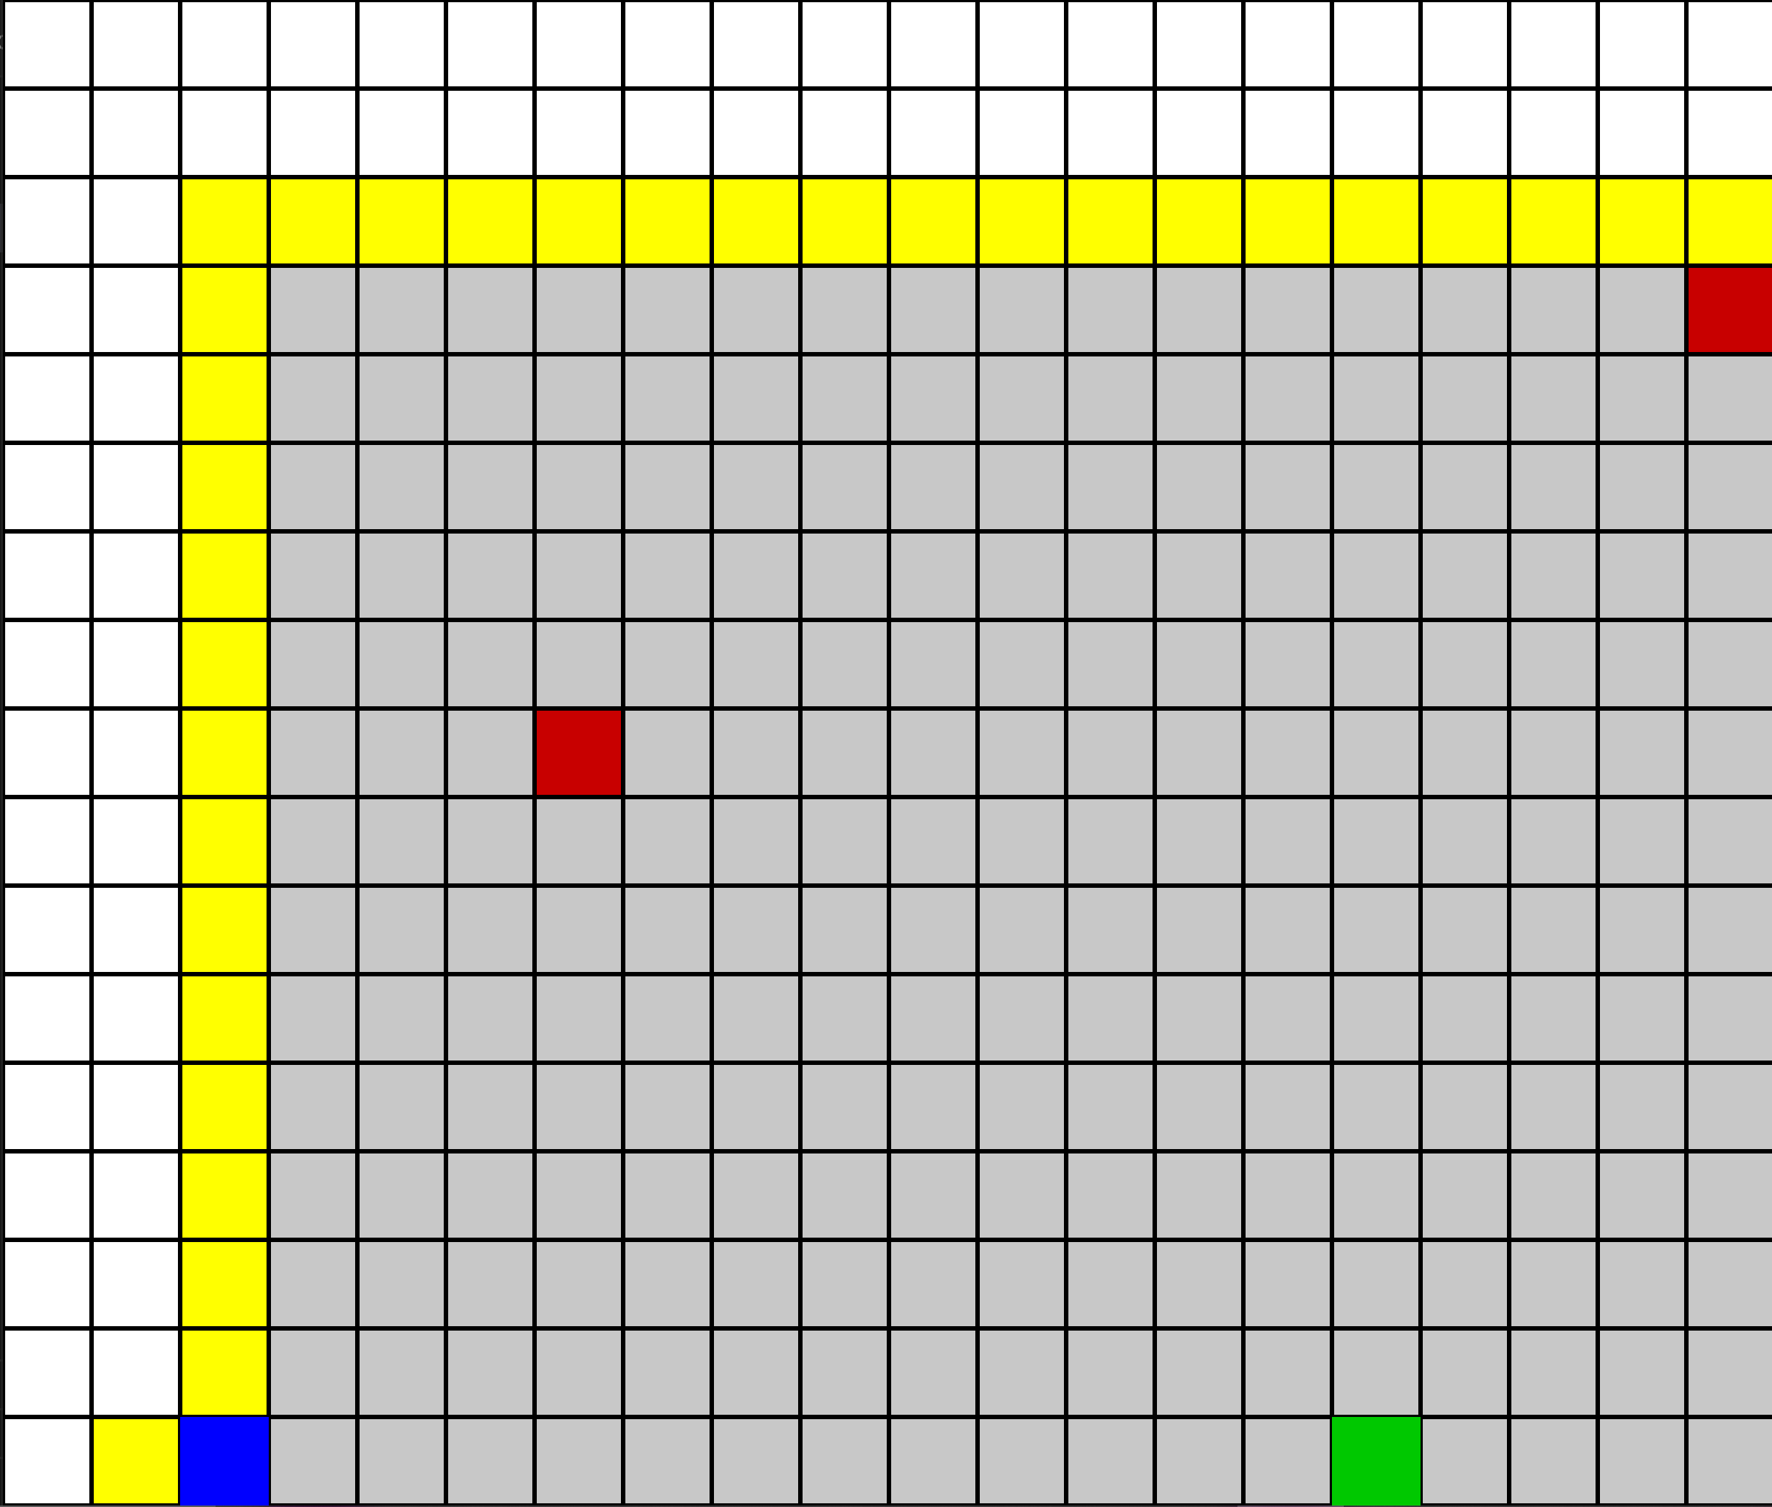

Worst case:
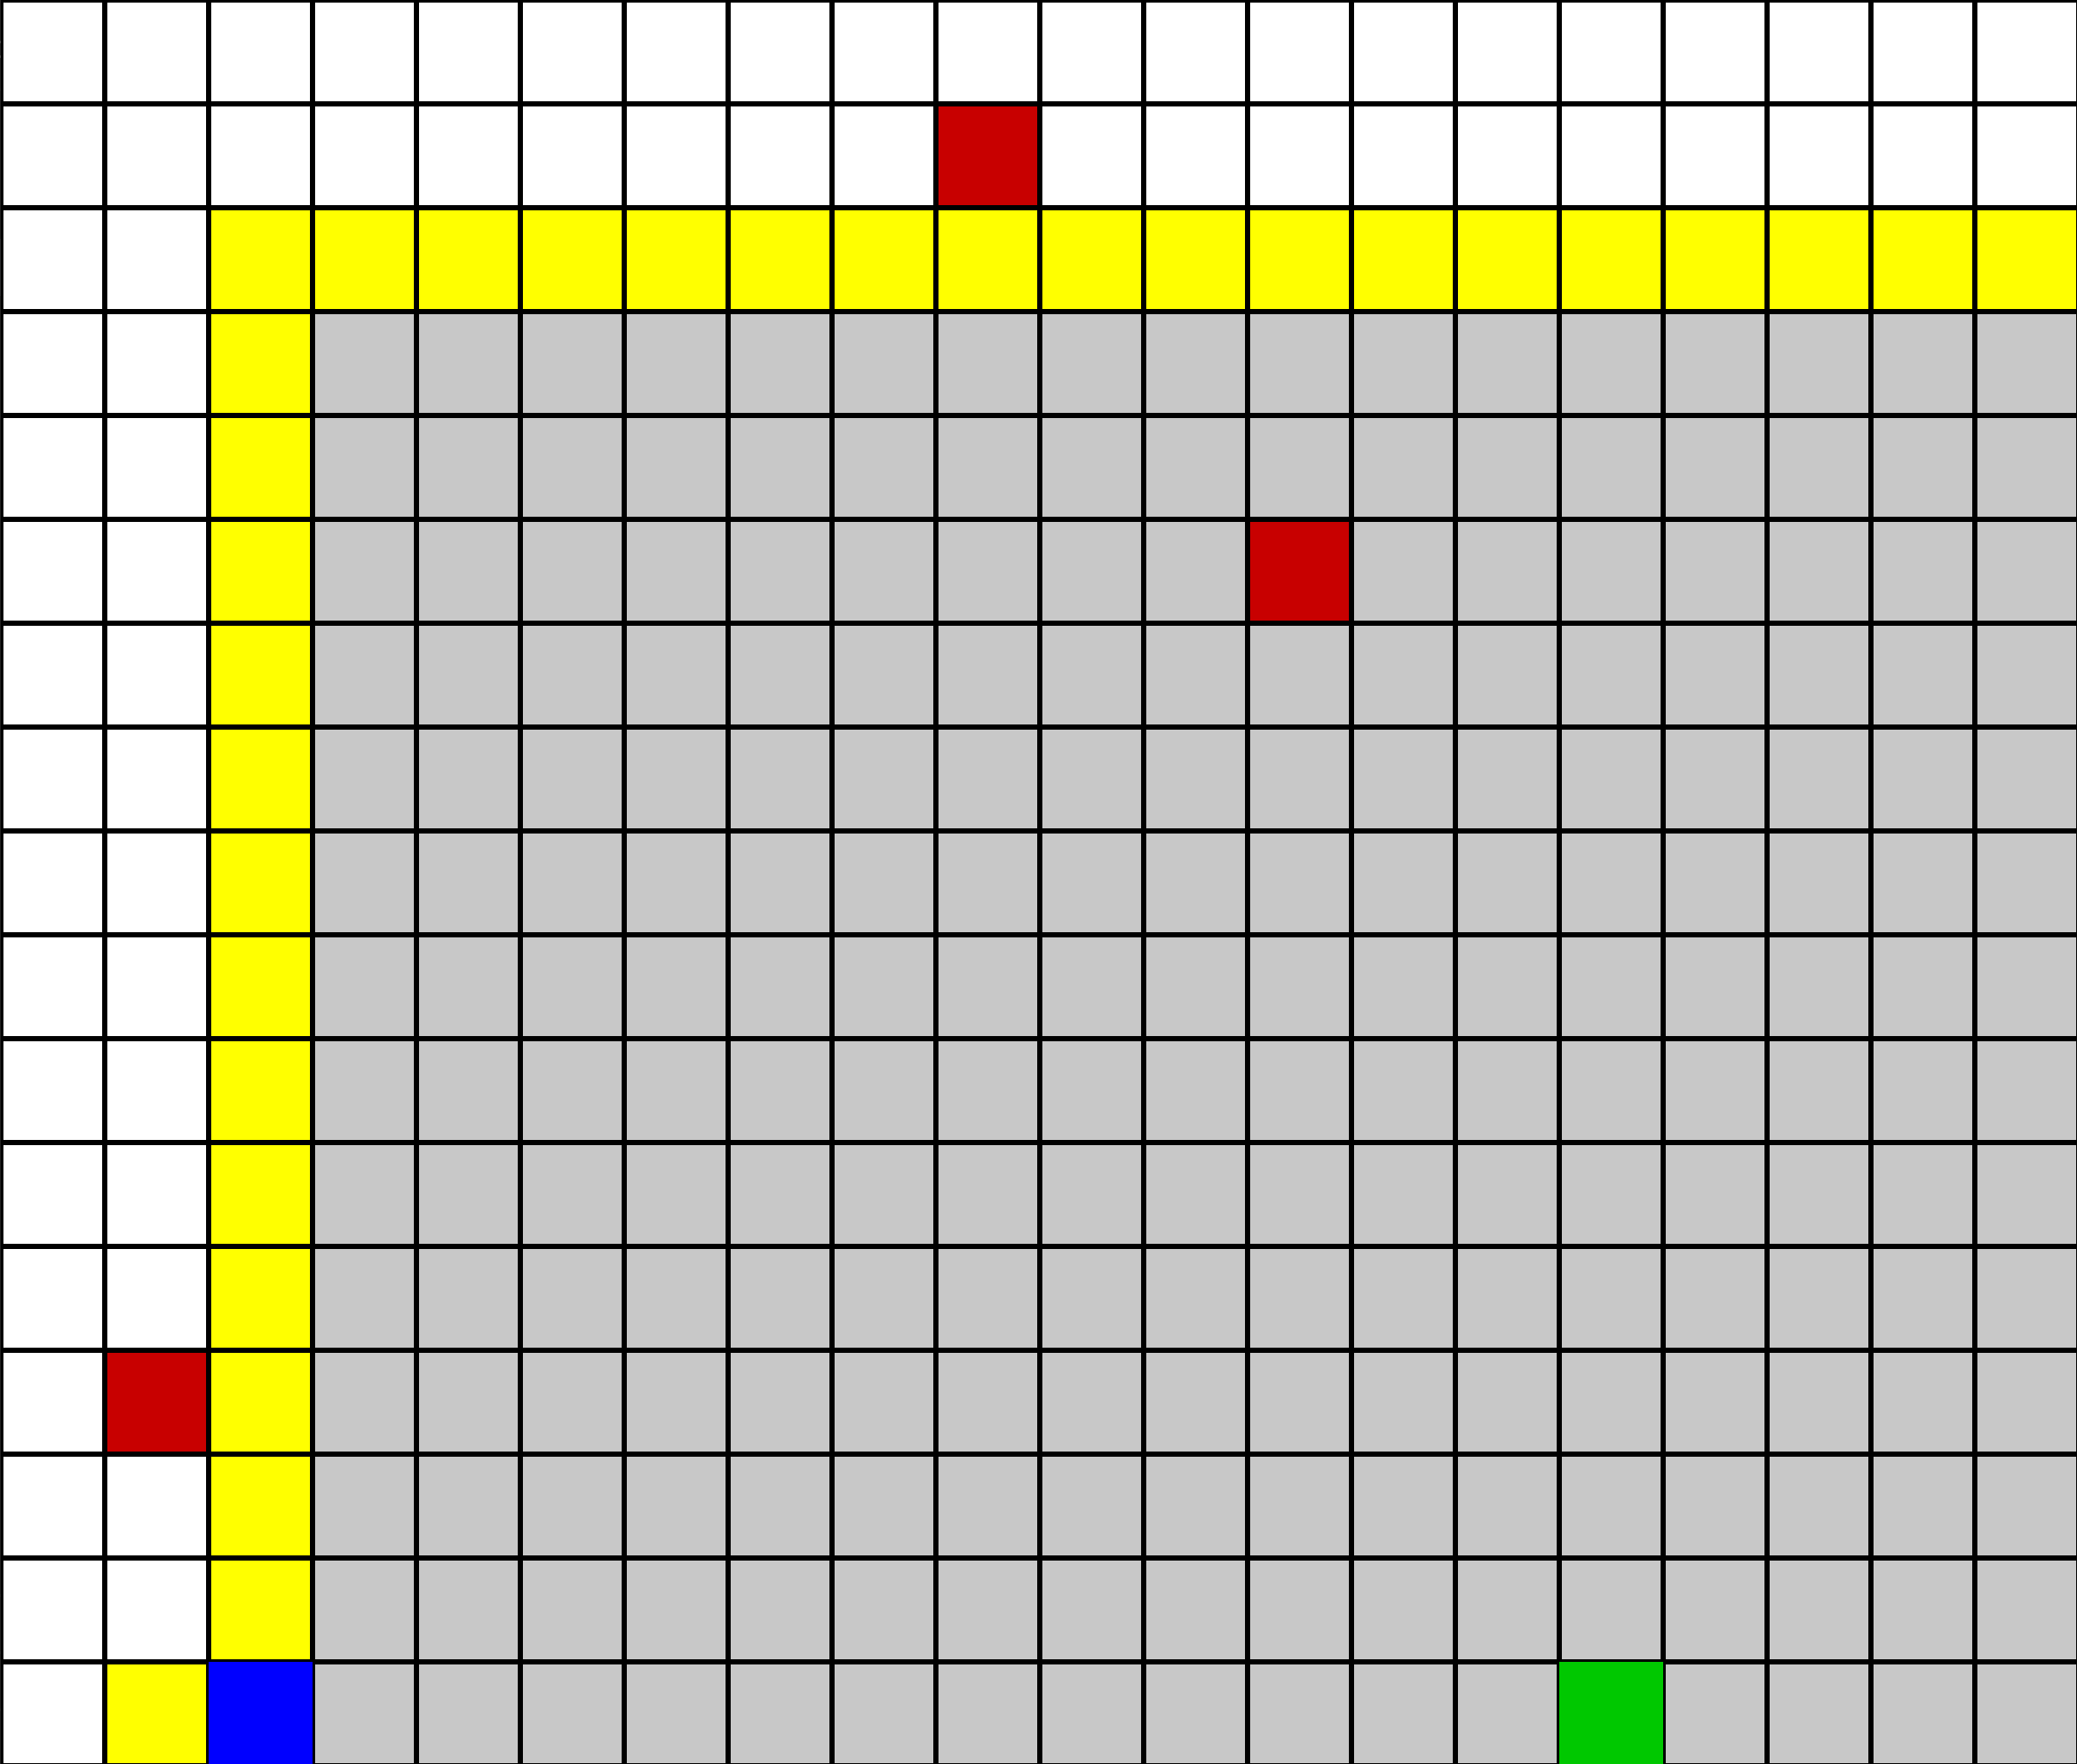

- Depth-First Search (DFS)
- Explores as deep as possible first using a stack.
- Same movement order as BFS.
- Dynamic obstacle handling: If the path is blocked, backtracks and tries alternative routes.

Pros:
- Low memory usage (only tracks current path).
- Good for large, deep grids where solution is far.
Cons:
- May not find the shortest path.
- Can get stuck in long dead-end paths if not careful.

Test cases (Screenshots):
Best case:
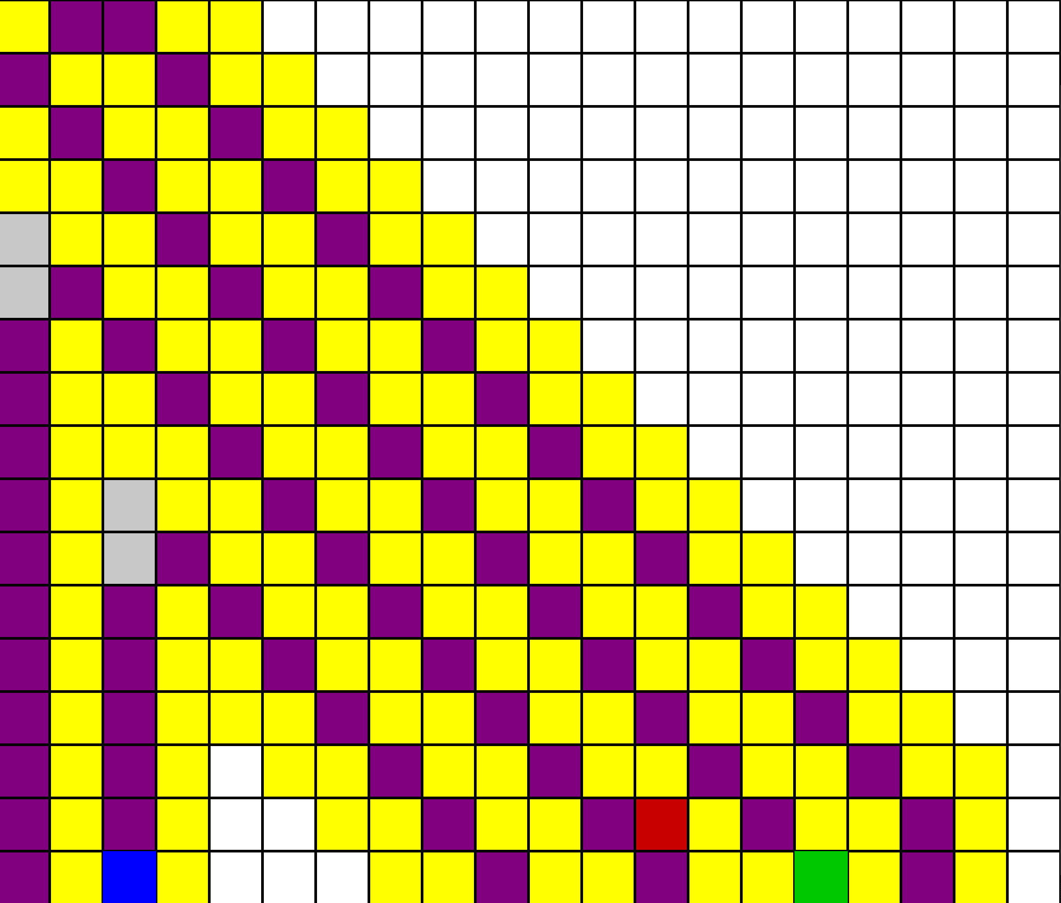

Worst case:
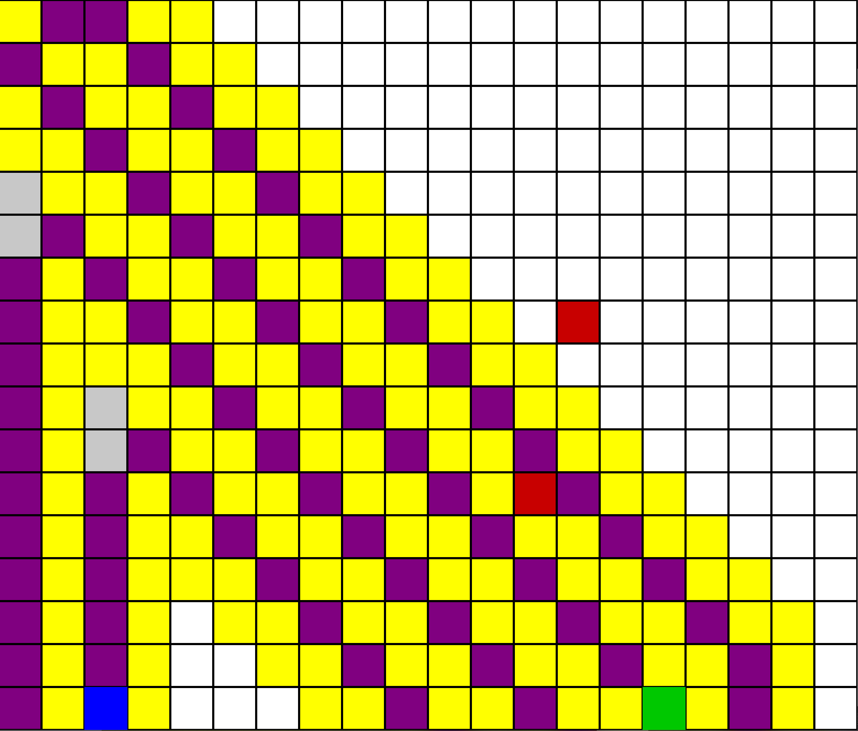

- Uniform-Cost Search (UCS)
- Expands nodes with the lowest cumulative cost first using a priority queue.
- Good if different moves have different costs (e.g., diagonal = cost 1.5, straight = 1)
- Handles dynamic obstacles by re-calculating paths if blocked.
Pros:
- Finds optimal (lowest cost) path.
- Works with weighted grids.

Cons:
- More computationally expensive than BFS/DFS.
- Memory usage can be high for large grids.

Test cases (Screenshots):
Best case:
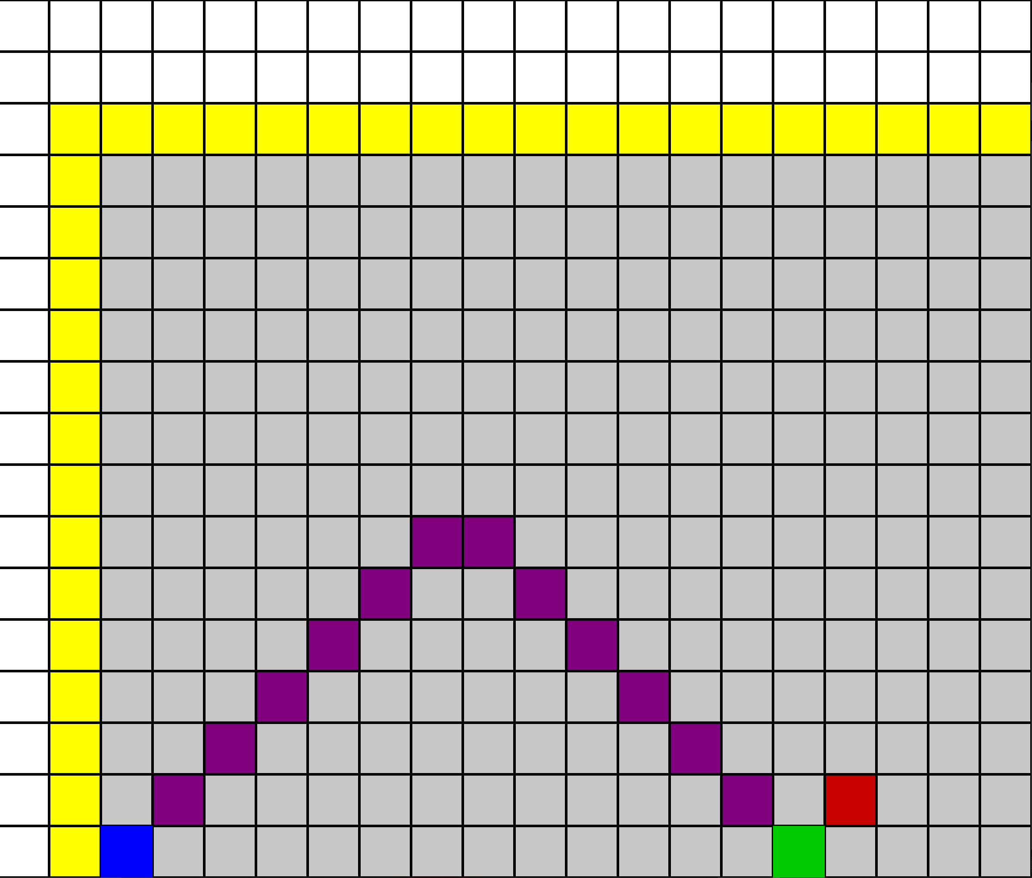

Worst case:
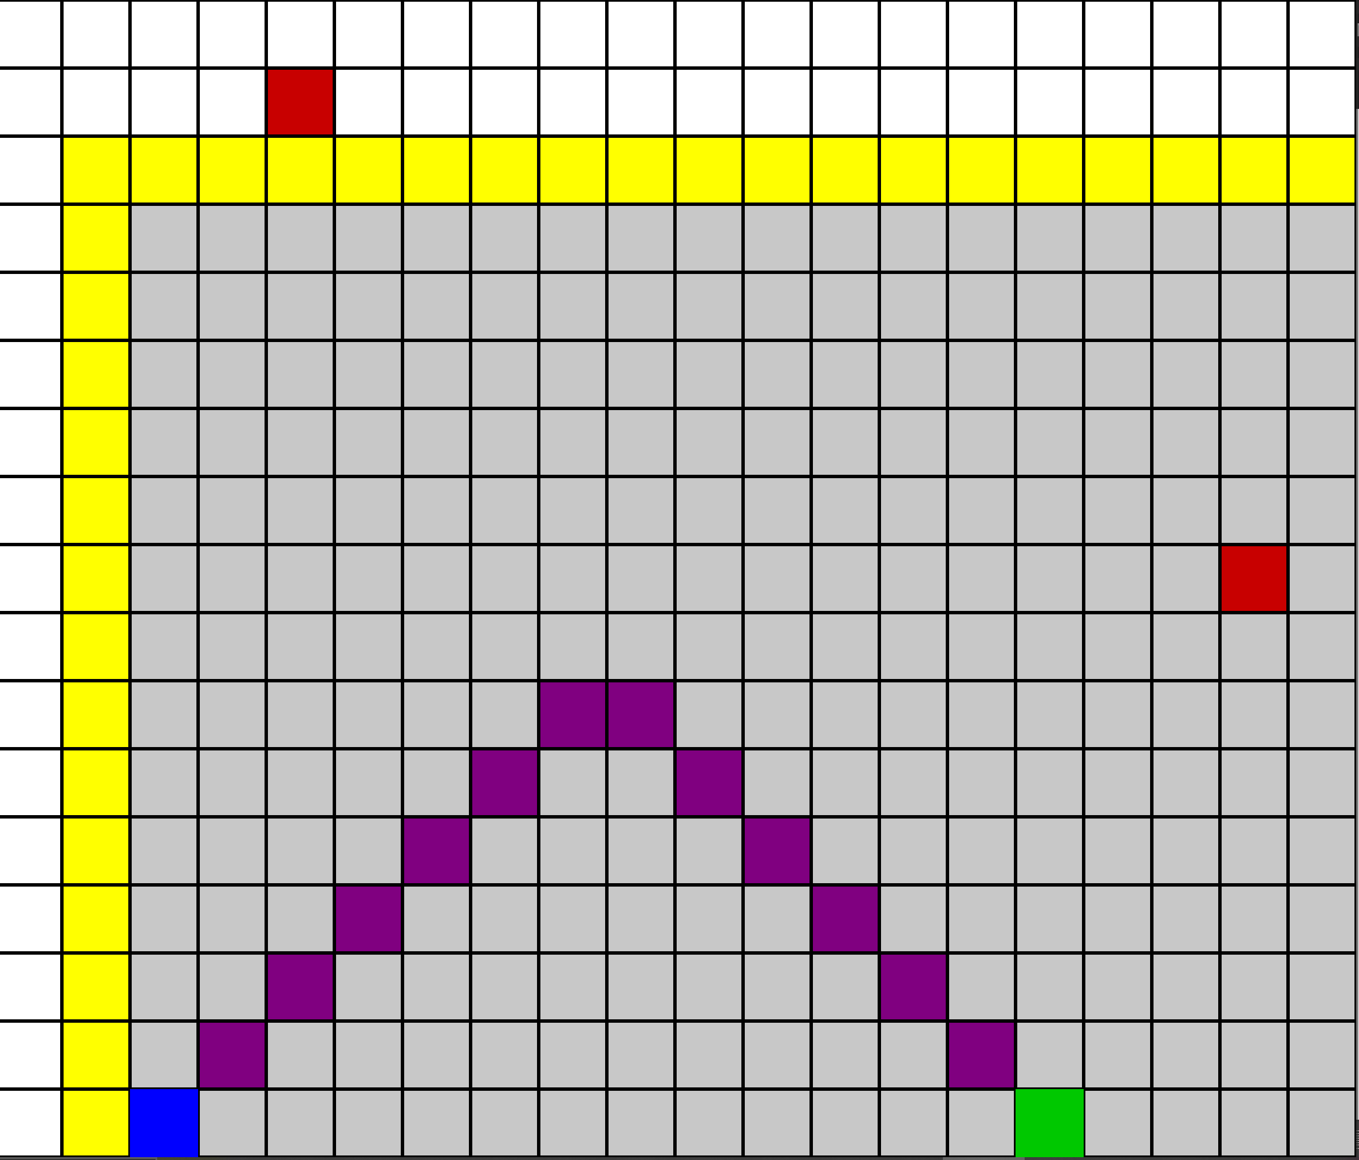

- Depth-Limited Search (DLS)
- DFS with a maximum depth limit.
- Avoids going too deep and wasting time.
Pros:
- Limits memory usage and execution time.
- Useful when the target is expected to be near.
Cons:
- If depth limit is too small → may fail to find solution.
- If too large → behaves like DFS (can be slow).
Test cases (Screenshots):
Best case:
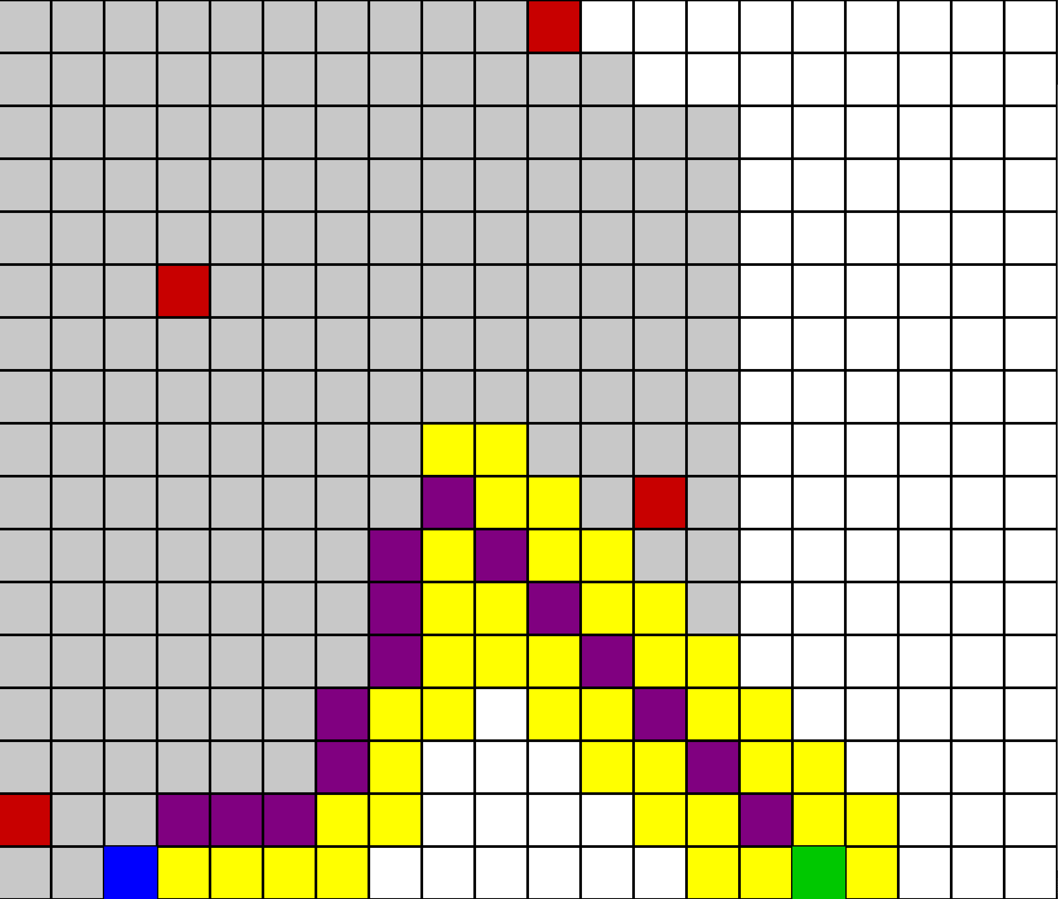

Worst case:
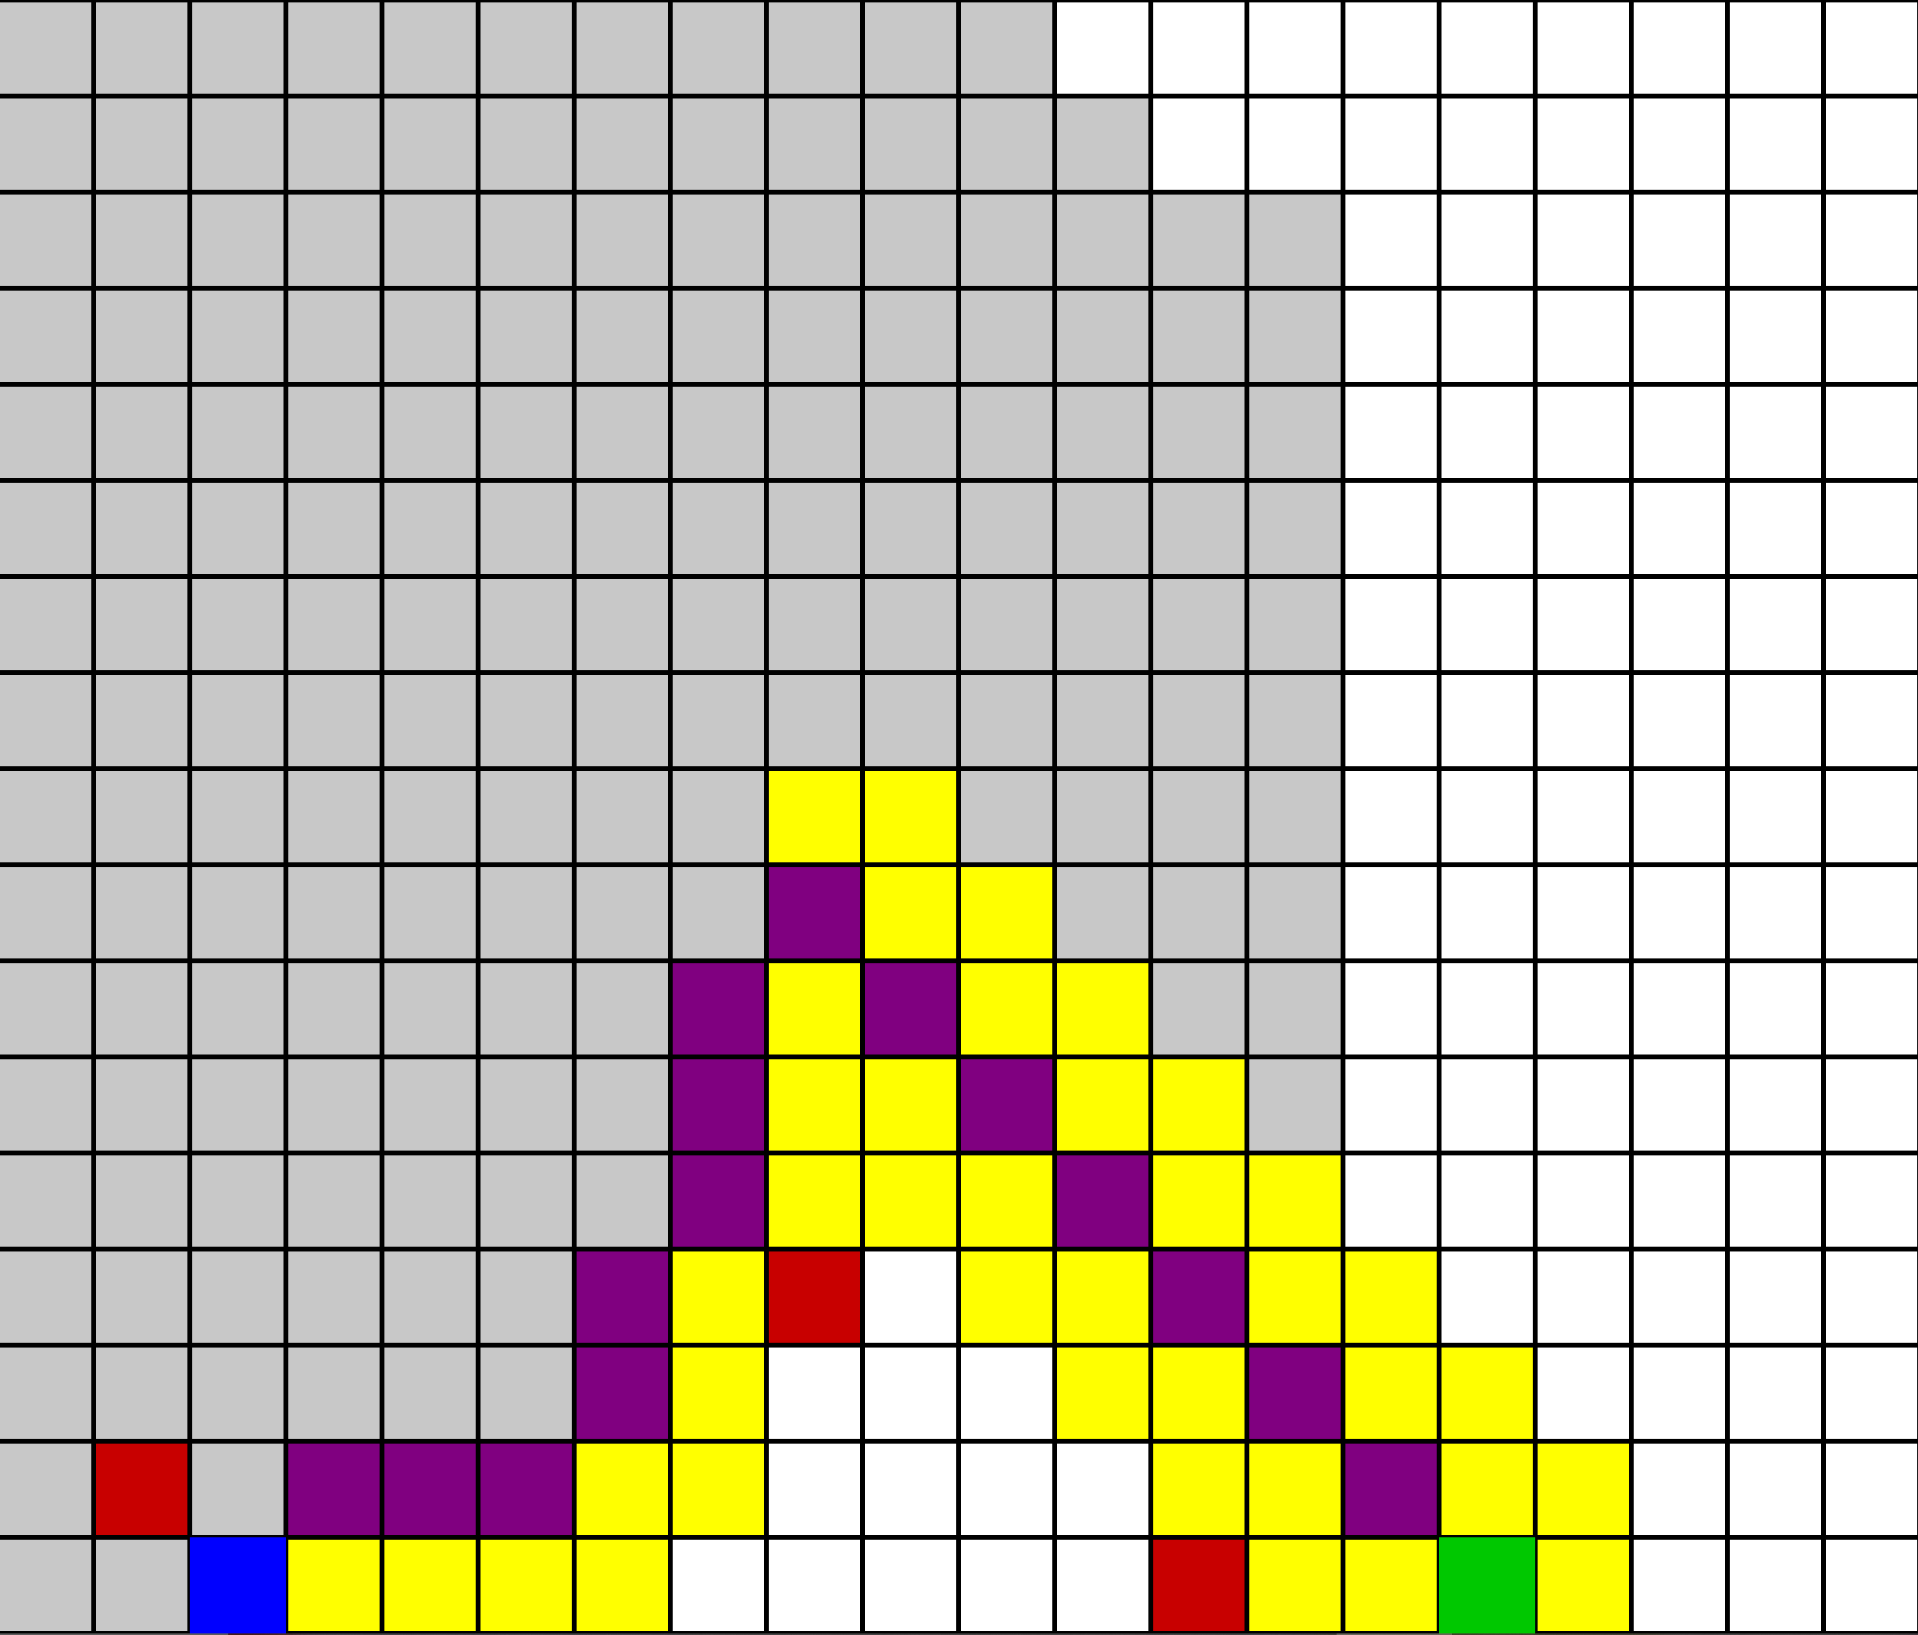

- Iterative Deepening DFS (IDDFS)
- Repeatedly runs DLS with increasing depth limit until solution is found.
- Combines low memory of DFS with guaranteed solution like BFS.
Pros:
- Finds the shortest path without high memory usage.
- Good compromise between DFS and BFS.
Cons:
- Repeats search at each depth → can be slower than BFS in some cases.

Test cases (Screenshots):
Best case:
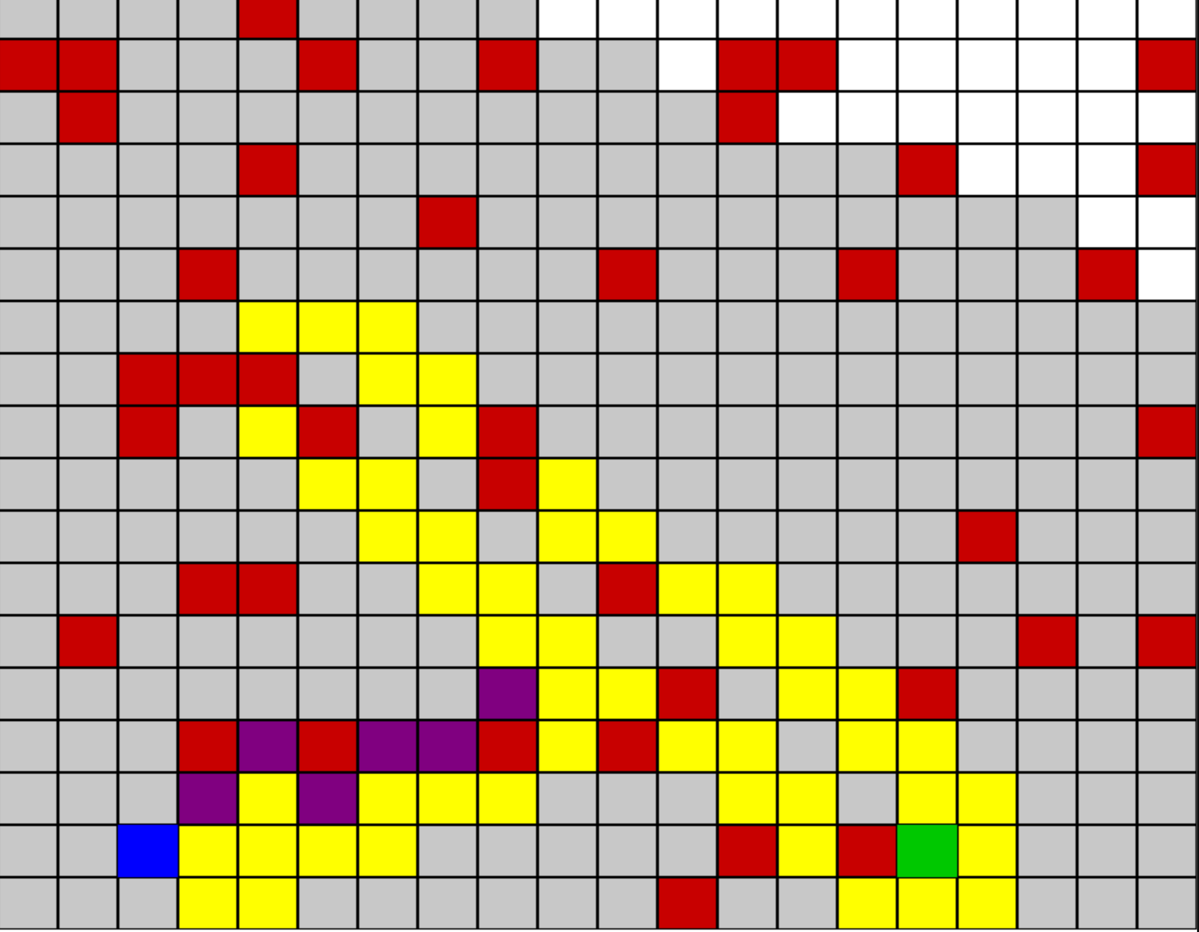

Worst case:
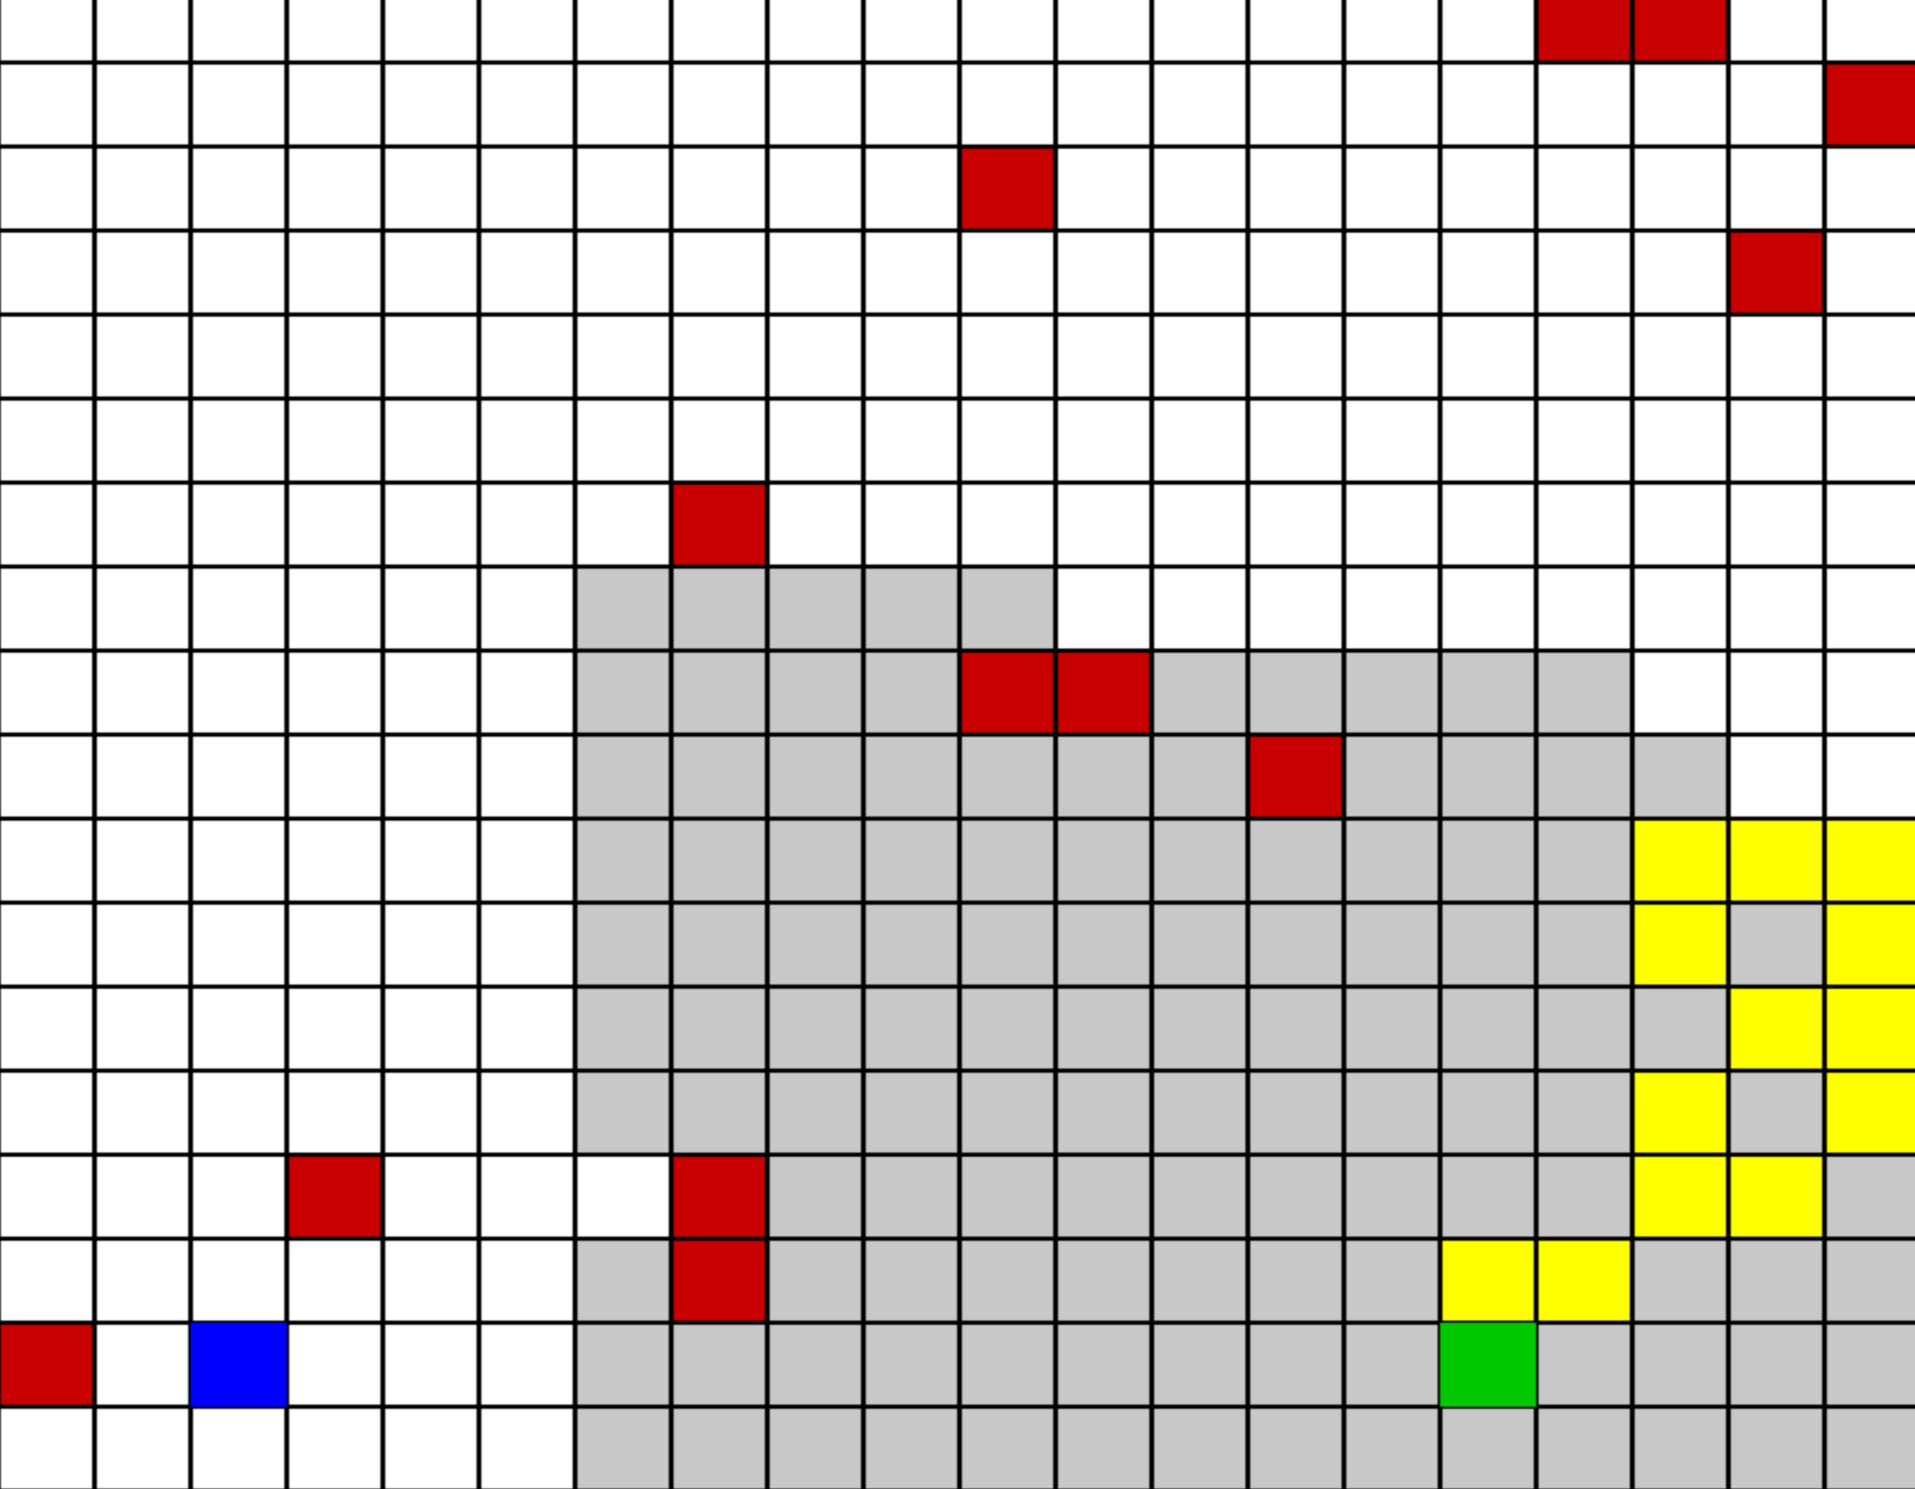

- Bidirectional Search
- Runs BFS from Start and Target simultaneously.
- Stops when the frontiers meet.
- Efficient for large grids with no obstacles in the middle.
Pros:
- Can be much faster than BFS alone.
- Reduces search space drastically.
Cons:
- Harder to implement.
- Dynamic obstacles can make it complicated (both searches must adapt).

Test cases (Screenshots):
Best case:
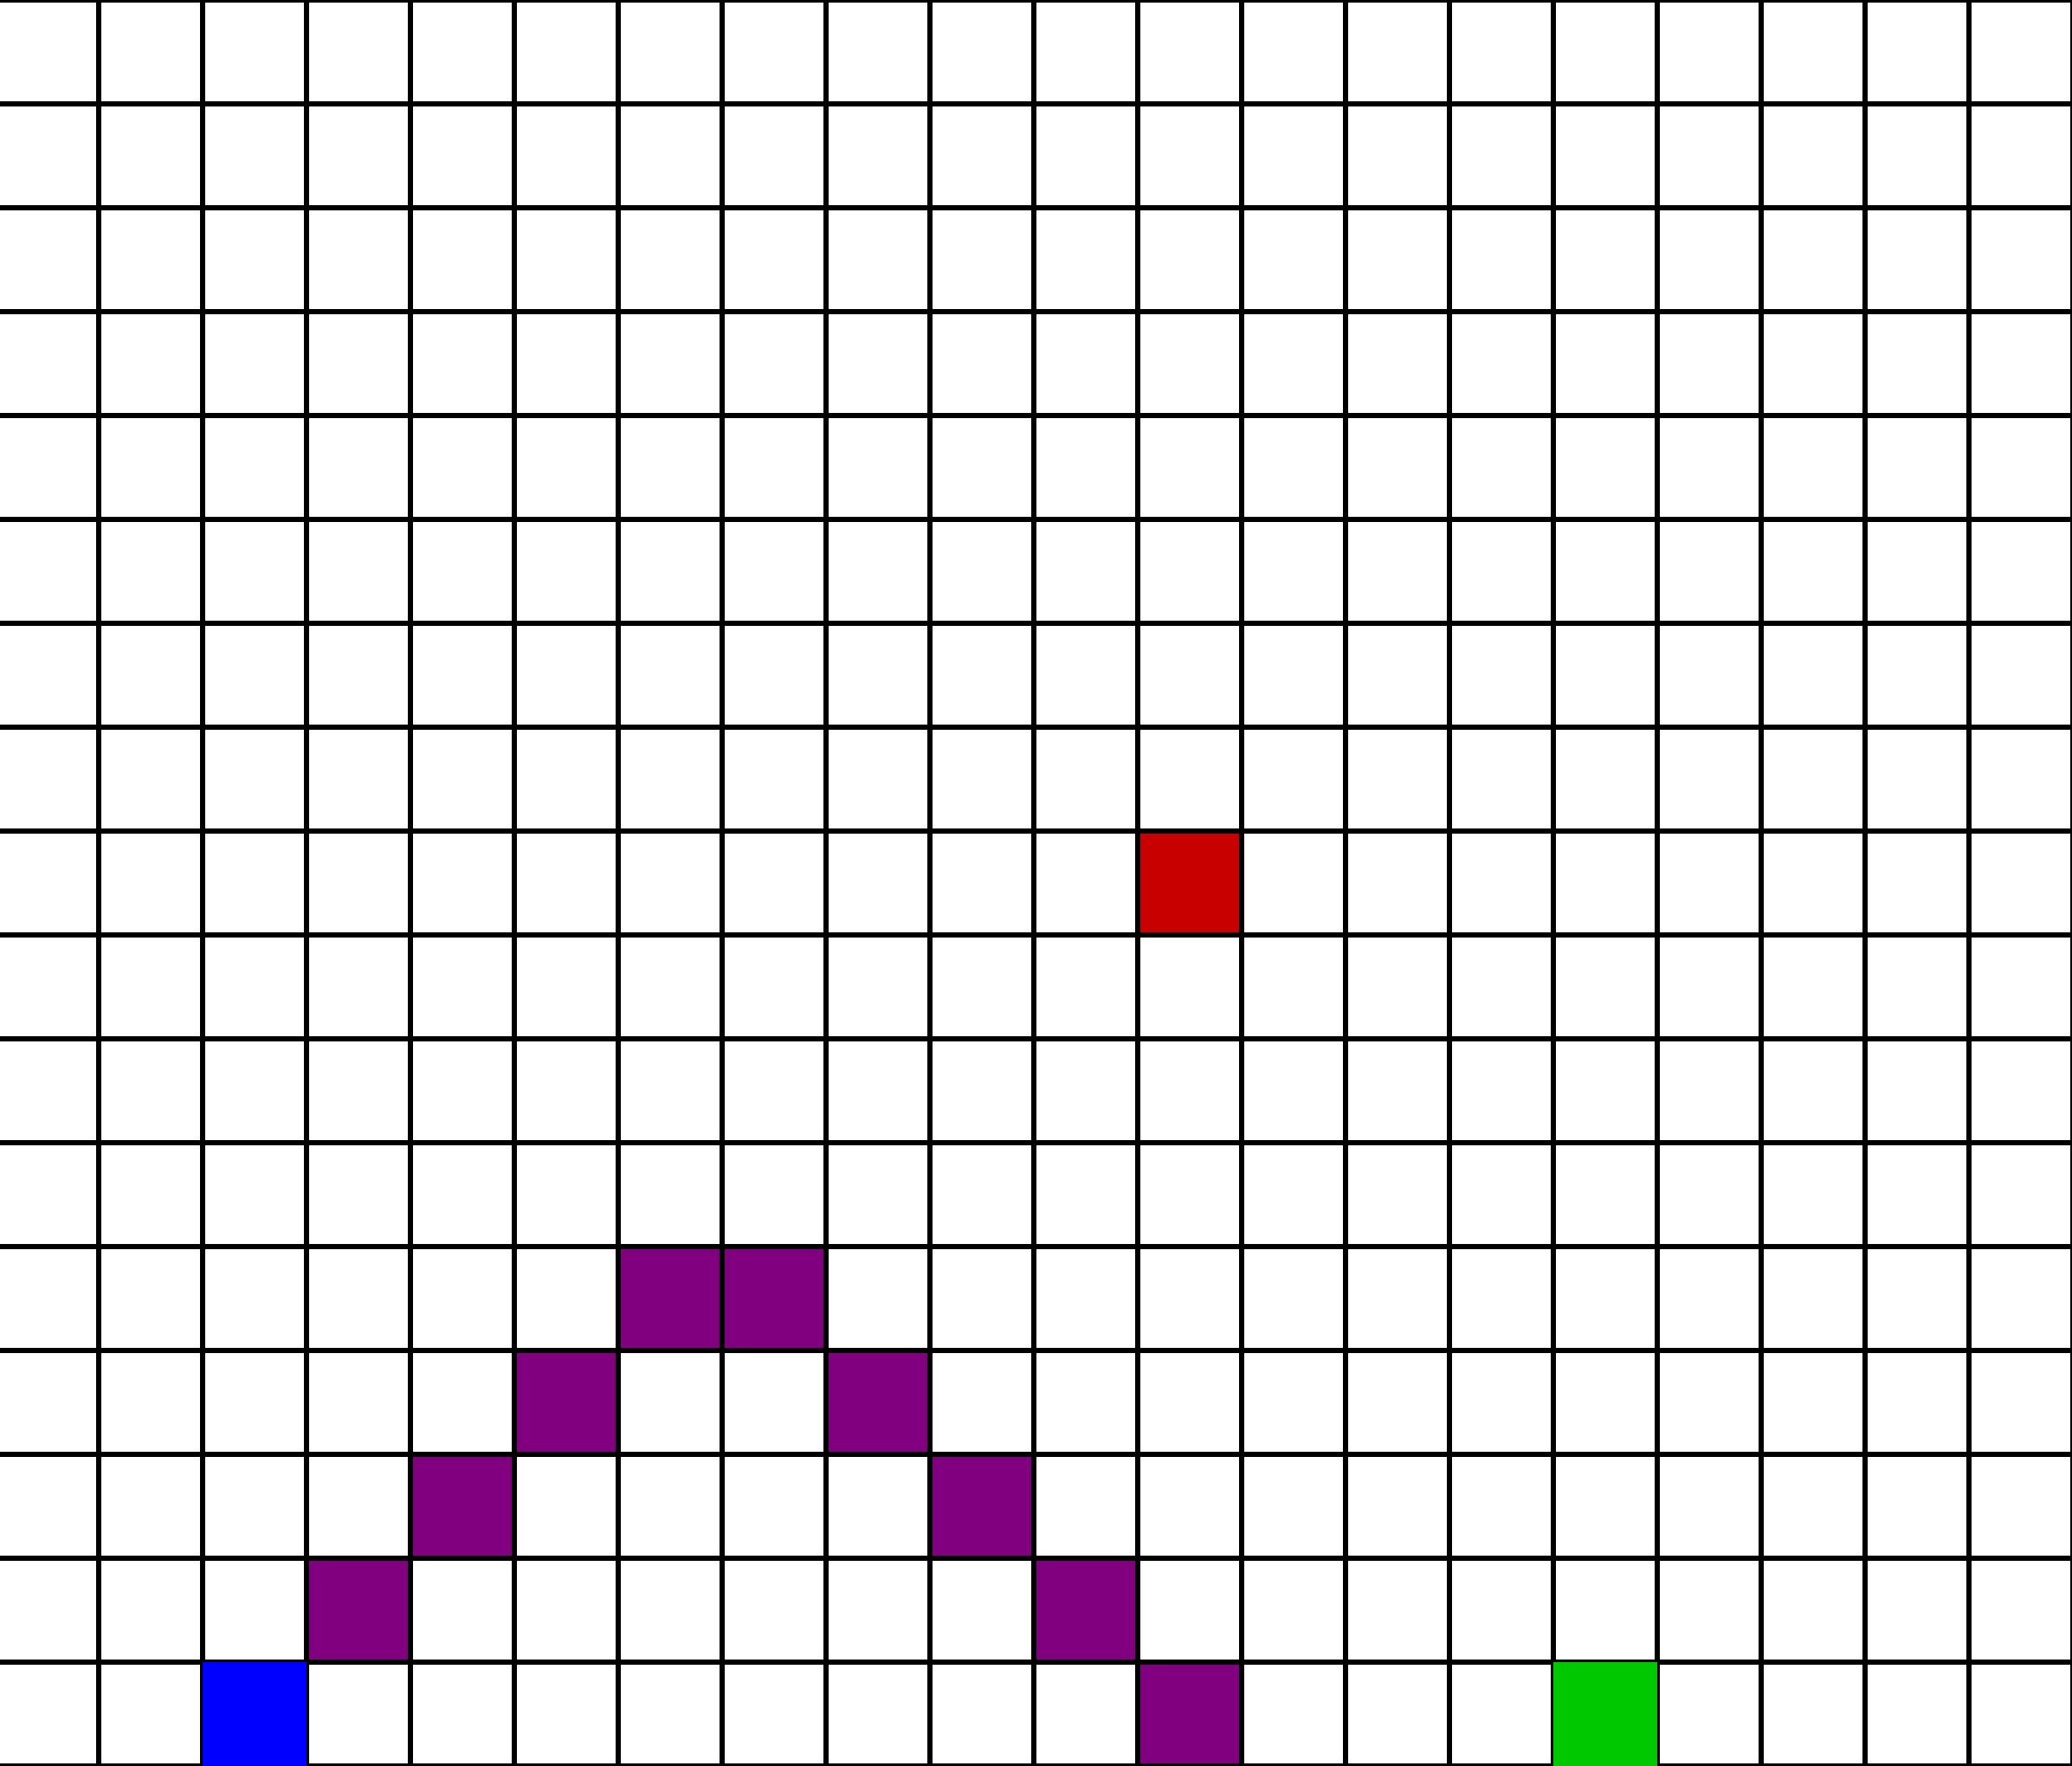

Worst case:
