--------------------------

METHODOLOGICAL INFORMATION

--------------------------

Rainfall data are collected using tipping bucket rain gauges (TBRG) (TB4, Hydrological Services America, Lake Worth, USA) at 21 stations across coastal British Columbia; 11 are on Calvert Island, 5 on Hecate Island, 1 on Ethel Island (Rivers Inlet, and 1 on Quadra Island (Discovery Islands) (Figure 1). The tipping buckets are installed at 2m above the ground surface, and visited semi-annually for maintenance and calibration. Calibration is done using a field calibration device (FCD, Kisters North America, Roseville, USA) with a nozzle calibrated to a rate of 200mm/hr. Data are available in near real-time using the Hakai Telemetry Network (www.hakai.org/technology/#science-1). Total precipitation is measured at 4m above the ground surface at 2 stations on Calvert Island, East Buxton and the Reference Station (liquid and solid; 400mm opening PVC; pressure transducer displacement gauge).

--------------------------

QUALITY CONTROL AND ASSURANCE PROCEDURES:

--------------------------

This precipitation time-series is created using 5-minute average measurements aggregated to the hourly timestep. General procedures for flagging data can be found in the “[Hakai Sensor Network Quality Control (QC)](https://docs.google.com/document/d/1mDZrPlHqRUK-L4An4eW3m_hvu2nfsXA7TdNZ2s6-JCw/edit)” document. Quality assurance procedures specific to precipitation involve a combination of visual and automated inspection of the data for inconsistencies, large increases in measurements, and outliers.

From 2013 to 2018, tipping bucket rain gauges at a number of wind-exposed sites (WSN693_703, WSN703_708, Hecate, East Buxton, and WSN819_1015, and SSN693) were not sufficiently anchored and were susceptible to wind-induced tips during storm events. These events were identified through visual inspection by comparing seasonal storm event magnitudes between wind-exposed sites and neighboring sheltered gauges (WSN703, SSN708, WSN844 and SSN819, SSN626). Because of the wind-exposure at WSN693_703, WSN703_708, Hecate, East Buxton, and WSN819_1015, and SSN693 data at these sites was also corrected for under catch following Yang et al. (2008) using the wind speed adjustment from Legates et al., (2005). Summary figures for these corrections can be found in the companion “Wind-Rain Summary” document.

Data from the wind-exposed sites identified as “suspect” were removed and gap-filled using simple linear regression with measurements from the nearby station which exhibited the greatest coefficient of determination (R2) and assigned an “EV” – Estimated Value flag. Data from the Quadra, Ethel, and Koeye stations are not gap-filled and missing data was assigned an “MV” – Missing Value flag. All other data points were flagged as “AV” – Accepted Value.

In February 2016, an automated quality assurance algorithm was implemented to filter out suspect events. When 3 or more tips occur within a 5s scan interval, the data are removed, and gap-filled using the above-mentioned methodology. This tip threshold assumes that 3 or more tips within 5s would yield an extremely unlikely rainfall rate for the area (>200 mm hr-1) and warrants further examination.

Appendix

Table 1. Detailed location information for rain gauge measurements on Calvert, Hecate, Quadra, and Ethel Islands, and the Koeye River.

|  |  |  |  |
| --- | --- | --- | --- |
| **Site** | **Elevation (m)** | **Latitude** | **Longitude** |
| Buxton | 672 | 51.60491 | -128.01782 |
| Buxton East | 740 | 51.58993 | -127.97523 |
| WSN693_703 | 449 | 51.61058 | -127.98708 |
| SSN693 | 51 | 51.64417 | -127.99777 |
| WSN703 | 42 | 51.64333 | -128.02277 |
| WSN703_708 | 289 | 51.62218 | -128.05065 |
| SSN708 | 12 | 51.64856 | -128.06835 |
| SSN626 | 13 | 51.64083 | -128.12194 |
| WSN626 | 78 | 51.62624 | -128.10178 |
| Reference Station | 43 | 51.65195 | -128.1287 |
| TSN3 | 49 | 51.65149 | -128.12880 |
| PruthDock | 5 | 51.65455 | -128.12942 |
| Lookout | 63 | 51.6475 | -128.14318 |
| SSN1015 | 17 | 51.69055 | -128.06527 |
| WSN819_1015 | 331 | 51.68265 | -128.04332 |
| SSN819 | 79 | 51.66194 | -128.04194 |
| Hecate | 477 | 51.68256 | -128.02278 |
| WSN844 | 90 | 51.66138 | -127.9975 |
| Koeye | 19 | 51.77083 | -127.87944 |
| Ethel | 3 | 51.54844 | -127.53174 |
| Quadra | 11 | 50.11625 | -125.22211 |

Table 2) Aggregated monthly rainfall by water year.

|  |  |  |  |  |
| --- | --- | --- | --- | --- |
| Water Year | All stations | High elevation | Low elevation | Other stations |
| 2019 | [MTD](https://hecate.hakai.org/sn/p/viewsndata.pl?dataTable=1daySamples&measurements=BuxtonEast.RainMtd,Ethel.RainMtd,Hecate.RainMtd,Koeye.RainMtd,PruthDock.RainMtd,Quadra.RainMtd,RefStn.RainMtd,SSN1015US.RainMtd,SSN626PWR.RainMtd,SSN693PWR.RainMtd,SSN708.RainMtd,SSN819PWR.RainMtd,TSN3.RainMtd,WSN626.RainMtd,WSN693_703.RainMtd,WSN703.RainMtd,WSN703_708.RainMtd,WSN819_1015.RainMtd,WSN844.RainMtd&firstMeasurementTime=2018-10-01%2000:00&lastMeasurementTime=2019-09-30%2023:59) | [MTD](https://hecate.hakai.org/sn/p/viewsndata.pl?dataTable=1daySamples&measurements=BuxtonEast.RainMtd,Hecate.RainMtd,WSN693_703.RainMtd,WSN703.RainMtd,WSN703_708.RainMtd,WSN819_1015.RainMtd&firstMeasurementTime=2018-10-01%2000:00&lastMeasurementTime=2019-09-30%2023:59) | [MTD](https://hecate.hakai.org/sn/p/viewsndata.pl?dataTable=1daySamples&measurements=RefStn.RainMtd,SSN1015US.RainMtd,SSN626PWR.RainMtd,SSN693PWR.RainMtd,SSN708.RainMtd,SSN819PWR.RainMtd,TSN3.RainMtd,WSN626.RainMtd,WSN844.RainMtd,PruthDock.RainMtd&firstMeasurementTime=2018-10-01%2000:00&lastMeasurementTime=2019-09-30%2023:59) | [MTD](https://hecate.hakai.org/sn/p/viewsndata.pl?dataTable=1daySamples&measurements=Ethel.RainMtd,Koeye.RainMtd,Quadra.RainMtd&firstMeasurementTime=2018-10-01%2000:00&lastMeasurementTime=2019-09-30%2023:59) |
| 2018 | [MTD](https://hecate.hakai.org/sn/p/viewsndata.pl?dataTable=1daySamples&measurements=BuxtonEast.RainMtd,Ethel.RainMtd,Hecate.RainMtd,Koeye.RainMtd,PruthDock.RainMtd,Quadra.RainMtd,RefStn.RainMtd,SSN1015US.RainMtd,SSN626PWR.RainMtd,SSN693PWR.RainMtd,SSN708.RainMtd,SSN819PWR.RainMtd,TSN3.RainMtd,WSN626.RainMtd,WSN693_703.RainMtd,WSN703.RainMtd,WSN703_708.RainMtd,WSN819_1015.RainMtd,WSN844.RainMtd&firstMeasurementTime=2017-10-01%2000:00&lastMeasurementTime=2018-09-30%2023:59) | [MTD](https://hecate.hakai.org/sn/p/viewsndata.pl?dataTable=1daySamples&measurements=BuxtonEast.RainMtd,Hecate.RainMtd,WSN693_703.RainMtd,WSN703.RainMtd,WSN703_708.RainMtd,WSN819_1015.RainMtd&firstMeasurementTime=2017-10-01%2000:00&lastMeasurementTime=2018-09-30%2023:59) | [MTD](https://hecate.hakai.org/sn/p/viewsndata.pl?dataTable=1daySamples&measurements=RefStn.RainMtd,SSN1015US.RainMtd,SSN626PWR.RainMtd,SSN693PWR.RainMtd,SSN708.RainMtd,SSN819PWR.RainMtd,TSN3.RainMtd,WSN626.RainMtd,WSN844.RainMtd&firstMeasurementTime=2017-10-01%2000:00&lastMeasurementTime=2018-09-30%2023:59) | [MTD](https://hecate.hakai.org/sn/p/viewsndata.pl?dataTable=1daySamples&measurements=Ethel.RainMtd,Koeye.RainMtd,Quadra.RainMtd&firstMeasurementTime=2017-10-01%2000:00&lastMeasurementTime=2018-09-30%2023:59) |
| 2017 | [MTD](https://hecate.hakai.org/sn/p/viewsndata.pl?dataTable=1daySamples&measurements=BuxtonEast.RainMtd,Ethel.RainMtd,Hecate.RainMtd,Koeye.RainMtd,PruthDock.RainMtd,Quadra.RainMtd,RefStn.RainMtd,SSN1015US.RainMtd,SSN626PWR.RainMtd,SSN693PWR.RainMtd,SSN708.RainMtd,SSN819PWR.RainMtd,TSN3.RainMtd,WSN626.RainMtd,WSN693_703.RainMtd,WSN703.RainMtd,WSN703_708.RainMtd,WSN819_1015.RainMtd,WSN844.RainMtd&firstMeasurementTime=2016-10-01%2000:00&lastMeasurementTime=2017-09-30%2023:59) | [MTD](https://hecate.hakai.org/sn/p/viewsndata.pl?dataTable=1daySamples&measurements=BuxtonEast.RainMtd,Hecate.RainMtd,WSN693_703.RainMtd,WSN703.RainMtd,WSN703_708.RainMtd,WSN819_1015.RainMtd&firstMeasurementTime=2016-10-01%2000:00&lastMeasurementTime=2017-09-30%2023:59) | [MTD](https://hecate.hakai.org/sn/p/viewsndata.pl?dataTable=1daySamples&measurements=RefStn.RainMtd,SSN1015US.RainMtd,SSN626PWR.RainMtd,SSN693PWR.RainMtd,SSN708.RainMtd,SSN819PWR.RainMtd,TSN3.RainMtd,WSN626.RainMtd,WSN844.RainMtd&firstMeasurementTime=2016-10-01%2000:00&lastMeasurementTime=2017-09-30%2023:59) | [MTD](https://hecate.hakai.org/sn/p/viewsndata.pl?dataTable=1daySamples&measurements=Ethel.RainMtd,Koeye.RainMtd,Quadra.RainMtd&firstMeasurementTime=2016-10-01%2000:00&lastMeasurementTime=2017-09-30%2023:59) |
| 2016 | [MTD](https://hecate.hakai.org/sn/p/viewsndata.pl?dataTable=1daySamples&measurements=BuxtonEast.RainMtd,Ethel.RainMtd,Hecate.RainMtd,Koeye.RainMtd,PruthDock.RainMtd,Quadra.RainMtd,RefStn.RainMtd,SSN1015US.RainMtd,SSN626PWR.RainMtd,SSN693PWR.RainMtd,SSN708.RainMtd,SSN819PWR.RainMtd,TSN3.RainMtd,WSN626.RainMtd,WSN693_703.RainMtd,WSN703.RainMtd,WSN703_708.RainMtd,WSN819_1015.RainMtd,WSN844.RainMtd&firstMeasurementTime=2015-10-01%2000:00&lastMeasurementTime=2016-09-30%2023:59) | [MTD](https://hecate.hakai.org/sn/p/viewsndata.pl?dataTable=1daySamples&measurements=BuxtonEast.RainMtd,Hecate.RainMtd,WSN693_703.RainMtd,WSN703.RainMtd,WSN703_708.RainMtd,WSN819_1015.RainMtd&firstMeasurementTime=2015-10-01%2000:00&lastMeasurementTime=2016-09-30%2023:59) | [MTD](https://hecate.hakai.org/sn/p/viewsndata.pl?dataTable=1daySamples&measurements=RefStn.RainMtd,SSN1015US.RainMtd,SSN626PWR.RainMtd,SSN693PWR.RainMtd,SSN708.RainMtd,SSN819PWR.RainMtd,TSN3.RainMtd,WSN626.RainMtd,WSN844.RainMtd&firstMeasurementTime=2015-10-01%2000:00&lastMeasurementTime=2016-09-30%2023:59) | [MTD](https://hecate.hakai.org/sn/p/viewsndata.pl?dataTable=1daySamples&measurements=Ethel.RainMtd,Koeye.RainMtd,Quadra.RainMtd&firstMeasurementTime=2015-10-01%2000:00&lastMeasurementTime=2016-09-30%2023:59) |
| 2015 | [MTD](https://hecate.hakai.org/sn/p/viewsndata.pl?dataTable=1daySamples&measurements=BuxtonEast.RainMtd,Ethel.RainMtd,Hecate.RainMtd,Koeye.RainMtd,PruthDock.RainMtd,Quadra.RainMtd,RefStn.RainMtd,SSN1015US.RainMtd,SSN626PWR.RainMtd,SSN693PWR.RainMtd,SSN708.RainMtd,SSN819PWR.RainMtd,TSN3.RainMtd,WSN626.RainMtd,WSN693_703.RainMtd,WSN703.RainMtd,WSN703_708.RainMtd,WSN819_1015.RainMtd,WSN844.RainMtd&firstMeasurementTime=2014-10-01%2000:00&lastMeasurementTime=2015-09-30%2023:59) | [MTD](https://hecate.hakai.org/sn/p/viewsndata.pl?dataTable=1daySamples&measurements=BuxtonEast.RainMtd,Hecate.RainMtd,WSN693_703.RainMtd,WSN703.RainMtd,WSN703_708.RainMtd,WSN819_1015.RainMtd&firstMeasurementTime=2014-10-01%2000:00&lastMeasurementTime=2015-09-30%2023:59) | [MTD](https://hecate.hakai.org/sn/p/viewsndata.pl?dataTable=1daySamples&measurements=RefStn.RainMtd,SSN1015US.RainMtd,SSN626PWR.RainMtd,SSN693PWR.RainMtd,SSN708.RainMtd,SSN819PWR.RainMtd,TSN3.RainMtd,WSN626.RainMtd,WSN844.RainMtd&firstMeasurementTime=2014-10-01%2000:00&lastMeasurementTime=2015-09-30%2023:59) | [MTD](https://hecate.hakai.org/sn/p/viewsndata.pl?dataTable=1daySamples&measurements=Ethel.RainMtd,Koeye.RainMtd,Quadra.RainMtd&firstMeasurementTime=2014-10-01%2000:00&lastMeasurementTime=2015-09-30%2023:59) |
| 2014 | [MTD](https://hecate.hakai.org/sn/p/viewsndata.pl?dataTable=1daySamples&measurements=BuxtonEast.RainMtd,Ethel.RainMtd,Hecate.RainMtd,Koeye.RainMtd,PruthDock.RainMtd,Quadra.RainMtd,RefStn.RainMtd,SSN1015US.RainMtd,SSN626PWR.RainMtd,SSN693PWR.RainMtd,SSN708.RainMtd,SSN819PWR.RainMtd,TSN3.RainMtd,WSN626.RainMtd,WSN693_703.RainMtd,WSN703.RainMtd,WSN703_708.RainMtd,WSN819_1015.RainMtd,WSN844.RainMtd&firstMeasurementTime=2013-10-01%2000:00&lastMeasurementTime=2014-09-30%2023:59) | [MTD](https://hecate.hakai.org/sn/p/viewsndata.pl?dataTable=1daySamples&measurements=BuxtonEast.RainMtd,Hecate.RainMtd,WSN693_703.RainMtd,WSN703.RainMtd,WSN703_708.RainMtd,WSN819_1015.RainMtd&firstMeasurementTime=2013-10-01%2000:00&lastMeasurementTime=2014-09-30%2023:59) | [MTD](https://hecate.hakai.org/sn/p/viewsndata.pl?dataTable=1daySamples&measurements=RefStn.RainMtd,SSN1015US.RainMtd,SSN626PWR.RainMtd,SSN693PWR.RainMtd,SSN708.RainMtd,SSN819PWR.RainMtd,TSN3.RainMtd,WSN626.RainMtd,WSN844.RainMtd&firstMeasurementTime=2013-10-01%2000:00&lastMeasurementTime=2014-09-30%2023:59) | - |

Table 3) Total annual and mean annual precipitation and discharge for each watershed in the Kwakshua Watersheds Observatory.

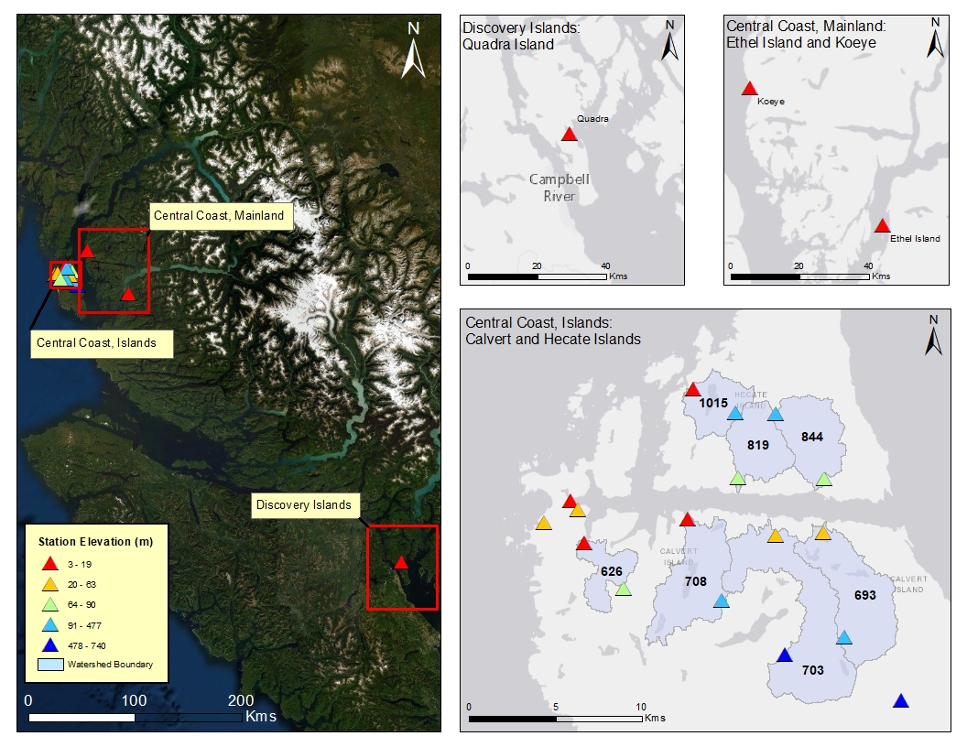

*Figure 1. The locations of Hakai meteorological stations along the British Columbia coast, Canada (left). Map insets displayed on the right depict the Discovery Islands (upper right-left), Central Coast, mainland (upper right-right), and Calvert and Hecate Islands (lower right). Station symbols are coloured red to blue from lowest (3m) to highest (741m) elevation.*

**References**

Legates, D., Yang, D., Quiring, S., Freeman, K., Bogart, T. (2005). Bias adjustments to Arctic precipitation: a comparison of daily versus monthly bias adjustments. 8TH Conference on polar meteorology and oceanography, 85th annual AMS meeting (San Digeo, CA).

Upton, G. J. G., & Rahimi, A. R. (2003). On-line detection of errors in tipping-bucket raingauges. *Journal of Hydrology*, *278*(1-4), 197-212.

Yang D., Goodison B.E., Metcalfe J.R. (1998). Accuracy of NWS 8" Standard non recording precipitation gauge: results and application of WMO intercomparison. *Journal of Atmospheric & Oceanic Technology,* 15: 54–68.