**Investigators:** Wiley Evans (Hakai Institute), Geoffrey Lebon (University of Washington Joint Institute for the Study of the Atmosphere and Ocean/NOAA Pacific Marine Environmental Laboratory), Christen D. Harrington (Alaska Department of Transportation), and Allison Bidlack (University of Alaska Southeast, Alaska Coastal Rainforest Center)

**Title:** Underway surface seawater and marine boundary layer observations made from the Alaska Marine Highway System M/V *Columbia*

**Abstract:** Between October 2017 and October 2019, underway surface water measurements were collected from the Alaska Marine Highway System M/V *Columbia* during 135 service route transits. The service route of the *Columbia* included the ports of Sitka, Juneau, Haines, Skagway, Wrangell, Petersburg, and Ketchikan in southeast Alaska, and between Ketchikan and Bellingham, WA. The vessel sailed south from Ketchikan every Wednesday, arrived in Bellingham on Friday, returned to Ketchikan on Sunday, and transited between southeast Alaska terminals between Sunday and Wednesday. Measurements of temperature, salinity, dissolved oxygen content, and CO2 partial pressure were made every 2 mins on seawater drawn into the vessel from a ~2 m intake. Seawater was delivered from the intake to analytical equipment on the car deck using a AMT 1/2 HP pump (4295-98). Temperature and salinity data were collected using a Sea-Bird SBE 45 MicroTSG Thermosalinograph, and intake temperature measured using a SBE 38 Digital Oceanographic Thermometer. Dissolved oxygen content was determined using an Aanderaa 4330F that had undergone multipoint calibration at the factory in Norway. CO2 measurements were made using a General Oceanics 8050 (GO8050) pCO2 Measuring System equipped with a LI-COR LI840A non-dispersive infrared detector. All data streams, including GPS information from an antenna and atmospheric pressure from a Vaisala barometer positioned on the foredeck, were captured by the GO8050 control computer. Atmospheric CO2 measurements were also made using the GO8050 on unaltered marine air drawn to the system through an intake located on the foredeck. The CO2 measurement scheme involved the analysis of four gas standards of known CO2 content (150 ppm, 349 ppm, 449 ppm, and 850 ppm; Praxair Distributions Inc), 12 analyses atmospheric CO2, and 240 seawater CO2 measurements in a 8.5 hour period. The atmospheric and seawater CO2 analyses were run in a sequence of 3 atmospheric measurements and 60 seawater measurements that was repeated 4 times between standardization. This project was supported by the Tula Foundation and Alaska Ocean Observing System, and was a collaborative effort between the Hakai Institute, University of Washington Joint Institute for the Study of the Atmosphere and Ocean/NOAA Pacific Marine Environmental Laboratory, State of Alaska Department of Transportation, University of Alaska Southeast Alaska Coastal Rainforest Center, and the Alaska Ocean Observing System.

**Cite as:** Evans, W., G. Lebon, C. D. Harrington, and A. Bidlack (2019). Underway surface seawater and marine boundary layer observations made from the Alaska Marine Highway System M/V *Columbia*. Version 1.0. Hakai Institute. Dataset. [access date].

**Type of Study:** Vessel-of-opportunity underway surface ocean and marine boundary layer measurements

**Temporal Coverage:** October 25, 2017 to October 4, 2018

**Spatial Coverage:** Surface (~2m) seawater measurements collected underway between Bellingham, Washington (48.7519°N, 122.4787°W) to Skagway, Alaska (59.4583°N, 135.3139°W).

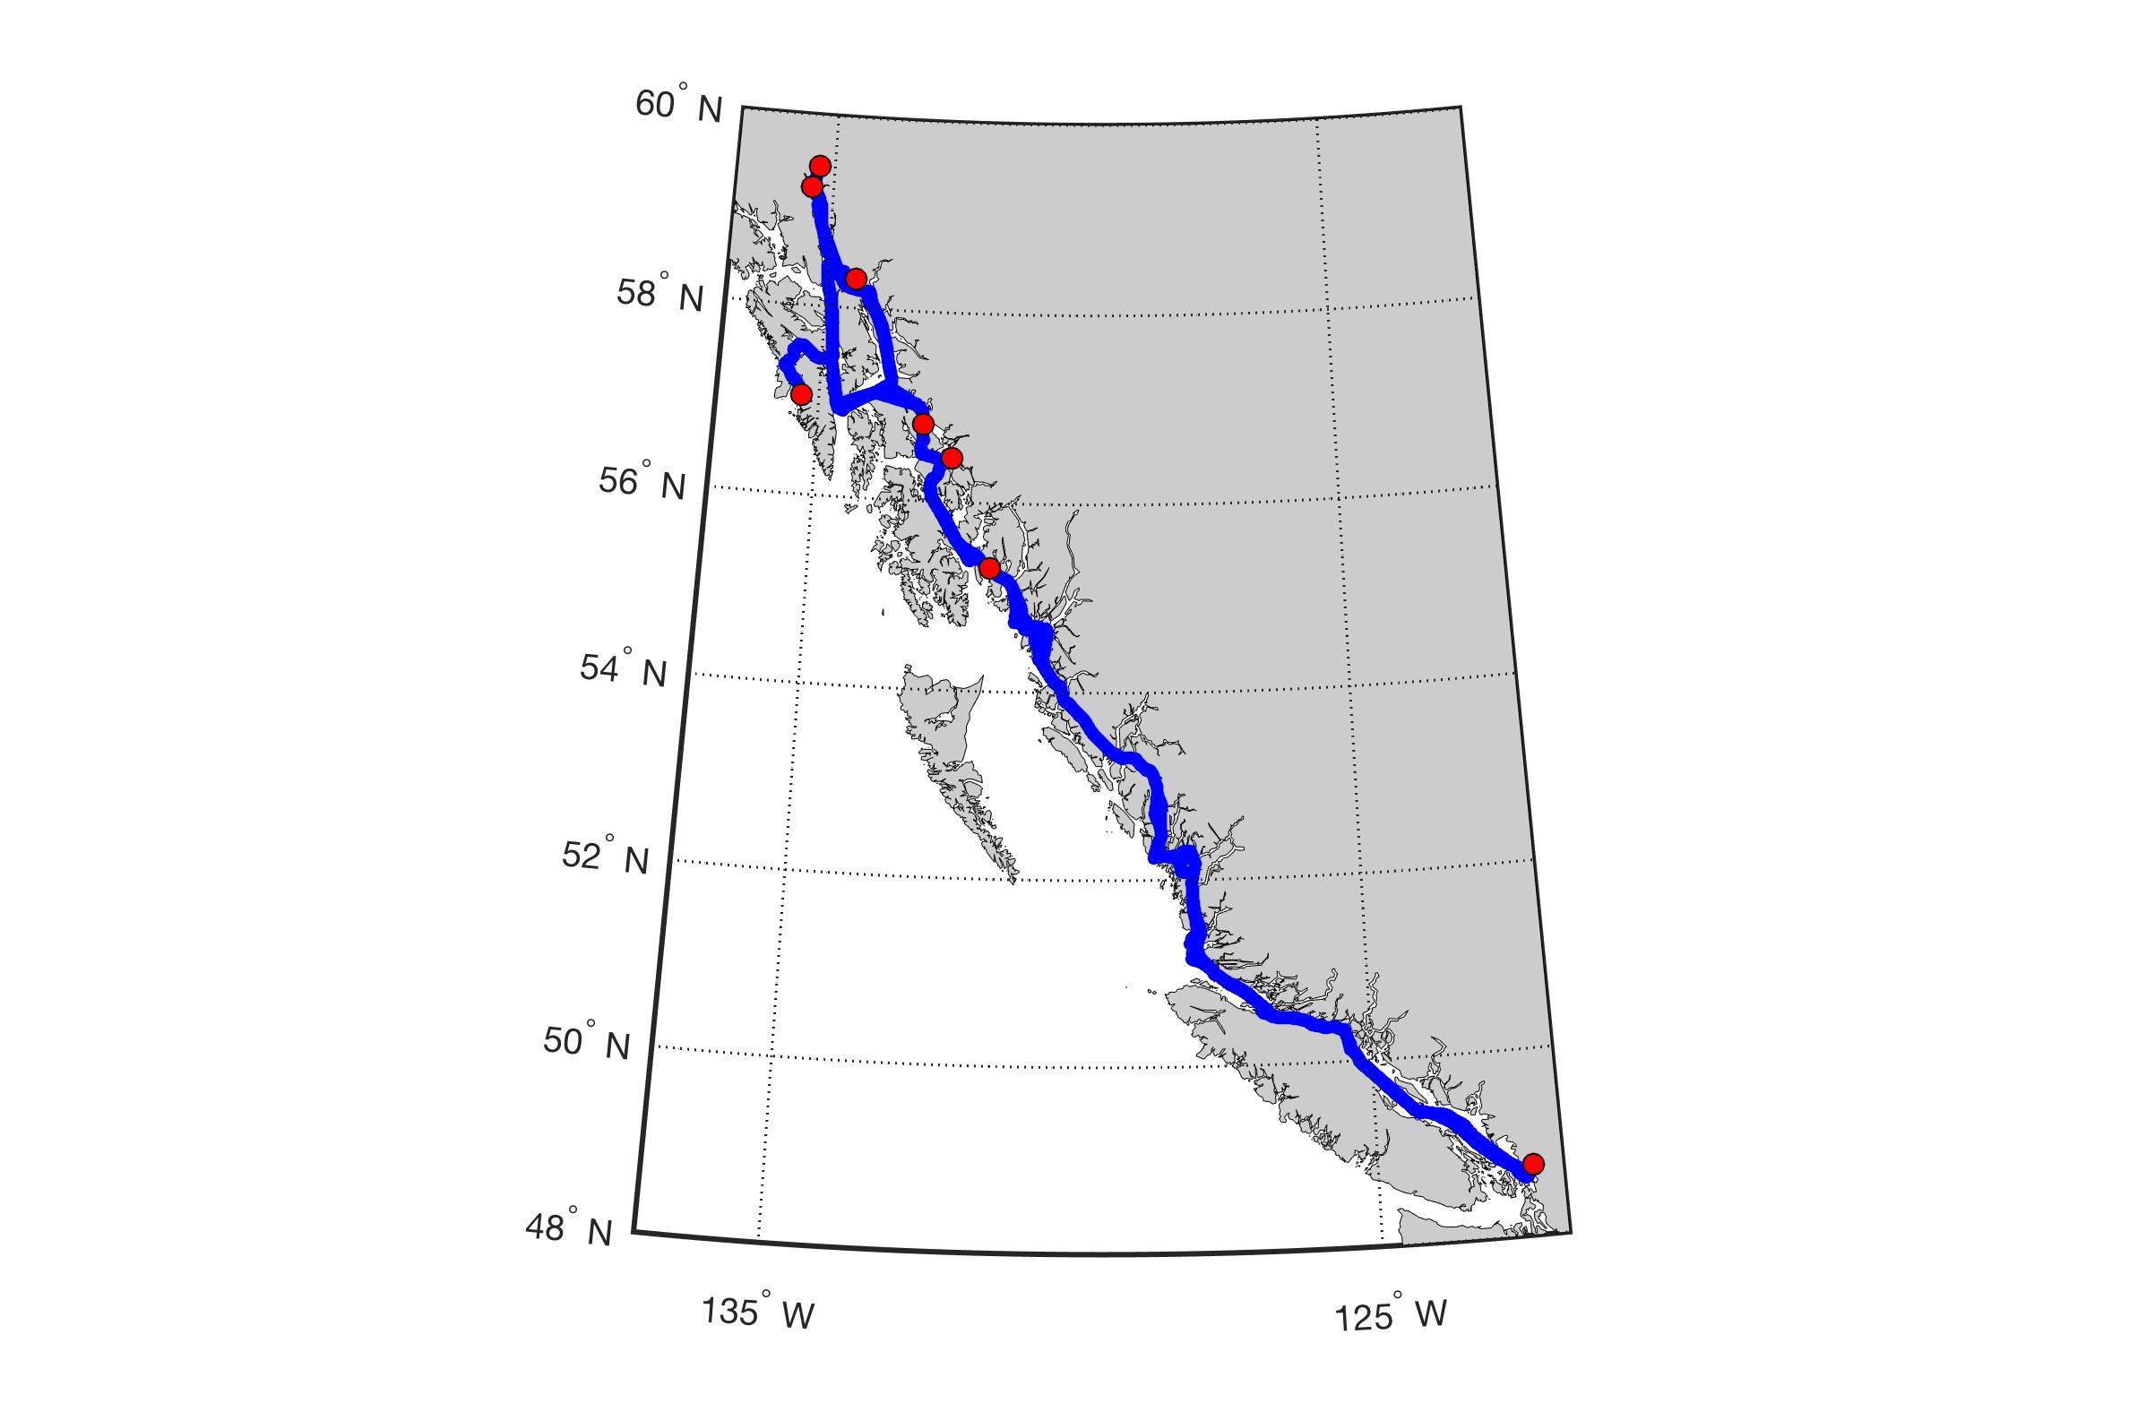

**Figure 1:** Track of the M/V Columbia (blue) between service ports (red dots).

**Geographic Names:** British Columbia coast; southeast Alaska coast; Gulf of Alaska; North Pacific Ocean

**Expocode:** 32C320171025

**Platforms:** Alaska Marine Highway System M/V *Columbia*

**Version:** 1.0

**Submission Date:** January 9, 2020

**Filename:** Columbia_UW_data_Y1_Y2_QCed.txt

**Column Header Information:** (1) Type code (2) Date and Time (yyyy-mm-dd hh:mm:ss) (3) PC Date (ddmmyy) (4) PC time (hhmmss) (5) GPS date (ddmmyy) (6) GPS time (hhmmss) (7) latitude (8) longitude (9) equ temp (deg C) (10) std val (ppm) (11) CO2 (abs) (12) CO2 (ppm) (13) H2O (abs) (14) H20 (ppm) (15) LICOR temp (deg C) (16) LICOR pressure (mbar) (17) equ differential pressure (mbar) (18) H2O flow (l/min) (19) LICOR flow (ml/min) (20) equ pump speed (rpm) (21) vent flow (ml/min) (22) atm moisture sensor (23) equil moisture sensor (24) drip sensor (25) cond temp (deg C) (26) dry box temp (deg C) (27) deck pressure (mbar) (28) raw O2 (uM) (29) raw O2 (%Sat) (30) O2 Temp (deg C) (31) Cal Phase (32) TCPhase (33) C1RPh (34) C2RPh (35) C1Amp (36) C2Amp (37) Raw Temp (38) TSG T (deg C) (39) TSG Conductivity (S/m) (40) TSG Salinity (PSS-78) (41) Intake T (deg C) (42) calibrated ATM xCO2 dry (ppm) (43) calibrated SW xCO2 dry (ppm) (44) ATM pressure for ATM xCO2 (mbar) (45) equilibrator pressure (mbar) (46) ATM pCO2 wet (uatm) (47) SW pCO2 wet equil T (uatm) (48) SW pCO2 wet SST (uatm) (49) O2 (umol/kg) (50) O2sol (umol/kg) (51) delta-O2 (umol/kg) (52) ATM fCO2_wet (uatm) (53) SW fCO2_wet (uatm)

**Researcher Contact:** Please direct questions regarding these data to Wiley Evans (wiley.evans@hakai.org).

**Researcher institution:** Hakai Institute

**Core Variables:**

*Seawater partial pressure of carbon dioxide at sea surface temperature*

**Abbreviation:** SW pCO2 wet SST

**Unit:** µatm

**Observation type:** Measurements from continuously flowing seawater stream

**In-situ/Manipulation/Response variable:** In situ observation

**Measured or calculated:** Calculated from measured CO2 mole fractions (xCO2) and ambient atmospheric pressure.

**Sampling instrument:** Shower-head equilibrator

**Analyzing instrument:** General Oceanics 8050 pCO2 Measuring System with LI-COR LI-840A

**Detailed sampling and analyzing information:** Seawater pCO2 data were obtained from corrected measurements of CO2 mixing ratio (xCO2) made using a General Oceanics 8050 (GO8050) pCO2 Measuring System and following recommended protocols by Pierrot et al. (2009). Surface (~2 m) seawater was delivered at ~3 l/min to a showerhead equilibrator in the GO8050 by a ½ HP pump located proximal to the seawater intake in the bow thruster room of the M/V *Columbia*. Seawater sample air from the equilibrator was supplied to a non-dispersive infrared gas analyzer (LI-COR LI840A CO2/H2O) housed within the system’s dry box. Carrier gas is then recirculated through the system, minimizing the need for make-up air supplied by a secondary equilibrator. Seawater sample air, four standard gases of known mixing ratio (nominally 150, 349, 449, and 850 ppm; Praxair), and unaltered marine air were all plumbed to provide gas flow to the GO8050 dry box. The GO8050 is controlled using National Instruments LabVIEW software run on a PC laptop computer. The software controls data acquisition from a SBE 45 MicroTSG Thermosalinograph coupled with the GO8050, a SBE 38 Digital Oceanographic Thermometer located at the seawater intake, an Aanderaa 4330F coupled with the GO8050, primary equilibrator temperature and pressure sensors, a Vaisala barometer and GPS antenna located on the vessel foredeck, and the LI840A; while also controlling a Valco Instruments Co. Inc. (VICI) multi-port actuator that cycles between the gas streams plumbed to the dry box. Analytical gas streams were dried prior to analysis using a condenser and Permapure Nafion tubes. The CO2 measurement scheme controlled by the software involved the analysis of the four gas standards of known CO2 content, 12 analyses atmospheric CO2, and 240 seawater CO2 measurements in a cycle that was repeated every 8.5 hours (with a ~2 min measurement frequency). The seawater and atmospheric CO2 analyses were run in a sequence of 3 atmospheric measurements and 60 seawater measurements that was repeated 4 times between standardization. Analyses of each gas standard were interpolated over the time record of the dataset, and used to create calibration functions needed to correct the raw LI840A xCO2 data. Calibrated seawater xCO2 data in dry air were quality controlled, and then converted to CO2 partial pressure (pCO2)in wet air at the equilibrator temperature by using atmospheric pressure measured by the LI840A plus the differential pressure recorded in the equilibrator corrected for the removal of water vapor and vessel pressurization, the latter determined by the differential between the Vaisala barometric pressure on the vessel foredeck and atmospheric pressure from the LI840A. Finally, seawaterpCO2 in wet air was adjusted to sea surface temperature using the offset between SBE 45 Micro-Thermosalinograph temperature recorded at the GO8050 and intake temperature from the SBE 38 Digital Oceanographic Thermometer located at the seawater intake.

**Replicate information:** N/A

**Standardization description:** xCO2 calibration functions developed during periodic sequential analysis of gas standards of known concentration (nominally 150, 349, 449, and 850 ppm; Praxair)

**Standardization frequency:** Every 8.5 hours

**CRM manufacturer:** Praxair, Inc.

**Poison name:** N/A

**Poison volume:** N/A

**Poison correction:** N/A

**Uncertainty:** 2 ppm for calibrated xCO2; ~2 µatm for pCO2

**Quality flag convention:** No quality flag applied

**Method reference:** Pierrot, D., C. Neill, K. Sullivan, R. Castle, R. Wanninkhof, H. Lüger, T. Johannessen, A. Olsen, R. A. Feely, and C. E. Cosca (2009), Recommendations for autonomous underway pCO2 measuring systems and data-reduction routines, *Deep Sea Research Part II: Topical Studies in Oceanography*, *56*(8-10), 512-522, doi:10.1016/j.dsr2.2008.12.005

**Researcher name:** Wiley Evans

**Researcher institution:** Hakai Institute

*Atmospheric partial pressure of carbon dioxide*

**Abbreviation:** ATM pCO2 wet

**Unit:** µatm

**Observation type:** Measurements from air intake on M/V Columbia foredeck

**In-situ/Manipulation/Response variable:** In situ observation

**Measured or calculated:** Calculated from measured CO2 mole fractions (xCO2) and ambient atmospheric pressure.

**Sampling instrument:** Air intake

**Analyzing instrument:** General Oceanics 8050 pCO2 Measuring System with LI-COR LI-840A

**Detailed sampling and analyzing information:** Atmospheric pCO2 data were obtained from corrected measurements of CO2 mixing ratio (xCO2) made using a General Oceanics 8050 (GO8050) pCO2 Measuring System and following recommended protocols by Pierrot et al. (2009). Atmospheric air was supplied from an air intake on the M/V Columbia foredeck to the GO8050 with a pump located in the system at a rate of 100 ml/min. Atmospheric sample air was supplied to a non-dispersive infrared gas analyzer (LI-COR LI840A CO2/H2O) housed within the system’s dry box. Seawater sample air, four standard gases of known mixing ratio (nominally 150, 349, 449, and 850 ppm; Praxair), and unaltered marine air were all plumbed to provide gas flow to the GO8050 dry box. The GO8050 is controlled using National Instruments LabVIEW software run on a PC laptop computer. The software controls data acquisition from a SBE 45 MicroTSG Thermosalinograph coupled with the GO8050, a SBE 38 Digital Oceanographic Thermometer located at the seawater intake, an Aanderaa 4330F coupled with the GO8050, primary equilibrator temperature and pressure sensors, a Vaisala barometer and GPS antenna located on the vessel foredeck, and the LI840A; while also controlling a Valco Instruments Co. Inc. (VICI) multi-port actuator that cycles between the gas streams plumbed to the dry box. Analytical gas streams were dried prior to analysis using a condenser and Permapure Nafion tubes. The CO2 measurement scheme controlled by the software involved the analysis of the four gas standards of known CO2 content, 12 analyses atmospheric CO2, and 240 seawater CO2 measurements in a cycle that was repeated every 8.5 hours (with a ~2 min measurement frequency). The seawater and atmospheric CO2 analyses were run in a sequence of 3 atmospheric measurements and 60 seawater measurements that was repeated 4 times between standardization. Analyses of each gas standard were interpolated over the time record of the dataset, and used to create calibration functions needed to correct the raw LI840A xCO2 data. Calibrated atmospheric xCO2 data in dry air were quality controlled, and then converted to CO2 partial pressure (pCO2)in wet air by using atmospheric pressure measured by the LI840A corrected for the removal of water vapor and vessel pressurization, the latter determined by the differential between the Vaisala barometric pressure on the vessel foredeck and atmospheric pressure from the LI840A.

**Replicate information:** N/A

**Standardization description:** xCO2 calibration functions developed during periodic sequential analysis of gas standards of known concentration (nominally 150, 349, 449, and 850 ppm; Praxair)

**Standardization frequency:** Every 8.5 hours

**CRM manufacturer:** Praxair, Inc.

**Poison name:** N/A

**Poison volume:** N/A

**Poison correction:** N/A

**Uncertainty:** 2 ppm for calibrated xCO2; ~2 µatm for pCO2

**Quality flag convention:** No quality flag applied

**Method reference:** Pierrot, D., C. Neill, K. Sullivan, R. Castle, R. Wanninkhof, H. Lüger, T. Johannessen, A. Olsen, R. A. Feely, and C. E. Cosca (2009), Recommendations for autonomous underway pCO2 measuring systems and data-reduction routines, *Deep Sea Research Part II: Topical Studies in Oceanography*, *56*(8-10), 512-522, doi:10.1016/j.dsr2.2008.12.005;

**Researcher name:** Wiley Evans

**Researcher institution:** Hakai Institute

*Sea surface temperature*

**Abbreviation:** Intake T

**Unit:** °C, ITS-90 scale

**Observation type:** Measurements from continuously flowing seawater stream

**In-situ/Manipulation/Response variable:** In situ observation

**Measured or calculated:** Measured

**Sampling instrument:** N/A

**Analyzing instrument:** SBE 38 Digital Oceanographic Thermometer

**Detailed sampling and analyzing information:** Data captured using National Instruments LabVIEW software on the GO8050 PC laptop control computer

**Replicate information:** N/A

**Standardization description:** N/A

**Standardization frequency:** N/A

**CRM manufacturer:** N/A

**Poison name:** N/A

**Poison volume:** N/A

**Poison correction:** N/A

**Uncertainty:** 0.002°C

**Quality flag convention:** No quality flag applied

**Method reference:**

**Researcher name:** Wiley Evans

**Researcher institution:** Hakai Institute

*Seawater Salinity*

**Abbreviation:** TSG Salinity

**Unit:** 1978 Practical Salinity Scale

**Observation type:** Measurements from continuously flowing seawater stream

**In-situ/Manipulation/Response variable:** In situ observation

**Measured or calculated:** Calculated from conductivity and temperature measurements

**Sampling instrument:** N/A

**Analyzing instrument:** SBE 45 MicroTSG Thermosalinograph

**Detailed sampling and analyzing information:** Data captured using National Instruments LabVIEW software on the GO8050 PC laptop control computer

**Replicate information:** N/A

**Standardization description:** N/A

**Standardization frequency:** N/A

**CRM manufacturer:** N/A

**Poison name:** N/A

**Poison volume:** N/A

**Poison correction:** N/A

**Uncertainty:** 0.003 S/m

**Quality flag convention:** No quality flag applied

**Method reference:**

**Researcher name:** Wiley Evans

**Researcher institution:** Hakai Institute

*Dissolved Oxygen*

**Abbreviation:** O2

**Unit:** µmol/kg

**Observation type:** Measurements from continuously flowing seawater stream

**In-situ/Manipulation/Response variable:** In situ observation

**Measured or calculated:** Measured

**Sampling instrument:** N/A

**Analyzing instrument:** Aanderaa 4330F Oxygen Optode

**Detailed sampling and analyzing information:** Data were captured using National Instruments LabVIEW software on the GO8050 PC laptop control computer. Raw dissolved oxygen measurements were salinity corrected followed Bittig et al. (2018) and manufacturer recommendations. Salinity corrected data were then converted to µmol/kg units using temperature and salinity recorded from the Sea-Bird SBE 45 MicroTSG Thermosalinograph.

**Replicate information:** N/A

**Standardization description:** Multi-point calibration by Aanderaa

**Standardization frequency:** N/A

**CRM manufacturer:** N/A

**Poison name:** N/A

**Poison volume:** N/A

**Poison correction:** N/A

**Uncertainty:** < 5 %

**Quality flag convention:** no quality flag applied

**Method reference:** Bittig, H.C., Körtzinger, A., Neill, C., van Ooijen, E., Plant, J.N., Hahn, J., Johnson, K.S., Yang, B., and Emerson, S.R. 2018. Oxygen Optode Sensors: Principle, Characterization, Calibration, and Application in the Ocean. Frontiers in Marine Science **4**(429): doi:10.3389/fmars.2017.00429; García, H.E., and Gordon, L.I. 1992. Oxygen solubility in seawater: Better fitting equations. Limnology and Oceanography **37**(6): 1301-1312.

**Researcher name:** Wiley Evans

**Researcher institution:** Hakai Institute