HACETTEPE UNIVERSITY
DEPARTMENT OF ELECTRICAL AND ELECTRONICS ENGINEERING
ELE 432: Advanced Digital Design
Experiment 3 / Preliminary Work
Hakan Töre
2210357024

- This lab took me around 6 hours. Since I have already finished the controller circuit for the previous homework.

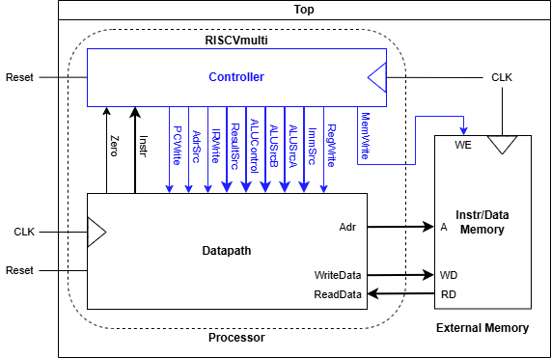

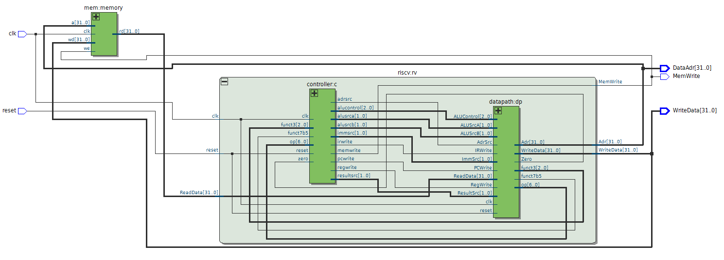

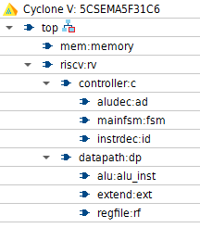

Step | PC | Instr | State | Result | Result Notes
3 | 00 | 00500113 | S0: Fetch | 4 | PC+4
4 | 04 | "" | S1: Decode | X | OldPC+Immediate
5 | 04 | "" | S8: ExecuteI | X | ALUResult = x0 (0) + 5 = 5
6 | 04 | "" | S7: ALUWB | 5 | Result = ALUOUT
7 | 04 | "" | S0: Fetch | 8 | PC+4
8 | 08 | 00c00193 | S1: Decode | X | OldPC+Immediate
9 | 08 | "" | S8: ExecuteI | X | ALUResult = x0 (0) + 12 = 12 (0xc)
10 | 08 | "" | S7: ALUWB | 12 | Result = ALUOUT
11 | 08 | "" | S0: Fetch | C_{h} | PC+4
12 | 0c | ff718393 | S1: Decode | X | OldPC+Immediate
13 | 0c | "" | S8: ExecuteI | X | ALUResult = x3 (12) + (-9) = 3
14 | 0c | "" | S7: ALUWB | 3 | Result = ALUOUT
15 | 0c | "" | S0: Fetch | 10_{h} | PC+4 (Starts next instruction)

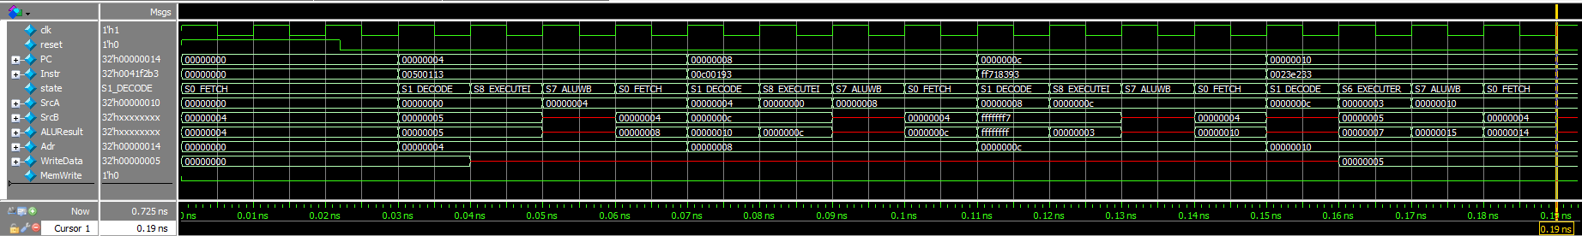
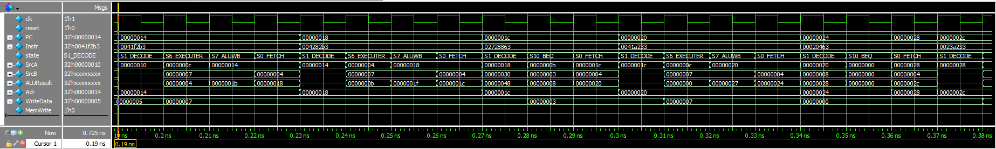
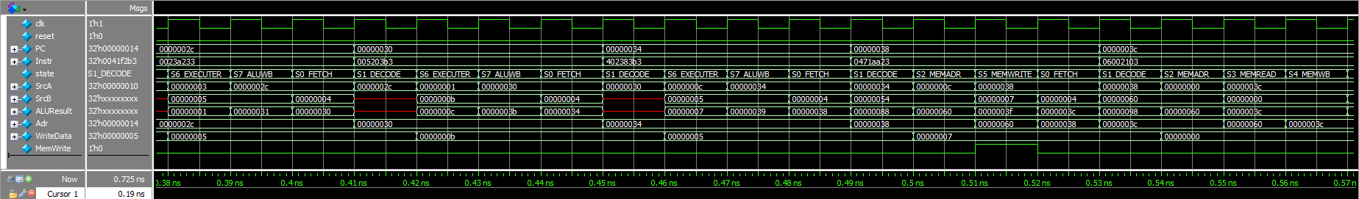
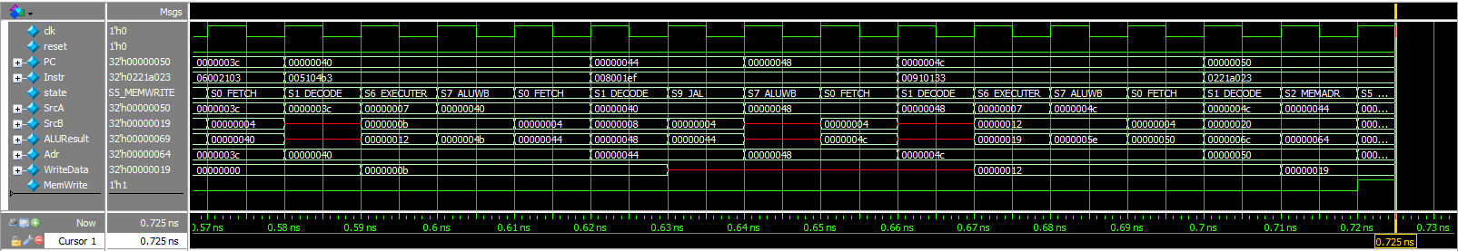

https://github.com/Hakan-26/Multicycle-Processor-Full

