LatheMacros documentation
better than nothing, right?

Turning
The turning macro generates the profile in the figure below. The input values are for the final dimensions.
Setting Nose radius to zero will make the tool tip to follow the profile.
Setting Nose radius to a positive value makes the tool path adjust for the nose radius, the tool tip will take a different path than the profile.
In the threading.ngc the points positions (P0, P1, P2, P3) are called
#<X0A>, #<Z0A> etc for the case without nose radius compensation, this case is there merely for understanding
#<X0N>,#<Z0N> etc for the case with nose radius compensation
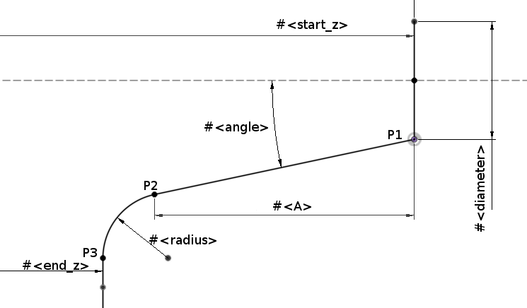
The start position of the tool defines the #<diameter> and #<start_z> parameters of the profile.
Help parameter #<A>:
#<A> = [#<start_z> - #<end_z> - #<radius>*[1-sin[#<angle>]]]
The coordinates for the P1, P2 and P3 are calulcated as follows (no P0 point)
#<X1A> = #<diameter>
#<Z1A> = #<start_z>
#<X2A> = [#<diameter> + 2*#<A>*tan[#<angle>]]
#<Z2A> = [#<end_z> + #<radius>*[1-sin[#<angle>]]]
#<X3A> = [#<diameter> + 2*#<A>*tan[#<angle>] + 2*#<radius>*cos[#<angle>]]
#<Z3A> = #<end_z>
#<G2IA>= [2*#<radius>*cos[#<angle>]]
#<G2KA>= [-#<radius>*sin[#<angle>]]
G2IA and G2KA are the radial offsets for the arc.
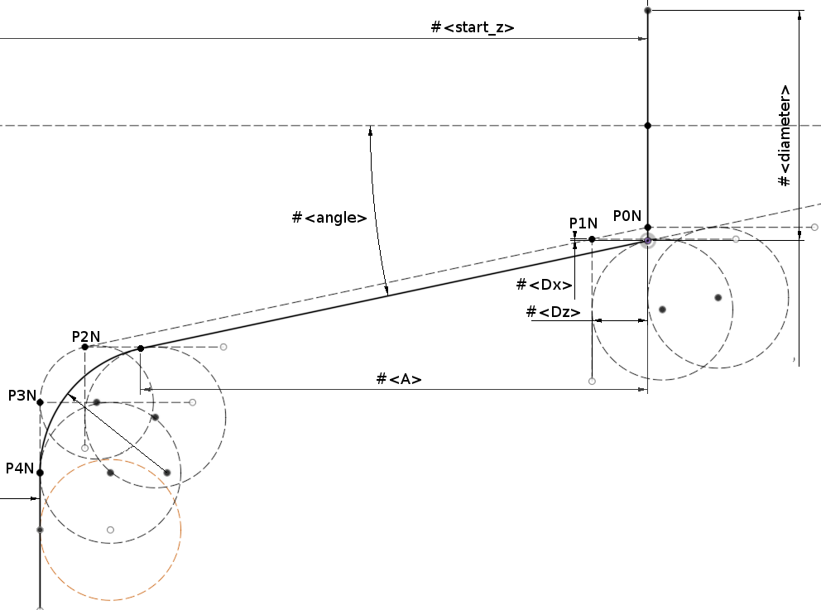
#<Dx> = [2*#<nose_radius>*[1-cos[#<angle>]]]
#<Dz> = [#<nose_radius>*[1-sin[#<angle>]]]
Add point P0N for tool to start outside of start_z. P4N is added to flatten out the path outside of this cut, the depth is #<depth_of_cut>
#<X0N> = [#<X0A> - #<Dx>]
#<Z0N> = #<Z0A>
#<X1N> = [#<X1A> - #<Dx>]
#<Z1N> = [#<Z1A> - #<Dz>]
#<X2N> = [#<X2A> - #<Dx>]
#<Z2N> = [#<Z2A> - #<Dz>]
#<X3N> = [#<X3A> - 2*#<nose_radius>]
#<Z3N> = #<end_z>
#<G2IN> = [[#<radius>-#<nose_radius>]*cos[#<angle>]]
#<G2KN> = [[#<radius>-#<nose_radius>]*sin[#<angle>]]
For negative angles there is the risk for gouging when retracting towards P1N. This is tried to compensate for.

Boring
For now, check out turning.

Facing

Chamfer

Radius

Drilling

Threading

Tapping

Plunge

