ANKARA UNIVERSITY

DEPARTMENT OF ELECTRİCAL ELECTRONİCS ENGINEERING

EEE4492

Restricted Boltzman Machine

|  |  |  |
| --- | --- | --- |
| **Student ID** | : | 20290457 |
| **Name Surname** | : | Hakan Birben |

1. **Problem Specifications**

Restricted Boltzmann Machine (RBM) is a probabilistic artificial neural network model widely used in deep learning. It is often used in applications such as dimensionality reduction, feature extraction, and recommender systems. The main purpose of RBM is to be able to derive new data and predict missing data by learning relationships in a data set. In this context, the goal of our RBM application is to learn the user-product interaction matrix and fill in missing data. While the scores given by users to some products are known, RBM creates missing or estimated scores using this data, thus forming the basis for recommendation systems.

1. **Details of the Method**

This work trains an RBM model to make product recommendations based on past interactions of e-commerce users. The core components of the code can be described as follows:

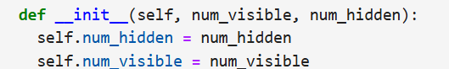

This function takes the input parameters of the model and assigns weights randomly.

Here:

* num_visible: The number of product on the user-product matrix,
* num_hidden: The number of neurons in the hidden layer (the size of the features to be learned).

The weights are initialized with the following formula:

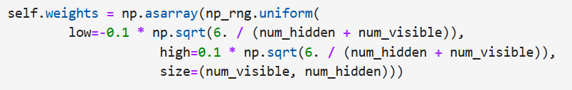

The model is trained using the Contrastive Divergence (CD-1) algorithm to fill in the gaps in the User-Product matrix.

Weights’ update:



This formula updates the weights directly proportional to the learning rate so that the model makes better predictions.

The trained RBM can make predictions for products that users have not interacted with.

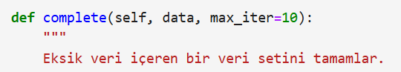

As a result, the code creates a recommendation system by completing the missing data in the e-commerce user-product matrix.

1. **Model Performance Evaluation Method**

------- To evaluate the method accuracy, precision, F1-score and recall evaluation methods can be considered; however, since the report is not completed yet, we will determine the performance evaluation later.

1. **Model Performance Evaluation/Test Results**

------- Since the model evaluations are ongoing, this section will also be completed after the evaluations.

1. **Strengths and Weaknesses of the Study**

The model has both advantages and disadvantages on applications.   
As an advantages, the model reduces computational cost by providing dimensionality reduction in large data sets. Also, it can work on large data sets thanks to the deep learning structure (hidden layers) it uses. On the other hand, If the training time is too long, the model may lose generalization(overfitting). The final version of the model only tells us whether a user will like the product or not, it does not give any information about how much they will like it. Users should evaluate these advantages and disadvantages by considering the requirements of their own projects.