Problem Definition
Blind and visually impaired individuals face numerous challenges in their everyday lives that are often not well understood. Daily activities, such as navigating independently, recognizing people, or detecting obstacles, can be extremely difficult without external assistance. Many visually impaired individuals require constant support in order to move safely, interact socially, and complete simple daily tasks. To address these difficulties, this study proposes the development of a smart system designed to assist blind and visually impaired people in their daily activities. Such a system can provide real-time guidance, object detection, and person recognition to enhance independence and safety.

Globally, the visual impairment scale remains significant. In 2020, there were approximately 43.3 million blind individuals and 295 million people with moderate-to-severe visual impairment (MSVI). Among them, 17 million people (approximately 39.6% of all blindness cases) and 83.5 million (28.3% of MSVI cases) were affected by cataracts. Notably, women represented a higher proportion of these cases, accounting for 60% of blindness cases and 59% of MSVI cases. Between 1990 and 2020, the total number of people blinded to cataracts increased by 29.7%, while the number of MSVI cases increased by 93.1%. However, when adjusted for population growth and aging, the overall global rate of cataract-related blindness decreased by 27.5%, showing progress in prevention and treatment. Cataracts remain a major cause of blindness, particularly in South Asia (62.9%), Southeast Asia, and Oceania (47.9%) (Khanna et al., 2024).[1]
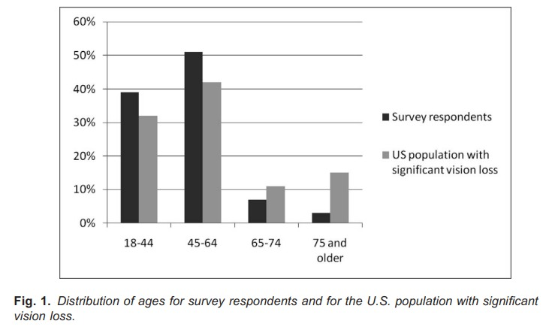
Fig2: illustrates the distribution of ages for the survey respondents compared with the age distribution for the U.S. population with significant vision loss.￼
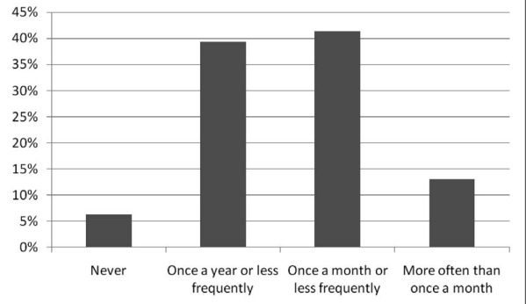fig1: study shows distribution of frequencies of head-level accidents for blind people in US

Goal
What will we do

This research addresses the efficiency paradox in AI-powered assistive technologies for the visually impaired. While advanced Computer Vision systems offer unprecedented support, their implementation in wearable devices is hampered by large memory and computational demands, leading to poor battery life and high costs. To address this, we propose an ultra-efficient, linear algebra-based filtering architecture that acts as a real-time gatekeeper, selectively engaging high-cost AI resources only upon detecting an external anomaly [2].
The core of our filter relies on low-rank matrix approximation, specifically the Adaptive-Rank Singular Value Decomposition (ARSVD), to compress the baseline representation of a user's familiar environment [2]. This process drastically reduces the parameter count and space complexity while adaptively selecting the optimal rank for each layer, ensuring the retention of essential spectral energy while eliminating redundant information [3].
The continuous detection loop performs one-class novelty detection, where an incoming input image is deemed "normal" if it closely matches the compressed low-rank model. Novelty is signaled by calculating the reconstruction error, which is typically larger for novel images than for normal images [4]. By setting a threshold on the reconstruction error, the heavy, full DNN model is only executed if the low-rank filter signals an anomaly.
This integrated approach significantly enhances the feasibility of advanced computer vision on wearable devices by providing superior efficiency with lower memory usage and faster inference times. The method proves its reliability as a filter, maintaining or improving classification accuracy on complex datasets while achieving increases of over 11 percentage points in some experiments [3]. This guarantees that the lightweight gatekeeper can accurately discriminate between safe, familiar environments and critical, novel threats, addressing major challenges in assistive device design.

Citation

Global estimates on the number of people blind or visually impaired by cataract from Nature:
[1] Khanna, R. C., Rathi, V. M., & Foster, A. Global prevalence, causes, and trends in cataract blindness and visual impairment, 1990–2020: A systematic analysis for the Global Burden of Disease Study. Eye, Nature. 2024 Available: https://www.nature.com/articles/s41433-024-02961-1

ArXiv preprint 1:
[2] P. Naayini, P. K. Myakala, C. Bura, et al., "AI-Powered Assistive Technologies for Visual Impairment," University of Colorado Boulder, 2025. Available: https://arxiv.org/html/2503.15494v1
ArXiv preprint 2:
[3] K. Cherukuri and A. Lala, "Low-Rank Matrix Approximation for Neural Network Compression," arXiv, 2025. Available: https://arxiv.org/html/2504.20078v1
Conference paper:
[4] P. Feeney and M. C. Hughes, "Evaluating the Use of Reconstruction Error for Novelty Localization," in Proc. UDL for All Workshop, 2021. Available: https://www.michaelchughes.com/papers/FeeneyHughes_UDL_2021.pdf

[Fig1, Fig2]
Research and Practice in Visual Impairment and Blindness aerj-04-02-01.3d
Roberto Manduchi, PhD* Sri Kurniawan, PhD University of Santa Cruz Santa Cruz, CA. 2025
Available: https://users.soe.ucsc.edu/~manduchi/papers/MobilityAccidents.pdf

