# ReadMe

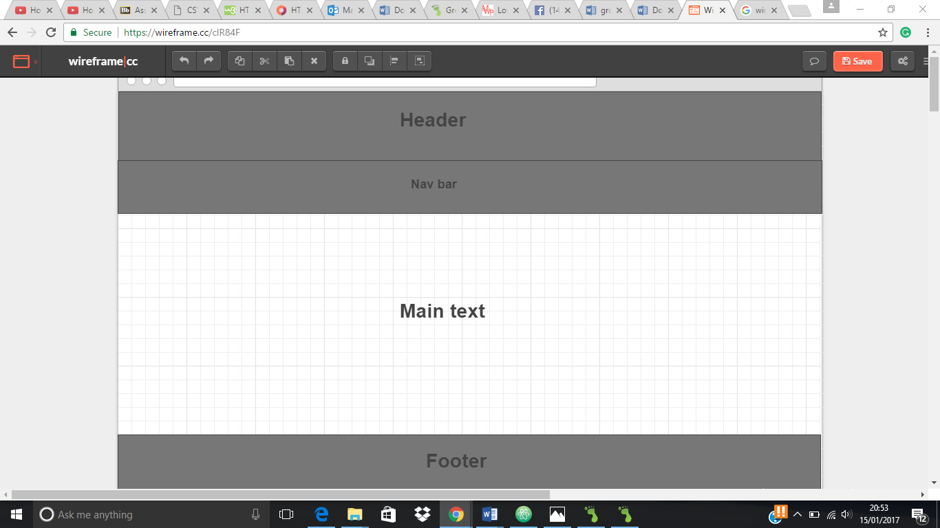This picture represents a wireframe of what I tried to implement into my website.

Within my website there are a number of different aspects which have been clearly implemented. Say for instance the header and footer. The header is clearly visible within my website as we can see on all pages the word home is clear and distinct. Within the footer there are a number of different visible texts and images which are all related and have meaning. This text includes a video map of my home address where I live through google maps. It is clear that on the video you are able to move around and zoom into a location on the map making it easier to locate a particular location this makes the web page more convenient for individuals wanting to contact me. Which also having a map to show my home location my web page also consists of a column called ways to contact me and includes ways such as:

* Twitter: @Hakeemkuyembeh
* Mobile: 07783030921
* E-Mail: [Hakeemkuyembehh97@hotmail.com](mailto:Hakeemkuyembehh97@hotmail.com)
* Linkdn: Hakeemkuyembeh

My header and footer is located on all the different pages. Also the pictures that I have implemented on my web page is clearly present on the home page as well as the bio page. The image is a picture of me to show individuals how and what I look like. In the main content area of my pages we can see the clear text on the page of what I am trying to communicate to the individual looking at the web page. The text also consists of different fonts and font sizes. We can see that in the headers they are written in bold font and are written in bigger sizes whereas in the normal text it is written in normal sizing. In addition to this the title and menu section of the website is written in different font color compared to the normal text.

In the creation of the website I have collaborated with different websites and individuals which have helped assist me in the creation of the web pages for instance:

<https://www.youtube.com/watch?v=5w2AkL3LczM&index=4&list=PLr5Y655yN6b-2cO72vNeuZNuLy4BRuVRe>