**Labs**

**Part 1: Capturing HTTP Traffic**

**Task 1**: Start Wireshark and capture packets

**Task 2**: Filter HTTP packets and analyze them

**HTTP**

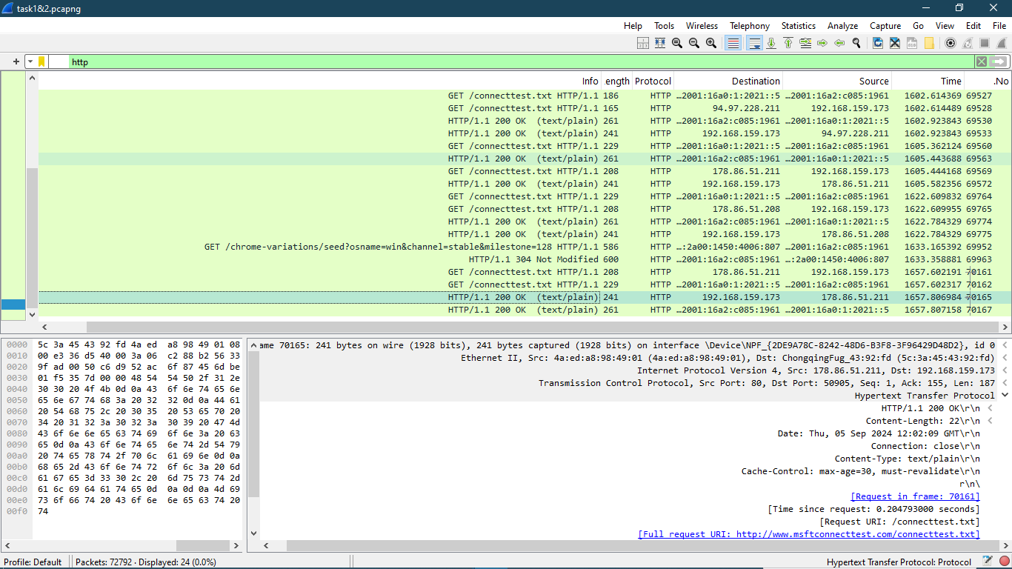

**GET**

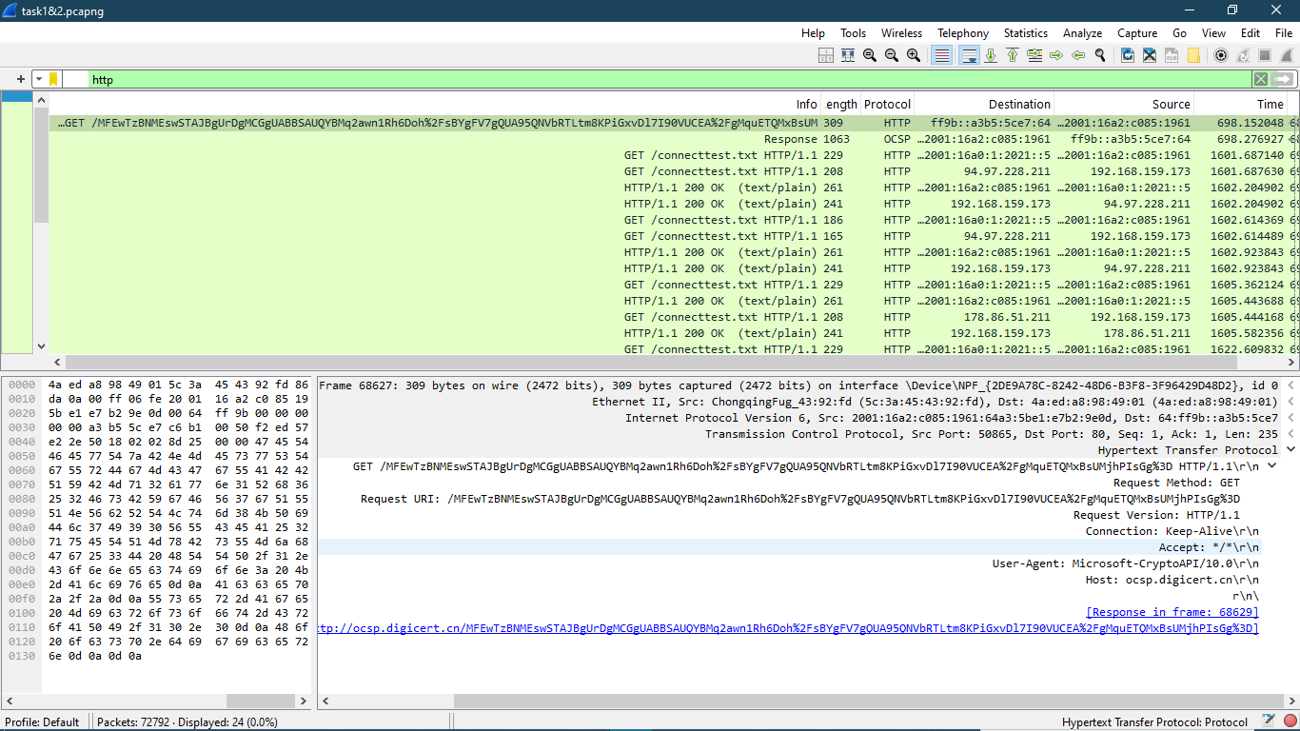

[Full request URI: <http://clientservices.googleapis.com/chrome-variations/seed?osname=win&channel=stable&milestone=128>

**Part 2**

**Part 2: Analyzing TCP/IP Traffic.**

**Task 1**: Filter TCP packets

**Task 2**: Analyze TCP handshake and investigate Data Transfer and Termination

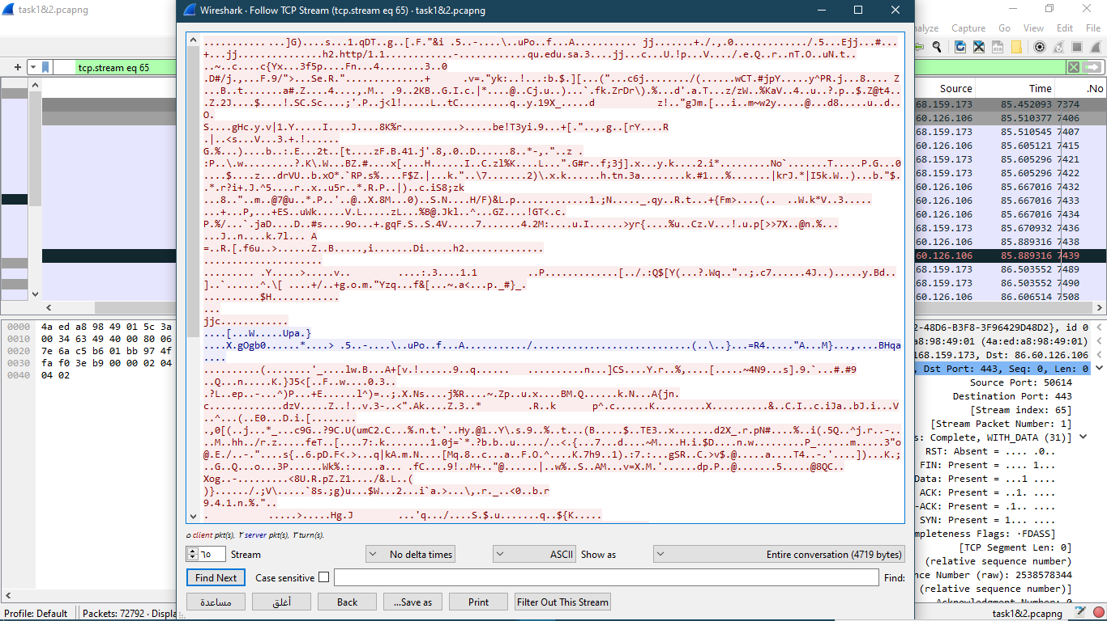

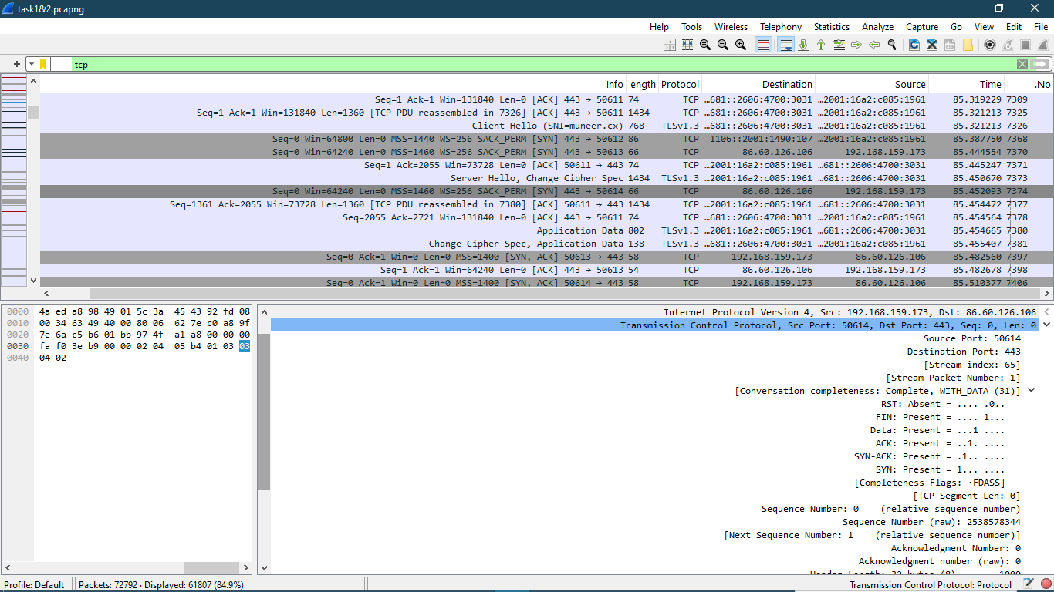

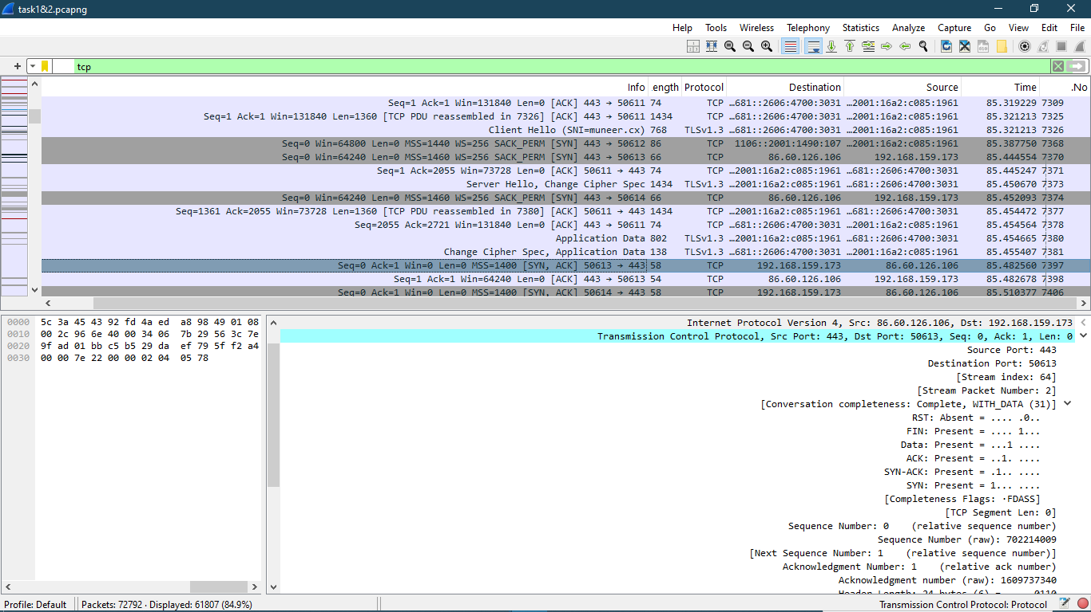

**Part 3**

**Part 3: Capturing and Analyzing UDP Traffic**

**Task 1**: Generate UDP traffic and capture packets

**Task 2**: Filter and analysis UDP Packets

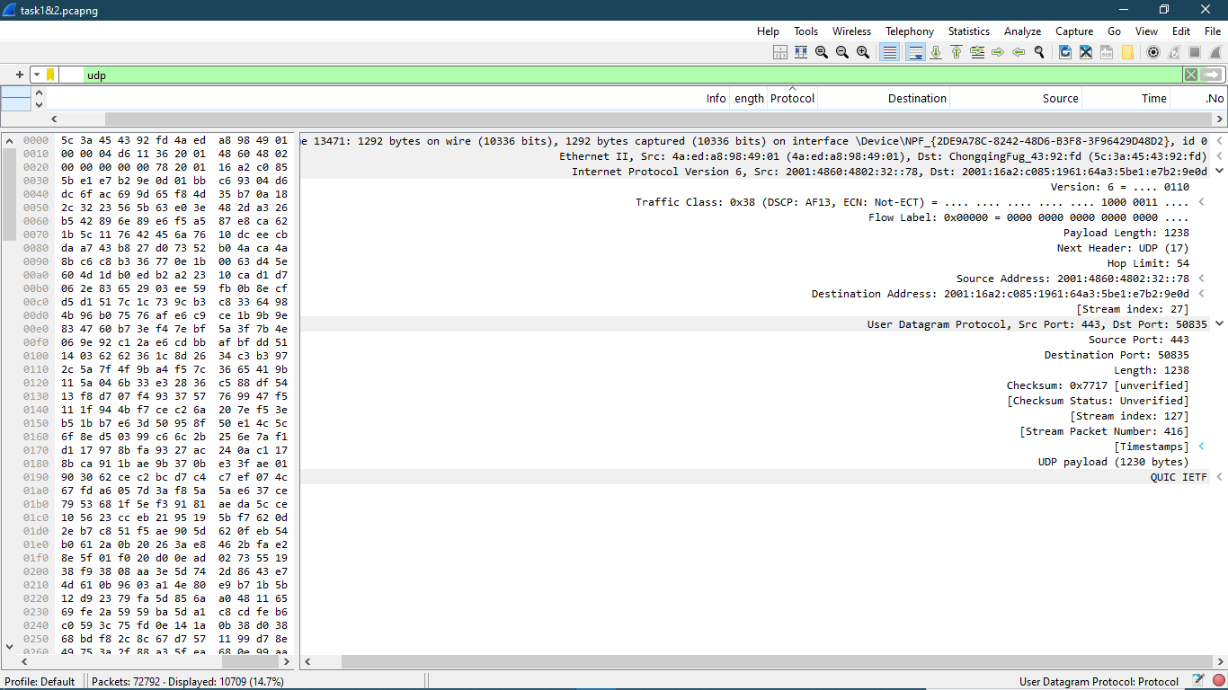

**Part 4**

**Part 4: Comparing TCP and UDP**

**Task 1**: Fill in the following table and provide reasons

|  |  |  |
| --- | --- | --- |
| Reasons | TCP or UDP |  |
| TCP is connection-oriented and uses a three-way handshake to establish a reliable connection. It ensures data is received correctly, handling retransmissions for lost packets. | TCP | Reliability and Connection Establishment |
| TCP ensures that data is delivered in the same order it was sent. It uses checksums for error-checking and retransmits any corrupted or lost packets. | TCP | Data Integrity and Ordering |

**Task 2**: Identify the use Cases and Performance of TCP and UDP.

|  |  |  |
| --- | --- | --- |
| UDP | TCP |  |
| Video streaming, online gaming, voice over IP (VoIP), DNS queries | Web browsing, file transfers, email, remote administration (SSH) | Use cases |
| Higher reliability, ordered data delivery, higher overhead due to connection management | Higher reliability, ordered data delivery, higher overhead due to connection management | Performance |