UNIVERSITY OF MARIBOR
FACULTY OF ELECTRICAL ENGINEERING AND COMPUTER SCIENCE
ADAPTIVE BUDGET ALLOCATION USING MACHINE LEARNING AND SOFTWARE-IN-THE-LOOP CONTROL SIMULATION
Bachelor's Thesis
Maribor, May 2026

ADAPTIVE BUDGET ALLOCATION USING MACHINE LEARNING AND SOFTWARE-IN-THE-LOOP CONTROL SIMULATION
Bachelor's Thesis
Student: | Abdul Hakim Nazari
Study program: | University study program Mechatronics
Track: | —
Supervisor: | Assoc. Prof. Dr. Aleš Hace
Co-supervisor: | —
Language editor: | ---
License: | CC BY 4.0

Maribor, May 2026

ACKNOWLEDGEMENTS
First and foremost, I would like to express my sincere gratitude to my supervisor, Assoc. Prof. Dr. Aleš Hace, for his guidance, support, and constructive feedback throughout the development of this thesis. His expertise in mechatronics and control systems was invaluable in shaping the academic framing of this work. I would also like to thank the Faculty of Electrical Engineering and Computer Science at the University of Maribor for providing the academic environment and resources that made this project possible. Finally, this thesis reflects many months of persistent, independent work — learning new fields, building a full-stack system from scratch, and connecting disciplines that do not often meet. I am grateful for the resilience that process required, and proud of what it produced.

Prilagodljivo razporejanje proračuna z uporabo strojnega učenja in simulacije regulacijskega sistema s programsko opremo v zanki
Ključne besede: prilagodljivo razporejanje proračuna, strojno učenje, gradientno ojačevanje, eksponentno glajenje, simulacija programske opreme v zanki
UDK: [vpiše knjižnica UM FERI]
Povzetek
V diplomskem delu je obravnavano prilagodljivo razporejanje osebnega proračuna kot programski regulacijski problem. Predlagana metoda združuje napovedovanje mesečne porabe z modelom gradientnega ojačevanja in eksponentno glajenje priporočil, da se zmanjša nihanje proračuna ob ohranjanju uporabne natančnosti. Pet regresijskih modelov je bilo primerjanih na sintetičnih podatkih petih uporabniških profilov. Izbrani model je bil nato uporabljen v simulaciji programske opreme v zanki. Rezultati kažejo, da prilagodljivi regulator zmanjša nestabilnost priporočil glede na neposredno napovedovanje in zagotovi primernejši kompromis med natančnostjo, stabilnostjo in preprečevanjem prekoračitev.

Adaptive Budget Allocation Using Machine Learning and Software-in-the-Loop Control Simulation
Keywords: adaptive budgeting, machine learning, Gradient Boosting, exponential smoothing, software-in-the-loop simulation

UDC: [PLACEHOLDER - obtain from UM FERI library]

Abstract
This thesis addressed adaptive personal budget allocation as a software-based control problem. A Gradient Boosting prediction model was combined with exponential smoothing to produce monthly category budget recommendations that balance accuracy and stability. Five regression models were evaluated on a synthetic persona-based spending dataset, and the selected model was tested in a software-in-the-loop simulation against static budgeting, last-month budgeting, and direct prediction. The adaptive controller reduced recommendation instability by 68.5% compared with direct prediction while preserving a 39.7% tracking-error improvement over static budgeting. The results support a control-oriented approach to machine-learning-assisted budgeting.

Razširjeni povzetek v slovenskem jeziku
Diplomsko delo obravnava problem prilagodljivega razporejanja osebnega proračuna z vidika mehatronike, regulacijskih sistemov in strojnega učenja. Izhodišče dela je ugotovitev, da večina osebnih finančnih aplikacij uporabniku omogoča sledenje porabi, ročno določanje kategorij in osnovno vizualizacijo, redkeje pa obravnava proračun kot dinamičen sistem, ki se mora odzivati na spremembe v vedenju uporabnika. Statični mesečni proračuni so pogosto preveč toga rešitev, saj ne upoštevajo sezonskih sprememb, nenavadnih mesecev, sprememb dohodka ali spremenjenih potrošniških navad.
V delu je bil zato razvit sistem Aura Finance, ki osebno proračunsko načrtovanje obravnava kot programski regulacijski problem. Uporabnikova poraba predstavlja opazovani proces, vnosi stroškov prek obrazca, govora in optičnega prepoznavanja računov delujejo kot mehki senzorski kanali, podatkovna baza hrani stanje sistema, model strojnega učenja ocenjuje prihodnjo porabo, regulator pa izračuna priporočene vrednosti proračuna po kategorijah. Ker sistem ne upravlja fizičnega aktuatorja, ampak uporabniku predlaga odločitev, je izhod regulatorja prikazan kot priporočilo v uporabniškem vmesniku. Končno odločitev o sprejetju priporočila ohrani uporabnik, kar ustreza nadzornemu vzorcu človek-v-zanki.
Eksperimentalni del uporablja sintetični nabor podatkov, zgrajen iz petih uporabniških profilov in osmih kategorij porabe. Na podatkih je bilo primerjanih pet regresijskih modelov za napoved mesečne porabe. Najboljšo povprečno napovedno zmogljivost je dosegel model gradientnega ojačevanja, zato je bil uporabljen kot napovedni del regulatorja. Sam regulator združuje novo napoved z vrednostjo prejšnjega proračuna z eksponentnim glajenjem in nato normalizira rezultate glede na razpoložljivi znesek po upoštevanju cilja varčevanja. S tem se zagotovi, da priporočeni proračun ostane izvedljiv in da se mesečna priporočila ne spreminjajo preveč sunkovito.
Rezultati simulacije programske opreme v zanki kažejo, da neposredna napoved strojnega učenja doseže najnižjo napako sledenja, vendar povzroča veliko nihanje mesečnih priporočil. Prilagodljivi regulator pri izbrani vrednosti parametra glajenja ohrani večino napovedne prednosti glede na statični proračun, hkrati pa bistveno zmanjša nestabilnost priporočil v primerjavi z neposredno uporabo napovedi. Glavni prispevek dela zato ni samo spletna aplikacija, temveč regulacijsko usmerjena metoda vrednotenja, ki osebno finančno priporočanje presoja po več merilih hkrati: natančnosti, stabilnosti, izvedljivosti in preprečevanju prekoračitev.
Omejitev dela je, da so bili podatki sintetični in da vedenjski odziv uporabnika na priporočila ni bil empirično izmerjen. Rezultati zato ne dokazujejo splošne veljavnosti pri resničnih uporabnikih, temveč potrjujejo delovanje predlagane metode v nadzorovanem simulacijskem okolju. Nadaljnje delo bi moralo vključevati anonimizirane resnične podatke, prilagodljiv parameter glajenja po kategorijah in manjšo uporabniško študijo zaupanja v priporočila.

DECLARATION OF AUTHORSHIP
I, Abdul Hakim Nazari, hereby declare that this bachelor’s thesis is my own original work, written under the supervision of Assoc. Prof. Dr. Aleš Hace at the University of Maribor, Faculty of Electrical Engineering and Computer Science.

I confirm that the work has not been submitted elsewhere for the purpose of obtaining any other qualification, and that all sources used have been duly cited and acknowledged.

I agree that this thesis may be made available in the University of Maribor digital library (DKUM).

Maribor, May 2026

Signature: ________________________________________

TABLE OF CONTENTS
List of Figures x
List of Tables xi
List of Symbols and Acronyms xii

1 INTRODUCTION 1
1.1 Background and Motivation 1
1.2 Research Question 2
1.3 Objectives 2
1.4 Scope and Limitations 3
1.5 Thesis Structure 3
2 LITERATURE REVIEW 4
2.1 Personal Finance Systems and Decision Support 4
2.2 Machine Learning for Financial Tabular Prediction 4
2.3 Control Theory, Exponential Smoothing, and Stability 5
2.4 Soft Sensing and Software-in-the-Loop Simulation 5
2.5 Research Gap 6
3 MECHATRONICS AND CONTROL-SYSTEM FRAMING 8
3.1 Interdisciplinary Framing 8
3.2 Control Loop Architecture 8
3.3 Soft Sensing Channels 9
3.3.1 Voice Input 9
3.3.2 Receipt OCR 10
3.3.3 Manual Entry 10
3.4 State Estimation 10
3.5 The Adaptive Controller: Design, Equations, and Stability 11
3.6 Human-Machine Interface 11
3.7 Scope of the Control Analogy 11
4 SYSTEM ARCHITECTURE 13
4.1 Three-Layer Structure 13
4.2 Database Schema 13
4.3 Backend-to-AI Integration 14
4.4 Architectural Limitations 14
5 SYNTHETIC DATASET AND SPENDING SIMULATION 15
5.1 Justification for Synthetic Data 15
5.2 Persona Profiles 15
5.3 Data Generation and Feature Engineering 16
6 MACHINE LEARNING PREDICTION MODELS 17
6.1 Problem Formulation 17
6.2 Candidate Models and Theoretical Basis 17
6.3 Training and Evaluation Protocol 18
6.4 Model Comparison Results 18
6.5 Per-Category Error Analysis 20
6.6 Feature Ablation Study 21
6.7 Hyperparameter Search 23
6.8 Feature Importance 23
6.9 Model Selection Rationale 24
7 ADAPTIVE BUDGET CONTROL METHOD 25
7.1 Motivation 25
7.2 The Four Compared Strategies 25
7.3 Alpha Sensitivity Analysis 26
7.4 Stability Analysis 27
7.5 SIL Simulation Procedure 27
8 EXPERIMENTAL EVALUATION AND RESULTS 29
8.1 Evaluation Setup 29
8.2 Evaluation Metrics 29
8.3 Main Results 29
8.4 Tracking Error Analysis 30
8.5 Budget Stability Analysis 31
8.6 Overspending Analysis 31
8.7 The Accuracy-Stability Trade-Off 32
8.8 Per-Category Context 32
8.9 Answer to Research Question 33
8.10 Threats to Validity 34
9 WEB APPLICATION IMPLEMENTATION 35
9.1 Purpose of the Web Application 35
9.2 Overall Runtime Architecture 35
9.3 AI Budget Optimizer Integration 35
9.4 Expense Input and Multi-Modal Soft Sensing 36
9.5 Academic Role of the Web Application 36
10 LIMITATIONS AND FUTURE WORK 37
10.1 Limitations 37
10.2 Future Work 38
11 CONCLUSION 39
11.1 Summary of Work 39
11.2 Main Findings 39
11.3 Contributions 40
11.4 Final Answer to Research Question 40

REFERENCES AND LITERATURE 41

LIST OF FIGURES
Figure 4.1 Simplified Entity-relationship diagram 14
Figure 6.1 Bar chart comparing average MAE across five regression models 19
Figure 6.2 Bar chart comparing average R² across five models 19
Figure 6.3 Per-category MAE heatmap for all five models 20
Figure 6.4 Feature ablation bar chart 22
Figure 6.5 Hyperparameter heatmap: MAE as a function of $n_{estimators}$ and $max_{depth}$
23
Figure 6.6 Feature importance horizontal bar chart 24
Figure 7.1 Alpha sensitivity dual-axis chart 27
Figure 8.1 Four-panel bar chart comparing all four strategies across all four metrics 30
Figure 8.2 Tracking error across 60 test months for all four strategies 31
Figure 8.3 Accuracy-stability scatter plot 32
Figure 8.4 Summary table chart showing all four metrics and percentage improvements 32
Figure 8.5 Per-category MAE comparison for the Gradient Boosting prediction pipeline 33
Figure 9.1 Dashboard screenshot showing financial summary 35

LIST OF TABLES
Table 1.1 Research objectives 2
Table 2.1 Research gap motivating the thesis contribution 6
Table 3.1 Complete mapping of Aura Finance components to Mechatronics and control-system concepts 8
Table 4.1 Technology stack by layer 13
Table 5.1 Synthetic personas used for spending simulation 15
Table 5.2 Time-based train-test split 16
Table 6.1 Average model performance across all eight categories (test set, 2025) 18
Table 6.2 Per-category MAE for Gradient Boosting 20
Table 6.3 Complete feature ablation results 21
Table 7.1 Alpha sensitivity analysis results 26
Table 8.1 Main software-in-the-loop control experiment results 29

LIST OF SYMBOLS AND ACRONYMS
Symbols
Symbol | Definition
α (alpha) | Smoothing parameter of the adaptive controller (0 < α < 1)
Ν | Learning rate in Gradient Boosting
$$B\left(c,t\right)$$ | Budget allocated to category c in month t
$$B_{ML}\left(c,t\right)$$ | Gradient Boosting prediction-based budget for category c
$$B_{adapt}\left(c,t\right)$$ | Smoothed (pre-normalization) budget for category c
$$B_{final}\left(c,t\right)$$ | Normalized final budget after income constraint enforcement
$$A\left(c,t\right)$$ | Actual spending in category c in month t
I | Monthly income of the user
S | Monthly saving target
$$x_{t}$$ | Feature vector at month t (11-dimensional)
$$y_{t}$$ | Target spending vector at month t (8-dimensional)
$$f_{c}$$ | Trained regression model for spending category c
$$F_{m}\left(x\right)$$ | Gradient Boosting Ensemble After m stages
$$h_{m}\left(x\right)$$ | Residual tree at stage m
$$H\left(z\right)$$ | IIR filter transfer function in the Z-domain
$$w_{c}$$ | Fixed category weight in static budget strategy
N | Total number of category-month observations (480)

Acronyms
Acronym | Full form
AA | Allocation Accuracy
AI | Artificial Intelligence
API | Application Programming Interface
BIBO | Bounded-Input Bounded-Output
DSS | Decision Support System
GB | Gradient Boosting
HMI | Human-Machine Interface
IIR | Infinite Impulse Response
LSTM | Long Short-Term Memory
MAE | Mean Absolute Error
ML | Machine Learning
MPC | Model Predictive Control
NLP | Natural Language Processing
OCR | Optical Character Recognition
OSR | Overspend Rate
PID | Proportional-Integral-Derivative
R² | Coefficient of Determination
RF | Random Forest
RMSE | Root Mean Squared Error
SIL | Software-in-the-Loop
SQL | Structured Query Language
ST | Budget Stability
SVR | Support Vector Regression
TE | Tracking Error
TOC | Table of Contents
UDC | Universal Decimal Classification
UM FERI | University of Maribor, Faculty of Electrical Engineering and Computer Science
YNAB | You Need A Budget (commercial app)

1 INTRODUCTION
1.1 Background and Motivation
Personal financial management is a continuous decision process. Each month, a user receives income, observes spending across multiple categories — food, transport, utilities, health, travel, and others — maintains a saving target, and must allocate the remaining disposable income. This process is dynamic: spending patterns shift across seasons, life circumstances, and income levels. A useful budgeting system must do more than record historical transactions. It must help the user form a forward-looking, feasible, and stable spending plan.

Commercial finance applications such as Mint, YNAB, and PocketGuard focus primarily on expense tracking, categorization, and manual budget setting. These tools are useful but leave the core allocation decision to the user. Research consistently shows that self-set budgets tend to be optimistic: people set targets that do not fully match their actual expenditure patterns [12]. Digital tools can support awareness, but there is limited evidence that awareness alone produces better financial outcomes [1]. The gap is therefore not in tracking functionality — it is in the intelligence layer that converts historical spending data into actionable, adaptive, and stable budget recommendations. This limitation is also consistent with the broader literature on financial recommendation and decision-support systems [18].

Machine learning creates the technical foundation for closing this gap. If a model can accurately estimate next-month category spending from past behavior, income, and seasonality, then budget recommendations can be data-driven rather than rule-based. However, directly using model predictions as budget values introduces a new problem: volatile, inconsistent recommendations that change sharply from month to month. In user-facing systems, recommendation volatility reduces trust and compliance [14]. The engineering challenge is therefore a multi-objective one: the budget allocation system must be accurate enough to adapt to changing patterns, stable enough to be practically usable, and constrained to respect the user's saving target.

This thesis addresses that challenge by framing personal budget allocation as a software-based adaptive control problem. The proposed system, Aura Finance, combines a full-stack web application with a Python machine learning and simulation module, and evaluates the resulting budget allocation behavior through formal software-in-the-loop experiments.
1.2 Research Question
Can a machine-learning-assisted adaptive controller provide a better trade-off between budget tracking accuracy, overspending prevention, and budget stability than static budgeting or direct ML prediction alone?

This question deliberately asks for a trade-off, not a single optimum. The best predictor is not always the best controller. In control-oriented systems, performance is evaluated under constraints such as stability, smoothness, and feasibility — not only by one-step prediction error [2]. This framing distinguishes the thesis from a pure machine learning comparison study.
1.3 Objectives
Table 1.1: Research objectives.
Ref. | Objective
O1 | Build a full-stack personal finance application with multi-modal expense input (manual, voice, OCR), budget management, and AI-assisted recommendation.
O2 | Generate a synthetic persona-based spending dataset to support controlled software-in-the-loop evaluation.
O3 | Train and compare five regression models for category-level monthly spending prediction, with feature ablation and hyperparameter analysis.
O4 | Design an adaptive budget controller that integrates ML predictions with smoothing, income constraints, and saving-target enforcement.
O5 | Evaluate four budget allocation strategies in software-in-the-loop simulation using tracking error, overspend rate, stability, and allocation accuracy.
O6 | Interpret the results through both a machine learning lens and a control-system lens, and answer the research question explicitly.
1.4 Scope and Limitations
The evaluation uses synthetic persona-based data rather than real bank data or a live user study. Results should be interpreted as simulation evidence under controlled conditions, not as proof of generalization to real users. The thesis does not claim to implement a full behavioral closed-loop controller: the simulated user does not change future spending in response to budget recommendations. The most accurate framing is a software-in-the-loop adaptive control simulation operating on a synthetic digital twin of user spending behavior.
1.5 Thesis Structure
Chapter 2 reviews the relevant literature and identifies the research gap. Chapter 3 provides the Mechatronics and control-system framing that positions the project academically. Chapter 4 summarizes the system architecture. Chapter 5 describes the synthetic dataset. Chapter 6 presents the machine learning model comparison in depth. Chapter 7 presents the adaptive budget control method. Chapter 8 presents the experimental evaluation and central results. Chapter 9 briefly documents the web application implementation. Chapter 10 states limitations and future work. Chapter 11 concludes the thesis.
2 LITERATURE REVIEW
2.1 Personal Finance Systems and Decision Support
Personal budgeting research demonstrates that budgets influence spending behavior but compliance is weak when budgets are static or disconnected from observed behavior [12]. Angel's randomized trial of digital finance tools found that app-based budgeting increased account monitoring frequency but did not produce significant improvements in financial literacy or decision quality [1]. This evidence motivates the argument that academic value in a budgeting system should come from the intelligence of its recommendation mechanism, not from data display alone.

Decision Support Systems provide theoretical foundation. Sprague and Carlson's classical framework identifies three components of an effective DSS: a data subsystem, a model subsystem, and a dialogue subsystem [16]. Aura Finance instantiates all three: the database and expense history form the data layer, the Gradient Boosting predictor and adaptive controller form the model layer, and the React dashboard and budget recommendation interface form the dialogue layer. Nunes and Jannach's systematic review of explanations in recommender and decision-support systems establishes that trust and acceptance of algorithmic recommendations depend on consistency and interpretability [14] a finding that motivates the stability objective of the adaptive controller.
2.2 Machine Learning for Financial Tabular Prediction
Tree-based ensemble methods consistently outperform both linear models and deep neural networks on structured tabular financial data [8]. This finding is directly relevant to the model selection methodology in this thesis, as the dataset is small, tabular, and structured, making tree-based ensembles the appropriate primary candidates.

Friedman's original formulation of Gradient Boosting Machines establishes the sequential residual-fitting principle: each tree in the ensemble corrects the errors of the previous ensemble, producing a model that is particularly effective at capturing nonlinear interactions in structured data [7]. Breiman's Random Forest reduces variance through bootstrap aggregation and random feature subsampling, providing a strong and interpretable ensemble baseline [3].

Feature engineering for temporal prediction follows standard time-series conventions. Hyndman and Athanasopoulos establish that directional train-test splits are mandatory in forecasting evaluation: training on past data and testing on future data reflects the real operational direction of the system [9]. Cross-validation that mixes time periods produces optimistically biased metrics and should be avoided in financial forecasting contexts.
2.3 Control Theory, Exponential Smoothing, and Stability
Control theory provides the central intellectual framework for the adaptive budget allocation method. Åström and Murray describe feedback control as the mechanism through which dynamic systems regulate behavior under uncertainty, disturbance, and constraint [2]. The budget allocation problem maps onto this framework: the state is the monthly spending distribution, the reference is the saving target, the control action is the per-category budget, and new observed spending constitutes the feedback signal for the next cycle.

Exponential smoothing is a classical technique in forecasting and control for recursively weighing recent observations more heavily than older ones [9]. Applied as a low-pass filter on budget recommendations — rather than on raw measurements — it introduces inertia against sudden prediction changes while preserving the responsiveness of the underlying ML prediction. The mathematical stability of exponential smoothing is straightforward: since it computes a convex combination of two bounded quantities (the previous budget and the current prediction, both bounded by the spendable income ceiling), the output is always bounded, and feasibility is preserved at every step.
2.4 Soft Sensing and Software-in-the-Loop Simulation
Soft sensors are software-based inference systems that derive state estimates from indirect or noisy inputs — analogously to physical sensors, but without transducers [11]. In Aura Finance, expense entry through manual forms, voice transcription, and OCR receipt parsing function as soft sensing channels: each converts user actions into structured financial signals that feed the prediction and control layers.

Software-in-the-loop simulation is a validated methodology for evaluating control logic before physical or behavioral deployment [4]. Sargent establishes the epistemological boundary of simulation: results are valid for comparing algorithmic strategies under the conditions defined by the simulation, not for claiming generalization beyond those conditions [15]. This thesis uses SIL simulation in precisely this way — to compare four budget allocation strategies under identical controlled conditions.
2.5 Research Gap
The reviewed literature supports the relevance of each component area. However, these areas are typically studied in isolation. Personal finance research does not evaluate algorithmic budget controllers. ML forecasting research focuses on prediction accuracy without evaluating output stability. Control theory is applied to physical plants, not software resource allocation. The specific combination — ML prediction integrated with an adaptive smoothing controller, evaluated through SIL simulation on a personal budgeting task, with stability and accuracy measured simultaneously — has not been addressed at this scope and framing in the existing bachelor-level engineering literature.

Table 2.1: Research gap motivating the thesis contribution.
Area | Typical focus | Gap addressed here
Personal finance systems | Tracking, visualization, manual budgeting | No algorithmic adaptive controller design.
ML forecasting | Prediction error minimization | Stability of recommendation output not evaluated.
Decision support | Data, model, dialogue integration | No control-theory design methodology for budgeting.
Control theory | Physical and industrial systems | Not applied to software financial resource allocation.
SIL simulation | Control validation for physical systems | Not applied to personal budget allocation comparison.
3 MECHATRONICS AND CONTROL-SYSTEM FRAMING
3.1 Interdisciplinary Framing
Although Aura Finance is implemented as a software system, its architecture follows the same structural logic as a mechatronic system: sensing, state estimation, decision-making, output generation, and feedback. In this thesis, the Mechatronics perspective is used as a methodological framework for understanding and evaluating the system, not as a claim that the project is a physical hardware platform. This framing is appropriate because the thesis combines data acquisition, prediction, control, and human-machine interaction within one closed decision loop. Modern mechatronics definitions emphasize exactly this integration of sensing, control, computation, and human interaction [10], [17].
3.2 Control Loop Architecture
The adaptive budget allocation system follows a closed-loop-inspired architecture. The control cycle proceeds monthly through the following stages:

- Soft sensing: the user enters expense data through one of three input channels.
- State estimation: transaction-level data is aggregated into a monthly category spending state vector.
- Prediction (feedforward path): the Gradient Boosting model estimates next-month category spending from the current state.
- Adaptive control: the controller blends the prediction with the previous budget and normalizes under the income-saving constraint.
- Output (actuation): the per-category budget recommendation is presented through the human-machine interface.
- Feedback: new spending in the next month updates the state features for the following cycle.

Table 3.1: Complete mapping of Aura Finance components to Mechatronics and control-system concepts.
System component | Mechatronics term | Technical role
Manual expense entry form | Soft sensor (direct) | Converts user text input to structured transaction records.
Voice recognition module | Soft sensor (acoustic) | Captures and transcribes spoken expense descriptions; NLP stage classifies category and extracts amount.
OCR receipt parsing | Soft sensor (visual) | Extracts amount and merchant from receipt images; keyword matching infers spending category.
Monthly category aggregation | State estimator | Reduces transaction stream to 8-dimensional monthly spending state vector.
Gradient Boosting model | Predictive feedforward model | Maps state features to expected next-month category spending.
Saving target (15% of income) | Setpoint / constraint | Defines the feasible allocation budget ceiling: I − S.
Exponential smoothing controller | Controller (discrete-time, first-order) | Produces stabilized, constrained budget output from ML prediction and previous state.
Per-category budget allocation | Control output | The actionable monthly spending plan delivered to the user.
Dashboard + alerts + budget page | Human-machine interface | Communicates system state, controller output, and budget status to the user.
New monthly spending history | Feedback signal | Updates prediction features for the next control cycle.
3.3 Soft Sensing Channels
The three expense input channels implement distinct soft sensing strategies and involve different signal processing pipelines.
3.3.1 Voice Input
The voice input subsystem converts spoken natural language into a structured financial record. The pipeline proceeds through six stages: (1) acoustic acquisition via the browser MediaRecorder API; (2) transmission of the audio blob to the backend endpoint POST /expenses/transcribe-voice; (3) speech-to-text conversion using a Whisper-based transcription script; (4) amount extraction through a regular expression supporting integer and decimal formats; (5) category classification via a deterministic multilingual keyword dictionary (English, Turkish, German); and (6) human-in-the-loop validation, in which the user reviews the parsed result before it is written to the database. The speech-recognition stage is affected by voice activity detection and noise robustness issues known from automatic speech recognition research [13], [19].

The validation step is particularly important: background noise, accents, or ambiguous phrasing can produce incorrect results. Human confirmation prevents inaccurate measurements from entering the financial state used by the prediction and control pipeline. The component operates as a five-state finite state machine: idle → listening → stopped → processing → review.
3.3.2 Receipt OCR
Receipt OCR provides a second soft sensing channel. The system uses Tesseract.js to extract text from a receipt image, then applies two-stage rule-based parsing: first searching for receipt-specific total markers such as "total", "toplam", or "sum"; falling back to the highest numeric value if the first strategy fails. The result is reviewed by the user before being saved, preventing recognition errors from corrupting the financial state.
3.3.3 Manual Entry
Manual entry through a structured form captures amount, category, date, and optional description. It provides the highest data quality and serves as the primary ground-truth input channel and a calibration reference for the other soft sensing channels.
3.4 State Estimation
Individual expense transactions are event-level, irregular, and noisy. The prediction model requires a consistent, fixed-dimension input vector at monthly intervals. State estimation bridges this gap through two operations: (1) grouping all transactions by (user_id, year, month, categoryId) and computing the sum of amounts per group, producing a monthly category spending vector of dimension 8; and (2) applying a temporal shift to create prev_* features representing the previous month's spending in each category.

The feature vector passed to the prediction model is therefore:
$x_{t}={\left[income,month,prev_food,…,prev_total\right]}^{T}, x_{t}∈R^{11}$ (3.1)
3.5 The Adaptive Controller: Design, Equations, and Stability
The adaptive controller operates as a discrete-time first-order low-pass filter applied to the budget recommendation signal. The smoothing parameter α determines the filter's cut-off behavior: high α retains more of the low-frequency stable component; low α allows more of the high-frequency responsive prediction. The transfer function in the Z-domain per category is:
$H\left(z\right)=\frac{1-α}{1-α⋅z^{-1}}$ (3.2)
The controller is unconditionally BIBO-stable for any valid smoothing parameter 0 < α < 1, since the pole lies at z = α, strictly inside the unit circle. The normalisation step additionally guarantees feasibility by enforcing the income constraint at every time step. Full equations are given in Chapter 7.
3.6 Human-Machine Interface
The human-machine interface presents budget recommendations, category summaries, alerts, and spending information to support user decision-making. In mechatronics terminology this is the dialogue layer between the system and the human operator. A stable and understandable recommendation is more likely to be accepted than an erratic one — this is one of the principal reasons the controller is designed to balance responsiveness and consistency. This design also supports situation awareness by making system state and recommended action visible to the human operator [6].
3.7 Scope of the Control Analogy
The mechatronic framing used in this thesis is structural and methodological. Aura Finance is not a physical mechatronic device and does not control motors, actuators, or a physical plant. Its academic value lies in the fact that it exhibits the same architectural logic as a mechatronic control system: sensing, state estimation, prediction, constrained control output, feedback, and human-machine interaction. The software-in-the-loop simulation is therefore the appropriate validation method for this type of system.
4 SYSTEM ARCHITECTURE
4.1 Three-Layer Structure
Aura Finance is organized into three independently deployable layers: the React frontend, the Express/TypeScript backend, and the Python AI module. This separation ensures that the academic evaluation components are reproducible without requiring the full web application stack.

Table 4.1: Technology stack by layer.
Layer | Technology | Primary role
Frontend | React 18, TypeScript, Vite, Tailwind CSS, Recharts | HMI: dashboard, expense entry (manual/voice/OCR), budget recommendations, alerts.
Backend | Node.js, Express 5, TypeScript, PostgreSQL, JWT | Authentication, data persistence, business logic, Python subprocess integration.
AI module | Python 3, scikit-learn, pandas, joblib | Data generation, model training, inference, SIL simulation.
4.2 Database Schema
The PostgreSQL schema stores six primary entities: User (id, email, income, saving_target, hashed password), Category (id, name — one of 8 fixed categories), Expense (userId, categoryId, amount, date, description), Budget (userId, categoryId, limitAmount), Loan, and UserPreferences. The Expense table is the primary data source for the AI pipeline; the User table provides income and saving_target fields that parameterise the adaptive controller at inference time.
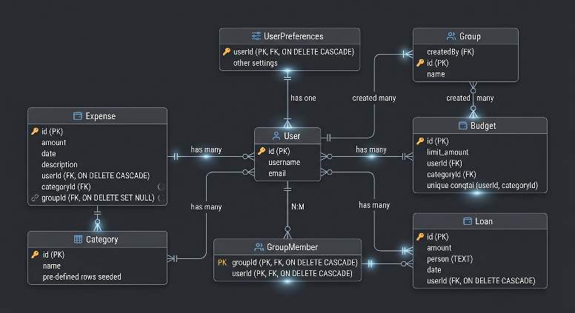
Figure 4.1: Simplified entity-relationship diagram.
4.3 Backend-to-AI Integration
The budget optimization route invokes the Python inference script as a Node.js child process, passing eleven arguments (income, month, and nine previous-category values) via the command line. The script loads budget_model_v2.pkl, constructs a pandas DataFrame with the stored feature column ordering, generates per-category predictions, and returns a JSON object to stdout. The backend scales the predictions to the user's spendable budget ceiling before returning the result to the frontend. The SIL evaluation script (control_evaluation.py) runs entirely offline and is independent of this integration path.
4.4 Architectural Limitations
Four limitations are noted. First, subprocess-based inference incurs process startup latency on each call; a persistent Python microservice would be more efficient at scale. Second, the backend includes rule-based AI insight generation and an LSTM forecast that are auxiliary product features, not part of the academically evaluated contribution. Third, inline SQL migrations lack formal versioning. Fourth, the LSTM model is trained on per-user expense history at runtime; with sparse data it falls back to a simple linear trend. None of these limitations affects the validity of the SIL experiment.
5 SYNTHETIC DATASET AND SPENDING SIMULATION
5.1 Justification for Synthetic Data
Real personal finance data is ethically impractical to collect at bachelor level: it requires consent, anonymization, institutional approval, and data processing agreements. Synthetic data provides a controlled alternative appropriate for the thesis's evaluation goal: comparing algorithmic budget allocation strategies under diverse but known conditions. Sargent's framework for simulation validity establishes that a simulation is valid if it accurately represents the phenomena it was designed to study [15]. This simulation is designed to produce diverse monthly spending trajectories with seasonal patterns and stochastic variation — the phenomena relevant to testing the adaptive controller.

The key limitation must be stated clearly: results cannot be claimed to generalize to real users. The model learns patterns embedded by the generator, not real psychological spending behavior. All results are simulation evidence, not real-world validation.
5.2 Persona Profiles
Table 5.1: Synthetic personas used for spending simulation.
Persona | Income | Saving rate | Dominant spending characteristics
Emily, College Student | $2,800 | 5% | Food and entertainment dominant; high variability; minimal travel.
Marcus, Junior Developer | $5,500 | 15% | Balanced across categories; moderate variability; occasional travel.
Sarah, Marketing Manager | $8,500 | 20% | Health and shopping emphasis; stable utilities; regular travel.
David, Senior Engineer | $13,000 | 25% | Family-oriented; consistent utilities and food; frequent travel.
Olivia, Executive Director | $22,000 | 30% | High travel and shopping; low relative food spend; low variability.
5.3 Data Generation and Feature Engineering
The generator assigns each persona a base category allocation vector, applies monthly seasonal multipliers (travel peaks in July and December; utilities peak in January and February), and adds Gaussian noise scaled to persona-specific variance parameters. If the total generated spending exceeds the persona's spendable budget, values are proportionally scaled down. This produces 6,979 transaction records, aggregated into 180 monthly rows.

Eleven prediction features are derived: income, month index (1–12), prev_food, prev_transport, prev_shopping, prev_entertainment, prev_utilities, prev_health, prev_travel, prev_other, and prev_total. These are created by sorting each persona's monthly records chronologically and applying a within-group lag shift of one month. The first month per persona is dropped (no prior state available), leaving 175 usable rows.

Table 5.2: Time-based train-test split.
Split | Period | Rows | Purpose
Training | Jan 2023 – Dec 2024 | 115 | Model fitting for all five regression candidates.
Test | Jan 2025 – Dec 2025 | 60 (12 months × 5 personas) | SIL simulation: strategy comparison and control evaluation.
6 MACHINE LEARNING PREDICTION MODELS
6.1 Problem Formulation
The machine learning task is multi-output regression. The feature vector $x_{t}$
is constructed from information available at the beginning of month t: income, month number, and previous-month spending values. The target $y_{t}$
is the spending vector observed during month t, making the model a one-step-ahead predictor. One independent regression model is trained per spending category c ∈ {food, transport, shopping, entertainment, utilities, health, travel, other}:
$y_{c}\left(t\right)=f_{c}\left(x_{t}\right)$ (6.1)
The eight models are trained and evaluated independently. Final budget allocation is computed by normalizing predictions to the spendable income ceiling, as described in Chapter 7.
6.2 Candidate Models and Theoretical Basis
Five models are evaluated. Linear Regression (OLS) serves as the lowest-complexity interpretable baseline; it assumes a linear additive relationship and cannot capture nonlinear feature interactions. Decision Tree Regression partitions the feature space through recursive binary splits; a single deep tree overfits this small dataset, demonstrating why variance reduction through assembling is necessary. Random Forest reduces variance through bootstrap aggregation and random feature subsampling [3], and was the model originally deployed in the application backend. Support Vector Regression uses an RBF kernel to enable nonlinear regression; its sensitivity to unscaled feature ranges limits performance here. The use of support vector methods as a nonlinear baseline follows the classical support-vector formulation [5].

Gradient Boosting builds the ensemble sequentially, fitting each new shallow tree to the residual errors of the current ensemble [7]:
$F_{m}\left(x\right)=F_{m-1}\left(x\right)+ν⋅h_{m}\left(x\right)$ (6.2)
Where $h_{m}$ is the m-th residual tree and $ν$ is the learning rate. This sequential error-correction strategy allows Gradient Boosting to capture complex nonlinear interactions in structured data. The production configuration is: $n_{estimators}=100$, $max_{depth}=4$, $min_{samples_leaf}=3$,$learning_{r}ate=0.1$,$random_{s}tate=42$.
6.3 Training and Evaluation Protocol
All five models are trained on the 2023–2024 dataset (115 rows) and evaluated on the 2025 dataset (60 rows). Three metrics are computed per model per category, then averaged:

- Mean Absolute Error (MAE): interpretable in currency units; the primary evaluation metric. MAE$=\frac{1}{n}\sum_{i=1}^{n}{\left|y_{i}-\hat{y_{i}}\right|}$
- Root Mean Squared Error (RMSE): penalizes large errors more strongly than MAE. $\text{RMSE}=\sqrt{\frac{1}{n}\sum_{i=1}^{n}{{\left(y_{i}-\hat{y_{i}}\right)}^{2}}}$
- Coefficient of determination (R²): proportion of variance explained; R² = 1.0 is perfect. $R^{2}=1-\frac{SS_{\text{res}}}{SS_{\text{tot}}}$
6.4 Model Comparison Results
Table 6.1: Average model performance across all eight categories (test set, 2025). Gradient Boosting is highlighted.
Model | Avg MAE ($) | Avg RMSE ($) | Avg R² | Train time
Linear Regression | 114.21 | 161.48 | 0.9304 | 0.01 s
Decision Tree | 115.23 | 196.57 | 0.9021 | 0.02 s
Random Forest | 106.93 | 161.76 | 0.9332 | 0.55 s
Gradient Boosting | 90.98 | 150.96 | 0.9415 | 0.41 s
Support Vector Regression | 143.98 | 232.15 | 0.8561 | 0.02 s

Gradient Boosting achieves the lowest MAE ($90.98), lowest RMSE ($150.96), and highest R² (0.9415) among all five models. The 15% MAE reduction relative to Random Forest ($106.93 → $90.98) is consistent with Gradient Boosting's known advantage on moderate-size tabular datasets where sequential error correction outperforms parallel aggregation.
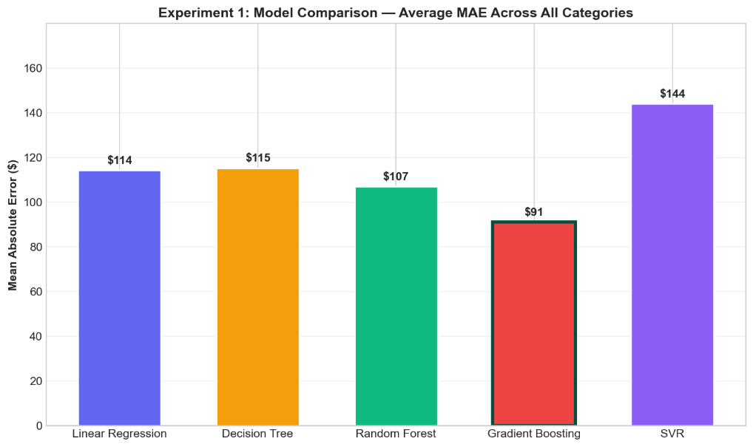

Figure 6.1: Bar chart comparing average MAE across five regression models. Gradient Boosting achieves the lowest average MAE at $90.98.
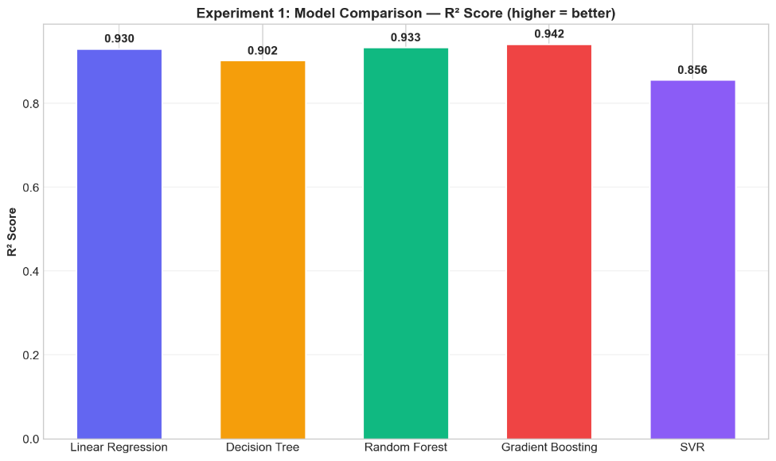
Figure 6.2: Bar chart comparing average R² across five models. Gradient Boosting achieves the highest R² at 0.9415.
6.5 Per-Category Error Analysis
Averaging across categories conceals important variation. Table 6.2 shows the per-category MAE for the selected Gradient Boosting model.

Table 6.2: Per-category MAE for Gradient Boosting. Categories sorted by difficulty.
Category | MAE ($) | Difficulty | Reason
other | 43.46 | Low | Stable catch-all category with low variance.
transport | 46.17 | Low | Consistent commute patterns; low seasonal variation.
health | 49.56 | Low | Infrequent but predictable recurring expenses.
entertainment | 52.19 | Low | Moderate variance; well-correlated with previous month.
utilities | 96.01 | Medium | Seasonal variation captured by month feature.
food | 102.33 | Medium | Consistent but varies with persona income scale.
shopping | 143.21 | High | Discretionary spikes; irregular purchase events.
travel | 194.94 | Very high | Sporadic; seasonal; large amplitude variation.

Travel is by far the hardest category, with MAE nearly four times higher than transport. Shopping is the second-hardest category due to discretionary purchase events. This category-level analysis has a direct consequence for the control experiment: volatile categories create the largest month-to-month prediction jumps in the direct ML strategy, which is precisely what the adaptive smoothing controller is designed to moderate.

Figure 6.3: Per-category MAE heatmap for all five models. Travel is consistently the hardest category across all models.
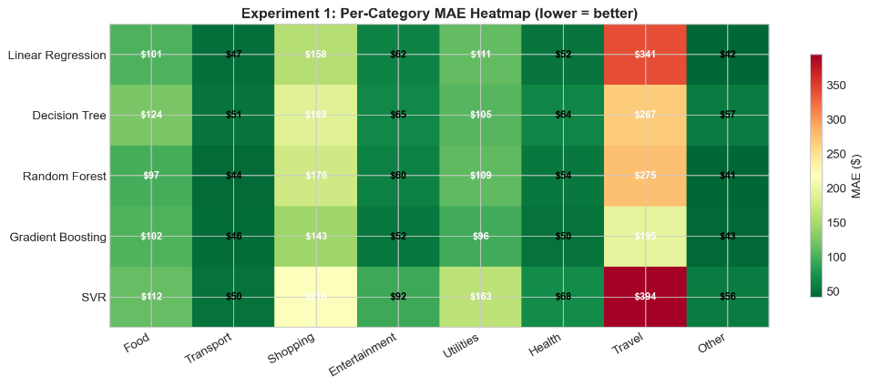
6.6 Feature Ablation Study
Feature ablation quantifies the marginal contribution of each feature by measuring the MAE change when that feature is excluded from training.

Table 6.3: Complete feature ablation results. Positive MAE change = feature is useful; negative = feature introduces noise.
Removed feature | MAE without ($) | MAE change | Impact % | Interpretation
month | 113.80 | +6.88 | +6.43% | Strongest contributor. Seasonality is critical for travel, utilities, entertainment.
prev_total | 110.05 | +3.12 | +2.92% | Previous total spend captures spending scale better than income alone.
prev_travel | 108.07 | +1.14 | +1.07% | Travel history helps predict future travel.
prev_entertainment | 107.70 | +0.77 | +0.72% | Some cross-month correlation in entertainment.
prev_shopping | 107.34 | +0.41 | +0.38% | Weak contribution.
income | 107.13 | +0.20 | +0.18% | Negligible: already encoded in previous spending levels.
prev_health | 106.72 | −0.21 | −0.20% | Removing slightly helps: health is stable; feature adds noise.
prev_utilities | 106.48 | −0.45 | −0.42% | Utilities are more seasonal than habit-based.
prev_transport | 104.05 | −2.88 | −2.69% | Cross-category interference.
prev_food | 103.40 | −3.53 | −3.30% | Cross-category noise: food spend does not predict other categories well.
prev_other | 103.27 | −3.66 | −3.42% | Largest noise source: catch-all category is uninformative as a predictor.

Two findings deserve emphasis. First, the month feature is the single most important predictor, confirming that seasonality is the dominant pattern in the synthetic spending process. Second, several previous-category features are net negative contributors: removing prev_food, prev_other, and prev_transport actually improves performance, revealing cross-category interference. The standard 11-feature set is retained for the control experiment to maintain consistency with the deployed application.
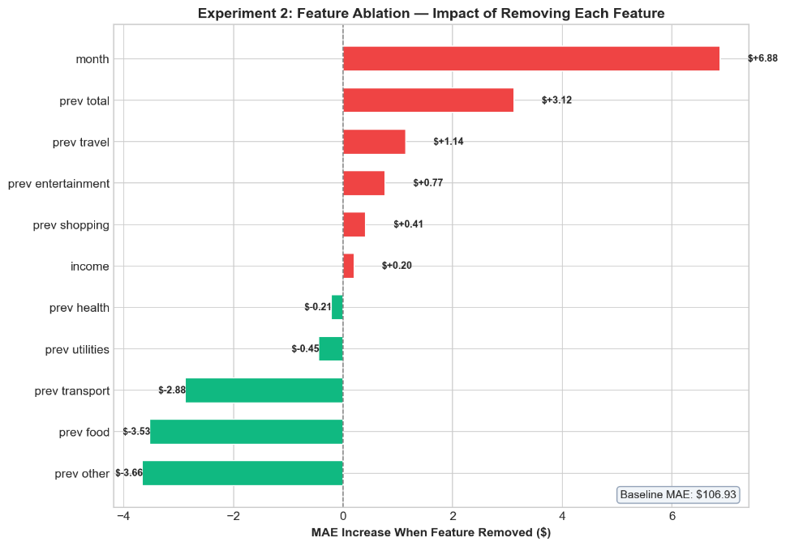

Figure 6.4: Feature ablation bar chart. Positive values (month, prev_total) indicate useful features; negative values (prev_food, prev_other, prev_transport) indicate noise-introducing features.
6.7 Hyperparameter Search
A grid search explored $n_{estimators}$∈ {50, 100, 200, 300} and $max_{depth}$∈ {2, 4, 6, 8, 10}. The best configuration found was $n_{estimators}$= 300, $max_{depth}$ = 10, achieving MAE = $98.00. The production configuration (n_estimators = 100, max_depth = 4) achieves MAE = $106.93 but provides a better trade-off between accuracy and reproducibility. The improvement from the production to the optimal configuration is only 8%, while complexity increases substantially. For a bachelor thesis, the simpler, more interpretable configuration is the appropriate choice.
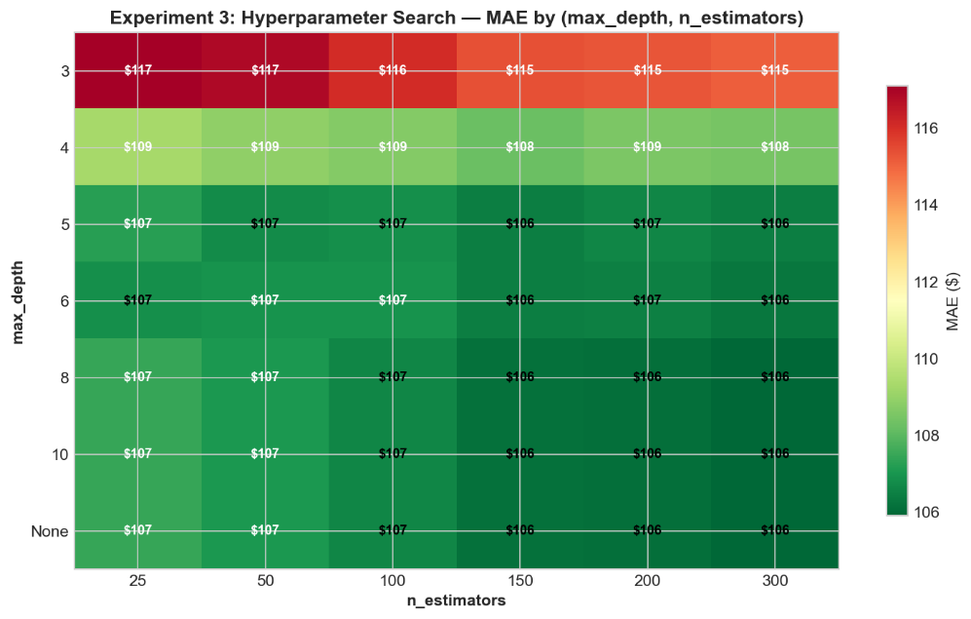
Figure 6.5: Hyperparameter heatmap: MAE as a function of $n_{estimators}$(x-axis) and $max_{depth}$(y-axis). Diminishing returns visible beyond depth = 4.
6.8 Feature Importance
Gradient Boosting provides impurity-based feature importance scores, averaged across the eight category-specific models. These scores reflect how often and how effectively each feature is used in split decisions across all trees. They should be interpreted as descriptive indicators of model behavior, not as causal explanations of spending patterns. As expected from the ablation study, month and prev_total rank among the most important features; income ranks lower because its information is largely encoded in the previous spending values for synthetic personas with stable incomes.

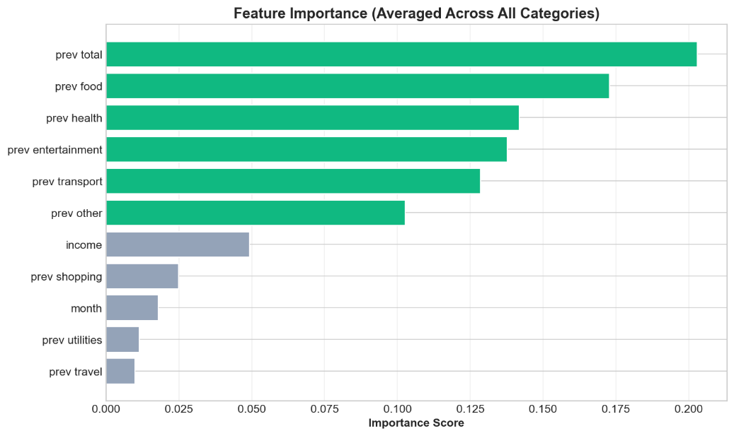
Figure 6.6: Feature importance horizontal bar chart, averaged across eight category-specific Gradient Boosting models.
6.9 Model Selection Rationale
Gradient Boosting is selected as the prediction component for the adaptive budget control experiment because it achieves the best empirical performance across all three-evaluation metrics on the synthetic dataset. This selection is based purely on evidence from the comparison experiment. The model is saved as budget_model_v2.pkl and used consistently in both the backend inference path and the SIL control simulation, eliminating any model-mismatch risk between the deployed application and the academic evaluation.
7 ADAPTIVE BUDGET CONTROL METHOD
7.1 Motivation
A machine learning prediction model estimates expected spending. It does not, by itself, produce a budget. A budget must satisfy three requirements: it must be feasible (total allocation must not exceed spendable income), it must respect a saving target, and it must be stable enough to be practically usable. The adaptive controller is introduced to enforce these requirements on top of the ML prediction.
7.2 The Four Compared Strategies
Strategy 1 — Static Budget (open-loop baseline): spendable income is allocated according to fixed category weights, with no feedback, no prediction, and no adaptation:
$B_{static}\left(c\right)=\left(I-S\right)⋅w_{c}$ (7.1)
where I = income, S = saving target, and $w_{c}$= fixed weight for category c (food 25%, transport 10%, shopping 12%, entertainment 8%, utilities 18%, health 8%, travel 7%, other 12%).

Strategy 2 — Last-Month Baseline (proportional feedback): the previous month's spending distribution is used as the next budget distribution, making it sensitive to anomalous expenses:
$B_{LM}\left(c,t\right)=\frac{A\left(c,t-1\right)}{\sum_{j}{A}\left(j,t-1\right)}⋅\left(I-S\right)$ (7.2)

Strategy 3 — Direct ML Prediction (feedforward): the Gradient Boosting prediction is used as the budget distribution, achieving the lowest tracking error but producing sharp month-to-month changes for volatile categories:
$B_{ML}\left(c,t\right)=\frac{{\overset{ˆ}{y}}_{c}\left(t\right)}{\sum_{j}{{\overset{ˆ}{y}}_{j}}\left(t\right)}⋅\left(I-S\right)$ (7.3)

Strategy 4 — Adaptive Controller (feedback-regulated feedforward): ML predictions are combined with the previous budget through exponential smoothing, then normalized under the income constraint:
$B_{adapt}\left(c,t\right)=α⋅B\left(c,t-1\right)+\left(1-α\right)⋅B_{ML}\left(c,t\right)$ (7.4)
$B_{final}\left(c,t\right)=\frac{B_{adapt}\left(c,t\right)}{\sum_{j}{B_{adapt}}\left(j,t\right)}⋅\left(I-S\right)$ (7.5)
At α = 0, the controller reduces to direct ML prediction; at α = 1, it reduces to the previous budget. The selected value α = 0.7 means 70% of the next budget comes from the previous budget and 30% from the new ML prediction.
7.3 Alpha Sensitivity Analysis
Table 7.1: Alpha sensitivity analysis results.
α value | Tracking error ($) | Stability ($) | OSR | Interpretation
0.1 (most reactive) | 182.62 | 822.41 | 24.2% | Near-ML accuracy but high volatility.
0.3 | 185.94 | 638.67 | 24.4% | Modest smoothing; still volatile.
0.5 | 192.99 | 464.63 | 23.8% | Balance point; best overspend rate.
0.7 (selected) | 202.55 | 289.48 | 24.4% | Strong stability reduction; acceptable accuracy loss.
0.9 (most stable) | 216.91 | 111.82 | 26.2% | Very stable but too slow to respond; overspend rises.

The selection criterion for α = 0.7 is: it achieves the largest absolute reduction in budget instability (from $919.93 for direct ML to $289.48, a 68.5% reduction) while maintaining a tracking error improvement of at least 35% over the static baseline (actual: 39.7%). The gain in stability from α = 0.5 to α = 0.7 outweighs the marginal loss in accuracy.

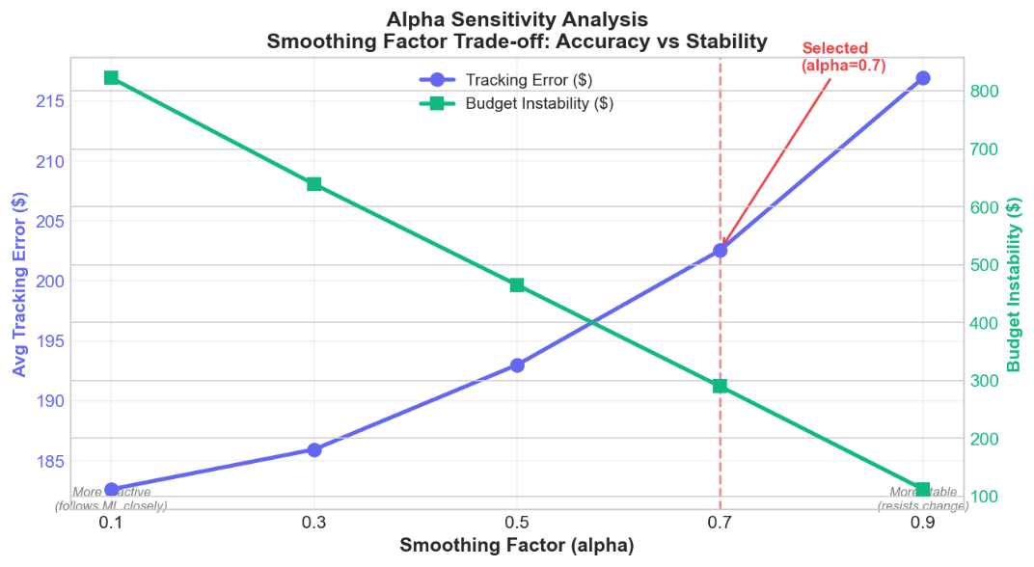
Figure 7.1: Alpha sensitivity dual-axis chart: tracking error (left axis) and budget instability (right axis) as functions of alpha. The selected value α = 0.7 is marked.

7.4 Stability Analysis
The adaptive controller (7.4) – (7.5) is stable in the Bounded-Input Bounded-Output sense. The proof is as follows: $B_{ML}\left(c,t\right)$ is bounded by the spendable income ceiling (I − S) through the normalization in (7.3);$B\left(c,t-1\right)$ is bounded by (I − S) because the normalization in (7.5) was applied in the previous step. Therefore $B_{adapt}\left(c,t\right)$ is a convex combination of two quantities bounded by (I − S):
$0≤B_{adapt}\left(c,t\right)≤I-S$ (7.6)
The normalization in (7.5) then guarantees $\sum_{c}{B_{final}}\left(c,t\right)=I-S$ exactly, enforcing feasibility at every time step. The controller cannot, under any valid input conditions, produce a budget that overspends the available income.
7.5 SIL Simulation Procedure
The software-in-the-loop simulation in control_evaluation.py executes the following steps: (1) load monthly_summary.csv and generate prev_* features; (2) train eight Gradient Boosting models on the 2023–2024 training period; (3) iterate over the 60 test months (2025, all five personas); (4) for each test month, apply all four strategies using the same input state; (5) compute tracking error, overspend rate, budget stability, and allocation accuracy; (6) run the alpha sensitivity loop (α ∈ {0.1, 0.3, 0.5, 0.7, 0.9}) separately; (7) save all results to control_results.json and generate chart files. The adaptive controller maintains a separate previous-budget state for each persona, ensuring state does not leak across users.
8 EXPERIMENTAL EVALUATION AND RESULTS
8.1 Evaluation Setup
The software-in-the-loop simulation evaluates four budget allocation strategies across 60 test months (5 personas × 12 months, year 2025). Each monthly case produces a budget vector of dimension 8, resulting in 480 category-month observations per strategy. The saving target is fixed at 15% of income for all personas; the adaptive controller uses α = 0.7 as justified in Chapter 7.
8.2 Evaluation Metrics
Four metrics are used. Tracking Error (TE) measures the average absolute difference between recommended budget and actual spending:
$TE=\frac{1}{N}\sum_{c,t}{\left|A\left(c,t\right)-B\left(c,t\right)\right|}, N=480$ (8.1)
Category Overspend Rate (OSR) measures the fraction of category-months where actual spending exceeds budget by more than a 5% tolerance:
$OSR=\frac{\text{count}\left\{A\left(c,t\right)>1.05⋅B\left(c,t\right)\right\}}{480}$ (8.2)
Budget Stability (ST) measures the average L1 norm of the month-to-month budget change per user:
$ST=\frac{1}{T}\sum_{t}{\sum_{c}{\left|B\left(c,t\right)-B\left(c,t-1\right)\right|}}$ (8.3)
Allocation Accuracy (AA) measures cosine similarity between the budget and actual spending distribution vectors:
$AA=\frac{B⋅A}{\left\|B\right\|⋅\left\|A\right\|}$ (8.4)
8.3 Main Results
Table 8.1: Main software-in-the-loop control experiment results (60 test months, 5 personas, 8 categories).
Strategy | TE ($) | vs static | OSR | ST ($) | AA
Static Budget | 335.64 | — | 35.4% | 0.00 | 95.6%
Last-Month Baseline | 219.78 | −34.5% | 30.4% | 1,210.58 | 98.5%
Direct ML Prediction | 181.91 | −45.8% | 24.8% | 919.93 | 99.3%
Adaptive Controller | 202.55 | −39.7% | 24.4% | 289.48 | 98.7%

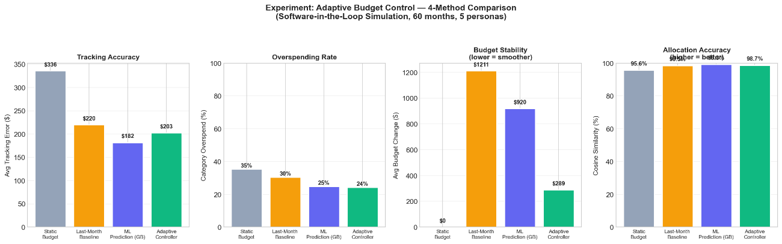
Figure 8.1: Four-panel bar chart comparing all four strategies across all four metrics.
8.4 Tracking Error Analysis
Direct ML prediction achieves the lowest tracking error at $181.91, a 45.8% improvement over static budgeting. The adaptive controller achieves $202.55, a 39.7% improvement. The accuracy cost of smoothing is $20.64 per category-month on average (11.3% reduction relative to direct ML prediction). Last-month budgeting performs worse than direct ML despite using real observed data because, in volatile categories, last month's spending is a worse predictor than the model's learned seasonal pattern.

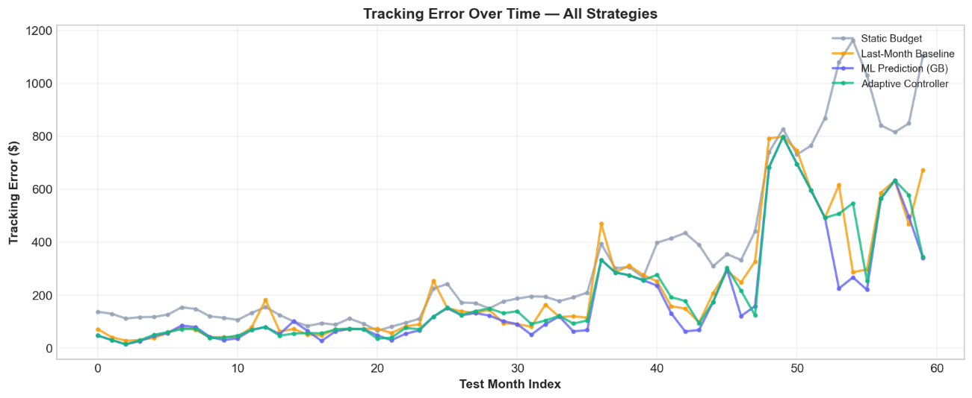
Figure 8.2: Tracking error across 60 test months for all four strategies. Note the higher volatility of direct ML compared to adaptive controller.
8.5 Budget Stability Analysis
The adaptive controller's advantage is most pronounced in budget stability. Among responsive strategies, the adaptive controller at $289.48 is dramatically smoother than direct ML prediction at $919.93 and the last-month baseline at $1,210.58. The reduction in instability from direct ML prediction to adaptive control is:
$\frac{919.93-289.48}{919.93}=68.5\%$ (8.5)
The adaptive controller accepts an 11.3% accuracy penalty in exchange for a 68.5% stability improvement — a favorable trade-off for a user-facing recommendation system where month-to-month consistency is a prerequisite for user trust.
8.6 Overspending Analysis
All four strategies produce overspend rates between 24.4% and 35.4%. The static budget's 35.4% rate is highest because fixed percentages systematically under-budget categories during high-demand months. The adaptive controller achieves the lowest overspend rate at 24.4%, marginally better than direct ML prediction at 24.8%. The improvement is small (0.4 percentage points) and should not be overstated; the primary value of the adaptive controller is budget stability.
8.7 The Accuracy-Stability Trade-Off
The central thesis result: direct ML prediction is the most accurate budget strategy, but the adaptive controller provides the best practical trade-off for user-facing budget recommendation by sacrificing 11% accuracy for a 69% improvement in stability.

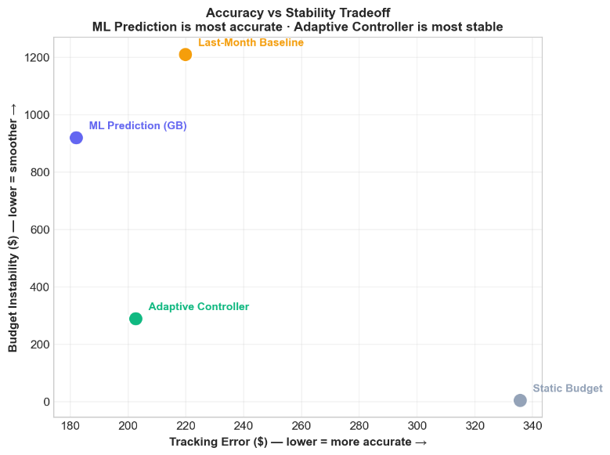
Figure 8.3: Accuracy-stability scatter plot: each strategy is plotted at (tracking error, budget instability). The ideal point is bottom-left. Adaptive Controller is closest to the ideal among responsive strategies.
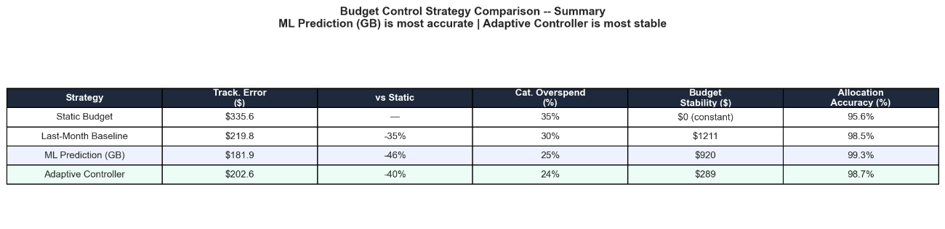

Figure 8.4: Summary table chart showing all four metrics and percentage improvements.

8.8 Per-Category Context
The volatile categories identified in Chapter 6 — travel (MAE $194.94) and shopping (MAE $143.21) — are the primary drivers of budget instability in the direct ML strategy. The adaptive controller dampens month-to-month budget shifts in these categories: 70% of the previous budget is preserved, reducing the travel budget change while still moving in the predicted direction.

Figure 8.5: Per-category MAE comparison for the Gradient Boosting prediction pipeline, showing travel as the dominant volatility source.
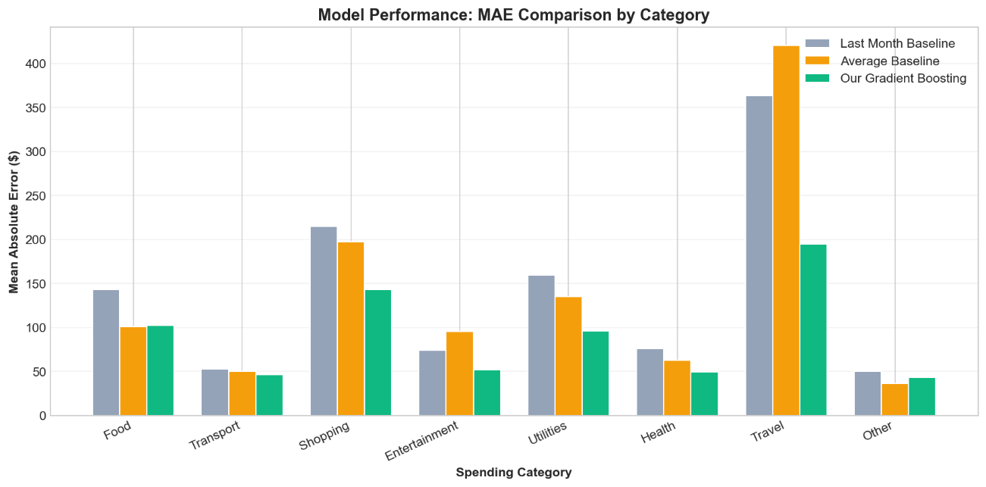
8.9 Answer to the Research Question
Research question: Can a machine-learning-assisted adaptive controller provide a better trade-off between budget tracking accuracy, overspending prevention, and budget stability than static budgeting or direct ML prediction alone?

Answer: Yes, within the limits of the synthetic software-in-the-loop simulation. The adaptive controller (α = 0.7) achieves a 39.7% improvement in tracking error over static budgeting, reduces overspend rate to 24.4%, and reduces budget instability by 69% compared with direct ML prediction. The cost is an 11.3% reduction in tracking accuracy relative to direct ML prediction. The adaptive controller is not the most accurate predictor — that is direct ML prediction. Its value is the accuracy-stability compromise it provides for practical, user-facing budget recommendation.
8.10 Threats to Validity
Five threats to validity must be acknowledged:

- Synthetic data: the model learns patterns embedded by the generator; real spending contains psychological dynamics not captured in the simulation.
- Limited test size: 60 test months across 5 personas is sufficient for a controlled comparison but insufficient for strong statistical generalization. No confidence intervals are reported.
- No behavioral feedback loop: the simulated user does not change spending in response to the recommendation.
- Simple controller design: exponential smoothing is a first-order IIR filter; PID, Kalman, or MPC approaches might achieve better trade-offs.
- Feature selection inconsistency: the ablation study reveals several prev_* features are net negative contributors, but the full 11-feature set is retained for consistency with the deployed application.
9 WEB APPLICATION IMPLEMENTATION
9.1 Purpose of the Web Application
The web application functions as an experimental platform through which the proposed AI-assisted budgeting and soft-sensing concepts are implemented, tested, and demonstrated. Its academic value is not that it is a finance app, but that it demonstrates how AI prediction, soft sensing, and human-supervised control can be combined in a working software system. Without this implementation layer, the thesis would remain only a simulation study.
9.2 Overall Runtime Architecture
The runtime architecture contains four main components: (1) a React/TypeScript frontend providing the dashboard, expense entry interfaces, and budget visualization; (2) a Node.js/Express backend handling authentication, data persistence, file upload, and budget optimization requests; (3) a PostgreSQL database storing users, budgets, expenses, and historical records; and (4) a Python AI/ML layer containing the trained prediction model, optimization scripts, Whisper transcription, and offline SIL simulation scripts.
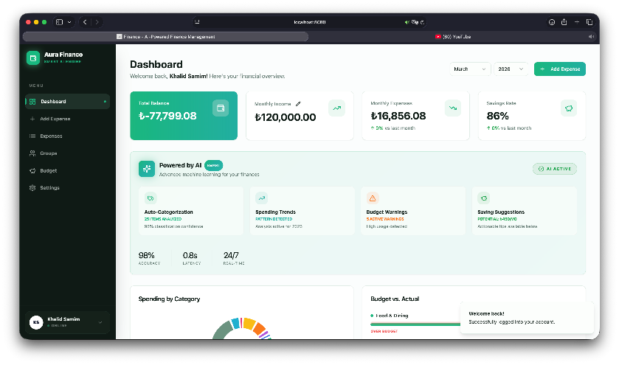

Figure 9.1: Dashboard screenshot showing financial summary.
9.3 AI Budget Optimizer Integration
When the user triggers AI optimization, the backend retrieves income, saving target, existing budget values, and recent expense history from the database. It then invokes predict_v2.py as a child process, which loads budget_model_v2.pkl and returns per-category predictions. The backend scales predictions to the user's spendable budget ceiling before returning the result to the frontend, where the user reviews a comparison of current and recommended values before applying the changes. This design follows a human-in-the-loop decision pattern: the AI proposes a control action but the user confirms the update.
9.4 Expense Input and Multi-Modal Soft Sensing
The application supports three expense input modes. Manual input (highest data quality, direct measurement analogue) captures amount, category, date, and description through a structured form. Voice input converts spoken expense descriptions into structured records through the six-stage pipeline described in Section 3.3.1; the result is presented in a review state before saving. Receipt OCR extracts expense information from receipt images using Tesseract.js and two-stage rule-based parsing, also with user confirmation before saving. In all three cases, human review before database commit prevents inaccurate measurements from corrupting the financial state.
9.5 Academic Role of the Web Application
The web application should be understood as the experimental implementation platform of the thesis. In a Mechatronics context it can be interpreted as a software-based control system: user spending behavior represents the dynamic process; manual, voice, and receipt inputs act as sensing channels; the database stores system state; the AI model estimates future spending demand; the budget optimizer proposes control actions; and the user confirmation step acts as supervisory control. This framing connects the project to Mechatronics without requiring physical hardware.
10 LIMITATIONS AND FUTURE WORK
10.1 Limitations
10.1.1 Synthetic Dataset
All training and evaluation data is generated by the thesis author. The five personas follow deterministic behavioral rules with stochastic noise. The model and controller have never been tested on real user spending data. This is the single most important limitation of the thesis.
10.1.2 No Behavioral Closed Loop
The simulation does not model how users respond to budget recommendations. A real user might reduce spending in over-budgeted categories or ignore the recommendation entirely. None of these behavioral dynamics are captured.
10.1.3 Simple Controller Design
Exponential smoothing is a first-order IIR filter. More sophisticated controllers — PID, Kalman-filtered prediction, or Model Predictive Control — might achieve better accuracy-stability trade-offs. Simplicity is appropriate for bachelor-level scope but is a genuine limitation.
10.1.4 Fixed Alpha
The smoothing parameter α = 0.7 is fixed across all users, categories, and months. Different categories have different volatility levels: travel benefits from more smoothing than transport. A category-adaptive alpha, tuned online based on recent prediction error variance, could improve the trade-off.
10.1.5 Statistical Significance
The experiment evaluates 60 test months, sufficient for observing consistent directional differences but insufficient for strong statistical significance claims. No hypothesis tests or confidence intervals are reported.
10.2 Future Work
Six directions for future work are identified:

- Real user data validation: replace the synthetic dataset with anonymized real expense data to test whether the model and controller generalize beyond synthetic behavioral rules.
- Category-adaptive smoothing: implement a per-category alpha that adjusts based on recent prediction error variance.
- Advanced controller designs: implement and compare PID-style and Model Predictive Control approaches against the exponential smoothing baseline.
- Behavioral response modelling: extend the SIL simulation to include a simple behavioral model of user compliance, enabling evaluation of true closed-loop dynamics.
- Expanded persona diversity: increase the number and diversity of synthetic personas to test controller robustness across a wider behavioral space.
- User study for trust and usability: conduct a small user study measuring whether budget stability improves user trust, compliance, and perceived usefulness compared with direct ML prediction.
11 CONCLUSIONS
11.1 Summary of Work
This thesis investigated whether a machine-learning-assisted adaptive controller can provide a better trade-off between budget tracking accuracy, overspending prevention, and budget stability than static budgeting or direct ML prediction alone. The investigation proceeded through five stages: generating a synthetic persona-based spending dataset; training and comparing five regression models for category-level spending prediction; designing a simple exponential-smoothing-based adaptive budget controller; evaluating four strategies in software-in-the-loop simulation; and interpreting the results through both a machine learning accuracy lens and a control-system stability lens.

The system was implemented as Aura Finance, a full-stack personal finance application with multi-modal soft sensing (voice, OCR, manual entry), a Gradient Boosting prediction pipeline, an adaptive budget controller, and a React-based human-machine interface. The system was framed within a Mechatronics and control-system architecture, connecting its components to standard concepts of sensing, state estimation, predictive control, constrained output, feedback, and HMI.
11.2 Main Findings
Gradient Boosting achieved the best average predictive performance among the five evaluated models (MAE = $90.98, R² = 0.9415). Its sequential residual-correction mechanism captures seasonal and persona-scale patterns in structured tabular financial data more effectively than the other approaches.

In the control experiment, direct ML prediction achieved the lowest tracking error, improving by 45.8% compared with static budgeting. The adaptive controller improved tracking error by 39.7% over static budgeting while reducing budget instability by approximately 68.5% compared with direct ML prediction — at a cost of 11.3% tracking accuracy.
11.3 Contributions
The thesis makes four contributions. First, it proposes a control-system framing for personal budget allocation that enables multi-objective evaluation across accuracy, stability, and feasibility simultaneously. Second, it provides an empirical model comparison that selects Gradient Boosting through evidence rather than assumption. Third, it designs an adaptive budget controller whose stability can be proven analytically (BIBO-stable, feasibility-guaranteed) and whose trade-off parameter is selected through sensitivity analysis. Fourth, it contributes a software-in-the-loop evaluation framework that can serve as a template for more advanced controller designs in future work.
11.4 Final Answer to the Research Question
Yes — within the limits of the synthetic software-in-the-loop simulation. The adaptive controller provides a better trade-off than both static budgeting and direct ML prediction. It is more accurate and adaptive than static budgeting, and more stable and consistent than direct ML prediction. However, direct ML prediction remains the most accurate strategy by tracking error. The adaptive controller's value is not maximum accuracy: it is the best accuracy-stability compromise for practical user-facing budget recommendation.

The broader conclusion is that treating personal budget allocation as a software control problem — with formal objectives, a constrained controller, stability analysis, and multi-metric evaluation — produces a more rigorous and academically defensible contribution than presenting the same system as a finance web application with AI features.
REFERENCES AND LITERATURE
[1] S. Angel, "Smart tools? A randomized controlled trial on the impact of three different media tools on personal finance," Journal of Behavioral and Experimental Economics, vol. 74, pp. 104-111, 2018, doi: 10.1016/j.socec.2018.04.002.
[2] K. J. Åström and R. M. Murray, Feedback Systems: An Introduction for Scientists and Engineers. Princeton, NJ: Princeton University Press, 2008.
[3] L. Breiman, "Random Forests," Machine Learning, vol. 45, pp. 5-32, 2001, doi: 10.1023/A:1010933404324.
[4] X. Chen, M. Salem, T. Das, and X. Chen, "Real Time Software-in-the-Loop Simulation for Control Performance Validation," Simulation, vol. 84, no. 8-9, pp. 399-407, 2008, doi: 10.1177/0037549708097420.
[5] C. Cortes and V. Vapnik, "Support-vector networks," Machine Learning, vol. 20, pp. 273-297, 1995, doi: 10.1007/BF00994018.
[6] M. R. Endsley, "Toward a theory of situation awareness in dynamic systems," Human Factors, vol. 37, no. 1, pp. 32-64, 1995, doi: 10.1518/001872095779049543.
[7] J. H. Friedman, "Greedy function approximation: A gradient boosting machine," The Annals of Statistics, vol. 29, no. 5, pp. 1189-1232, 2001, doi: 10.1214/aos/1013203451.
[8] L. Grinsztajn, E. Oyallon, and G. Varoquaux, "Why tree-based models still outperform deep learning on tabular data," Advances in Neural Information Processing Systems, vol. 35, pp. 507-520, 2022.
[9] R. J. Hyndman and G. Athanasopoulos, Forecasting: Principles and Practice, 3rd ed. Melbourne, Australia: OTexts, 2021.
[10] Institution of Mechanical Engineers, "What is Mechatronics." Available at: https://www.imeche.org/industry-sectors/mechatronics-informatics-and-control/ [accessed: 3 Jun. 2026].
[11] P. Kadlec, B. Gabrys, and S. Strandt, "Data-driven soft sensors in the process industry," Computers & Chemical Engineering, vol. 33, no. 4, pp. 795-814, 2009, doi: 10.1016/j.compchemeng.2008.12.012.
[12] M. F. Lukas and R. C. Howard, "The Influence of Budgets on Consumer Spending," Journal of Consumer Research, vol. 49, no. 5, pp. 697-720, 2023, doi: 10.1093/jcr/ucac024.
[13] N. Nagaraja et al., "Role of noise elimination algorithms in speech processing applications," Engineering Applications of Artificial Intelligence, vol. 148, 2025, doi: 10.1016/j.engappai.2025.110952.
[14] I. Nunes and D. Jannach, "A systematic review and taxonomy of explanations in decision support and recommender systems," User Modeling and User-Adapted Interaction, vol. 27, pp. 393-444, 2017, doi: 10.1007/s11257-017-9195-0.
[15] R. G. Sargent, "Verification and validation of simulation models," Journal of Simulation, vol. 7, no. 1, pp. 12-24, 2013, doi: 10.1057/jos.2012.20.
[16] R. H. Sprague and E. D. Carlson, Building Effective Decision Support Systems. Englewood Cliffs, NJ: Prentice-Hall, 1982.
[17] M. Tomizuka, "Mechatronics: from the 20th to 21st century," Control Engineering Practice, vol. 10, no. 8, pp. 877-886, 2002, doi: 10.1016/S0967-0661(02)00016-3.
[18] D. Wu and X. Li, "A Systematic Literature Review of Financial Product Recommendation Systems," Information, vol. 16, no. 3, article 196, 2025, doi: 10.3390/info16030196.
[19] T. Yoshimura et al., "End-to-End Automatic Speech Recognition Integrated With CTC-Based Voice Activity Detection," Proc. ICASSP, 2020, doi: 10.1109/ICASSP40776.2020.9053553.

