UNIVERSITY OF HERTFORDSHIRE
Department of Computer Science
BSc Honours Computer Science | Information Technology | Data Science (Online)
<Module Code and Title e.g. 6WCM0029 Computer Science Project (COM)>
Final Project Report
<Project Title>
<Full Name>
Student Number: <Student Number>
Academic Supervisor: <Supervisor's name>
<Year>
Title page format is prescribed by the guide (page 6). Replace every <…> placeholder. Do not restyle it.

Acknowledgements
A page acknowledging people who helped with your project. Supervisor, family, anyone who tested the app.
[ Write this section here — target ≈ 150 words. ]

Abstract
MARK SCHEME — Background 5%. Outstanding = 'Complete and concise abstract. It is clear what the project is about, how it was conducted and what was found.' Maximum 300 words — this is a hard limit in the guide.
Write LAST. Cover four things: the problem, what you built, how you evaluated it, and what you found (your headline numbers). A reader should be able to decide from this alone whether your report is relevant to them.
[ Write this section here — target ≈ 280 words. ]

Contents
In Word: References → Table of Contents → Automatic Table. It populates from the Heading styles already applied here. Right-click → Update Field before every submission. The guide says show chapters and sections, but no deeper.
Right-click here and choose Update Field to build the contents listing.

Add a List of Figures and a List of Tables from the same menu.

1. Introduction
MARK SCHEME — Background 5%, with the Abstract. Outstanding requires: aim and objectives clear, objectives split into CORE and ADVANCED and SMART; a statement on ethics approval showing you understand when it is needed; a statement on AI use showing understanding of University policy AND how you applied it; and a summary of each chapter of no more than 3 paragraphs each.
Chapter target ≈ 700 words. Written last, because it summarises everything.

1.1 Background and motivation
The problem: people describe trips in their own words, but destination search matches keywords. Keep it specific to your work — the guide says your reader already has a CS degree, so do not explain textbook material.
[ Write this section here — target ≈ 200 words. ]

1.2 Project aim
A simple statement of the aim. State it as the question you set out to answer.
[ Write this section here — target ≈ 100 words. ]

1.3 Objectives
! The mark scheme explicitly requires objectives to be split into CORE and ADVANCED and to be SMART (Specific, Measurable, Achievable, Relevant, Time-bound). Your interim objectives are not currently measurable — rewrite them so each one states how you would know it was met.
Example of the shift: 'Assemble a realistic dataset' is not measurable. 'Assemble a catalogue of at least 40 destinations spanning all seven categories and at least four continents' is.
ID | Objective | Type | Success criterion
CO1 |  | Core
CO2 |  | Core
AO1 |  | Advanced
Table 1.1 — Project objectives (extend this table).
[ Write this section here — target ≈ 200 words. ]

1.4 Ethics approval
MARK SCHEME — Assessed in Background. Must show you understand WHEN approval is needed, not just whether you needed it.
State the rule first, then apply it: approval is required for studies involving human participants. Your evaluation was offline against a labelled query set with no participants, so approval was not required. Then say what WOULD have triggered it — the relevance-judgement study you kept as an advanced objective would have needed approval, which is precisely why it stayed out of scope. Confirm you discussed this with your supervisor.
[ Write this section here — target ≈ 200 words. ]

1.5 Use of Artificial Intelligence
MARK SCHEME — Assessed in Background. Outstanding = 'demonstrates a clear understanding of University policy about the use of AI and also how it has been applied in your project.'
! This section is worth MARKS. A thorough, specific declaration scores better than a vague one. Policy: ask.herts.ac.uk/ai-tools — read it and cite it.
Quote the policy, then give a specific account. Distinguish clearly between: (a) where AI assisted with code and debugging — which the policy permits; (b) the fact that the report text, analysis, interpretation and conclusions are your own. Name the tools. The guide suggests recording this in your repository as you go — commit messages and a declarations file are good evidence to point at.
[ Write this section here — target ≈ 250 words. ]

1.6 Structure of the report
Two to three paragraphs maximum per chapter, per the mark scheme.
[ Write this section here — target ≈ 250 words. ]

2. Literature Review
MARK SCHEME — Discovery 20%, with Requirements. Outstanding = 'A critical analysis … goes beyond REPORTING peer-reviewed research and identifies THEMES relevant to the project … The VAST MAJORITY of sources are peer-reviewed papers or authoritative sources.'
! SOURCE RECENCY. The guide says prioritise work less than 10 years old (2016+). Older work is acceptable only for: development timelines, necessary theoretical background, or seminal papers. Six of your ten current sources predate 2016 (2005, 2007, 2011, 2011, 2013, 2014). Keep them where they are genuinely seminal or provide the timeline — and say so explicitly — but you need a substantial body of 2016+ work alongside them.
Chapter target ≈ 1,700 words. Synthesise by theme, do NOT summarise one paper per paragraph — 'goes beyond reporting' is the difference between Good and Outstanding. Critically evaluate each source for quality and relevance.

2.1 Recommender systems and the cold-start problem
Why collaborative filtering is unavailable to you: no interaction history. Adomavicius & Tuzhilin (2005) and Ricci et al. (2011) are your timeline sources — justify their age explicitly.
[ Write this section here — target ≈ 300 words. ]

2.2 Content-based retrieval and vocabulary mismatch
TF-IDF, cosine similarity, and the known weakness your study exploits: a keyword model cannot match what shares no term with the query. Lops et al. (2011); Pazzani & Billsus (2007); Manning et al. (2008).
[ Write this section here — target ≈ 350 words. ]

2.3 Sentence embeddings for semantic retrieval
BERT → Sentence-BERT → MiniLM. Why bi-encoders suit retrieval (document vectors can be pre-computed). Devlin et al. (2019); Reimers & Gurevych (2019); Wang et al. (2020) — all within the 10-year window.
[ Write this section here — target ≈ 400 words. ]

2.4 Recommender systems in tourism
Borràs et al. (2014); Sarkar et al. (2022). Borràs et al. identify evaluation as underdeveloped in this domain — that finding is the justification for your whole project, so give it weight.
[ Write this section here — target ≈ 350 words. ]

2.5 Evaluating ranked retrieval
! YOU HAVE NO SOURCES HERE YET AND YOU CANNOT SUBMIT WITHOUT THEM. nDCG is your headline metric and it must be cited. Järvelin & Kekäläinen (2002) is the originating paper — justify its age as seminal. Manning, Raghavan & Schütze (2008) chapter 8 covers precision@k and evaluation generally, and is free online.
Cover: the Cranfield paradigm, graded relevance, precision@k, nDCG.
[ Write this section here — target ≈ 250 words. ]

2.6 Research gap
One tight paragraph: what has not been done, that you did.
[ Write this section here — target ≈ 100 words. ]

3. Requirements
MARK SCHEME — Discovery 20%. Outstanding = 'A SYSTEMATIC approach to requirements is adopted and the METHODOLOGY used is set out in sufficient detail that the reader could REPLICATE the approach … requirements are categorised and set out unambiguously such that it is clear what the requirement is and HOW WE WILL KNOW whether it has been met … requirements include an EXPLICIT REFERENCE TO THE OBJECTIVE(S) they apply to.'
Chapter target ≈ 1,100 words.

3.1 Requirements methodology
! The mark scheme wants a replicable METHOD, not just a list. Name the technique you used (e.g. goal-driven decomposition from objectives, MoSCoW prioritisation) and cite a source for it. The guide explicitly says to draw on literature here.
[ Write this section here — target ≈ 250 words. ]

3.2 Functional requirements
! Every requirement needs an objective reference AND a verifiable acceptance criterion. Both are named in the Outstanding descriptor.
ID | Requirement | Priority | Objective | How verified
FR1 |  | Must | CO1
FR2 |  | Must | CO1
FR3 |  | Should
Table 3.1 — Functional requirements (extend this table).
[ Write this section here — target ≈ 250 words. ]

3.3 Non-functional requirements
Response time, graceful degradation on provider failure, database portability, running without the ML stack installed. Same table format, same traceability.
[ Write this section here — target ≈ 200 words. ]

3.4 Legal, ethical, professional and environmental constraints
! The mark scheme names FOUR categories: legal, ethical, professional AND ENVIRONMENTAL. Your interim report covers the first three well but not environmental. You already have the hook — over-tourism, which you raised in your ethics section. Add the compute cost of transformer inference versus the TF-IDF baseline: that is an environmental argument your own latency data supports, and it ties directly to your research question.
Legal: UK GDPR and DPA 2018 (accounts and stated preferences are personal data); third-party data licensing. Professional: BCS Code of Conduct — you already have three standards identified. Ethical: your interim (a)–(e), plus the concrete mitigation you actually implemented (deliberate geographic spread of the catalogue). Environmental: as above.
[ Write this section here — target ≈ 400 words. ]

4. Design
MARK SCHEME — Implementation 20%, with Technical Development. Outstanding = 'CRITICALLY REFLECTIVE in the choices made in terms of methodology selected … well justified selection … deliverables set out the design with sufficient clarity, breadth and depth that NO FURTHER EXPLANATION IS REQUIRED.'
Chapter target ≈ 1,000 words. For every decision, name the alternative you rejected and why. Description alone caps you at Good; justification reaches Outstanding.

4.1 System architecture
Diagram: Expo client → DRF API → recommender engine → database, plus two external providers.
[ Write this section here — target ≈ 200 words. ]
[ Insert Figure 4.1 — system architecture diagram. Draw in draw.io. ]

4.2 Data model
ER diagram: User, Destination, Review, favourites M2M. Explain the embedding cache fields.
[ Write this section here — target ≈ 200 words. ]
[ Insert Figure 4.2 — entity relationship diagram ]

4.3 API design
REST resource naming, JWT access/refresh, why external calls are made server-side.
[ Write this section here — target ≈ 150 words. ]

4.4 Recommender design
The core of the chapter. Three decisions determine whether your study is valid, and each needs justifying: (1) the two models are peers, not primary-and-fallback; (2) both are fitted over the full catalogue even under filtering, so IDF weights stay stable and scores stay comparable; (3) every response records which model served it and whether a fallback occurred.
[ Write this section here — target ≈ 300 words. ]

4.5 Evaluation design
Cranfield-style: fixed corpus, fixed query set, graded judgements, paired comparison.
[ Write this section here — target ≈ 150 words. ]

5. Technical Development
MARK SCHEME — Implementation 20%. Outstanding = 'reporting the functionality achieved is REFLECTIVE RATHER THAN DEFENSIVE … Testing is systematically applied and reported with examples of KEY functionality in this chapter and the full test report as an APPENDIX … artefact meets the requirements with no bugs or extraneous functionality.'
Chapter target ≈ 1,300 words. The guide lists topics it expects: development environment, VERSION CONTROL approach, database design decisions, how you resolved specification uncertainties, PROBLEMS THAT OCCURRED (referencing your risk register in the appendix), software tools used, intermediate results, and testing strategy. Organise by problem solved, not by file.

5.1 Development environment and version control
! The guide explicitly asks for your version control approach, and separately recommends recording AI use in your repository as you go. Be accurate about what you actually did — an honest account of limited version control costs less than an inaccurate claim.
[ Write this section here — target ≈ 200 words. ]

5.2 Making the two models comparable
Risk 1 from your register. Originally primary-and-fallback, which made the comparison impossible in code. Explain the rewrite and why response provenance matters to the validity of the study.
[ Write this section here — target ≈ 250 words. ]

5.3 Embedding caching and invalidation
Cached in the database, keyed by model name and timestamp. Why staleness would silently corrupt results.
[ Write this section here — target ≈ 150 words. ]

5.4 External API integration and a provider change mid-project
Risk 4 materialising exactly as predicted: the country data provider deprecated its keyless API and its replacement requires a paid key. Explain the pluggable provider abstraction and the graceful-degradation contract. Reference your risk register in the appendix, as the guide asks.
[ Write this section here — target ≈ 250 words. ]

5.5 Defects encountered and resolved
Be reflective, not defensive — the mark scheme says so explicitly. Strongest candidates: the aggregate annotation that silently dropped the default ordering and broke pagination; the transitive dependency that pulled an incompatible major version and prevented the app from starting at all; the cold-start model load exceeding the client HTTP timeout; a provider response with no charset header corrupting non-ASCII names.
[ Write this section here — target ≈ 250 words. ]

5.6 Testing strategy
139 automated tests. Show EXAMPLES of key tests here; the full output goes in the appendix. Explain why the ranking metrics are verified against hand-computed values rather than another library. Note that CI runs the suite with the transformer disabled, which also proves the degradation path works.
[ Write this section here — target ≈ 250 words. ]

6. Evaluation
MARK SCHEME — Outcomes 15%, with Results, Discussion and Conclusion.
Chapter target ≈ 650 words. METHOD ONLY — results belong in chapter 7.

6.1 Approach
Offline evaluation against a labelled query set; why this is the standard method; paired design.
[ Write this section here — target ≈ 150 words. ]

6.2 Test collection
Property | Value
Destinations in catalogue | 48
Categories | 7
Labelled queries | 26
Lexical queries | 18
Paraphrase queries | 8
Relevance judgements | 155
Mean judgements per query | 5.96
Embedding model | all-MiniLM-L6-v2
Table 6.1 — Test collection statistics.
[ Write this section here — target ≈ 150 words. ]

6.3 Query design and the lexical/paraphrase contrast
This design choice is what makes your finding possible. Say so explicitly.
[ Write this section here — target ≈ 150 words. ]

6.4 Relevance judgements
Grade | Meaning
3 | Ideal — satisfies every part of the query
2 | Relevant — satisfies the main intent, misses a secondary condition
1 | Marginal — defensible but weak
0 | Not relevant (anything unlisted)
Table 6.2 — Graded relevance scale.
State that judgements were written BEFORE either model was run, so grades were not fitted to any system's output. Markers look for this.
[ Write this section here — target ≈ 100 words. ]

6.5 Metrics
Give the formulas for precision@k and nDCG@k. Cite Järvelin & Kekäläinen (2002). Note that metrics were implemented directly and unit-tested against hand-computed values rather than trusted to a library.
[ Write this section here — target ≈ 150 words. ]

6.6 Threats to validity
Put this BEFORE your results, not buried after them. Single annotator, no inter-annotator agreement. You authored both catalogue text and queries, so the contrast is designed rather than natural. n=26 overall, n=8 for the paraphrase subgroup. Stating these yourself earns credit; having a marker find them does not.
[ Write this section here — target ≈ 150 words. ]

7. Results
MARK SCHEME — Outcomes 15%.
Chapter target ≈ 450 words. The tables and figures below are your real data, already inserted. Write only enough prose to state what each one shows — save ALL interpretation for chapter 8.

7.1 Overall performance
Metric | Semantic | TF-IDF | Difference
precision@1 | 0.8846 | 0.8846 | +0.0000
precision@3 | 0.6539 | 0.6539 | +0.0000
precision@5 | 0.5923 | 0.5231 | +0.0692
precision@10 | 0.4077 | 0.3462 | +0.0615
ndcg@1 | 0.7308 | 0.7967 | -0.0659
ndcg@3 | 0.6573 | 0.6530 | +0.0043
ndcg@5 | 0.6704 | 0.6492 | +0.0212
ndcg@10 | 0.7346 | 0.6740 | +0.0606
mrr | 0.8997 | 0.8923 | +0.0074
map | 0.5849 | 0.5166 | +0.0683
Mean latency (ms) | 16.59 | 4.94 | 3.36×
Table 7.1 — Overall retrieval performance across 26 labelled queries.
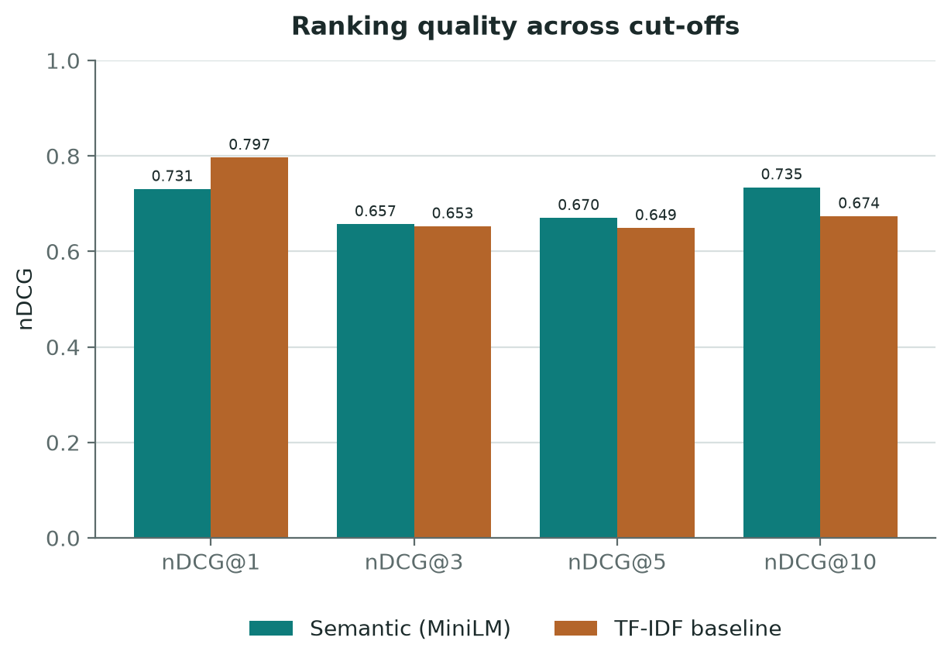
Figure 7.1 — Ranking quality (nDCG) across cut-offs.
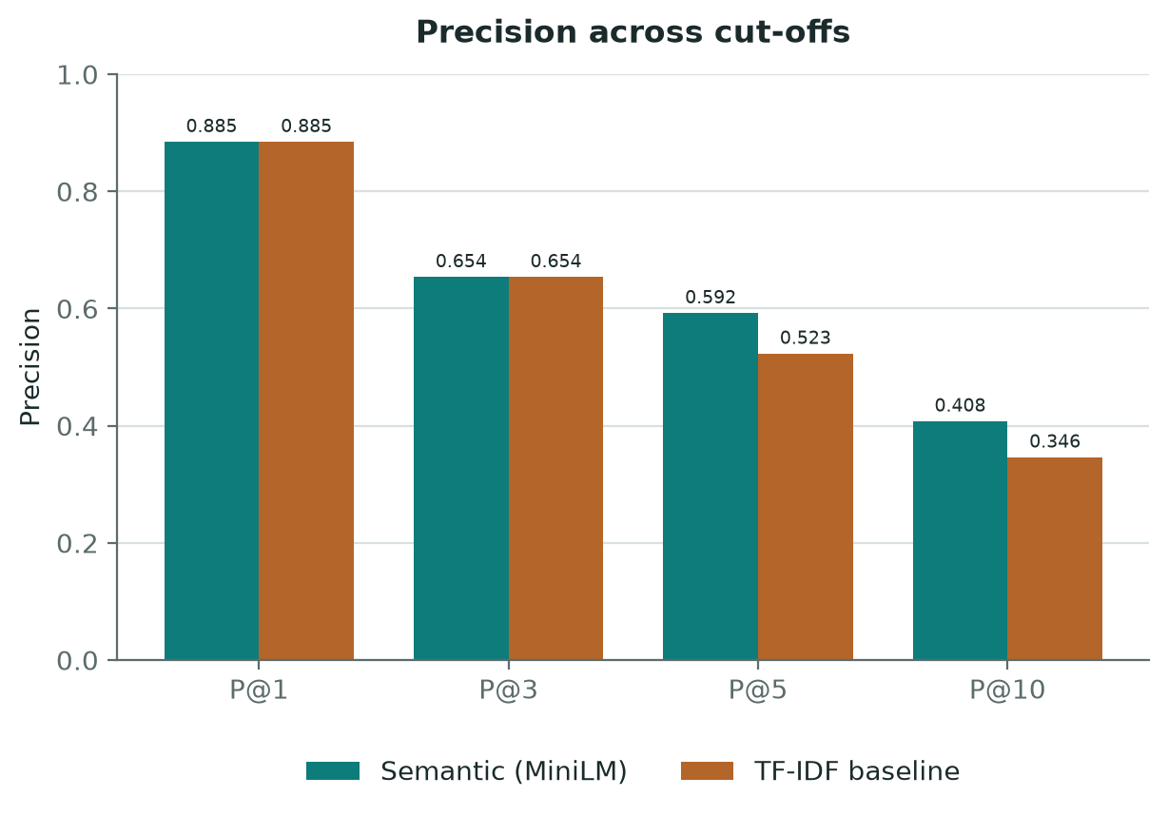
Figure 7.2 — Precision across cut-offs.
[ Write this section here — target ≈ 120 words. ]

7.2 Statistical comparison
Statistic | Value
Queries (n) | 26
Mean difference (nDCG@5) | +0.0212
SD of differences | 0.2636
Paired t | 0.4103
Cohen's d | 0.0805
Queries where semantic ranked higher | 11
Queries where TF-IDF ranked higher | 15
Table 7.2 — Paired per-query comparison on nDCG@5.
Report t and d as descriptive effect sizes, not as a significance test.
[ Write this section here — target ≈ 100 words. ]

7.3 Performance by query type
Query type | n | Semantic | TF-IDF | Difference
lexical | 18 | 0.7450 | 0.7980 | -0.0530
paraphrase | 8 | 0.5026 | 0.3145 | +0.1881
all | 26 | 0.6704 | 0.6492 | +0.0212
Table 7.3 — nDCG@5 disaggregated by query type.
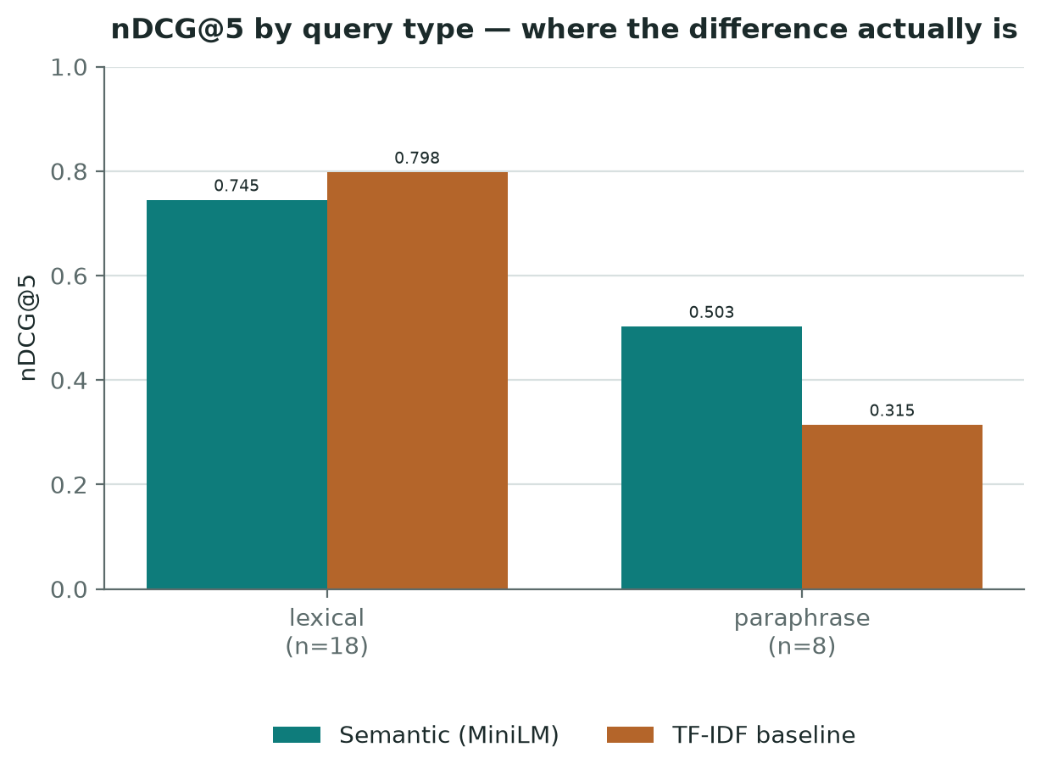
Figure 7.3 — nDCG@5 by query type.
[ Write this section here — target ≈ 120 words. ]

7.4 Per-query results
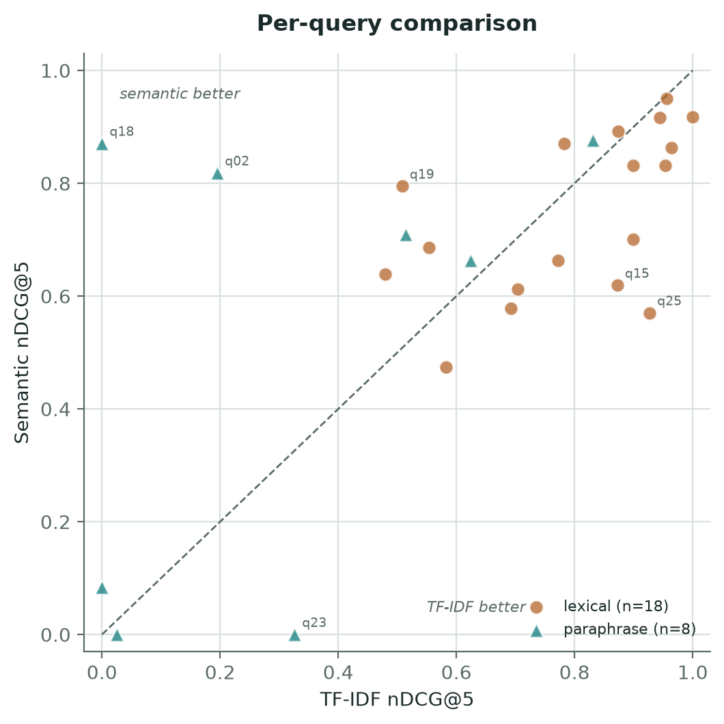
Figure 7.4 — Per-query comparison. Points above the diagonal favour the semantic model.
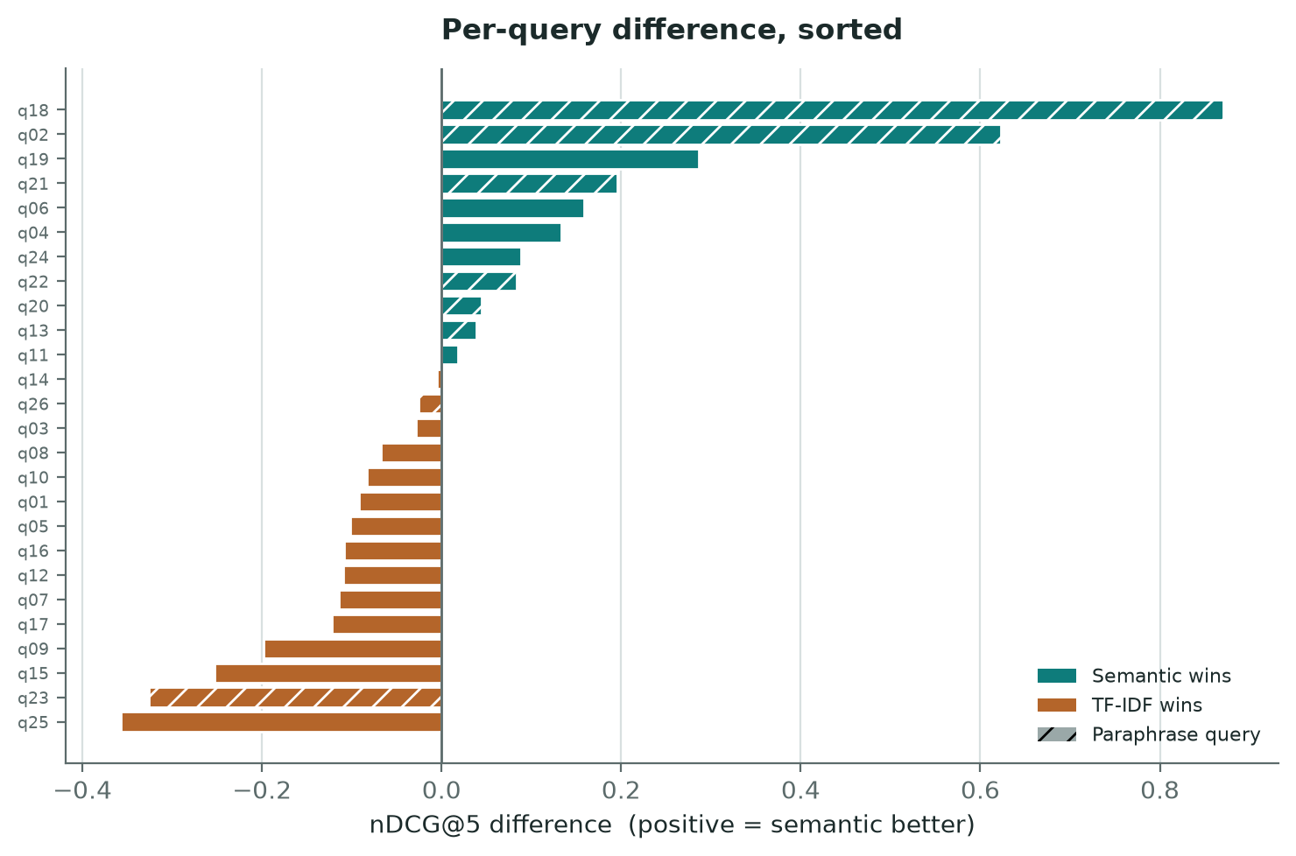
Figure 7.5 — Per-query nDCG@5 difference, sorted. Hatched bars are paraphrase queries.
[ Write this section here — target ≈ 110 words. ]

7.5 Retrieval cost
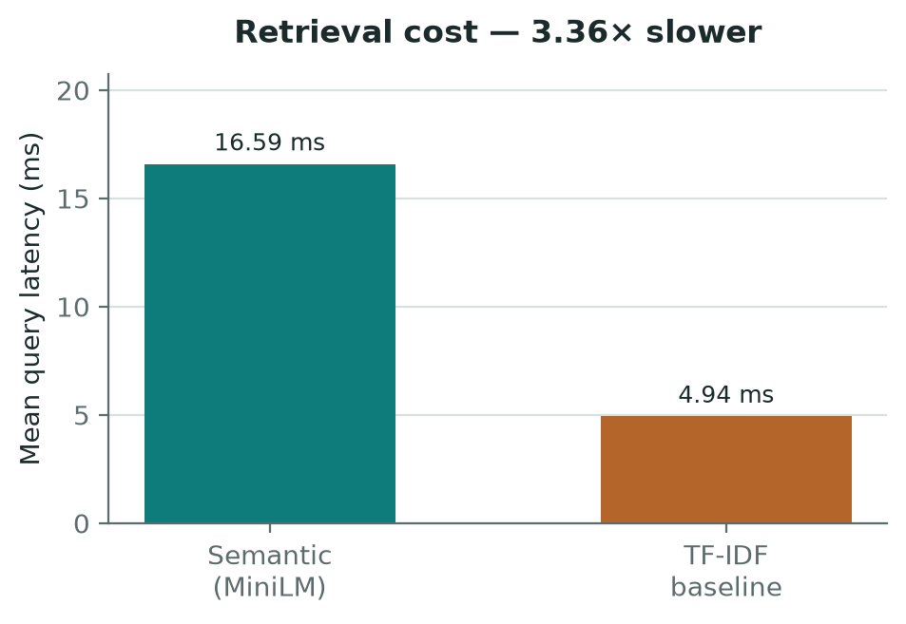
Figure 7.6 — Mean query latency.

8. Discussion
MARK SCHEME — Outcomes 15%. This chapter carries more marks per word than any other.
Chapter target ≈ 800 words. Everything below is a question for YOU to answer. This is where the analysis happens.

8.1 Interpreting the headline result
Your aggregate difference is small and the effect size negligible. Say so plainly — an honestly reported null result is a legitimate finding, and your interim report anticipated this outcome.
[ Write this section here — target ≈ 180 words. ]

8.2 Where the difference lies
The subgroup analysis reverses the aggregate. Explain the MECHANISM: a keyword model cannot rank what shares no term with the query. Why does averaging conceal it?
[ Write this section here — target ≈ 200 words. ]

8.3 Distribution of the effect
! DO NOT OMIT THIS. Of your 8 paraphrase queries, 6 favour semantic and 2 favour TF-IDF. Two queries (q18, q02) contribute a large share of the subgroup difference. On q18, TF-IDF returned nothing relevant in ten results (0.000) while semantic scored 0.871 — investigate why and write it up as a worked example. Then examine q23 and q26, where semantic scored 0.000. A discussion that explains only the wins is not a discussion. Consider narrowing your claim.
[ Write this section here — target ≈ 220 words. ]

8.4 Cost and practical implications
3.4× latency. At 48 destinations both are imperceptible. What changes at 10,000? When does approximate nearest-neighbour indexing stop being optional? Would a hybrid, or routing by query characteristics, beat choosing one model?
[ Write this section here — target ≈ 200 words. ]

8.5 Relation to existing work and limitations
Borràs et al. identified evaluation as underdeveloped in tourism recommenders — what does your result add? Then restate limitations specifically. Examiners reward candour and penalise overclaiming.
[ Write this section here — target ≈ 200 words. ]

9. Conclusion
MARK SCHEME — Outcomes 15%.
Chapter target ≈ 420 words.

9.1 Achievement of objectives
Objective by objective, with evidence, using the IDs from Table 1.1. Be accurate about what was not achieved — the user study and the vector-index work were not completed. Saying so costs far less than claiming otherwise.
Objective | Status | Evidence
CO1 | Met / Partially met / Not met | Section x.y
Table 9.1 — Achievement against objectives (extend this table).
[ Write this section here — target ≈ 180 words. ]

9.2 Answer to the research question
One clear paragraph. Do not hedge, do not overclaim.
[ Write this section here — target ≈ 120 words. ]

9.3 Future work
A larger and better-balanced query set; a second annotator with ethics approval; pgvector and ANN indexing; hybrid or query-routed retrieval; a user study.
[ Write this section here — target ≈ 120 words. ]

Bibliography
Harvard system, as required by the guide. Not included in the word count. Your interim sources are below as a starting point — verify each against your department's Harvard variant.
! Two problems to fix: (1) you have NO evaluation-methodology sources, and nDCG is your headline metric; (2) six of these ten predate 2016. Keep the older ones where they are genuinely seminal or provide the timeline, and justify that in the text — but add recent work alongside them.
Adomavicius, G. and Tuzhilin, A. (2005) 'Toward the next generation of recommender systems: A survey of the state-of-the-art and possible extensions', IEEE Transactions on Knowledge and Data Engineering, 17(6), pp. 734–749.
Borràs, J., Moreno, A. and Valls, A. (2014) 'Intelligent tourism recommender systems: A survey', Expert Systems with Applications, 41(16), pp. 7370–7389.
Devlin, J., Chang, M.-W., Lee, K. and Toutanova, K. (2019) 'BERT: Pre-training of Deep Bidirectional Transformers for Language Understanding', Proceedings of NAACL-HLT 2019, pp. 4171–4186.
Lops, P., de Gemmis, M. and Semeraro, G. (2011) 'Content-Based Recommender Systems: State of the Art and Trends', in Recommender Systems Handbook. Boston, MA: Springer, pp. 73–105.
Mikolov, T., Sutskever, I., Chen, K., Corrado, G. and Dean, J. (2013) 'Distributed representations of words and phrases and their compositionality', Advances in Neural Information Processing Systems, pp. 3111–3119.
Pazzani, M.J. and Billsus, D. (2007) 'Content-Based Recommendation Systems', in The Adaptive Web, LNCS 4321. Berlin: Springer, pp. 325–341.
Reimers, N. and Gurevych, I. (2019) 'Sentence-BERT: Sentence Embeddings using Siamese BERT-Networks', Proceedings of EMNLP-IJCNLP 2019, pp. 3982–3992.
Ricci, F., Rokach, L. and Shapira, B. (2011) 'Introduction to Recommender Systems Handbook', in Recommender Systems Handbook. Boston, MA: Springer, pp. 1–35.
Sarkar, J.L., Majumder, A., Panigrahi, C.R., Roy, S. and Pati, B. (2022) 'Tourism recommendation system: a survey and future research directions', Multimedia Tools and Applications, 82(6), pp. 8983–9027.
Wang, W., Wei, F., Dong, L., Bao, H., Yang, N. and Zhou, M. (2020) 'MiniLM: Deep Self-Attention Distillation for Task-Agnostic Compression of Pre-Trained Transformers', Advances in Neural Information Processing Systems, 33, pp. 5776–5788.
STILL TO ADD:
Järvelin, K. and Kekäläinen, J. (2002) 'Cumulated gain-based evaluation of IR techniques', ACM Transactions on Information Systems, 20(4), pp. 422–446.
Manning, C.D., Raghavan, P. and Schütze, H. (2008) Introduction to Information Retrieval. Cambridge University Press.
Plus 2016+ work on dense retrieval, tourism recommenders, and evaluation. Also cite the software you depend on: Django, DRF, scikit-learn, sentence-transformers, Open-Meteo, React Native.

Appendices
Not included in the word count. The guide states the source code you wrote yourself is included as an appendix, and the full code is submitted separately on Canvas.

Appendix A — Risk register
The guide asks you to reference this register from the Technical Development chapter when discussing problems. Show it as a living document with outcomes — several of your predicted risks materialised, which shows the analysis was real.
# | Risk | L | I | Mitigation | Outcome
1 | Models run as alternatives, so comparison impossible | M | H | [from interim] | Materialised — resolved by engine rewrite
2 | No ground-truth relevance data | M | H | [from interim] | Materialised — resolved with 26 labelled queries
3 | ML dependency friction | M | M | [from interim] | Partially materialised — version conflict resolved by pinning
4 | External API downtime or terms change | M | L | [from interim] | Materialised — provider deprecated; pluggable provider added
5 | Competing time demands | H | H | [from interim] | [your assessment]
6 | Loss of work | L | H | [from interim] | [state honestly what version control was in place]
7 | Late frontend integration issues | M | M | [from interim] | Materialised — CORS, JWT refresh, cold-start timeout
8 | Semantic may not beat the baseline | M | L | [from interim] | Materialised — reported as the finding, as planned
Table A.1 — Risk register with outcomes.

Appendix B — Labelled query set
All 26 queries with graded relevance judgements. Source: backend/evaluation/queries.py

Appendix C — Full per-query results
One row per query per model, every metric. Source: backend/evaluation_results/results.csv

Appendix D — Full test report
The guide requires the full test report as an appendix. Output of `python manage.py test --verbosity 2`, all 139 tests.

Appendix E — API endpoint reference
Complete endpoint listing. Source: README.md

Appendix F — Source code
The code you wrote yourself. Full codebase submitted separately on Canvas.

Appendix G — AI use log
The guide suggests recording AI use as you go, and the Introduction statement is assessed. A dated log of where AI assisted is strong supporting evidence.

Appendix H — Supervisor meeting log
Dates, topics discussed, actions agreed.

