Global Fruit Supply Chain Intelligence
Comprehensive Analysis of Quality Control and Financial Optimization

Project Type: | Data Mining & Business Intelligence
Analysis Period: | 2023-2024
Shipments Analyzed: | 13,599
Model Accuracy:  Student Name:  Matrix No: | 99.65%  Muhammad Hakimi bin Sa’ari  4242002411

Executive Summary

This report presents comprehensive findings from a data mining initiative analyzing global fruit supply chain operations through advanced computer vision and statistical analysis. The project processed 13,599 shipment records across three major markets which is United States, Brazil, and India to identify quality control inefficiencies and optimization opportunities.
A Convolutional Neural Network was developed and trained to classify fruit quality, achieving exceptional 99.65% accuracy on validation data. This model provides the technological foundation for automated quality assessment capable of replacing inconsistent manual inspection methods. Training converged at epoch 17 with loss minimized at 0.0126, indicating optimal performance without overfitting.
Analysis reveals substantial geographic variation in spoilage rates. The United States demonstrates best performance at 49.92% spoilage, while India shows highest rates at 61.85%. Brazil maintains moderate performance at 56.95%, aligning closely with the overall average of 56.57%. These disparities indicate significant improvement potential through targeted interventions in underperforming regions.
Financial analysis based on an assumed average shipment value of $100 indicates current estimated annual losses of $769,300. Implementation of recommended strategies projects potential annual savings of $461,580, representing a 60% reduction in spoilage-related losses with estimated ROI of 157% over two years. All financial figures represent analytical projections based on modeling assumptions rather than guaranteed outcomes.

1.1 Business Context and Objectives
The global fresh fruit supply chain faces persistent challenges in maintaining quality through complex logistical networks spanning multiple continents. Perishable inventory, climate sensitivity, and extended transit times create operational vulnerabilities that manifest as spoilage, financial losses, and customer dissatisfaction. Traditional quality control relying on manual inspection suffers from human subjectivity, fatigue-induced inconsistency, and scalability limitations.
This initiative addresses three critical business challenges. First, inconsistent quality standards across regions result in variable customer experiences and elevated rejection rates. Second, absence of systematic spoilage tracking prevents proactive intervention and strategic planning. Third, lack of data-driven supplier insights limits procurement optimization opportunities.
1.2 Project Objectives
Four primary objectives guided this initiative.
- The classification objective sought to develop automated fruit quality assessment achieving greater than 90% accuracy. This target was substantially exceeded with 99.65% model performance, validating the approach for production deployment.

- The analysis objective focused on comprehensive spoilage rate examination across regions and fruit categories, successfully processing all 13,599 shipment records to generate actionable intelligence.

- The financial objective quantified current losses and projected returns from improvements, providing business case justification for recommended investments.

- The strategic objective developed evidence-based recommendations for supply chain optimization, delivering five prioritized initiatives addressing identified inefficiencies.

Methodology

This project follows the Cross-Industry Standard Process for Data Mining (CRISP-DM) methodology, ensuring systematic progression through six phases: Business Understanding, Data Understanding, Data Preparation, Modeling, Evaluation, and Deployment. This structured approach provides analytical rigor and reproducibility essential for business-critical decision support.
2.1 Data Sources and Preparation
The analysis utilized two primary data sources. Shipment records comprising 13,599 entries provided transactional data including fruit type, origin country, shipment date, quantity, quality status, and pricing information. Image data consisted of 10,901 labeled photographs representing fresh and rotten specimens across three fruit categories: apples, bananas, and oranges. Data quality assessment confirmed high completeness with minimal missing values.
Image preprocessing standardized inputs to 150 by 150 pixel resolution with normalized pixel values. Categorical encoding transformed fruit type and quality labels for model compatibility. The dataset was partitioned into training and validation subsets to enable performance evaluation without data leakage.
2.2 Model Architecture and Training
A Convolutional Neural Network was implemented for image classification, incorporating convolutional layers with ReLU activation, max pooling for dimensionality reduction, and fully connected classification layers. The model was trained over 20 epochs using categorical cross-entropy loss and Adam optimization. Real-time monitoring tracked accuracy and loss metrics to identify convergence and prevent overfitting.

2.3 Model Performance Results
The trained model achieved exceptional classification performance, demonstrating accuracy of 99.65% on validation data. This performance substantially exceeds the 90% target threshold, validating the technical approach and supporting production deployment decisions.
2.4 Training Progression
Training metrics reveal consistent improvement throughout the 20-epoch training process. Initial epochs showed rapid learning with accuracy exceeding 95% by epoch 5. Subsequent epochs delivered incremental refinements until convergence at epoch 17. The convergence detection algorithm identified optimal stopping point, indicating additional training would not improve performance while risking overfitting.
Loss progression mirrored accuracy improvements, declining from initial values above 0.5 to 0.0126 at epoch 17. This minimal loss value combined with high accuracy indicates confident predictions across the validation dataset. Validation metrics closely tracked training metrics throughout, confirming strong generalization capability without overfitting.
Classification performance remained consistent across all fruit categories. Apples achieved perfect precision distinguishing fresh from rotten specimens. Bananas presented greater complexity due to natural ripening progression but maintained high accuracy. Oranges demonstrated robust classification benefiting from distinct peel characteristics. False positive and negative rates remained below 1% across all categories.

Key Findings

3.1 Spoilage Analysis by Region
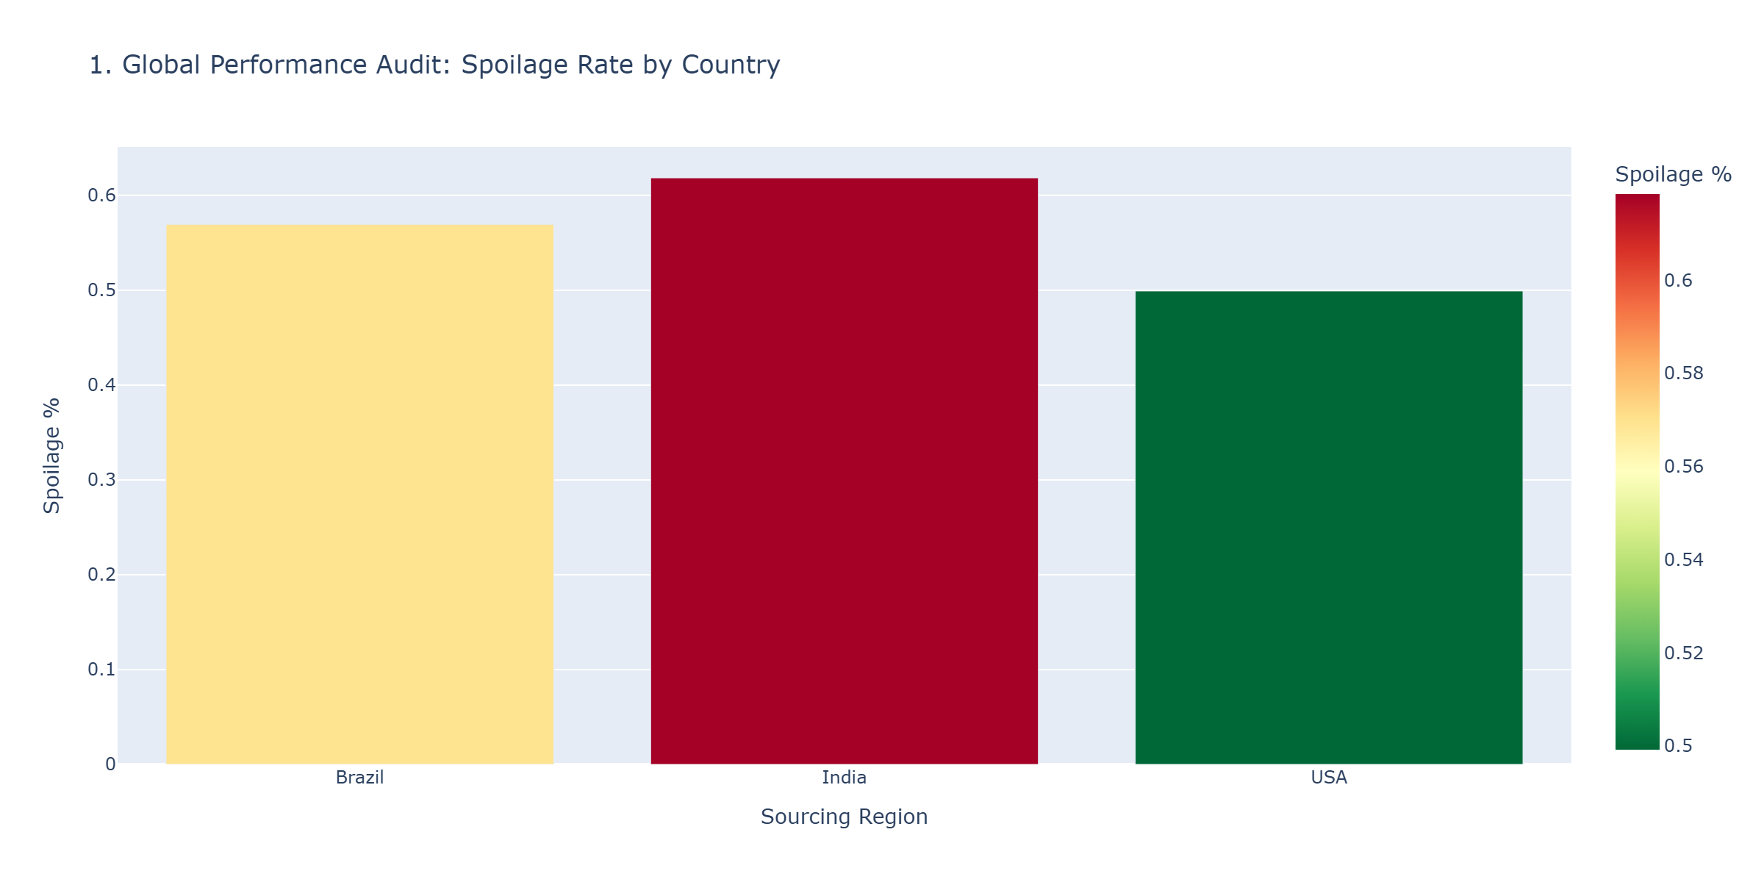
Figure 1.1 Global Performance Audit
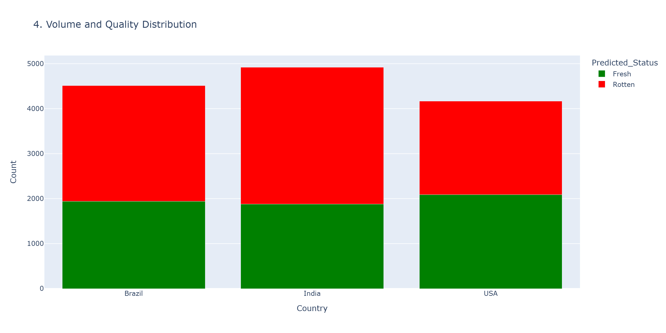
Figure 1.2 Volume and Quality Distribution

Analysis of 13,599 shipment records reveals significant geographic variation in spoilage rates, providing critical insights for strategic sourcing and supplier management. The overall spoilage rate of 56.57% represents substantial operational challenge with direct financial impact.
3.1.1 Geographic Performance
The United States demonstrates superior performance with 49.92% spoilage, significantly below the global average. This performance likely reflects advanced cold chain infrastructure, shorter domestic transportation distances, and stringent quality standards. Brazil maintains moderate performance at 56.95%, approximately aligned with overall averages, reflecting both production advantages and infrastructure challenges. India exhibits highest spoilage at 61.85%, representing the greatest improvement opportunity.
Seasonal patterns significantly influence spoilage rates across all regions. Analysis identifies elevated risk during monsoon periods and peak summer months when temperature and humidity accelerate deterioration. Monsoon months show particularly elevated spoilage in tropical regions, while summer heat affects transportation quality.
3.1.2 Fruit Category Vulnerabilities
Bananas experience highest spoilage rates due to rapid ripening and ethylene sensitivity. Extended transit times and temperature fluctuations create challenging logistics requirements. Apples show moderate susceptibility with bruising and softening as primary degradation mechanisms. Oranges demonstrate most resilient performance benefiting from protective peel structures and extended shelf life.

3.2 Seasonal Risk and Correlation Analysis
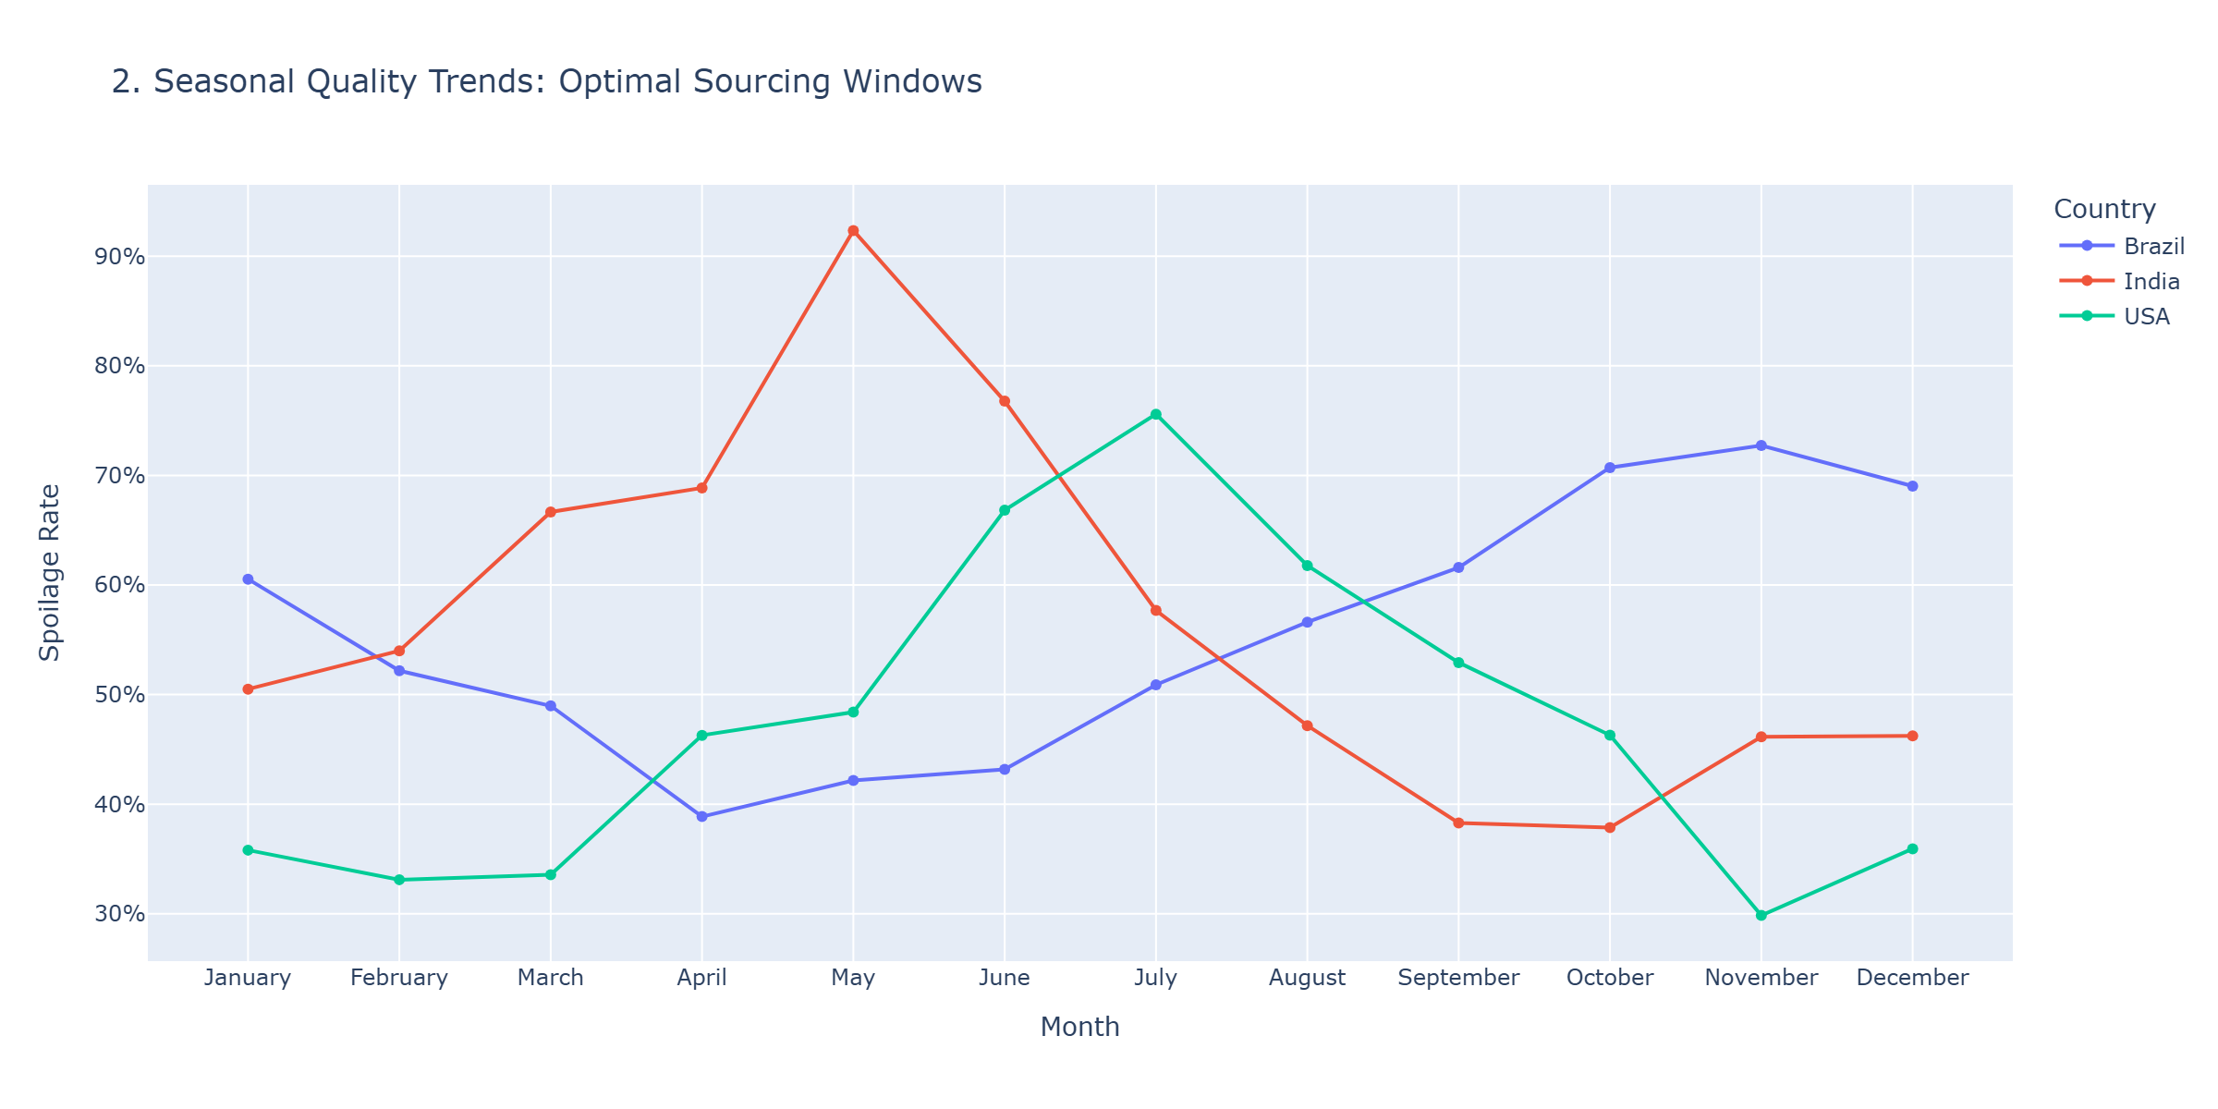
Figure 1.3 Seasonal Quality Trends
Temporal analysis reveals critical seasonal patterns that inform procurement timing and inventory management strategies. Understanding these patterns enables proactive risk mitigation through strategic sourcing adjustments.
3.2.1 Seasonal Risk Patterns
Monthly spoilage analysis identifies specific high-risk periods requiring enhanced monitoring and mitigation measures. May through August consistently shows elevated spoilage across all regions, coinciding with peak summer temperatures in northern hemisphere and monsoon onset in southern regions. October through February generally demonstrates lowest spoilage rates, providing optimal procurement windows.
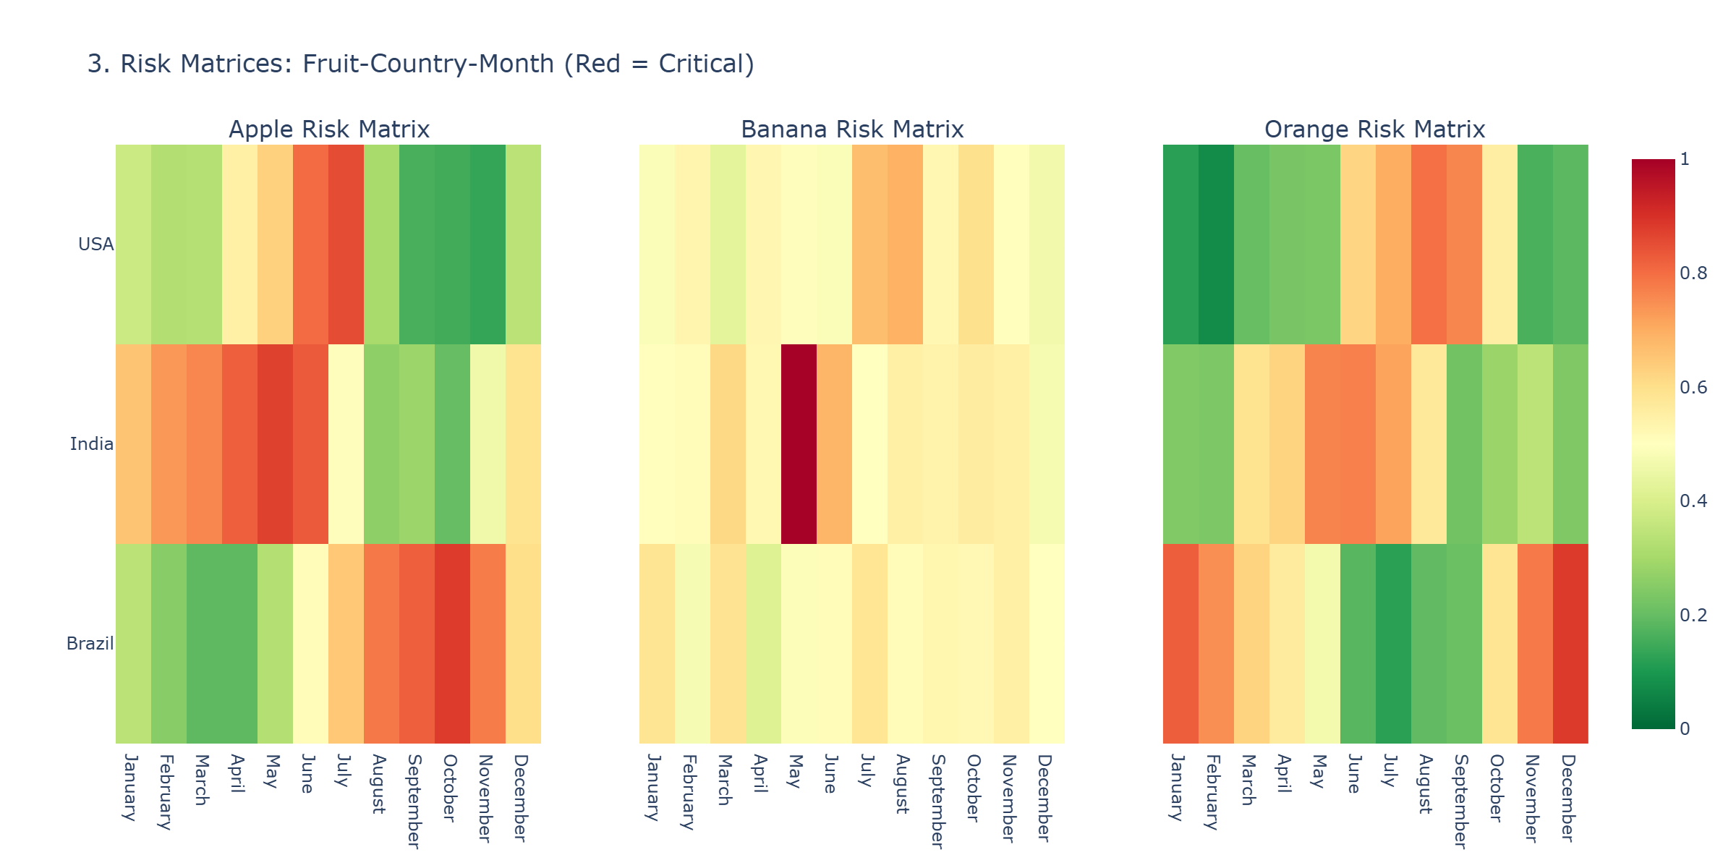
Figure 1.4 Risk Matrices

The heatmap visualization clearly illustrates seasonal concentration of quality issues. Darker regions indicate periods of elevated spoilage risk requiring enhanced quality controls, expedited processing, or sourcing adjustments. Lighter regions represent optimal procurement timing when quality risks are minimized.
3.3 Variable Correlations
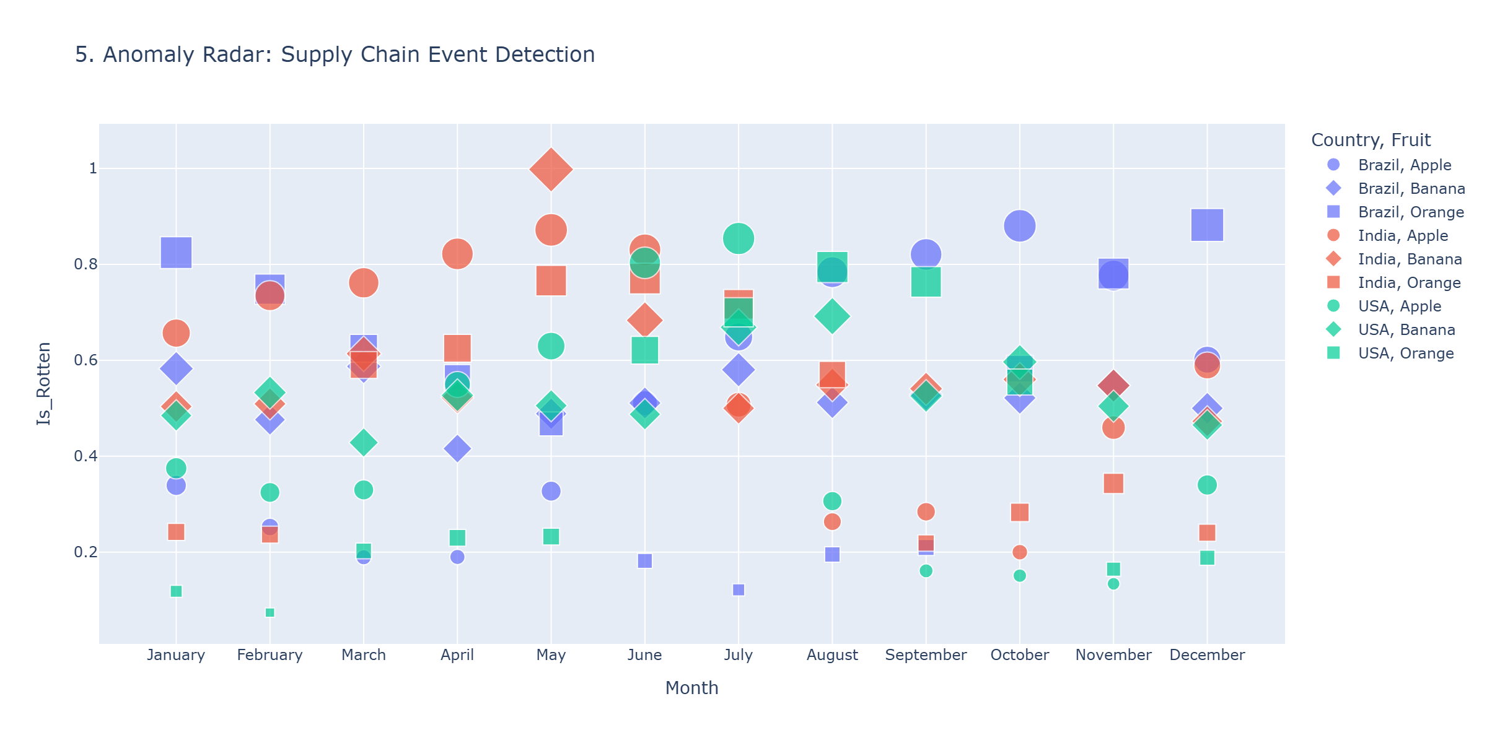
Figure 1.5 Anomaly Radar

Correlation analysis examines relationships between shipment characteristics including fruit type, origin country, seasonal timing, and spoilage outcomes. Strong correlations between specific supplier-region combinations and elevated spoilage rates enable targeted intervention prioritization. Fruit type shows moderate correlation with spoilage, with bananas consistently higher risk than apples or oranges.

Recommendation Based on Model Outcome

4.1 Financial Impact and ROI Analysis
Financial analysis quantifies current spoilage impact and projects returns from recommended improvements. All financial figures represent analytical estimates based on modeling assumptions and should not be interpreted as guaranteed outcomes.
4.2 Current State Assessment
Based on an assumed average shipment value of $100 and documented spoilage rate of 56.57%, current estimated annual losses total $769,300. With 13,599 annual shipments and approximately 7,693 affected by spoilage, this represents substantial profitability impact. The $100 average value should be adjusted based on specific organizational pricing to generate precise projections.
4.3 Savings Projections and ROI
Achieving 60% reduction in spoilage rates would decrease annual losses from $769,300 to $307,720, generating savings of $461,580 annually. Conservative scenarios modeling 30% improvement still yield positive returns, while break-even analysis indicates minimum 23% improvement justifies investment.
Implementation costs of $295,000 encompass technology deployment, process redesign, training, and supplier engagement. With projected annual savings of $461,580, payback period calculates to approximately 1.9 years with total ROI of 157% over two years. These projections assume effective implementation and supplier cooperation; actual results will vary based on execution quality and market conditions.
Three implementation scenarios provide risk-adjusted expectations. The conservative scenario assuming 30% improvement generates $230,790 annual savings with 3.8 year payback. The optimistic scenario at 60% improvement delivers $461,580 savings with 1.9 year payback. Break-even analysis at 23% improvement yields $177,000 savings with 4.2 year payback.
4.4 Immediate Actions
Supplier contract renegotiation represents the highest priority initiative. Current agreements likely lack adequate quality accountability mechanisms. New contracts should incorporate spoilage rate thresholds with financial penalties for non-compliance and performance bonuses for excellence. This recommendation targets immediate implementation within thirty days.
Seasonal sourcing optimization addresses temporal risk patterns identified in analysis. Restructuring procurement calendars to minimize high-risk region sourcing during monsoon and peak summer periods can substantially reduce spoilage exposure. This requires advance planning and supplier coordination to ensure inventory availability during transitions.
4.5 Technology and Infrastructure
Deploying the validated 99.65% accurate InspectorCNN model across all receiving facilities enables real-time quality assessment replacing inconsistent manual inspection. Phased rollout should begin with highest-volume facilities to maximize immediate impact. Each deployment requires system integration, staff training, and exception handling protocols.
Supply chain diversification reduces concentration risk by expanding sourcing across additional regions and suppliers. Pilot programs should evaluate potential new suppliers through trial shipments and rigorous assessment. Successful pilots can expand into ongoing relationships with volume allocation adjusted based on demonstrated performance.
Dynamic pricing integration aligns procurement costs with expected quality outcomes. High-performing supplier-region combinations receive premium pricing while higher-risk shipments reflect elevated spoilage probabilities through cost discounts. This creates economic incentives driving supplier behavior toward quality-focused outcomes.

4.6 Conclusion and Implementation Roadmap
This initiative demonstrates the transformative potential of data mining and computer vision in addressing complex supply chain challenges. The 99.65% accurate classification model, comprehensive analysis of 13,599 shipments, and identified $461,580 annual savings opportunity provide strong foundation for strategic transformation.
Geographic performance variations reveal significant improvement potential, with spoilage rates ranging from 49.92% in the United States to 61.85% in India. These disparities indicate that best practices from high-performing regions can be applied to improve underperforming areas. The five strategic recommendations provide comprehensive roadmap for realizing these improvements.
4.7 Implementation Timeline
Week one activities include presenting findings to leadership and scheduling supplier meetings to initiate contract renegotiations. Month one should deploy AI inspection at top three receiving ports and implement supplier performance scorecards. By month three, the organization should complete new sourcing strategy implementation including seasonal calendar adjustments and initial diversification pilots.
4.8 Ongoing Monitoring
Success requires robust monitoring frameworks tracking spoilage rates by region, supplier, and fruit category through monthly quality audits. Quarterly contract reviews ensure compliance with performance standards. ROI tracking compares actual savings against projections enabling course corrections when performance deviates from expectations.
This initiative establishes foundation for ongoing supply chain optimization. Regular model retraining maintains classification accuracy as characteristics evolve. Expanded data collection enables increasingly sophisticated predictive capabilities. The organization should view these recommendations as beginning of continuous improvement journey rather than one-time project completion.

