

EE 464 SOFTWARE PROJECT 1

Hakkı GÜLCÜ

Tel: +90 534 397 29 66

mail: [hakkigulcu35@gmail.com](mailto:hakkigulcu35@gmail.com)

2093862

Hikmet Murat ÇOLAKOĞLU

Tel: +90 534 668 41 01

mail: hmuratcolakoglu@gmail.com

1937846

**Supervisor:** Ozan KEYSAN

Date of Submission: 07.03.2019

# Contents

1. **Introduction**................................................................................................................2
2. **Part A**...........................................................................................................................2
3. **Part B**...........................................................................................................................5
4. **Part C**...........................................................................................................................7
5. **Part D**...........................................................................................................................8
6. **Part E**...........................................................................................................................9
7. **Conclusion**..................................................................................................................10

# Introduction

In this project, we design CuK converter respect with these desired values:

* Input Voltage: 9 V
* Output Voltage: -12 V
* Output Current: 3 A
* Switching frequency: 100 kHz
* Max. Output voltage ripple: 2%

# Part a. Choosen a Suitable Capacitor and Inductance That Can Produce the Output within Given Tolerances Under Under CCM.

|  |  |
| --- | --- |
| Input Voltage | 9V |
| Output Voltage | -12V |
| Output Current | 3A |
| Switching Frequency | 100 kHz |
| Max. Output Voltage Ripple | 2% |

For duty cycle of Cuk Converter:

D = $\frac{Vo}{Vo+Vd}$ = $\frac{12}{12+9}$ = 0.5714

By assume ideal condition, Poutput=Pin

Then, Id = Io*= = 4 A Id = Io * = 4 A

## Selection of Inductors

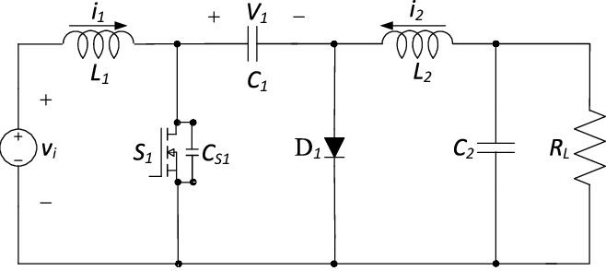

**Figure 1:** Circuit Schematic of Cuk converter

In the figure 1, average current of inductor (L2) is equal to output current Io and average current of inductor (L1) is equal to input current Id :

IL1 = Id = 4 A

IL2 = Io = 3 A

To calculate inductance value of L1 and L2, ΔIL1 assumed tobe % 25 ripple:

ΔIL1 = 0,25*4 = 1 A

As a proporties of CuK converter ΔIL1 = ΔIL2 = 1 A

During switch is on, inductor voltage is equal to input voltage.

## VL1 = L1*

Vd = L1*

IL1= 56 µH is chosen.

For chosen inductor values, our ΔIL1= 0.918 A

$V_{c}-V_{O}=L2*\frac{ΔI_{L2}}{D*Ts}$

IL2= 56 µH

IL1,max = 4 +0.918/2 = 4.459 A IL1,min= 4-0.918/2 = 3.541 A

IL2,max= 3+0.918/2 = 3.459 A IL2,min= 3-0.918/2= 2.541 A

Therefore, our inductors should be able to carry 4.5 A, so we chose inductor with 6.2 A current rating. Our inductor values are same, so same inductor can be used and its link is shown below.

<https://www.digikey.com/product-detail/en/bourns-inc/PM2110-560K-RC/M8765-ND/775304>

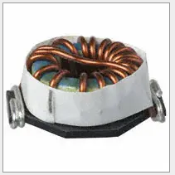

**Figure 2:** Selected Inductor

## Capacitor Selection

Outout voltage ripple is restricted with % 2, so we choose same ripple value for C1.

VC1 = Vd+VO

Δ VC1= 0.02*(12+9)=0.42 V

In switch off duration, C1 capacitor is charging thourh IL1 which is equal to 4 A. Then;

IC1 = C1* ΔVC1/((1-D)*Ts)

C1= 47 µF is chosen.

For output capacitor calculation,

ΔVO=0.02*12=0.24 V

${ΔV_{O}/V}_{O}=\left(1-D\right)*\frac{Ts^{2}}{8*L*C}$

C= 6.8 µF is chosen.

For chosen capacitor values, our ΔVO=0.17 V

For commercial product, we chose ceramic capacitor because of low ESR. These capacitor should also carry at least 12 V. Chosen capacitor links are shown below:

C1:

<https://www.digikey.com/product-detail/en/murata-electronics-north-america/GRM32EC81C476KE15L/490-10531-2-ND/5027615>

CO:

<https://www.digikey.com/product-detail/en/tdk-corporation/CGA4J1X7S1C685M125AC/445-16113-2-ND/4712729>

# Part.B

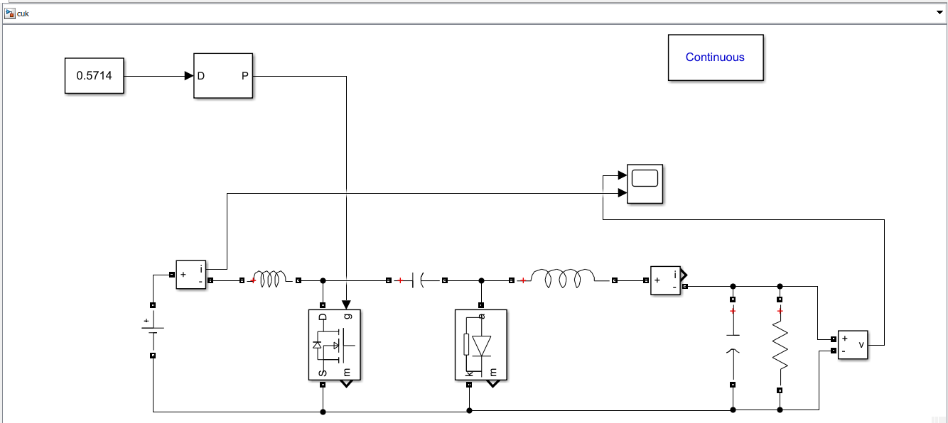

Figure 4: Design of Cuk Converter

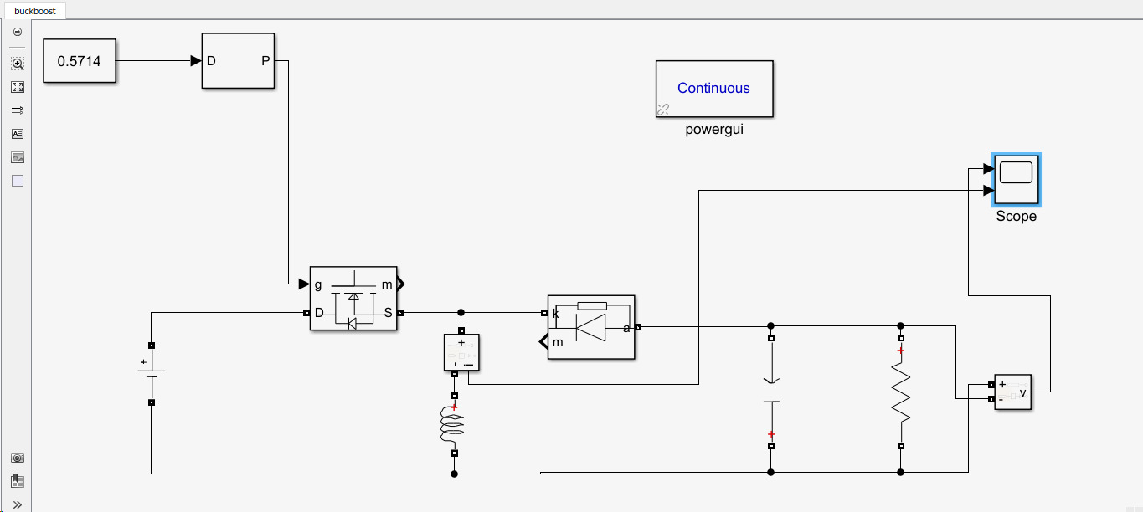

Figure 5: Design of same sized Buck-Boost Converter

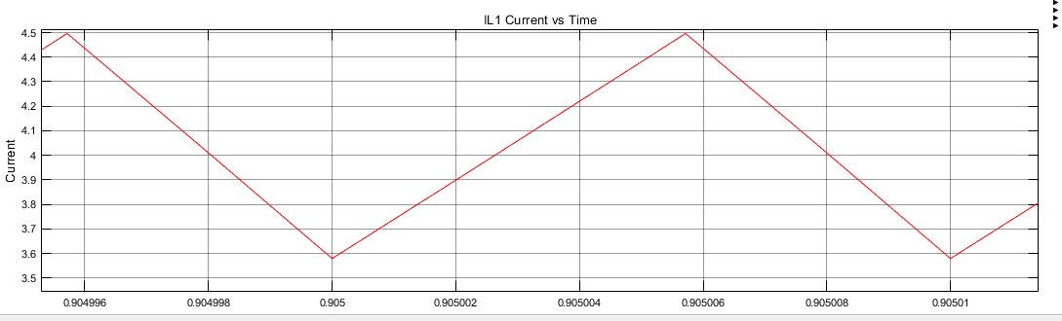

Figure 6: Input Current Waveform of Inductor(L1) in CuK Converter Design

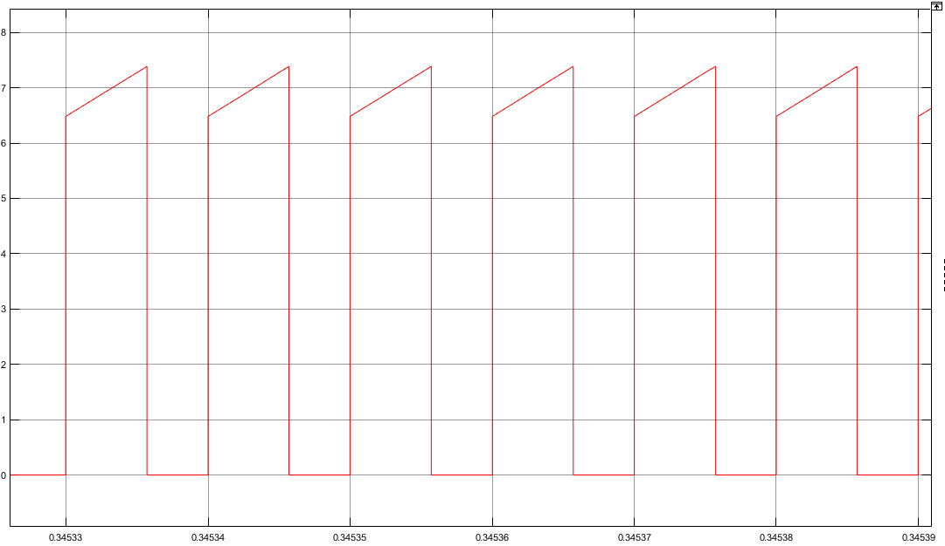

Figure 7 : Input Current Waveform of Inductor(L1) in Same Sized Back-Boost Converter Design

When we compared Cuk converter and same sized Back-Boost converted, as seen these figures, there is a discontinuous current flow in buck-boost converter because there is no path for current when the switch is off. Therefore, this leads to high ripple, bad harmonic and badly effect on the grid side. However, in CuK converter, there is no such a ripple and continuos current drawn from grid.

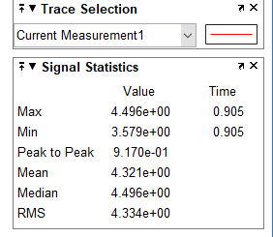 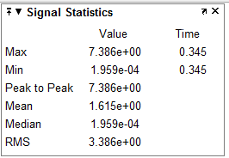

Figure 8: Current Measurement of CuK converter and Buck-Boost

## Part.c

These values is calculated from part a for selection capacitor and inductor values.

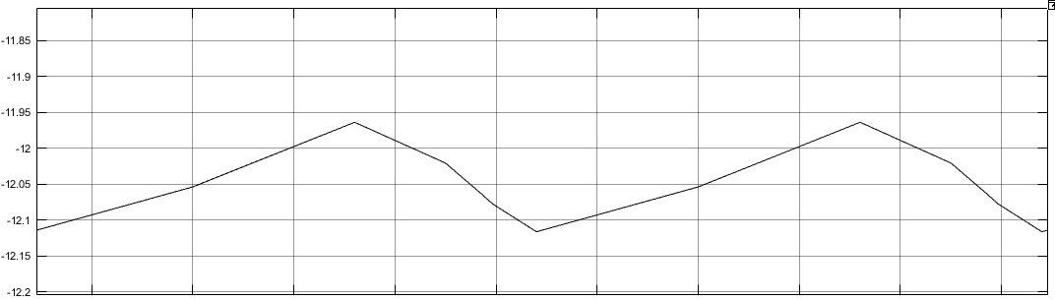 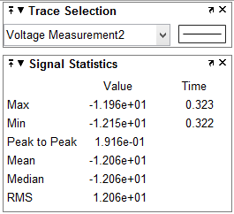

**Figure 9:** Output capacitor voltage waveorms of CuK converter

As seen in figure 8 and 9, our ripple values are 0.917 A and 0.1916 V. Our analytical values are 0.918 A and 0.17 V. These values are same as we expected.

## Pard.D

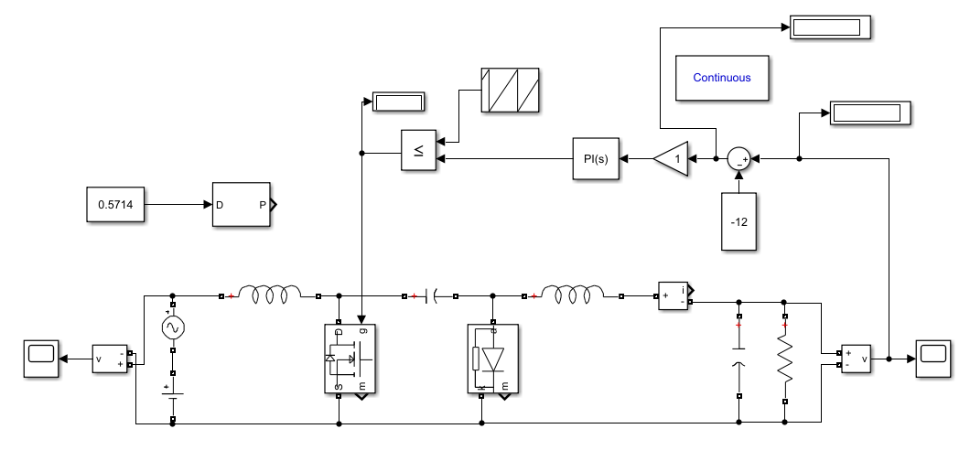

Figure 10: Design of CuK Converter with controller

Due to located harmonics voltage in input voltage (6th harmonics ).We have to design controller in order to get prevent output voltage distortion. Principle of our controller : Firstly we get output voltage value to controller. Then, because of desired mean voltage 12 volt, we substract 12 volt from output voltage. At this point, in order to hold 12 volt, it is processed in PI controller. Then this PI controller control the switch . That's , when output voltage get over 12 volt value, swich is open then it decrease the output voltage. Similarly, when output voltage get below 12 volt value, swich is closed then it increases the output voltage . Thats it based on Voutput= Vd*D/(1-D). Thanks to this controller, we controller output voltage by control D (Switch time).

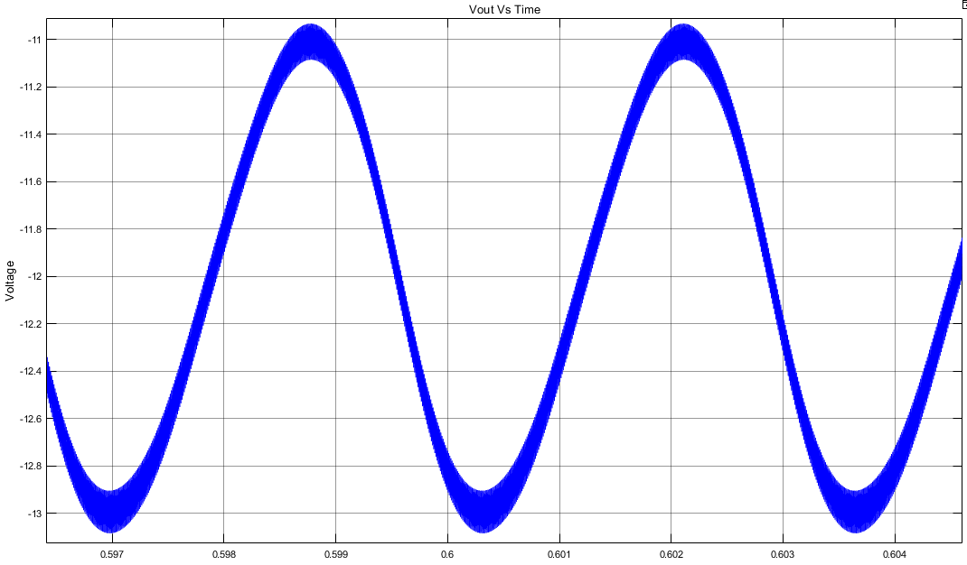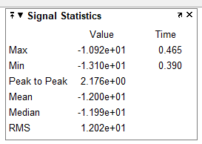

Figure 11: Output Voltage vs Time of Controller CuK Converter and its statistics

In order to get -12 V output voltage from 9 V input voltage ,according to our reseach we prefer to select bipolar voltage switching PWM controller. In this controller design, by using sawtooth generator which have 90 degree phase angle in 100kHz. Then we connect PI controller. Thans to this controller system, we get 12 volt mean as seen as output voltage simulation figure. According to Mohan book (pg 191) we fixed output signal -12 Volt.

## Part.e

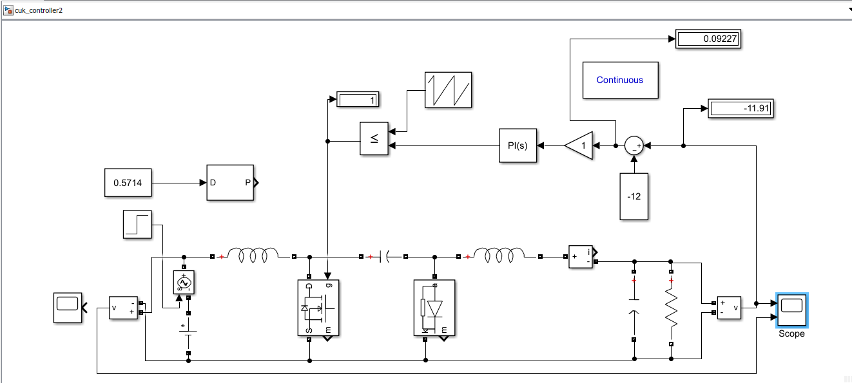

**Figure 12:** Cuk Converter with controller for step increase in input voltage

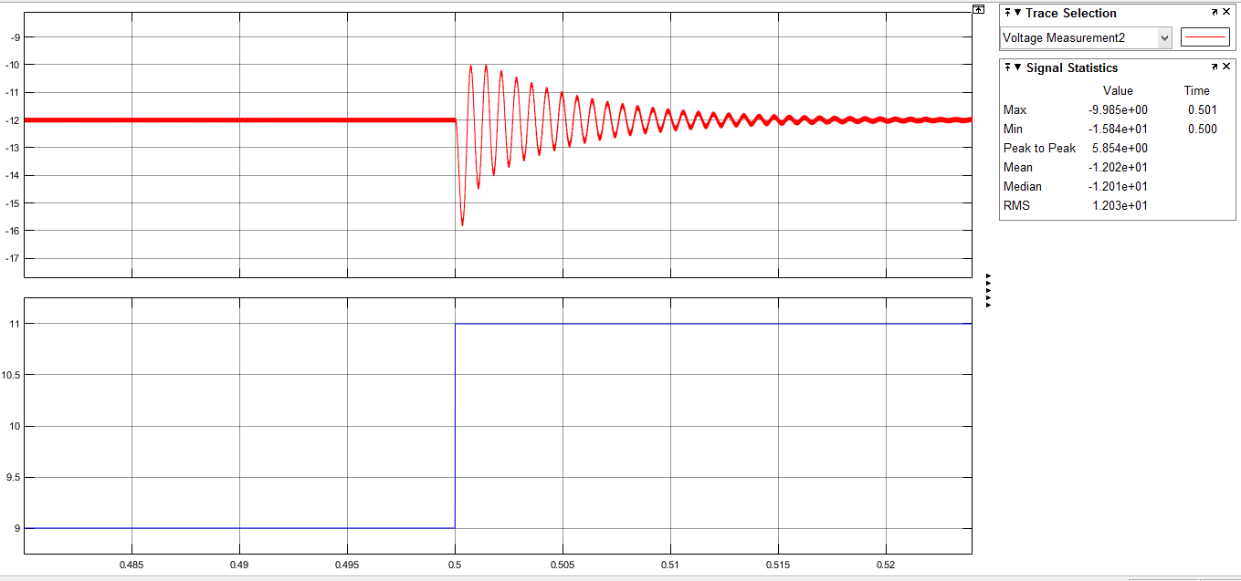

**Figure 13:** Input and output voltage waveform of CuK converter for step increase in input voltage

Our controller works well under that situation as seen in figure 13. At step time voltage varies between 10 and 16 V and controller stabilize that output voltage under 0.01 seconds which is good enugh.

## Conclusion

In this project, we learned how to design cuk controller with desired output voltage and ripple values by adjusting inductors and capacitors values. We also calculated min,max and avrage values of inductor current and capacitor voltages. These values help us to choose right component by considering its rated values. After that, we saw that our analytical results are same as simulation results as we expected. We compared this converter with buck-boost converter with same size. We gained experience about cuk converter draw current from grid continuously which is good for source, but buck-boost converter draw current from grid discontinuously which is very bad for source. We learned how to control this converter with changing duty cycle by taking feedback from output voltage. These controller is good for step increase in voltage also. To sum up, we learned design characterictics of cuk converter, its control mechanism, advantages and disadvantages of using it.