Exercise 1
Course: 34373 Microcontroller Development for Advanced IoT using Embedded C
Made by: Hákon Hlynsson (s225765)

EX1: Look up the HAL_Delay() function in the HAL manual and explain what it does
According to the HAL manual (page 32), the HAL_Delay(Delay) function is used to pause code execution for a specific duration, defined in milliseconds by the input parameter Delay.
The function operates by relying on the SysTick ISR, which triggers every 1ms to increment a global tick variable. HAL_Delay() then continuously polls this variable, stopping the execution until the variable has increased by the specified delay value.
HAL manual:
HAL_Delay(). this function implements a delay (expressed in milliseconds) using the SysTick timer. Care must be taken when using HAL_Delay() since this function provides an accurate delay (expressed in milliseconds) based on a variable incremented in SysTick ISR. This means that if HAL_Delay() is called from a peripheral ISR, then the SysTick interrupt must have highest priority (numerically lower) than the peripheral interrupt, otherwise the caller ISR will be blocked.
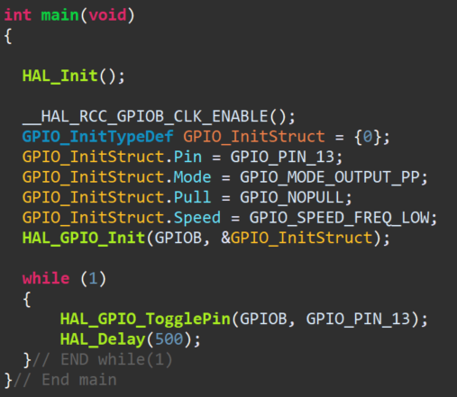
EX2: Use the defined names found in gpio.c instead, and change frequency to 100ms.

EX3: Look in HAL manual for another way to manipulate the GPIO (set/reset) and use this to make LED blink.

EX4: Create a variable X (char, int or uint8_t type) that counts up from 0. With each step the LED should blink X times (speed 100ms). Incorporate a pause of 1 sec between each increase of X. 0, 1, 2, 3, 4 etc blinks..

EX5: Use the Debug function to monitor and observe value of X and steps through code. Make screenshots.

EX6: Use CubeMX to configure one more GPIO to make an externally added LED blink. Upload code, screenshots from CubeMX and images of LED

