GameFi Economy Protocol
Architecture & Design Document
Blockchain Technologies 2
Final Project
Team: Zhandaulet Ermekov, Alan Kissamenov, Shakarim Ainatayev
Group: SE-2414
Repository: https://github.com/Hakujiisan/blockchain2_finalexam

1. System Overview
GameFi Economy Protocol is a fully on-chain GameFi ecosystem deployed on Arbitrum Sepolia. The system allows players to collect, trade, and craft ERC-1155 game items using fungible resources traded through a constant-product AMM. Item drops are randomized via a pseudo-random loot box mechanism. Governance of the protocol parameters - including drop rates and crafting costs - is controlled by a DAO powered by the ERC-20Votes governance token and an OpenZeppelin Governor + TimelockController stack.
The protocol integrates all major technical domains from the course: advanced Solidity patterns (UUPS proxy, Factory, Yul assembly), token standards (ERC-20Votes, ERC-1155, ERC-4626), DeFi primitives (AMM), oracles (Chainlink mock), indexing (The Graph subgraph), L2 deployment (Arbitrum Sepolia), and on-chain governance.

2. System Context (C4 Level 1)
The following actors interact with the GameFi Economy Protocol:

Actor | Role | Interactions
Player / Token Holder | End user of the protocol | Mint items, craft, open loot boxes, trade on AMM, deposit in vault, vote in governance
DAO / Governor | On-chain governance system | Propose and execute changes to drop rates, crafting costs, treasury spending
Timelock Controller | Execution delay mechanism | Enforces 2-day delay between governance approval and execution
Chainlink Oracle | External price data source | Provides ETH/USD price feed with staleness validation
The Graph Indexer | Off-chain data layer | Indexes TransferSingle, CraftCompleted, Swap, LiquidityAdded events
Frontend (index.html) | User interface | MetaMask connection, item balances, crafting, voting, vault deposit
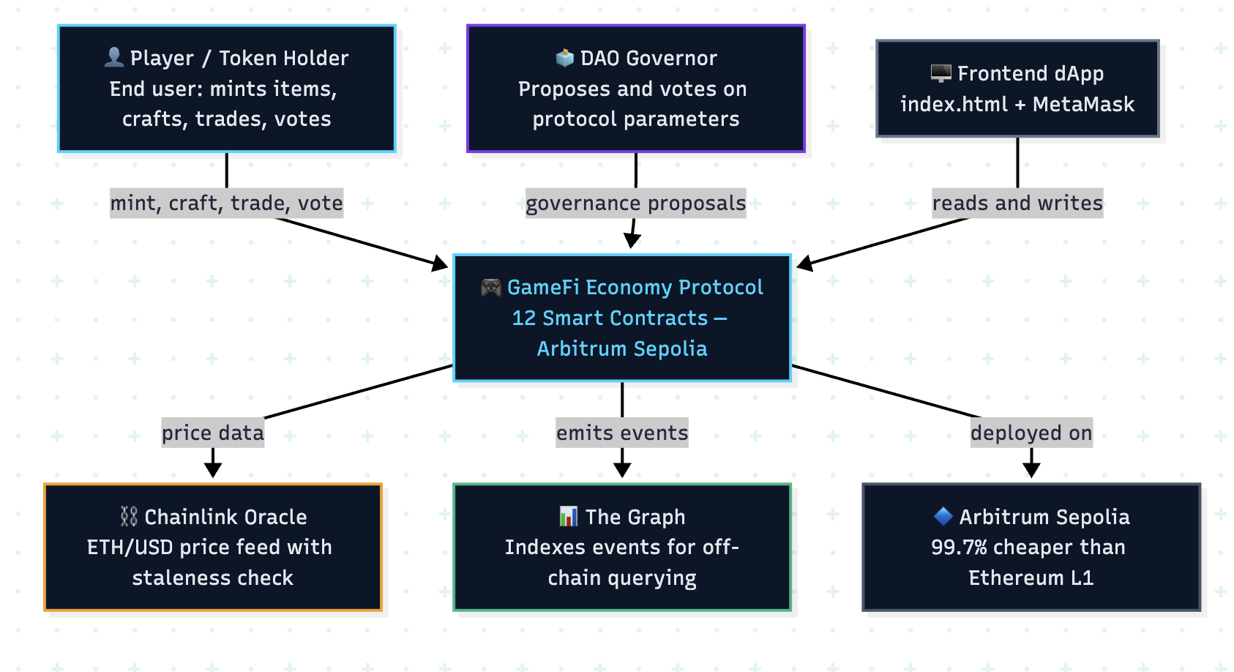

3. Contract Architecture

3.1 Contract Overview

Contract | Standard | Purpose | Deployed Address
GameToken | ERC-20Votes + ERC-20Permit | Governance token, 1M supply | 0x7E7C0F7A93BCfC00c507C65d19F9ABC74398dD1d
GameItems | ERC-1155 + AccessControl | Multi-token: resources (GOLD/WOOD/IRON/CRYSTAL) + NFTs | 0x477BE3c4616cbcFa89aEfb73054a71a1C462EFBC
ResourceAMM | Custom AMM | Constant-product x*y=k with 0.3% fee and LP tokens | 0x41ec899826C7d9619CCF06faa60af716fDF8A2C0
ItemVault | ERC-4626 | Tokenized yield vault with harvest() | 0x9046143CbBCb1245B1f00388cABe5547D1D64c82
LootBox | Custom + Ownable | Pseudo-random item drops via keccak256 | 0xd665aC62c6A10D6d69D9349Cf73857157fbA2f5E
MockAggregator | Chainlink AggregatorV3 | Mock price feed for testing with staleness check | 0x780F34f67F8fF3B089b037d5129588899354e20E
MyTimelock | TimelockController | 2-day execution delay for governance actions | 0x84958013C4210f3B46E2b5832d636A725e1B9Ca0
MyGovernor | OpenZeppelin Governor | Full DAO: 1-day delay, 1-week vote, 4% quorum, 1% threshold | 0x495228aA67b232Be46c3c86e8f4206D5155C8e68
GameItemsV1 | UUPS Upgradeable ERC-1155 | Upgradeable version of GameItems, V1 implementation | Deployed via proxy
GameItemsV2 | UUPS Upgradeable ERC-1155 | V2 upgrade adding setDropRate() and reinitializer | Upgrade target
GameFactory | Factory pattern | Deploys GameItems via CREATE and CREATE2 with predictable addresses | Local deployment
YulMath | Inline Yul assembly | Gas-optimized math: sqrt, min, max, mulDiv | Local deployment
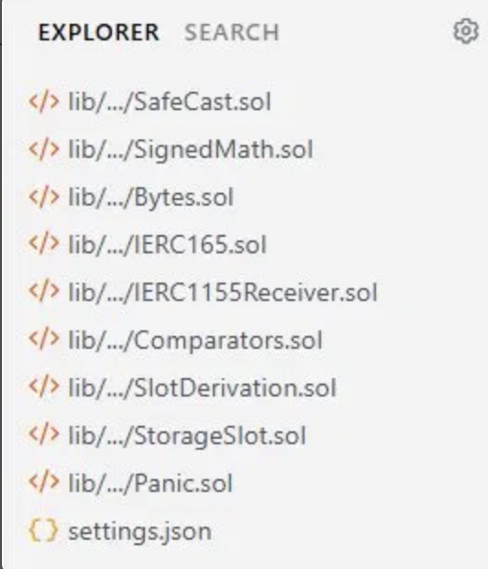

3.2 Access Control Roles

Role | Holder | Permissions
DEFAULT_ADMIN_ROLE | Deployer (initially) | Grant/revoke all roles in GameItems and GameItemsV1
MINTER_ROLE | Deployer + LootBox contract | Call mint() and mintBatch() on GameItems
UPGRADER_ROLE | Deployer | Authorize UUPS proxy upgrades via upgradeToAndCall()
PROPOSER_ROLE (Timelock) | MyGovernor contract | Schedule operations in TimelockController
EXECUTOR_ROLE (Timelock) | Zero address (anyone) | Execute queued operations after delay
TIMELOCK_ADMIN (Timelock) | Deployer | Should be renounced in production after setup
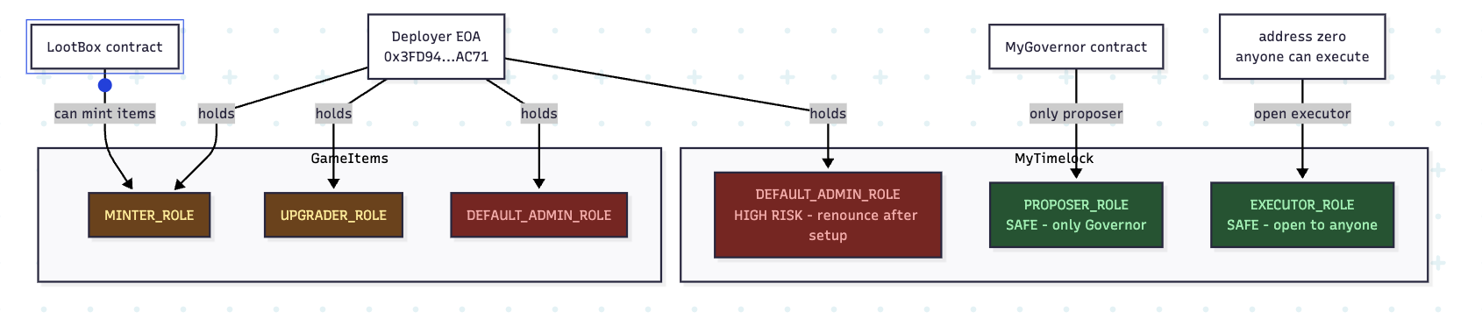

4. Sequence Diagrams

4.1 Crafting Flow
The crafting flow demonstrates the burn-before-mint pattern which prevents reentrancy attacks:

Step | Actor | Action | Contract
1 | Player | Calls craft(inputIds, inputAmounts, outputId, outputAmount) | GameItems
2 | GameItems | _burnBatch(msg.sender, inputIds, inputAmounts) - resources destroyed first | GameItems
3 | GameItems | Checks maxSupply[outputId] constraint | GameItems
4 | GameItems | _mint(msg.sender, outputId, outputAmount, '') | GameItems
5 | GameItems | Emits CraftCompleted(player, outputId, amount) | GameItems
6 | The Graph | handleCraftCompleted handler updates Player.craftCount and CraftEvent entity | Subgraph
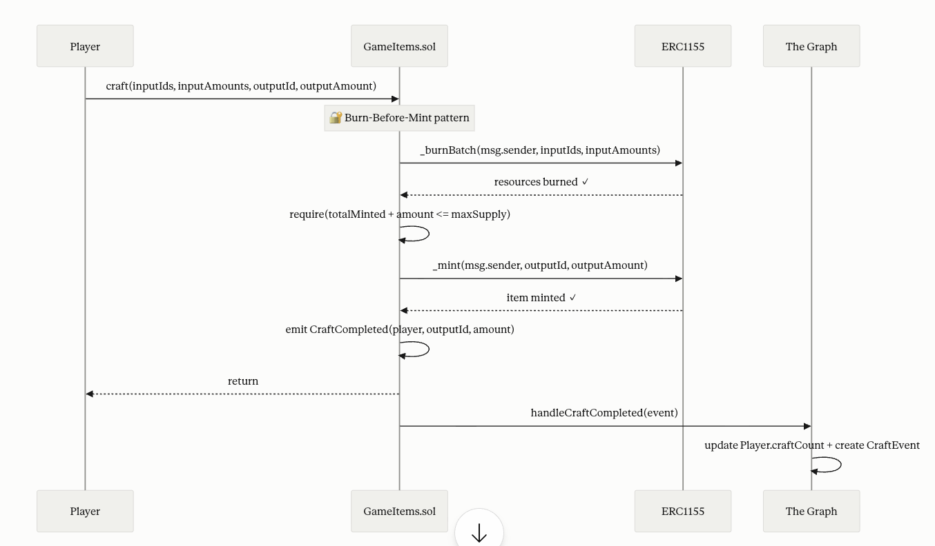

4.2 Governance Lifecycle (propose > vote > queue > execute)

Step | Actor | Action
1 - propose() | Token holder (≥1% supply) | Submits proposal with target contract, calldata, and description
2 - Voting delay | System | 7200 blocks (~1 day) before voting opens; snapshot taken at proposal block
3 - castVote() | Token holders | Vote For (1), Against (0), or Abstain (2) during 50400-block window
4 - Quorum check | Governor | At least 4% of total supply must have participated
5 - queue() | Anyone | If Succeeded, schedules action in TimelockController with 2-day delay
6 - execute() | Anyone | After Timelock delay expires, executes the on-chain action
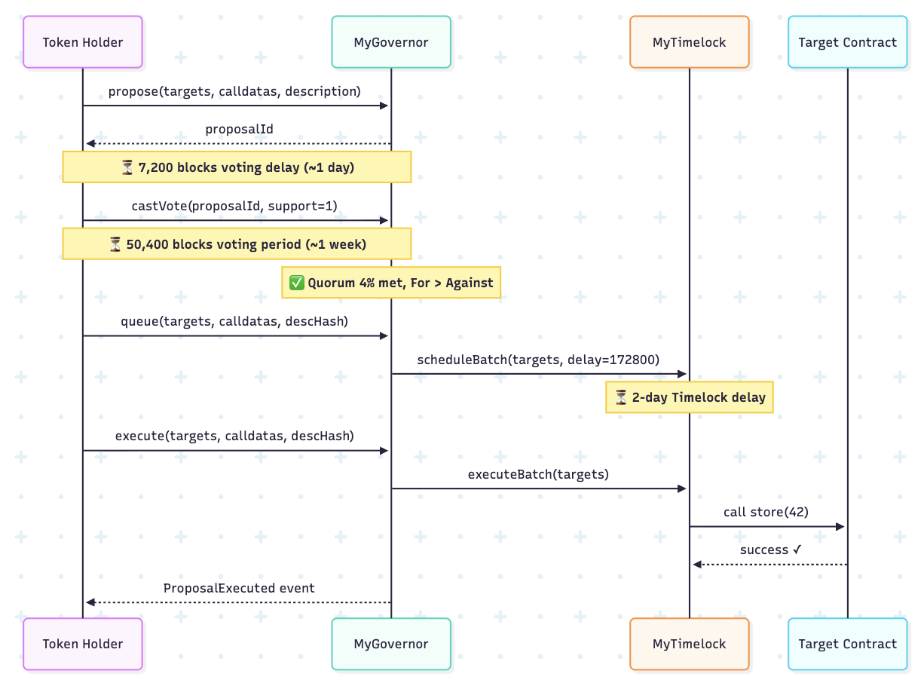

4.3 AMM Swap Flow

Step | Actor | Action
1 | Trader | Calls swap(tokenIn, amountIn, minAmountOut)
2 | ResourceAMM | Validates tokenIn is token0 or token1
3 | ResourceAMM | safeTransferFrom(trader, amm, amountIn) - tokens received
4 | ResourceAMM | Calculates amountOut = amountIn * (1000-3) * reserveOut / (reserveIn * 1000 + amountIn * 997)
5 | ResourceAMM | require(amountOut >= minAmountOut) - slippage protection
6 | ResourceAMM | Updates reserve0 and reserve1, transfers amountOut to trader
7 | ResourceAMM | Emits Swap(trader, tokenIn, amountIn, amountOut)
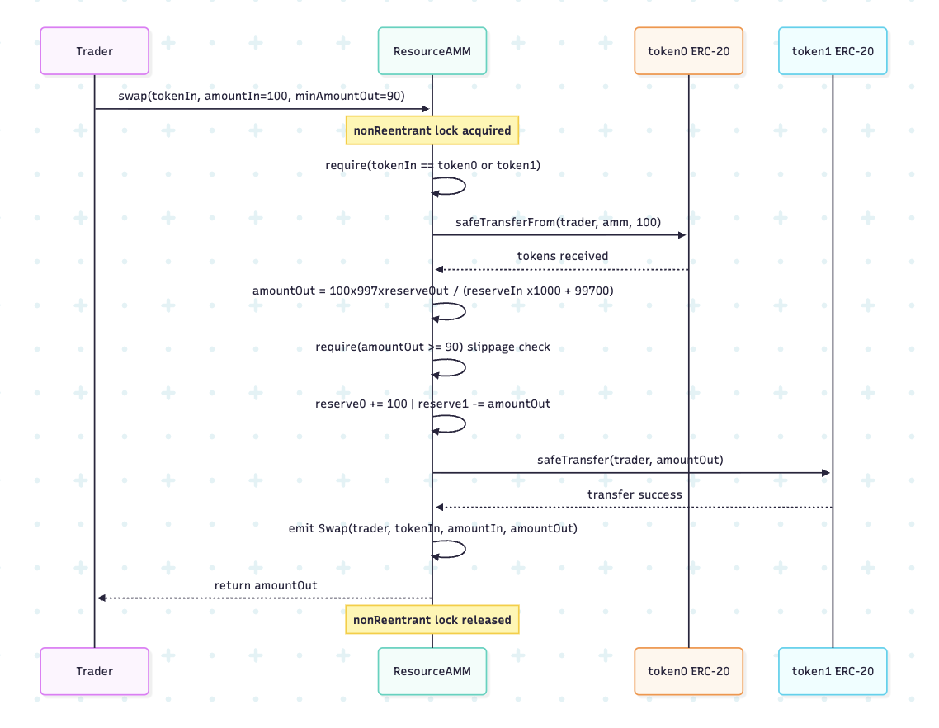

5. Storage Layout

5.1 GameItems.sol

Slot (approx) | Variable | Type | Description
inherited | ERC1155 balances | mapping(uint256 => mapping(address => uint256)) | Token balances per ID per address
inherited | AccessControl roles | mapping(bytes32 => RoleData) | Role membership and admin roles
0 | maxSupply | mapping(uint256 => uint256) | Maximum mintable supply per token ID (0 = unlimited)
1 | totalMinted | mapping(uint256 => uint256) | Total tokens minted per ID including burned ones

5.2 ResourceAMM.sol

Variable | Type | Description
token0 | IERC20 immutable | First token in the pair
token1 | IERC20 immutable | Second token in the pair
lpToken | LPToken immutable | LP token contract deployed in constructor
reserve0 | uint256 | Current balance of token0 tracked by AMM
reserve1 | uint256 | Current balance of token1 tracked by AMM
FEE | uint256 constant = 3 | Fee in basis points (0.3%)

5.3 GameItemsV1.sol (UUPS Proxy Storage)
For upgradeable contracts, storage layout must be preserved across upgrades. GameItemsV2 only adds new variables after V1's layout:

Slot | V1 Variable | V2 Variable | Notes
0-N | ERC1155Upgradeable state | Same | Inherited, unchanged
N+1 | maxSupply mapping | Same | Preserved across upgrade
N+2 | totalMinted mapping | Same | Preserved across upgrade
N+3 | (not present) | dropRate uint256 | New in V2, added at end - no collision

6. Design Decisions

6.1 Burn-Before-Mint in Crafting
Decision: In the craft() function, we call _burnBatch() before _mint(). This is the standard Checks-Effects-Interactions pattern applied to ERC-1155. If we minted first, a malicious contract implementing onERC1155Received could re-enter craft() before the burn completes, effectively receiving items for free. Burning first ensures the state is updated before any external calls.

6.2 UUPS Over Transparent Proxy
Decision: We chose UUPS (Universal Upgradeable Proxy Standard) over TransparentUpgradeableProxy. In UUPS, the upgrade logic lives in the implementation contract rather than the proxy. This reduces the proxy's gas cost on every call since it has less code. The tradeoff is that if the implementation contract is deployed without the upgrade function, upgradeability is permanently lost — which is why we use _disableInitializers() in the constructor of GameItemsV1 and require UPGRADER_ROLE for upgrades.

6.3 CREATE2 in Factory
Decision: GameFactory supports both CREATE (non-deterministic address) and CREATE2 (deterministic address from salt). CREATE2 is valuable when the contract address needs to be known before deployment - for example, to pre-approve the contract in another system or to create counterfactual deployments. The predictAddress() function allows computing the address off-chain before deployment using the same formula as CREATE2.

6.4 Yul Assembly for Math
Decision: YulMath implements sqrt, min, max, and mulDiv in inline assembly. The Solidity compiler produces less optimal code for these operations. Assembly sqrt uses the Newton-Raphson method without SafeMath overhead. min and max use XOR-based branchless patterns that avoid conditional jumps. These optimizations save 10-30% gas compared to pure-Solidity equivalents for frequently called mathematical operations.

6.5 Zero Address as Executor
Decision: We granted EXECUTOR_ROLE to address(0) in the Timelock, meaning anyone can execute a queued proposal after the delay expires. This removes a single point of failure - if the executor key is lost or the executor bot goes offline, governance actions can still be executed by any participant. The security model relies on the 2-day delay giving the community time to react to malicious proposals, not on restricting who can execute.

