Who are our heroes?

This, *gods willing*, will serve as part 1 of a series exploring the character data from the popular [DnDBeyond](http://www.dndbeyond.com) website.

In this series I want to take a deep dive into who the heroes of DnD really are. The choices we make when we make a character always reveal a little about ourselves, every choice is for a reason. Now, I may not have the material components [read: data] to scry your characters' darkest secrets, but what we can do is to start breaking down some of the choices the users at [DnDBeyond](http://www.dndbeyond.com) have made over the years.

Today, let's dig into the spread of the different races available, and see what questions we can ask ourselves. I'll get to classes in a later post.

Also, an important note before we get started; Let's hold onto the suspension of disbelief and treat this data as more of a census of a real world. It'll be more fun that way, and we can always use more Roleplay in our lives.

Growing up, my DMs *almost* always raised an eyebrow at non-human race choices. *Especially* if those races weren't your classic Elf, Dwarf, or Halfling. "You just don't see very many, Humans just vastly out-number the other races. " They'd say.

But does the data back them up?

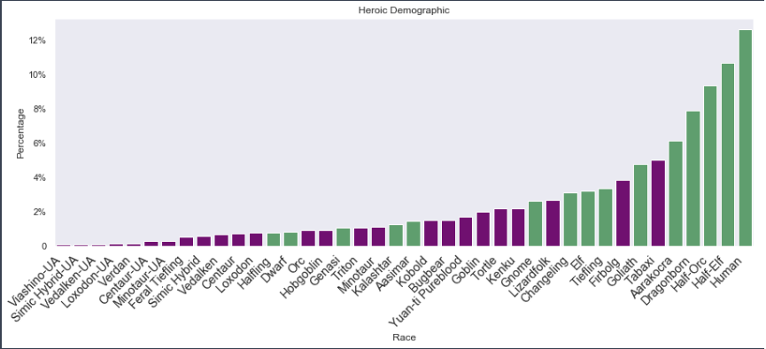

|  |  |
| --- | --- |
| Race | Percent of Population |
| Human | 12.62% |
| Half-Elf | 10.66% |
| Half-Orc | 9.34% |
| Dragonborn | 7.91% |
| Aarakocra | 6.11% |
| Tabaxi | 5% |

In this *very* cleverly titled bar graph, we see that Humans **dominate** the fantasy world, making up a whopping **12.62%** of all characters! Case closed. Okay, okay, 12% is hardly dominating. Actually, to put that into perspective, that’s a smaller percentage than any one minority in the U.S, according to [census.gov](https://www.census.gov/quickfacts/fact/table/US/PST045218). So, take that, my old stuffy Dungeon Masters.

Nipping on their heels are Half-Elves and Half-Orcs at 10.66% and 9.34%. The psychological implications aside, is it all that odd that the 'Outcasts' of the D&D races would be second and third ranks of adventurers?

Hey, hang on a tick! Where are the Elves? We'll I suppose they're hiding with the Dwarves, and **everyone** knows a halfling is only spotted when they choose to be... right?

Seriously though, looking at this, those races that 'Everyone' plays are much lower in the ranks than one might expect.

|  |  |
| --- | --- |
| Race | Percent of Population |
| Tiefling | 3.36% |
| Elf | 3.19% |
| Gnome | 2.64% |
| Dwarf | 0.81% |
| Halfling | 0.79% |

I mean, according to this, my village is more likely to be saved by a traveler whose Fiend-touched than to have an Elf roll in to save the day!

To be fair, this data has multiple confounding factors. That is to say; there are forces collaborating in the depths of obscurity to skew what we are looking at. For one, this is only one sample in a much wider population, not everyone creates their character on DnD Beyond. One that we can account for in this data is that not all these races are free to use. Being, a mere level 1 Apprentice Data Wizard, I'm not here to discuss business models, mind you. But it is worth taking into consideration with our beloved fantasy-world's "Hero Census."

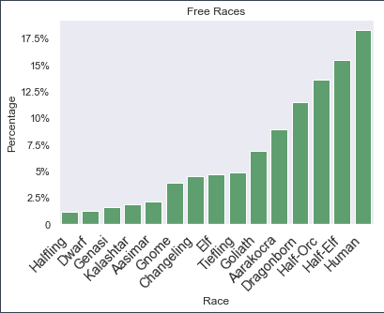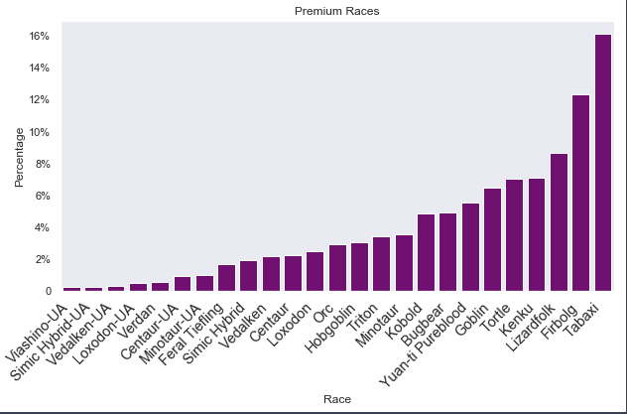

On the left, we have the 'Free' races, race that you have access to just by registering on [DnDBeyond](http://www.dndbeyond.com) . On the right is the group of races that one must purchase in some way to crate. I have taken these two subgroups and recalculated the percentages to show the percent each race makes up of their corresponding group. With that explanation out of the way, let us revisit those pesky Humans.

|  |  |
| --- | --- |
| Race | Percent of ‘Free Group’ |
| Human | 18.28% |
| Half-Elf | 15.44% |
| Half-Orc | 13.53% |
| Dragonborn | 11.47% |
| Aarakocra | 8.85% |
| Goliath | 6.88% |

18% Not bad, but still not staggering.

|  |  |
| --- | --- |
| Race | Percent of ‘Premium Group’ |
| Tabaxi | 16.13% |
| Firbolg | 12.33% |
| Lizardfolk | 8.65% |
| Kenku | 7.08% |
| Tortle | 7.01% |
| Goblin | 6.47% |

Here's something interesting. 16% of all 'Premium' races are Tabaxi, with the with the runner up being Firbolgs at 12%. If nothing else that is a larger gap than the top 2 'Free' races.

But what does this all mean!? Well, I'll leave that to you to decide.

I'll tell you this, though. I'm showing this to the next DM that tells me my race is too obscure.

The data in this post was provided by and used with permission from [DnDBeyond.com](http://www.dndbeyond.com). This data is presented accurately, to the best of my abilities. Any opinions you form or assume that I have formed are yours, and do not represent any opinions held by me or DnDBeyond. This is post is just made to be a fun exploration into the choices people make with their characters, and not to be taken seriously. The next post in this series will dive into classes.