Civicconnect
Project Engineering Document
Milestone 1 – Engineering Foundation & Requirements Baseline
Version: 0.1
Status: Draft
Team:
Hermanus Jacobus Bantjes (601427)
Jason Crous (601662)
Zander De Groote (602789)
Module: SEN381
Institution: Belgium Campus iTversity
Date: 2026/09/09

Document Control Table:
Document | CivicConnect Project Engineering Document
Version | 0.1
Status | Draft
Project | CivicConnect
Milestone | M1
Owner | CivicConnect Team
Created | 2026/09/07
Last Reviewed

Version History Table:
Version | Date | Author | Description | Approval
0.1 | 2026/09/07 | Jason Crous | Initial Requirements Analysis | Pending

Baseline sign-off Table:
Role | Name | Approval | Date
Requirements & Analysis Lead | Jason Crous | Pending | 2026/09/07

Problem & Business Need:

Current Operational Problem:
CivicConnect currently manages service requests through multiple uncontrolled communication channels, including email, telephone, WhatsApp, spreadsheets, and paper records. This fragmented process thus prevents the organisation from maintaining a reliable, central record of each service request and its lifecycle.
The main operational problem is therefore not simply the use of multiple communication methods, but the lack of a controlled process for recording, assigning, tracking and closing requests.
This scenario creates several consequences:
Problem: | Impact on CivicConnect:
Requests are widely spread across multiple channels. | Requests could be duplicated, lost and even overlooked.
No central request records. | Staff cannot reliably determine the current state of a request.
Uncertainty of Ownership. | Requests may remain unassigned or be delayed.
Limited requester visibility. | Requesters are unaware whether a request has been received or resolved.
Poor status accountability. | It is currently difficult to establish who changed a request and what action was taken.
Manual reporting procedures. | Management information is inconsistent and difficult to audit.
Informal handling of sensitive information. | Request information may not receive consistent access protection.

Supporting Evidence: Process Diagram

Current state of operations:

Business Impact:
The fragmented request process creates operational problems and prevents CivicConnect from consistently managing service demand.
Operationally, staff might spend extra time searching for requests, identifying ownership, requesting updates, and manually gathering information for management. Requesters often feel uncertain because they have limited visibility into whether their requests have been received, assigned, delayed, resolved, or closed.
At the management level, the absence of a controlled request lifecycle reduces the reliability of information on outstanding, overdue and resolved work. This limits the organisation's ability to identify service bottlenecks, monitor performance and demonstrate accountability.
The current process also creates an information-management and security concern because sensitive request information may be distributed through informal channels without consistent access controls.

Business Impact Matrix:
Impact Area: | Current Effect: | Business Consequence:
Efficiency | Manual coordination and reporting. | The staff’s time is wasted.
Visibility | Requests cannot be reliably tracked by requesters. | Increased uncertainty and follow-up requests.
Accountability | Changes may not be consistently recorded. | Difficult to audit responsibility.
Service Management | Ownership and prioritisation are unclear. | Delays and inconsistent handling.
Reporting | Information is manually consolidated. | Management information is less reliable.
Information security | Sensitive information can move through informal channels. | Greater risk of security exposure.

Intended Business Value:
CivicConnect requires a controlled digital service-request platform that establishes a single, traceable record for each request.
The intended business value is to:
- Improve visibility of request status and ownership.
- Reduce the likelihood of requests being lost, duplicated or overlooked.
- Provide staff with a structured way to manage and prioritise work.
- Improve accountability through controlled status and action recording.
- Provide management with more reliable information about service activity.
- Reduce dependence on fragmented manual reporting.
- Improve the consistency with which sensitive request information is handled.
The solution should achieve these benefits without introducing an unsustainable technical, financial or operational burden.

From Business Value to Requirements mapping:
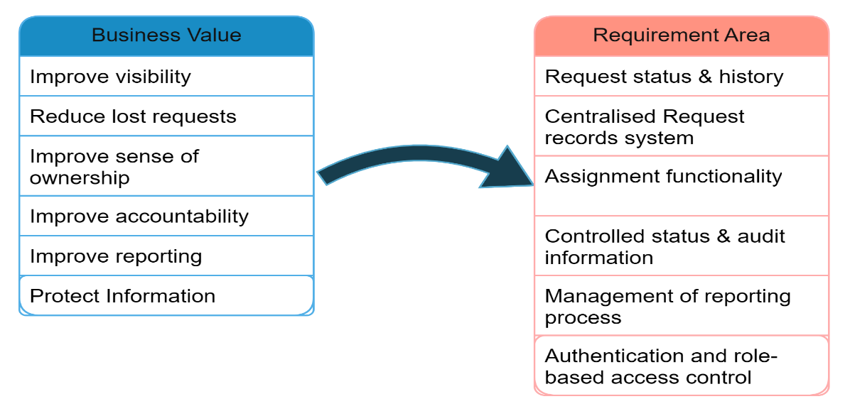

Stakeholder Analysis:

Stakeholder Identification
The following table lists the groups of stakeholders that are significant to CivicConnect:
ID | Stakeholder | Role in System | Primary Interest
STK-001 | Requesters | Submitting and Monitoring requests | Ease of use and visibility
STK-002 | Service Staff | Managing and resolving requests. | Efficient request processing.
STK-003 | Management | Monitoring service activities. | Reporting and accountability.
STK-004 | System Administrator | Manage users and system access. | Security and access control.
STK-005 | IT/Technical Support | Support during tech operations. | System reliability and maintainability.
STK-006 | Organisational leadership personnel | Oversight of business processes. | Cost, quality and operational value.

Stakeholder Needs:

Stakeholder | Need | Why it Matters
Requester | Submit a request with required information | Ensures the organisation receives sufficient information
Requester | Receive confirmation | Provides evidence that the request was recorded
Requester | See status of submitted requests | Reduces Uncertainty during decision-making
Requester | View previous requests. | Supports history and follow-up management.
Staff | See relevant requests. | Creates a manageable work queue.
Staff | Search/filter/sort requests. | Helps prioritise and locate work.
Staff | Assign responsibility. | Establishes ownership.
Staff | Records actions and resolutions. | Supports continuity and accountability.
Management | Views requests that are open or overdue. | Supports service oversight.
Management | Analyse activity by status/category | Supports performance analysis
Administrator | Control access according to roles. | Protects request information.
IT Support | Maintains a reliable system | Reduces operational disruption
Leadership | Maintains sustainable cost and scope decisions. | Prevents an unnecessarily complex solution.

Influence/Interest Analysis:
Stakeholder | Influence | Interest | Engagement Approach
Management | High | High | Keep management closely involved in the requirements validation process.
Service Staff | High | High | Encourage regular feedback on workflow requirements.
Requesters | Medium | High | Validate usability and submission needs.
System Admin | High | Medium | Validate security and access requirements.
IT Support | Medium | Medium | Consult on maintainability and technical constraints.
Leadership | High | Medium | Review scope, cost and business value.

Stakeholder Conflicts and Trade-offs:
Conflict 1: Usability vs Security
Requesters benefit from a quick and simple submission process, while the organisation requires controlled access to potentially sensitive request information.
The engineering implication is that CivicConnect must provide an accessible submission process while still enforcing appropriate authentication and authorisation. Security should therefore be incorporated into the requirements rather than added after functionality is implemented.

Conflict 2: Additional Functionality vs Scope/Schedule
Management may benefit from advanced functionality such as extensive analytics, integrations or automated notifications. However, every additional feature increases specification, development, testing, security, documentation and maintenance obligations.
The engineering implication is that additional functionality should only be included where stakeholder value justifies its effect on scope, schedule, cost, quality and risk.

Scope Baseline:
Establishing the boundaries of the project.

In Scope:
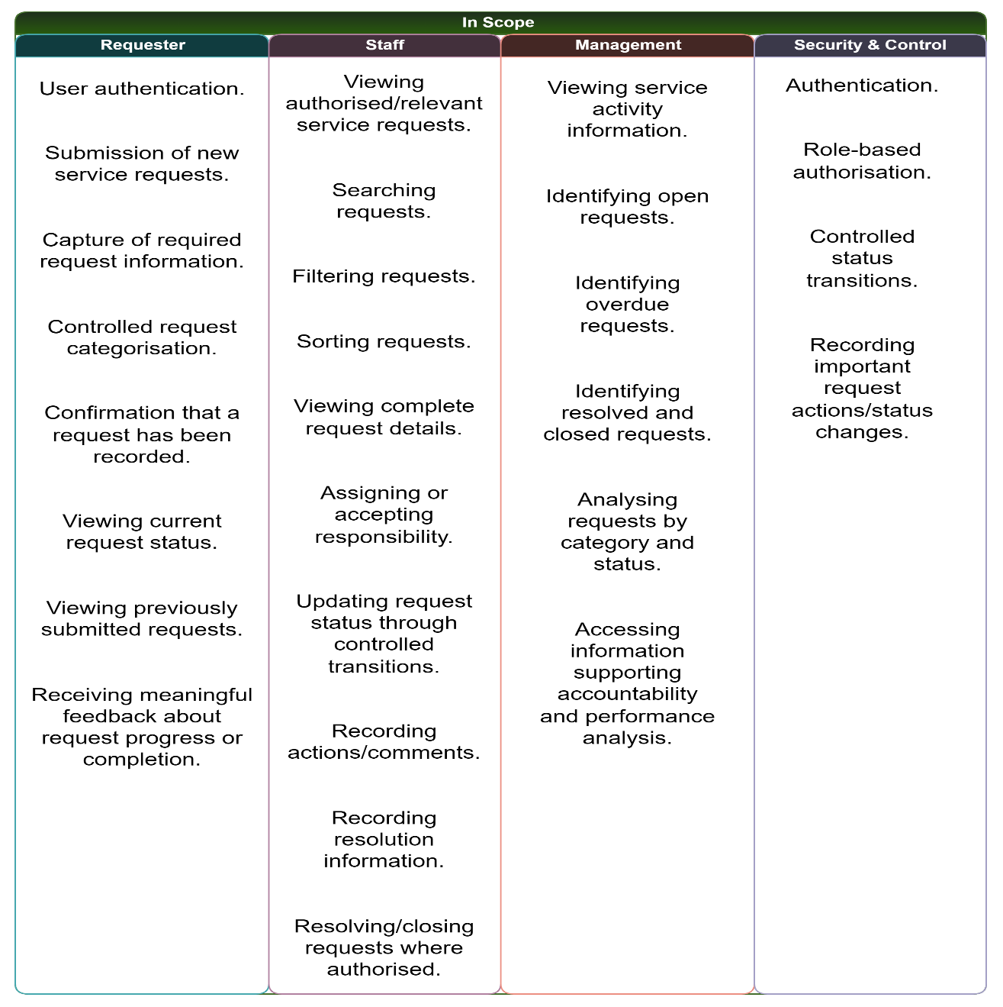

Out of Scope:
The following are considered out of Scope for the initial baseline:
- Native mobile applications.
- Replacement of existing communication channels.
- Complex integration with external enterprise systems.
- Advanced AI functionality.
- Predictive analytics functionality.
- Full automation of service dispatching.
These exclusions prevent the initial solution from becoming unnecessarily large and protect the project's schedule and quality objectives.

Deferred/Future Scope:
Potential future enhancements/features may include:
- WhatsApp Integration.
- Automated SMS notifications.
- Overly engineered dashboards.
- AI-assisted categorisation.
- Predictive service-demand analysis procedures.
- Integration with external organisational systems.
- Dedicated mobile applications.
These features are not rejected permanently. They are deliberately deferred until their business value, technical feasibility, security implications, cost and schedule impact are evaluated.

Scope Exclusion Justification:
Decision: Defer WhatsApp integration.
Based on the information presented in the scenario, our team has deduced that CivicConnect currently receives requests through WhatsApp, making integration appear attractive. However, integrating WhatsApp into the initial solution would introduce additional API/integration dependencies, security considerations, testing obligations and maintenance requirements.
The immediate business need is to establish a reliable, controlled service-request lifecycle rather than reproduce every existing communication channel within the first release.
Therefore, WhatsApp integration is deliberately deferred so that the team can prioritise the controlled central request record and core requester, staff and management capabilities within the available schedule and resources.

Functional Requirements:

Requester Requirements:
ID | Requirement | Priority | Source
FR-REQ-001 | The system shall allow an authenticated requester to submit a new service request containing all mandatory request information. | Must | CAP-REQ-001 / STK-NEED-001
FR-REQ-002 | The system will require each service request to be assigned a category from a controlled set of categories. | Must | CAP-REQ-002
FR-REQ-003 | The system will generate a unique reference for each successfully submitted service request. | Must | Business Need
FR-REQ-004 | The system shall confirm the recording of submitted requests. | Must | STK-NEED-002
FR-REQ-005 | The system shall allow a requester to view the status of their submitted requests. | Must | STK-NEED-003
FR-REQ-006 | The system shall allow a requester to view a history of previously submitted requests. | Must | CAP-REQ-003
FR-REQ-007 | The system shall display meaningful feedback when a request is updated, resolved or closed. | Must | Business Capability

Staff Requirements:
ID | Requirement | Priority | Source
FR-STF-001 | The system shall allow authorised staff to view service requests relevant to their responsibilities. | Must | CAP-STF-001
FR-STF-002 | The system shall allow authorised staff to search service requests using defined search criteria. | Must | CAP-STF-002
FR-STF-003 | The system shall allow authorised staff to filter service requests by useful criteria such as status and category. | Must | CAP-STF-002
FR-STF-004 | The system shall allow authorised staff to sort service requests using supported criteria. | Must | CAP-STF-002
FR-STF-005 | The system shall allow authorised staff to view the full details of an individual service request. | Must | CAP-STF-003
FR-STF-006 | The system shall allow authorised staff to assign or accept responsibility for a service request. | Must | CAP-STF-004
FR-STF-007 | The system shall restrict status changes to defined request workflow transitions. | Must | Business Need
FR-STF-008 | The system shall allow authorised staff to record actions and comments against a service request. | Must | CAP-STF-005
FR-STF-009 | The system shall allow authorised staff to record resolution information. | Must | CAP-STF-005
FR-STF-010 | The system shall allow authorised staff with appropriate permissions to resolve or close a service request. | Must | CAP-STF-006

Management Requirements:
ID | Requirement | Priority | Source
FR-MGT-001 | The system shall provide management users with visibility of open service requests. | Must | CAP-MGT-001
FR-MGT-002 | The system shall identify service requests that have become overdue according to the defined service criteria. | Must | CAP-MGT-002
FR-MGT-003 | The system shall provide visibility of resolved and closed requests. | Must | CAP-MGT-003
FR-MGT-004 | The system shall allow management users to view request information by category and status. | Must | CAP-MGT-004
FR-MGT-005 | The system shall provide information that supports accountability for request status and recorded actions. | Must | Business Need

Security and Control Requirements:
ID | Requirement | Priority | Source
FR-SEC-001 | The system shall authenticate users before providing access to protected functions. | Must | CON-SEC-001
FR-SEC-002 | The system shall restrict system functions and request information according to the user's authorised role. | Must | CON-SEC-002
FR-SEC-003 | The system shall prevent unauthorised users from accessing protected service-request information. | Must | Business Need
FR-SEC-004 | The system shall record the user responsible for important service-request status changes. | Must | Business Need

Non-Functional Requirements:
The following NFRs are attributed to being measurable, testable and aligned with business goals.

Security:
NFR-SEC-001
The system shall enforce role-based access control so that users can only access functions and service-request information permitted by their assigned role.
Acceptance target:
100% of defined protected functions shall require appropriate authorisation during security testing.
NFR-SEC-002
The system shall not store user passwords in plaintext.
Acceptance target:
Password storage shall be verified during security review and source/database inspection.

Performance:
NFR-PERF-001
Under normal expected operating conditions, 95% of standard request-list and request-detail operations shall return results within 2 seconds.

Usability:
NFR-USAB-001
A requester shall be able to submit a standard service request using the provided interface without assistance from a staff member.
Acceptance target:
At least 4 out of 5 representative test users shall complete the standard submission process without assistance.

Reliability:
NFR-REL-001
Once the system verifies that a request has been successfully submitted, it will remain accessible for retrieval.
Acceptance target:
100% of successfully confirmed test submissions remain retrievable after submission.

Auditability:
NFR-AUD-001
The system shall record the responsible user and timestamp for defined request status changes.
Acceptance target:
100% of tested status changes shall contain the required user and timestamp information.

Maintainability:
NFR-MAIN-001
Project requirements, risks, decisions, changes, tests and defects shall use controlled identifiers and version-controlled artefacts.
Acceptance target:
All baselined M1 requirements shall have unique IDs and corresponding entries in the RTM.

Acceptance Criteria:
FR-REQ-001 – Submit Request
The system shall allow an authenticated requester to submit a new service request containing all mandatory request information.
ID | Given | When | Then
AC-REQ-001-A | User is authenticated, and all mandatory fields are completed. | User submits request. | A new request is created.
AC-REQ-001-B | One or more mandatory fields are empty. | User submits request. | Submission is prevented, and missing information is indicated.
AC-REQ-001-C | Request is successfully created. | Submission completes. | System provides confirmation and request reference.

FR-REQ-002 – Controlled Category
The system will require each service request to be assigned a category from a controlled set of categories.
ID | Given | When | Then
AC-REQ-002-A | Requester is creating a request | Category is selected | Category must come from the controlled list
AC-REQ-002-B | No category is selected | Requester submits | Submission is prevented

FR-STF-006 – Assignment
The system shall allow authorised staff to assign or accept responsibility for a service request.
ID | Given | When | Then
AC-STF-006-A | Authorised staff member views an unassigned request | Staff assigns responsibility | Assigned owner is recorded
AC-STF-006-B | Unauthorised user attempts assignment | Assignment is attempted | Operation is denied

FR-STF-007 – Status Transition
The system shall restrict status changes to defined request workflow transitions.
ID | Given | When | Then
AC-STF-007-A | Request is in a valid status | Staff selects a permitted next status | Status change is accepted
AC-STF-007-B | Requested transition is invalid | Staff attempts to save | System rejects the transition
AC-STF-007-C | Valid transition succeeds | Status changes | User and timestamp are recorded

Requirement Prioritisation:
During the prioritisation process, our team uses the tried-and-true MoSCoW method:
Must Have
The core functionality necessary to satisfy the business need:
- Submit requests
- Categorise requests
- View status
- View request history
- View/manage requests
- Assignment
- Status transitions
- Actions/comments
- Resolution/closure
- Management visibility
- Authentication
- Authorisation
- Accountability/audit information
Should Have
Useful functionality that improves the system but isn't fundamental to the first baseline:
- Automated email notifications
- Additional reporting filters
- More advanced dashboard functionality
Could Have
Potential future enhancements:
- AI-assisted categorisation
- WhatsApp integration
- SMS notifications
- Advanced predictive analytics
- Mobile application

Won't Have in Current Baseline
Features intentionally excluded from the current release:
- Full enterprise-system integration
- Native mobile application
- Advanced predictive service management

