**Progress made in the past week.**

**Issues/Questions/Comments**

1. More Research for KNN model

After I reran the KNN model, I found if the hyper parameter weight = “distance”, the train AUC will equal to 1. Why I chose “distance” as weight was that the mean test AUC was higher than “uniform” before parameter tuning. On the paper, I want to display the best result before parameter tuning.

For the weight parameter, there are two values “uniform” and “distance”, “uniform” means no matter how far the distance is, the model will use the same weight. While “distance” means closer distance has higher weight.

5 year

{'algorithm': 'kd_tree', 'leaf_size': 10, 'metric': 'manhattan', 'n_neighbors': 60, 'weights': 'distance'}

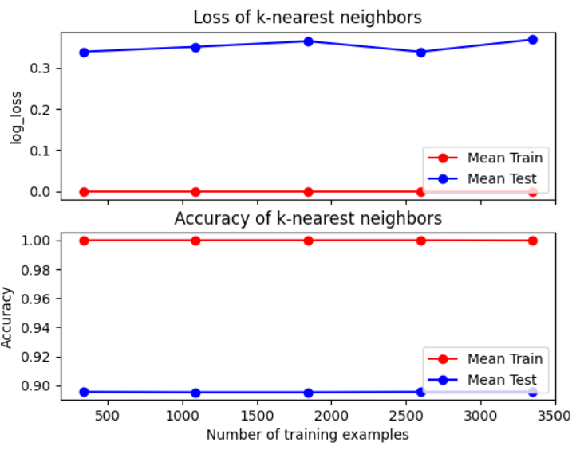 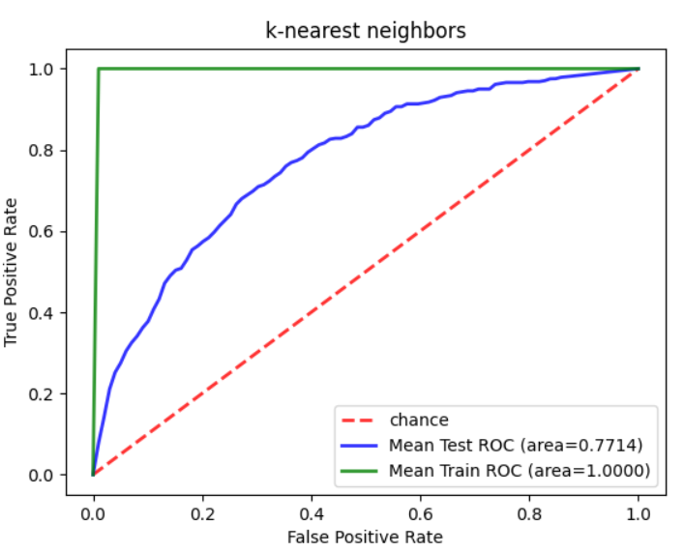

{'algorithm': 'kd_tree', 'leaf_size': 10, 'metric': 'manhattan', 'n_neighbors': 37, 'weights': 'uniform'}

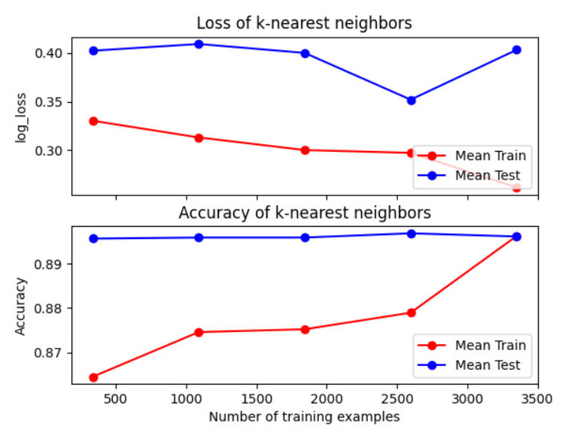 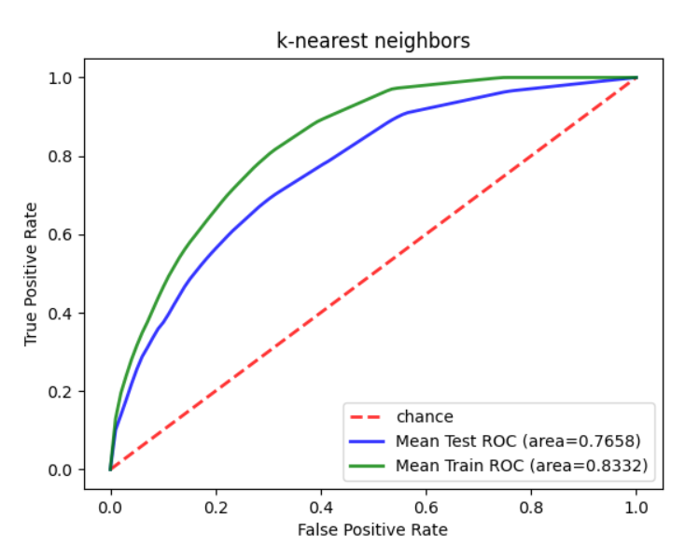

10 year

{'algorithm': 'brute', 'leaf_size': 10, 'metric': 'manhattan', 'n_neighbors': 55, 'weights': 'distance'}

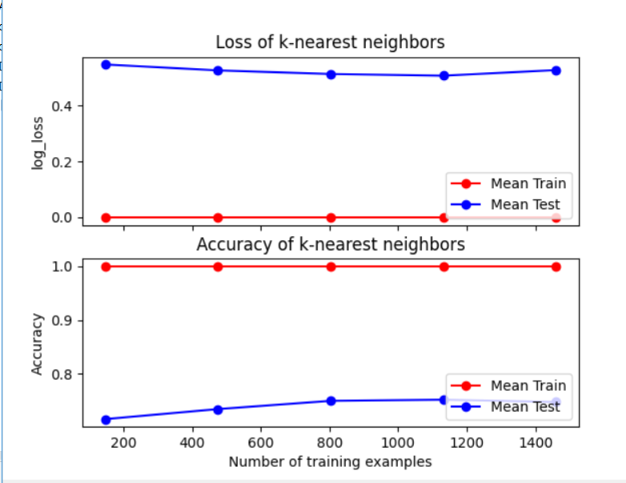 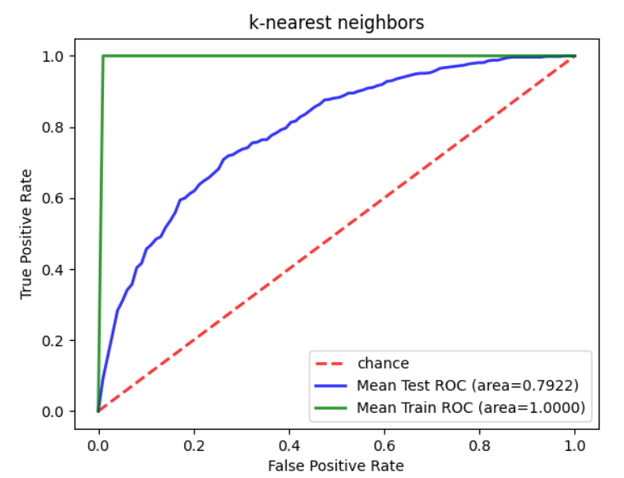

{'algorithm': 'kd_tree', 'leaf_size': 18, 'metric': 'manhattan', 'n_neighbors': 36, 'weights': 'uniform'}

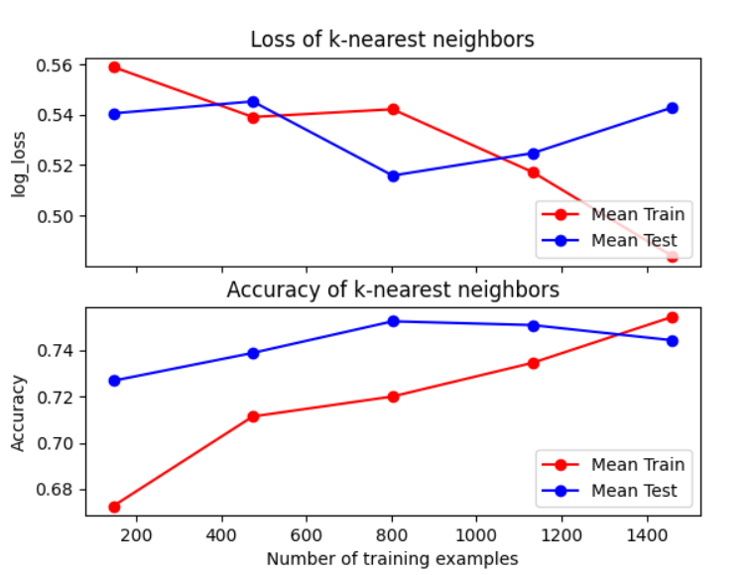 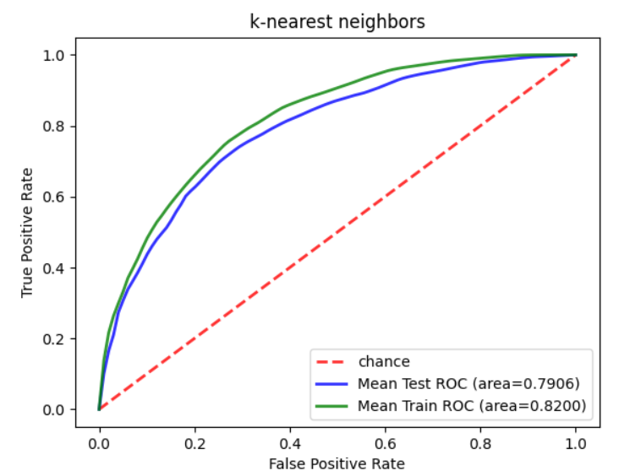

15 year

{'algorithm': 'brute', 'leaf_size': 10, 'metric': 'manhattan', 'n_neighbors': 50, 'weights': 'distance'}

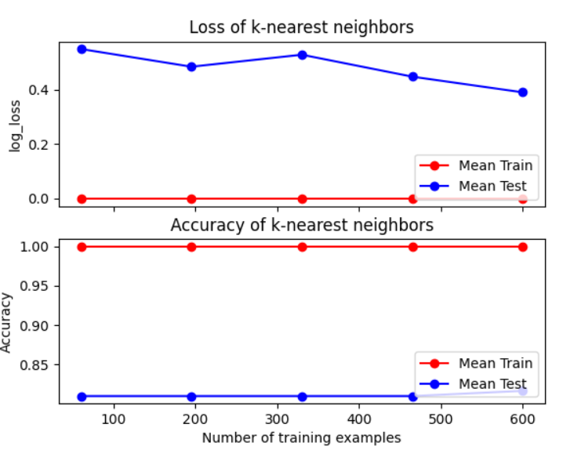 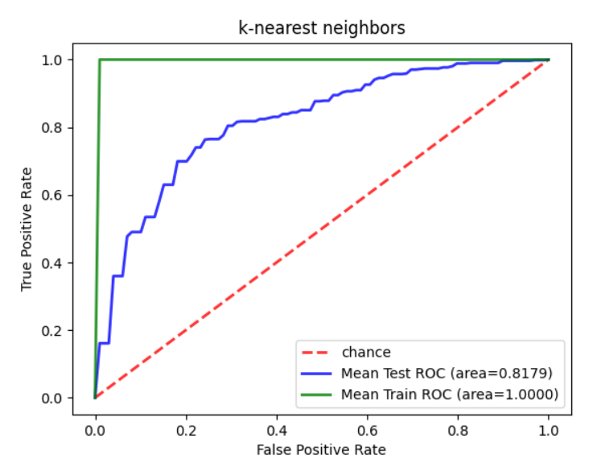

{'algorithm': 'kd_tree', 'leaf_size': 38, 'metric': 'manhattan', 'n_neighbors': 37, 'weights': 'uniform'}

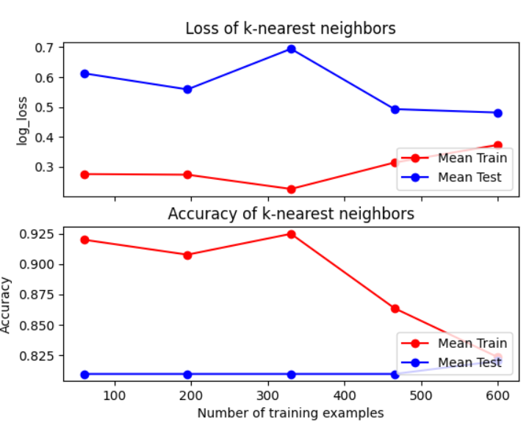 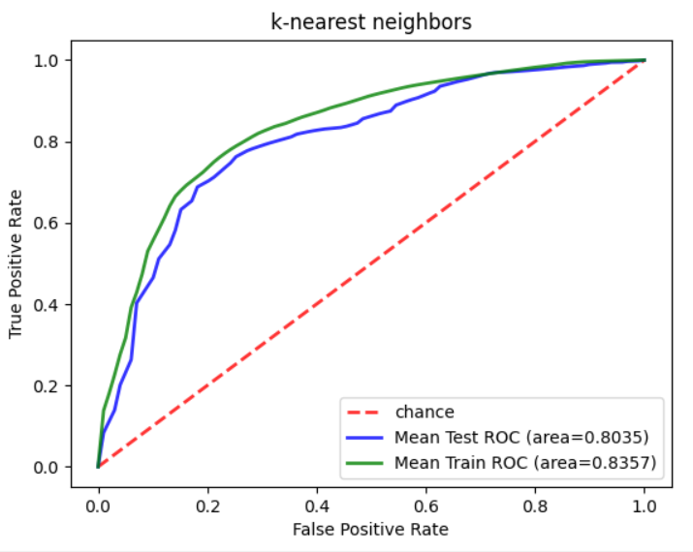

1. medical robot

<https://www.flaticon.com/search?word=medical%20robot>

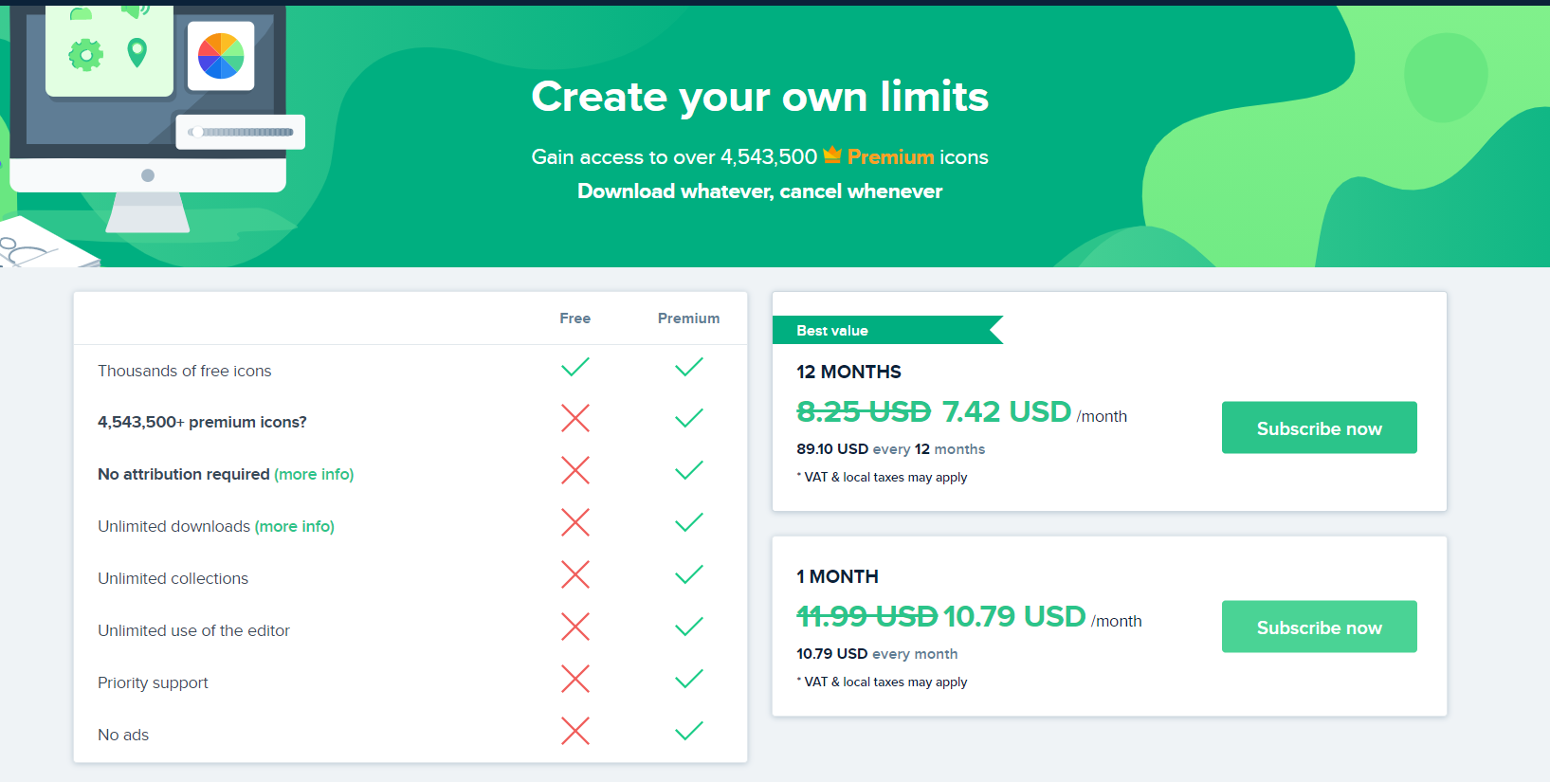

1. Tutorial of audio function

<https://xiaotianxia.github.io/blog/vuepress/js/speech_in_js_recognition.html>

1. Request for mic

**Ongoing tasks that cover more than a week**

1. The Robot speed of robot is too slow
2. I need to set a variable to control record in time, otherwise it will recognize what the robot talking as well as user talking
3. Setting the icon to replace button



1. Could you buy a mic for me?

**Specific tasks for the coming week**

**Less urgent specific tasks**