**Corrleation -** <https://datatofish.com/correlation-matrix-pandas/>

**Probability Density Function:**

A probability density function (PDF), or density of a continuous random variable, is a function that describes the relative likelihood for this random variable to take on a given value

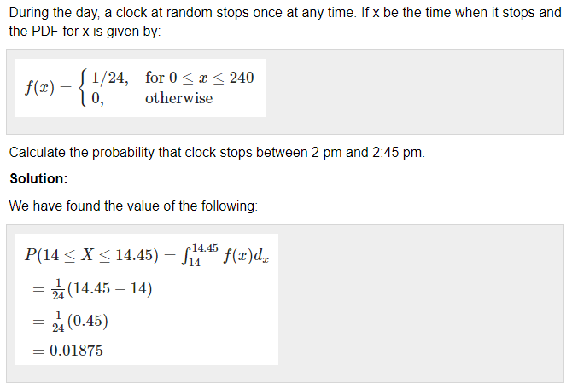

**Probability mass functions: Discrete probability distributions**

When we use a probability function to describe a discrete probability distribution we call it a **probability mass function** (commonly abbreviated as pmf)

Example: So if we use the dice roll as our example random variable, we can write the probability of the die landing on the number 3 as P(X=3) = 1/6.

The probability mass function outputs values between 0 and 1 inclusive and the sum of the probability mass function (pmf) over all outcomes is equal to 1.

P(X = 3) = 1/6

P(X =2) = 1/6

P(X =1) = 1/6

P(X = 4) = 1/6

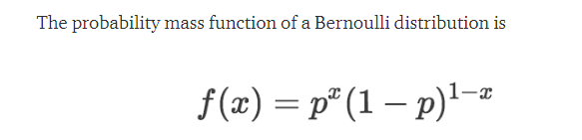

Binomial Distribution



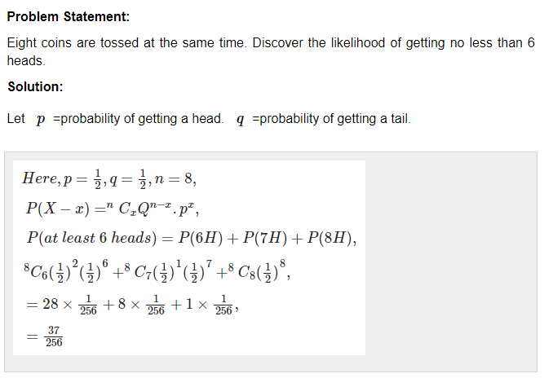

P(6H) = n!

8!

6! (8 -6)! =

=

8 * 7 * 6!

6! * 2!

=

4* 7

Poisson Distribution

100 – 5

1000 – 50

100 < 4

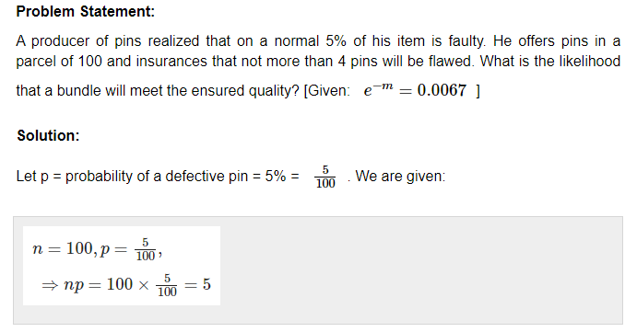

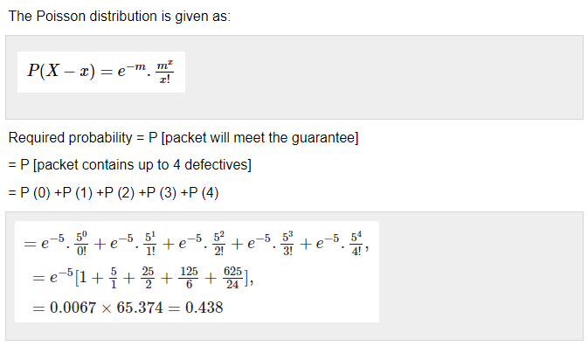

Probaility of stopping 1 in 24 hour = 1/24

Tossing a coin (H/T)

Event -how many time is tossing

H T H H T

P(H) = No of H / Total no of event

= 3 / 5

0.6

P(T) = 2 / 5 = 0.4

Probaility of both occurence of event H and T = 1

P(H) + P(T)

= 0.6 + 0.4

= 1

WE are trying pull ball (R, G, B)

P(R) + P(G) + P(B) = 1

X is continuous

x between 1 to 2

x = 1.1, 1.2, 1.3,1.4,1.5,1.6,1.7.1.8.1.9,2.0

x = 1.0001,1.

X is discrete

X between 1 and 2

X = 1,2

isPayingLoan - column

1

0

1

0

1

1

1

0

0

1

six - 1

four - 0

Mean = 6/10 = 0.6

Var = (1 - 0.6)sq + (0-0.6)

P(1) = 6/10 = 0.6

Var = P(1) * P(0) = 0.6 * 0.4

Prediction Sale Price house = Y

Area of house = X1

No. Bedroom = X2

Size of house = x3

aH = x4 0.9

Ag = x5 0.9

Product name = x6

Linear Regression : y = aX1 + bX2 + cX3 + dX4 + eX5 + fX6

a,b,c, f = closer to 0

d,e higher than 0

P(B | A ) = P(A and B) / P(A)

3 balls –R, G , B

P(R) = 1/3 = 0.33

P(G | R) = ½ * 1/3 = 16.5

P(G) = 1/3