
Gene Expression Signatures and Pathway Dysregulation in Sjögren’s Disease

Done by: Hala Alshaar
Date: 18/06/2026

Table of Contents
1 Abstract 3
2. Introduction 3
3. Materials and Methods 4
3.1. Dataset and Preprocessing 4
3.2. Differential Gene Expression Analysis 4
3.3. Unsupervised learning 5
3.3.1 Principal Component Analysis 5
3.3.2. Uniform Manifold Approximation and Projection 5
3.3.3. K-means Clustering 5
3.4. Supervised learning 5
3.4.1. Random Forest 5
3.4.2. Linear Discriminant Analysis 5
3.4.3. LASSO Logistic Regression 6
3.4.4. Functional Enrichment Analysis Using g:Profiler 6
3.5. Pathway Analysis 6
3.5.1 Using PathfindR 6
4. Results: 7
4.1.Preprocessing Analysis and Exploratory Analysis 7
4.2 Differential Gene Expression Analysis 9
4.3 unsupervised K-means clustering 9
4.4 Random Forest 10
4.5 Linear discriminant analysis 11
4.6 LASSO logistic regression 12
4.7 Model Comparison 13
4.8 Enrichment analysis 14
5. Discussion 19
6. Conclusion 21
7. Codes and extra tables 21
8. References 22

1 Abstract

Sjögren’s disease is an autoimmune condition that causes chronic inflammation and problems with exocrine glands, but its molecular basis is not well understood. In this study, gene expression data from the GSE51092 microarray dataset were analyzed to investigate changes in transcription associated with the disease.

The results showed a significant increase in interferon-related genes, such as IFI27, RSAD2, LY6E, and CXCL10, indicating strong activation of antiviral immune pathways. While unsupervised analyses did not distinctly separate patients from controls, supervised machine learning models successfully classified individuals based on selected gene signatures. Enrichment analysis also confirmed the significant role of type I interferon signaling and related immune pathways. These findings indicate that Sjögren’s disease features a notable interferon-driven gene expression pattern, emphasizing the role of dysregulated antiviral immune responses in its development.

2. Introduction
Sjögren’s disease is a chronic, systemic autoimmune disorder primarily characterized by dysfunction of the exocrine glands. Although it is commonly associated with dry eye and dry mouth symptoms, its underlying pathology is considerably more complex. The condition involves an abnormal immune response targeting moisture-producing glands, which may also extend to multiple internal organs (Branch, 2025).
The disease predominantly affects women, who account for approximately 90% of cases, and it most frequently presents between the ages of 40 and 60. However, it can occur at any stage of life. The estimated prevalence ranges from 0.1% to 4% globally, with cases reported across all ethnic groups. Some studies indicate that African American and Hispanic populations may experience more severe systemic manifestations and higher levels of inflammation compared to Caucasian patients (Branch, 2025).
The exact etiology of Sjögren’s disease remains unclear, but it is thought to arise from a combination of genetic predisposition and environmental triggers, such as infections. The disease process may begin with localized events in the glands, followed by a broader autoimmune response, although the precise role of B-cell activation is still not fully understood. Diagnosis is often delayed due to the heterogeneity of clinical presentations, and there is currently no curative treatment; management is primarily focused on alleviating symptoms (Jonsson et al., 2011).
Genetic studies have identified strong associations between Sjögren’s disease and several susceptibility loci, particularly within the human leukocyte antigen (HLA) region. Additional genes, including IRF5, STAT4, and IL12A, have also been implicated. These findings highlight the involvement of both innate and adaptive immune pathways in disease development, suggesting that multiple genetic factors contribute to overall susceptibility (Registry et al., 2013).
In this study, gene expression profiling by microarray analysis was performed using the GEO dataset GSE51092 to investigate molecular changes associated with Sjögren’s disease. The raw data were downloaded, normalized, and processed to ensure quality and comparability between samples. Differential gene expression analysis was then conducted to identify genes that were significantly up- or downregulated between patients and healthy controls. To further explore the data, unsupervised analyses (PCA and clustering) were used to assess natural sample structure, while supervised machine learning models were applied to evaluate the ability of gene expression signatures to classify disease status. Finally, functional enrichment and pathway analyses were performed to interpret the biological roles of the identified genes and highlight dysregulated immune pathways involved in the disease.

3. Materials and Methods

3.1. Dataset and Preprocessing
The gene expression dataset used in this study was obtained from the Gene Expression Omnibus (GEO) database under accession number GSE51092. The dataset was downloaded in R using the GEOquery package, which enabled retrieval of both the expression matrix and associated sample annotation data. A total of 222 samples were included, comprising 190 case samples and 32 control samples.
Raw expression data were processed to generate a normalized expression matrix suitable for downstream analyses. Sample labels were assigned according to the metadata provided in the dataset, allowing clear separation between case and control groups. Several quality control procedures were performed to evaluate data consistency and reliability, including boxplots and density plots to assess the distribution of expression values across samples. Histograms of adjusted p-values, MA plots, and volcano plots were also generated to examine the overall distribution and significance of differential gene expression patterns.

3.2. Differential Gene Expression Analysis
Differential expression analysis was conducted using the limma package in R. For each gene, a linear model was fitted to compare expression levels between case and control samples. Empirical Bayes moderation was applied to stabilize variance estimates and improve statistical robustness, particularly for genes with low expression variability (Ritchie et al., 2015).
Genes showing statistically significant expression differences between the two groups were identified based on adjusted p-values and fold-change thresholds. The resulting differentially expressed genes (DEGs) were considered potential biomarkers and were used for subsequent analyses.

3.3. Unsupervised learning

3.3.1 Principal Component Analysis
Principal Component Analysis (PCA) is an unsupervised dimensionality reduction method used to summarize high-dimensional datasets while preserving the major sources of variation. PCA transforms the original variables into a smaller number of orthogonal principal components, each representing a proportion of the total variance within the data (Greenacre et al., 2022).
In this study, PCA was applied to visualize sample distribution and investigate whether case and control samples formed distinct clusters based on their gene expression profiles.

3.3.2. Uniform Manifold Approximation and Projection
Uniform Manifold Approximation and Projection (UMAP) is a nonlinear dimensionality reduction technique designed to preserve both local and global relationships within high-dimensional data. Compared with linear methods, UMAP is particularly effective for visualizing complex biological datasets and identifying hidden sample structures.
UMAP was performed to further explore sample heterogeneity and assess clustering patterns between case and control groups in a low-dimensional space.

3.3.3. K-means Clustering
K-means clustering is an unsupervised machine learning algorithm used to partition samples into a predefined number of clusters according to similarity in expression patterns. The algorithm iteratively assigns samples to the nearest cluster centroid and updates centroid positions until convergence is achieved (Ikotun et al., 2022).
In this analysis, K-means clustering was employed to investigate potential subgroup structures within the dataset and evaluate whether samples naturally grouped according to disease status.

3.4. Supervised learning

3.4.1. Random Forest
Random Forest is a supervised ensemble learning approach widely used for classification and feature selection. The method constructs multiple decision trees using bootstrap sampling and combines their predictions to improve classification accuracy and reduce overfitting (Salman et al., 2024).
In the present study, Random Forest analysis was used to identify genes with high predictive importance for distinguishing case samples from controls. Variable importance measures generated by the model were used to prioritize candidate biomarkers.

3.4.2. Linear Discriminant Analysis
Linear Discriminant Analysis (LDA) is a supervised classification technique that seeks to maximize separation between predefined classes by projecting the data into a lower-dimensional space. The method identifies linear combinations of variables that best discriminate between groups while minimizing within-class variability.
LDA was applied to evaluate the discriminatory ability of the selected features and to assess classification performance between case and control samples.

3.4.3. LASSO Logistic Regression
Least Absolute Shrinkage and Selection Operator (LASSO) logistic regression is a regularized regression method that incorporates an L1 penalty term to reduce model complexity and perform feature selection simultaneously. The penalty constrains regression coefficients and can shrink less informative variables to zero, thereby improving model interpretability (Lee & Kim, 2020).
In this study, LASSO logistic regression was used to identify the most informative genes associated with disease status. The optimal regularization parameter was determined through cross-validation to balance predictive performance and model generalizability.

3.4.4. Functional Enrichment Analysis Using g:Profiler
Functional enrichment analysis was performed using the g:Profiler tool to investigate the biological significance of the identified gene sets (Kolberg et al., 2023). The analysis examined enrichment of Gene Ontology (GO) terms, biological pathways, transcription factor targets, and other functional categories.
Statistical significance was determined using multiple testing correction methods, allowing identification of biological processes and pathways significantly associated with the differentially expressed genes.

3.5. Pathway Analysis

3.5.1 Using PathfindR
Pathway enrichment and active subnetwork analysis were conducted using the pathfindR package (Ulgen et al., 2019). This approach integrates differential expression results with protein–protein interaction networks to identify biologically relevant subnetworks enriched with significant genes.
The identified subnetworks were mapped to known biological pathways from databases such as KEGG and Reactome, providing a systems-level interpretation of the molecular mechanisms associated with the disease condition.

3.5.2 Using EnrichNet
To further investigate the biological relevance of the differentially expressed genes (DEGs), network-based pathway enrichment analysis was performed using EnrichNet (Glaab et al., 2012). Unlike conventional over-representation analyses, EnrichNet incorporates protein–protein interaction (PPI) network information to assess the proximity between a query gene set and known biological pathways. This approach enables the identification of functionally related pathways even when direct gene overlap is limited.
The list of significant DEGs identified through differential expression analysis was used as input for EnrichNet. Analyses were performed using the human protein interaction network and KEGG pathway annotations. Pathways were ranked according to the XD-score, a network-based similarity measure that quantifies the functional association between the input gene set and reference pathways. Higher XD-scores indicate stronger network connectivity and greater biological relevance of the pathway to the analyzed gene set (Glaab et al., 2012).

4. Results:

4.1.Preprocessing Analysis and Exploratory Analysis
To assess data quality and evaluate the effectiveness of the normalization procedure, boxplots of normalized gene expression values were generated for all samples (Figure 1). The distributions of expression values were highly comparable across samples, with closely aligned median expression levels and similar interquartile ranges. No samples exhibited substantial deviations in distribution or variability, indicating the absence of obvious outliers. Furthermore, both control and case samples displayed consistent overall expression profiles, suggesting that technical variation had been effectively minimized through normalization. These results demonstrate good data quality and support the suitability of the dataset for subsequent differential expression and machine learning analyses.
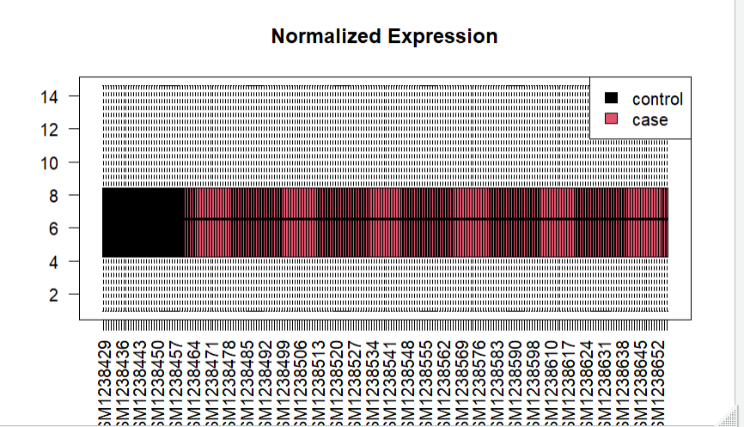
Figure 1: Boxplot of normalized gene expression values across control and case samples.

To further investigate the underlying structure of the data, PCA was conducted using the normalized expression matrix (Figure 2). The projection of samples onto the first two principal components revealed a considerable degree of overlap between the experimental groups. No distinct clustering pattern was evident, indicating that the largest sources of variation in the dataset are not primarily driven by group membership. This suggests that the molecular differences between the two groups are relatively subtle and may not be readily detectable through unsupervised dimensionality reduction alone. Consequently, more advanced supervised approaches are required to identify the features that best discriminate between the groups.
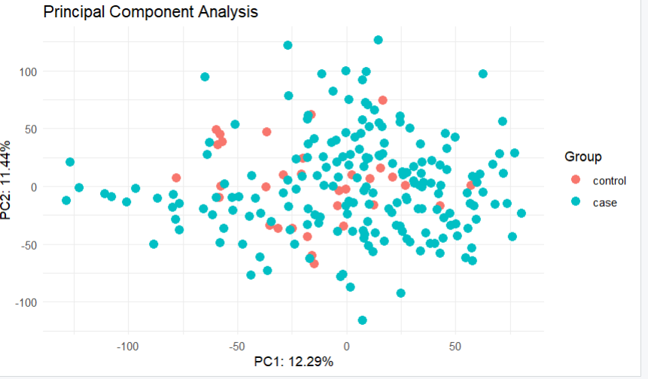
Figure 2: PCA plot based on the first two principal components. Samples are colored according to their respective groups.

4.2 Differential Gene Expression Analysis

Differential gene expression analysis identified several genes that were significantly altered between Sjögren's disease and healthy control groups (Figure 3). Although the majority of genes exhibited little or no change in expression, a subset showed marked differences. Notably, LY6E, IFI27, CXCL10, HLA-DRB6, and RSAD2 were significantly upregulated in patient samples. In contrast, MMP28, RBPMS2, LRRC26, CD248, FEZ1, and LRRN3 were downregulated relative to controls. These results indicate distinct transcriptional differences between Sjögren’s disease patients and healthy individuals and highlight potential candidate genes and pathways for further investigation into disease pathogenesis and biomarker discovery.

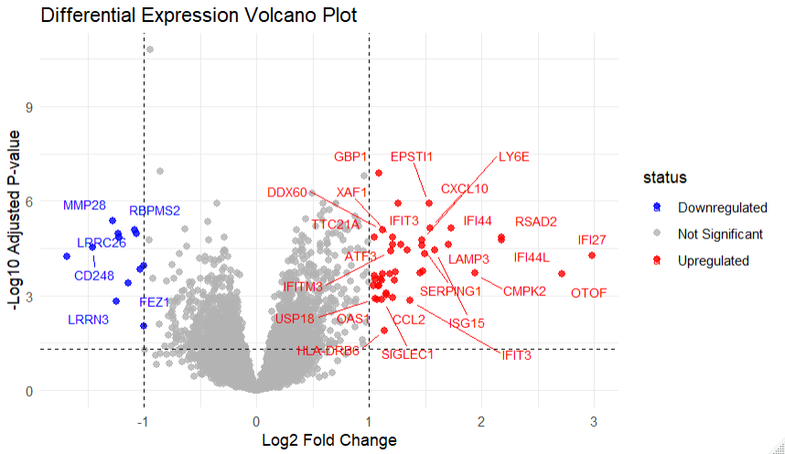

Figure 3: Volcano plot showing differential gene expression between case and control samples. Red points represent significantly upregulated genes, blue points represent significantly downregulated genes, and gray points indicate non-significant genes

4.3 unsupervised K-means clustering
To further assess potential sample stratification, K-means clustering (k = 2) was performed to determine whether the samples could be grouped according to the two biological conditions: Controls (healthy individuals) and Cases (Sjögren’s disease) (Figure 4). The analysis revealed considerable overlap between the groups, with samples from both conditions distributed across the clusters rather than forming clearly distinct patterns. Together with the PCA findings, these results suggest that unsupervised approaches are not sufficient to effectively separate the samples, indicating that the transcriptional differences associated with Sjögren’s disease are relatively subtle and may require supervised methods for improved discrimination.

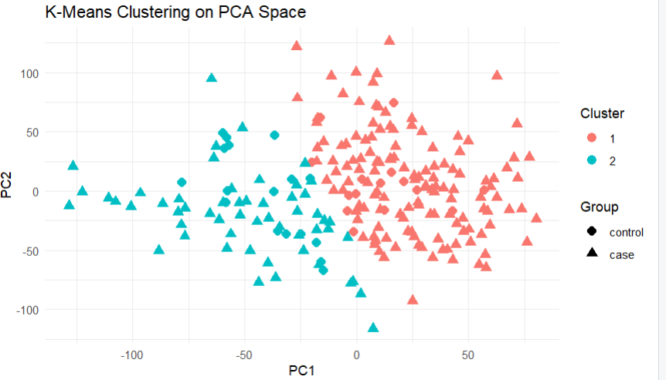

Figure 4: K-means clustering ((k = 2)) performed on the normalized gene expression data. Samples are colored according to cluster assignment. Control (healthy) and Sjögren’s disease samples show substantial overlap across clusters.

4.4 Random Forest

Although the Random Forest classifier achieved an overall accuracy of 86%, its performance was strongly biased toward the majority class. The model correctly identified case samples with high reliability but showed very low sensitivity for control samples (3.1%), indicating poor generalization across groups. Consistently, the low of Cohen’s Kappa (0.05) and balanced accuracy (0.52) suggest that performance for the minority class is only marginally better than random classification.
As shown in Figure 5, the out-of-bag (OOB) error rate decreases rapidly during the early stages of model training as the number of trees increases, reflecting that the model quickly captures the main structure of the data. After approximately 500 trees, the error stabilizes at around 13–14%, indicating convergence and minimal benefit from adding further trees. Minor fluctuations around this plateau likely reflect variability from bootstrap sampling, but the overall trend remains stable. This stabilized OOB error corresponds to an estimated accuracy of about 86–87%, confirming moderate overall performance but limited discriminatory power for the minority class.

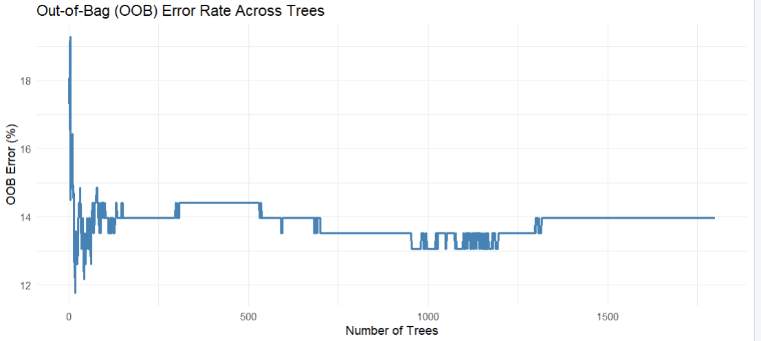

Figure 5: The OOB error rate decreases rapidly with increasing number of trees and then stabilizes after about 500 trees, indicating convergence at a consistent error level around 13–14%.

4.5 Linear discriminant analysis
Linear Discriminant Analysis (LDA) showed strong separation between control and case samples based on selected gene expression features. The classifier achieved an accuracy of 97.75% with a Cohen’s kappa of 0.91, indicating excellent agreement beyond chance. Sensitivity for the control group was 0.94 and specificity was 0.98, demonstrating reliable classification of both groups. Overall, the results suggest that the selected genes provide strong discriminatory power between control and case samples.

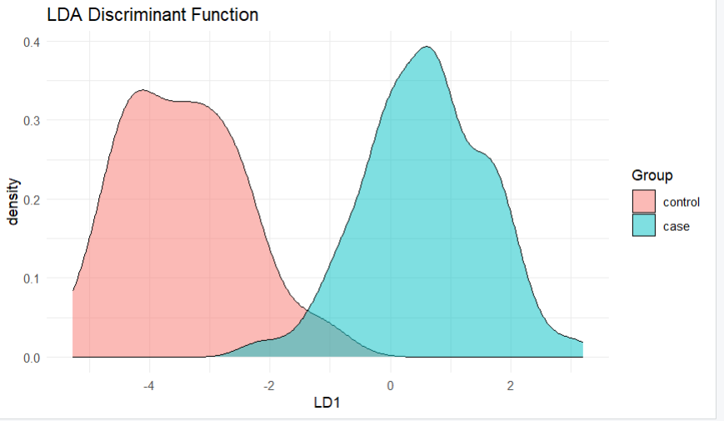
figure 6 : LD1 plot showing clear separation between control and case samples based on LDA of selected gene expression features, with minimal overlap between groups.
Figure 7 shows a heatmap of the top 30 genes selected from the LDA model. Samples were ordered by biological group (Control and Sjögren’s disease), while genes were hierarchically clustered based on expression similarity. Several interferon-related genes, including IFIT1, IFIT3, IFI27, and ISG15, showed higher expression in many Sjögren’s disease samples. However, substantial overlap between groups remained, indicating that the overall expression differences are relatively subtle.
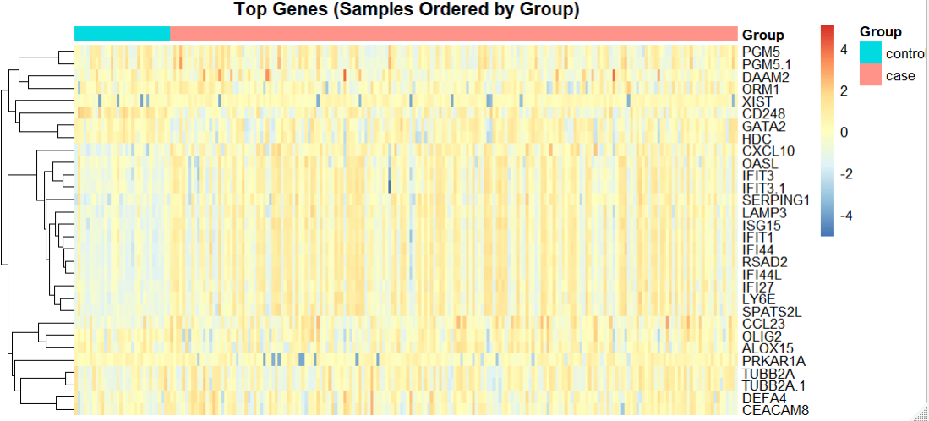
figure 7 Heatmap of the top 30 LDA-selected genes across Control and Sjögren’s disease samples.

4.6 LASSO logistic regression
To evaluate the predictive power of gene expression data, LASSO logistic regression was used to distinguish cases from controls. The dataset was randomly split into training (70%) and independent test (30%) sets. The model was trained using 10-fold cross-validation to select the optimal regularization parameter (λ). The final model was evaluated on the independent test set.On the test set, the model achieved an accuracy of 85.1%, correctly classifying the majority of samples. The confusion matrix showed 55 true positives, 2 true negatives, 10 false positives, and 0 false negatives, indicating high sensitivity but moderate specificity. Receiver operating characteristic (ROC) analysis demonstrated strong discriminatory ability, with an AUC of 0.86, reflecting good overall classification performance in distinguishing cases from controls
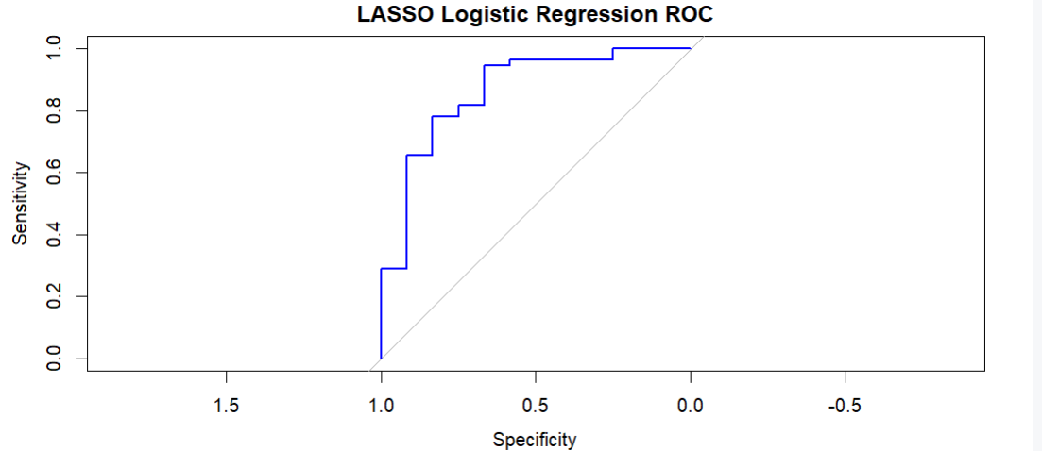
figure 8: ROC curve for LASSO logistic regression on the test set

4.7 Model Comparison
To compare the predictive performance of the three classifiers, 5-fold cross-validation was applied to Random Forest (RF), Linear Discriminant Analysis (LDA), and LASSO logistic regression. As shown in Figure 9, LDA and LASSO achieved the highest mean accuracies (0.914), while Random Forest showed lower performance (0.874). These results suggest that the gene expression profiles can be effectively classified using linear models. To obtain more robust performance estimates, the classifiers were further evaluated using repeated 5×5-fold cross-validation. As shown in Figure 10, LASSO achieved the highest mean accuracy (0.911), followed closely by LDA (0.904), whereas Random Forest obtained a mean accuracy of 0.872. The similarity between the repeated and standard cross-validation results indicates that model performance was stable across different data partitions. Overall, LDA and LASSO consistently outperformed Random Forest in both validation strategies. The small differences between 5-fold and repeated 5×5-fold cross-validation suggest that the observed classification performance is robust and reproducible, supporting the reliability of the selected gene expression features for distinguishing between the study groups.
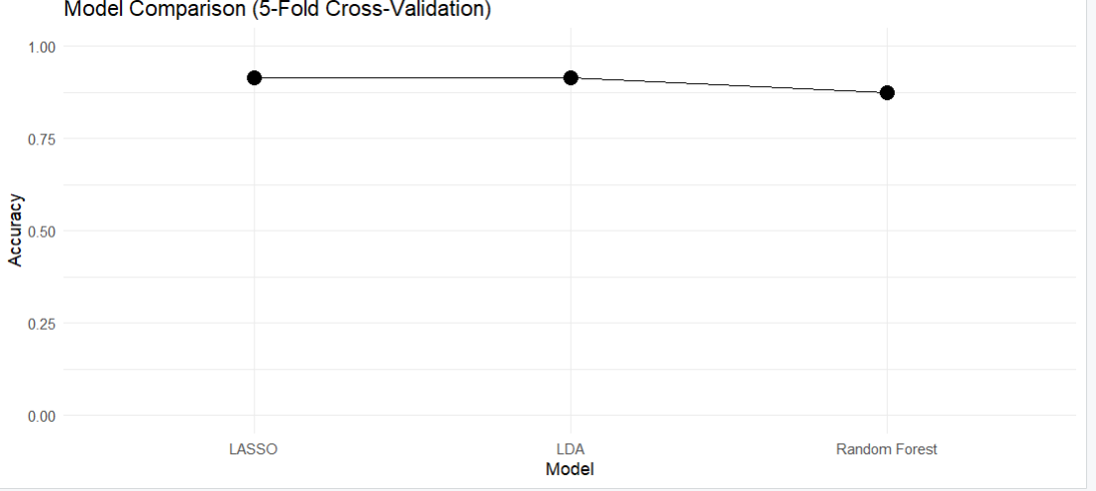
figure 9: Comparison of Random Forest (RF), Linear Discriminant Analysis (LDA), and LASSO logistic regression using 5-fold cross-validation.
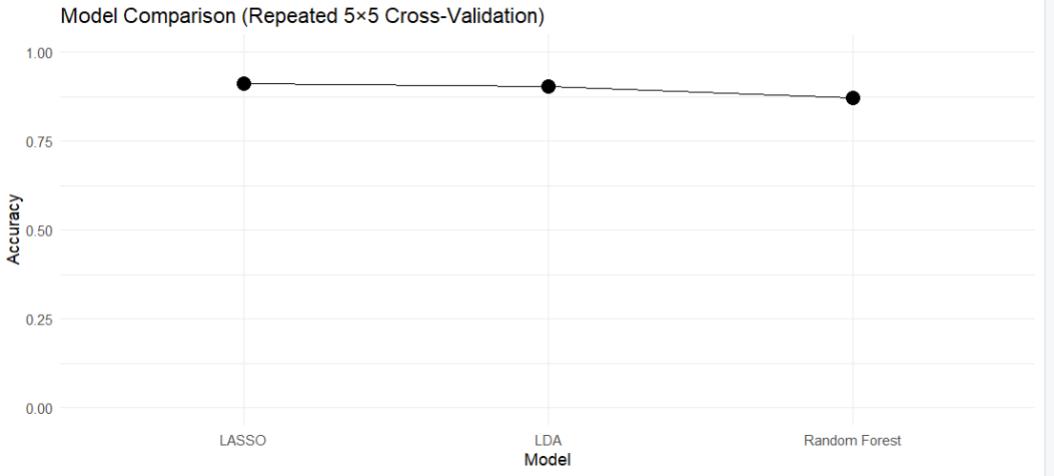
Figure 10: Comparison of model performance using repeated 5×5-fold cross-validation.

4.8 Enrichment analysis
To understand the biological processes involved in Sjögren's disease,functional enrichment analysis was done on the specific gene set using the gprofiler2 package.. The enriched terms identified from multiple annotation databases are summarized in Figure 11. In the plot, each dot represents an enriched term, grouped by database along the x-axis, while the y-axis indicates enrichment significance as −log10(p-value). Dot size corresponds to the number of genes associated with each term. Among the analyzed databases, GO Biological Process (GO) and Reactome (REAC) showed the strongest enrichment signals, indicating that the most significant changes are linked to biological pathways and cellular processes. Transcription factor (TF) categories also contained numerous enriched terms with relatively large gene counts. In contrast, GO Cellular Component (GO), GO Molecular Function (GO), KEGG, and CORUM displayed fewer and less significant enrichments. Overall, the plot suggests that the dominant transcriptomic changes in Sjögren’s disease are concentrated in pathway and process-related functional categories.
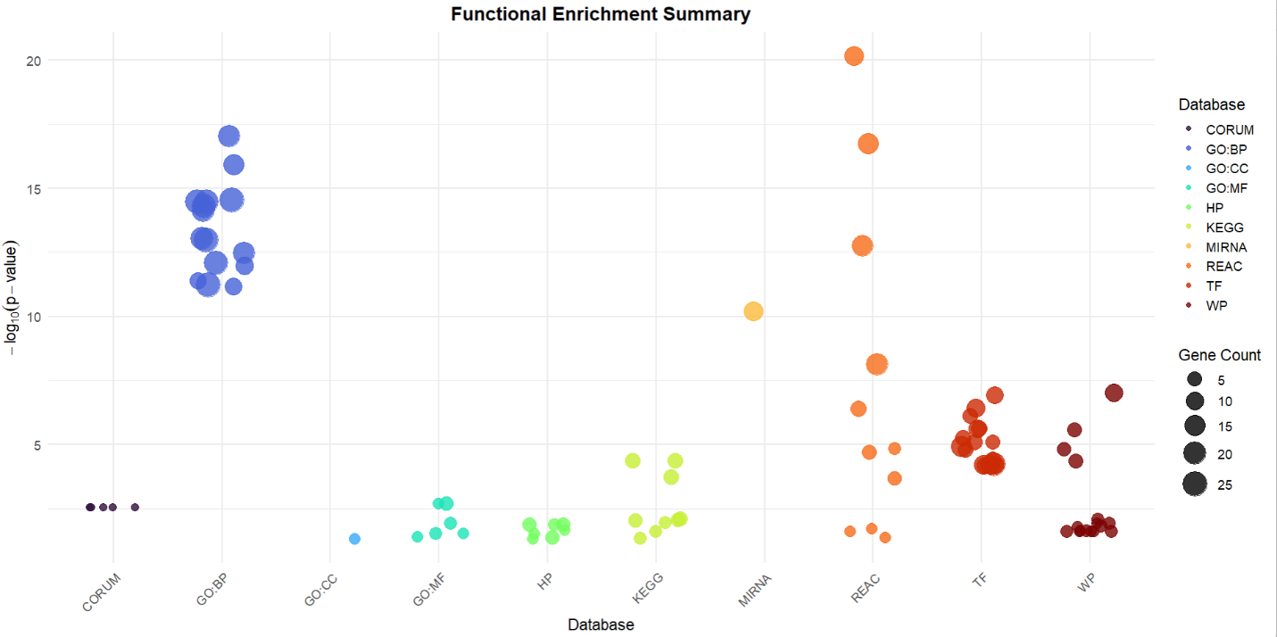
Figure 11. Functional enrichment analysis of genes associated with Sjögren’s disease

4.8.1 GO Biological Process enrichment analysis
To investigate the biological processes associated with Sjögren’s disease, GO Biological Process enrichment analysis was performed on the discriminative gene set, and the results are shown in Figure 12. In the bubble plot, the x-axis represents the GeneRatio, the y-axis lists the enriched biological processes, bubble size indicates the number of associated genes, and color reflects the adjusted p-value. The most significantly enriched terms were response to virus and defense response to virus, which showed the highest GeneRatio values and gene counts. Other enriched processes included viral life cycle, viral genome replication, response to type I interferon, and antiviral innate immune response. Several regulatory pathways related to viral replication and viral processes were also significantly enriched. The results indicate that the discriminative genes are predominantly involved in antiviral defense mechanisms, interferon signaling, and regulation of viral replication, highlighting the importance of immune and antiviral responses in the pathogenesis of Sjögren’s disease.

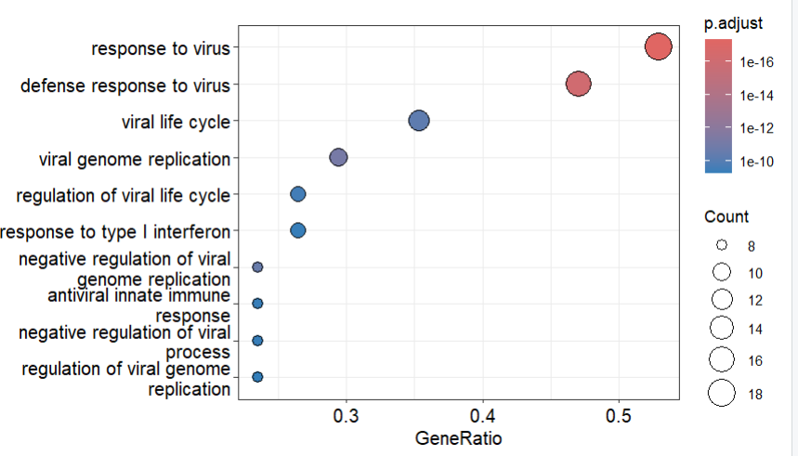
Figure 12. GO Biological Process enrichment analysis of the discriminative genes associated with Sjögren’s

4.8.2 Reactome pathway enrichment analysis
Reactome pathway enrichment analysis was performed to identify pathways associated with the discriminative genes in Sjögren’s disease. As shown in Figure 13, the enriched pathways are mainly related to interferon-mediated immune responses. The most significantly enriched pathway was Interferon Signaling, followed by Antimicrobial mechanism of IFN-stimulated genes, Interferon alpha/beta signaling, and Interferon gamma signaling However, the results indicate that the discriminative genes are strongly involved in interferon signaling and antiviral immune pathways, highlighting the important role of interferon-driven immune dysregulation in the pathogenesis of Sjögren’s disease.

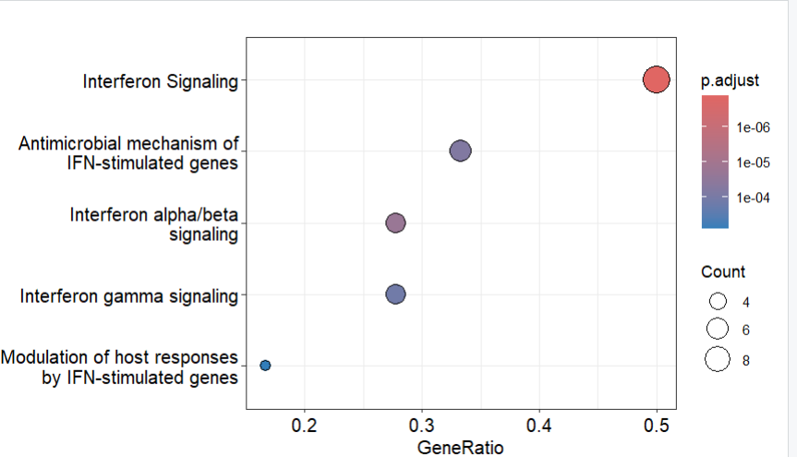
Figure 13. Reactome pathway enrichment analysis of the discriminative genes associated with Sjögren’s disease.

4.8.3 EnrichNet Network-Based Functional Analysis
To validate the pathway enrichment results obtained with PathfindR, an additional network-based analysis was performed using EnrichNet. The analysis identified several immune and antiviral pathways among the highest-ranked KEGG categories. The most strongly connected pathways included the NOD-like receptor signaling pathway, RIG-I-like receptor signaling pathway, cytosolic DNA-sensing pathway, chemokine signaling pathway, cytokine–cytokine receptor interaction, and Toll-like receptor signaling pathway. These pathways are key components of innate immune sensing and antiviral defense mechanisms and are closely linked to type I interferon production and inflammatory signaling.
The enrichment of RIG-I-like receptor and cytosolic DNA-sensing pathways is particularly noteworthy, as these pathways are responsible for detecting viral nucleic acids and triggering interferon-mediated immune responses. Activation of these signaling cascades leads to the induction of interferon-stimulated genes such as IFI27, IFI44, IFIT1, IFIT3, ISG15, OAS1, OAS2, MX1, and RSAD2, many of which were significantly upregulated in the present dataset. Similarly, enrichment of chemokine and cytokine signaling pathways is consistent with the increased expression of CXCL10, CCL2, and CCL8, which contribute to leukocyte recruitment and chronic inflammatory responses.
Importantly, the EnrichNet results were highly consistent with both the PathfindR and g:Profiler analyses, which also highlighted interferon signaling, antiviral defense mechanisms, and immune activation as major biological themes. The agreement among multiple independent enrichment approaches strengthens the evidence that Sjögren’s disease is characterized by dysregulated innate immune responses and persistent activation of interferon-dependent signaling pathways. These findings are consistent with previous studies describing a prominent type I interferon signature as a central molecular feature of Sjögren’s disease and a key contributor to disease pathogenesis (Bodewes et al., 2018; Maria et al., 2024).
A.
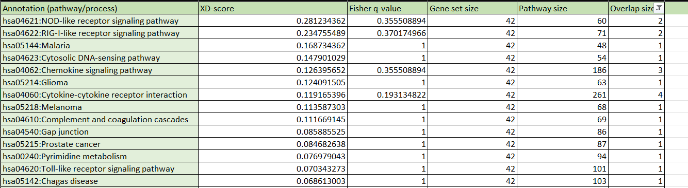
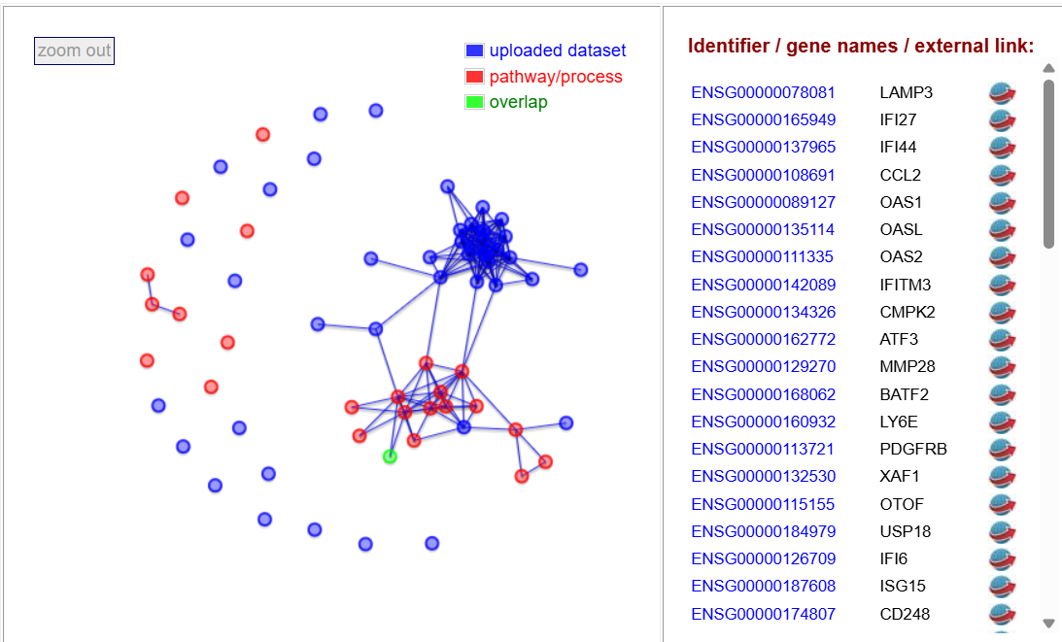
B.

Figure 14A. EnrichNet KEGG pathway enrichment analysis showing the top pathways associated with the differentially expressed genes. Immune-related pathways, including cytokine–cytokine receptor interaction, chemokine signaling, and NOD-like receptor signaling, were among the most highly ranked pathways. Figure 14B. EnrichNet network visualization illustrating the interactions between the uploaded gene set and the enriched KEGG pathway. Blue nodes represent genes from the dataset, red nodes represent pathway genes, and green nodes indicate overlapping genes connecting the dataset to the enriched pathway.

5. Discussion
The findings of this study provide further evidence that dysregulated type I interferon signaling is a central feature of Sjögren’s disease. The consistent upregulation of interferon-stimulated genes, including IFI27, IFI44, IFIT1, IFIT3, ISG15, OAS1, and OAS2, supports the concept of an "interferon signature" that has been repeatedly observed in patients with Sjögren’s disease. Type I interferons play a crucial role in antiviral defense; however, persistent activation of these pathways may contribute to autoimmunity by enhancing antigen presentation, promoting immune-cell activation, and sustaining chronic inflammatory responses. The enrichment of pathways involved in viral sensing, including RIG-I-like receptor, Toll-like receptor, NOD-like receptor, and cytosolic DNA-sensing pathways, suggests that aberrant activation of innate immune mechanisms may represent an important driver of disease pathology.
Interestingly, while unsupervised methods failed to clearly separate patients from healthy controls, supervised machine learning approaches demonstrated strong classification performance. This discrepancy highlights the substantial biological heterogeneity of Sjögren’s disease, which likely reflects differences in disease stage, clinical manifestations, genetic background, and immune activation among patients. Such heterogeneity may mask disease-specific transcriptional patterns when all genes are considered simultaneously. The success of LDA and LASSO models suggests that only a subset of highly informative genes is required to distinguish disease from healthy states, supporting their potential value as candidate biomarkers.
The agreement between multiple analytical approaches strengthens confidence in the robustness of the findings. Differential expression analysis identified key interferon-responsive genes, while enrichment analyses consistently highlighted interferon-mediated immune pathways. Furthermore, network-based analysis demonstrated that many of the identified genes occupy functionally connected positions within innate immune signaling networks. The convergence of these independent methods reduces the likelihood that the observed associations are artefactual and supports their biological relevance in Sjögren’s disease.
These results are consistent with previous studies reporting elevated interferon activity and genetic susceptibility variants affecting interferon signaling pathways, including IRF5 and STAT4 (Jonsson et al., 2011; Lessard et al., 2013). The present findings therefore contribute to a growing body of evidence suggesting that chronic interferon activation is not merely a consequence of inflammation but may represent a fundamental mechanism underlying disease initiation and progression. Moreover, the identification of genes such as CXCL10, which is involved in immune-cell recruitment and glandular inflammation, highlights potential molecular targets for future therapeutic intervention.
Despite these promising findings, several limitations should be acknowledged. The analysis was restricted to a single microarray dataset with a marked imbalance between case and control samples, which may have influenced classifier performance and reduced generalizability. In addition, microarray platforms provide lower transcriptomic resolution than RNA sequencing technologies and may fail to detect low-abundance transcripts or novel gene isoforms. Finally, the absence of independent validation cohorts limits the ability to confirm the reproducibility of the identified biomarkers.
Future studies should integrate larger and more diverse patient populations, employ RNA sequencing datasets, and include external validation to confirm the diagnostic and biological significance of the identified gene signatures. Functional studies investigating the role of key interferon-regulated genes may also provide further insight into the mechanisms driving disease pathogenesis and reveal opportunities for targeted therapeutic development. Collectively, the findings of this study support the view that persistent interferon-mediated immune activation is a defining molecular characteristic of Sjögren’s disease and may represent a valuable avenue for both biomarker discovery and therapeutic intervention.

6. Conclusion
In conclusion, this study identified significant gene expression changes associated with Sjögren’s disease, with a strong emphasis on the upregulation of interferon-stimulated genes and activation of type I interferon signaling pathways. While unsupervised analyses were unable to clearly distinguish patients from healthy controls, supervised machine learning models achieved high classification accuracy, demonstrating the presence of disease-specific transcriptional signatures. The consistent findings across differential expression, pathway enrichment, and network-based analyses highlight chronic interferon-mediated immune activation as a key molecular feature of Sjögren’s disease. Although further validation in larger and independent cohorts is required, these results improve our understanding of disease pathogenesis and identify potential biomarkers and therapeutic targets for future investigation.
.

7. Codes and extra tables
For the generated tables and the code used, please refer to the following GitHub repository: https://github.com/Hala-Alshaar/Gene-Expression-and-Pathway-Dysregulation-in-Sjogrens-Disease

8. References
- Bodewes ILA, Al-Ali S, van Helden-Meeuwsen CG, et al. Systemic interferon type I and type II signatures in primary Sjögren's syndrome reveal differences in biological disease activity. Rheumatology. 2018;57(5):921–930. https://pubmed.ncbi.nlm.nih.gov/29474655/
- Branch, N. S. C. a. O. (2025, June 5). Sjögren’s Disease. National Institute of Arthritis and Musculoskeletal and Skin Diseases. https://www.niams.nih.gov/health-topics/sjogrens-disease
- Glaab E, Baudot A, Krasnogor N, Schneider R, Valencia A. EnrichNet: network-based gene set enrichment analysis. Bioinformatics. 2012;28(18):i451–i457. https://pubmed.ncbi.nlm.nih.gov/22962466/
- Greenacre, M., Groenen, P. J. F., Hastie, T., D’Enza, A. I., Markos, A., & Tuzhilina, E. (2022). Principal component analysis. Nature Reviews Methods Primers, 2(1). https://doi.org/10.1038/s43586-022-00184-w
- Hanne Borge, Ingrid Beate Ringstad, Lara A Aqrawi, Siren Fromreide, Harsh Nitin Dongre, Hilde Kanli Galtung, Janicke Liaaen Jensen, Kathrine Skarstein. Increased expression of CXCL10 and CCL3 salivary gland chemokines in primary Sjögren’s syndrome detected and systematically quantified using RNAscope® in situ hybridization. Clinical and Experimental Immunology, Volume 219, Issue 1, 2025, uxae087. https://doi.org/10.1093/cei/uxae087
- Ikotun, Abiodun M., et al. “K-Means Clustering Algorithms: A Comprehensive Review, Variants Analysis, and Advances in the Era of Big Data.” Information Sciences, vol. 622, no. 622, Dec. 2022, www.sciencedirect.com/science/article/pii/S0020025522014633, https://doi.org/10.1016/j.ins.2022.11.139.
- Jonsson, R., Vogelsang, P., Volchenkov, R., Espinosa, A., Wahren-Herlenius, M., & Appel, S. (2011). The complexity of Sjögren’s syndrome: Novel aspects on pathogenesis. Immunology Letters, 141(1), 1–9. https://doi.org/10.1016/j.imlet.2011.06.007
- Kolberg, L., Raudvere, U., Kuzmin, I., Adler, P., Vilo, J., & Peterson, H. (2023). g:Profiler—interoperable web service for functional enrichment analysis and gene identifier mapping (2023 update). Nucleic Acids Research, 51(W1), W207–W212. https://doi.org/10.1093/nar/gkad347
- Lee, H., & Kim, H. (2020). Logistic regression and least absolute shrinkage and selection operator. Cardiovascular Prevention and Pharmacotherapy, 2(4), 142. https://doi.org/10.36011/cpp.2020.2.e15
- Maria NI, Verstappen GM, Kroese FGM, Bootsma H. Interferon pathways in Sjögren's disease: mechanisms and therapeutic opportunities. Nature Reviews Rheumatology. 2024. https://pubmed.ncbi.nlm.nih.gov/24062752/
- Registry, F. U. P. S. S., Lessard, C. J., Li, H., Adrianto, I., Ice, J. A., Rasmussen, A., Grundahl, K. M., Kelly, J. A., Dozmorov, M. G., Miceli-Richard, C., Bowman, S., Lester, S., Eriksson, P., Eloranta, M., Brun, J. G., Gøransson, L. G., Harboe, E., Guthridge, J. M., Kaufman, K. M., . . . Sivils, K. L. (2013). Variants at multiple loci implicated in both innate and adaptive immune responses are associated with Sjögren’s syndrome. Nature Genetics, 45(11), 1284–1292. https://doi.org/10.1038/ng.2792
- Ritchie, M. E., Phipson, B., Wu, D., Hu, Y., Law, C. W., Shi, W., & Smyth, G. K. (2015). limma powers differential expression analyses for RNA-sequencing and microarray studies. Nucleic Acids Research, 43(7), e47. https://doi.org/10.1093/nar/gkv007
- Salman, Hasan Ahmed, et al. “Random Forest Algorithm Overview.” Babylonian Journal of Machine Learning, vol. 2024, 8 June 2024, pp. 69–79, www.researchgate.net/publication/382419308_Random_Forest_Algorithm_Overview, https://doi.org/10.58496/bjml/2024/007.
- Ulgen, E., Ozisik, O., & Sezerman, O. U. (2019). PathFindR: an R package for comprehensive identification of enriched pathways in Omics data through active subnetworks. Frontiers in Genetics, 10, 858. https://doi.org/10.3389/fgene.2019.00858

