SmartUmrah : Project Management Case Study

Prepared by: Hala Abdullatif Alghamdi
Computer Science Student Princess Nourah University

Year 1447

Table of Contents:

- Introduction…………………………………………………………………..4
- Problem Statement…………………………………………………………..4
- Methodology………………………………………………………………….5
  - Selected SDLC Model…………………………………………………………5
  - Justification…………………………………………………………………… 5
- Project Charter………………………………………………………………6
- Project Scope Statement……………………………………………………. 8
- Techniques for Collecting Requirements with Justification………………9
- Project Requirements……………………………………………………….10
  - Software………………………………………………………………………10
  - Hardware……………………………………………………………………..10
  - Functional and Non-Functional………………………………………………10
- Work Breakdown Structure (WBS)………………………………………..12
- WBS Dictionary……………………………………………………………..14
- RACI Chart………………………………………………………………….16
- Gantt Chart………………………………………………………………….19
- Risk Register…………………………………………………………………21
- References……………………………………………………………………22

List of Tables:
Table1 : WBS Dictionary…………………………………………………………15
Table 2 : Raci chart………………………………………………………………..18
Table 3 : Gantt chart………………………………………………………………20
Table 4: Risk Register…………………………………………………………… 21

List of Figures:
Figure 1: Project charter………………………………………………………..7
Figure 2: Scope Statement……………………………………………………..8
Figure 3: Work Breakdown Structure (WBS) Diagram……………………….13

    - Introduction:
Every year, millions of Muslims visit Makkah to perform Umrah, which creates significant challenges in managing crowd movement and organizing visitor access to the holy sites [2]. To address these challenges, digital platforms have been introduced to help organize permits and improve the overall experience for visitors. One of the main platforms currently used is the Nusuk application, which allows users to book Umrah permits and access different services related to their visit [1]. The application helps regulate entry and organize appointments; however, there are still opportunities to improve how users plan their visits and how crowd conditions are managed. Therefore, this project proposes an enhanced system called SmartUmrah, which aims to improve the Umrah experience by introducing features such as crowd prediction, improved booking guidance, and intelligent notifications.
    - Problem Statement:
The Nusuk system helps organize Umrah visits by allowing users to reserve permits and schedule their appointments [1]. This contributes to controlling the number of visitors and improving the organization of entry to the holy sites.
However, several limitations still affect the efficiency of the system. First, the current system does not provide crowd level predictions, which means users cannot know how crowded a specific time may be before making a reservation. As a result, many visitors may choose similar time slots, leading to increased congestion.
Second, the system provides limited guidance during the booking process, as users are not informed about less crowded times that may offer a better visiting experience. In addition, the application lacks intelligent notifications that could inform users about crowd conditions or important updates related to their reservations.
To address these limitations, the proposed system SmartUmrah introduces several improvements, including crowd prediction, improved booking guidance, intelligent notifications, and alerts. These features aim to help distribute visitors more effectively, assist users in choosing better visiting times, and enhance safety and overall experience during Umrah [2].

- Methodology:

  - Selected SDLC Model:
For this project, the Hybrid Life Cycle using the Incremental Model will be adopted [3]. The hybrid model combines elements of both predictive and adaptive development approaches. In the incremental model, the system is developed and delivered in smaller functional components rather than building the entire system at once.
Each increment goes through the phases of analysis, design, development, and testing before being integrated into the overall system. This approach allows the development team to deliver system features gradually while ensuring that each component works correctly before moving to the next stage.
The proposed system aims to enhance the functionality of the existing application Nusuk by introducing several new features. These features include predicting crowd levels in advance, providing intelligent notifications about crowd conditions, and offering improved booking guidance based on predicted demand. Each of these features can be developed and implemented as separate increments within the system.

  - Justification:
The Hybrid Incremental Model was selected because it is well suited for systems that consist of multiple independent features that can be developed and delivered gradually [3]. The proposed project introduces several enhancements to the existing system, including crowd prediction, intelligent notification services, and improved booking guidance. Developing these features incrementally allows the project team to focus on one component at a time and ensure its quality before integrating it into the complete system.
Another reason for selecting this model is that it improves project control and reduces risk. Since the system is built in increments, testing and evaluation can occur after each stage, allowing the team to identify potential issues early in the development process. This approach also makes it easier to refine system features based on stakeholder feedback.

- Project Charter: 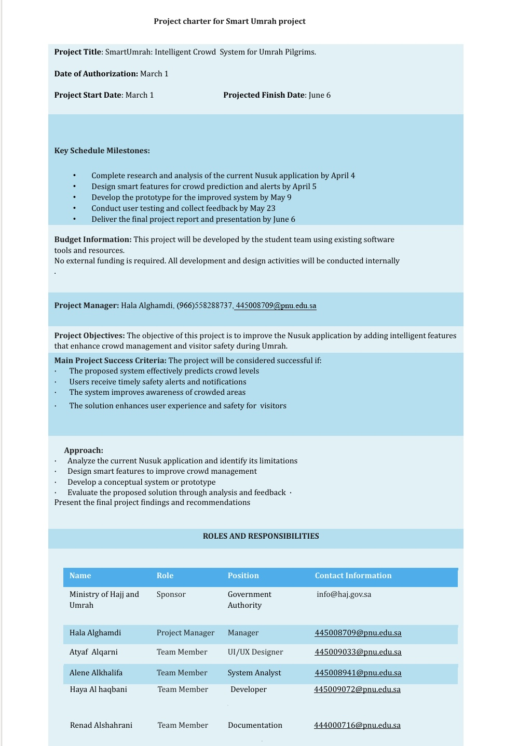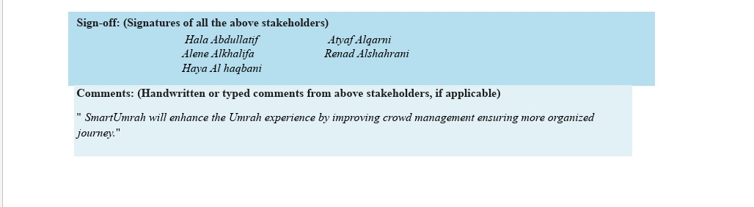
Confidential

Confidential

Confidential

Confidential

Figure 1: Project charter

- Project Scope Statement:
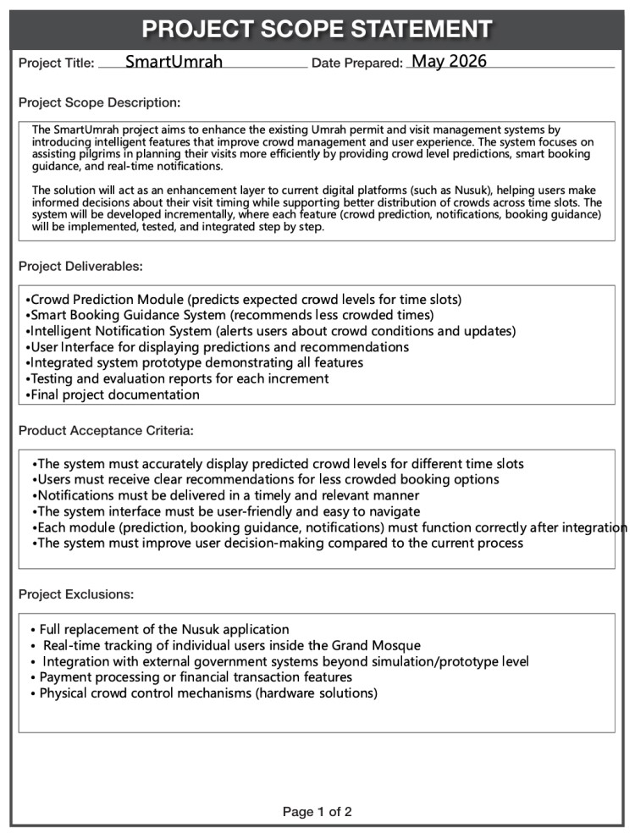
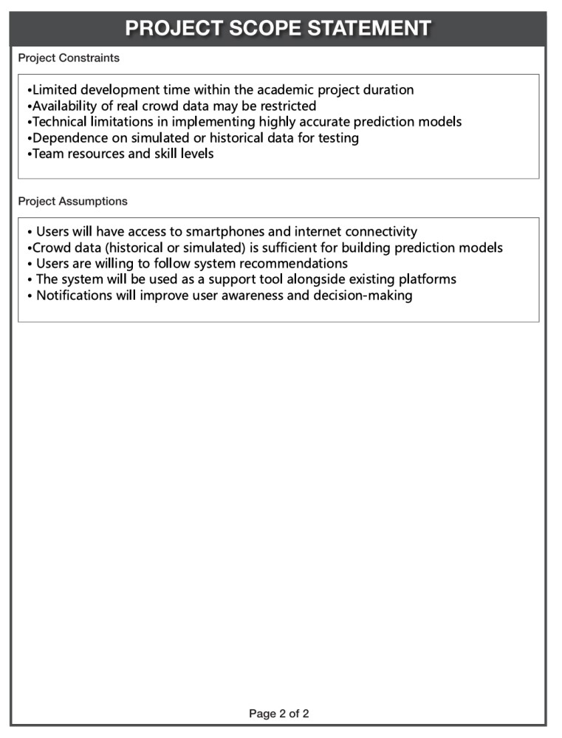

Figure 2: Scope Statement

- Techniques for Collecting Requirements with Justification:
To collect the requirements for the SmartUmrah system, several stakeholders were identified, including Umrah pilgrims, Ministry of Hajj and Umrah staff, system administrators, and technical developers. Different requirement investigation techniques were selected to ensure accurate understanding of user needs and system expectations.
The first technique used is Interviews. Interviews allow direct communication with stakeholders to understand their problems, expectations, and suggestions regarding the current Umrah management systems. This technique was selected because it provides detailed information about user experiences, especially regarding crowd management, booking difficulties, and notification services.
The second technique is Questionnaires. Online questionnaires can be distributed to Umrah visitors to collect feedback from a large number of users in a short time. This technique helps identify common issues faced by users and allows the project team to analyze user preferences related to booking times, crowd conditions, and system usability.
Another technique is Observation. Observing how users interact with existing systems such as Nusuk helps identify practical problems that may not be mentioned directly by users. This technique was chosen because it provides a realistic understanding of user behavior during the booking and permit process.
Finally, Document Analysis was used to review existing information related to the Nusuk platform, crowd management procedures, and Umrah services provided by the Ministry of Hajj and Umrah. This technique helps the team understand the current system structure and identify areas that require improvement.
These techniques were selected because they provide both qualitative and quantitative information, which supports accurate requirement collection and improves the overall quality of the proposed SmartUmrah system.

- Project Requirements:
  - Software requirements:
      - Operating System: Windows 10 or later.
      - Development Tools: Visual Studio Code or Android Studio.
      - Programming Languages: Java, Python, and JavaScript.
      - Database Management System: MySQL.
      - Web Technologies: HTML, CSS, and React.
      - API Services: Google Maps API for location and crowd tracking.
      - Notification Services: Firebase Cloud Messaging (FCM).
      - Project Management Tools: Microsoft Project for planning and scheduling activities.
These software tools are necessary to develop the crowd prediction system, booking guidance features, and intelligent notification services efficiently.

  - Hardware requirements:
      - Developer computers with at least Intel Core i5 processor.
      - Minimum 8 GB RAM.
      - Minimum 256 GB storage capacity.
      - Stable internet connection.
      - Cloud server for storing and processing system data.
      - Smartphones for testing the mobile application features and notifications.
These hardware requirements ensure system stability, efficient processing, and smooth application performance.

  - Functional and Non-Functional requirements:
Functional Requirements:
The SmartUmrah system should provide the following functions:
      - The system shall allow users to book Umrah permits online.
      - The system shall predict crowd levels for different time slots.
      - The system shall recommend less crowded times for users.
      - The system shall send intelligent notifications and alerts to users.
      - The system shall display crowd information using maps and visual indicators.
      - The system shall allow administrators to manage booking data and monitor crowd conditions.
      - The system shall store user reservations and booking history securely.
Non-Functional Requirements:
      - The system shall provide high availability and reliability during peak seasons.
      - The system shall respond quickly to user requests and display results efficiently.
      - The system shall ensure data privacy and secure user information.
The system shall support large numbers of concurrent users.
      - The system shall provide a user-friendly and simple interface.
      - The system shall be scalable for future improvements and additional services.
      - The system shall maintain accurate notification delivery and real-time updates.

- Work Breakdown Structure (WBS):
• Tabular:

1.1. Project Planning (2 weeks)
    - Define project scope and objectives.
    - Identify system requirements.
    - Develop project charter.
    - Prepare project scope statement.

1.2. Research and Analysis (3 weeks)
    - Analyze limitations of the current Nusuk system.
    - Conduct research on crowd management systems.
    - Identify user needs and system expectations.
    - Define functional and non-functional requirements.
    - Determine system features and functionality.

1.3. System Design and Development (5 weeks)
    - Design system architecture.
    - Design user interface and user experience.
    - Create database structure.
    - Develop crowd prediction module.
    - Develop smart booking guidance feature.
    - Develop intelligent notification system.
    - Integrate all system modules.

1.4. System Testing and Evaluation (2 weeks) 1.4.1. Test system functionality and performance.
    - Conduct usability testing.
    - Identify and fix system errors.
    - Evaluate system efficiency and reliability.

1.5. Documentation and Final Delivery (2 weeks)
    - Prepare technical documentation.
    - Prepare final project report.
    - Create project presentation slides.
    - Submit final project deliverables.

• Diagram:

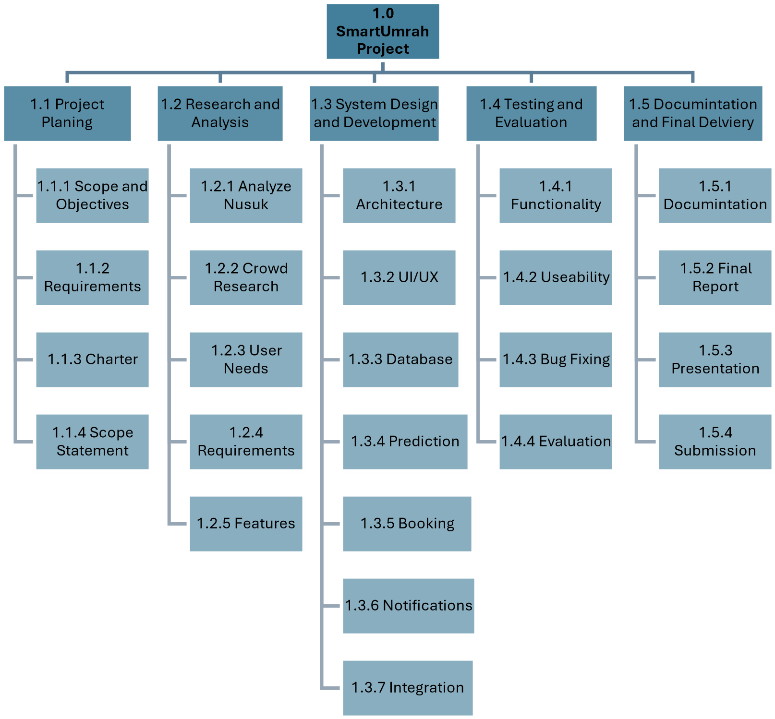

Figure 3: Work Breakdown Structure (WBS) Diagram

- WBS Dictionary:
WBS  ID | Task Name | Description
1.1 | Project Planning | Define the overall project objectives, scope, and planning activities.
1.1.1 | Define Project Scope and  Objectives | Identify the purpose, goals, and expected outcomes of the SmartUmrah project.
1.1.2 | Identify System Requirements | Gather system requirements needed for development and implementation.
1.1.3 | Develop Project Charter | Prepare the project charter including stakeholders, goals, and responsibilities.
1.1.4 | Prepare Project Scope Statement | Define project boundaries, assumptions, and exclusions.
1.2 | Research and Analysis | Conduct research and analyze the current Umrah management systems and user needs.
1.2.1 | Analyze Limitations of the Current Nusuk System | Study weaknesses and limitations in the existing system.
1.2.2 | Conduct Research on Crowd Management Systems | Review existing crowd management and prediction solutions.
1.2.3 | Identify User Needs and System Expectations | Determine what users expect from the SmartUmrah system.
1.2.4 | Define Functional and NonFunctional Requirements | Specify system functionalities and quality requirements.
1.2.5 | Determine System Features and Functionality | Define the major system features and services.
1.3 | System Design and Development | Design and develop the SmartUmrah system components and modules.
1.3.1 | Design System Architecture | Define system structure and communication between modules.
1.3.2 | Design User Interface and User Experience | Create user-friendly screens and navigation flow.
1.3.3 | Create Database Structure | Design database tables and relationships.
1.3.4 | Develop Crowd Prediction Module | Implement functionality for predicting crowd levels.
1.3.5 | Develop Smart Booking  Guidance Feature | Implement recommendation system for selecting less crowded times.
1.3.6 | Develop Intelligent Notification System | Implement notification and alert services.
1.3.7 | Integrate All System Modules | Combine all developed modules into one integrated system.
1.4 | System Testing and Evaluation | Test the system and evaluate performance and usability.
1.4.1 | Test System Functionality and Performance | Verify that all system functions operate correctly.
1.4.2 | Conduct Usability Testing | Evaluate ease of use and user satisfaction.
1.4.3 | Identify and Fix System Errors | Detect and correct bugs and technical issues.
1.4.4 | Evaluate System Efficiency and Reliability | Measure system stability and reliability.
1.5 | Documentation and Final  Delivery | Prepare final documentation and submit all deliverables.
1.5.1 | Prepare Technical  Documentation | Document system design, implementation, and technical details.
1.5.2 | Prepare Final Project Report | Complete the academic project report.
1.5.3 | Create Project Presentation  Slides | Prepare presentation materials for project demonstration.
1.5.4 | Submit Final Project  Deliverables | Submit all required project files and documents.

Table1 : WBS Dictionary

RACI Chart for SmartUmrah Project
- RACI Chart:

WBS Task | Project  Manager | UI/UX Designer | System Analyst | Developer | Documentation | Sponsor
1.1. Project Planning
1.1.1. Define project scope and objectives | R/A | I | C | I | C | I
1.1.2. Identify system requirements | A | C | R | C | I | I
1.1.3. Develop project charter | R/A | I | I | I | C | I
1.1.4. Prepare project scope statement | R/A | I | C | I | C | I
1.2. Research and Analysis
1.2.1. Analyze limitations of current Nusuk system | A | I | R | I | C | I
1.2.2. Conduct research on crowd management | A | I | R | C | C | I
1.2.3. Identify user needs and expectations | A | R | R | I | I | C
1.2.4. Define functional and non-functional requirements | A | C | R | C | I | I
1.2.5.  Determine system features and functionality | A | C | R | C | I | C
1.3. System Design and Developmen |  |  | t

WBS Task | Project  Manager | UI/UX Designer | System Analyst | Developer | Documentation | Sponsor
1.3.1. Design system architecture | A | I | R | R | I | I
1.3.2. Design user interface and experience (UI/UX) | A | R | C | I | I | I
1.3.3. Create database structure | A | I | C | R | I | I
1.3.4. Develop crowd prediction module | A | I | I | R | I | I
1.3.5. Develop smart booking guidance feature | A | I | I | R | I | I
1.3.6. Develop intelligent  notification system | A | I | I | R | I | I
1.3.7.  Integrate all system modules | A | C | C | R | I | I
1.4. System Testing and Evaluation
1.4.1. Test system  functionality and performance | A | I | R | R | I | I
1.4.2. Conduct usability testing | A | R | R | I | I | C
1.4.3. Identify and fix system errors | A | C | C | R | I | I
1.4.4.  Evaluate system | A | I | R | I | I | C
WBS Task | Project  Manager | UI/UX Designer | System Analyst | Developer | Documentation | Sponsor
efficiency and reliability
1.5. Documentation and Final Delivery
1.5.1. Prepare technical documentation | A | I | I | R | R | I
1.5.2. Prepare final project report | A | C | C | C | R | I
1.5.3. Create project presentation slides | R | R | R | R | R | I
1.5.4. Submit final project deliverables | R | I | I | I | I | A
Table 2: RACI Chart

11• Gantt Chart:

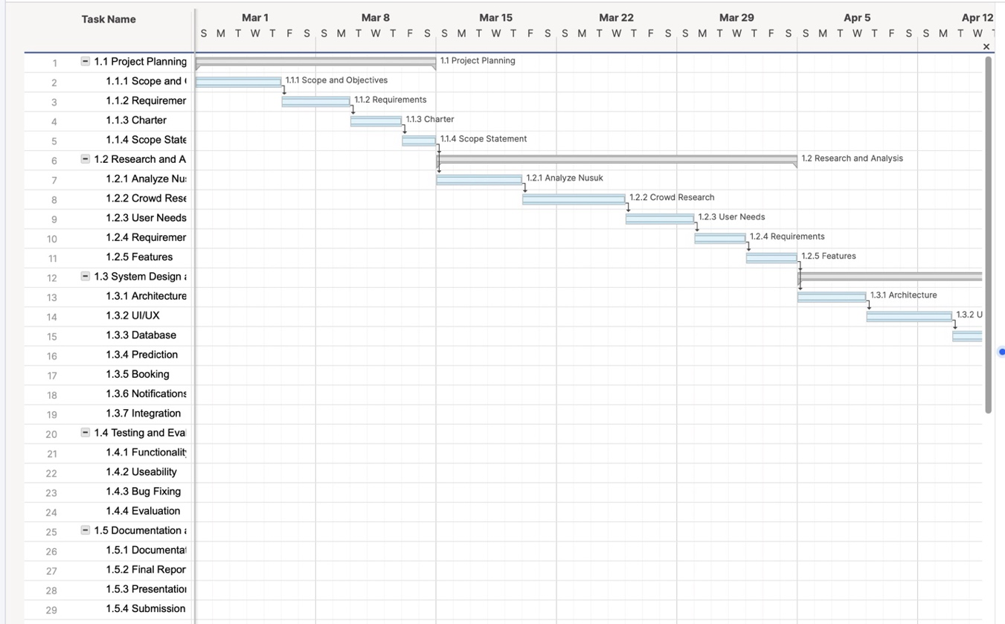
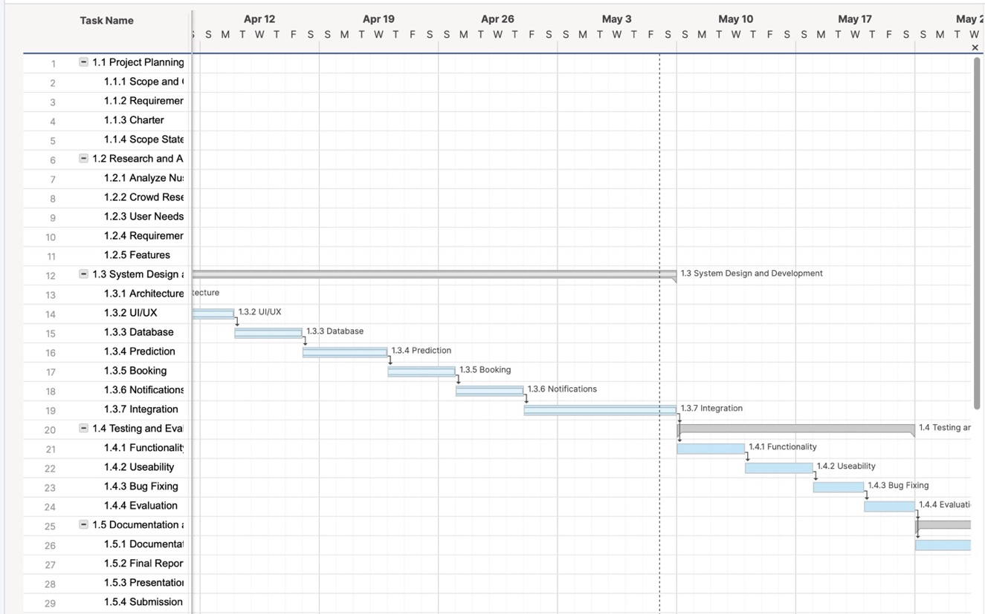
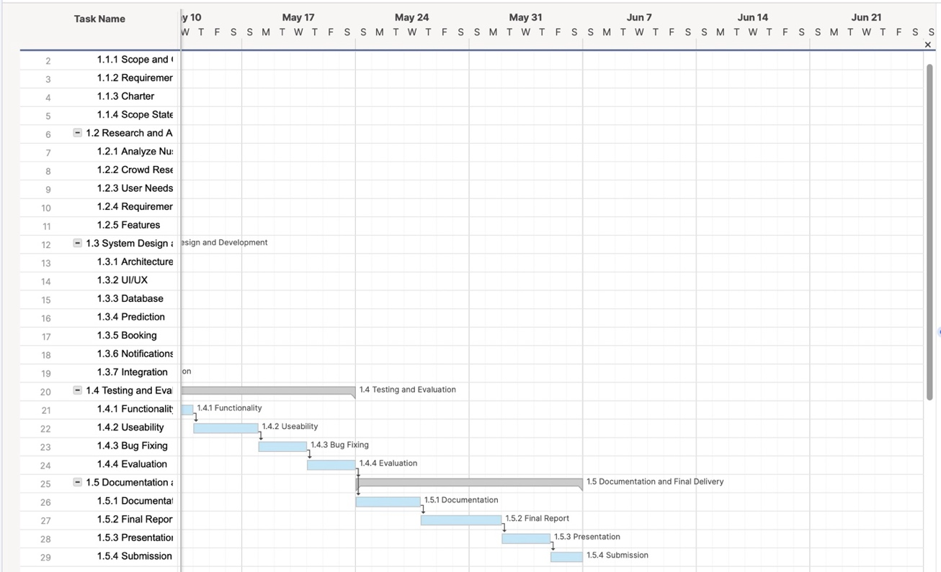

Gantt Chart Table:
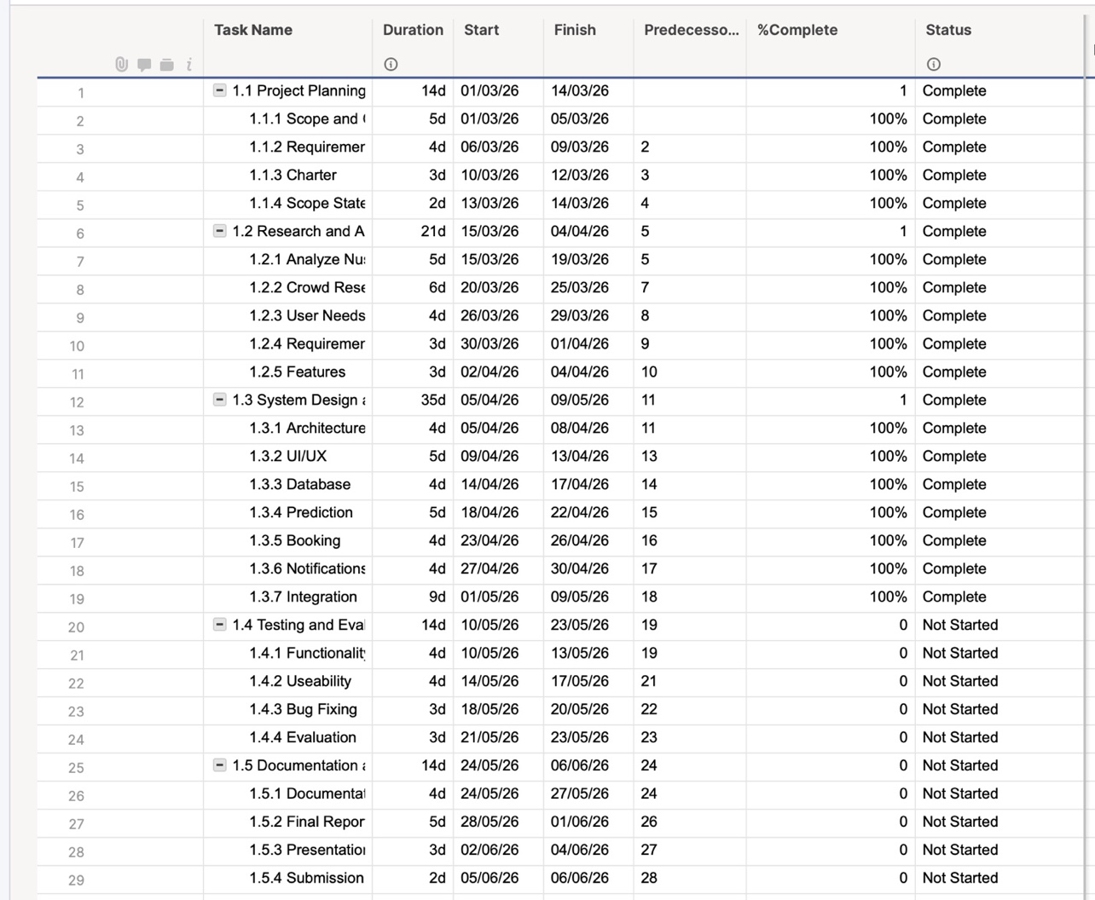
Table 3 :Gantt chart

12.Risk Register:

No. | Rank | Risk | Description | Category | Root Cause | Triggers | Potential Responses | Probability | Impact if the Risk Occurs
R1 | 1 | Delay in crowd updates | Delay in updating crowd data may affect the accuracy of information shown to users | Negative | Server overload or slow data processing | Slow response time or delayed data synchronization | Improve data update speed and use reliable servers | H | H
R2 | 2 | System overload during Umrah seasons | High traffic on the system may cause slow performance or temporary service interruption | Negative | Large number of concurrent users | Sudden increase in active users during peak times | Use backup cloud servers and monitor system performance | M | H
R3 | 3 | Future system expansion | The system may successfully expand by adding more smart services in the future | Positive | System scalability and successful performance | Increased demand for additional smart services | Plan for future scalability and feature expansion | M | M
R4 | 4 | Increased user adoption | Users may increasingly rely on the system because of ease of use | Positive | Simple interface and accurate notifications | Positive feedback and increasing number of users | Continuously improve user experience and notification services | H | M

Table 4 : Risk register

13. References:
- Ministry of Hajj and Umrah, "Nusuk Platform," https://www.nusuk.sa

- Ministry of Hajj and Umrah, "Hajj and Umrah Services," https://www.haj.gov.sa

- K. Schwalbe, "Information Technology Project Management,"
https://accord.edu.so/web/content/33460

