

**Palestine Technical Universiy – Kadoorie**

**College of Engineering & Technology**

**Computer Engineering Department**

**ISAD Project Task**

**Prepared By :**

**Eng. Momen Khaleafa**

**Eng.Baraa Jaber**

**Eng.Zaid Zaidan**

**Supervisor :**

**Dr.Nael Salman**

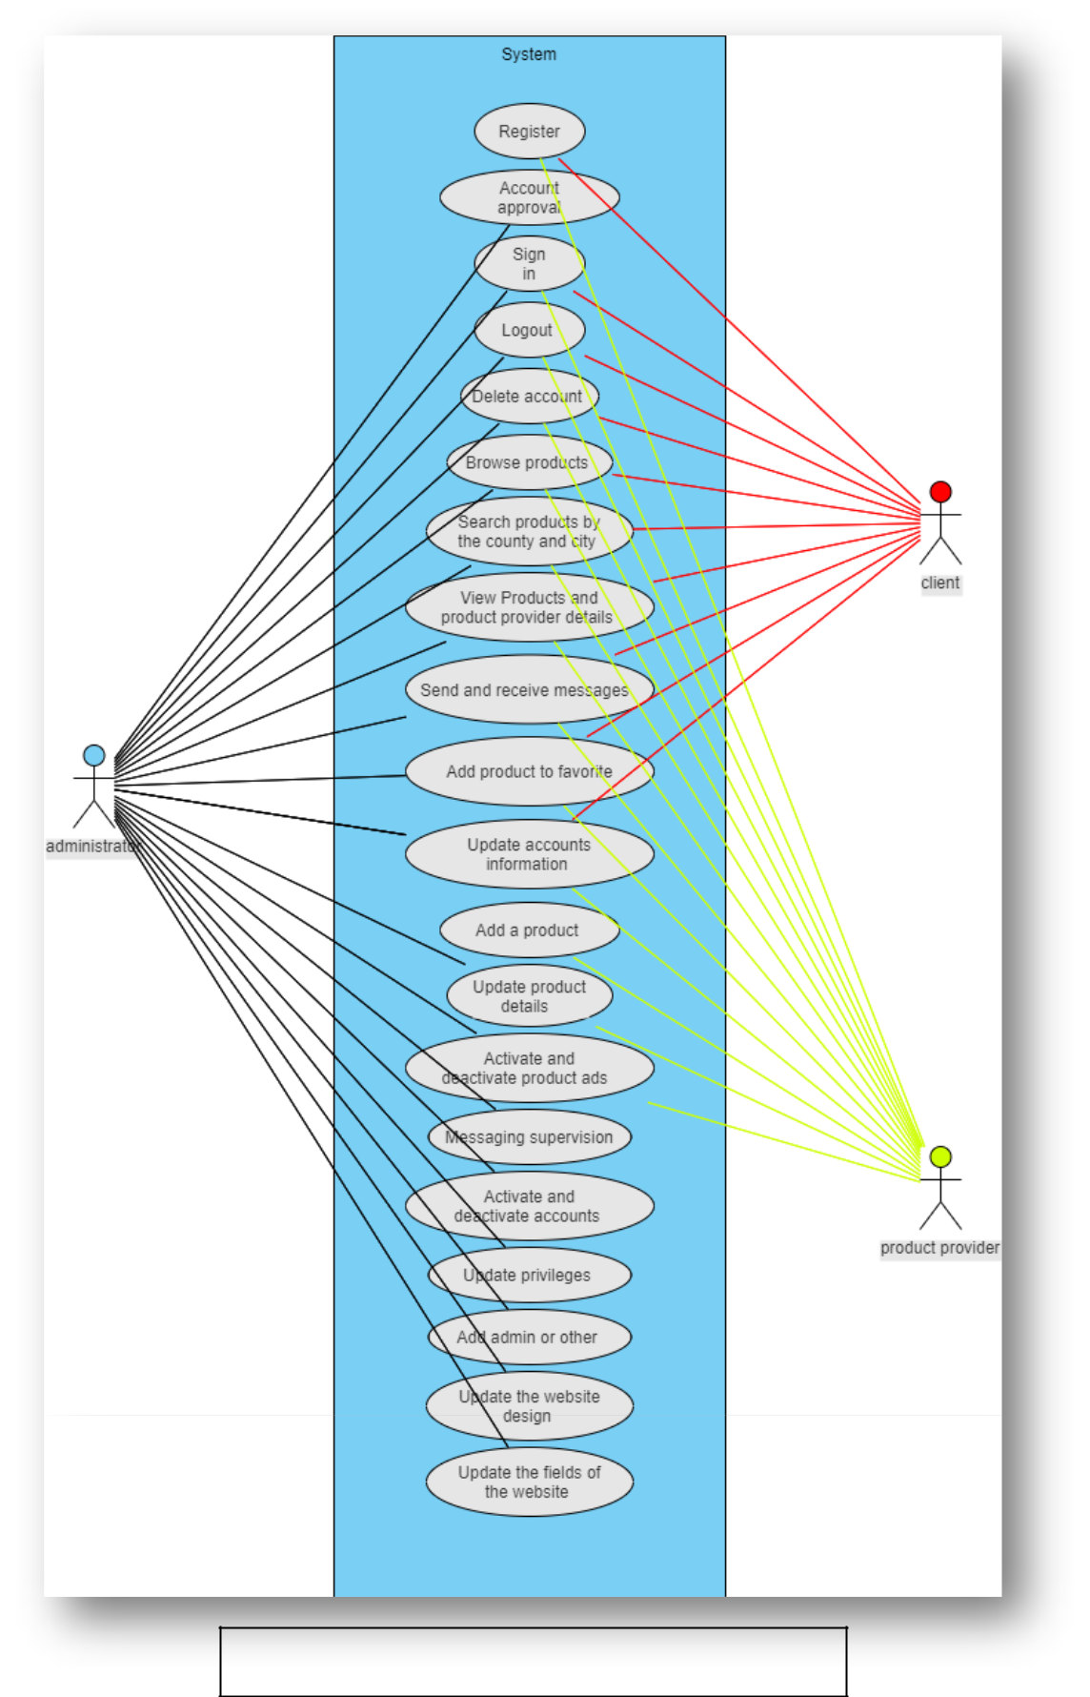 **) Use Case Diagram :1**

2) Entity relationship diagram :

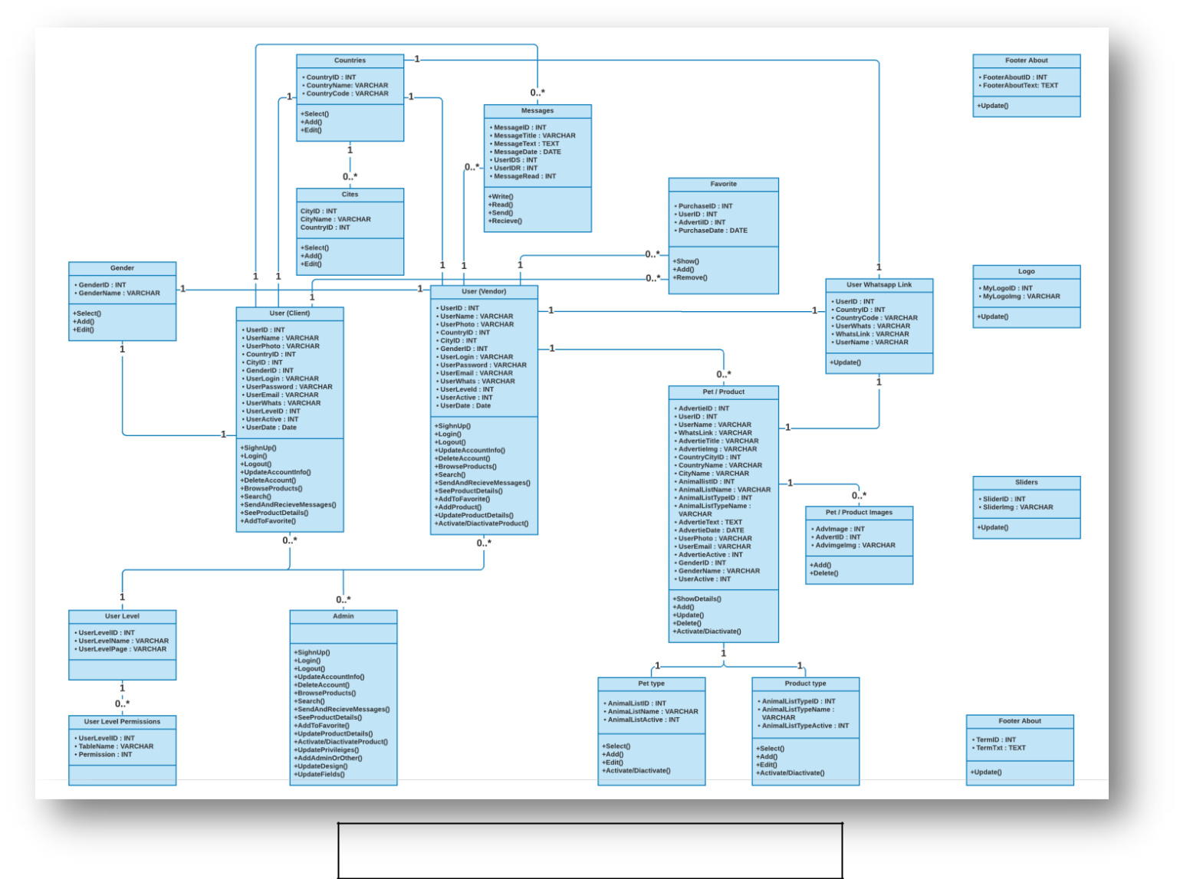3) Domain Model Class Diagram :

Fully Developed use case description :(4

Yara :

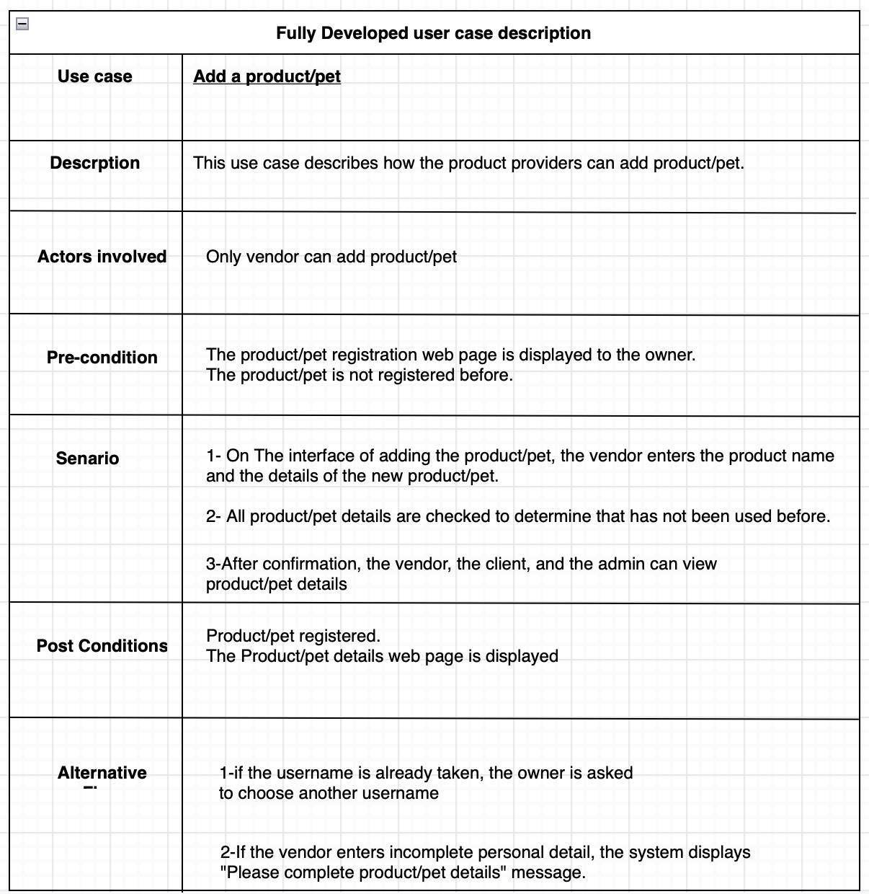

Duaa(2

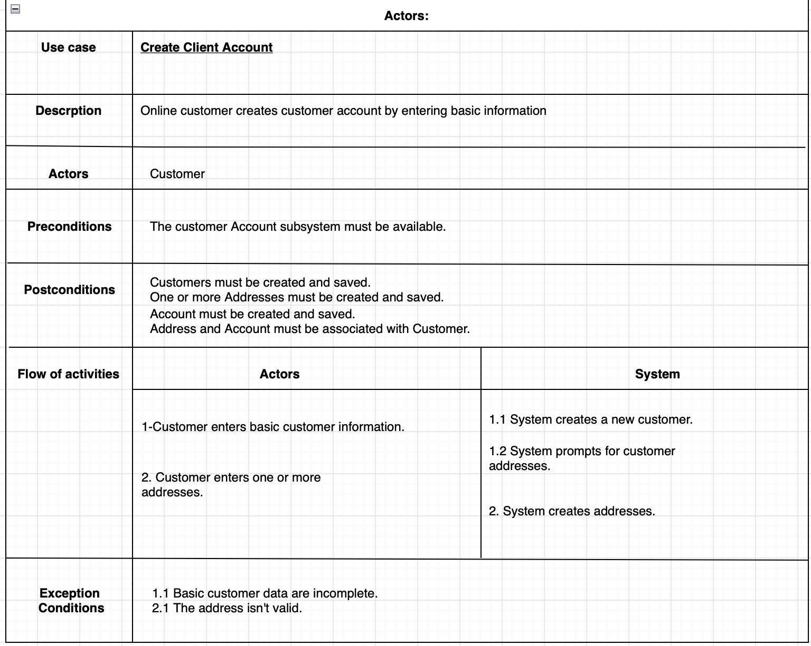

Aseel (3

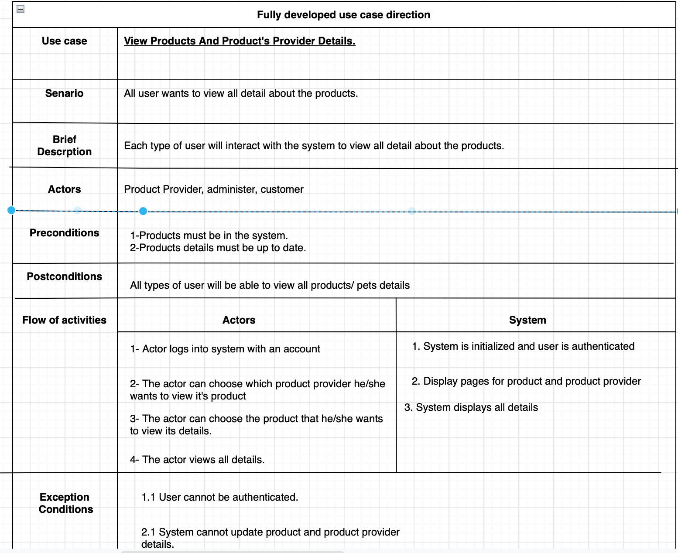

4) Muthana

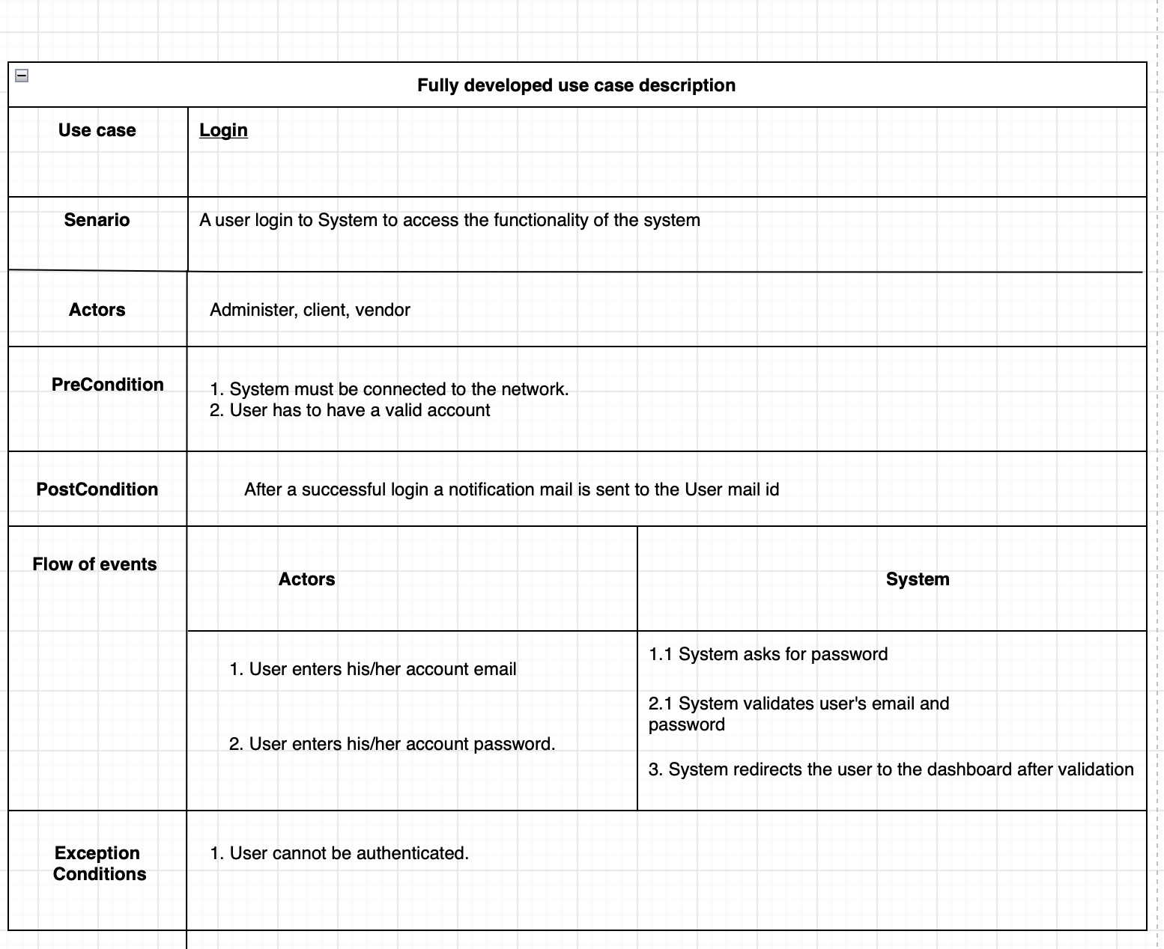

5) Activity Diagram :

1) Yara

2) Duaa

3) Aseel

4) Muthana

6) System Sequence diagram :

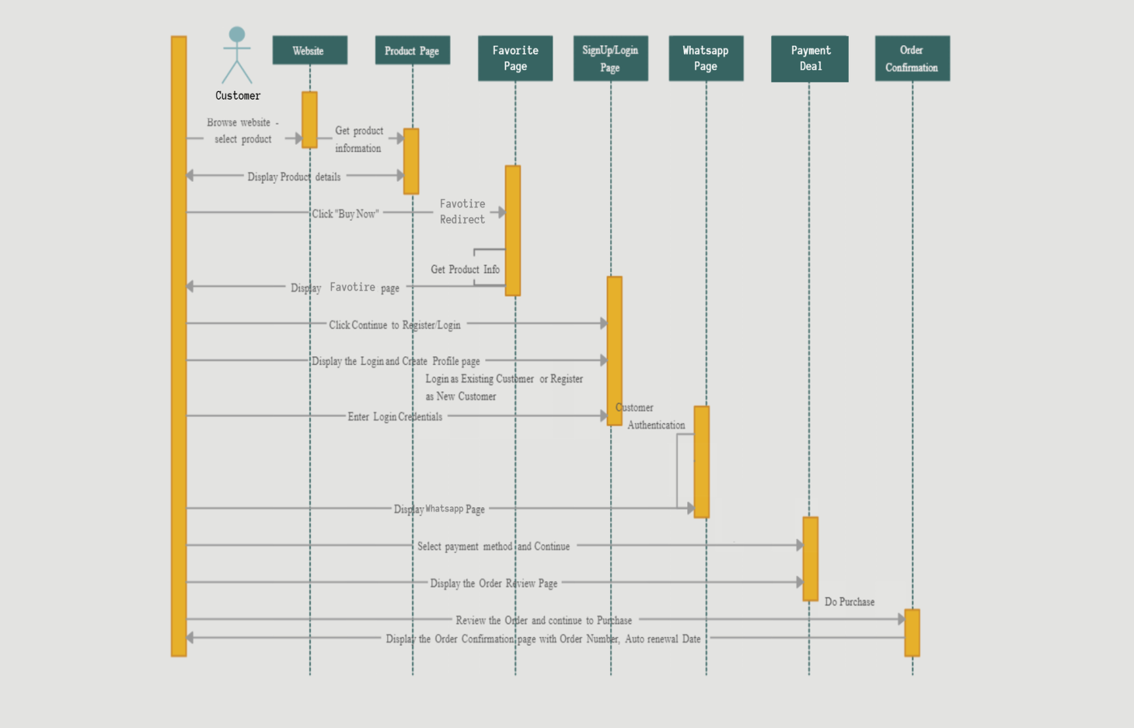

7) State Machine Digram :

1) Yara

2) Duaa

3) Aseel

4) Muthana

8) Network Diagram :

9) Dialog Design And GUI interface :

1) Yara :

The login page :

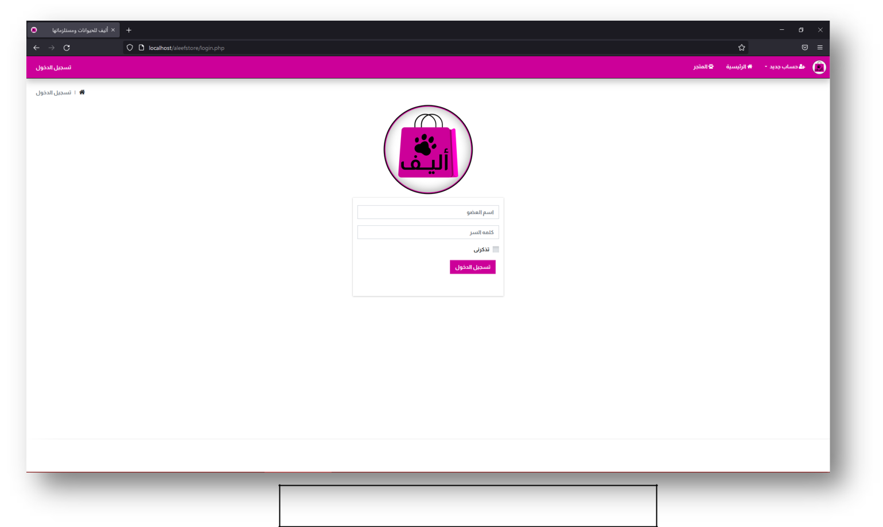

2) Duaa :

The client registration :

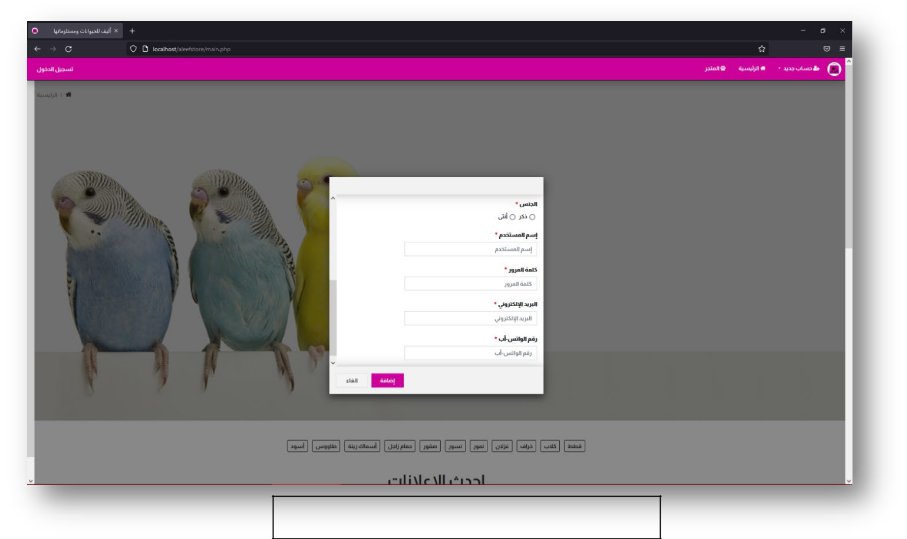

3) Aseel

The register buttons in the main page :

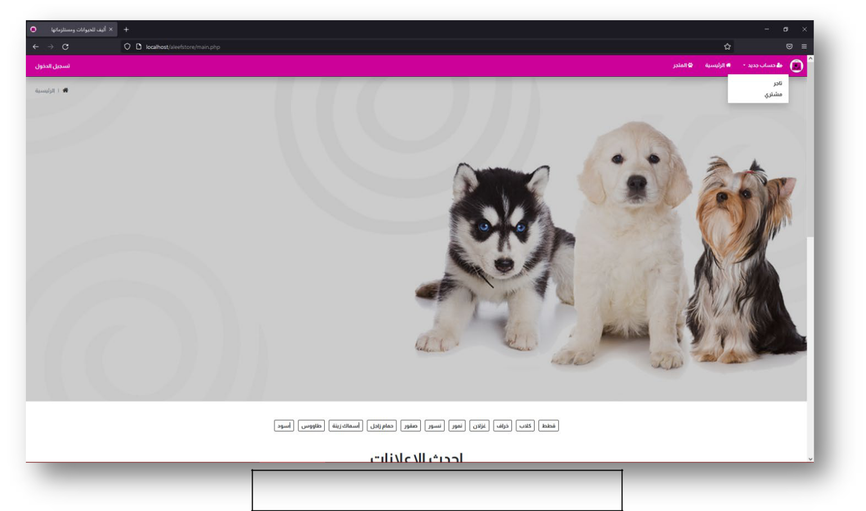

4) Muthana :

The vendor registration :

