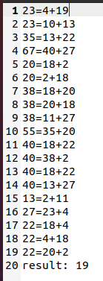

How to run:

1. make
2. ./submission input.txt output.txt

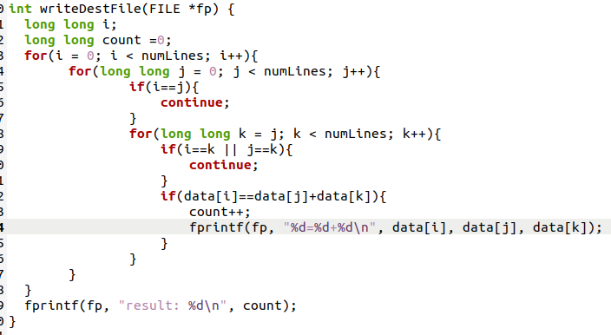

The first for loop is to find which number can be the summation of other two numbers. The second for loop is to find the first number; the third for loop is to find the second number. If any two of these three numbers are the same, skip the current loop.