Table of Contents
Web Scraping Case Study 1
Example 1: Extracting Rows of Content 1
Example 2: Custom Parsing 3
Example 3: Cleaning Up Our Output 5
Example 4: Clicking and Sending Key 8
Sending Keys 8
Example 5: Sending Keys 9
Reading From CSV Files 10
Connecting to Databases 11
Creating a Database Table with a DataFrame 12
Viewing Your Data 13
Reading and Writing to an Excel File 15

Submission Instructions:
10% will be deducted each day this document is late. Please do not submit pdf documents and do not zip your documents.

Note:
You are encouraged to work with others, and you can discuss your solutions verbally as well but DO NOT SHARE COPIES of YOUR WORK ELECTONICALLY OR IN ANY OTHER FORM. Keep good karma with your career network and protect your reputation – do not plagiarize.

Web Scraping Case Study

Example 1: Extracting Rows of Content
Until now we have scraped neighbouring reviews and ratings separately, but we really should consider extracting all related content together to ensure our data attributes are properly related.

This example demonstrates how to extract table row-by-row for events that are hosted by the Vancouver Public Libraries. We will extract the event name, date, time and location from their site for each event. To do this, in Chrome navigate to https://vpl.bibliocommons.com/events/search/index

Then, using Selector Gadget identify only the rows which contain the event name, date, time and location so your highlighting is similar to the following.

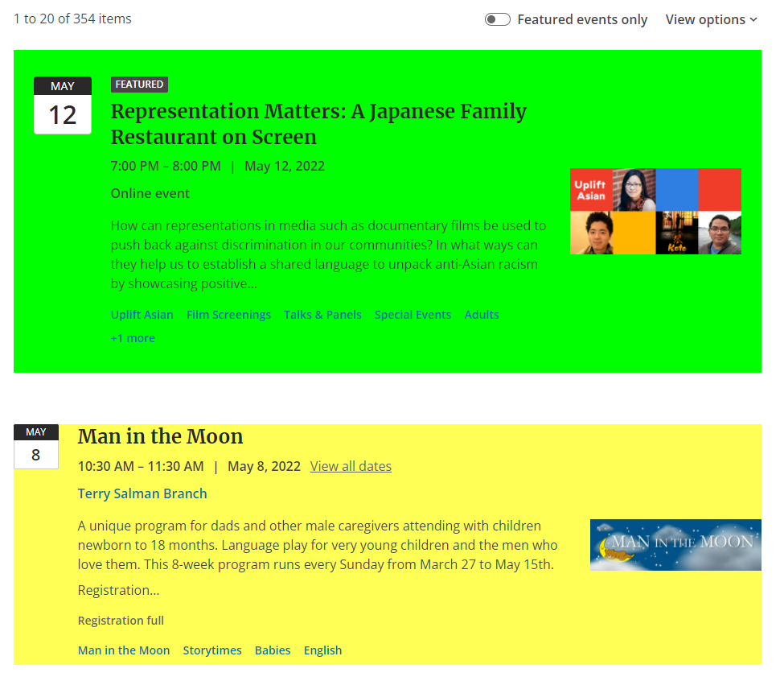
The CSS selector should appear as:
.event-details

Code:
import time
from selenium import webdriver
from selenium.webdriver.chrome.service import Service
from bs4 import BeautifulSoup
from selenium.webdriver.common.by import By

DRIVER_PATH = "/Python/ChromeDriver/chromedriver"
URL = "https://vpl.bibliocommons.com/events/search/index"

browser = webdriver.Chrome(service=Service(DRIVER_PATH))
browser.get(URL)

# Give the browser time to load all content.
time.sleep(3)

content = browser.find_elements(By.CSS_SELECTOR," .event-details")
for e in content:
start = e.get_attribute('innerHTML')
# Beautiful soup allows us to remove HTML tags from our content if it exists.
soup = BeautifulSoup(start, features="lxml")
print(soup.get_text())
print("***") # Go to new line.

Now try running our scraping code above. You should get the following output:
FeaturedRepresentation Matters: A Japanese Family Restaurant on ScreenFeatured Event. Representation Matters: A Japanese Family Restaurant on Screen7:00 PM – 8:00 PM7:00 PM to 8:00 PM | May 12, 2022on May 12, 2022Online eventHow can representations in media such as documentary films be used to push back against discrimination in our communities? In what ways can they help us to establish a shared language to unpack anti-Asian racism by showcasing positive…Uplift AsianFind more events in: Uplift AsianFilm ScreeningsFind more events in: Film ScreeningsTalks & PanelsFind more events in: Talks & PanelsSpecial EventsFind more events in: Special EventsAdultsFind more events in: Adults+1 more1 more categories, expands popover
***
Man in the MoonIn Progress10:30 AM – 11:30 AM10:30 AM to 11:30 AM | May 8, 2022on May 8, 2022Terry Salman BranchEvent location: Terry Salman BranchA unique program for dads and other male caregivers attending with children newborn to 18 months. Language play for very young children and the men who love them. This 8-week program runs every Sunday from March 27 to May 15th.
Registration…Registration fullMan in the MoonFind more events in: Man in the MoonStorytimesFind more events in: StorytimesBabiesFind more events in: BabiesEnglishFind more events in: English
***
Family Storytime11:00 AM – 11:30 AM11:00 AM to 11:30 AM | May 8, 2022on May 8, 2022View all datesView all dates for: Family StorytimeKitsilano BranchEvent location: Kitsilano BranchA program for parents and caregivers with young children. Songs,
rhymes and stories are shared. Suitable for children of all ages and
abilities to enjoy and learn together.
We are very excited to start offering in-library programs for…StorytimesFind more events in: StorytimesPreschool Age ChildrenFind more events in: Preschool Age ChildrenToddlersFind more events in: ToddlersEnglishFind more events in: English
***
There are some hidden characters in the output which causes unwanted new lines, tabs, and spaces. There might also be some hidden characters, special characters or unwanted lines and spaces. We need to be creative in the way that we extract our text.

Example 2: Custom Parsing
We want to remove the unwanted and hidden characters and we want to isolate each section of data in our output from Web Scraping Case Study

. If we are not careful though, we could end up stripping out all spaces. The final result may end up with allwordsthatarestucktogether.

To avoid this problem, we can create a string of content that is separated with a common delimiter. The delimited string can later be used to split the different sections of text into an array. We can then use indexes to access the desired portions of our array. To create this delimited string:

- First strip out the new line and tab characters.
- Remove all groupings of two or more consecutive spaces.
- Inspect your output after the changes and make custom changes with the replace() function.

This code performs the described tasks:

# Remove hidden characters for tabs and new lines.
rawString = re.sub(r"[\n\t]*", "", rawString)

# Replace two or more consecutive empty spaces with '*'.
rawString = re.sub('[ ]{2,}', '*', rawString)

# Replace old string with new string.
rawString.replace("Old String", "New String*")

To fully implement a revised solution, start with Web Scraping Case Study

and import the regular expression library.
import re

Then replace the for-loop Web Scraping Case Study

with this new version. The comments describe each section of code:
for e in content:
textContent = e.get_attribute('innerHTML')
# Beautiful soup removes HTML tags from our content if it exists.
soup = BeautifulSoup(textContent, features="lxml")
rawString = soup.get_text().strip()

# Remove hidden characters for tabs and new lines.
rawString = re.sub(r"[\n\t]*", "", rawString)

# Replace two or more consecutive empty spaces with '*'
rawString = re.sub('[ ]{2,}', '*', rawString)

# Fine tune the results so they can be parsed.
rawString = rawString.replace("In Progress", "")
rawString = rawString.replace("Online event", "*Online event*")
rawString = rawString.replace("location: ", "location*")
rawString = rawString.replace("BranchRhymes", "Branch*")
rawString = rawString.replace("Rhymes", "*")
rawString = rawString.replace("A ", "*")
rawString = rawString.replace("BranchCome", "Branch*")
print(rawString)
print("***")

The output shows a more easily manageable series of strings.
****
Man in the MoonIn Progress10:30 AM – 11:30 AM10:30 AM to 11:30 AM | May 8, 2022on May 8, 2022Terry Salman BranchEvent location: Terry Salman BranchA unique program for dads and other male caregivers attending with children newborn to 18 months. Language play for very young children and the men who love them. This 8-week program runs every Sunday from March 27 to May 15th. Registration…Registration fullMan in the MoonFind more events in: Man in the MoonStorytimesFind more events in: StorytimesBabiesFind more events in: BabiesEnglishFind more events in: English
****
Family Storytime11:00 AM – 11:30 AM11:00 AM to 11:30 AM | May 8, 2022on May 8, 2022View all datesView all dates for: Family StorytimeKitsilano BranchEvent location: Kitsilano BranchA program for parents and caregivers with young children. Songs, rhymes and stories are shared. Suitable for children of all ages and abilities to enjoy and learn together.We are very excited to start offering in-library programs for…StorytimesFind more events in: StorytimesPreschool Age ChildrenFind more events in: Preschool Age ChildrenToddlersFind more events in: ToddlersEnglishFind more events in: English
****
Family Storytime11:00 AM – 11:30 AM11:00 AM to 11:30 AM | May 8, 2022on May 8, 2022View all datesView all dates for: Family StorytimeMount Pleasant BranchEvent location: Mount Pleasant BranchA program for parents and caregivers with young children. Songs, rhymes and stories are shared. Suitable for children of all ages and abilities to enjoy and learn together. We are very excited to start offering in-library programs for…StorytimesFind more events in: StorytimesPreschool Age ChildrenFind more events in: Preschool Age ChildrenToddlersFind more events in: ToddlersEnglishFind more events in: English
****
Family Storytime11:30 AM – 12:00 PM11:30 AM to 12:00 PM | May 8, 2022on May 8, 2022View all datesView all dates for: Family StorytimeCentral LibraryEvent location: Central LibraryA program for parents and caregivers with young children. Songs, rhymes and stories are shared. Suitable for children of all ages and abilities to enjoy and learn together.*We are very excited to start offering in-library programs for…StorytimesFind more events in: StorytimesPreschool Age ChildrenFind more events in: Preschool Age ChildrenToddlersFind more events in: ToddlersEnglishFind more events in: English
****……

Example 3: Cleaning Up Our Output
Now that the scraped content is more manageable, we can format it. If you examine the output from Example you will notice that some of the data is repeated. Some sections may still not be ideal for parsing. For example, the event time is always directly located after event name (Family Storytime11:00 AM – 11:30 AM11:00 AM to 11:30 AM | May 8, 2022on May 8). In order to split them by using split() function, we need to add a delimitator between event name and event time. In addition, we also need to extract event date and time by using regular expressions.

# select the time (format:xx:xx AM or PM)
def selectEventTime(originalStr):
matchList=re.findall(r"((1[0-2]|0?[1-9]):([0-5][0-9]) ?([AaPp][Mm]))", originalStr)
time=matchList[0][0]+" - "+matchList[1][0]
return time
#select the date (format: May x, 2022)

def selectEventData(originalStr):
import re
matchList = re.findall(r"((Jan|Feb|Mar|Apr|May|Jun|Jul|Aug|Sep|Oct|Nov|Dec)(\.)?(\w*)?(\.)?(\s*\d{0,2}\s*),(\s*\d{4}))", originalStr)
date=matchList[0][0]
return date
The full code:
import re
import time
from selenium import webdriver
from selenium.webdriver.chrome.service import Service
from bs4 import BeautifulSoup
from selenium.webdriver.common.by import By

DRIVER_PATH = "/Python/ChromeDriver/chromedriver"
URL = "https://vpl.bibliocommons.com/events/search/index"

browser = webdriver.Chrome(service=Service(DRIVER_PATH))
browser.get(URL)

# Give the browser time to load all content.
time.sleep(3)

content = browser.find_elements(by=By.CSS_SELECTOR, value=".event-details")

# insert a "*" in front of the first digital number
def insertDelimiter(originalStr):
index=re.search(r'\d+', originalStr).start()
newStr=originalStr[:index]+"*"+originalStr[index:]
return newStr
# select the time (format:xx:xx AM or PM)
def selectEventTime(originalStr):
matchList=re.findall(r"((1[0-2]|0?[1-9]):([0-5][0-9]) ?([AaPp][Mm]))", originalStr)
time=matchList[0][0]+" - "+matchList[1][0]
return time
#select the date (format: May x, 2022)
def selectEventData(originalStr):
import re
matchList = re.findall(r"((Jan|Feb|Mar|Apr|May|Jun|Jul|Aug|Sep|Oct|Nov|Dec)(\.)?(\w*)?(\.)?(\s*\d{0,2}\s*),(\s*\d{4}))", originalStr)
date=matchList[0][0]
return date

def catchKey(eventList, key):
for i in eventList:
#print(i)
if i == key:
value = "True"
break
else:
value = "False"
return value
# clean data for extracting date
def cleanStringData(originalStr):
rawString=originalStr
# Remove hidden characters for tabs and new lines.
rawString = re.sub(r"[\n\t]*", "", rawString)
# Replace two or more consecutive empty spaces with '*'
rawString = re.sub('[ ]{2,}', '*', rawString)
# Insert a delimiter before time
rawString = rawString.replace("Event location: ", "*Event location*")
rawString = rawString.replace("BranchRhymes", "Branch*")
rawString = rawString.replace("Rhymes", "*")
rawString = rawString.replace("A ", "*")
rawString = rawString.replace("BranchCome", "Branch*")
rawString = rawString.replace("Branch", "Branch*")
rawString = rawString.replace("Hastings", "*Hastings")
rawString = rawString.replace("LibraryDrop","Library*")
rawString = rawString.replace("BranchJoin", "Branch*")
rawString = rawString.replace("Central Library", "Central Library*")
rawString = rawString.replace("Renfrew BranchLearn", "Renfrew Branch*")
rawString = rawString.replace("All day", "12:00 AM – 12:00 PM*")
rawString = rawString.replace("Online event", "*Online event*")
rawString = rawString.replace("Featured", "")
return rawString
for e in content:
textContent = e.get_attribute('innerHTML')
# Beautiful soup removes HTML tags from our content if it exists.
soup = BeautifulSoup(textContent, features="lxml")
rawString = soup.get_text()

# Remove hidden characters for tabs and new lines.
rawString = re.sub(r"[\n\t]*", "", rawString)

# Replace two or more consecutive empty spaces with '*'
rawString = re.sub('[ ]{2,}', '*', rawString)
# Insert a delimiter before time
print("Raw String")
print(rawString)
cleanRawString = cleanStringData(rawString)

cleanRawString=insertDelimiter(cleanRawString)
print("Raw String After Clean\n",cleanRawString)
eventArray = cleanRawString.split('*')
print("Event List\n",eventArray)
EVENT_NAME = 0
value = catchKey(eventArray,"Online event")
print(value)
if value == "True":
location = "Online"
elif value == "False":
EVENT_LOCATION = 4
location = eventArray[EVENT_LOCATION]
eventTime=selectEventTime(cleanRawString)
eventDate=selectEventData(cleanRawString)

eventName=eventArray[EVENT_NAME]
eventLocation=location

print("Event Name: ", eventName)
print("Event Date: ", eventDate)
print("Event Time: ", eventTime)
print("Event Location: ",eventLocation)

print("***") # Go to new line.

You can get the following output:
Raw String
LEGO® Block Party*3:30 PM – 4:30 PM3:30 PM to 4:30 PM | May 9, 2022on May 9, 2022View all datesView all dates for: LEGO® Block PartyKitsilano BranchEvent location*Kitsilano Branch* to the library for some LEGO® building fun at this block party! Connect with other kids and break out the bricks for a building bonanza at the library. For Grades K-7.We are very excited to start offering in-library programs for…Activities & GamesFind more events in: Activities & GamesSchool Age ChildrenFind more events in: School Age ChildrenEnglishFind more events in: English
Event List

['LEGO® Block Party', '3:30 PM – 4:30 PM3:30 PM to 4:30 PM | May 9, 2022on May 9, 2022View all datesView all dates for: LEGO® Block PartyKitsilano BranchEvent location', 'Kitsilano Branch', ' to the library for some LEGO® building fun at this block party! Connect with other kids and break out the bricks for a building bonanza at the library. For Grades K-7.We are very excited to start offering in-library programs for…Activities & GamesFind more events in: Activities & GamesSchool Age ChildrenFind more events in: School Age ChildrenEnglishFind more events in: English']
***
……

From one of the event lists above, we know the first item (green color highlight) in the array is the event name. The third item in the array contains the location. The Date and Time, we use the regular express to extract from rawstring.
When running the code now we are able to obtain our desired output:
Event Name: Family Board Games
Event Date: May 8, 2022
Event Time: 2:00 PM - 4:00 PM
Event Location: Central Library
***
Event Name: Babytime
Event Date: May 9, 2022
Event Time: 10:00 AM - 10:30 AM
Event Location: Terry Salman Branch
******……

Example 4: Clicking and Sending Key

Sending Keys

It is possible to send keys to input boxes. To automate a search for a specific topic on the AnimalFactGuide website we could find the search textbox with the CSS selector and use Selenium’s send_keys() function to input the word “Zebras”.

# Find the search input.
search = browser.find_element(By.CSS_SELECTOR,"#s")
search.send_keys("Zebra")

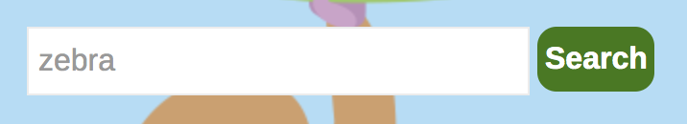

After sending keys we can then click the button to trigger the search:

# Find the search button - this is only enabled when a search query is entered
button = browser.find_element(By.CSS_SELECTOR,"#searchsubmit")
button.click() # Click the button.
Clicking on the search button brings up the search results which we can then scrape.

Here is the full program for scraping the headers after automatically searching on zebra at https://animalfactguide.com/links/" with Selenium.

Note: In this example I am searching on more than one item during each pass through the loop. You may want to do this too. When it is possible to isolate the data with a different selector, parsing is much easier in comparison to obtaining an entire row of mixed content like in the Vancouver Public Library example.
import time
from selenium import webdriver
from selenium.webdriver.chrome.service import Service
from bs4 import BeautifulSoup
from selenium.webdriver.common.by import By

# driver = webdriver.Chrome(ChromeDriverManager().install())
DRIVER_PATH = "/Python/ChromeDriver/chromedriver"
URL = "https://animalfactguide.com/links/"

browser = webdriver.Chrome(service=Service(DRIVER_PATH))
browser.get(URL)

time.sleep(3)

# Find the search input.
search = browser.find_element(By.CSS_SELECTOR,"#s")
search.send_keys("Zebra")

# Find the search button - this is only enabled when a search query is entered
button = browser.find_element(By.CSS_SELECTOR,"#searchsubmit")
button.click() # Click the button.

# Extracts text from scraped content.
def extractText(data):
text = data.get_attribute('innerHTML')
soup = BeautifulSoup(text, features="lxml")
content = soup.get_text()
return content

titles = browser.find_elements(By.CSS_SELECTOR,".entry-title a")
descriptions = browser.find_elements(By.CSS_SELECTOR,".entry-summary p")

titleList = []
descriptionList = []

for i in range(0, len(titles)):
# extract title and add to list.
title = extractText(titles[i])
titleList.append(title)

# extract description and add to list.
description = extractText(descriptions[i])
descriptionList.append(description)

# Show the content.
for i in range(0, len(descriptionList)):
print("\n********************")
print("Title: " + titleList[i])
print("Description: " + descriptionList[i])
The output is not in an ideal format but with further experimentation and manipulation we should be able to accurately extract the desired content:
********************
Title: PHOTOS: Baby Zebra at Taronga Western Plains Zoo
Description: …Magner. “Zina is staying close by her mother’s side at present but does enjoy a gallop around the paddock in the morning.” Photo by Taronga Western Plains Zoo. Photo by Taronga Western Plains Zoo. In the wild, plains zebras (or common zebras) inhabit the grasslands of eastern and southern Africa. To learn more about Zina, see the Taronga Western Plains Zoo website. To learn more about zebras, see our article, Plains Zebra…. Continue reading →
********************
Title: Grevy’s Zebra Born
Description: …g them a spot on the endangered species list. Add to that number one more as the Denver Zoo welcomes a baby male zebra. The baby, named Lakota, was born on November 27th. He is the third Grevy’s zebra to ever be born at the zoo. Grevy’s zebras differ from other zebras in their appearance. Gervy’s zebras have thinner stripes and white stomachs. They also have longer legs and larger, rounder ears. In the wild they are found in Kenya and Ethiopia. Fo… Continue reading →
…

Reading From CSV Files

As you may know already, reading from CSV files is easy with Python. CSV stands for comma separated file which means all column values in the file are separated with commas. If you open any valid CSV file with a text editor, you may see a header row which is optional and rows of data that follow. The values in each row of data will be aligned sequentially and they will be separated with a common delimiter. In this case shown in Figure 1, each value within the data row is separated with a comma. When viewing the CSV content in a spreadsheet application like Excel, the comma separated values are displayed in separate columns.

Figure 1: Raw View of a Comma Separated File
Raw Data View | Spreadsheet View
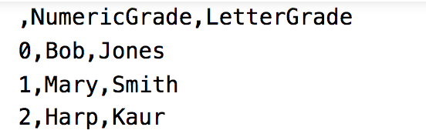 | 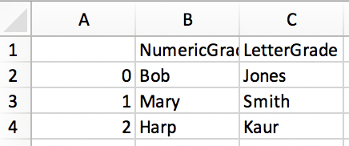

Example 5: CSV Files
This example demonstrates how to write DataFrame content to a CSV file with the to_csv() function. In this case, a tab separator, ‘\t’, is used as a delimiter but any character could be used. You may want to use a delimiter other than a default comma when your data has commas in it. Customizing the delimiter can avoid potentially misaligned rows and columns. Here is the code.

import pandas as pd
DRIVER_PATH = "/Users/pm/desktop/"
CSV_FILE = 'grades.csv'
dataset = { "NumericGrade":[99,98,84], "LetterGrade":['A+', 'A', 'B']}
dfOut = pd.DataFrame( data = dataset)

# Here I have decided to use a tab separator.
# The default separator is a comma which also could work.
dfOut.to_csv(DRIVER_PATH + CSV_FILE, sep='\t')

# Since I saved the file with a tab separator the instruction
# that reads the content must also use a tab separator.
dfIn = pd.read_csv(DRIVER_PATH + CSV_FILE, sep='\t')
print(dfIn.head(2))

Exercise 1 (1 mark)
Adjust the file path to a folder on your machine that you can find easily. Change the delimiter in Example 5: CSV Files
to ‘*’. Next, run the program and navigate to the location where the file is created. Open the file with a text editor such as Notepad, Notepad ++ or Visual Studio Code. Take a screenshot of the text editor with the data in it. Show your screenshot here:
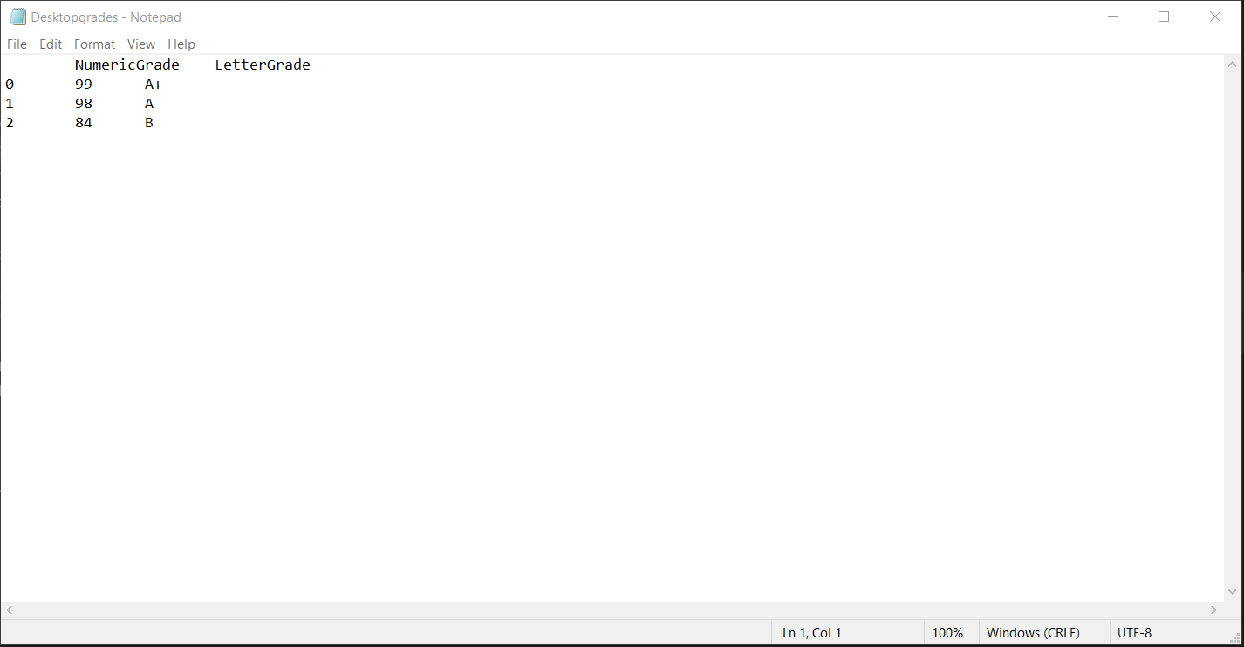

Exercise 2 (1 mark)
Change the separator in Example 5: CSV Files
to a comma. Run the program again and open the file in a spreadsheet application. Show a screenshot of the data in a spreadsheet application.
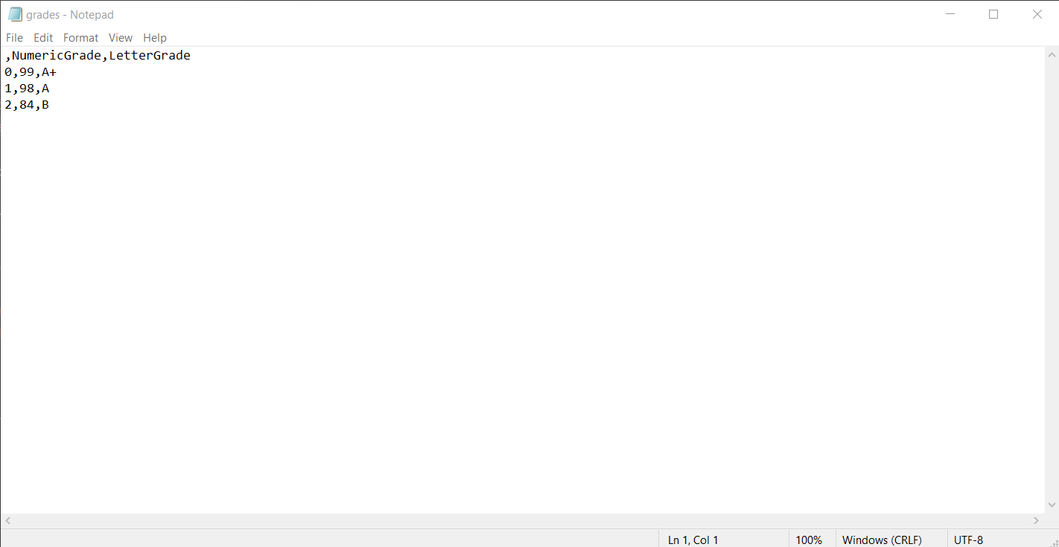

Connecting to Databases

In this section we will revisit working with SQL Alchemy but this time we will connect to a database.

Creating a Database Table with a DataFrame

The code needed to create a database table from a DataFrame is not much at all. A connection must first be created.

# Create the database at the specified path.
DB_FILE = 'forestFire.db'
engine = create_engine('sqlite:///' + PATH + DB_FILE, echo=False)
connection = engine.connect()

Then the table is created and given data by using the DataFrame instruction to_sql().

# Store data in database in a table named 'brazilForest'.
df.to_sql(name='table_name', con=connection, if_exists='replace', index=False)

Example 6: Creating a Database (Convert a DataFrame to DB)
This first example shows how to create a Sqlite database. In case you did not know this, Sqlite is a popular platform-independent database for mobile applications.

Before running this example be sure to update the file path to the location where your brazil_forestFires.csv file resides. You can find the brazil_forestFires.csv in the Data Sets folder on the learning hub.
import pandas as pd
from sqlalchemy import create_engine

# The data file path and file name need to be configured.
PATH = "C:\\datasets\\"
CSV_DATA = "brazil_forestFires.csv"

# Note this has a comma separator.
df = pd.read_csv(PATH + CSV_DATA, skiprows=1, encoding = "ISO-8859-1", sep=',',
names=('year', 'state', 'month', 'number','date', ))
print(df.tail(2))

# Create the database at the specified path.
DB_FILE = 'forestFire.db'
engine = create_engine('sqlite:///' + PATH + DB_FILE, echo=False)
connection = engine.connect()

# Store data in database in a table named 'brazilForest'.
df.to_sql(name='brazilForest', con=connection, if_exists='replace', index=False)

When finished, you will notice a Sqlite file has been created in the folder where your data set exists on your machine.
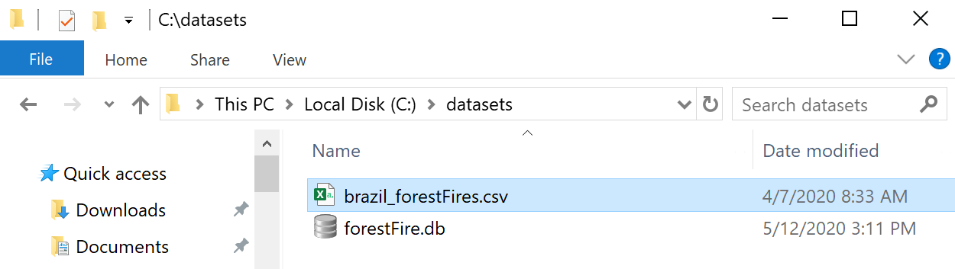

Viewing Your Data

To inspect the database, download DB Brower for Sqlite from https://sqlitebrowser.org/. Then navigate to your file and browse the data.

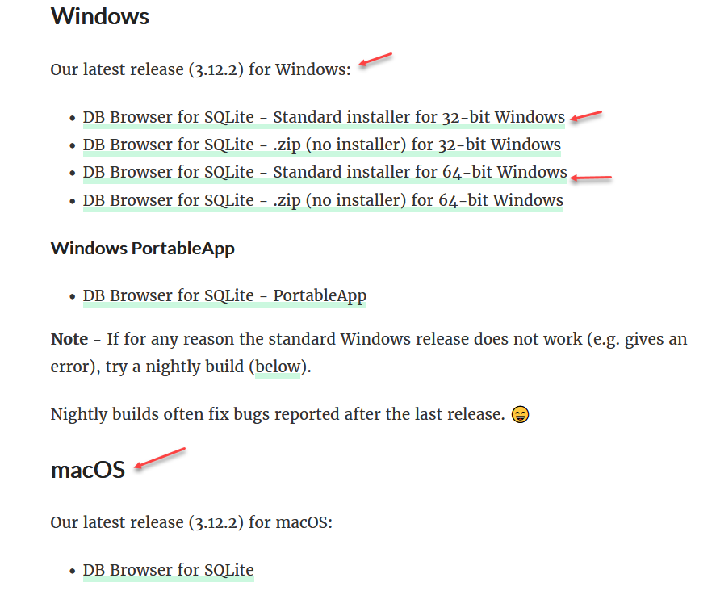
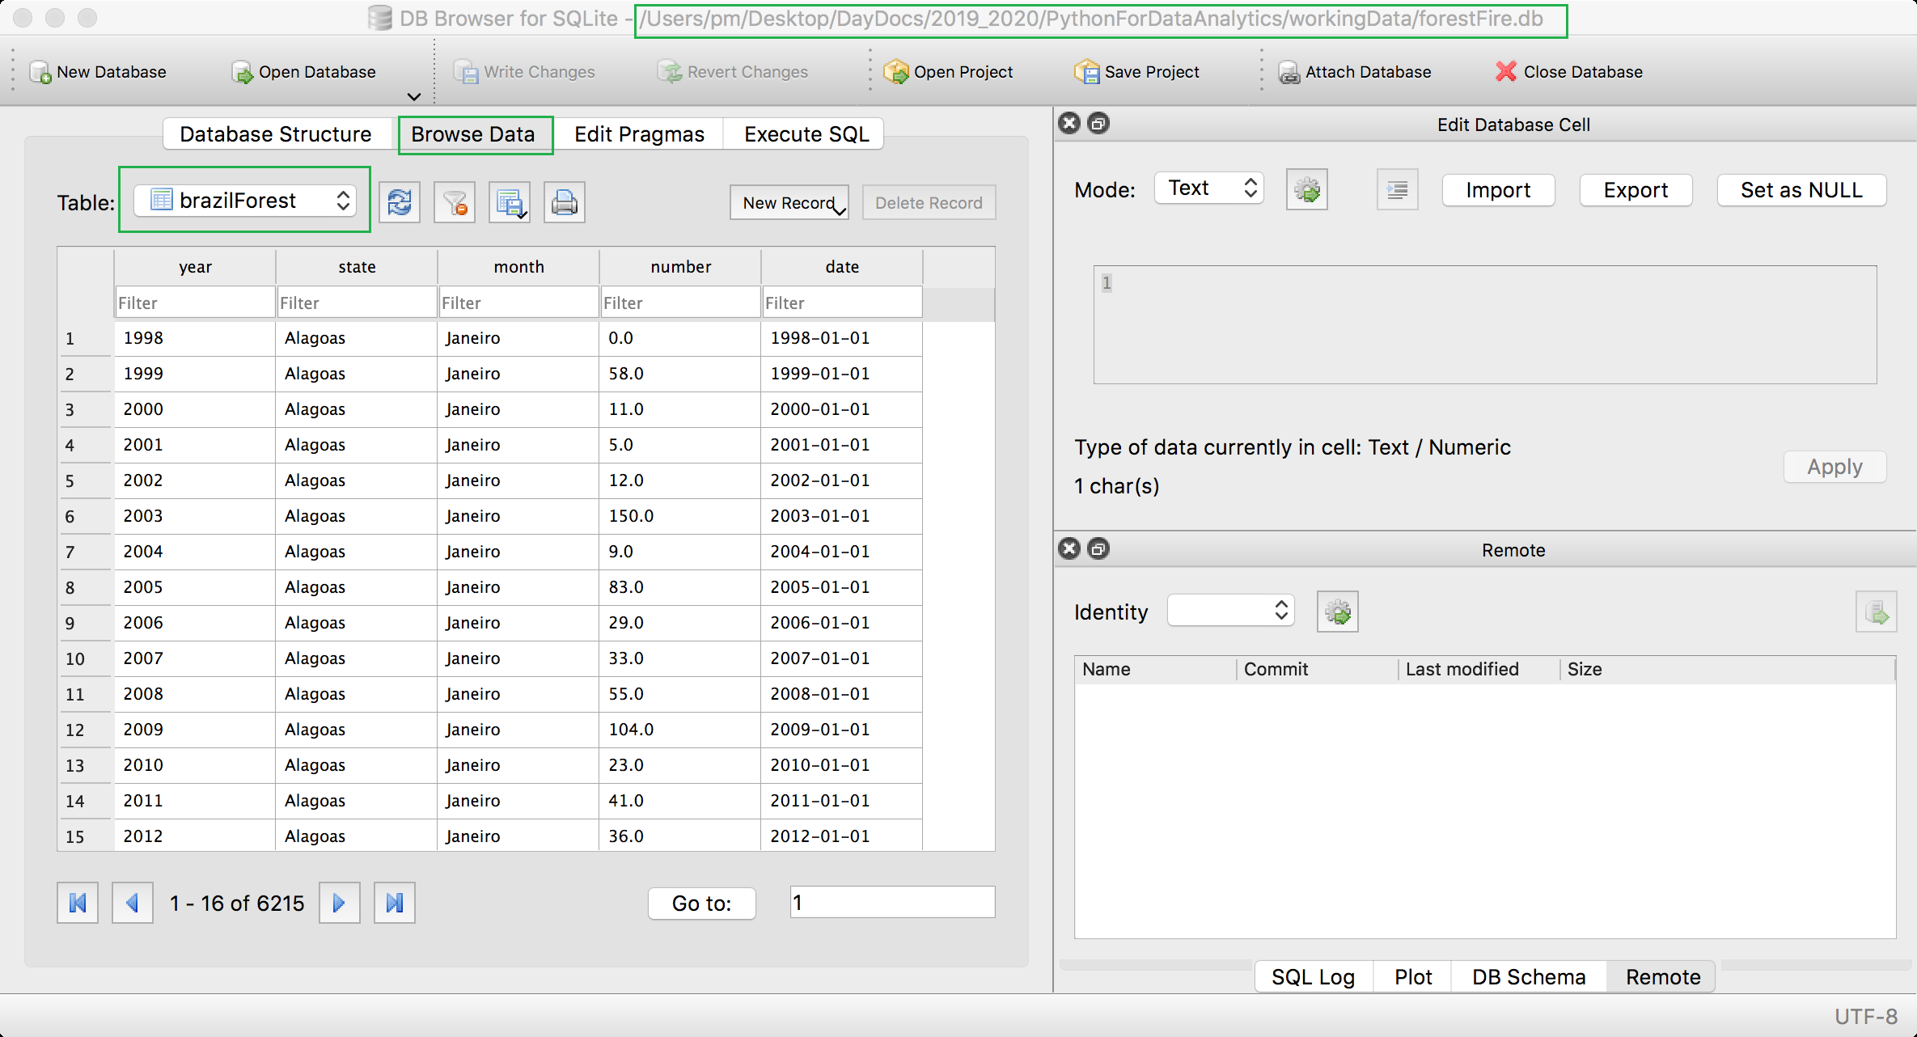

Exercise 3 (2 marks)
Download the ramenReviews.db file from the Data Sets folder. View the Review table in DB Browser for Sqlite. Show a screenshot of the Sqlite window while browsing the Review data here:
I am not allowed to install the ramenRe because I don’t own this computer is from an organization and I don’t have the credentials of an administrator. But I was able to have access to the db file online please see screenshots
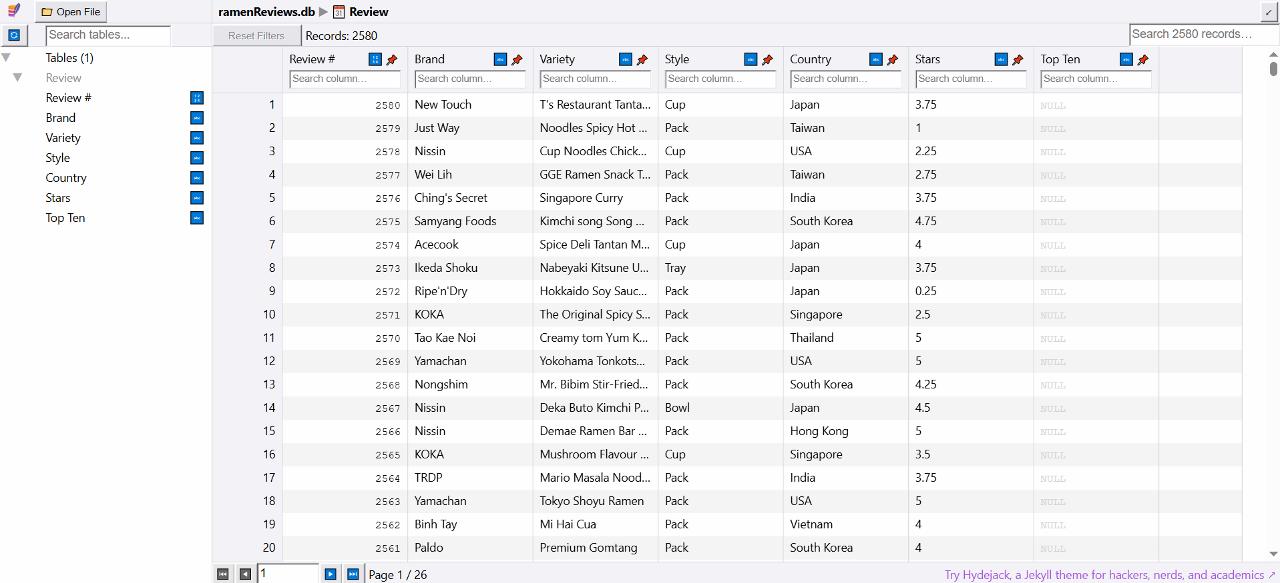

Example 7: Reading from a SQlite Database
This example demonstrates how to read from a Sqlite database into a database frame. To build this example, add this code to the end of Example 6.
# Placed query in this function to enable code re-usuability.
def showQueryResult(sql, dbconnection):
print("\n*** Showing SQL statement")
print(sql)
# Perform query
subDf = pd.read_sql(sql, dbconnection)
print("\n*** Showing dataframe summary")
return subDf

# Get DataFrame contents for 'Rio' and 'Sao Paulo' only.
sql = "SELECT * FROM " + "brazilForest" \
+ " WHERE state = 'Rio' OR state='Sao Paulo' " \
+ " ORDER BY date"

newDf = showQueryResult(sql, connection)
print(newDf.tail())

The output verifies that the query was able to obtain data from the database:
*** Showing SQL statement
SELECT * FROM brazilForest WHERE state = 'Rio' OR state='Sao Paulo' ORDER BY date

*** Showing dataframe summary
year state month number date
951 2017 Sao Paulo Julho 802.000 2017-01-01
952 2017 Sao Paulo Agosto 981.000 2017-01-01
953 2017 Sao Paulo Setembro 2.868 2017-01-01
954 2017 Sao Paulo Outubro 179.000 2017-01-01
955 2017 Sao Paulo Novembro 37.000 2017-01-01

Exercise 4 (1 mark)
- In Example 7, is the scope of the dbconnection variable local or global?
local

- In Example 7, is the scope of the connection variable local or global?
global

Exercise 5 (4 marks)
Adjust the code from Example 7 to select all rows from Review table of the ramenReviews.db database. Remember to set the table name in the Example 6 code to Review. (See the pink highlight). Show your code here (no screenshots please).
import pandas as pd
from sqlalchemy import create_engine
# Placed query in this function to enable code re-usuability.
def showQueryResult(sql, dbconnection):
print("\n*** Showing SQL statement")
print(sql)
# Perform query
subDf = pd.read_sql(sql, dbconnection)
print("\n*** Showing dataframe summary")
return subDf
pd.set_option('display.max_columns',None)
pd.set_option('display.width', 1000)
DB_FILE = 'ramenReviews.db'
PATH = '../../'
engine = create_engine('sqlite:///' + PATH + DB_FILE, echo=False)
connection = engine.connect()
sql = "SELECT * FROM " + "Review"
newDf = showQueryResult(sql, connection)
print(newDf)

Show a screenshot of the output in your Python editor when running your code here:
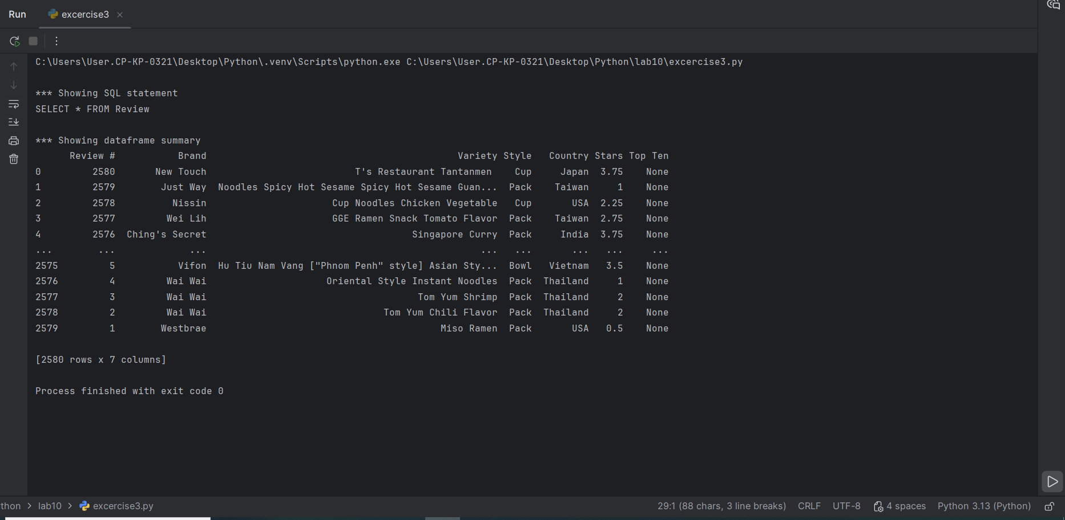

Reading and Writing to an Excel File

Python and Pandas data frames make it really simple to read and write to and from data frames.

Example 8: Reading from and to Excel
This example demonstrates how to read from an Excel document into a dataframe. Then it shows how to write from a data frame back into the Excel document. First, the following packages must be installed in either the Spyder console or in the PyCharm terminal:

pip install xlrd
pip install openpyxl

import openpyxl
import pandas as pd

PATH = "C:\\datasets\\"
FILE_NAME = "Tides.xlsx"
df = pd.read_excel(PATH + FILE_NAME, sheet_name='Sheet1')
df.to_excel(PATH + "NewFile.xlsx", sheet_name='Sheet1')
print (df)

When finished running the code, a new excel document is created in the path specified:
