Table of Contents
SQLAlchemy 1
Filtering (WHERE clause) 2
Sorting 3
Descending Sort 3
Sorting on Multiple Columns 4
Filtering on a List of Values 4
IS NULL / IS NOT NULL 4
Selecting Unique Rows 5
Alias Columns 5
Arithmetic Operators (+ - * / ) 6
LIKE 6
Aggregate (Summary) Functions 7
Including Detail with Summaries 8
Filtering Summary Queries 8
Web Scraping 9
Selenium 10
Selector Gadget 11
Selenium 12
BeautifulSoup 13
Sleep 13

Submission Instructions:
10% will be deducted each day this document is late. Please do not submit pdf documents and do not zip your documents.

Note:
You are encouraged to work with others, and you can discuss your solutions verbally as well but DO NOT SHARE COPIES of YOUR WORK ELECTONICALLY OR IN ANY OTHER FORM. Keep good karma with your career network and protect your reputation – do not plagiarize.

SQLAlchemy

SqlAlchemy provides an interface that allows you to query DataFrames with SQL as if the DataFrame is a database table.

Example 1: Retail SQL
To demonstrate different ways of querying the data run the following script to create an Inventory table and to display its contents.
import pandas as pd
from sqlalchemy import create_engine

# The data file path and file name need to be configured.
PATH = "/Users/pm/Desktop/DayDocs/data/"
CSV_DATA = "retailerDB.csv"
df = pd.read_csv(PATH + CSV_DATA)

# Placed query in this function to enable code re-usuability.
def showQueryResult(sql):
# This code creates an in-memory table called 'Inventory'.
engine = create_engine('sqlite://', echo=False)
connection = engine.connect()
df.to_sql(name='Inventory', con=connection, if_exists='replace', index=False)

# This code performs the query.
queryResult = pd.read_sql(sql, connection)
return queryResult

# Read all rows from the table.
SQL = "SELECT * FROM Inventory"
results = showQueryResult(SQL)
print(results)
The output from running this query is:
productID productName vendor quantity price stockDate
0 1 Wonder Bar Cadbury 11.0 1.11 2020-10-01
1 2 Too too Toucan Inc. 22.0 2.22 2020-10-02
2 3 Fork Silverware Inc. 44.0 4.44 2020-10-04
3 4 Fork Waterford Corp. 34.0 5.31 2020-10-04
4 5 Futon Sleep Country NaN 4.32 2020-10-05
5 6 Coffee Crisp Cadbury 9.0 1.32 2020-10-06

Exercise 1 (1 mark)
This question may seem trivial once you know how to do it but I am asking so you do not miss it. In Example 1, the DataFrame is referred to as Inventory. Then, the Inventory table is referred to in the SQL statement. However, we could have created a virtual table with any name. For this exercise, change the virtual table name from Inventory to RetailInventory in both places where it is referenced and verify that the code still works. Show your code here:
import pandas as pd
from sqlalchemy import create_engine
# The data file path and file name need to be configured.
PATH = "../../retailer_data.txt"
df = pd.read_csv(PATH,skiprows=1,sep=',', names=('productID','productName','vendor','quantity','price','stockDate'))
# Placed query in this function to enable code re-usuability.
def showQueryResult(sql):
# This code creates an in-memory table called 'Inventory'.
engine = create_engine('sqlite://', echo=False) #here you change if you have a real DataBase
connection = engine.connect()
df.to_sql(name='RetailInventory', con=connection, if_exists='replace', index=False)#this allow to act as a db because
#we dont have one in this case
# This code performs the query.
queryResult = pd.read_sql(sql, connection)
return queryResult
# Read all rows from the table.
SQL = "SELECT * FROM RetailInventory"
results = showQueryResult(SQL)
print(results)

Exercise 2 (2 marks)
Set a breakpoint inside the showQueryResult() function. With the debugger window open, while the program is halted, show a screenshot of the program from Example 1 while it is halted at the breakpoint. The value that is stored in the sql parameter must be visible in the debugger window. Show your screenshot here:
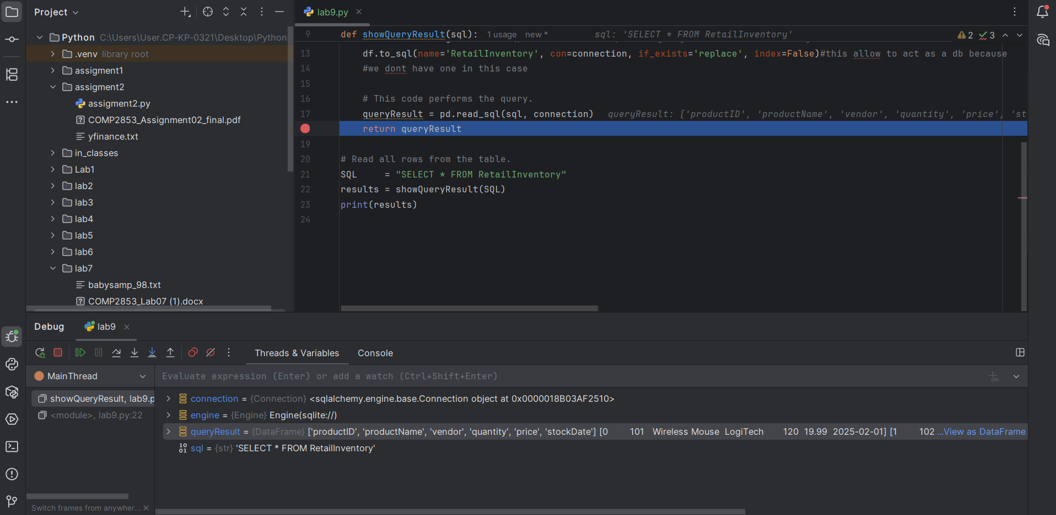

Filtering (WHERE clause)
WHERE classes allow us to select a subset of rows with conditional filtering.

Example 2: Filtering with a WHERE clause
To build this example. replace the SQL declaration in Example 1 with the following:
SQL = "SELECT * FROM Inventory WHERE vendor == 'Cadbury'"
The output is:
productID productName vendor quantity price stockDate
0 1 Wonder Bar Cadbury 11.0 1.11 2020-10-01
1 6 Coffee Crisp Cadbury 9.0 1.32 2020-10-06

Exercise 3: (1 mark)
Starting with Example 1, modify the SQL to select all rows from the DataFrame where the price is greater than or equal to 4. Show your SQL statement here:
SQL = "SELECT * FROM RetailInventory WHERE price>= 4"
results = showQueryResult(SQL)
print(results)

Show your output here:
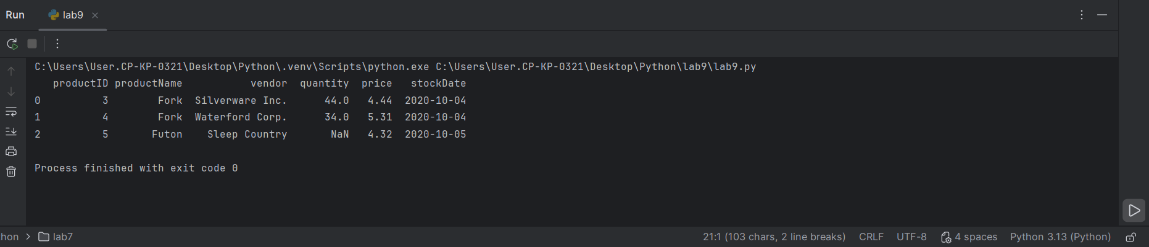

Sorting
The ORDER BY command beside an attribute forces the SELECT statement to retrieve data in a sorted sequence by the designated attribute. For example, the following query displays products sequenced according to their quantity in stock:
SQL = "SELECT productID, quantity, price FROM Inventory ORDER BY quantity"
The output is:
productID quantity price
0 5 NaN 4.32
1 6 9.0 1.32
2 1 11.0 1.11
3 2 22.0 2.22
4 4 34.0 5.31
5 3 44.0 4.44

Exercise 4 (1 mark)
Starting with Example 1, sort the DataFrame by productName. Show your SQL statement here:
SQL = "SELECT * FROM Inventory ORDER BY productName"

Show your output here:
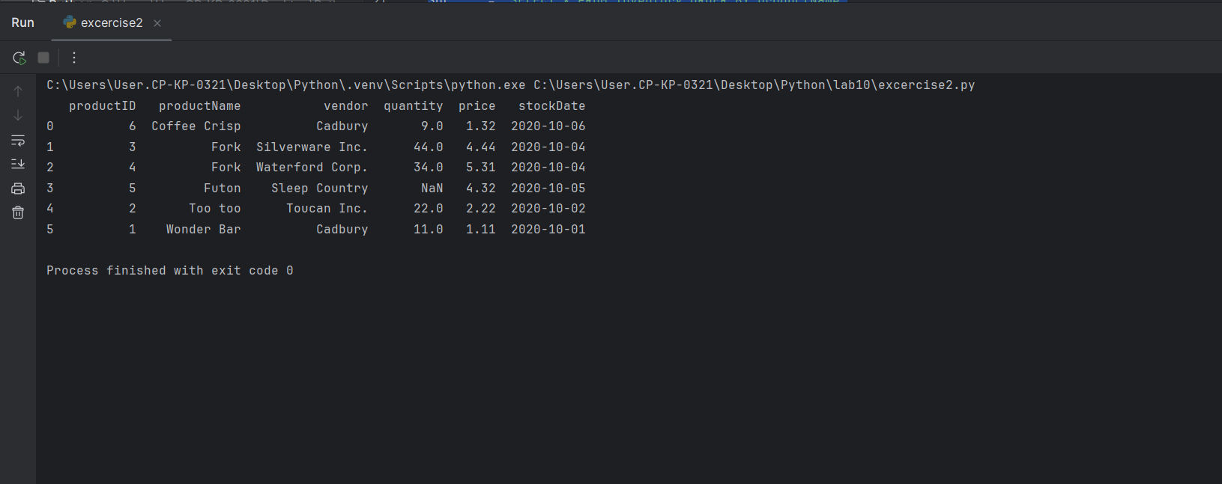

Descending Sort
To sort items in descending order, use the DESC clause after the sort column. The query;
SQL = "SELECT productID, quantity, price FROM Inventory ORDER BY quantity DESC"
Generates the output;
productID quantity price
0 3 44.0 4.44
1 4 34.0 5.31
2 2 22.0 2.22
3 1 11.0 1.11
4 6 9.0 1.32
5 5 NaN 4.32

Sorting on Multiple Columns
To group items, you can sort on one column and then another with a comma separated list of columns. The query below sorts by vendor and then by productName;
SQL = "SELECT productName, vendor, price FROM Inventory ORDER BY \
vendor, productName"
The output is;
productName vendor price
0 Coffee Crisp Cadbury 1.32
1 Wonder Bar Cadbury 1.11
2 Fork Silverware Inc. 4.44
3 Futon Sleep Country 4.32
4 Too too Toucan Inc. 2.22
5 Fork Waterford Corp. 5.31

Exercise 5 (1 mark)
Write a SELECT statement to select all items from the Inventory table and order the items by productName and then quantity. Show productName, vendor, quantity and price columns in your query:
SQL = "SELECT productName,vendor,quantity,price FROM RetailInventory ORDER BY productName,quantity"

Filtering on a List of Values
To filter a query against a list of values you may use the IN clause before the list:
SQL="SELECT DISTINCT productID, productName FROM Inventory WHERE productID IN(1, 3)"

The output is;
productID productName
0 1 Wonder Bar
1 3 Fork

Exercise 6 (1 mark)
Write a statement to retrieve all products except products that are sold by Cadbury and Waterford Corp. Use an IN statement.
SQL = "SELECT * FROM RetailInventory Where vendor NOT IN ('Cadbury', 'Waterford Corp.')"

IS NULL / IS NOT NULL
It is possible to check for NULL values in the WHERE clause. This statement only pulls records with empty values for the designated attribute.
SQL = "SELECT * FROM Inventory WHERE quantity IS NULL"
The output from running this statement is:
productID productName vendor quantity price stockDate
0 5 Futon Sleep Country None 4.32 2020-10-05

IS NOT NULL obviously retrieves items that only have values so;
SQL = "SELECT * FROM Inventory WHERE quantity IS NOT NULL"
retrieves;
productID productName vendor quantity price stockDate
0 1 Wonder Bar Cadbury 11.0 1.11 2020-10-01
1 2 Too too Toucan Inc. 22.0 2.22 2020-10-02
2 3 Fork Silverware Inc. 44.0 4.44 2020-10-04
3 4 Fork Waterford Corp. 34.0 5.31 2020-10-04
4 6 Coffee Crisp Cadbury 9.0 1.32 2020-10-06

Selecting Unique Rows
Distinct ensures that each row in the query is unique. For the following query;
SQL = "SELECT DISTINCT vendor FROM Inventory"
Cadbury only appears once:
vendor
0 Cadbury
1 Toucan Inc.
2 Silverware Inc.
3 Waterford Corp.
4 Sleep Country
Without DISTINCT in the following query;
SQL = "SELECT vendor FROM Inventory"
Cadbury would appear twice:
vendor
0 Cadbury
1 Toucan Inc.
2 Silverware Inc.
3 Waterford Corp.
4 Sleep Country
5 Cadbury

Alias Columns
When generating new information in a query you may assign a new name to your columns. The new name is called an alias.

Example 3: Alias
This example shows how to combine the productName and vendor to create a new alias column called ProductVendor: To build this example. replace the SQL declaration in Example 10 with the following:

SQL = "SELECT productName || '-' || vendor AS ProductVendor FROM Inventory"
The output is:
ProductVendor
0 Wonder Bar-Cadbury
1 Too too-Toucan Inc.
2 Fork-Silverware Inc.
3 Fork-Waterford Corp.
4 Futon-Sleep Country
5 Coffee Crisp-Cadbury

Arithmetic Operators (+ - * / )
You can perform mathematical operations (+-*/) in your select statements. Here is an example which calculates the dollar value of each product in stock. Notice that the total value is calculated during the query by multiplying quantity times price. A new column with the alias name total is generated to display the calculation result:
SQL = "SELECT quantity, price, quantity * price AS total FROM Inventory"
The output is:
quantity price total
0 11.0 1.11 12.21
1 22.0 2.22 48.84
2 44.0 4.44 195.36
3 34.0 5.31 180.54
4 NaN 4.32 NaN
5 9.0 1.32 11.88

Exercise 7 (1 mark)
Query the Inventory table to show the productName, price, and after tax price with an alias column named afterTaxPrice. Assume that the tax rate is 7%:
SQL = "SELECT productName,price, price+(price*0.07) AS afterTax FROM RetailInventory"

LIKE
The LIKE command is used to finding matching string patterns. The LIKE command is used in combination with regular expression symbols which are summarized in the following table;
% | Any string of zero or more characters
_ | Any single character
[ ] | Any single character within the specified range (for example, [a-f]) or set (for example, [abcdef])
[^] | Any single character not within the specified range (for example, [^a - f]) or set (for example, [^abcdef])

Here are some examples;
- LIKE 'Mc%' searches for all names that begin with the letters "Mc" (eg. McBadden).
- LIKE '%inger' searches for all names that end with the letters "inger" (eg. Ringer, Stringer).
- LIKE '%en%' searches for all names that have the letters "en" (eg. Bennet, Green, McBadden).
- LIKE '_heryl' searches for all six-letter names ending with the letters "heryl" (eg. Cheryl, Sheryl).
- LIKE '[CK]ars[eo]n' searches for Carsen, Karsen, Carson, and Karson (eg. Carson).
- LIKE '[M-Z]inger' searches for all names ending with the letters "inger" that begin with any single letter from M to Z (eg. Ringer).
- LIKE 'M[^c]%' searches for all names beginning with the letter M that don't have the letter c as the second letter (eg. MacFeather).

When used with the Inventory table, the query;
SQL = "SELECT * FROM Inventory WHERE productName LIKE '%on%'"
Retrieves productName values which have the substring ‘on’ in it;
productID productName vendor quantity price stockDate
0 1 Wonder Bar Cadbury 11.0 1.11 2020-10-01
1 5 Futon Sleep Country NaN 4.32 2020-10-05
Exercise 8 (1 mark)
Show the query needed to display vendor and productName values where the vendor name ends with ‘ry’:
SQL = "SELECT vendor,productName FROM RetailInventory WHERE vendor LIKE '%ry'"

Exercise 9 (1 mark)
Show the query needed to output productName values that begin with ‘F’:
SQL = "SELECT productName FROM RetailInventory WHERE productName LIKE 'F%'"

Aggregate (Summary) Functions
Aggregates are summaries. Here is a list of common aggregate functions that can be found in most database platforms:

Function Description
AVG Gets the average of numeric value.
COUNT Gets distinct count.
MAX Gets maximum value.
MIN Gets minimum value.
SUM Gets combined total,

Example 4: Summary Query
This example shows how a summary query could be used to calculate the dollar total value of inventory.
SQL = "SELECT SUM(quantity*price) AS InventoryValue FROM Inventory"
results = showQueryResult(SQL)
print(results.iloc[0]['InventoryValue'])
The output is:
448.83000000000004

Including Detail with Summaries
A challenge with summary queries is by default they only show the numeric summary values. If you need to detail you must include them in the GROUP BY clause.

Example 5: GROUP BY
For example, if you are trying to show the total number of product types stocked per vendor, you need to create a grouping column for vendor to include this column in the SELECT clause. If you add this code to the end of Example 10.
SQL = "SELECT vendor, COUNT(productName) AS TotalProductTypes FROM Inventory \
GROUP BY vendor"
results = showQueryResult(SQL)
print(results)
When the code is run, the following counts of total product types sold by vendor is displayed.
vendor TotalProductTypes
0 Cadbury 2
1 Silverware Inc. 1
2 Sleep Country 1
3 Toucan Inc. 1
4 Waterford Corp. 1

Exercise 10 (2 marks)
Write a statement to show the minimum price for each product. Note that a GROUP BY clause is needed to show productName. Also note that there are two types of forks in the inventory. Your output should appear as shown below with the productName in the output:
productName minPrice
0 Coffee Crisp 1.32
1 Fork 4.44
2 Futon 4.32
3 Too too 2.22
4 Wonder Bar 1.11
Show your code here:
SQL = "SELECT productName,MIN(price) AS minPrice FROM RetailInventory GROUP BY productName"

Filtering Summary Queries
A HAVING clause is needed to filter rows using columns that are contained a GROUP BY clause. A HAVING clause can contain summary or grouping columns.

Example 6: Filtering Summary Queries
Notice here that the query only retrieves vendors as long as at least twenty of their items are in stock:
SQL = "SELECT vendor, SUM(quantity) AS TotalItemsStocked FROM Inventory \
GROUP BY vendor HAVING SUM(quantity) > 20"
results = showQueryResult(SQL)
print(results)

The output from this is:
vendor TotalItemsStocked
0 Silverware Inc. 44.0
1 Toucan Inc. 22.0
2 Waterford Corp. 34.0

Exercise 11 (2 mark)
Write a summary query to display the total quantities of items stocked for Cadbury and Waterford Corp.. Your output should appear as:

vendor TotalItemsStocked
0 Cadbury 20.0
1 Waterford Corp. 34.0

SQL = "SELECT vendor, SUM(quantity) as TotalItemStock FROM RetailInventory GROUP BY vendor HAVING vendor='Cadbury' OR vendor='Waterford Corp.'"

Exercise 12 (2 marks)
Write a summary query which shows the total inventory revenue potential (price*quantity) for Silverware Inc. and Wateford Corp. only. The output should appear as:
vendor revenueValue
0 Silverware Inc. 195.36
1 Waterford Corp. 180.54
Show your code here:
SQL = "SELECT vendor, price*quantity AS revenueValue FROM RetailInventory GROUP BY vendor HAVING vendor='Silverware Inc.' OR vendor='Waterford Corp.'"

Web Scraping

This section offers a foundation in web scraping. Web scraping is the process of extracting content from web sites.

Note: Please be careful. Most sites will not permit public or commercial use of scraped content without permission. If you are making scraped data public or if you are using the data for competitive or commercial gain then please obtain approval from the provider.

Web scraping requires a creative approached to text parsing. Even experienced coders can struggle with the countless ways needed to extract real content from mountains of text. Getting comfortable parsing text takes practice. Parsing raw content will always be a continuous source of new and unique challenges. The experience gained though will definitely strengthen your coding skill. You have enough skill now to get started so I encourage you to practice.

Selenium

There are several ways to conduct web scraping with Python. I have chosen selenium for this course because it offers robust and simple mechanisms for scraping. Selenium is also a well-established and well-recognized framework in the developer community. You can easily find documentation for Selenium such as at:

https://selenium-python.readthedocs.io/locating-elements.html

To install Selenium and webdriver-manager run the following two commands in the IPython console of Spyder. You can also run these commands in the terminal window within PyCharm.
pip install selenium
pip install webdriver-manager

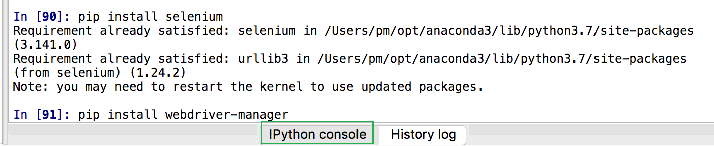
Note: if you can’t successfully install webdriver-manager, you need to install python and switch to python interpreter from Conda environment.
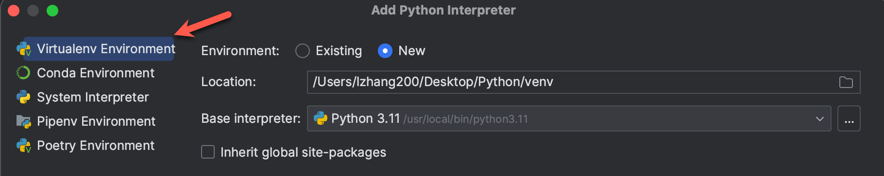

Example 7: Installing WebDriver
This example invokes an install of the ChromeDriver. You will need to have Chrome installed on your computer for this to work. To get ChromeDriver go to
https://chromedriver.chromium.org/ and get the latest stable build. Save it in a folder that you can find easily. Replace the path to chromedriver with the path that is displayed after the first run when the install occurs.
from selenium import webdriver
from webdriver_manager.chrome import ChromeDriverManager
from selenium.webdriver.chrome.service import Service
DRIVER_PATH = "/Python/ChromeDriver/chromedriver.exe"
browser = None

# This loads webdriver from the local machine if it exists.
try:
browser = webdriver.Chrome(service=Service(DRIVER_PATH))
print("The path to webdriver_manager was found.")

# If a webdriver not found error occurs it is then downloaded.
except:
print("webdriver not found. Update 'DRIVER_PATH' with file path in the download.")
browser = webdriver.Chrome(ChromeDriverManager().install())

When you run Example 7 a second time you will see the following output:

"The path to webdriver_manager was found."

Exercise 13 (1 mark)
Place the path to your chromedriver download here and keep it in a safe place. You will want to refer to it later:
"/Python/chromedriver.exe"

Selector Gadget
Selector Gadget is a Chrome plugin that allows us to easily obtain unique CSS selectors and XPath queries to extract targeted sections of a web site. Find the Selector Gadget plug-in for Chrome by Google and add it to your browser.

Example 8: Using Selector Gadget
Last day we used Python to perform sentiment analysis of movie reviews. Now let’s scrape some movie reviews. First, we can use Selector Gadget to help find a CSS selector to identify the desired movie text. In Chrome navigate to:

https://www.rottentomatoes.com/critics/source/268
Open Selector Gadget but selecting the plugin at the top right of your Chrome tab. Then place your cursor on some movie review text. The green and yellow colours identify all of the content that is selected. Currently we want to collect all the reviews from critics about Los Angeles Times. Click on the text in the Quote columns to select all the reviews.
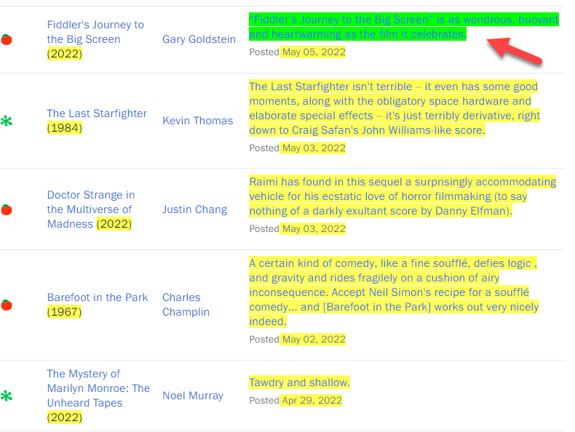
You should find that the years in Title| Year column (year) have been selected also. You can click the one of years in Title|Year column again to deselect the undesired text. The undesired text should then be highlighted in red to indicate that it will not be selected.
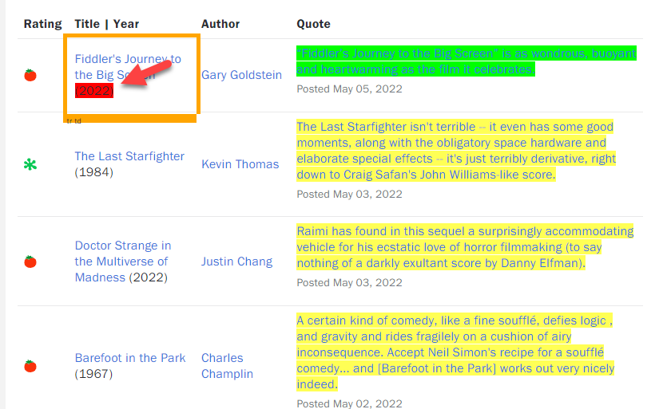

Now that we only have the “Quote” text highlighted we can obtain the CSS selector. You can copy the selector from the box provided by Selector Gadget at the bottom left of the browser window. I have also pasted the selector here:

.publication-link span

Selenium

We are going to start scraping soon. Selenium provides the following methods to locate a single element in a page. The two methods that we are going to use to locate the content identified by Selector Gadget are highlighted in green. Of course, you are welcome to experiment with the other methods as well.
find_element_by_id
find_element_by_name
find_element_by_xpath
find_element_by_link_text
find_element_by_partial_link_text
find_element_by_tag_name
find_element_by_class_name
find_element_by_css_selector->->find_element(By.CSS_SELECTOR)

To find multiple elements (these methods will return a list):
find_elements_by_name
find_elements_by_xpath
find_elements_by_link_text
find_elements_by_partial_link_text
find_elements_by_tag_name
find_elements_by_class_name
find_elements_by_css_selector->find_elements(By.CSS_SELECTOR)

For more information see:
https://selenium-python.readthedocs.io/locating-elements.html

BeautifulSoup
To simplify the parsing of our scraped content we will use BeautifulSoup to remove the HTML tags. BeautifulSoup reduces our workload considerably.

soup = BeautifulSoup(start, features="lxml")
print(soup.get_text())

Sleep

When we scrape with Selenium we are really extracting downloaded content that is delivered to our browser. To allow the browser enough time to load content before we scrape it we can use a sleep() function to pause the code.

# Sleep three seconds.
time.sleep(3)

Example 9: Scraping Rotten Tomatoes
Now that we have webdriver-manager from Example 7 and the CSS selector that we obtained in Example 8, we can scrape the data. This code extracts the actual reviews from RottenTomatoes.com:
import time
from selenium import webdriver
from selenium.webdriver.chrome.service import Service
from bs4 import BeautifulSoup
from selenium.webdriver.common.by import By

DRIVER_PATH = "/Python/ChromeDriver/chromedriver.exe"
URL = "https://www.rottentomatoes.com/critics/source/268"

browser = webdriver.Chrome(service=Service(DRIVER_PATH))
browser.get(URL)

# Give the browser time to load all content.
time.sleep(3)

content = browser.find_elements(By.CSS_SELECTOR, ".publication-link span")
for e in content:
start = e.get_attribute('innerHTML')
# Beautiful soup allows us to remove HTML tags from our content if it exists.
soup = BeautifulSoup(start, features="lxml")
print(soup.get_text())
print("***") # Go to new line.

Note: if you get following error:
", line 10, in <module>
browser = webdriver.Chrome(service=Service(DRIVER_PATH))
TypeError: __init__() got an unexpected keyword argument 'service'

Modify the green highlight to following:
browser = webdriver.Chrome(DRIVER_PATH)

The output shows all reviews that are currently on the page that we scraped:

***
“Fiddler’s Journey to the Big Screen” is as wondrous, buoyant and heartwarming as the film it celebrates.
***
The Last Starfighter isn't terrible -- it even has some good moments, along with the obligatory space hardware and elaborate special effects -- it's just terribly derivative, right down to Craig Safan's John Williams-like score.
***
……

Exercise 14 (2 marks)
In Chrome navigate to:
https://www.rottentomatoes.com/browse/tv_series_browse/sort:popular
See if you can figure out how to only scrape titles of Most Popular TV Show 2024. Show your code here:
from bs4 import BeautifulSoup
from selenium import webdriver
from selenium.webdriver.common.by import By
from webdriver_manager.chrome import ChromeDriverManager
from selenium.webdriver.chrome.service import Service
import time
DRIVER_PATH = "/Python/chromedriver.exe"
URL = "https://www.rottentomatoes.com/browse/tv_series_browse/sort:popular"
#'https://www.rottentomatoes.com/critics/source/268'
# This loads webdriver from the local machine if it exists.
try:
browser = webdriver.Chrome(service=Service(DRIVER_PATH))
browser.get(URL)
time.sleep(3)
# content = browser.find_elements(By.CSS_SELECTOR, ".publication-link span")
content = browser.find_elements(By.CSS_SELECTOR,".p--small")
for e in content:
start = e.get_attribute('innerHTML')
# Beautiful soup allows us to remove HTML tags from our content if it exists.
soup = BeautifulSoup(start, features="lxml")
print(soup.get_text())
print("***") # Go to new line.

Hint:
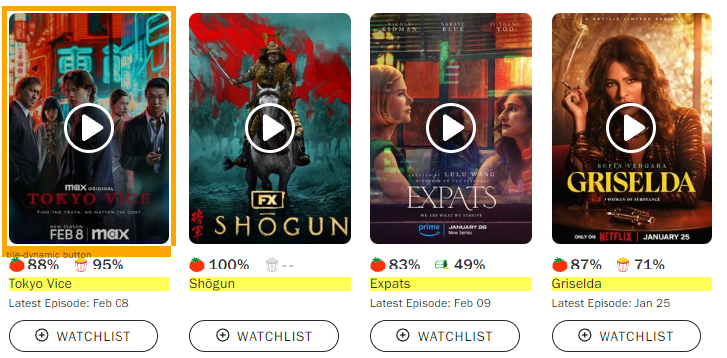

Exercise 15 (3 marks)
See if you can scrape the course names for the Applied Data Analytics Certificate. The URL is https://www.bcit.ca/study/programs/5512cert#courses
When you use Selector Gadget to obtain the content the values highlighted below will be selected.

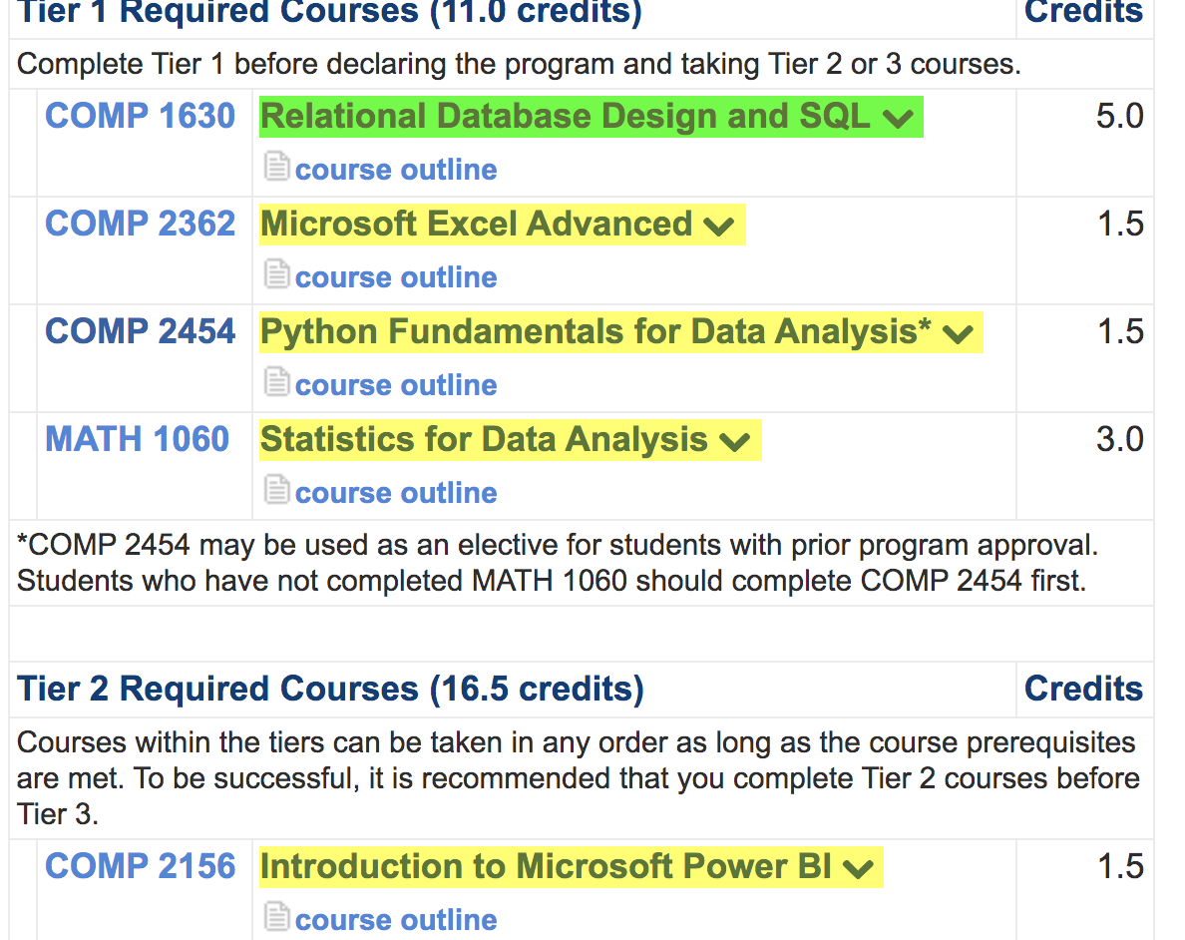

Show your CSS selector here:
.clicktoshow

Show your code here:
DRIVER_PATH = "/Python/chromedriver.exe"
URL = "https://www.bcit.ca/study/programs/5512cert#courses"
# "https://www.rottentomatoes.com/browse/tv_series_browse/sort:popular"
#'https://www.rottentomatoes.com/critics/source/268'
# This loads webdriver from the local machine if it exists.
try:
browser = webdriver.Chrome(service=Service(DRIVER_PATH))
browser.get(URL)
time.sleep(3)
# content = browser.find_elements(By.CSS_SELECTOR, ".publication-link span")
content = browser.find_elements(By.CSS_SELECTOR,".clicktoshow")
for e in content:
start = e.get_attribute('innerHTML')
# Beautiful soup allows us to remove HTML tags from our content if it exists.
soup = BeautifulSoup(start, features="lxml")
print(soup.get_text())
print("***") # Go to new line.

Show a screenshot of your output in the Python console window here:
