Table of Contents
Lists (Arrays) 1
Array (List) Methods 3
Dictionaries 4
DataFrames 4
Creating a DataFrame 4
Adding Columns to a DataFrame 5
Looping Through DataFrames 6
Appending a DataFrame to Another 7
Adding Rows to DataFrames 9
head () and tail() 10
dtypes 11
describe() 11
Extracting Column Subsets 14

Submission Instructions:
10% will be deducted each day this document is late. Please do not submit pdf documents and do not zip your documents.

Note:
You are encouraged to work with others, and you can discuss your solutions verbally as well but DO NOT SHARE COPIES of YOUR WORK ELECTONICALLY OR IN ANY OTHER FORM. Keep good karma with your career network and protect your reputation – do not plagiarize.

Lists (Arrays)
In addition to using constants and variables for storing and referencing data values you will need structures to manage larger data sets that store multiple values. One of the simplest structures for storing and accessing multiple data values is the array.

Arrays in Python are also called lists. Arrays store multiple values of the same data type. Each value within the array is stored inside an element of the array. Elements of the array are referenced sequentially with an index.

Most often arrays have only one dimension. This means each element of a single dimensional array is referenced with only one index. By default, the first element of a single dimensional array has a numeric index of 0. All elements that follow are referenced with an incremented index.

Figure 1 highlights the features of a typical single dimensional array structure.

Figure 1: Array Syntax
# Array declaration and initialization.
islands = ["Hawaii", "Maui", "Oahu"]

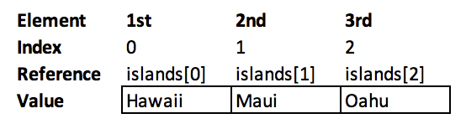

Example 1: Arrays
This example demonstrates two different ways to iterate through an array and print it. The first loop uses the len() function to obtain the count of the items in the array.

The second loop selects a single object if the array and prints it. The object is actually a string, so it is possible to print the element value directly in this case.
islands = ["Hawaii", "Maui", "Oahu"]
print("The array length is " + str(len(islands)) + ".")
for index in range(0, len(islands)):
print("index " + str(index) + ": " + islands[index])
print("\nHere is the list again.\n")
for island in islands:
print(island)
The output shows all array items using the two different loop types. Notice that array count starts at zero which is typical for all arrays in Python.
The array length is 3.
index 0: Hawaii
index 1: Maui
index 2: Oahu

Here is the list again.

Hawaii
Maui
Oahu

Exercise 1 (3 marks)
Create an array of five numbers including 1.3, 2.6, 8.9, 11.5 and 14.8. Then, similar to Example 1, show two different ways to loop through the array and print all of its values. Be sure to show the index for each element when looping through the index range. Remember also you will need to use the str() function to print the number. Show your program here:
numbers = [1.3,2.6,8.9,11.5,14.8]

for i in range(len(numbers)):
print(f“index {str(i)}- {str(numbers[i])}”)

for numbers in numbers:
print(numbers)

Array (List) Methods
Python lists are dynamic so they can be expanded to store more data and reduced to store less values. Table 1 shows methods for manipulating list content.

Table 1: Python List Methods
Method | Description
append() | Adds element to end of list.
clear() | Removes all items from the list.
copy() | Creates a copy of a list from an existing list.
extend() | Allows you to append a list to a list.
insert() | Allows you to insert an item into a list at a specific index.
pop() | Allows you to remove an item from a list by index.
sort() | Sorts the list.

Example 2: List Methods
def showFruitList(fruitList):
print("\n*** DISPLAYING ARRAY CONTENTS")
# Loop from 0 to 1 - length of array.
for i in range(len(fruitList)):
print(fruitList[i])
# Create array.
fruit = ["apples"]
# Add items to array.
fruit.append("pears")
fruit.insert(0, "plums")
# Show array contents.
showFruitList(fruit)
# Remove third element (counting starts at 0).
fruit.pop(2)
# Show array contents.
showFruitList(fruit)

The output shows that even though the list is declared with one element, it is possible to add or and remove elements:
*** DISPLAYING ARRAY CONTENTS
plums
apples
pears

*** DISPLAYING ARRAY CONTENTS
plums
apples

Exercise 2 (1 mark)
After all of the elements have been added to the list in Example 2, sort the list and show the output to verify that they have been sorted. Show your code here:
Fruit.sort()
Print(fruit)

Exercise 3 (1 mark)
Add bananas, dates, and peaches to the list in Example 2. Show your revised program here:
Fruit.append(“bananas”)
Fruit.append(“dates”)
Fruit.append(“peaches”)

Dictionaries

Dictionaries in Python are custom objects. These objects are comprised of key-value-pair combinations which are separated with a comma. You can access keys, values, and whole items by using the functions, .keys(), .values(), .items().

This sample shows a dictionary which has two properties. One property is named Market and the other is named Last.

{“Student ID":10234, "Student Name ": "Tom", "Grade": 90 }

Each dictionary makes one row of a DataFrame. The dictionary presented could be added to the end of a DataFrame as long as the DataFrame column names match the dictionary property names.

DataFrames
One of the most useful structures in data analysis, whether you are programming in R or Python is the DataFrame. A DataFrame organizes data into a table of rows and columns. Many functions exist to manipulate the DataFrame contents efficiently. For data analysts and the data modeling cycle this is really helpful.

Creating a DataFrame

Example 3: Creating a DataFrame
This example shows how to create a DataFrame. First a data set is created. Each property of the data set stores a List of values for a specific column of the table. The DataFrame object can then be initialized with the data set and column names. Note that the column names given must match the property names of the data set object.
import pandas as pd
# Create data set.
dataSet = {'First Name': ['Jonny','Holly','Nira'],
'Grade': [85,95,91] }
# Create dataframe with data set and named columns.
# Column names must match the dataSet properties.
df = pd.DataFrame(dataSet, columns= ['First Name', 'Grade'])
# Show DataFrame
print(df)

Printing the DataFrame contents shows the data in tabular form.
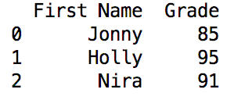

Exercise 4 (1 mark)
Given the full names of Jonny Staub, Nira Arora and Holly Conway modify the DataFrame declaration in Example 3 to include a Last Name column in addition to the original two columns. Adjust to program to declare the DataFrame with three columns and to assign data properly to all three columns. Test your code by printing the DataFrame object to ensure it works. Show your code here:
dataSet = {'First Name': ['Jonny','Holly','Nira'],'Last Name':['Stuab','Aurora','Conway'],
'Grade': [85,95,91]}
# Create dataframe with data set and named columns.
# Column names must match the dataSet properties.
df = pd.DataFrame(dataSet, columns= ['First Name', 'Grade'])
# Show DataFrame
print(df)

Adding Columns to a DataFrame
You can add columns to DataFrames after the DataFrame has been created. The syntax for adding a column to a DataFrame object is:

df['New Column Name'] = columnDataArray
Example 4: Adding Columns to DataFrames
This example shows the complete code needed to add a data column to an existing DataFrame.
import pandas as pd
# Create data set.
dataSet = {'Market': ['S&P 500', 'Dow', 'Nikkei'],
'Last': [2932.05, 26485.01, 21087.16] }
# Create dataframe with data set and named columns.
df = pd.DataFrame(dataSet, columns= ['Market', 'Last'])
# Show original DataFrame.
print("\n*** Original DataFrame ***")
print(df)
# Create change column.
change = [-21.51, -98.41, -453.83]
# Append change column.
df['Change'] = change
# Show revised DataFrame.
print("\n*** Adjusted DataFrame ***")
print (df)

The output shows the original data frame when it is first created and the DataFrame after a column has been added.
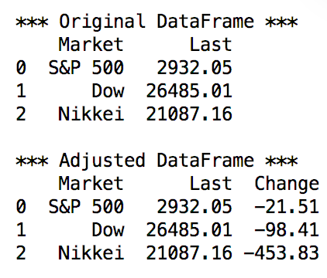

Exercise 5 (1 mark)
Adjust the DataFrame in Example 4 so it also includes a fourth column with the name Percentage Change. Add in the following values: S&P 500 -0.73, Dow -0.37, Nikkei -2.11. Display the three column DataFrame and then after add on the fourth column and display the DataFrame again. Show your revised program here.
percentage_change=['S&P 500 -0.73', 'Dow -0.37', 'Nikkei -2.11']
df['Percentage Change']= percentage_change
print("\n*** Adjusted DataFrame ***")
print (df)

Looping Through DataFrames
Individual cell values can be accessed with by specifying the row number and column name.
df.loc[rowNum]['Market'])

Example 5: Accessing Cell Values
This example shows how to access individual cell values of the Market column:
import pandas as pd
# Create data set.
dataSet = {'Market': ['S&P 500', 'Dow', 'Nikkei'],
'Last': [2932.05, 26485.01, 21087.16] }
# Create dataframe with data set and named columns.
df = pd.DataFrame(dataSet, columns= ['Market', 'Last'])
# Show original DataFrame.
print("\n*** Original DataFrame ***")
print(df)
# Add new line.
print("\n")
# Show names only
for i in range(len(df)):
print(df.loc[i]['Market'])

The output initially shows the original DataFrame as well as the individual Market names:
*** Original DataFrame ***
Market Last
0 S&P 500 2932.05
1 Dow 26485.01
2 Nikkei 21087.16

S&P 500
Dow
Nikkei

Exercise 6 (1 mark)
Modify Example 5 to show only cell values for Last. Show your code here.
dataSet = {'Market': ['S&P 500', 'Dow', 'Nikkei'],
'Last': [2932.05, 26485.01, 21087.16] }
# Create dataframe with data set and named columns.
df = pd.DataFrame(dataSet, columns= ['Market', 'Last'])
# Show original DataFrame.
print("\n*** Original DataFrame ***")
print(df)
# Add new line.
print("\n")
# Show names only
for i in range(len(df)):
print(df.loc[i]['Last'])

Exercise 7 (1 mark)
Modify Example 5 so only the first row of the DataFrame is printed. Do not use a loop. Show your code here.
print("Printing the first row")
print(df.loc[0])

Exercise 8 (1 mark)
Show the output of Exercise 7 here:
Printing the first row
Market S&P 500
Last 2932.05
Name: 0, dtype: object

Process finished with exit code 0

Appending a DataFrame to Another

Several functions exist for adding rows to a DataFrame. One way to add a row of data involves appending one DataFrame object to another. It is important to note that the column names of both DataFrame objects must match for the append() function to work.

df1 = df1.append(df2)

Example 6: Adding Rows to DataFrames
This example shows the complete code used to append one DataFrame to another.
import pandas as pd
# Create data set.
dataSet = {'Market': ['S&P 500', 'Dow', 'Nikkei'],
'Last': [2932.05, 26485.01, 21087.16] }
# Create dataframe with data set and named columns.
df1 = pd.DataFrame(dataSet, columns= ['Market', 'Last'])
# Show original DataFrame.
print("\n*** Original DataFrame ***")
print(df1)
dataSet2 = { 'Market': ['Hang Seng', 'DAX'],
'Last': [26918.58, 11872.44]}
df2 = pd.DataFrame(dataSet2, columns= ['Market', 'Last'])
df1 = df1.append(df2)
print("\n*** Adjusted DataFrame ***")
print(df1)
The output after adding the data is:
*** Original DataFrame ***
Market Last
0 S&P 500 2932.05
1 Dow 26485.01
2 Nikkei 21087.16

*** Adjusted DataFrame ***
Market Last
0 S&P 500 2932.05
1 Dow 26485.01
2 Nikkei 21087.16
0 Hang Seng 26918.58
1 DAX 11872.44

Exercise 9 (1 mark)

Starting with Example 6, declare a third DataFrame object and use it to add a row that contains a Last value of 7,407.06 for the FTSE100 market to the original DataFrame object. Show the contents of your DataFrame after adding this data set. All of the data from Example 9 and the new data should now appear in the new DataFrame. Show your revised program here:
dataSet3 = {'Market':['FTSE100'],'Last':[7407.06]}
df3 = pd.DataFrame(dataSet3,columns=['Market','Last'])
df1 = df1._append(df3)
print("\n*** Adjusted DataFrame ***")
print(df1)

Adding Rows to DataFrames

Example 7: Appending Dictionaries to DataFrames
This example shows how to create the dictionary and how to append a dictionary to the DataFrame:
import pandas as pd
# Create data set.
dataSet = {'Market': ['S&P 500', 'Dow', ],
'Last': [2932.05, 26485.01 ]}
# The dictionary is an object made of name value pairs.
stockDictionary = {'Market': 'Nikkei', 'Last': 21087.16 }
# Create dataframe with data set and named columns.
df = pd.DataFrame(dataSet, columns= ['Market', 'Last'])
# Show original DataFrame.
print("\n*** Original DataFrame ***")
df = df.append(stockDictionary, ignore_index=True)
print(df);
Note: FutureWarning: The frame.append method is deprecated and will be removed from pandas in a future version. Use pandas.concat instead.
df = df.append(stockDictionary, ignore_index=True)
Solution 1: function
import pandas as pd
def expendDictValues(dict,valueDictionary):
dictList=list(dict.keys())
for key in dictList:
dict[key].append(valueDictionary[key])
return dict
# Create data set.
dataSet = {'Market': ['S&P 500', 'Dow', ],
'Last': [2932.05, 26485.01 ]}
# The dictionary is an object made of name value pairs.
stockDictionary = {'Market': 'Nikkei', 'Last': 21087.16 }
# Create dataframe with data set and named columns.
df = pd.DataFrame(dataSet, columns= ['Market', 'Last'])
# Show original DataFrame.
print("\n*** Original DataFrame ***")
print(df)
# Show new DataFrame.
print("\n*** New DataFrame ***")
newDataSet=expendDictValues(dataSet,stockDictionary)
df = pd.DataFrame(newDataSet, columns= ['Market', 'Last'])
print(df)

Solution 2: concate
import pandas as pd
# Create data set.
dataSet = {'Market': ['S&P 500', 'Dow', ],
'Last': [2932.05, 26485.01 ]}
# The dictionary is an object made of name value pairs.
stockDictionary = {'Market': ['Nikkei'], 'Last': [21087.16] }
# Create dataframe with data set and named columns.
df = pd.DataFrame(dataSet, columns= ['Market', 'Last'])
dfAdd =pd.DataFrame(stockDictionary, columns=['Market', 'Last'])
# Show original DataFrame.
print("\n*** Original DataFrame ***")
df=pd.concat([df,dfAdd]).reset_index(drop=True)
print(df)

The output shows data after the row has been to the DataFrame object:
*** Original DataFrame ***
Market Last
0 S&P 500 2932.05
1 Dow 26485.01
2 Nikkei 21087.16

Exercise 10 (1 mark)

Starting with Example 7, create a dictionary that contains the DAX market and a Last value of 11872.44. Append this object to the DataFrame. Show your code here:
dict = {'Market':['DAX'],'Last':[11872.44]}
dict_df = pd.DataFrame(dict,columns =['Market','Last'])
print("Adjusted DataFrame")
df = pd.concat([df,dict_df]).reset_index(drop=True)
print(df)

head () and tail()

The head() and tail() functions of the DataFrame allow you to display the first and last columns of a DataFrame. These two functions are useful for a quick scan of contents of the DataFrame.

dtypes
The dtypes property allows you to determine the data type required for cells of a specific column.

describe()
The describe() function lets us quickly generate statistical summaries for the numerical columns of a data frame. Here we can observe count, mean, std, min, max and percentile.

Using include=['object'])) as a parameter in the describe() function allows you to obtain the count, number of unique values, top items, and frequency of the top items.

Example 8: Performing a Preliminary EDA
When we know the file contents we can write a script to read it. This code reads the data from a text file into a data frame. A whitespace delimiter is used and the columns assigned to the data table are identical to the ones that are displayed in the file.

The use of the head() and tail() methods in this example allow us to quickly observe all columns and the type of data that each contains. Here is some code that is used to read the data set and apply the DataFrame functions to display statistics about the sample.
import pandas as pd
# Import data into a DataFrame.
path = "/python/Datasets/babysamp-98.txt"
df = pd.read_table(path, skiprows=1,
delim_whitespace=True,
names=('MomAge', 'DadAge', 'MomEduc', 'MomMarital', 'numlive',
"dobmm", 'gestation', 'sex', 'weight', 'prenatalstart',
'orig.id', 'preemie'))
# Show all columns.
pd.set_option('display.max_columns', None)
# Increase number of columns that display on one line.
pd.set_option('display.width', 1000)
print("\n FIRST 2 ROWS") # Prints title with space before.
print(df.head(2))
print("\n LAST 2 ROWS")
print(df.tail(2))
# Show data types for each columns.
print("\n DATA TYPES") # Prints title with space before.
print(df.dtypes)
# Show statistical summaries for numeric columns.
print("\nSTATISTIC SUMMARIES for NUMERIC COLUMNS")
print(df.describe())
# Show summaries for objects like dates and strings.
print("\nSTATISTIC SUMMARIES for DATE and STRING COLUMNS")
print(df.describe(include=['object']))

When running the code from Example 8, the head() and tail() functions display a nicely formatted view of the file contents. Not only does the display offer a quick understanding of the file contents, but we can see that there are 200 rows in this sample.

print(df.head(2))
print(df.tail(2))

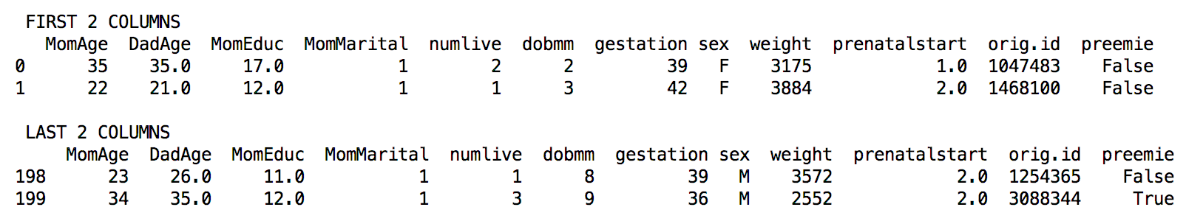

Printing the dtypes property provides a quick summary of the data types inside the file.

print(df.dtypes)

The dtypes display tells us about the data format for all variables. Integers are whole numbers. Floats are decimal point numbers. Objects can mean many things but, in this case, the term ‘object’ refers to storing alpha-numeric and special characters. A bool type only stores True or False values and nothing else.
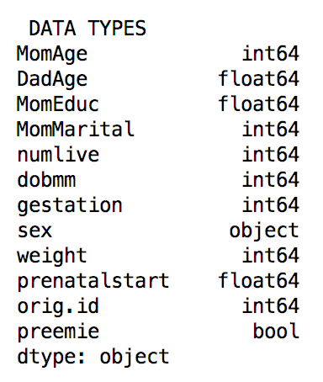

A brief statistical summary is displayed with the describe() function.

print(df.describe())

Here you can see a helpful display of statitics for the numeric columns in the set. The count property generally shows that all MomAge values are present but 34 DadAge values are missing. It is also apparent that not all values are present for MomEduc and prenatalstart columns as well. The mean, standard deviation, percentiles and maximums are also displayed.

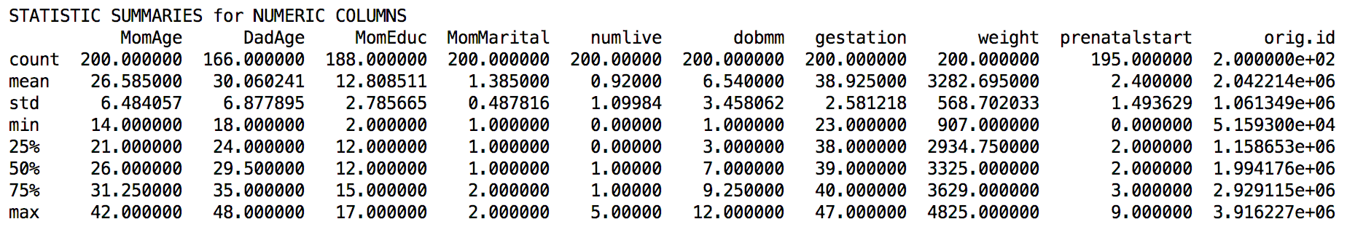

When the describe() function is used with include=['object'] as a parameter, we also can view a quick statistical summary about String columns in the data set.

print(df.describe(include=['object']))

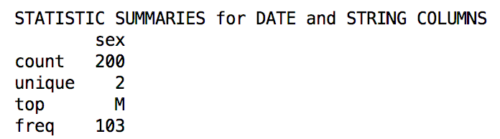

Exercise 11 (1 Mark)
What is the default value of n in head () and tail () functions of pandas DataFrame object?

0 the result is the full DataFrame

Exercise 12 (4 marks)
This exercise uses a data set for measurements of body fat. [1] Using this code, you can read in the data but you will need to adjust the path.
import pandas as pd
path = "/Python/DataSets /bodyfat.txt"
df = pd.read_csv(path, skiprows=1,
sep='\t',
names=('Density', 'Pct.BF', 'Age', 'Weight', 'Height',
'Neck', 'Chest', 'Abdomen', 'Waist', 'Hip', 'Thigh',
'Ankle', 'Knee', 'Bicep', 'Forearm', 'Wrist'))
# Show all columns.
pd.set_option('display.max_columns', None)

# Increase number of columns that display on one line.
pd.set_option('display.width', 1000)

- Use Python to print out the first and last two rows of the data frame. Show a screenshot of the output.
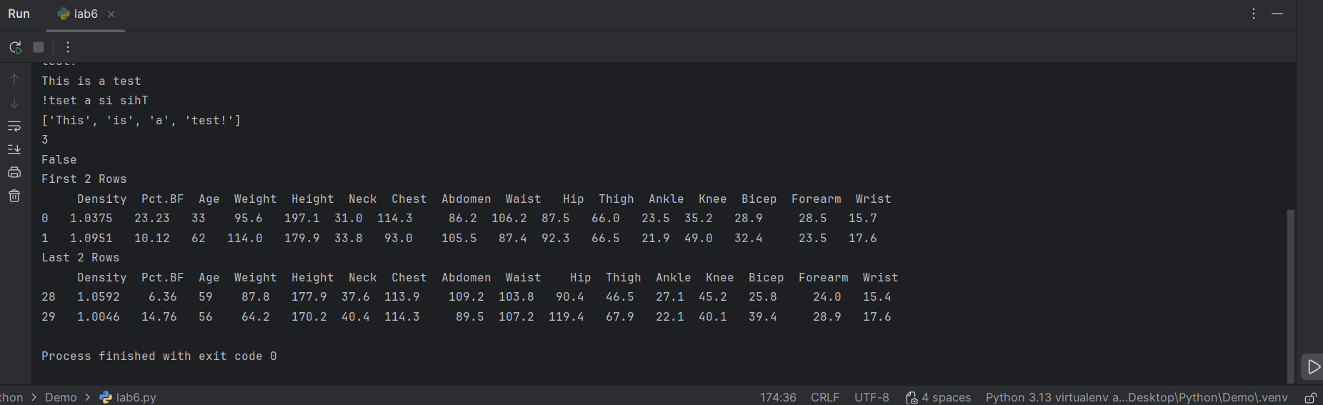

Show your code here:
import pandas as pd
path = "../random_body_data.txt"
df = pd.read_csv(path, skiprows=1,
sep='\t',
names=('Density', 'Pct.BF', 'Age', 'Weight', 'Height',
'Neck', 'Chest', 'Abdomen', 'Waist', 'Hip', 'Thigh',
'Ankle', 'Knee', 'Bicep', 'Forearm', 'Wrist'))
# Show all columns.
pd.set_option('display.max_columns', None)
# Increase number of columns that display on one line.
pd.set_option('display.width', 1000)
print("First 2 Rows \n " , df.head(2))
print("Last 2 Rows \n", df.tail(2))

- Use Python to print out the data types for each of the columns. Show a screenshot of the output.
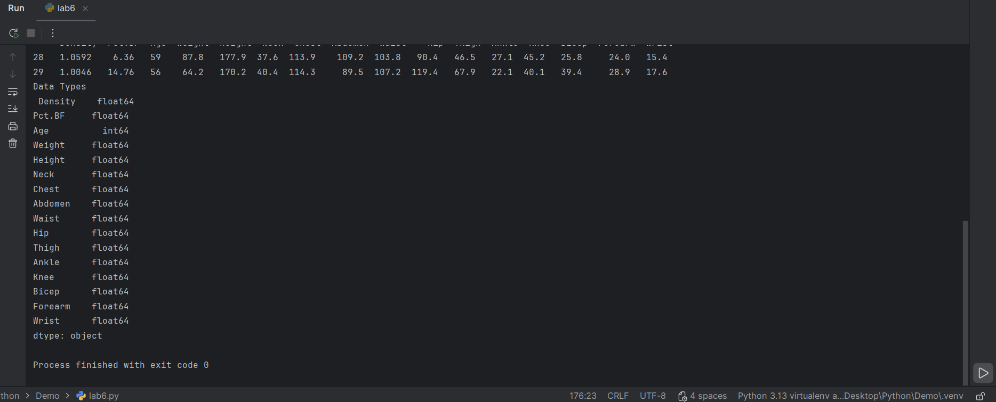

- Use Python to print out simple statistical summaries for each of the columns. Show a screenshot of the output.

Tip: The numeric rounding is not reader-friendly. To format the number more nicely use the line of code here.

﻿ print(df.describe().round(2))

Show a screenshot of the DataFrame output with rounding here:
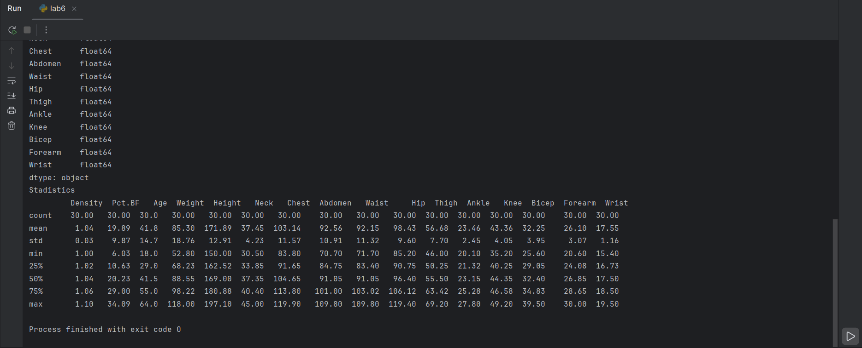

Extracting Column Subsets

You can extract a subset of DataFrame columns from an existing DataFrame by nesting an array of desired column names within square brackets.

df2 = df[["Market", "Change"]]

Example 9: Extracting Column Subsets
This example first builds a data frame with Market, Last, and Change columns and then creates a smaller table from it with only Market and Change columns.
import pandas as pd

# Create data set.
dataSet = {'Market': ['S&P 500', 'Dow', 'Nikkei'],
'Last': [2932.05, 26485.01, 21087.16] }

# Create dataframe with data set and named columns.
df = pd.DataFrame(dataSet, columns= ['Market', 'Last'])
change = [-21.51, -98.41, -453.83]

df['Change'] = change

df2 = df[["Market", "Change"]]
# Show DataFrame
print("\n*** Adjusted DataFrame ***")
print (df2)

Exercise 13 (2 marks)
Using the starter code for Exercise 12 create a DataFrame from the original DataFrame which only contains columns for Height, Waist, Weight and Pct.BF. Show your code here:
Df3 = df[['Height', 'Waist', 'Weight','Pct.BF']]

Show a screenshot of the first rows of the new DataFrame here after printing the DataFrame to the console.
