Table of Contents
String Manipulation 1
Finding Initial Position of a String 1
Obtaining Substrings 2
Finding Multiple Occurrences of Strings 2
Replacing Strings 3
split() 3
join() 4
Scope and Precedence 4
Visualizations 5
Scatter Plots 7
Bar Plots 9
Grouped Bar Plots 10
Frequency Histograms 11
Displaying Multiple Graphs 12

Submission Instructions:
10% will be deducted each day this document is late. Please do not submit pdf documents and do not zip your documents.

Note:
You are encouraged to work with others, and you can discuss your solutions verbally as well but DO NOT SHARE COPIES of YOUR WORK ELECTONICALLY OR IN ANY OTHER FORM. Keep good karma with your career network and protect your reputation – do not plagiarize.

String Manipulation
There are many ways to manipulate strings in Python. We introduce some basic functions which are useful when cleaning and preparing data.

Finding Initial Position of a String

Example 1: Finding String Position
This example treats a string like an array. The find() function is used to find the starting position of both ‘dog’ and ‘cat’.
﻿ # Searches for match in an array of characters and starts count at 0.
sentence = "A lazy dog jumped over a log"
print("Starting position: " + str(sentence.find('dog')))

# When item not found, -1 is returned.
sentence = "A lazy dog jumped over a log"
print("Starting position: " + str(sentence.find('cat')))

The output shows the starting position of the dog. The output also shows -1 when searching on ‘cat’ to indicate that it was not found.
Starting position: 7
Starting position: -1

Obtaining Substrings

Example 2: Obtaining Substrings
This code is used to extract the first name from a full name string. The string can be referenced with a start and end index.
﻿fullName = "Bob Jones"
spacePosition = fullName.find(" ")
startPosition = 0
endPosition = spacePosition
firstName = fullName[startPosition:endPosition]
print(firstName)
The output shows a successfully parsed first name:
﻿Bob

Exercise 1 (1 mark)
Figure out how to extract the last name from the fullName string in Example 2. Remember that the index count for the string begins at 0. You will want to use len() to calculate the end of the string. Show your program here:
lastName = fullName[spacePosition+1:]
print(lastName)

Finding Multiple Occurrences of Strings

Example 3: Finding Multiple Occurrences of a Substring
This example finds the all indexes for the starting position of ‘og’ within a sentence. A for loop and len() function work together to iterate through the string to find a match.
text = "A lazy dog jumped over a log."
positions = []
for i in range(0,len(text)-1):
if(text[i:i+2] == "og"):
positions.append(i)

print(positions)
The output shows a list which contains two starting positions:
[8, 26]

Exercise 2 (1 mark)
Find the positions of ‘sea’ in the following sentence:
“She sells seashells by the sea shore.”

Show your code here:
text = "She sells seashells by the sea shore"
positions = []
for i in range(0, len(text) - 1):
if (text[i:i + 3] == "sea"):
positions.append(i)
print(positions)
Show your output here:
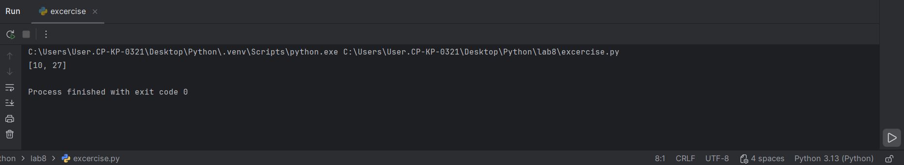

Replacing Strings

The replace() function offers a nice simple way to exchange old text and with new text.

Example 4: Replacing Strings
This code replaces ‘dog’ with ‘cat’ and prints the result.
text = "A lazy dog jumped over a log."
newText = text.replace("dog", "cat")
print(newText)
The output shows a successful replacement:
﻿A lazy cat jumped over a log.

Exercise 3 (1 mark)
Figure out how to use the replace() function to change the sentence in Example 4 to “A dog jumped over a log”. (The answer may be simpler than you think) Show your code here:
text = "A lazy dog jumped over a log."
newText = text.replace(" lazy", "")
print(newText)

split()

The split() function separates a string based on a preferred delimiter. This function is really helpful when reading from a comma separated list of values.

Example 5: Using the Split() Function
This example shows how all words can be extracted from a sentence and stored in an array.
word = "A lazy dog jumped over a log."
sentenceArray = word.split(' ')
print(sentenceArray)

for counter in range(0, len(sentenceArray)):
print(sentenceArray[counter])
The output confirms that sentence has successfully been stored in an array:
['A', 'lazy', 'dog', 'jumped', 'over', 'a', 'log.']
A
lazy
dog
jumped
over
a
log.

join()

The join() function performs in an opposite manner compared to the split() function. The join() function converts an array back into a single string. This function is especially helpful when writing comma separated value content to a file.

Example 6: join()
This example shows how an array is converted back into one string with a single space between each word.
sentenceArray = ['A', 'lazy', 'dog', 'jumped', 'over', 'a', 'log.']
delimiter = ' '
newSentence = delimiter.join(sentenceArray)
print(newSentence)
The output shows that all elements have been concatenated into one string where all words are separated by an empty space:
﻿A lazy dog jumped over a log.

Exercise 4 (1 mark)
Modify Example 6 so the string created contains all words in the original array separated by a comma. Show your code here. No screenshots please:
delimiter = ','
newSentence = delimiter.join(sentenceArray)
print(newSentence)

Scope and Precedence

Scope refers to the region where a variable is defined. A variable only exists in the region where it is defined. When two variables have the same name, the variable with the most localized scope is the one that is recognized. This bias to recognize local variables over global variables is called precedence.

Example 7: Local Scope

In this program notice a variable named ‘a’ is declared twice. Outside the function, a global declaration of variable ‘a’ has precedence but inside the function the local declaration of ‘a’ has precedence.
def displayContent(x):
a = 25 # The number is born here.
print('Inside the function the variable \'a\'=' + str(a))
print('The parameter x=' + str(x))
return # Locally declared variables die here when the function exits.

a = 100
displayContent(a)
print("The global value for \'a\'=" + str(a))
The output shows how both definitions of the variable ‘a’ exist separately yet the most local version always takes precedence.
Inside the function the variable 'a'=25
The parameter x=100
The global value for 'a'=100

Exercise 5 (4 marks)
- Inside the function, the locally declared variable ‘a’ equals:
25
- The globally declared variable ‘a’ equals:
100
- How does the output change if the instruction ‘a=25’ is removed from Example 7?
Inside the function the variable ‘a’=100
- What does your observation in part (c) of this question say about precedence?
that a = 25 only can be used in the function no outside and local variables have high priority than global variables

Visualizations
This section will discuss some basic but essential ways to visualize statistical data. We will then apply these techniques towards exploratory data analysis to help understand the potential and limitations of a data set. You may want to refer back to this document – if you do be sure to use the table of contents and side bar navigation to find the resources that you need from it.

Example 8: Line Graphs
This example demonstrates how to plot two different lines that show changes to population for Connecticut and Colorado. Notice how the legend labels, titles, axis labels and line styles are set – you may want to refer back to this example to see how these features are implemented. This is the output:
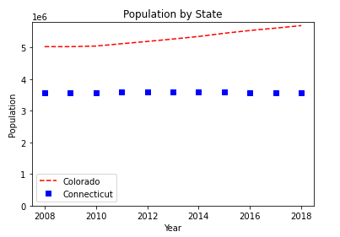

Here is the code:
import numpy as np
import matplotlib.pyplot as plt
years = [2008,2009,2010,2011,2012,2013,2014,2015,2016,2017,2018]
colorado = [5029196,5029316,5048281,5121771,5193721,5270482,5351218,5452107,
5540921,5615902,5695564]
connecticut = [3574097,3574147,3579125,3588023,3594395,3594915,3594783,3587509,
3578674,3573880,3572665]
# red dashes, blue squares and green triangles
plt.plot(years, colorado, "--", color='red', label="Colorado")
plt.plot(years,connecticut, "s", color='blue', label="Connecticut")
# legend
# https://matplotlib.org/users/legend_guide.html
plt.ylim(ymin=0) # Set's y axis start to 0.
plt.legend(loc=0)
plt.xlabel("Year")
plt.ylabel("Population")
plt.title('Population by State')
plt.show()

Exercise 6 (2 marks)
See if you can figure out how to adjust your code in Example 8 to include a third line for Delaware. The population Delaware between 2008 and 2018 is included in this array.

delaware = [897934,897934,899595,907316,915188,923638,932596,941413,949216,
957078,967171]

You can make the line a straight line by not including a style parameter. “--" and “s” were used as style parameters previously. Try not including a style parameter to draw a solid line which is the default. Or if you prefer to add line formatting, you can look up linestyle at https://matplotlib.org/3.1.1/api/_as_gen/matplotlib.lines.Line2D.html#matplotlib.lines.Line2D

Figure out how to make the legend appear at the center left of the graph. See https://matplotlib.org/3.1.1/api/_as_gen/matplotlib.pyplot.legend.html to look up location code.

Show your revised program here:
import matplotlib.pyplot as plt
years = [2008,2009,2010,2011,2012,2013,2014,2015,2016,2017,2018]
colorado = [5029196,5029316,5048281,5121771,5193721,5270482,5351218,5452107,
5540921,5615902,5695564]
connecticut = [3574097,3574147,3579125,3588023,3594395,3594915,3594783,3587509,
3578674,3573880,3572665]
delaware = [897934,897934,899595,907316,915188,923638,932596,941413,949216,
957078,967171]
# red dashes, blue squares and green triangles
plt.plot(years, colorado, "--", color='red', label="Colorado")
plt.plot(years,connecticut, "s", color='blue', label="Connecticut")
plt.plot(years,delaware,color='green',label='Delaware')
# legend
# https://matplotlib.org/users/legend_guide.html
plt.ylim(ymin=0) # Set's y axis start to 0.
plt.legend(loc='center left')
plt.xlabel("Year")
plt.ylabel("Population")
plt.title('Population by State')
plt.show()

Show a screenshot of your chart with three lines in it here:
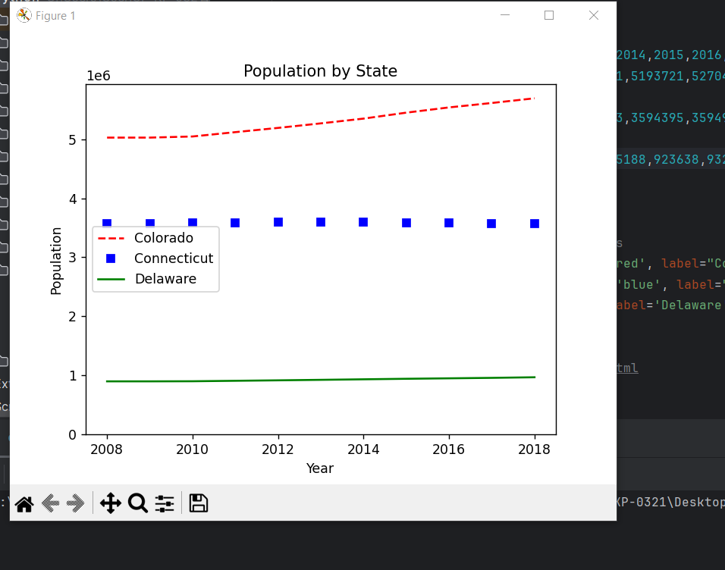

Scatter Plots

Scatter plots show how one variable is correlated to another for multiple samples.

Example 9: Simple Scatter Plot
Figure 1 shows a simplified scatter plot which illustrates how the level of bacteria A growth is related to time in days for six different samples.

Figure 1: Bacteria A growth over time
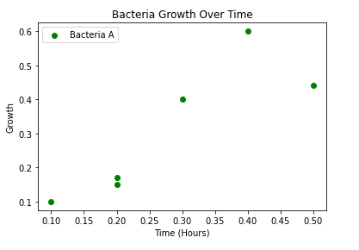
This is the code that is needed to draw the scatter plot. Notice how the x and y values are supplied as arrays to the scatter() function to provide data for the graph. Also notice how the axis, title and legend items are labelled.

import matplotlib.pyplot as plt
# Plot scatter of x and y coordinates.
time_X = [0.1, 0.2, 0.3, 0.4, 0.5, 0.2]
growth_Y = [0.1, 0.15, 0.4, 0.6, 0.44, 0.17]
plt.scatter(time_X, growth_Y, color='green', label='Bacteria A')
# Add a legend, axis labels, and title.
plt.legend()
plt.xlabel("Time (Hours)")
plt.ylabel("Growth")
plt.title('Bacteria Growth Over Time')
plt.show()

Exercise 7 (2 marks)
Draw a scatter plot that looks exactly like the following one.
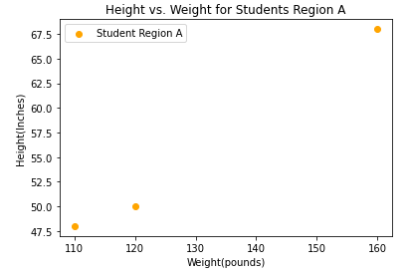
These are the data arrays:

pounds = [120, 110, 160]
inches = [50, 48, 68]

Show your program here:
import matplotlib.pyplot as plt

pounds_W = [120, 110, 160]
inches_H = [50, 48, 68]
plt.scatter(pounds_W,inches_H,color='orange',label='Student Region A')
plt.legend(loc='upper left')
plt.xlabel('Wight(pounds)')
plt.ylabel('Height(inches)')
plt.title('Height vs Weight for Student Region A')
plt.show()

Exercise 8 (2 marks)
Starting with your solution from Exercise 7, add in code to plot a second scatter group as shown in Figure 2. Keep your new code above the plt.show() instruction.

Figure 2: Comparing Height and Weight Correlations of Two Sample Groups
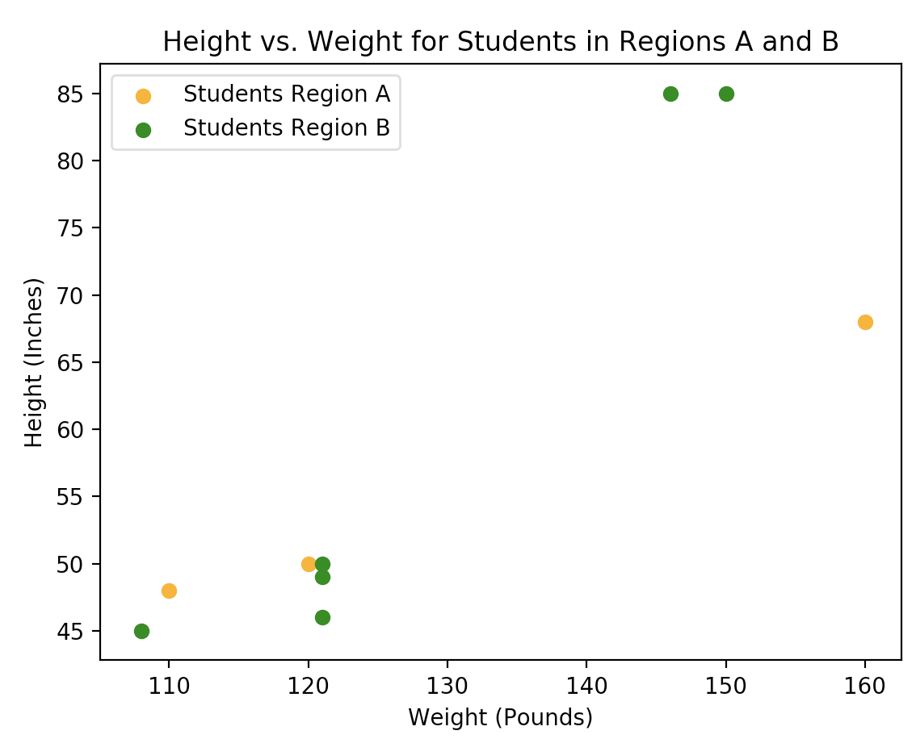
These are the data sets:
poundsA = [120, 110, 160]
inchesA = [50, 48, 68]
poundsB = [121, 108, 150, 121, 121, 146]
inchesB = [49, 45, 85, 46, 50, 85]

Show your program here:
import matplotlib.pyplot as plt

poundsA = [120, 110, 160]
inchesA = [50, 48, 68]
poundsB = [121, 108, 150, 121, 121, 146]
inchesB = [49, 45, 85, 46, 50, 85]
plt.scatter(poundsA,inchesA,color='orange',label='Student Region A')
plt.scatter(poundsB,inchesB,color='green', label='Student Region B')
plt.legend(loc='upper left')
plt.xlabel('Wight(pounds)')
plt.ylabel('Height(inches)')
plt.title('Height vs Weight for Student Region A and B')
plt.show()

Bar Plots

Bar plot documentation can be viewed here:
https://matplotlib.org/3.1.0/api/_as_gen/matplotlib.pyplot.bar.html

Example 10: Bar Plots
This example shows how to create a basic bar plot.
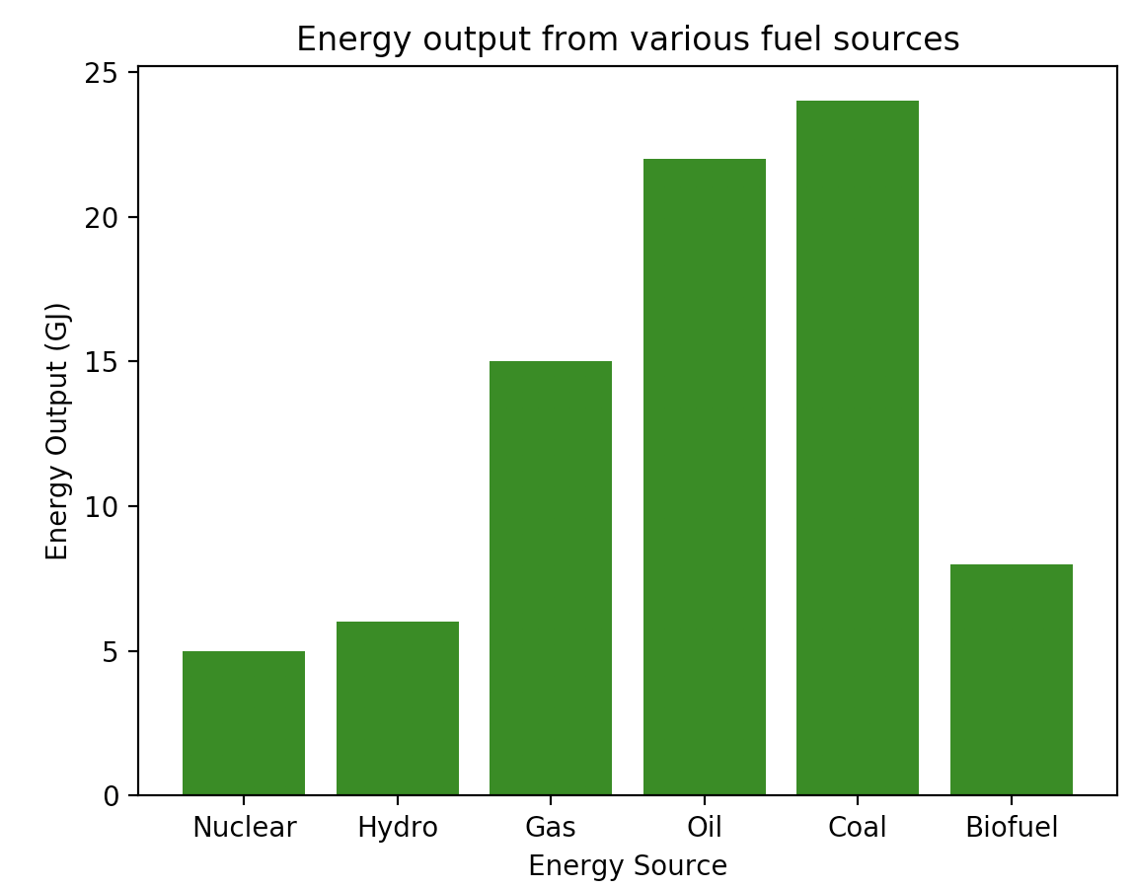
import matplotlib.pyplot as plt
x = ['Nuclear', 'Hydro', 'Gas', 'Oil', 'Coal', 'Biofuel']
energy = [5, 6, 15, 22, 24, 8]
plt.bar(x, energy, color='green')
plt.xlabel("Energy Source")
plt.ylabel("Energy Output (GJ)")
plt.title("Energy output from various fuel sources")
plt.xticks(x, x)
plt.show()

Grouped Bar Plots

Example 11: Grouped Bar Plots

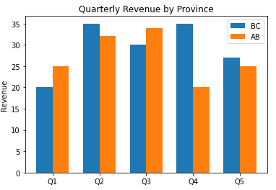

import matplotlib.pyplot as plt
import numpy as np
NUM_MEANS = 5
NUM_GROUPS = 2
bc_means = [20, 35, 30, 35, 27]
alberta_means = [25, 32, 34, 20, 25]
# This generates indices from 0 to 4 in a format that is accepted for
# plotting bar charts.
ind = np.arange(NUM_MEANS)
print(ind)
width = 0.35
plt.bar(ind, bc_means, width, label='BC')
plt.bar(ind + width, alberta_means, width, label='AB')
plt.ylabel('Revenue')
plt.title('Quarterly Revenue by Province')
plt.xticks(ind + width / NUM_GROUPS, ('Q1', 'Q2', 'Q3', 'Q4', 'Q5'))
plt.legend(loc='best')
plt.show()

Exercise 9: (4 marks)
Modify the code in Example 11 to show groupings for BC, Alberta and Saskatchewan but for the first four quarters only. Customize the color of the bars. You may need to reduce the width to make the bars fit together.

saskatchewan_means = [18, 28, 32, 24, 31]

Show your code here:
import matplotlib.pyplot as plt
import numpy as np
NUM_MEANS = 5
NUM_GROUPS = 3
bc_means = [20, 35, 30, 35, 27]
alberta_means = [25, 32, 34, 20, 25]
saskatchewan_means = [18, 28, 32, 24, 31]
# This generates indices from 0 to 4 in a format that is accepted for
# plotting bar charts.
ind = np.arange(NUM_MEANS)
print(ind)
width = 0.25
plt.bar(ind[0], bc_means[0],width, label='BC')
plt.bar(ind[0] + width,alberta_means[0],width,label='AB')
plt.bar(ind[0]+width*2, saskatchewan_means[0],width, label='SK')
plt.ylabel('Revenue')
plt.title('Quarterly Revenue by Province')
plt.xticks(ind + width / NUM_GROUPS, ('Q1', 'Q2', 'Q3', 'Q4', 'Q5'))
plt.legend(loc='best')
plt.show()

Show a screenshot of your graph here:
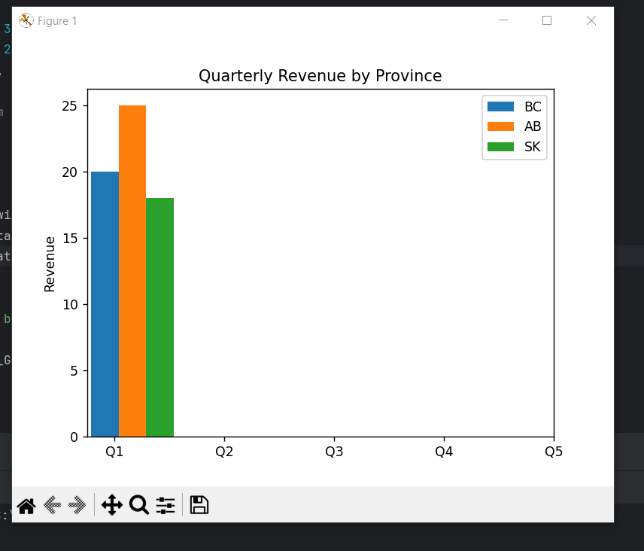

Frequency Histograms

Having tables with precise frequency and ranges is helpful. However, many numbers in a summary report can be overwhelming so histograms offer a quick but effective overview of frequency, range, and distribution.

Example 12: Histogram Introduction

When examining a histogram of the mother age we can observe a distribution that looks a bit like a normal distribution with a peak around 24 years of age. Some other spikes may also be significant.
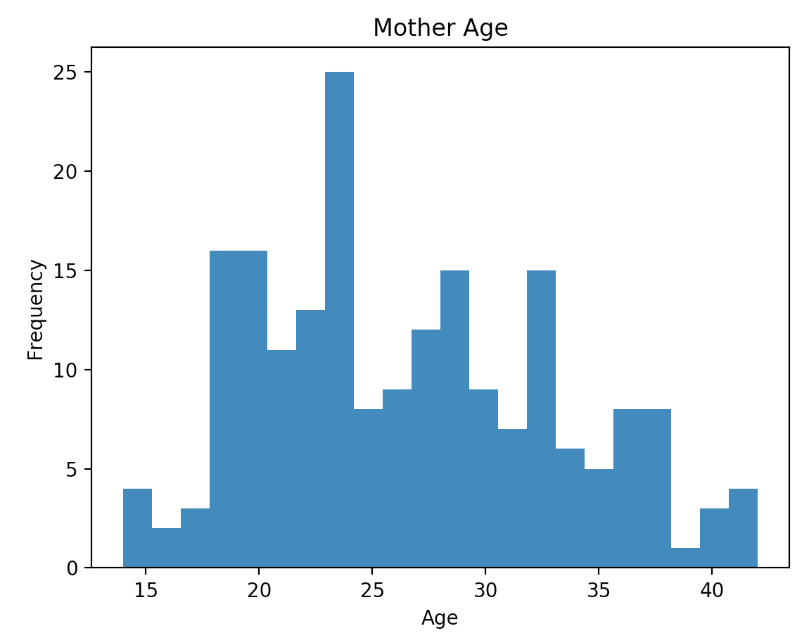
Here is the code used to generate the histogram for the Mother’s age.
import pandas as pd
import matplotlib.pyplot as plt

# Import data into a DataFrame.
path = "/Python/DataSets/babysamp-98.txt"
df = pd.read_csv(path, skiprows=1,
sep='\t',
names=('MomAge', 'DadAge', 'MomEduc', 'MomMarital', 'numlive',
"dobmm", 'gestation', 'sex', 'weight', 'prenatalstart',
'orig.id', 'preemie'))
# Show all columns.
pd.set_option('display.max_columns', None)

# Increase number of columns that display on one line.
pd.set_option('display.width', 1000)

plt.hist(df["MomAge"], bins=22)
plt.xlabel("Age")
plt.ylabel("Frequency")
plt.title('Mother Age')

plt.show()

Displaying Multiple Graphs

During exploratory data analysis (EDA) and reporting you will often need to present summaries about many variables. You can adjust graphics output so more than one chart appears in the same row (See Figure 3).

Figure 3: Plotting Multiple Charts in One Row
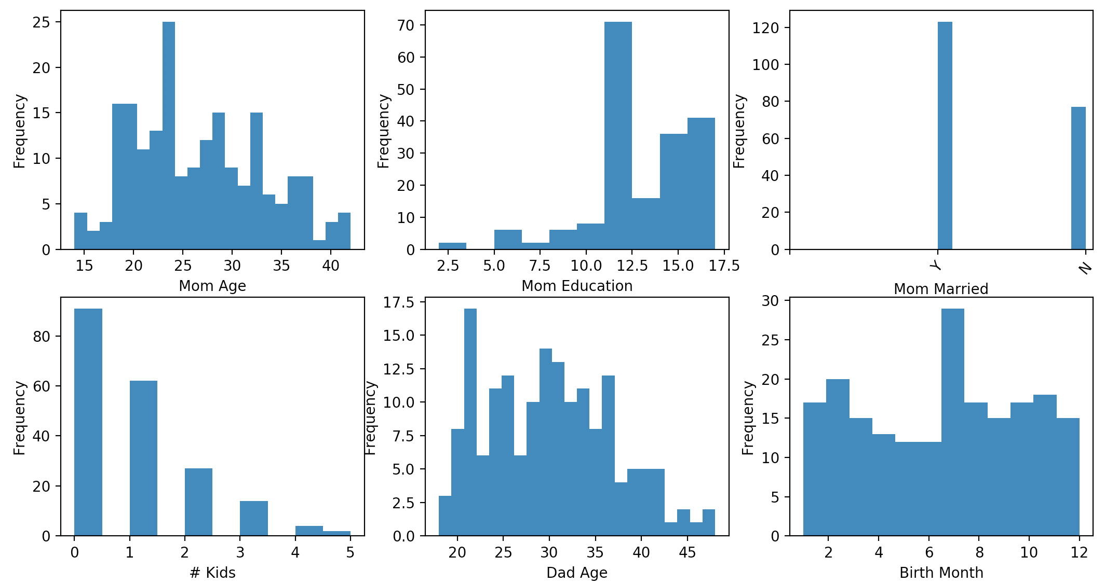

Example 13: Drawing Multiple Graphs on One Line
This example shows how to output multiple graphs in the same row-column layout as Figure 3. Placing the following line before instructions to draw all graphs allows you to control the size of each of the graphs. I have not perfected the sizing, so I use the width and height parameters in the figsize attribute as relative measures and experiment with them until getting the proper size.

# This line allows us to set the figure size supposedly in inches.
# When rendered in the IDE the output often does not translate to inches.
plt.subplots(nrows=2, ncols=3, figsize=(3,4))

Placing a line like this one above each chart sets the position of the chart in the matrix. The first two parameters represent the number of rows and columns of the output. The final number is the position in the matrix where charts are rendered in a clock-wise manner. I find the syntax to be a bit odd but it works. Each time you plot a new chart in the series you state the number of rows and columns in the series as well as the position of the current plot within it.

plt.subplot(2, 3, 1) # Specfies total rows, columns and image #
# where images are drawn clockwise.

import pandas as pd
import matplotlib.pyplot as plt

# Import data into a DataFrame.
path = "/Python/DataSets/babysamp-98.txt"
df = pd.read_csv(path, skiprows=1,
sep='\t',
names=('MomAge', 'DadAge', 'MomEduc', 'MomMarital', 'numlive',
"dobmm", 'gestation', 'sex', 'weight', 'prenatalstart',
'orig.id', 'preemie'))

# Show all columns.
pd.set_option('display.max_columns', None)

# Increase number of columns that display on one line.
pd.set_option('display.width', 1000)
# This line allows us to set the figure size supposedly in inches.
# When rendered in the IDE the output often does not translate to inches.
plt.subplots(nrows=2, ncols=3, figsize=(14,7))

plt.subplot(2, 3, 1) # Specfies total rows, columns and image #
# where images are drawn clockwise.
plt.hist(df["MomAge"], bins=22)
plt.xlabel("Mom Age")
plt.ylabel("Frequency")
#plt.title('Mother Age')

plt.subplot(2, 3, 2)
plt.hist(df["MomEduc"], bins=10)
plt.xlabel("Mom Education")
plt.ylabel("Frequency")

# 1 is married
# 2 is unmarried
plt.subplot(2, 3, 3)
plt.hist(df["MomMarital"], bins=10)
t11 = ['', 'Y', 'N']
plt.xticks(range(len(t11)), t11, rotation=50)

#plt.xticks(['Mar', '2'], rotation=50)
plt.xlabel("Mom Married")
plt.ylabel("Frequency")

# 1 is married. 2 is unmarried.
plt.subplot(2, 3, 4)
plt.hist(df["numlive"], bins=10)
plt.xlabel("# Kids")
plt.ylabel("Frequency")

plt.subplot(2, 3, 5) # of rows, # of columns, # plots.
plt.hist(df["DadAge"], bins=22)
plt.xlabel("Dad Age")
plt.ylabel("Frequency")

plt.subplot(2, 3, 6)
plt.hist(df["dobmm"], bins=12)
plt.xlabel("Birth Month")
plt.ylabel("Frequency")

plt.show()

Exercise 10 (4 marks)
Starting with the following code;
﻿import pandas as pd
import matplotlib.pyplot as plt

# Import data into a DataFrame.

path = "/Python/DataSets/bodyfat.txt"
df = pd.read_csv(path, skiprows=1,
sep='\t',
names=('Density', 'Pct.BF', 'Age', 'Weight', 'Height',
'Neck', 'Chest', 'Abdomen', 'Waist', 'Hip', 'Thigh',
'Ankle', 'Knee', 'Bicep', 'Forearm', 'Wrist'))
Make the following histograms by drawing 2 per row with 10 bins each.
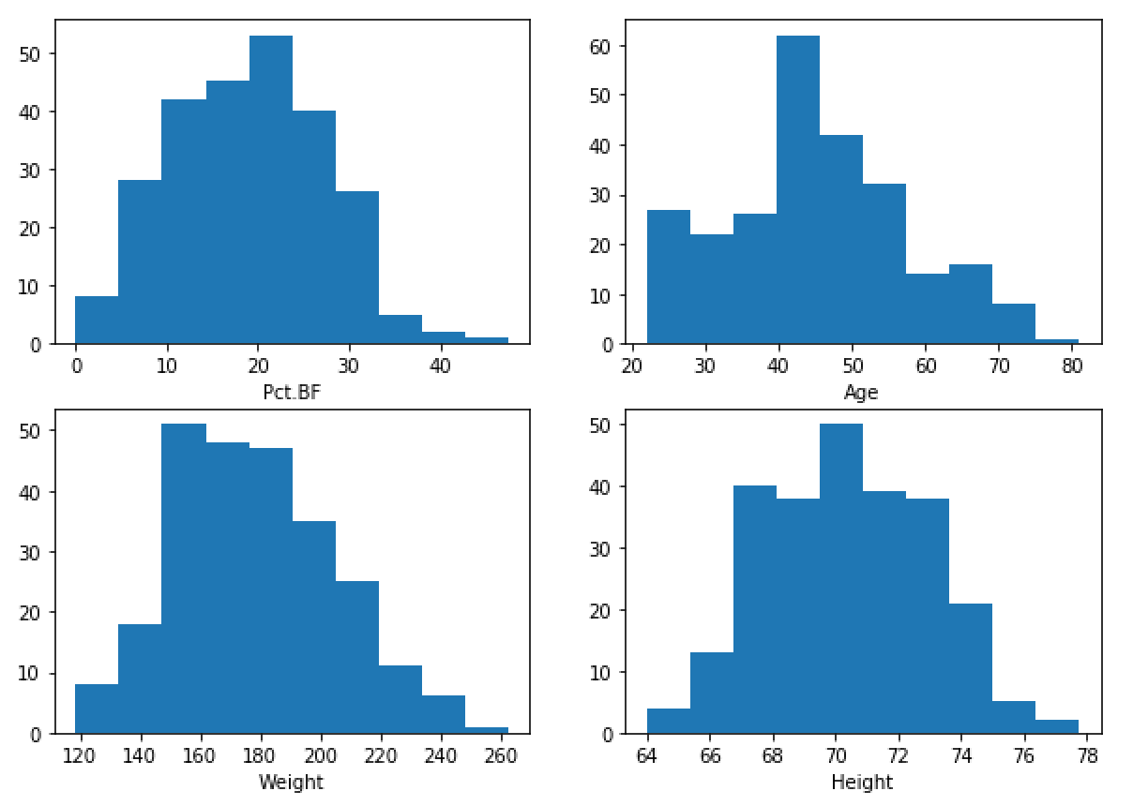
Show your code here:
import pandas as pd
import matplotlib.pyplot as plt
# Import my own data into a DataFrame.
path = "../lab7/random_body_data.txt"
df = pd.read_csv(path, skiprows=1,
sep='\t',
names=('Density', 'Pct.BF', 'Age', 'Weight', 'Height',
'Neck', 'Chest', 'Abdomen', 'Waist', 'Hip', 'Thigh',
'Ankle', 'Knee', 'Bicep', 'Forearm', 'Wrist'))
plt.subplots(nrows=2,ncols=2,figsize=(14,7))
plt.subplot(2,2,1)
plt.hist(df['Pct.BF'],bins=10)
plt.xlabel('Pct.BF')
plt.ylabel('Frequency')
plt.subplot(2,2,2)
plt.hist(df['Age'],bins=10)
plt.xlabel('Age')
plt.ylabel('Frequency')
plt.subplot(2,2,3)
plt.hist(df['Weight'],bins=10)
plt.xlabel('Weight')
plt.ylabel('Frequency')
plt.subplot(2,2,4)
plt.hist(df['Height'],bins=10)
plt.xlabel('Height')
plt.ylabel('Frequency')
plt.show()

