Writing an effective personal statement

Near miss

Every University will read your PS if you encounter a near miss (just missed your target grades)

What are offers based on?

Previous academic performance (GCSEs)
Predicted academic performance
Personal Statement
Interview
Admissions or aptitude tests
Mitigating circumstances
Contextual data

BATH DEFINITELY READS YOUR PERSONAL STATEMENT!

The way Bath sees it: these are the two PS questions:
- Why do you want to study the course and...
- Why are you the right person for the course?

At Bath, personal statement is 95% academic, 5% extra-curricular.
EVIDENCE is key.
Be clear with your language
Don't overuse quotes.

Don't overcomplicated your sentences:
- Don't make the reader have to go back to earlier text all the time.

Bath is MOST INTERESTED in QUESTION ONE and QUESTION THREE

Key points for question 1
Key in this section is authenticity. Think about:
- Your motivations for wanting to study your course
- Knowledge of this subject area and interests
- Future plans and why this course/subject is a good fit

Key points for question 2

What could you discuss?
- EPQ/IPQ, skills challenge certificate, own project (e.g. cansat!)
- Extra maths study (further maths, STEP/MAT/TMUA)

Key points for question 3

Use PEEL (Point, evidence, explain, link)
e.g:

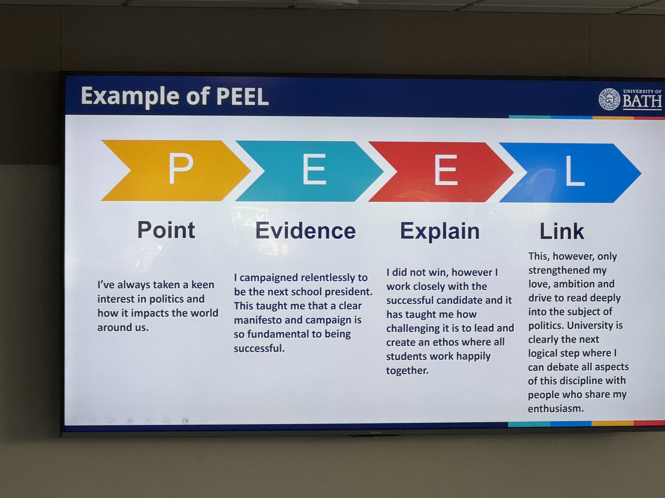
DON’Ts:
Don’t repeat information.
Don’t just list achievements and skills
Don’t begin every sentence with ‘I’
Don’t be tempted to plagiarise

Dos:
Do draft then re-draft til you’re happy.
Do get external feedback
Do think carefully about spelling, grammar and vocabulary.
Do demonstrate your enthusiasm.
Do be honest about why you want to study the course and why you’re the right person for it.

In applying: 90% course requirements and tick-box filtering (like discriminating based on GCSEs), 10% PS. PS is still important because it’s that bit that you can change!

MechEng – 200 spaces a year, 3800 applications for it!
This is where GCSEs become more important because they need to fit everyone in.

