BÁO CÁO THỰC HÀNH LAP 1  
LẬP TRÌNH HƯỚNG ĐỐI TƯỢNG

# The Very First Java Programs

## *2.2.1* Write, compile the first Java application

Kết quả:

## 2.2.2 Write, compile the first dialog Java program

Kết quả:

## 2.2.3 Write, compile the first input dialog Java application

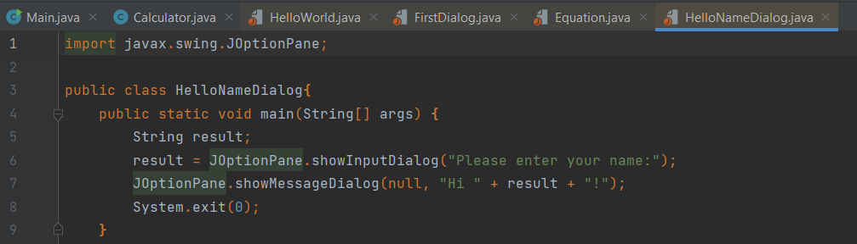

Kết quả:

## 2.2.4 Write, compile, and run the following example:

Kết quả

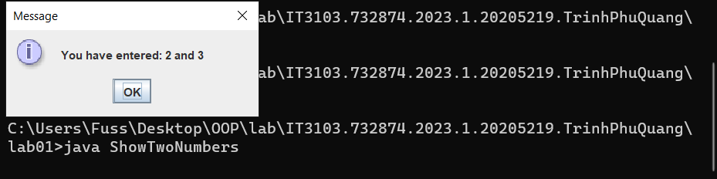

## 2.2.5 Write a program to calculate sum, difference, product, and quotient of 2 double numbers which are entered by users.

**Notes**

* To convert from String to double, you can use

**double num1 = Double.parseDouble(strNum1)**

* Check the divisor of the division

Kết quả:

## 6.1 Write, compile and run the ChoosingOption program:

Kết quả:

Nếu chọn cancel:

Chọn yes:

Chọn No:

## 6.2 Write a program for input/output from keyboard

Kết quả:

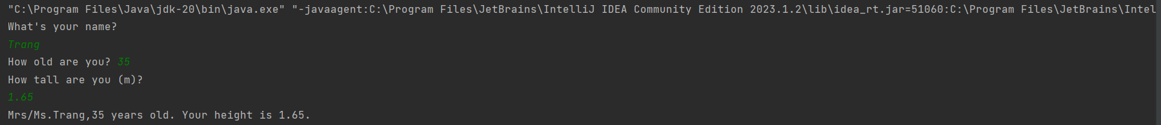

## 6.3 Write a program to display a triangle with a height of n stars (*), n is entered by users

Kết quả:

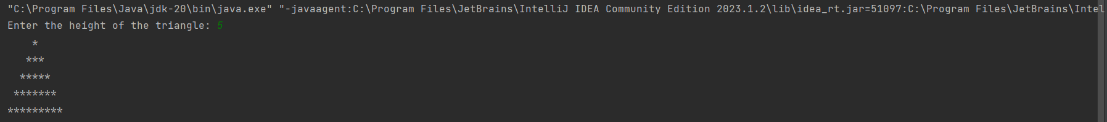

## 6.4 Write a program to display the number of days of a month, which is entered by users (both month and year).

Kết quả:  


## 6.5 Write a Java program to sort a numeric array, and calculate the sum and average value of array elements.

Kết quả:

## 6.6 Write a Java program to add two matrices of the same size.

Kết quả:

