BÁO CÁO THỰC HÀNH LAP 1  
LẬP TRÌNH HƯỚNG ĐỐI TƯỢNG

Table of Contents

2. The Very First Java Programs 3

*2.2.1* Write, compile the first Java application 3

2.2.2 Write, compile the first dialog Java program 3

2.2.3 Write, compile the first input dialog Java application 5

2.2.4 Write, compile, and run the following example: 6

2.2.5 Write a program to calculate sum, difference, product, and quotient of 2 double numbers which are entered by users. 8

6. Exercises 8

6.1 Write, compile and run the ChoosingOption program: 8

Questions: 10

6.2 Write a program for input/output from keyboard 11

6.3 Write a program to display a triangle with a height of n stars (*), n is entered by users 13

6.4 Write a program to display the number of days of a month, which is entered by users (both month and year). 13

6.5 Write a Java program to sort a numeric array, and calculate the sum and average value of array elements. 16

6.6 Write a Java program to add two matrices of the same size. 17

Figure table of content

Figure 1 2.2.1 example 3

Figure 3 2.2.1 result 3

Figure 4 2.2.2 example 4

Figure 6 2.2.2 result 4

Figure 7 2.2.3 example 5

Figure 8 2.2.3 code **Error! Bookmark not defined.**

Figure 9 2.2.3 result (1) 5

Figure 10 2.2.3 result (2) **Error! Bookmark not defined.**

Figure 11 2.2.4 example 6

Figure 12 2.2.4 code **Error! Bookmark not defined.**

Figure 13 2.2.4 result (1) 6

Figure 14 2.2.4 result (2) 7

Figure 15 2.2.4 result (3) 7

Figure 16 2.2.5 code (1) **Error! Bookmark not defined.**

Figure 17 2.2.5 code (2) **Error! Bookmark not defined.**

Figure 18 2.2.5 result 8

Figure 19 6.1 example 8

Figure 20 6.1 code 9

Figure 21 6.1 result (1) 9

Figure 22 6.1 result (2) 9

Figure 23 6.1 result (3) 10

Figure 24 6.1 result (4) 10

Figure 25 6.1 Question code 10

Figure 26 6.1 Question result 10

Figure 27 6.2 example 11

Figure 28 6.2 code 12

Figure 29 6.2 result 12

Figure 30 6.3 code 13

Figure 31 6.3 result 13

Figure 32 6.4 code (1) 14

Figure 33 6.4 code (2) 15

Figure 34 6.4 result 15

Figure 35 6.5 code 16

Figure 36 6.5 result 16

Figure 37 6.6 code (1) 17

Figure 38 6.6 code (2) 18

Figure 39 6.6 result 18

JDK: 20, IDE: Intellij

# 2. The Very First Java Programs

## *2.2.1* Write, compile the first Java application

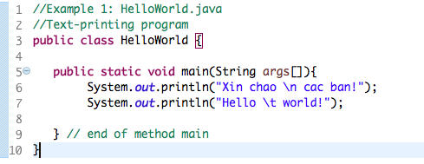

Figure 1 2.2.1 example

Result:

Figure 2 2.2.1 result

## 2.2.2 Write, compile the first dialog Java program

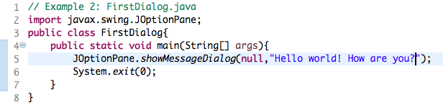

Figure 3 2.2.2 example

Figure 4 2.2.2 result

## 2.2.3 Write, compile the first input dialog Java application

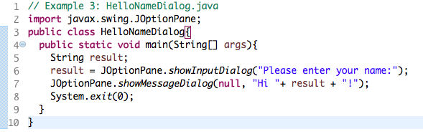

Figure 6 2.2.3 example

Kết quả:

Figure7 2.2.3 result (1)

## 2.2.4 Write, compile, and run the following example:

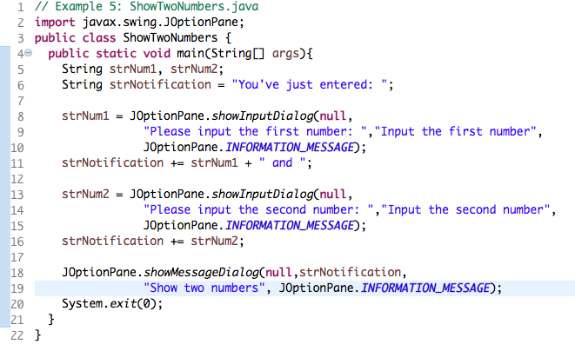

Figure 8 2.2.4 example

Figure 9 2.2.4 result (1)

Figure 10 2.2.4 result (2)

Figure 11 2.2.4 result (3)

## 2.2.5 Write a program to calculate sum, difference, product, and quotient of 2 double numbers which are entered by users.

**Notes**

* To convert from String to double, you can use

**double num1 = Double.parseDouble(strNum1)**

* Check the divisor of the division

Kết quả

Figure 12 2.2.5 result

# 6. Exercises

## 6.1 Write, compile and run the ChoosingOption program:

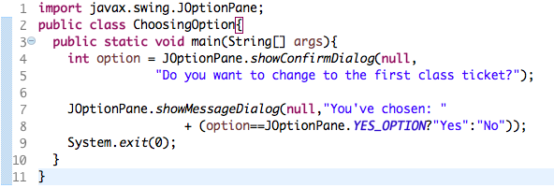

Figure 13 6.1 example

Figure 14 6.1 code

Figure 15 6.1 result (1)

IF cancel:

Figure 16 6.1 result (2)

IF yes:

Figure 18 6.1 result (3)

IF No:

Figure 19 6.1 result (4)

### Questions:

* What happens if users choose “Cancel”? – Result is No
* How to customize the options to users, e.g. only two options: “Yes” and “No”, OR “I do” and “I don’t” (Suggestion: Use Javadocs or using Eclipse/Netbean IDE help).

Code can change to:

Figure 20 6.1 Question code

Result:

Figure 21 6.1 Question result

## 6.2 Write a program for input/output from keyboard

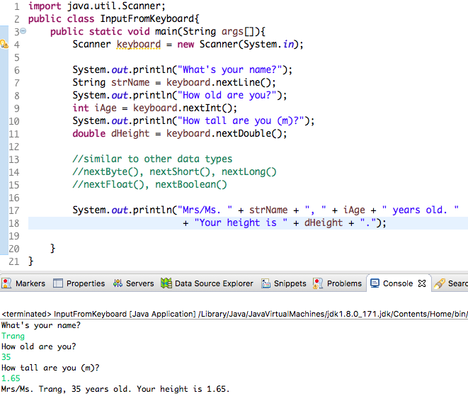

Figure 22 6.2 example

Kết quả:

Figure 23 6.2 code

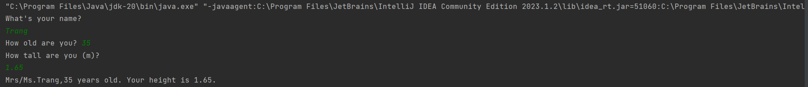

Figure 24 6.2 result

## 6.3 Write a program to display a triangle with a height of n stars (*), n is entered by users

Kết quả:

Figure 25 6.3 code

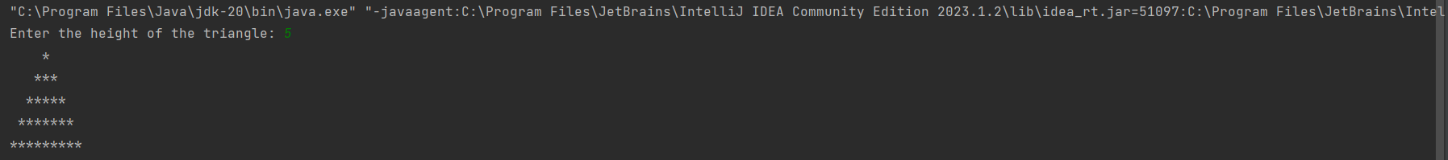

Figure 26 6.3 result

## 6.4 Write a program to display the number of days of a month, which is entered by users (both month and year).

You must create a new Java project for this exercise.

* The user can either enter a month in its full name, abbreviation, in 3 letters, or in number. To illustrate, the valid inputs of *January* are January, Jan., Jan, and 1.
* The user must enter a year in a non-negative number and enter all the digits. For instance, the valid inputs of year *1999* is only 1999, but not 99, “one thousand nine hundred ninety-nine”, or anything else.
* A year is either a common year of 365 days or a leap year of 366 days. Every year that is divisible by 4 is a leap year, except for years that are divisible by 100, but not by 400. For instance, year 1800 is not a leap year, yet year 2000 is a leap year. In a year, there are twelve months, which are listed in order as follows.

Result:

Figure 27 6.4 code (1)

Figure 28 6.4 code (2)



Figure 29 6.4 result

## 6.5 Write a Java program to sort a numeric array, and calculate the sum and average value of array elements.

Result:

Figure 30 6.5 code

Figure 31 6.5 result

## 6.6 Write a Java program to add two matrices of the same size.

- The matrices can be entered by the user or constants.

Result:

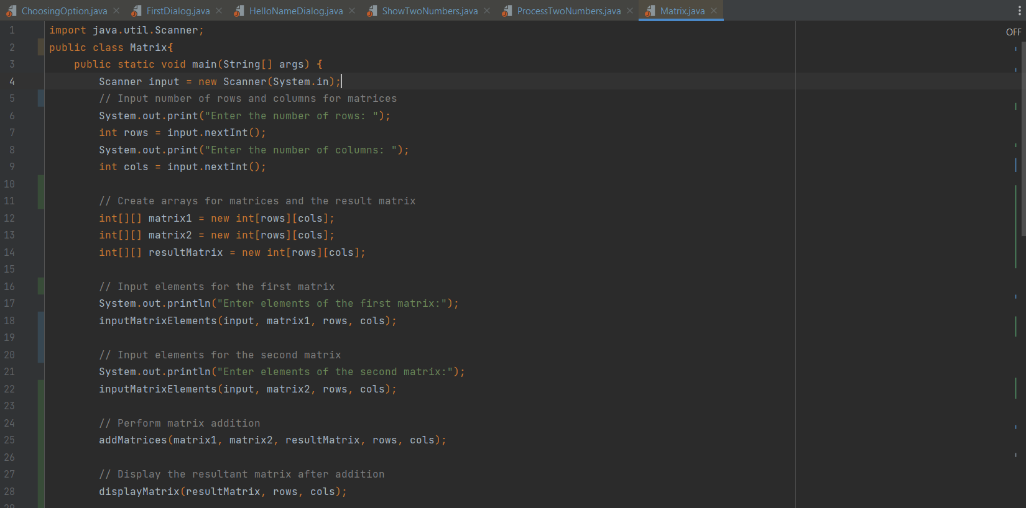

Figure 32 6.6 code (1)

Figure 33 6.6 code (2)

Figure 34 6.6 result