Team: C02

Members: Carter Hale and Jonathan Hagen

**CAR EVASION GAME**

**Project Progress**

As of Thursday, November 15, 2018, our progress towards our final Car Evasion Game is quite limited. We started by independently researching and understanding the VGA specifications and what all goes into outputting an image on the monitor. After finding online tutorials and guides to kickstart our project we eventually began to spend our time inside and out of Lab Hours working on a VGA Driver. After failing to get our own driver up and running, we found and modified some pre-existing project files created by Digi-Key to use for our project.

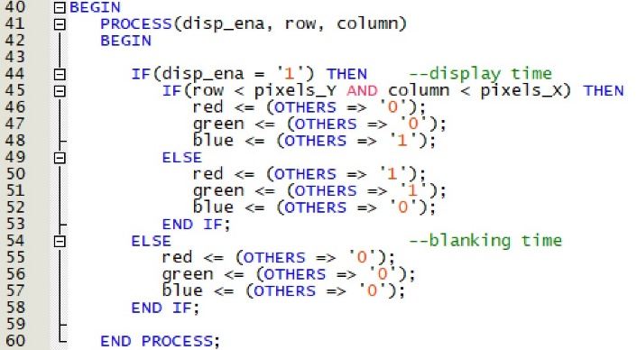 The time spent attempting to create our own driver was not an entire waste of time, as it helped us understand how the Digi-Key one works with frame buffers and Vertical/Horizontal Sync. With this information, we are now working on getting a general game layout outputted to the screen with plans to animate obstacles next. Collision Logic will then be our next challenge, which we hope to begin after Thanksgiving.

To the right is our simple Graphical Output Process which displays a blue rectangle in the top left portion of the monitor. Its size is based on the **pixel_Y** and **pixel_X** variables in the ‘if’ statement.

Below is a Block Diagram File provided by Digi-Key. We modified the Pulse and Porch Sizes, as well as the Pixel Clock in the PLL to get the proper timings for our Display.

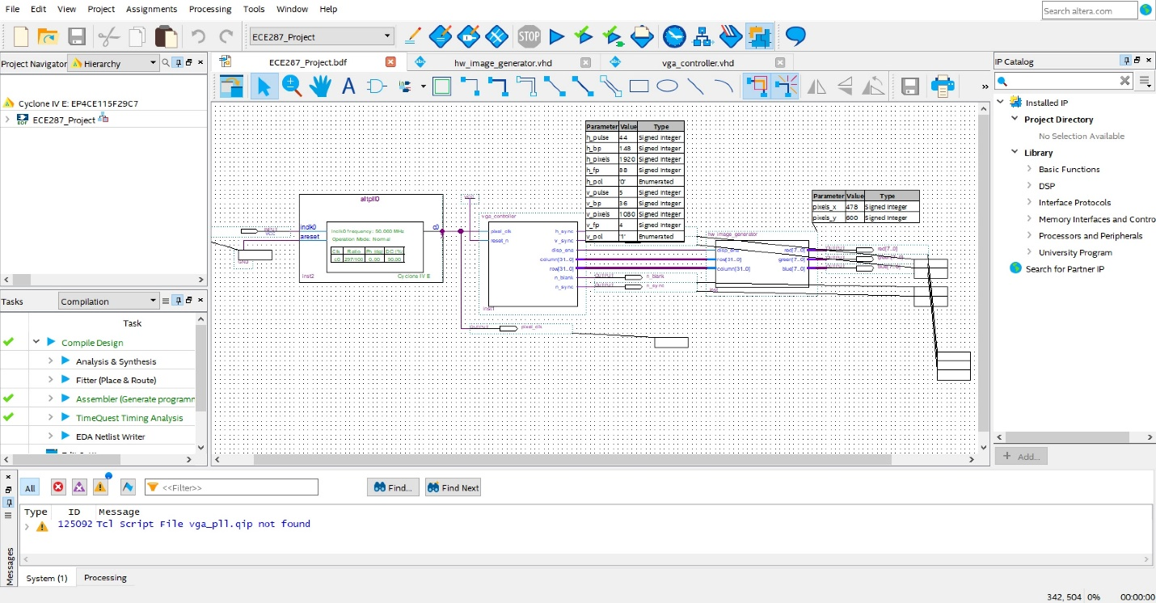

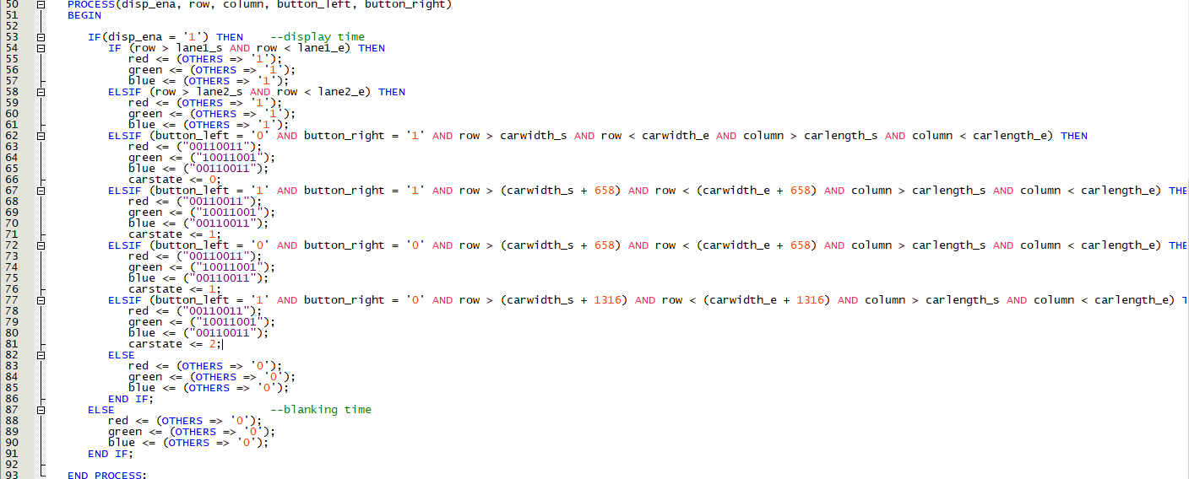

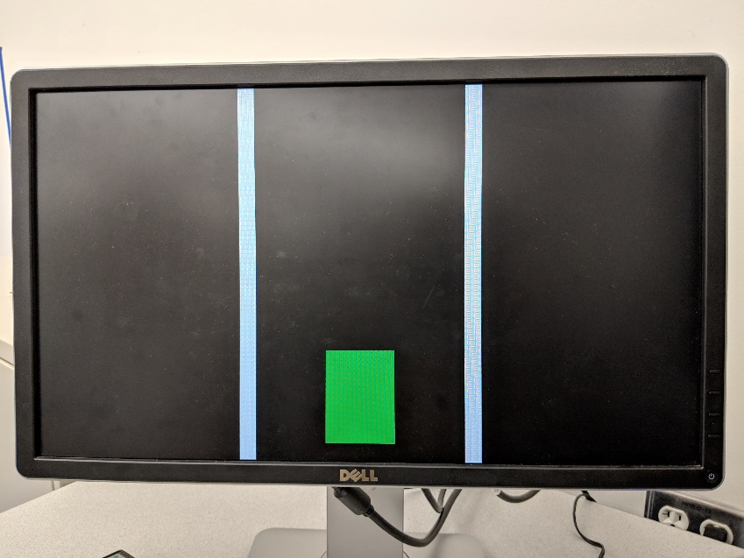

Above are our draw statements that correlate to the car lanes as well as the car itself. With input from the onboard buttons, we can redraw the car in the left and right lanes corresponding to what buttons are actively being pressed.

To the right is the output when we are pressing neither button as well as when we are pressing both ‘left’ and ‘right’.

**Challenges**

A big challenge that we ran into was the difficulty in understanding VGA specifications and getting a VGA driver up and running. We did not expect such issues and such limitations, and these obstacles have been a huge deterrent in productivity and our overall project schedule.

Another challenge that has come about is our collaborative efforts and the lack of communication between team members. We have not taken advantage of our GitHub repository and have found ourselves working independently of each other on the same problem. As for how we will overcome these issues, we hope communication will improve on both parts after addressing such issues and both members will work equally as hard to get our game up and running.

**Project Changes**

In terms of our Project Scope, we have only made plans to change one key aspect of our Game that was outlined in our original Proposal. The original plan called for using a computer keyboard for our input, but after dealing with complications with the VGA output, we have decided to back up and first use the Development Board’s onboard push buttons. That way, we can move onto game logic first, as that is the main component of our Car Evasion game.

We have not planned on making any other changes to the final product but realize that time constraints could very likely keep us from adding additional features like a scoring system, randomized encounters, or additional controls. This along with Keyboard I/O, are all only expansions to be made after getting a well-working base game.

**Relation to Original Schedule**

Referring to our original proposal’s Gantt chart, we aimed to have properly working input and output by November 16, 2018. This deadline was roughly met after adjusting our plans and simplifying input to the onboard push buttons. However, another goal that we planned to be working on simultaneously has not even been started. We hoped to start working on the actual game logic on Monday, the 12th, and have it completed by November 28, 2018. Instead, we were stuck on the graphical output and have fallen behind in our project schedule. To compensate for this, we hope to make a significant amount of progress before Thanksgiving break.